Date:02.02.2026 | Implement Tower Of Hanoi

Exp:1
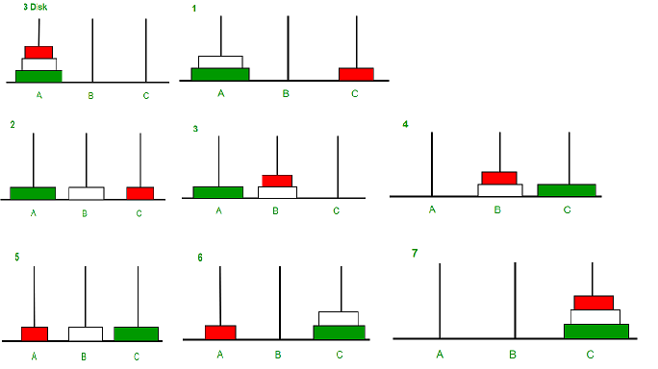
Tower of Hanoi is a mathematical puzzle where we have three rods and n disks. The objective of the puzzle is to move the entire stack to another rod, obeying the following simple rules:
1) Only one disk can be moved at a time.
2) Each move consists of taking the upper disk from one of the stacks and placing it on top of another stack i.e. a disk can only be moved if it is the uppermost disk on a stack.
3) No disk may be placed on top of a smaller disk.

Aim:
To write a C program to solve the Tower of Hanoi problem using recursion and display the sequence of moves required to transfer all disks from the source rod to the destination rod following the rules of the puzzle.

Algorithm:
- Start the program.
- Define a recursive function towerOfHanoi(n, from_rod, to_rod, aux_rod).
- If the number of disks n equals 1:
  - Move the disk directly from the source rod to the destination rod.
  - Return from the function.
- Otherwise:
  - Move n-1 disks from the source rod to the auxiliary rod using the destination rod as helper.
  - Move the nth disk from the source rod to the destination rod.
  - Move the n-1 disks from the auxiliary rod to the destination rod using the source rod as helper.
- In the main() function:
  - Set the number of disks.
  - Call the recursive function with appropriate rods.
- Stop the program.

Code:
#include <stdio.h>
// C recursive function to solve Tower of Hanoi puzzle
void towerOfHanoi(int n, char from_rod, char to_rod, char aux_rod)
{
if (n == 1)
{
printf("Move disk 1 from rod %c to rod %c\n", from_rod, to_rod);
return;
}

towerOfHanoi(n - 1, from_rod, aux_rod, to_rod);
printf("Move disk %d from rod %c to rod %c\n", n, from_rod, to_rod);
towerOfHanoi(n - 1, aux_rod, to_rod, from_rod);
}
int main()
{
int n = 4;
towerOfHanoi(n, 'A', 'C', 'B');
return 0;
}
Output:

Move disk 1 from rod A to rod B
Move disk 2 from rod A to rod C
Move disk 1 from rod B to rod C
Move disk 3 from rod A to rod B
Move disk 1 from rod C to rod A
Move disk 2 from rod C to rod B
Move disk 1 from rod A to rod B
Move disk 4 from rod A to rod C
Move disk 1 from rod B to rod C
Move disk 2 from rod B to rod A
Move disk 1 from rod C to rod A
Move disk 3 from rod B to rod C
Move disk 1 from rod A to rod B
Move disk 2 from rod A to rod C
Move disk 1 from rod B to rod C

Time Complexity: O(2^{n})
Auxiliary Space: O(n)
Result:
The program successfully prints the sequence of steps required to solve the Tower of Hanoi problem for 4 disks, showing the movement of disks from rod A to rod C using rod B as auxiliary. The output displays the correct order of moves according to the rules of the Tower of Hanoi puzzle.
- As the count of disks increases,the number of steps to solve the problem also increases.

Date:02.02.2026 | Implement factorial using

Exp:2 recursion & iteration

Aim
To write a C program to find the the factorial of a number using both recursive and iterative methods and compare the approaches.

Algorithm

Recursive Method
- Start the program.
- Read the value of n.
- Initialize fact = 1 and i = 1.
- Check the condition i ≤ n.
- If true, calculate fact = fact × i.
- Increment i by 1.
- Repeat steps 4–6 until the condition becomes false.
- Print the factorial value.
- Stop the program
Illustraion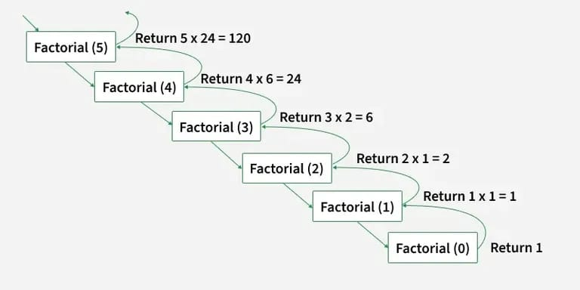
Code
#include <stdio.h>

// Function to calculate factorial using recursion
int factorial(int n)
{
if (n == 0)
return 1;
else
return n * factorial(n - 1);
}
int main()
{
int num = 5;
printf("Factorial of %d is %d", num, factorial(num));
return 0;
}

Output
120

Time Complexity:O(n)
Space Complexity : O(n) (due to recursion stack)
Algorithm
B. Iterative Method
- Start the program.
- Define a recursive function factorial(n).
- If n == 0, return 1.
- Otherwise, return n × factorial(n − 1).
- Call the function from the main program.
- Display the factorial value.
- Stop the program.

Illustration
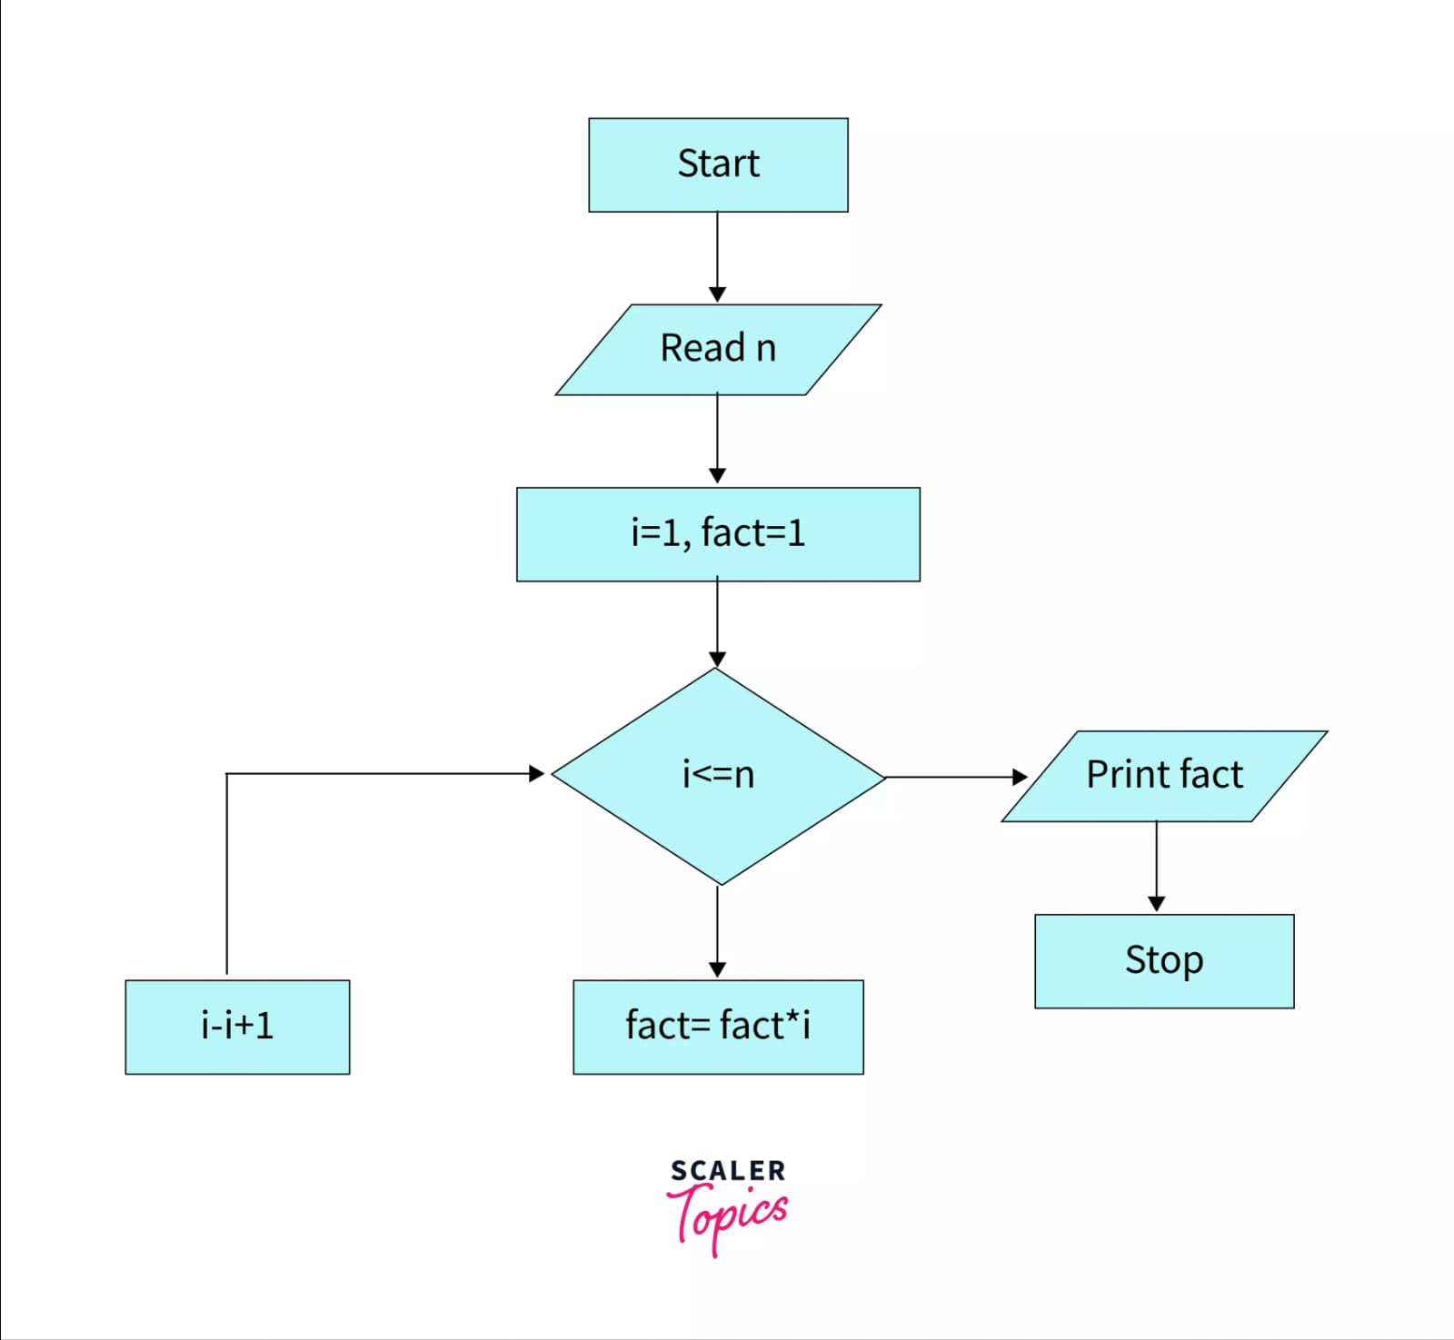

Code
#include <stdio.h>
int main()
{
int n, i = 1;
int fact = 1;
// Read n
printf("Enter a number: ");
scanf("%d", &n);
// Loop: i <= n
while (i <= n)
{
fact = fact * i; // fact = fact * i
i = i + 1; // i = i + 1
}
// Print fact
printf("Factorial = %d", fact);
return 0;
}

Output
120
Time Complexity : O(n)
Space Complexity : O(1) (no recursive stack used)

Which approach is better - iterative or recursive?
Iterative approach is better as the recursive approach requires extra space for recursion call stack and overhead of recursion calls. However writing a recursive code is always a fun exercise.

Result
The program successfully calculates the factorial of a given number using both recursive and iterative method.

Date:02.02.2026 | Implement Bin Packing

Exp:3

Aim
To write a C program to implement the Bin Packing algorithm and determine the minimum number of bins required to store a given set of items based on the given bin capacity.

Algorithm
- Start the program.
- Read the number of items n.
- Read the sizes of n items into an array.
- Read the bin capacity size.
- Initialize:
  - binCount = 1 (at least one bin is required)
  - s = size (remaining capacity of current bin)
- For each item:
  - If the current item size is less than the remaining capacity of the bin:
    - Place the item in the current bin.
    - Reduce the remaining capacity.
  - Otherwise:
    - Increase the bin count.
    - Reset remaining capacity to bin size.
    - Recheck the same item in the new bin.
- After all items are placed, display the number of bins required.
- Stop the program.

Illustration

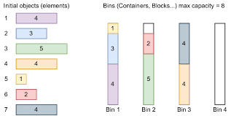

The diagram represents the bin packing process where items are placed into bins of fixed capacity. When the current bin cannot accommodate an item, a new bin is created. This illustrates the working of the bin packing algorithm implemented in the program.

In the bin packing problem, objects of different volumes must be packed into a finite number of bins or containers each of volume V in a way that minimizes the number of bins used.

Code
#include<stdio.h>
void binPacking(int *a, int size, int n) {
int binCount = 1, i;
int s = size;
for (i = 0; i < n; i++) {
if (s - *(a + i) > 0) {
s -= *(a + i);
continue;
} else {
binCount++;
s = size;
i--;
}
}

printf("Number of bins required: %d", binCount);
}

int main(int argc, char **argv) {
printf("Enter the number of items in Set: ");
int n;
int a[n], i;
int size;
scanf("%d", &n);
printf("Enter %d items:", n);

for (i = 0; i < n; i++)
scanf("%d", &a[i]);
printf("Enter the bin size: ");
scanf("%d", &size);
binPacking(a, size, n);
return 0;
}

Output
Enter the number of items in Set: 5
Enter 5 items:12 23 34 45 56
Enter the bin size: 70
Number of bins required: 3

Time Complexity: O(n)
Space Complexity: O(n)

Result
The program successfully calculates and displays the number of bins required to store the given items based on the specified bin capacity using the bin packing method.

Date:14.02.2026 | Implement Fractional Knapsack

Exp:4 problem using greedy method

Aim
To implement the Fractional Knapsack Problem using a greedy approach in C programming and to find the maximum profit that can be obtained for a given knapsack capacity.

Algorithm
- Start the program.
- Define a structure to store item details:
  - Item ID
  - Weight
  - Profit
  - Profit-to-weight ratio.
- Input the number of items and knapsack capacity.
- For each item:
  - Calculate the ratio = Profit / Weight.
- Sort all items in descending order based on the profit-to-weight ratio.
- Initialize:
  - Total profit = 0
  - Remaining capacity = Knapsack capacity.
- Traverse through the sorted items:
  - If item weight ≤ remaining capacity:
    - Add the whole item to the knapsack.
    - Reduce remaining capacity.
    - Add full profit to total profit.
  - Else:
    - Add the fractional part of the item.
    - Add proportional profit.
    - Set remaining capacity to 0 and stop.
- Display the maximum total profit.
- Stop the program.
Illustration:
Step 1
Given, n = 5
Wi = {3, 3, 2, 5, 1}
Pi = {10, 15, 10, 12, 8}
Calculate P_{i}/w_{i} for all the items
Items | 1 | 2 | 3 | 4 | 5
Weights (in kg) | 3 | 3 | 2 | 5 | 1
Profits | 10 | 15 | 10 | 20 | 8
P_{i}/w_{i} | 3.3 | 5 | 5 | 4 | 8
Step 2
Arrange all the items in descending order based on P_{i}/w_{i}
Items | 5 | 2 | 3 | 4 | 1
Weights (in kg) | 1 | 3 | 2 | 5 | 3
Profits | 8 | 15 | 10 | 20 | 10
P_{i}/w_{i} | 8 | 5 | 5 | 4 | 3.3
Step 3
Without exceeding the knapsack capacity, insert the items in the knapsack with maximum profit.
Knapsack = {5, 2, 3}
However, the knapsack can still hold 4 kg weight, but the next item having 5 kg weight will exceed the capacity. Therefore, only 4 kg weight of the 5 kg will be added in the knapsack.
Items | 5 | 2 | 3 | 4 | 1
Weights (in kg) | 1 | 3 | 2 | 5 | 3
Profits | 8 | 15 | 10 | 20 | 10
Knapsack | 1 | 1 | 1 | 4/5 | 0
Hence, the knapsack holds the weights = [(1 * 1) + (1 * 3) + (1 * 2) + (4/5 * 5)] = 10, with maximum profit of [(1 * 8) + (1 * 15) +(1 * 10) + (4/5 * 20)] = 37

Code
#include <stdio.h>
#include <stdlib.h>

// Structure for item
typedef struct {
int id;
float weight;
float profit;
float ratio;
} Item;

// Comparator for sorting in descending order of ratio
int compareItems(const void *a, const void *b) {
Item *itemA = (Item *)a;
Item *itemB = (Item *)b;

if (itemB->ratio > itemA->ratio)
return 1;
else if (itemB->ratio < itemA->ratio)
return -1;
else
return 0;
}

// Fractional Knapsack Function
float fractionalKnapsack(Item items[], int n, float capacity) {

// Step 1: Calculate ratio Pi/Wi
for (int i = 0; i < n; i++) {
items[i].ratio = items[i].profit / items[i].weight;
}

// Step 2: Sort items based on ratio
qsort(items, n, sizeof(Item), compareItems);

float totalProfit = 0.0;
float remainingCapacity = capacity;

printf("\nItems added to knapsack:\n");

// Step 3: Fill knapsack
for (int i = 0; i < n; i++) {

if (items[i].weight <= remainingCapacity) {
totalProfit += items[i].profit;
remainingCapacity -= items[i].weight;

printf("Item %d added completely (W=%.0f, P=%.0f)\n",
items[i].id, items[i].weight, items[i].profit);
}
else {
float fraction = remainingCapacity / items[i].weight;
totalProfit += fraction * items[i].profit;

printf("Item %d added %.2f fraction (W=%.0f, P=%.0f)\n",
items[i].id, fraction,
items[i].weight, items[i].profit);
break;
}
}

return totalProfit;
}

int main() {

int n = 5;
float capacity = 10;

Item items[] = {
{1, 3, 10, 0},
{2, 3, 15, 0},
{3, 2, 10, 0},
{4, 5, 20, 0},
{5, 1, 8, 0}
};

float maxProfit = fractionalKnapsack(items, n, capacity);

printf("\nMaximum Profit = %.2f\n", maxProfit);

return 0;
}

Time Complexity
The program mainly performs two operations:
- Calculating Profit/Weight Ratio
  - Done for all n items.
  - Time Complexity = O(n)
- Sorting Items based on Ratio
  - Sorting is done using qsort().
  - Time Complexity = O(n log n)
- Selecting Items for Knapsack
  - Traversing all items once.
  - Time Complexity = O(n)

Overall Time Complexity
O(n)+O(nlog⁡n)+O(n)=O(nlog⁡n)O(n) + O(n \log n) + O(n) = O(n \log n)O(n)+O(nlogn)+O(n)=O(nlogn)
So, the overall time complexity is:
O(n log n)

Space Complexity
- No extra data structures are used apart from variables.
- Sorting is done in-place.
Space Complexity = O(1) (Constant extra space)

Auxiliary Space Complexity:O(1)
That means constant extra space is used.

Result
The program successfully implements the Fractional Knapsack Algorithm using a greedy approach.

Date:14.02.2026 | Implement Travelling Salesman

Exp:5 Problem(TSP)

What is Travelling Salesman Problem?
The Travelling Salesperson Problem (TSP) is an optimization problem where a salesperson must visit a given set of cities exactly once, starting and ending at the same city. The goal is to find the shortest possible route that covers all the cities and returns to the starting point.

TSP is an NP-hard problem, meaning there is no known efficient solution for large datasets, but various algorithms can provide exact or approximate solutions.

Why is TSP Algorithm Important?
The algorithm for salesman Travelling problem is important because it represents real-world problems that many industries face, such as:
- Delivery services need to plan routes to drop off packages at multiple locations.
- Logistics companies need to find the shortest path to transport goods efficiently.
- Manufacturing companies need to reduce the travel of robotic arms in factories.
Solving TSP helps reduce time, fuel costs, and energy, making operations faster and cheaper.

Aim
To find the minimum travelling cost required to visit all cities exactly once and return to the starting city using Dynamic Programming with Bitmasking approach for the Travelling Salesman Problem.

Algorithm
- Start the program.
- Define the number of cities N and the distance matrix representing distances between cities.
- Create a DP table dp[mask][pos] to store minimum cost values:
  - mask represents visited cities using bitmasking.
  - pos represents the current city.
- Initialize all DP values to -1.
- Define a recursive function tsp(mask, pos):
  - If all cities are visited (mask == (1<<N) - 1), return distance from current city back to starting city.
  - If value already exists in DP table, return it.
  - Otherwise:
    - Initialize answer as a large value.
    - For every unvisited city:
      - Calculate cost of visiting that city and recursively call tsp.
      - Update minimum cost.
- Store the computed value in DP table.
- Call tsp(1, 0) assuming starting city as city 0.
- Print the minimum travelling cost.
- Stop the program.

Illustration:

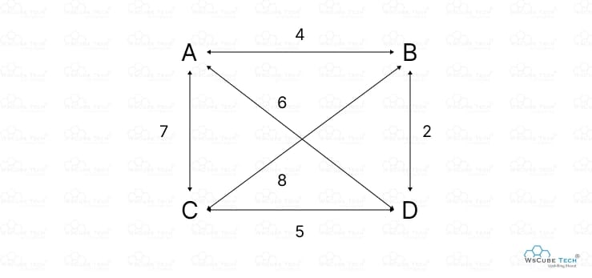
Code:
#include <stdio.h>
#define INF 9999999
#define N 4 // Number of cities

int dist[N][N] = {
{0, 10, 15, 20},
{10, 0, 35, 25},
{15, 35, 0, 30},
{20, 25, 30, 0}
};

int dp[1 << N][N]; // dp[mask][i]

int tsp(int mask, int pos) {
if (mask == (1 << N) - 1) {
return dist[pos][0]; // Return to the starting city
}

if (dp[mask][pos] != -1) {
return dp[mask][pos];
}

int ans = INF;
for (int city = 0; city < N; city++) {
if (!(mask & (1 << city))) {
int newAns = dist[pos][city] + tsp(mask | (1 << city), city);
ans = (newAns < ans) ? newAns : ans;
}
}
return dp[mask][pos] = ans;
}

int main() {
for (int i = 0; i < (1 << N); i++) {
for (int j = 0; j < N; j++) {
dp[i][j] = -1;
}
}
printf("The minimum cost is %d\n", tsp(1, 0));
return 0;
}

Output:
The minimum cost is 80

The optimal path is:
0 → 1 → 3 → 2 → 0

Time Complexity
The time complexity of the TSP using dynamic programming and bitmasking is:
O(N² x 2N)

Explanation:
- There are 2^{n} possible subsets of cities (bitmask states).
- For each subset, we compute values for NNN possible current cities.
- For each state, we try visiting up to NNN remaining cities.
Therefore,
O(N x 2^{N} x N) = O(N² x 2^{N})

Space Complexity
The space complexity is:
O(N x 2^{N})
Explanation:
- The DP table dp[mask][pos] stores results for every subset of cities and each city.
- Total entries = 2^{N} x N

Result
- The program successfully computes the minimum travelling cost for visiting all cities exactly once and returning to the starting city.
- For the given distance matrix:
{0, 10, 15, 20}
{10, 0, 35, 25}
{15, 35, 0, 30}
{20, 25, 30, 0}

Date:23.02.2026 | Implement Minimum Spanning Tree

Exp:6a (Prims’s Algoithm)

Prim’s algorithm is a Greedy algorithm like Kruskal's algorithm. This algorithm always starts with a single node and moves through several adjacent nodes, in order to explore all of the connected edges along the way.

• The algorithm starts with an empty spanning tree.

• The idea is to maintain two sets of vertices. The first set contains the vertices already included in the MST, and the other set contains the vertices not yet included.

• At every step, it considers all the edges that connect the two sets and picks the minimum weight edge from these edges. After picking the edge, it moves the other endpoint of the edge to the set containing MST.

Aim
To implement Prim’s Algorithm to find the Minimum Spanning Tree (MST) of a connected weighted graph using an adjacency matrix representation.
Working of the Prim's Algorithm
- Determine an arbitrary vertex as the starting vertex of the MST. We pick 0 in the diagram.
- Follow steps 3 to 5 till there are vertices that are not included in the MST (known as fringe vertex).
- Find edges connecting any tree vertex with the fringe vertices.
- Find the minimum among these edges.
- Add the chosen edge to the MST. Since we consider only the edges that connect fringe vertices with the rest, we never get a cycle.
- Return the MST and exit
Illustartion:

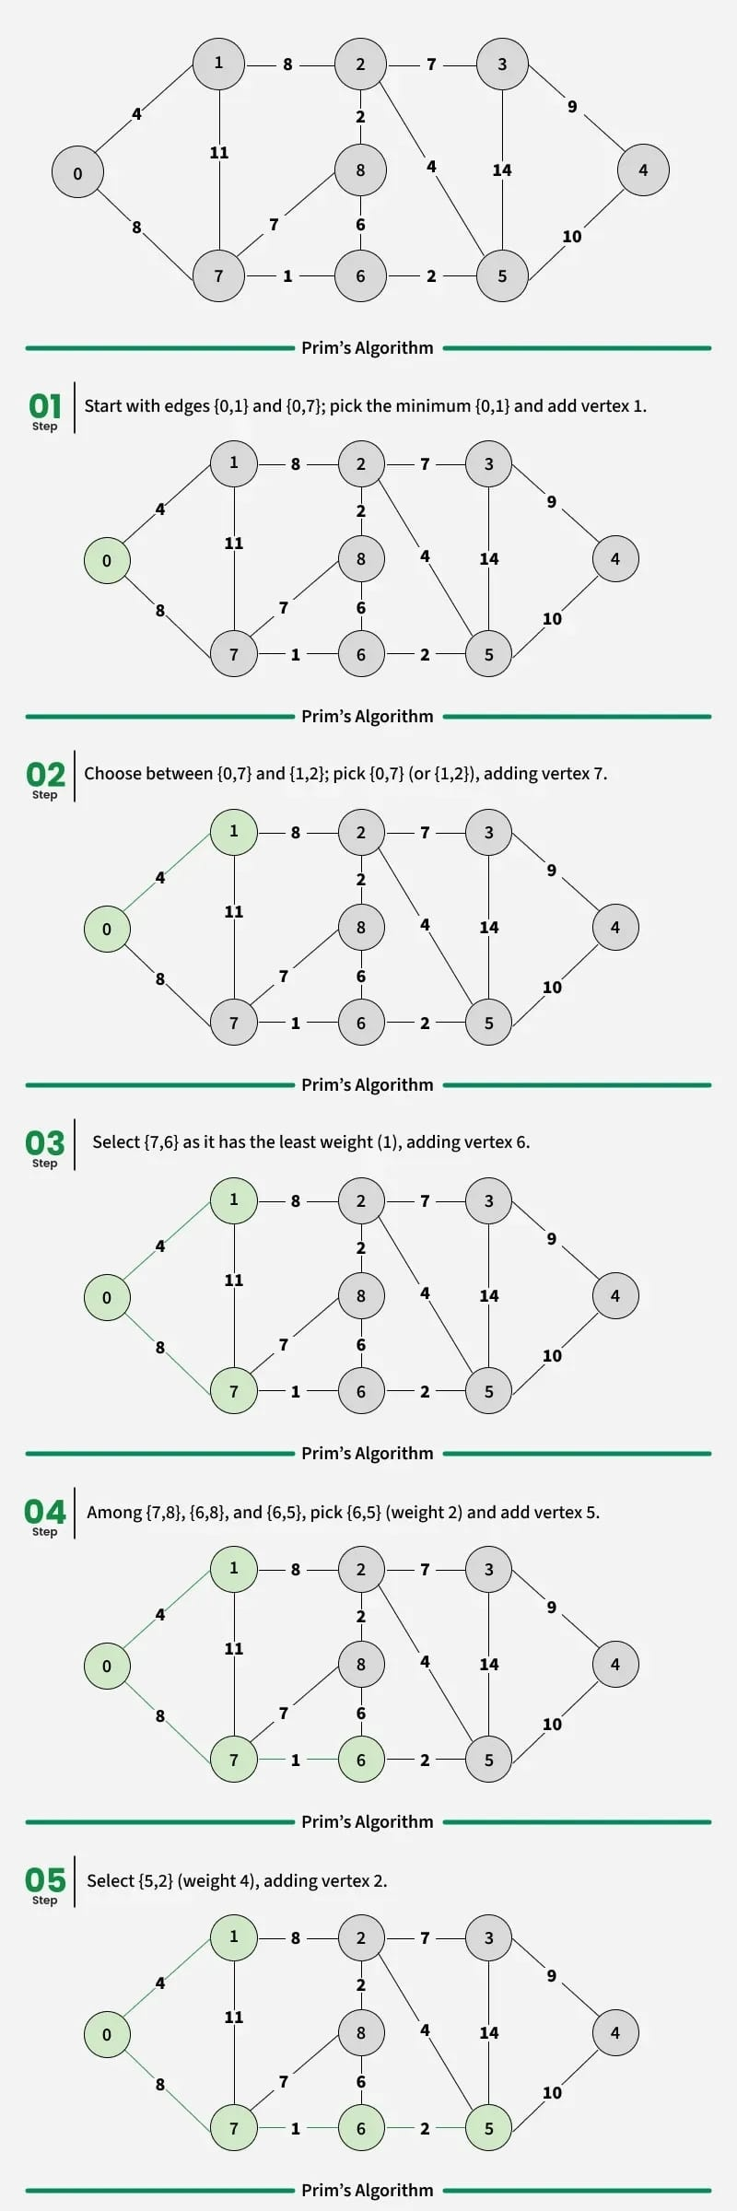
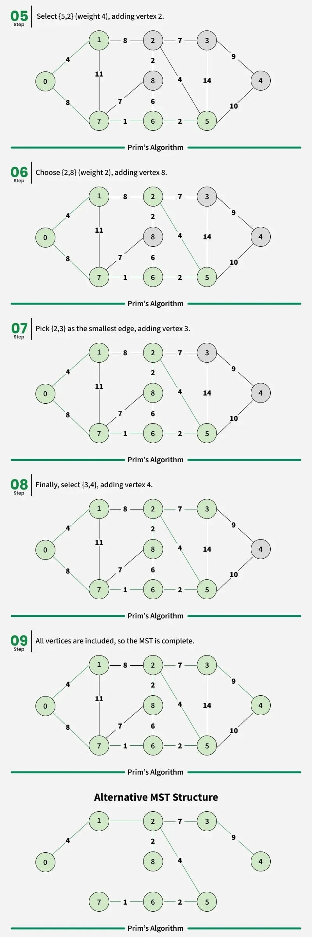
Code:
#include <limits.h>
#include <stdbool.h>
#include <stdio.h>

// Number of vertices in the graph
#define V 5

// A utility function to find the vertex with
// minimum key value, from the set of vertices
// not yet included in MST
int minKey(int key[], bool mstSet[]) {

// Initialize min value
int min = INT_MAX, min_index;

for (int v = 0; v < V; v++)
if (mstSet[v] == false && key[v] < min)
min = key[v], min_index = v;

return min_index;
}

// A utility function to print the
// constructed MST stored in parent[]
int printMST(int parent[], int graph[V][V]) {
printf("Edge \tWeight\n");
for (int i = 1; i < V; i++)
printf("%d - %d \t%d \n", parent[i], i,
graph[parent[i]][i]);
}

// Function to construct and print MST for
// a graph represented using adjacency
// matrix representation
void primMST(int graph[V][V]) {

// Array to store constructed MST
int parent[V];
// Key values used to pick minimum weight edge in cut
int key[V];
// To represent set of vertices included in MST
bool mstSet[V];

// Initialize all keys as INFINITE
for (int i = 0; i < V; i++)
key[i] = INT_MAX, mstSet[i] = false;

// Always include first 1st vertex in MST.
// Make key 0 so that this vertex is picked as first
// vertex.
key[0] = 0;

// First node is always root of MST
parent[0] = -1;

// The MST will have V vertices
for (int count = 0; count < V - 1; count++) {

// Pick the minimum key vertex from the
// set of vertices not yet included in MST
int u = minKey(key, mstSet);

// Add the picked vertex to the MST Set
mstSet[u] = true;

// Update key value and parent index of
// the adjacent vertices of the picked vertex.
// Consider only those vertices which are not
// yet included in MST
for (int v = 0; v < V; v++)

// graph[u][v] is non zero only for adjacent
// vertices of m mstSet[v] is false for vertices
// not yet included in MST Update the key only
// if graph[u][v] is smaller than key[v]
if (graph[u][v] && mstSet[v] == false
&& graph[u][v] < key[v])
parent[v] = u, key[v] = graph[u][v];
}

// print the constructed MST
printMST(parent, graph);
}

int main() {
int graph[V][V] = { { 0, 2, 0, 6, 0 },
{ 2, 0, 3, 8, 5 },
{ 0, 3, 0, 0, 7 },
{ 6, 8, 0, 0, 9 },
{ 0, 5, 7, 9, 0 } };

// Print the solution
primMST(graph);

return 0;
}
Output:
Edge Weight
0 - 1 2
1 - 2 3
0 - 3 6
1 - 4 5
Time Complexity: O(V²), As, we are using adjacency matrix, if the input graph is represented using an adjacency list, then the time complexity of Prim's algorithm can be reduced to O((E+V) * logV) with the help of a binary heap.
Auxiliary Space: O(V)

Result:
The program successfully constructs the Minimum Spanning Tree by selecting edges with minimum weight without forming cycles.

Date:23.02.2026 | Implement Minimum Spanning Tree

Exp:6b (Kruskal’s Algorithm)

A minimum spanning tree (MST) or minimum weight spanning tree for a weighted, connected, and undirected graph is a spanning tree (no cycles and connects all vertices) that has minimum weight. The weight of a spanning tree is the sum of all edges in the tree.

It picks the minimum weighted edge at first and the maximum weighted edge at last. Thus we can say that it makes a locally optimal choice in each step in order to find the optimal solution. Hence this is a Greedy Algorithm

Aim
To write a C program to find the Minimum Spanning Tree (MST) of a given weighted undirected graph using Kruskal’s Algorithm and to calculate the minimum total cost of the spanning tree.
Algorithm
- Sort all the edges in a non-decreasing order of their weight.
- Pick the smallest edge. Check if it forms a cycle with the spanning tree formed so far. If the cycle is not formed, include this edge. Else, discard it. It uses the Disjoint Sets to detect cycles.
- Repeat step 2 until there are (V-1) edges in the spanning tree.

Illustration:
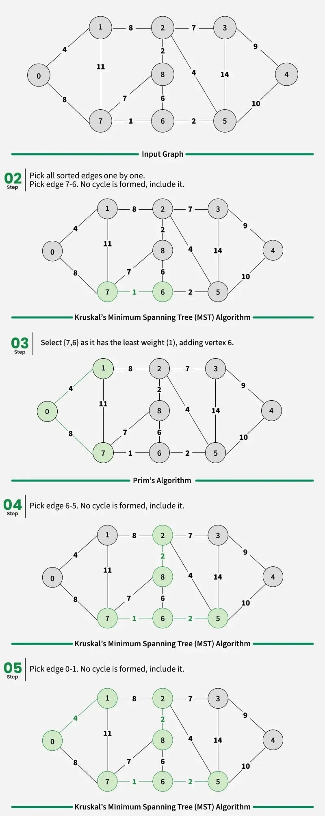
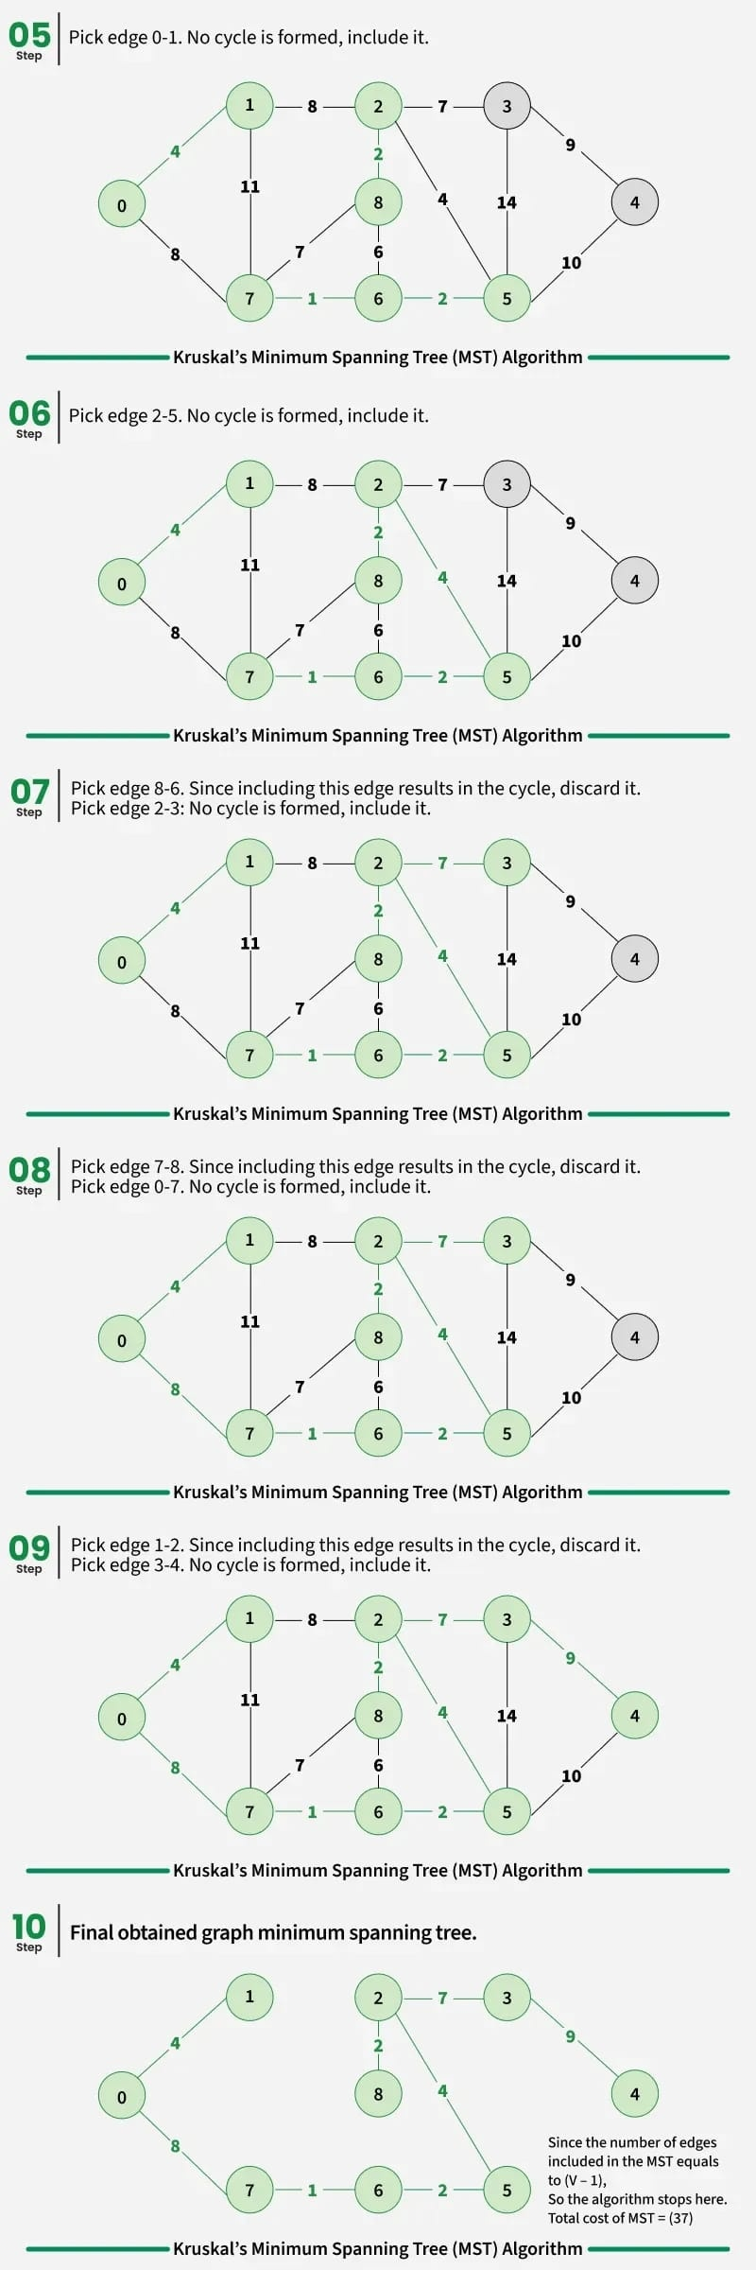
Code:
// C code to implement Kruskal's algorithm

#include <stdio.h>
#include <stdlib.h>

// Comparator function to use in sorting
int comparator(const int p1[], const int p2[])
{
return p1[2] - p2[2];
}

// Initialization of parent[] and rank[] arrays
void makeSet(int parent[], int rank[], int n)
{
for (int i = 0; i < n; i++) {
parent[i] = i;
rank[i] = 0;
}
}

// Function to find the parent of a node
int findParent(int parent[], int component)
{
if (parent[component] == component)
return component;

return parent[component]
= findParent(parent, parent[component]);
}

// Function to unite two sets
void unionSet(int u, int v, int parent[], int rank[], int n)
{
// Finding the parents
u = findParent(parent, u);
v = findParent(parent, v);

if (rank[u] < rank[v]) {
parent[u] = v;
}
else if (rank[u] > rank[v]) {
parent[v] = u;
}
else {
parent[v] = u;

// Since the rank increases if
// the ranks of two sets are same
rank[u]++;
}
}

// Function to find the MST
int kruskalAlgo(int n, int edge[n][3])
{
// First we sort the edge array in ascending order
// so that we can access minimum distances/cost
qsort(edge, n, sizeof(edge[0]), comparator);

int parent[n];
int rank[n];

// Function to initialize parent[] and rank[]
makeSet(parent, rank, n);

// To store the minimun cost
int minCost = 0;
for (int i = 0; i < n; i++) {
int v1 = findParent(parent, edge[i][0]);
int v2 = findParent(parent, edge[i][1]);
int wt = edge[i][2];

// If the parents are different that
// means they are in different sets so
// union them
if (v1 != v2) {
unionSet(v1, v2, parent, rank, n);
minCost += wt;
}
}

return minCost;
}

// Driver code
int main()
{
int edge[5][3] = { { 0, 1, 10 },
{ 0, 2, 6 },
{ 0, 3, 5 },
{ 1, 3, 15 },
{ 2, 3, 4 } };

printf("%d",kruskalAlgo(5, edge));

return 0;
}
Output:
Following are the edges in the constructed MST
2 -- 3 == 4
0 -- 3 == 5
0 -- 1 == 10
Minimum Cost Spanning Tree: 19

Time Complexity: O(E * log E) or O(E * log V)
- Sorting of edges takes O(E*logE) time.
- After sorting, we iterate through all edges and apply the find-union algorithm. The find and union operations can take at most O(logV) time.
- So overall complexity is O(E*logE + E*logV) time.
- The value of E can be at most O(V²), so O(logV) and O(logE) are the same. Therefore, the overall time complexity is O(E * logE) or O(E*logV)

Auxiliary Space: O(E+V), where V is the number of vertices and E is the number of edges in the graph.

Result:
The program successfully constructs the Minimum Spanning Tree using Kruskal’s algorithm by selecting edges in increasing order of weight and avoiding cycles using the Disjoint Set (Union-Find) method.

Shortest Path Algorithm
In C programming, finding the shortest path between nodes in a graph is a common and crucial problem with applications in various fields such as networking, transportation, and logistics. Shortest path algorithms are designed to find the most efficient route from a starting node to a destination node, minimizing the total travel cost, which could be in terms of distance, time, or any other metric.

Types of Shortest Path Algorithms

Shortest path algorithms can be categorized into two main types:
- Single Source Shortest Path Algorithms: These algorithms find the shortest paths from a single source vertex to all other vertices in the graph.
- All Pair Shortest Path Algorithms: These algorithms find the shortest paths between every pair of vertices in the graph.

Single Source Shortest Path Algorithms
- Dijkstra's Algorithm: Works for graphs with non-negative edge weights.
- Bellman-Ford Algorithm: Can handle graphs with negative edge weights.
- A*Search Algorithm: Uses heuristics to try to speed up the search.

All Pair Shortest Path Algorithms
- Floyd-Warshall Algorithm: Finds shortest paths between all pairs of vertices.
- Johnson's Algorithm: Combines Dijkstra's algorithm with Bellman-Ford to find all pair shortest paths.

Date:00.00.0000 | Implement Shortest path algorithm

Exp:7a (Dijkstra’s Algorithm)
Dijkstra's algorithm is often considered to be the most straightforward algorithm for solving the shortest path problem.Dijkstra's algorithm is used for solving single-source shortest path problems for directed or undirected paths.

Aim:
To write a C program to find the shortest path from a source vertex to all other vertices in a weighted graph using Dijkstra’s Algorithm.

Algorithm (Dijkstra’s Algorithm):
- Start.
- Define the number of vertices in the graph.
- Represent the graph using an adjacency matrix.
- Create two arrays:
  - dist[] to store the shortest distance from the source.
  - included[] to track visited vertices.
- Initialize all distances as infinity and included array as false.
- Set the distance of the source vertex as 0.
- Repeat the following steps for all vertices:
  - Select the vertex having minimum distance value that is not yet included.
  - Mark the selected vertex as included.
  - For all adjacent vertices of the selected vertex:
    - If the new calculated distance is smaller than the current distance,
update the distance.
- After processing all vertices, print the shortest distances.
- Stop.
Illustration:
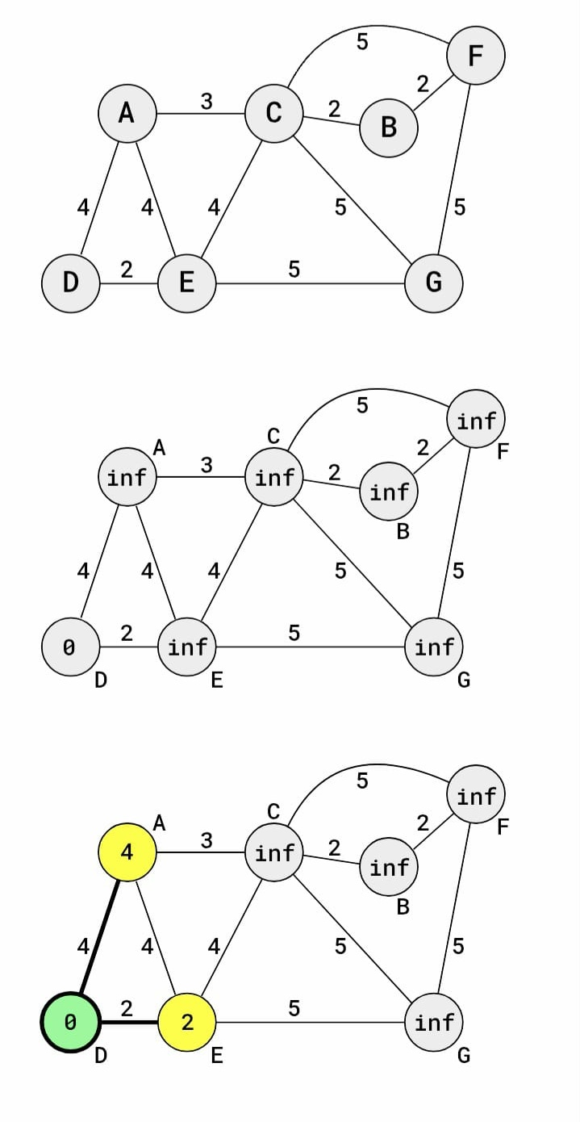
1)To find the shortest path from the source vertex D to all other vertices, so that for example the shortest path to C is D->E->C, with path weight 2+4=6.

2)Dijkstra's algorithm then sets vertex D as the current vertex, and the initial distance to vertices A and E is infinite. So vertex A gets the distance changed from inf to 4, and vertex E gets the distance changed to 2. updating the distancevalues in this way is called 'relaxing'.

3)After relaxing vertices A and E, vertex D is considered visited, and will not be visited again.The next vertex to be chosen as the current vertex must the vertex with the shortest distance to the source vertex (vertex D), among the previously unvisited vertices. Vertex E is therefore chosen as the current vertex after vertex D.
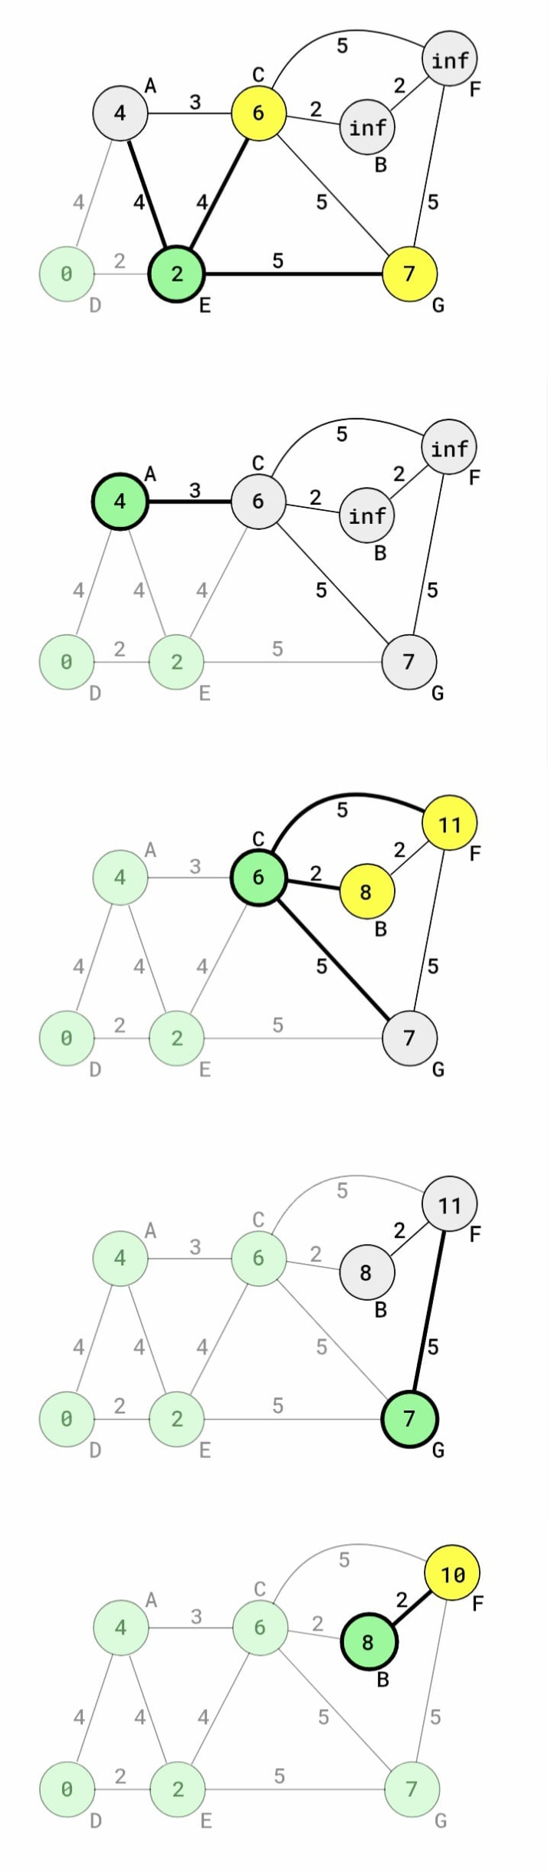
4)The calculated distance from D to vertex A, via E, is 2+4=6. But the current distance to vertex A is already 4, which is lower, so the distance to vertex A is not updated.The distance to vertex C is calculated to be 2+4=6, which is less than infinity, so the distance to vertex C is updated.Similarly, the distance to node G is calculated and updated to be 2+5=7. The next vertex to be visited is vertex A because it has the shortest distance from D of all the unvisited vertices.

5)The calculated distance to vertex C, via A, is 4+3=7, which is higher than the already set distance to vertex C, so the distance to vertex C is not updated.Vertex A is now marked as visited, and the next current vertex is vertex C because that has the lowest distance from vertex D between the remaining unvisited vertices.

6)Vertex F gets updated distance 6+5=11, and vertex B gets updated distance 6+2=8. Vertex C is marked as visited, and the next vertex to be visited is G because is has the lowest distance between the remaining unvisited vertices.

7)Vertex F already has a distance of 11. This is lower than the calculated distance from G, which is 7+5=12, so the distance to vertex F is not updated.Vertex G is marked as visited, and B becomes the current vertex because it has the lowest distance of the remaining unvisited vertices.

8)The new distance to F via B is 8+2=10, because it is lower than F's existing distance of 11.Vertex B is marked as visited, and there is nothing to check for the last unvisited vertex F, so Dijkstra's algorithm is finished.Every vertex has been visited only once, and the result is the lowest distance from the source vertex D to every other vertex in the graph.

The Dijksta's algorithm works fine for graphs having positive weights but it fails for graphs having negative weights. To find the shortest path for graphs having negative weights ,we can use Bellman-Ford Algorithm
Code:
#include <limits.h>
#include <stdio.h>

#define V 7 // A,B,C,D,E,F,G

int findminDistance(int dist[], int included[])
{
int min = INT_MAX, min_index;

for (int v = 0; v < V; v++) {
if (!included[v] && dist[v] <= min) {
min = dist[v];
min_index = v;
}
}
return min_index;
}

void printSolution(int dist[])
{
char node[] = {'A','B','C','D','E','F','G'};

printf("Vertex \t Distance from Source\n");
for (int i = 0; i < V; i++)
printf("%c \t\t %d\n", node[i], dist[i]);
}

void DijkstrasAlgo(int graph[V][V], int src)
{
int dist[V];
int included[V];

for (int i = 0; i < V; i++) {
dist[i] = INT_MAX;
included[i] = 0;
}

dist[src] = 0;

for (int count = 0; count < V - 1; count++) {

int u = findminDistance(dist, included);
included[u] = 1;

for (int v = 0; v < V; v++) {
if (!included[v] && graph[u][v] &&
dist[u] != INT_MAX &&
dist[u] + graph[u][v] < dist[v]) {

dist[v] = dist[u] + graph[u][v];
}
}
}

printSolution(dist);
}

int main()
{
int graph[V][V] = {

//A B C D E F G
{0, 0, 3, 4, 4, 0, 0}, // A
{0, 0, 2, 0, 0, 2, 0}, // B
{3, 2, 0, 0, 4, 5, 5}, // C
{4, 0, 0, 0, 2, 0, 0}, // D
{4, 0, 4, 2, 0, 0, 5}, // E
{0, 2, 5, 0, 0, 0, 5}, // F
{0, 0, 5, 0, 5, 5, 0} // G
};

// Source = D (index 3)
DijkstrasAlgo(graph, 3);

return 0;
}

Output:

Vertex Distance from Source
A 4
B 8
C 6
D 0
E 2
F 10
G 7

Time Complexity:
In this program:
- The function findminDistance() searches all vertices to find the minimum distance vertex → O(V) time.
- This function is called for every vertex → V times.
- Inside the loop, all adjacent vertices are checked → O(V).
Therefore,Time Complexity = O(V²) where V is the number of vertices.

Space Complexity (Auxiliary Space):
The extra space used is for:
- dist[V] array
- included[V] array
Therefore,Space Complexity= O(V)

Result:
Thus, the C program for Dijkstra’s Shortest Path Algorithm was successfully implemented, and the shortest distances from the source vertex to all other vertices were obtained.

Date:23.02.2026 | Implement Shortest path algorithm

Exp:7b (Bellman-Ford Algorithm)
The Bellman-Ford algorithm is best suited to find the shortest paths in a directed graph, with one or more negative edge weights, from the source vertex to all other vertices.
Using the Bellman-Ford algorithm on a graph with negative cycles will not produce a result of shortest paths because in a negative cycle we can always go one more round and get a shorter path.

Aim:
To implement the Bellman–Ford algorithm in C to find the shortest path distances from a single source vertex D to all other vertices in a directed weighted graph, even in the presence of negative edge weights, and to detect negative weight cycles if they exist.

Algorithm:
- Initialize the distance of the source vertex D to 0 and the distance of all other vertices to infinity.
- Repeat the following steps V − 1 times, where V is the number of vertices:
  - For each edge (u, v) with weight w,
if distance[u] + w < distance[v],
then update distance[v] = distance[u] + w.
- After completing the relaxations, check for negative weight cycles:
  - For each edge (u, v) with weight w,
if distance[u] + w < distance[v],
then a negative weight cycle exists.
- If no negative cycle is found, print the shortest distance from the source to all vertices.
Illustration:
The first four edges that are checked in our graph are A->C, A->E, B->C, and C->A. These first four edge checks do not lead to any updates of the shortest distances because the starting vertex of all these edges has an infinite distance.
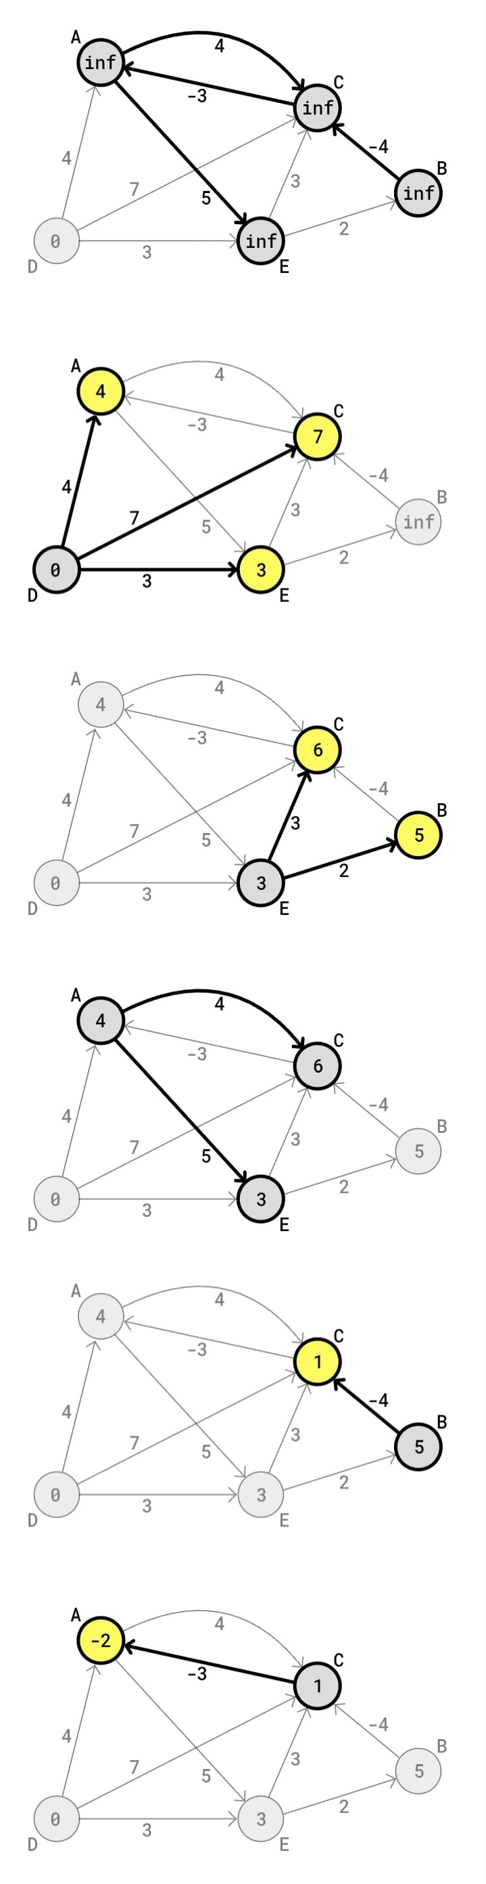
After the edges from vertices A, B, and C are checked, the edges from D are checked. Since the starting point (vertex D) has distance 0, the updated distances for A, B, and C are the edge weights

The next edges to be checked are the edges going out from vertex E, which leads to updated distances for vertices B and C.


The Bellman-Ford algorithm have now checked all edges 1 time.The algorithm will check all edges 3 more times before it is finished, because Bellman-Ford will check all edges as many times as there are vertices in the graph, minus 1.
The algorithm starts checking all edges a second time, starting with checking the edges going out from vertex A. Checking the edges A->C and A->E do not lead to updated distances.

The next edge to be checked is B->C, going out from vertex B. This leads to an updated distance from vertex D to C of 5-4=1.

Checking the next edge C->A, leads to an updated distance 1-3=-2 for vertex A


The check of edge C->A in round 2 of the Bellman-Ford algorithm is actually the last check that leads to an updated distance for this specific graph. The algorithm will continue to check all edges 2 more times without updating any distances.
Checking all edges V−1 times in the Bellman-Ford algorithm may seem like a lot, but it is done this many times to make sure that the shortest distances will always be found.

Code:
// Bellman-Ford Algorithm
#include <stdio.h>
#include <stdlib.h>
#include <limits.h>

// Edge structure
struct Edge {
int src, dest, weight;
};

// Graph structure
struct Graph {
int V, E;
struct Edge* edge;
};

// Create graph
struct Graph* createGraph(int V, int E) {
struct Graph* graph = (struct Graph*)malloc(sizeof(struct Graph));
graph->V = V;
graph->E = E;
graph->edge = (struct Edge*)malloc(E * sizeof(struct Edge));
return graph;
}

// Bellman-Ford algorithm
void BellmanFord(struct Graph* graph, int src) {
int V = graph->V;
int E = graph->E;
int dist[V];

for (int i = 0; i < V; i++)
dist[i] = INT_MAX;
dist[src] = 0;

for (int i = 1; i <= V - 1; i++) {
for (int j = 0; j < E; j++) {
int u = graph->edge[j].src;
int v = graph->edge[j].dest;
int w = graph->edge[j].weight;

if (dist[u] != INT_MAX && dist[u] + w < dist[v]) {
dist[v] = dist[u] + w;
}
}
}
for (int i = 0; i < E; i++) {
int u = graph->edge[i].src;
int v = graph->edge[i].dest;
int w = graph->edge[i].weight;

if (dist[u] != INT_MAX && dist[u] + w < dist[v]) {
printf("Graph contains a negative weight cycle\n");
return;
}
}
// Print results
printf("Vertex Distance from Source (D)\n");
for (int i = 0; i < V; i++)
printf("%d \t\t %d\n", i, dist[i]);
}
int main() {
int V = 5; // D, A, E, C, B
int E = 9;
struct Graph* graph = createGraph(V, E);
// D -> A (4)
graph->edge[0] = (struct Edge){0, 1, 4};

// D -> E (3)
graph->edge[1] = (struct Edge){0, 2, 3};

// D -> C (7)
graph->edge[2] = (struct Edge){0, 3, 7};

// A -> C (4)
graph->edge[3] = (struct Edge){1, 3, 4};

// C -> A (-3)
graph->edge[4] = (struct Edge){3, 1, -3};

// A -> E (5)
graph->edge[5] = (struct Edge){1, 2, 5};

// E -> C (3)
graph->edge[6] = (struct Edge){2, 3, 3};

// E -> B (2)
graph->edge[7] = (struct Edge){2, 4, 2};
// B -> C (-4)
graph->edge[8] = (struct Edge){4, 3, -4};

// Run Bellman-Ford from source D (0)
BellmanFord(graph, 0);
return 0;
}

Time Complexity:
- The Bellman–Ford algorithm relaxes all edges V − 1 times
- Each relaxation checks E edges
Time Complexity=O(V×E)
For the given graph:
- Number of vertices, V = 5
- Number of edges, E = 9
O(5×9)=O(45)
Output:
Vertex Distance from Source (D)
0 0
1 -2
2 3
3 1
4 5

Result:
The Bellman–Ford algorithm was successfully executed on the given graph with D as the source vertex

Date:23.02.2026 | Implement Shortest path algorithm

Exp:7c (A* Search Algorithm)
The A* algorithm is highly effective and well-known search technique utilized for finding the most efficient path between two points in a graph. It is applied in scenarios such as pathfinding in video games, network routing and various artificial intelligence (AI) applications. It was developed in 1968 by Peter Hart, Nils Nilsson and Bertram Raphael as an improvement on Dijkstra's algorithm.

- While Dijkstra’s algorithm explores all possible directions around the starting node uniformly

- A* combines actual travel cost with an estimated future cost(heuristics)

This optimizes the search process, reduces computational load and ensures the most efficient path is found with minimal unnecessary exploration.

Key Components of A* Algorithm
A* uses two important parameters to find the cost of a path:
- g(n): Actual cost of reaching node nnfrom the start node. This is the accumulated cost of the path from the start node to node n.
- h(n): The heuristic finds of the cost to reach the goal from node n. This is a weighted guess about how much further it will take to reach the goal.

The function, f(n)=g(n)+h(n)f(n)=g(n)+h(n) is the total estimated cost of the cheapest solution through node n. This function combines the path cost so far and the heuristic cost to estimate the total cost guiding the search more efficiently.

How A* Algorithm Works?
A* is an informed search algorithm, means it uses the f(n) function to prioritize which nodes to explore next. The process can be broken down into the following steps:
- Initialization: The initial node is added to the open set, a collection of nodes that are yet to be explored. The f(n)value for the start node is calculated using the heuristic.

- Loop: A* selects the node with the lowest f(n)value from the open set. This node is expanded and its neighbors are examined.

- Goal Check: If the node being processed is the goal node, the search terminates and the algorithm returns the path to the goal.

- Node Expansion: Each neighbor of the current node is evaluated based on the g(n),h(n) and f(n) values. If a better path to a neighbor is found i.e a lower f(n) then the neighbor is added to the open set or its values are updated.

- Repeat: This process continues until the goal is found or the open set is empty which means there is no solution.

Heuristic Function in A* Algorithm
The efficiency of the A* algorithm heavily depends on the heuristic function. The choice of heuristic can affect the performance and efficiency of the algorithm. A good heuristic is one that helps the algorithm find the shortest path by exploring the least number of nodes possible.

Properties of a Good Heuristic:
A good heuristic function can improve A*’s performance. Some important characteristics include:
- Admissibility: It means a heuristic never guesses a cost higher than the actual cost to the goal. This helps A* always find the shortest path. For example, using straight-line distance on a map is an admissible heuristic.
- Consistency (Monotonicity): It means a heuristic gives estimates that don't jump around too much. For any node and its next step, the cost to the goal should not be more than going to the next step and then to the goal. This helps A* avoid rechecking the same nodes and makes it faster.

Common Heuristics:
- Manhattan Distance: It is used for grid-based environments where movement is restricted to horizontal and vertical directions. It calculates the sum of the absolute differences in the xx and yy coordinates between two points.

- Euclidean Distance: The straight-line distance between two points often used when movement is

- Chebyshev Distance: It is used when diagonal movement is allowed.

Aim:
To implement the A* Search Algorithm to find the shortest path between a start node and a goal node in a 3×3 grid, using Manhattan distance heuristic and 4-directional movement, and to display the path that matches the given graph visualization.

Algorithm (A* Search):
- Initialize two empty lists:
  - Open list (nodes to be evaluated)
  - Closed list (nodes already evaluated)
- Create the start node with:
  - g = 0 (cost from start)
  - h = heuristic(start, goal)
  - f = g + h
Add it to the open list.
- While the open list is not empty:
- Select the node with the lowest f-value from the open list.
- If the selected node is the goal, reconstruct the path by following parent pointers and stop.
- Move the selected node from the open list to the closed list.
- Generate all valid 4-directional neighbors (up, down, left, right).
- For each neighbor:
- Ignore it if it is outside the grid or already in the closed list.
    - Compute:
      - g = current g + 1
      - h = Manhattan distance to goal
      - f = g + h
    - Add it to the open list if not already present.
- If the open list becomes empty and the goal is not reached, report no path found.
Illustration:
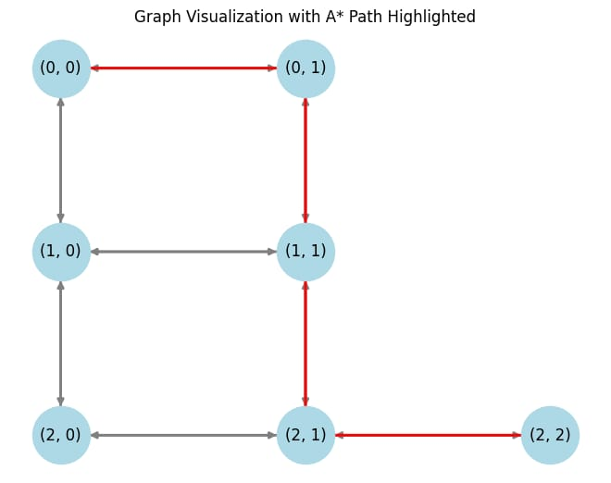
Code:
// C Program for A* Search Algorithm (Exact Image Match)

#include <stdio.h>
#include <stdlib.h>
#include <stdbool.h>

#define ROWS 3
#define COLS 3
#define MAX_NODES 9

typedef struct {
int x, y;
} Point;

typedef struct Node {
Point pos;
int g, h, f;
struct Node* parent;
} Node;

typedef struct {
Node* nodes[MAX_NODES];
int size;
} List;

// Manhattan distance heuristic
int heuristic(Point a, Point b) {
return abs(a.x - b.x) + abs(a.y - b.y);
}

Node* createNode(Point pos, Node* parent, int g, int h) {
Node* node = (Node*)malloc(sizeof(Node));
node->pos = pos;
node->parent = parent;
node->g = g;
node->h = h;
node->f = g + h;
return node;
}

void addToList(List* list, Node* node) {
list->nodes[list->size++] = node;
}

bool isInList(List* list, Point pos) {
for (int i = 0; i < list->size; i++) {
if (list->nodes[i]->pos.x == pos.x &&
list->nodes[i]->pos.y == pos.y)
return true;
}
return false;
}

Node* getLowestF(List* list) {
int idx = 0;
for (int i = 1; i < list->size; i++) {
if (list->nodes[i]->f < list->nodes[idx]->f)
idx = i;
}
Node* best = list->nodes[idx];
list->nodes[idx] = list->nodes[--list->size];
return best;
}
Point* aStar(Point start, Point goal, int* pathLen) {
List open = {0}, closed = {0};

addToList(&open, createNode(start, NULL, 0, heuristic(start, goal)));

while (open.size > 0) {
Node* current = getLowestF(&open);

if (current->pos.x == goal.x && current->pos.y == goal.y) {
int len = 0;
Node* temp = current;
while (temp) {
len++;
temp = temp->parent;
}

Point* path = (Point*)malloc(len * sizeof(Point));
temp = current;
for (int i = len - 1; i >= 0; i--) {
path[i] = temp->pos;
temp = temp->parent;
}
*pathLen = len;
return path;
}
addToList(&closed, current);
// Only 4-directional movement (matches image)
Point moves[4] = {
{current->pos.x, current->pos.y + 1}, // Right
{current->pos.x + 1, current->pos.y}, // Down
{current->pos.x, current->pos.y - 1}, // Left
{current->pos.x - 1, current->pos.y} // Up
};
for (int i = 0; i < 4; i++) {
Point next = moves[i];

if (next.x < 0 || next.x >= ROWS ||
next.y < 0 || next.y >= COLS ||
isInList(&closed, next))
continue;

int g = current->g + 1;
int h = heuristic(next, goal);

if (!isInList(&open, next)) {
addToList(&open, createNode(next, current, g, h));
}
}
}
return NULL;
}
int main() {
Point start = {0, 0};
Point goal = {2, 2};

int pathLen;
Point* path = aStar(start, goal, &pathLen);

if (path) {
printf("A* Path :\n");
for (int i = 0; i < pathLen; i++) {
printf("(%d,%d)", path[i].x, path[i].y);
if (i != pathLen - 1) printf(" -> ");
}
printf("\n");
free(path);
} else {
printf("No path found\n");
}
return 0;
}

Output:
A* Path :
(0,0) -> (0,1) -> (1,1) -> (2,1) -> (2,2)

Time & Space Complexity

Time Complexity: O(V+E)
Where:
- V = number of nodes (vertices)
- E = number of edges (connections)
For the given 3×3 grid, the values are very small, so execution is fast.

Space Complexity:
O(V×E)
Because:
- The algorithm stores nodes in open and closed lists
- Each node maintains cost values and parent references

Result:
The A* algorithm successfully finds the shortest path from the start node to the goal node.

Date:23.02.2026 | Implement Shortest path algorithm

Exp:7d (Floyd-Warshall Search Algorithm)
Floyd-Warshall algorithm is a dynamic programming algorithm used to find the shortest paths between all pairs of vertices in a weighted graph. It works for both directed and undirected graphs and can handle negative weights, provided there are no negative weight cycles.
Principle of Floyd-Warshall Algorithm
The principle behind the Floyd-Warshall algorithm is to use a matrix to keep track of the shortest paths between all pairs of vertices. The algorithm iteratively updates this matrix by considering each vertex as an intermediate point and checking if a shorter path exists through that vertex.

Applications of Floyd-Warshall Algorithm
The Floyd-Warshall algorithm is used in various applications:
- To find the shortest paths in computer networks.
- To compute the transitive closure of a graph.
- For graphs where we need to find the shortest path between every pair of vertices.
- To determine the shortest paths in transportation networks.
- To find the shortest paths in game maps and terrains.

Aim:
To implement the Floyd–Warshall algorithm in to find the shortest distances between all pairs of vertices in a weighted graph using a distance matrix representation.
Algorithm:
- Create a matrix dist[][] initialized with the input graph's weights. If there is no edge between vertices i and j, set dist[i][j] to infinity (or a large value).
- For each pair of vertices (i, j), update dist[i][j] by considering each vertex k as an intermediate point. The update rule is:
  - if (dist[i][k] + dist[k][j] < dist[i][j])
  - dist[i][j] = dist[i][k] + dist[k][j];
- Repeat the update step for all vertices k as intermediates to ensure all possible paths are considered.

The key idea is to improve the distance between any two vertices (i, j) by considering an intermediate vertex k. If the distance from i to j through k is shorter than the current known distance, update the distance.

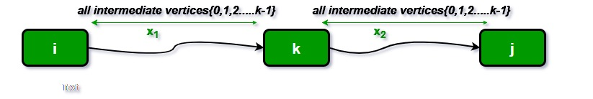

Illustration:
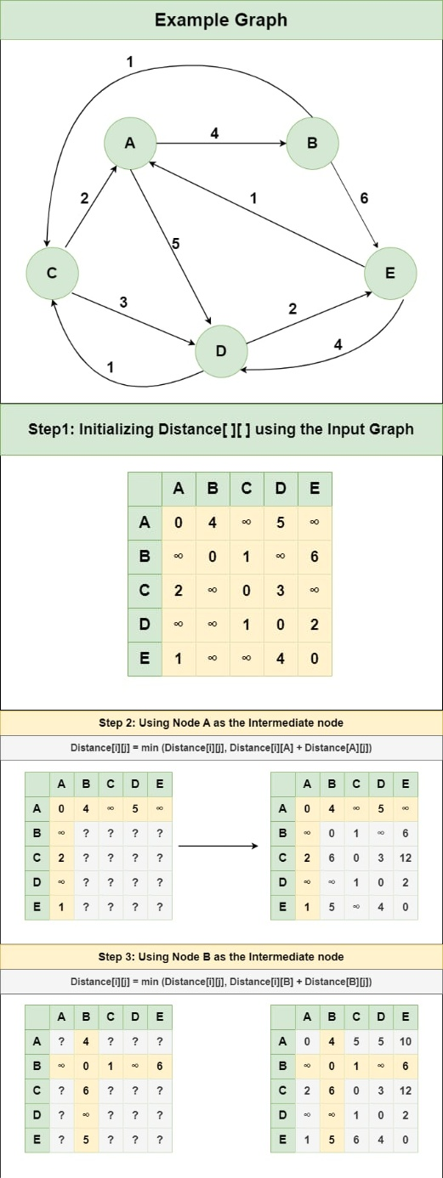

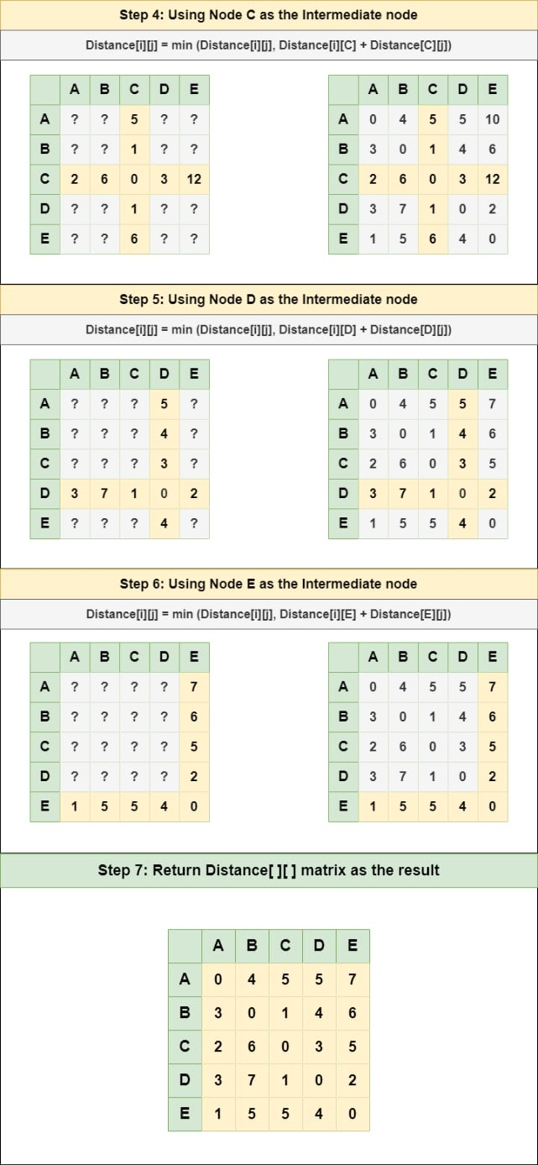
Code:
// C Program for Floyd Warshall Algorithm
#include <stdio.h>

// Number of vertices in the graph
#define V 4

/* Define Infinite as a large enough
value. This value will be used
for vertices not connected to each other */
#define INF 99999

// A function to print the solution matrix
void printSolution(int dist[][V]);

// Solves the all-pairs shortest path
// problem using Floyd Warshall algorithm
void floydWarshall(int dist[][V])
{
int i, j, k;

/* Add all vertices one by one to
the set of intermediate vertices.
---> Before start of an iteration, we
have shortest distances between all
pairs of vertices such that the shortest
distances consider only the
vertices in set {0, 1, 2, .. k-1} as
intermediate vertices.
----> After the end of an iteration,
vertex no. k is added to the set of
intermediate vertices and the set
becomes {0, 1, 2, .. k} */
for (k = 0; k < V; k++) {
// Pick all vertices as source one by one
for (i = 0; i < V; i++) {
// Pick all vertices as destination for the
// above picked source
for (j = 0; j < V; j++) {
// If vertex k is on the shortest path from
// i to j, then update the value of
// dist[i][j]
if (dist[i][k] + dist[k][j] < dist[i][j])
dist[i][j] = dist[i][k] + dist[k][j];
}
}
}

// Print the shortest distance matrix
printSolution(dist);
}

/* A utility function to print solution */
void printSolution(int dist[][V])
{
printf(
"The following matrix shows the shortest distances"
" between every pair of vertices \n");
for (int i = 0; i < V; i++) {
for (int j = 0; j < V; j++) {
if (dist[i][j] == INF)
printf("%7s", "INF");
else
printf("%7d", dist[i][j]);
}
printf("\n");
}
}

// driver's code
int main()
{
/* Let us create the following weighted graph
10
(0)------->(3)
| /|\
5 | |
| | 1
\|/ |
(1)------->(2)
3 */
int graph[V][V] = { { 0, 5, INF, 10 },
{ INF, 0, 3, INF },
{ INF, INF, 0, 1 },
{ INF, INF, INF, 0 } };

// Function call
floydWarshall(graph);
return 0;
}
Output:

The following matrix shows the shortest distances between every pair of vertices
0 5 8 9
INF 0 3 4
INF INF 0 1
INF INF INF 0

Time Complexity: O(V³), where V is the number of vertices in the graph and we run three nested loops each of size V.
Auxiliary Space: O(V²), to create a 2-D matrix in order to store the shortest distance for each pair of nodes.

Result
The Floyd–Warshall algorithm was successfully implemented, and the shortest distances between every pair of vertices in the given weighted graph were obtained and displayed in the form of a distance matrix.

Date:23.02.2026 | Implement Shortest path algorithm

Exp:7d (Johnson’s Search Algorithm)
Johnson's Algorithm is an efficient algorithm used to find the shortest paths between all pairs of vertices in a weighted graph. It works even for graphs with negative weights, provided there are no negative weight cycles. This algorithm is particularly useful for sparse graphs and combines both Dijkstra's and Bellman-Ford algorithms to achieve optimal performance.
Johnson's Algorithm works by transforming the original graph to ensure that all edge weights are non-negative. It does this by adding a new vertex, computing a potential function using Bellman-Ford, re-weighting the edges, and then running Dijkstra's algorithm from each vertex.
Steps of Johnson's Algorithm to Implement in C
- Add a new vertex q to the graph and connect it to all other vertices with edges of weight 0.
- Use the Bellman-Ford algorithm from the new vertex q to compute the shortest path estimates, which act as the potential function h(v).
- Re-weight the edges using the potential function to ensure all edge weights are non-negative.
- Run Dijkstra's algorithm from each vertex in the re-weighted graph to find the shortest paths.

Aim:
To find the shortest paths between all pairs of vertices in a weighted graph using Johnson’s Algorithm, which combines Bellman–Ford and Dijkstra algorithms.
Algorithm:

Step 1: Initialize the Graph
- Represent the graph using an adjacency matrix and edge list.Allow negative edge weights but no negative weight cycles.

Step 2: Apply Bellman–Ford Algorithm
- Initialize the potential array h[] to zero.
- Relax all edges (V−1) times.
- Compute potential values h[] for all vertices.
- If further relaxation is possible, report a negative weight cycle and stop.

Step 3: Re-weight the Edges
- Modify each edge weight using:
w′(u,v)=w(u,v)+h[u]−h[v]

Step 4: Apply Dijkstra’s Algorithm
- Run Dijkstra’s algorithm from each vertex using the re-weighted graph.
- Store shortest distances for all vertex pairs.
Step 5: Restore Original Distances
Convert distances back using:dist[u][v]=dist[u][v]−h[u]+h[v]
Step 6: Print the all-pairs shortest path matrix.
Illustration:
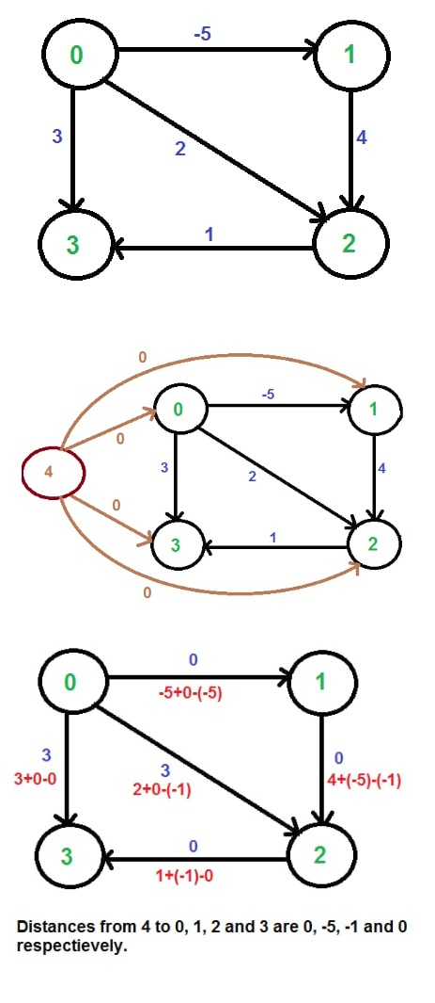


Code:

#include <stdio.h>

#include <limits.h>

#include <stdbool.h>

#define V 4

#define INF 99999

/* ---------- DIJKSTRA ---------- */

int minDistance(int dist[], bool sptSet[])

{

int min = INT_MAX, min_index = -1;

for (int v = 0; v < V; v++)

if (!sptSet[v] && dist[v] <= min)

min = dist[v], min_index = v;

return min_index;

}

void dijkstra(int graph[V][V], int src, int dist[])

{

bool sptSet[V];

for (int i = 0; i < V; i++)

{

dist[i] = INT_MAX;

sptSet[i] = false;

}

dist[src] = 0;

for (int count = 0; count < V - 1; count++)

{

int u = minDistance(dist, sptSet);

sptSet[u] = true;

for (int v = 0; v < V; v++)

if (!sptSet[v] &&

graph[u][v] != INF &&

dist[u] != INT_MAX &&

dist[u] + graph[u][v] < dist[v])

dist[v] = dist[u] + graph[u][v];

}

}

/* ---------- BELLMAN FORD ---------- */

bool bellmanFord(int edges[][3], int E, int h[])

{

/* equivalent to adding dummy vertex with 0 edges */

for (int i = 0; i < V; i++)

h[i] = 0;

for (int i = 0; i < V - 1; i++)

for (int j = 0; j < E; j++)

{

int u = edges[j][0];

int v = edges[j][1];

int w = edges[j][2];

if (h[u] + w < h[v])

h[v] = h[u] + w;

}

/* negative cycle check */

for (int j = 0; j < E; j++)

{

int u = edges[j][0];

int v = edges[j][1];

int w = edges[j][2];

if (h[u] + w < h[v])

return false;

}

return true;

}

/* ---------- JOHNSON ALGORITHM ---------- */

void johnson(int graph[V][V], int edges[][3], int E)

{

int h[V];

/* Step 1 & 2: Bellman-Ford */

if (!bellmanFord(edges, E, h))

{

printf("Negative weight cycle exists\n");

return;

}

printf("Potential values (h[]): ");

for (int i = 0; i < V; i++)

printf("%d ", h[i]);

printf("\n\n");

/* Step 3: Reweight edges */

int newGraph[V][V];

for (int i = 0; i < V; i++)

for (int j = 0; j < V; j++)

{

if (graph[i][j] != INF)

newGraph[i][j] = graph[i][j] + h[i] - h[j];

else

newGraph[i][j] = INF;

}

/* Step 4: Run Dijkstra */

int dist[V][V];

for (int i = 0; i < V; i++)

{

dijkstra(newGraph, i, dist[i]);

for (int j = 0; j < V; j++)

if (dist[i][j] != INT_MAX)

dist[i][j] = dist[i][j] - h[i] + h[j];

}

printf("All Pairs Shortest Path Matrix:\n");

for (int i = 0; i < V; i++)

{

for (int j = 0; j < V; j++)

{

if (dist[i][j] == INT_MAX)

printf("%7s", "INF");

else

printf("%7d", dist[i][j]);

}

printf("\n");

}

}

/* ---------- MAIN ---------- */

int main()

{

int graph[V][V] = {

{0, -5, INF, 3},

{INF, 0, 4, INF},

{INF, INF, 0, 1},

{INF, INF, 2, 0}

};

int edges[][3] = {

{0,1,-5},

{1,2,4},

{2,3,1},

{0,3,3},

{3,2,2}

};

int E = 5;

johnson(graph, edges, E);

return 0;

}

Time Complexity

O(V² log V + VE)
- Bellman–Ford → O(VE)
- Dijkstra (V times) → O(V² log V)

Auxiliary Space
O(V² ) for storing distance matrices.
Output:
Potential values (h[]): 0 -5 -1 0

All Pairs Shortest Path Matrix:
0 -5 -1 0
INF 0 4 5
INF INF 0 1
INF INF 2 0

Result:
The program computes and displays the shortest distance matrix between every pair of vertices. It also detects if the graph contains a negative weight cycle.

Date:23.02.2026 | Implement Network Flow algorithm

Exp:8a (Ford-Fulkerson Algorithm)
The Ford-Fulkerson algorithm is a widely used algorithm to solve the maximum flow problem in a flow network. The maximum flow problem involves determining the maximum amount of flow that can be sent from a source vertex to a sink vertex in a directed weighted graph, subject to capacity constraints on the edges.
The algorithm works by iteratively finding an augmenting path, which is a path from the source to the sink in the residual graph, i.e., the graph obtained by subtracting the current flow from the capacity of each edge. The algorithm then increases the flow along this path by the maximum possible amount, which is the minimum capacity of the edges along the path.
Problem:
Given a graph which represents a flow network where every edge has a capacity. Also, given two vertices source 's' and sink 't' in the graph, find the maximum possible flow from s to t with the following constraints:

- Flow on an edge doesn't exceed the given capacity of the edge.
- Incoming flow is equal to outgoing flow for every vertex except s and t.

Aim:
To find the maximum flow from a source vertex to a sink vertex in a flow network using the Ford–Fulkerson Algorithm

Algorithm (Ford–Fulkerson Method):
- Initialize the flow of all edges as 0.
- Construct the residual graph using given capacities.
- Find an augmenting path from source to sink using DFS (or any search method).
- Determine the minimum residual capacity of edges along the selected path (bottleneck capacity).
- Add this flow to the current flow.
- Update the residual capacities:
  - Reduce forward edge capacity.
  - Increase reverse edge capacity.
- Repeat steps 3–6 until no augmenting path exists from source to sink.
- The sum of flows reaching the sink is the maximum flow.
Illustration:

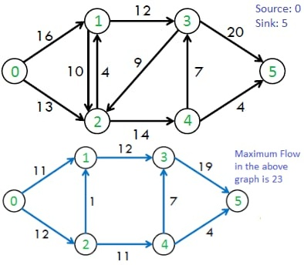


Code:
#include <stdio.h>
#include <limits.h>
#include <stdbool.h>

#define V 6

// DFS function to find augmenting path
bool dfs(int rGraph[V][V], int s, int t, bool visited[], int parent[]) {
visited[s] = true;

if (s == t)
return true;

for (int v = 0; v < V; v++) {
if (!visited[v] && rGraph[s][v] > 0) {
parent[v] = s;
if (dfs(rGraph, v, t, visited, parent))
return true;
}
}
return false;
}

// Ford–Fulkerson Algorithm
int fordFulkerson(int graph[V][V], int s, int t) {
int u, v;

int rGraph[V][V];

// Initialize residual graph
for (u = 0; u < V; u++)
for (v = 0; v < V; v++)
rGraph[u][v] = graph[u][v];

int parent[V];
int max_flow = 0;

// Augment flow while path exists
while (1) {
bool visited[V] = {false};

if (!dfs(rGraph, s, t, visited, parent))
break;

int path_flow = INT_MAX;

// Find minimum capacity in path
for (v = t; v != s; v = parent[v]) {
u = parent[v];
if (rGraph[u][v] < path_flow)
path_flow = rGraph[u][v];
}

// Update residual graph
for (v = t; v != s; v = parent[v]) {
u = parent[v];
rGraph[u][v] -= path_flow;
rGraph[v][u] += path_flow;
}

max_flow += path_flow;
}

return max_flow;
}
// Driver program
int main() {
int graph[V][V] = {
{0,16,13,0,0,0},
{0,0,10,12,0,0},
{0,4,0,0,14,0},
{0,0,9,0,0,20},
{0,0,0,0,0,4},
{0,0,0,0,0,0}
};
printf("Maximum flow is %d\n", fordFulkerson(graph, 0, 5));
return 0;
}
Output:
Maximum flow is 23

Time Complexity : O(E×Max Flow)

Result:
The Ford–Fulkerson algorithm successfully finds the maximum possible flow from the source to the sink in the given flow network.

Date:23.02.2026 | Implement Network Flow algorithm

Exp:8b (Edmonds-Karp Algorithm)

Edmonds-Karp algorithm is a special implementation of Ford-Fulkerson algorithm

Aim:
To find the maximum possible flow from a source vertex to a sink vertex in a flow network such that the flow through each edge does not exceed its capacity.

Algorithm:
- Initialize the residual graph as the same as the original graph.
- Set maximum flow to 0.
- While there exists an augmenting path from source to sink (found using BFS):
  - Find the minimum residual capacity (bottleneck value) along the path.
  - Add this flow to the maximum flow.
  - Update the residual capacities:
    - Reduce capacity of forward edges.
    - Increase capacity of reverse edges.
- Repeat until no augmenting path exists.
- The accumulated flow is the maximum flow.
Illustration:


Code:
#include <stdio.h>
#include <limits.h>
#include <stdbool.h>

#define V 6 // Number of vertices in the graph

/* A BFS-based path finding algorithm that checks if an augmenting path exists
from source 's' to sink 't' in the residual graph.
It also fills parent[] to store the path. */
bool bfs(int rGraph[V][V], int s, int t, int parent[]) {
// Create a visited array and mark all vertices as not visited
bool visited[V] = {false};
// Create a queue for BFS
int queue[V];
int head = 0, tail = 0;

// Mark the source node as visited and enqueue it
queue[tail++] = s;
visited[s] = true;
parent[s] = -1;

// Standard BFS loop
while (head < tail) {
int u = queue[head++];

for (int v = 0; v < V; v++) {
// If v is not visited and there is residual capacity from u to v
if (!visited[v] && rGraph[u][v] > 0) {
// If we found a connection to the sink node, we are done
if (v == t) {
parent[v] = u;
return true;
}
queue[tail++] = v;
visited[v] = true;
parent[v] = u;
}
}
}

// If we didn't find an augmenting path during BFS
return false;
}

/* Returns the maximum flow from s to t in the given graph */
int fordFulkerson(int graph[V][V], int s, int t) {
int u, v;

// Create a residual graph and fill it with original capacities
int rGraph[V][V];
for (u = 0; u < V; u++) {
for (v = 0; v < V; v++) {
rGraph[u][v] = graph[u][v];
}
}

// This array is filled by BFS and stores the path
int parent[V];

int max_flow = 0; // Initialize max flow to 0

// Augment the flow while there is an augmenting path from source to sink
while (bfs(rGraph, s, t, parent)) {
// Find the maximum flow through the path found by BFS
int path_flow = INT_MAX;
for (v = t; v != s; v = parent[v]) {
u = parent[v];
if (rGraph[u][v] < path_flow) {
path_flow = rGraph[u][v];
}
}

// Update residual capacities of the edges and reverse edges along the path
for (v = t; v != s; v = parent[v]) {
u = parent[v];
rGraph[u][v] -= path_flow; // Reduce capacity for forward edge
rGraph[v][u] += path_flow; // Increase capacity for reverse edge (to allow sending flow back)
}

// Add path flow to overall flow
max_flow += path_flow;
}

// Return the overall maximum flow
return max_flow;
}

// Driver program to test above functions
int main() {
// Example graph represented as an adjacency matrix
// Vertices: 0=Source, 1, 2, 3, 4=Sink.
int graph[V][V] = { {0, 16, 13, 0, 0, 0},
{0, 0, 10, 12, 0, 0},
{0, 4, 0, 0, 14, 0},
{0, 0, 9, 0, 0, 20},
{0, 0, 0, 0, 0, 4},
{0, 0, 0, 0, 0, 0} };

int source = 0;
int sink = 5;

printf("The maximum possible flow is %d\n", fordFulkerson(graph, source, sink));

return 0;
}
Output:
The maximum possible flow is 23

Time Complexity:
- Using BFS (Edmonds–Karp method): O(V×E²)
where
- V = number of vertices
- E = number of edges

Auxiliary Space Complexity: O(V²) because a residual graph is stored as an adjacency matrix.
Result: For the given graph : Source = 0,Sink = 5
The maximum possible flow is:
Maximum Flow = 23

Date:23.02.2026 | Implement Network Flow algorithm

Exp:8c (Dinic’s Algorithm)

Aim:

To implement Dinic’s Algorithm to find the maximum possible flow from a source vertex (S) to a sink vertex (T) in a flow network such that the flow through each edge does not exceed its given capacity.

Algorithm:
- Initialize the flow in all edges as 0.
- Construct the residual graph using the given capacities.
- Perform Breadth First Search (BFS) from the source node to assign levels to all vertices.
- Create a level graph where edges exist only if they go from level i to level i+1.
- If the sink is not reachable in the level graph, terminate the algorithm.
- Perform Depth First Search (DFS) to send flow from source to sink along valid level edges.
- Push flow equal to the minimum residual capacity along the path found.
- Update forward and reverse edges in the residual graph.
- Repeat DFS until no more blocking flow can be sent in the current level graph.
- Rebuild the level graph using BFS and repeat the process.
- The sum of all flows sent from source to sink gives the maximum flow.

Illustration:

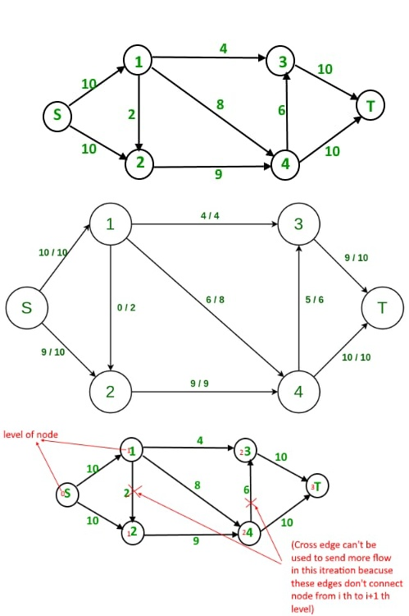
Total Flow = 0

First Iteration : We assign levels to all nodes using BFS. We also check if more flow is possible (or there is a s-t path in residual graph).



the maximum s-t flow is 19


Now we find blocking flow using levels (means every flow path should have levels as 0, 1, 2, 3). We send three flows together. This is where it is optimized compared to Edmond Karp where we send one flow at a time.
4 units of flow on path s - 1 - 3 - t.
6 units of flow on path s - 1 - 4 - t.
4 units of flow on path s - 2 - 4 - t.
Total flow = Total flow + 4 + 6 + 4 = 14
After one iteration, residual graph changes to following.
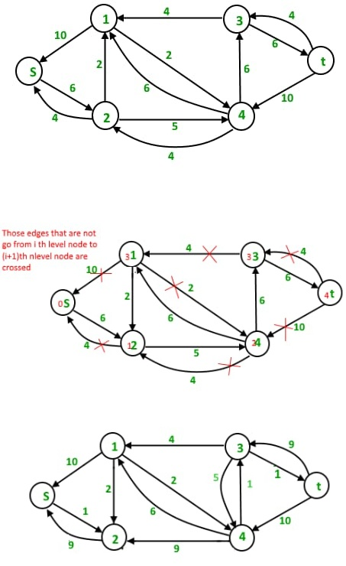
Second Iteration : We assign new levels to all nodes using BFS of above modified residual graph. We also check if more flow is possible (or there is a s-t path in residual graph).


Now we find blocking flow using levels (means every flow path should have levels as 0, 1, 2, 3, 4). We can send only one flow this time.
5 units of flow on path s - 2 - 4 - 3 - t
Total flow = Total flow + 5 = 19
The new residual graph is

Third Iteration : We run BFS and create a level graph. We also check if more flow is possible and proceed only if possible. This time there is no s-t path in residual graph, so we terminate the algorithm.

Code:
#include <stdio.h>
#include <string.h>
#include <limits.h>
#define MAXN 100
#define MAXE 1000

struct Edge {
int to;
int capacity;
int flow;
int rev;
};

struct Edge graph[MAXN][MAXE];
int edgeCount[MAXN];

int level[MAXN];
int start[MAXN];

int N; // number of nodes

/* Add edge and reverse edge */
void addEdge(int u, int v, int cap) {
graph[u][edgeCount[u]].to = v;
graph[u][edgeCount[u]].capacity = cap;
graph[u][edgeCount[u]].flow = 0;
graph[u][edgeCount[u]].rev = edgeCount[v];

graph[v][edgeCount[v]].to = u;
graph[v][edgeCount[v]].capacity = 0;
graph[v][edgeCount[v]].flow = 0;
graph[v][edgeCount[v]].rev = edgeCount[u];

edgeCount[u]++;
edgeCount[v]++;
}

/* BFS builds level graph */
int bfs(int s, int t) {
memset(level, -1, sizeof(level));

int queue[MAXN];
int front = 0, rear = 0;

queue[rear++] = s;
level[s] = 0;

while (front < rear) {
int u = queue[front++];

for (int i = 0; i < edgeCount[u]; i++) {
struct Edge *e = &graph[u][i];

if (level[e->to] < 0 && e->flow < e->capacity) {
level[e->to] = level[u] + 1;
queue[rear++] = e->to;
}
}
}

return level[t] >= 0;
}

/* DFS sends blocking flow */
int dfs(int u, int t, int flow) {
if (u == t)
return flow;

for (; start[u] < edgeCount[u]; start[u]++) {
struct Edge *e = &graph[u][start[u]];

if (level[e->to] == level[u] + 1 && e->flow < e->capacity) {
int curr_flow = flow < (e->capacity - e->flow)
? flow
: (e->capacity - e->flow);

int temp_flow = dfs(e->to, t, curr_flow);

if (temp_flow > 0) {
e->flow += temp_flow;
graph[e->to][e->rev].flow -= temp_flow;
return temp_flow;
}
}
}
return 0;
}

/* Dinic Max Flow */
int dinic(int s, int t) {
if (s == t) return 0;

int total = 0;

while (bfs(s, t)) {
memset(start, 0, sizeof(start));

while (1) {
int flow = dfs(s, t, INT_MAX);
if (!flow)
break;
total += flow;
}
}
return total;
}

int main() {
N = 6;
memset(edgeCount, 0, sizeof(edgeCount));

int S = 0;
int T = 5;

/* Graph exactly matching the images */
addEdge(0, 1, 10); // S->1
addEdge(0, 2, 10); // S->2
addEdge(1, 2, 2);
addEdge(1, 3, 4);
addEdge(1, 4, 8);
addEdge(2, 4, 9);
addEdge(4, 3, 6);
addEdge(3, 5, 10);
addEdge(4, 5, 10);

int maxflow = dinic(S, T);

printf("Maximum Flow = %d\n", maxflow);

return 0;
}
Output:
Maximum Flow = 19

Complexity of Dinic’s Algorithm

Time Complexity :
The time complexity of Dinic’s Algorithm depends on the type of network:
- General case:
O(V²E)
where
V = number of vertices
E = number of edges
Explanation:
- BFS to build the level graph takes O(E) time.
- DFS to find blocking flow also takes O(E) time.
- In the worst case, the number of level graphs formed is O(V).
- Hence total complexity becomes O(V²E).

Space Complexity : O(V+E)
because:
- The graph (including residual edges) stores all vertices and edges.
- Additional arrays like level[], start[], and queue for BFS require O(V) space.

Result:
The Dinic’s Algorithm was successfully implemented.
The maximum flow obtained from source (S) to sink (T) is:
Maximum Flow = 19

Approximation Algorithms

Overview:
An approximation algorithm is a way of dealing with NP-completeness for an optimization problem. This technique does not guarantee the best solution. The goal of the approximation algorithm is to come as close as possible to the optimal solution in polynomial time. Such algorithms are called approximation algorithms or heuristic algorithms.
Here, we will discuss the features of the Approximation Algorithm as follows.

- An approximation algorithm guarantees to run in polynomial time though it does not guarantee the most effective solution.

- An approximation algorithm guarantees to seek out high accuracy and top quality solution(say within 1% of optimum)

- Approximation algorithms are used to get an answer near the (optimal) solution of an optimization problem in polynomial time

Performance Ratios for approximation algorithms:

Scenario-1 :

- Suppose that we are working on an optimization problem in which each potential solution has a cost, and we wish to find a near-optimal solution. Depending on the problem, we may define an optimal solution as one with maximum possible cost or one with minimum possible cost,i.e, the problem can either be a maximization or minimization problem.
- We say that an algorithm for a problem has an appropriate ratio of P(n) if, for any input size n, the cost C of the solution produced by the algorithm is within a factor of P(n) of the cost C* of an optimal solution as follows.

max(C/C*,C*/C)<=P(n)

Scenario-2:
If an algorithm reaches an approximation ratio of P(n), then we call it a P(n)-approximation algorithm.

- For a maximization problem, 0< C < C*, and the ratio of C*/C gives the factor by which the cost of an optimal solution is larger than the cost of the approximate algorithm.

- For a minimization problem, 0< C* < C, and the ratio of C/C* gives the factor by which the cost of an approximate solution is larger than the cost of an optimal solution.

Some examples of the Approximation algorithm :
Here, we will discuss some examples of the Approximation Algorithm as follows.
1.The Vertex Cover Problem-
In the vertex cover problem, the optimization problem is to find the vertex cover with the fewest vertices, and the approximation problem is to find the vertex cover with few vertices.

VERTEX COVER PROBLEM
│
├── Exact Methods (5 ways to solve exactly)
│ ├── Decision ← uses Naive / Brute Force
│ ├── Optimization (Minimum VC) ← uses Naive / Brute Force
│ ├── DP (Tree)
│ ├── Matching (Bipartite)
│ └── Parameterized
│
├── Approximation Method
│ └── 2-Approx Algorithm
│
└── Variant of Problem
└── Weighted Vertex Cover
2.Travelling Salesman Problem
In the traveling salesperson problem, the optimization problem is to find the shortest cycle, and the approximation problem is to find a short cycle.

3.The Set Covering Problem
This is an optimization problem that models many problems that require resources to be allocated. Here, a logarithmic approximation ratio is used.

4.The Subset Sum Problem
In the Subset sum problem, the optimization problem is to find a subset of {x1,×2,×3...xn} whose sum is as large as possible but not larger than the target value t.

Date:09.03.2026 | Implement Approximation Algorithm

Exp:9 (Decision Vertex Cover problem using Naive Approach)

Decision Vertex Cover Problem:
The Decision Vertex Cover Problem asks whether a graph contains a vertex cover of a given size.
A vertex cover of a graph is a set of vertices such that every edge in the graph is connected to at least one vertex in that set.

Problem Statement:
Given:
- An undirected graph G=(V,E)G = (V, E)G=(V,E)
- An integer kkk
The problem is to determine:
Is there a subset of vertices C⊆V such that
- ∣C∣≤k, and
- every edge in E has at least one endpoint in C?
If such a set exists, the answer is YES; otherwise, the answer is NO.

Aim:
To determine whether a graph contains a vertex cover of size ≤ k.

Algorithm (Subset Checking / Backtracking):
- Generate all subsets of vertices.
- For each subset of size ≤ k:
  - Check whether all edges are covered.
- If yes, return TRUE.
- Otherwise return FALSE.

Illustration:
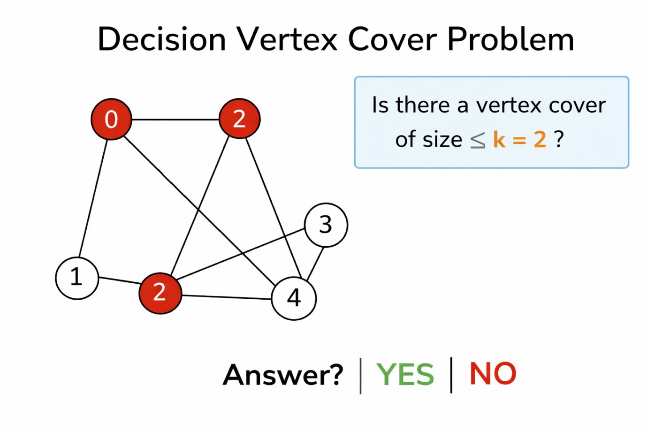

Code:
#include <stdio.h>
#include <stdbool.h>

#define V 4

int graph[V][V] = {
{0,1,1,0},
{1,0,1,1},
{1,1,0,1},
{0,1,1,0}
};

bool isCover(int set[], int size) {
for(int i=0;i<V;i++){
for(int j=i+1;j<V;j++){
if(graph[i][j]){
bool covered=false;
for(int k=0;k<size;k++)
if(set[k]==i || set[k]==j)
covered=true;
if(!covered) return false;
}
}
}
return true;
}

bool decisionVC(int k){
int set[V];
for(int mask=0; mask<(1<<V); mask++){
int cnt=0;
for(int i=0;i<V;i++)
if(mask&(1<<i))
set[cnt++]=i;

if(cnt<=k && isCover(set,cnt))
return true;
}
return false;
}

int main(){
int k=2;
if(decisionVC(k))
printf("YES");
else
printf("NO");
}

Time Complexity
- Number of subsets = 2^{V}
- Checking edges takes O(E)
Time Complexity=O(2^{V}×E)

Space Complexity
O(V)
(Only few variables used; no extra memory proportional to input size)

Result:
Prints YES if vertex cover of size ≤ k exists, otherwise NO.
Date:09.03.2026 | Implement Approximation Algorithm

Exp:9 (Minimum Vertex Cover problem)

Minimum Vertex Cover Problem
The Minimum Vertex Cover Problem is an optimization problem in graph theory. It aims to find the smallest possible set of vertices in a graph such that every edge in the graph is incident to at least one vertex in that set.
In other words, a vertex cover is a set of vertices that covers all edges, and the goal is to find the vertex cover with minimum size.

Problem Statement
Given:
- An undirected graph G=(V,E)
Find:
- A subset of vertices C⊆VC such that every edge in E is connected to at least one vertex in C, and
- The size of C is minimum.

Aim:
To find the minimum size vertex cover of a graph.

Algorithm:
- Generate all subsets of vertices.
- Check if subset covers all edges.
- Store smallest valid subset.
- Output minimum vertex cover.
Illustration:
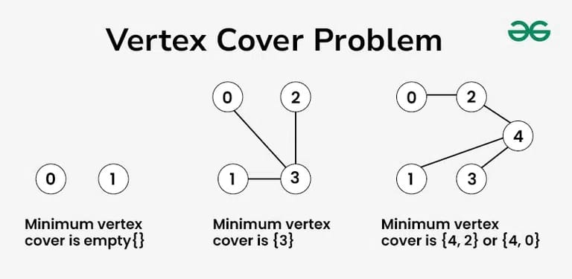

Code:
#include <stdio.h>
#include <stdbool.h>

#define V 4

int graph[V][V]={
{0,1,1,0},
{1,0,1,1},
{1,1,0,1},
{0,1,1,0}
};

bool isCover(int mask){
for(int i=0;i<V;i++)
for(int j=i+1;j<V;j++)
if(graph[i][j])
if(!(mask&(1<<i)) && !(mask&(1<<j)))
return false;
return true;
}

int main(){
int minSize=V;

for(int mask=0; mask<(1<<V); mask++){
if(isCover(mask)){
int count=__builtin_popcount(mask);
if(count<minSize)
minSize=count;
}
}
printf("Minimum Vertex Cover Size = %d",minSize);
}

Time Complexity:
Time Complexity=O(2^{V}×E)
where
- V = number of vertices
- E = number of edges

Space Complexity:
O(1)
(for storing subsets and variables)

Result
Displays size of minimum vertex cover.

Date:09.03.2026 | Implement Approximation Algorithm

Exp:9 (Approximation Vertex Cover problem)
- vertex-cover of an undirected graph G = (V,E) is the subset of vertices of the graph such that, for all the edges (u,v) in the graph,u and v ∈ V. The junction is treated as the node of a graph and the roads as the edges. The algorithm finds the minimum set of junctions that cover maximum number of roads.

- Vertex Cover Problem is a known NP Complete problem, i.e., there is no polynomial-time solution for this unless P = NP. There are approximate polynomial-time algorithms to solve the problem though

- It is a minimization problem since we find the minimum size of the vertex cover the size of the vertex cover is the number of vertices in it. The optimization problem is an NP-Complete problem and hence, cannot be solved in polynomial time; but what can be found in polynomial time is the near optimal solution.

- The vertex cover approximation algorithm takes an undirected graph as an input and is executed to obtain a set of vertices that is definitely twice as the size of optimal vertex cover.
The vertex cover is a 2-approximation algorithm.
Aim:
To implement an Approximation Algorithm for the Vertex Cover Problem and to find a near-optimal vertex cover of an undirected graph using the 2-Approximation Vertex Cover algorithm.
Algorithm:
Step 1 − Select any random edge from the input graph and mark all the edges that are incident on the vertices corresponding to the selected edge.
Step 2 − Add the vertices of the arbitrary edge to an output set.
Step 3 − Repeat Step 1 on the remaining unmarked edges of the graph and add the vertices chosen to the output until theres no edge left unmarked.
Step 4 − The final output set achieved would be the near-optimal vertex cover.
Pseudocode:
APPROX-VERTEX-COVER(G)
1. C ← ∅
2. E ← E[G] // set of edges in graph G
3. while E ≠ ∅ do
4. select an arbitrary edge (u, v) from E
5. C ← C ∪ {u, v}
6. remove from E every edge incident on u or v
7. end while
8. return C
Illustration:
The set of edges of the given graph is -{(1,6),(1,2),(1,4),(2,3),(2,4),(6,7),(4,7),(7,8),(3,5),(8,5)}
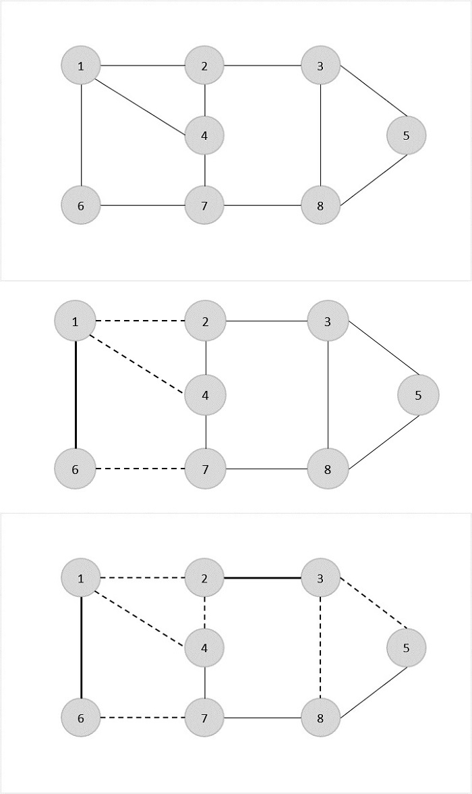
Now, we start by selecting an arbitrary edge (1,6). We eliminate all the edges, which are either incident to vertex 1 or 6 and we add edge (1,6) to cover.

In the next step, we have chosen another edge (2,3) at random.


Now we select another edge (4,7).
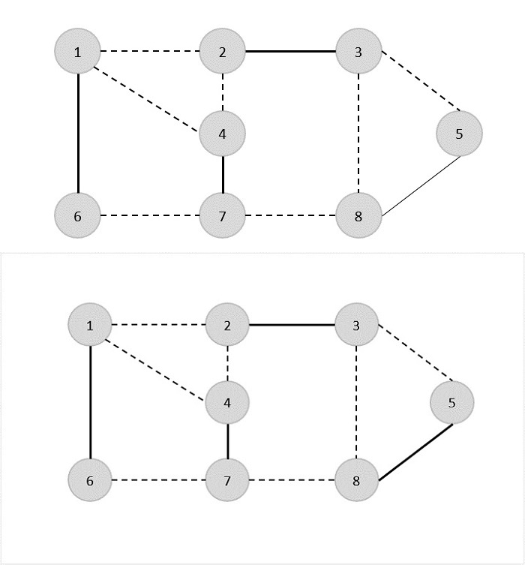

We select another edge (8,5).

Hence, the vertex cover of this graph is {1,6,2,3,4,7,5,8}.

Analysis:
It is easy to see that the running time of this algorithm is O(V + E), using adjacency list to represent E'.

Code:
#include <stdio.h>
#include <stdbool.h>
#define MAX_VERTICES 100
int graph[MAX_VERTICES][MAX_VERTICES];
bool included[MAX_VERTICES];
// Function to find Vertex Cover using the APPROX-VERTEX_COVER algorithm
void approxVertexCover(int vertices, int edges) {
bool edgesRemaining[MAX_VERTICES][MAX_VERTICES];
for (int i = 0; i < vertices; i++) {
for (int j = 0; j < vertices; j++) {
edgesRemaining[i][j] = graph[i][j];
}
}
while (edges > 0) {
int u, v;
for (int i = 0; i < vertices; i++) {
for (int j = 0; j < vertices; j++) {
if (edgesRemaining[i][j]) {
u = i;
v = j;
break;
}
}
}
included[u] = included[v] = true;
for (int i = 0; i < vertices; i++) {
edgesRemaining[u][i] = edgesRemaining[i][u] = false;
edgesRemaining[v][i] = edgesRemaining[i][v] = false;
}
edges--;
}
}
int main() {
int vertices = 8;
int edges = 10;
int edgesData[10][2] = {
{1, 6}, {1, 2}, {1, 4}, {2, 3}, {2, 4},
{6, 7}, {4, 7}, {7, 8}, {3, 5}, {8, 5}};
for (int i = 0; i < edges; i++) {
int u = edgesData[i][0];
int v = edgesData[i][1];
graph[u][v] = graph[v][u] = 1;
}
approxVertexCover(vertices, edges);
printf("Vertex Cover: ");
for (int i = 1; i <= vertices; i++) {
if (included[i]) {
printf("%d ", i);
}
}
printf("\n");
return 0;
}

Output:
Vertex Cover: 1 3 4 5 6 7

Time Complexity: O(V²)
(Due to scanning of adjacency matrix to find remaining edges)
Time Complexity: O(V+E)
(only if Graph is stored using Adjacency List)
Space Complexity: O(V²)
(For storing adjacency matrix and remaining edges matrix)

Result:
The program successfully finds a vertex cover for the given undirected graph using the approximation method.
The obtained vertex cover covers all edges of the graph and its size is at most twice the size of the minimum vertex cover.

Date:09.03.2026 | Implement Network Algorithm

Exp:10

AIM:
To implement the Quick Sort algorithm using a randomized pivot and sort a given array in ascending order.

ALGORITHM (Quick Sort with Random Pivot)
- Start.
- Take an array arr[] with low and high indices.
- If low < high, do:
  - Select a random pivot using partition_r().
  - Swap the random pivot with the first element.
  - Call partition():
    - Set pivot = first element.
    - Initialize:
      - i = low - 1
      - j = high + 1
    - Repeat:
      - Increment i until arr[i] ≥ pivot
      - Decrement j until arr[j] ≤ pivot
      - If i ≥ j, return j
      - Else swap arr[i] and arr[j]
  - Recursively apply:
    - quickSort(arr, low, pi)
    - quickSort(arr, pi + 1, high)
- Repeat until the array is sorted.
- Stop.

Code:
#include <stdio.h>
#include <stdlib.h>
#include <time.h>

int partition(int arr[], int low, int high)
{
int pivot = arr[low];
int i = low - 1, j = high + 1;

while (1) {

do {
i++;
} while (arr[i] < pivot);

do {
j--;
} while (arr[j] > pivot);

if (i >= j)
return j;

int temp = arr[i];
arr[i] = arr[j];
arr[j] = temp;
}
}

int partition_r(int arr[], int low, int high)
{
srand(time(0));
int random = low + rand() % (high - low);

int temp = arr[random];
arr[random] = arr[low];
arr[low] = temp;

return partition(arr, low, high);
}

void quickSort(int arr[], int low, int high)
{
if (low < high) {
int pi = partition_r(arr, low, high);

quickSort(arr, low, pi);
quickSort(arr, pi + 1, high);
}
}

void printArray(int arr[], int n)
{
for (int i = 0; i < n; i++)
printf("%d ", arr[i]);
printf("\n");
}

int main()
{
int arr[] = { 10, 7, 8, 9, 1, 5 };
int n = sizeof(arr) / sizeof(arr[0]);
quickSort(arr, 0, n - 1);
printf("Sorted array: \n");
printArray(arr, n);
return 0;
}

Input:
10 7 8 9 1 5
Output:
Sorted array:
1 5 7 8 9 10

TIME COMPLEXITY
- Best Case:
O(n log n) → when pivot divides array equally
- Average Case:
O(n log n) → due to random pivot selection
- Worst Case:
O(n²) → when pivot is always smallest/largest

SPACE COMPLEXITY
- O(log n) → due to recursion stack
RESULT:
The program executed succesfully

