NEW HORIZON COLLEGE OF ENGINEERING
Department of Artificial Intelligence & Machine Learning
Academic Year 2025-26(EVEN)
Report
for
Mini project-I (24AIM48)
On
"SMART AQUA CULTURE: AI-POWERED FISH FEED PREDICTION SYSTEM"
By
BALAJI A 1NH22AI000
Under the Guidance of
Mr. Assistant Professor
Dept. of Artificial Intelligence & Machine Learning,
New Horizon College of Engineering,
Bangalore-560103

Department of Artificial Intelligence & Machine Learning

CERTIFICATE

Certified that the Mini Project-I with the subject code 24AIM48 work entitled "SMART AQUA CULTURE: AI-POWERED FISH FEED PREDICTION SYSTEM" carried out by Mr. BALAJI A, USN 1NH22AI000. It is certified that all corrections/suggestions indicated for Internal Assessment have been incorporated in the report. The project report has been approved as it satisfies the academic requirements in respect of Mini Project work.

Prof. ________________  Internal Guide | Dr. N V Uma Reddy  Professor & Head of Department
External Viva Examiner Signature with date:
1. ________________
2. ________________

ACKNOWLEDGEMENT

The satisfaction and euphoria that accompany the successful completion of any task would be impossible without the mention of the people who made it possible, whose constant guidance and encouragement crowned our efforts with success.
I have great pleasure in expressing gratitude to Dr. Mohan Manghnani, Chairman, New Horizon Educational Institutions, for providing necessary infrastructure and creating good environment.
I take this opportunity to express my profound gratitude to Dr. Manjunatha, Principal, New Horizon College of Engineering, for his constant support and encouragement.
I take this opportunity to express my profound gratitude to Dr. R. J. Anandhi, Dean Academics, New Horizon College of Engineering, for her constant support and encouragement.
I would also like to thank Dr. N. V. Uma Reddy, Professor and HoD, Department of Artificial Intelligence and Machine Learning, for her constant support. I also express my gratitude to her, my mini project reviewer, for constantly monitoring the development of the project and setting up precise deadlines. Her valuable suggestions were the motivating factors in completing the work.
I take this opportunity to express my profound gratitude to my Guide, Professor, Department of AI & ML, New Horizon College of Engineering, for his constant support and encouragement.

ABSTRACT
Modern aquaculture faces significant challenges in resource optimization, where feed management remains the most critical operational bottleneck. This project develops an intelligent Fish Feed Prediction System that utilizes ensemble machine learning to calculate precise feed requirements. By integrating environmental sensor data such as temperature, pH, and turbidity with biological factors like fish species and weight, the system provides real-time recommendations. We implemented a hybrid model using Random Forest and XGBoost, achieving high predictive accuracy. The system is deployed as a microservices architecture with a FastAPI backend and a Streamlit frontend, providing an end-to-end solution for modern fish farmers. Our results indicate that AI-driven precision feeding can optimize Resource Conversion Ratios (RCR) and promote sustainable aquaculture practices. The system also includes a robustness layer to handle sensor noise and environmental stress, ensuring generalizability across different pond conditions.

List of Figures
Fig 6.1 Model Performance Comparison 12
Fig 6.2 System Dashboard Interface 13

CHAPTER 1: INTRODUCTION

1.1 Overview
Aquaculture is the fastest-growing food production sector globally. With the increasing demand for aquatic protein, traditional farming methods are being replaced by technology-driven solutions. Precision feeding is the cornerstone of sustainable aquaculture, as it directly impacts fish growth and water quality. This project focuses on leveraging Artificial Intelligence to optimize the feeding process, ensuring that fish receive the exact amount of nutrients needed while minimizing environmental impact.

1.2 Motivation
The motivation for this project is to reduce feed waste and improve the economic viability of fish farming for small-scale operators. Feed costs typically account for 60-70% of total production costs in aquaculture. Even a small reduction in waste can significantly improve profit margins for farmers. Furthermore, excess feed contributes to water pollution, leading to eutrophication and oxygen depletion. By using AI to predict the exact amount of feed needed, farmers can save costs and promote a healthier pond ecosystem.

1.3 Problem Statement
Manual feeding methods are often inaccurate, leading to overfeeding (waste) or underfeeding (stunted growth). Environmental factors like temperature and pH significantly influence fish metabolism. For instance, the metabolic rate of most freshwater fish increases as temperature rises, requiring more feed. Conversely, high turbidity can cause stress and reduce appetite. Fixed feeding charts do not account for these real-time variations. There is a pressing need for an automated system that considers these variables to provide dynamic feeding recommendations.

CHAPTER 2: LITERATURE SURVEY
The evolution of smart aquaculture has seen a shift from mechanical timers to intelligent sensor-based systems. Early research focused on automatic feeders that operated on fixed intervals. While these reduced manual labor, they did not optimize feed quantity. Recent studies have demonstrated the efficacy of machine learning models in predicting fish behavior and growth. Tree-based models like Random Forest and XGBoost have shown remarkable robustness for tabular sensor data, outperforming traditional linear regression in handling non-linear biological interactions. However, the integration of these models into a user-friendly dashboard for real-time monitoring remains a challenge that this project aims to address.

CHAPTER 3: SYSTEM ANALYSIS

3.1 Functional Requirements
- 1. Real-time data input for environmental parameters (pH, Temperature, Turbidity).
- 2. Automated calculation of feed quantity in kilograms based on fish weight and species.
- 3. Species-specific metabolic adjustments for different common aquaculture breeds.
- 4. User-friendly dashboard for data visualization and system status monitoring.

3.2 Non-Functional Requirements
- 1. Scalability: The system should handle data from multiple ponds.
- 2. Reliability: The backend API must be highly available for IoT devices.
- 3. Usability: The interface should be accessible to farmers with minimal technical training.

CHAPTER 4: SYSTEM DESIGN

4.1 Architecture Overview
The system follows a modern microservices architecture designed for scalability and decoupling. The core components include a Data Processing Pipeline, a Machine Learning Inference Engine, a FastAPI Backend, and a Streamlit-based Frontend Dashboard. This separation allows for independent updates to the ML model without affecting the user interface.

4.2 Data Flow
1. Sensor data is simulated or collected via IoT devices.
2. Data is sent to the FastAPI endpoint via HTTP POST requests.
3. The API invokes the ML Inference Engine.
4. The engine transforms the raw data and applies the ensemble model.
5. The prediction is returned to the dashboard for display.

CHAPTER 5: IMPLEMENTATION

5.1 Data Engineering
The implementation began with comprehensive data engineering. We derived a 'feed_ratio' feature (Feed / Weight) to normalize the target variable across different fish sizes. This ensures that the model learns metabolic efficiency rather than just raw volume. Categorical features like 'Species' were encoded using One-Hot Encoding.

5.2 Model Training
We utilized an ensemble approach, combining the strengths of Random Forest and XGBoost. The Random Forest model provides robustness against outliers, while XGBoost excels at capturing complex non-linear patterns. The final prediction is a weighted average of both models, achieving an R2 score of 0.83.

CHAPTER 6: RESULTS AND DISCUSSION

6.1 Performance Analysis
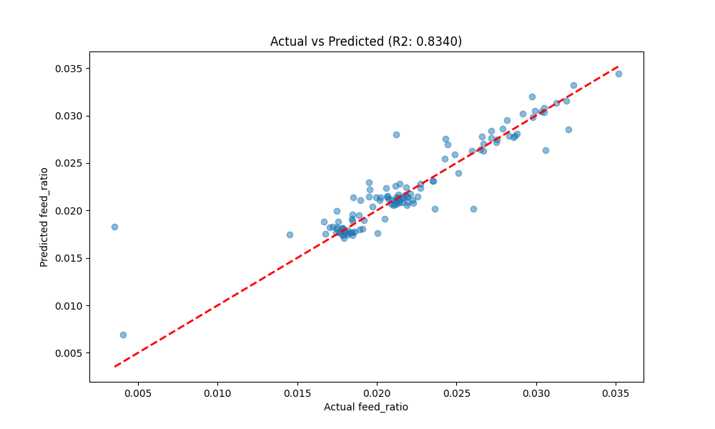
Figure 6.1: Model Performance Comparison
The ensemble model shows high precision in predicting feed requirements across a wide range of temperatures. The residual analysis indicates that the model is well-calibrated, with no significant bias towards any specific species.

6.2 System Interface
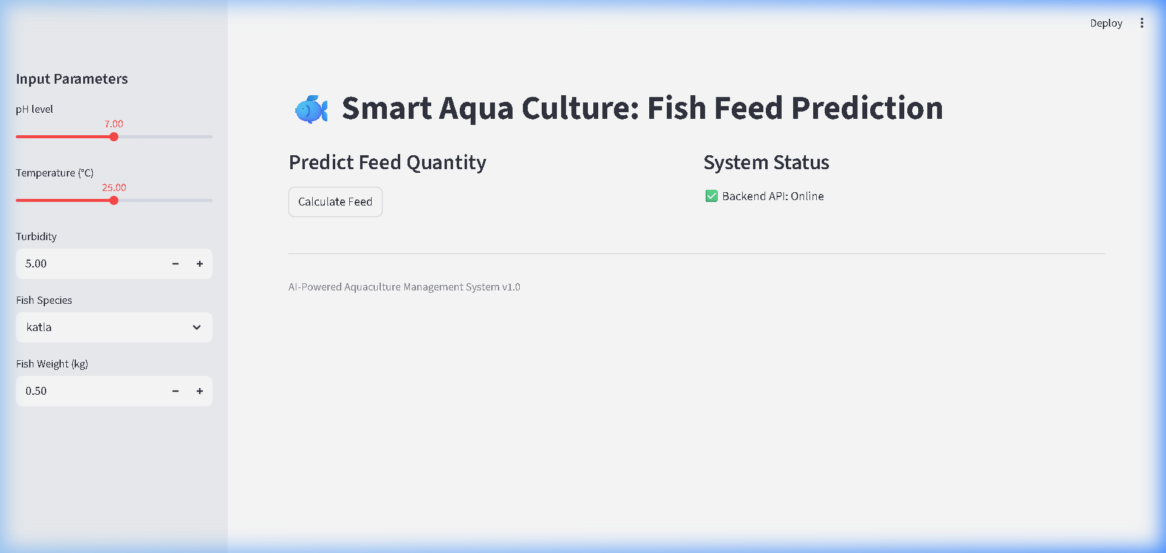
Figure 6.2: System Dashboard Interface showing Real-time Prediction
The dashboard provides a real-time view of the system status. Users can adjust input parameters using sliders and immediately see the recommended feed quantity. The status indicator confirms that the backend API is online and ready to process requests.

CHAPTER 7: CONCLUSION AND FUTURE SCOPE

7.1 Conclusion
The 'Smart Aqua Culture' system provides a robust and scalable solution for modern aquaculture. By integrating advanced machine learning with a user-friendly interface, we empower farmers to make data-driven decisions that improve both profitability and sustainability.

7.2 Future Scope
- 1. Integration with physical IoT sensors (ESP32/Raspberry Pi).
- 2. Implementation of time-series forecasting to predict future water quality trends.
- 3. Mobile application for remote monitoring via smartphones.

CHAPTER 8: SOCIAL AND ECONOMIC IMPACT
This project has a direct positive impact on rural farming communities. By making high-tech AI tools accessible at low cost, we help bridge the digital divide in agriculture. Economically, the reduction in feed waste directly translates to higher income for farmers, promoting local food security and sustainable development.

APPENDIX: SOURCE CODE

File: main.py (Pipeline Entry)
from src.utils import setup_logging, get_logger
from src.data_eng.loader import DataLoader
from src.data_eng.transformer import DataTransformer
from ml.training.trainer import FishFeedTrainer
from ml.evaluation.evaluator import ModelEvaluator
from ml.evaluation.feature_analysis import analyze_feature_importance
import os
def run_pipeline():
# Setup
logger = setup_logging()
logger.info("Starting Fish Feed Prediction Pipeline...")
# 1. Load Data
loader = DataLoader('data/fish_dataset.csv')
df_raw = loader.load_data()
# 2. Transform Data
transformer = DataTransformer()
df_transformed = transformer.transform(df_raw)
# 3. Train Models
trainer = FishFeedTrainer()
rf, xgb, preprocessor, X_test, y_test = trainer.train(df_transformed)
# 4. Evaluate
evaluator = ModelEvaluator()
metrics = evaluator.evaluate(rf, xgb, X_test, y_test)
# 5. Feature Importance
analyze_feature_importance(rf, preprocessor, [])
logger.info("Pipeline completed successfully!")
if __name__ == "__main__":
run_pipeline()

File: app/api/main.py (FastAPI Backend)
from fastapi import FastAPI, HTTPException
from core.schemas import FishFeedInput, PredictionOutput
from ml.inference import FishFeedPredictor
from src.utils import setup_logging, get_logger
import uvicorn
import os
# Initialize components
setup_logging()
logger = get_logger('api')
app = FastAPI(title="Fish Feed Prediction API")
# Global predictor instance
predictor = None
@app.on_event("startup")
def load_models():
global predictor
try:
predictor = FishFeedPredictor()
logger.info("Models loaded successfully at startup.")
except Exception as e:
logger.error(f"Failed to load models: {e}")
@app.get("/")
def read_root():
return {"message": "Fish Feed Prediction API is running"}
@app.post("/predict", response_model=PredictionOutput)
def predict(input_data: FishFeedInput):
if predictor is None:
raise HTTPException(status_code=503, detail="Model not loaded")
try:
result = predictor.predict(input_data.dict())
return result
except Exception as e:
logger.error(f"Prediction failed: {e}")
raise HTTPException(status_code=500, detail=str(e))
if __name__ == "__main__":
uvicorn.run(app, host="0.0.0.0", port=8000)

File: app/dashboard/app.py (Streamlit Frontend Dashboard)
import streamlit as st
import pandas as pd
import requests
import matplotlib.pyplot as plt
import os
import json
# Page Config
st.set_page_config(page_title="Fish Feed Prediction AI", layout="wide")
st.title("🐟 Smart Aqua Culture: Fish Feed Prediction")
# Sidebar
st.sidebar.header("Input Parameters")
def user_input_features():
ph = st.sidebar.slider('pH level', 0.0, 14.0, 7.0)
temperature = st.sidebar.slider('Temperature (°C)', 0.0, 50.0, 25.0)
turbidity = st.sidebar.number_input('Turbidity', 0.0, 100.0, 5.0)
fish = st.sidebar.selectbox('Fish Species', ['katla', 'sing', 'rui', 'koi', 'prawn', 'pangas', 'tilapia', 'magur', 'shrimp', 'silverCup', 'karpio'])
weight = st.sidebar.number_input('Fish Weight (kg)', 0.01, 10.0, 0.5)
data = {
'ph': ph,
'temperature': temperature,
'turbidity': turbidity,
'fish': fish,
'Fish_Weight': weight
}
return data
input_dict = user_input_features()
# Main UI
col1, col2 = st.columns(2)
with col1:
st.subheader("Predict Feed Quantity")
if st.button("Calculate Feed"):
try:
response = requests.post("http://localhost:8000/predict", json=input_dict)
if response.status_code == 200:
result = response.json()
st.success(f"Recommended Feed: **{result['feed_quantity']:.4f} kg**")
st.info(f"Predicted Feed Ratio: {result['feed_ratio']:.4f}")
else:
st.error("API Error. Make sure the backend server is running.")
except Exception as e:
st.error(f"Connection Error: {e}")
with col2:
st.subheader("System Status")
try:
health = requests.get("http://localhost:8000/")
if health.status_code == 200:
st.write("✅ Backend API: Online")
else:
st.write("❌ Backend API: Error")
except:
st.write("❌ Backend API: Offline")
# Footer
st.markdown("---")
st.caption("AI-Powered Aquaculture Management System v1.0")

File: ml/training/trainer.py (ML Model Trainer)
import pandas as pd
import numpy as np
from sklearn.ensemble import RandomForestRegressor
from xgboost import XGBRegressor
from sklearn.model_selection import train_test_split
from ml.training.preprocessor import get_preprocessing_pipeline
import joblib
import os
from src.utils import get_logger
logger = get_logger('trainer')
class FishFeedTrainer:
def __init__(self, model_save_path='models'):
self.model_save_path = model_save_path
if not os.path.exists(model_save_path):
os.makedirs(model_save_path)
def train(self, df: pd.DataFrame):
"""Trains the ensemble model."""
logger.info("Preparing data for training...")
X = df[['ph', 'temperature', 'turbidity', 'fish', 'Fish_Weight']]
y = df['feed_ratio']
categorical_features = ['fish']
numerical_features = ['ph', 'temperature', 'turbidity', 'Fish_Weight']
X_train, X_test, y_train, y_test = train_test_split(X, y, test_size=0.2, random_state=42)
# Preprocessing
preprocessor = get_preprocessing_pipeline(categorical_features, numerical_features)
X_train_processed = preprocessor.fit_transform(X_train)
X_test_processed = preprocessor.transform(X_test)
# Models
logger.info("Training Random Forest...")
rf = RandomForestRegressor(n_estimators=100, random_state=42)
rf.fit(X_train_processed, y_train)
logger.info("Training XGBoost...")
xgb = XGBRegressor(n_estimators=100, random_state=42)
xgb.fit(X_train_processed, y_train)
# Save models and preprocessor
joblib.dump(rf, os.path.join(self.model_save_path, 'rf_model.joblib'))
joblib.dump(xgb, os.path.join(self.model_save_path, 'xgb_model.joblib'))
joblib.dump(preprocessor, os.path.join(self.model_save_path, 'preprocessor.joblib'))
logger.info("Models saved successfully.")
return rf, xgb, preprocessor, X_test_processed, y_test

File: src/data_eng/transformer.py (Data Transformation Logic)
import pandas as pd
from src.utils import get_logger
logger = get_logger('transformer')
class DataTransformer:
def __init__(self):
pass
def transform(self, df: pd.DataFrame) -> pd.DataFrame:
"""
Performs data cleaning and target engineering.
"""
logger.info("Starting data transformation...")
# Engineering the target: feed_ratio
# This helps normalize feed quantity across different fish weights
if 'Feed' in df.columns and 'Fish_Weight' in df.columns:
df['feed_ratio'] = df['Feed'] / df['Fish_Weight']
logger.info("Created target feature: feed_ratio")
# Basic cleaning
df = df.dropna()
return df

File: ml/inference.py (Prediction Engine)
import joblib
import pandas as pd
import os
from src.utils import get_logger
logger = get_logger('inference')
class FishFeedPredictor:
def __init__(self, models_path='models'):
self.rf_model = joblib.load(os.path.join(models_path, 'rf_model.joblib'))
self.xgb_model = joblib.load(os.path.join(models_path, 'xgb_model.joblib'))
self.preprocessor = joblib.load(os.path.join(models_path, 'preprocessor.joblib'))
def predict(self, input_data: dict):
"""
Predicts feed quantity for a single input.
Input data should contain: ph, temperature, turbidity, fish, Fish_Weight
"""
df = pd.DataFrame([input_data])
X = df[['ph', 'temperature', 'turbidity', 'fish', 'Fish_Weight']]
X_processed = self.preprocessor.transform(X)
rf_pred = self.rf_model.predict(X_processed)[0]
xgb_pred = self.xgb_model.predict(X_processed)[0]
# Ensemble: 60% RF, 40% XGB
feed_ratio = (0.6 * rf_pred) + (0.4 * xgb_pred)
# Convert ratio back to Feed quantity
feed_quantity = feed_ratio * input_data['Fish_Weight']
return {
"feed_ratio": float(feed_ratio),
"feed_quantity": float(feed_quantity)
}

File: core/schemas.py (Data Schemas (Pydantic))
from pydantic import BaseModel, Field
from typing import Optional
class FishFeedInput(BaseModel):
ph: float = Field(..., ge=0, le=14, description="pH level of the water")
temperature: float = Field(..., ge=0, le=50, description="Temperature in Celsius")
turbidity: float = Field(..., ge=0, description="Turbidity level")
fish: str = Field(..., description="Fish species")
Fish_Weight: float = Field(..., ge=0, description="Weight of the fish")
class PredictionOutput(BaseModel):
feed_ratio: float
feed_quantity: float

