COVER PAGE
Data Science ToolBox:Python Programming
PROJECT REPORT
(Project Semester January-April 2025)

“BHIM UPI Transactions”

Submitted by:
Bandaru Balaji
(Name of student)

Registration No:12306397

Programme and Section :B.tech(CSE),K23EL
Course Code:INT375

Under the Guidance of

Name Of the Faculty: Dr.Dhiraj Kapila(UID:23509)
Desgination: Faculty Coordinator, Department of School Of Computing

Discipline of CSE/IT

Lovely School of Computing

Lovely Professional University, Phagwara

DECLARATION

I Bandaru Balaji student of Data Science ToolBox:Python Programming(INT375) (Program name) under CSE/IT Discipline at, Lovely Professional University, Punjab, hereby declare that all the information furnished in this project report is based on my own intensive work and is genuine.

Date:05/04/2025 Signature : Balaji
Registration No. 12306397 Name of the Student:Bandaru Balaji

CERTIFICATE

This is to certify that Bandaru Balaji (student’s name) bearing Registration no. 12306397 has completed INT375 <Course Code> project titled, “BHIM UPI Transactions: A Data Science Perspective” under my guidance and supervision. To the best of my knowledge, the present work is the result of his/her original development, effort, and study.

Signature and Name of the Supervisor: Dr.Dhiraj Kapila(Dhiraj Kapila)
Designation of the Supervisor: Faculty Coordinator, Department of School of Computer Science and Engineering
School of Computer Science and Engineering
Lovely Professional University
Phagwara, Punjab.

ACKNOWLEDGMENT

I would like to express my sincere gratitude to all those who supported me throughout the completion of my project titled “BHIM UPI Transactions: A Data Science Perspective.” I extend my heartfelt thanks to my course instructor and the faculty of the Department of Computer Science for their valuable guidance, encouragement, and insightful feedback during the course. INT375: Data Science Toolbox: Python Programming.
I would also like to thank the developers and contributors of the BHIM UPI dataset, which served as the foundation of my analysis. The tools and knowledge gained from this course empowered me to explore, visualize, and interpret real-world financial transaction data in a meaningful and insightful way.
Name:Bandaru Balaji
Course: INT375 – Data Science Toolbox: Python Programming
Date: 05/04/2025
School of Computer Science and Engineering
Lovely Professional University
Phagwara, Punjab

TABLE OF CONTENTS

1. Cover Page…………………………….............. (1)
2. Declaration…………………………………….. (2)
3. Certificate………………………………………. (3)
4. Acknowledgement……………………………… (4)
5. Table of Contents……………………………….. (5)
6. Introduction ……………………………………. (6)
i)Source of the DataSet
7. EDA Process......................................................... (7 – 10)
8. Analysis on dataset (for each analysis)………… (11 – 24)
- Introduction
- General Description
- Specific Requirements, functions and formulas
- Analysis results
- Visualization
- 5. Conclusion
- 6. Future scope
- 7. References
9. Conclusion………………………………………… (25)
10. Future Scope…………………………………....... (26)
11. References………………………………………... (26)

INTRODUCTION

In today’s fast-paced digital economy, Unified Payments Interface (UPI) has revolutionized the way financial transactions are carried out in India. The BHIM UPI platform, a flagship initiative in the country's push for digital payments, facilitates millions of transactions daily, offering a seamless, real-time mode of fund transfer across a wide range of users.
This project, "Analyzing UPI Transactions Through the Lens of Data Science", aims to delve into the BHIM UPI transactional dataset to uncover insights about user behavior, transaction patterns, success/failure rates, and usage trends based on payment methods, banks, and purposes. By leveraging data cleaning, exploratory data analysis (EDA), and visualization techniques using Python, the project brings forth valuable perspectives that can help improve the digital payment ecosystem.
The core objective is not only to understand the structure and dynamics of the dataset but also to communicate the findings through intuitive charts and concise summaries. This paves the way for data-driven decision-making, better financial product strategies, and enhanced user experience in digital payments.

SOURCE OF THE DATASET

The dataset used in this project has been sourced from publicly available repositories for educational purposes. Specifically, it comprises anonymized transaction data related to the BHIM UPI (Unified Payments Interface) platform, a cornerstone of India’s digital payments infrastructure developed by the National Payments Corporation of India (NPCI).
The dataset includes transaction details such as date and time, sender and receiver UPI IDs, transaction amounts, types, status, associated banks, and payment purposes. It has been prepared and shared to enable exploratory analysis, pattern detection, and data-driven learning in the financial technology domain.
All data has been utilized strictly for academic and non-commercial research, with due consideration to privacy and ethical standards. Appropriate acknowledgment has been provided, and usage complies with the data provider’s terms and policies.

EDA PROCESS
Problem Statement 1): Analyze the structure of the given dataset and summarize key statistical details.
Solution:
Description:
The dataset contains 1000+ records of transactions made via the BHIM UPI platform. Each row represents a transaction with fields such as UPI ID, transaction ID, amount, transaction type, date/time, and status. A preliminary examination of the dataset reveals the structure, completeness, and basic statistics—helping us understand transaction patterns and potential data quality issues.
# Load the dataset
df = pd.read_csv("BHIM_UPI_Dataset.csv")
# Basic EDA
print("Dataset Shape (Rows, Columns):", df.shape)
print("Column Names:", df.columns.tolist())
print("Data Types and Non-Null Counts:")
print(df.info())
print("Statistical Summary of All Columns:")
print(df.describe(include='all'))
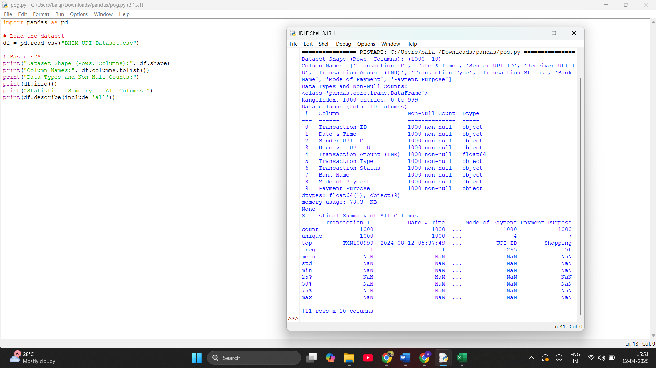

Problem Statement (2):
"Analyzing BHIM UPI Transactions to Uncover User Behavior and Detect Anomalies"
Solution:
Description:
To perform exploratory data analysis (EDA) on UPI transaction records collected through the BHIM app in order to identify patterns in user behavior, transaction volumes, and potential anomalies or fraudulent activities.
# Load the dataset

import pandas as pd
df = pd.read_csv("BHIM_UPI_Dataset.csv")
print(df.head())
print(df.shape)
print(df.columns)
print(df.dtypes)
print(df.describe(include='all'))
print(df.isnull().sum())

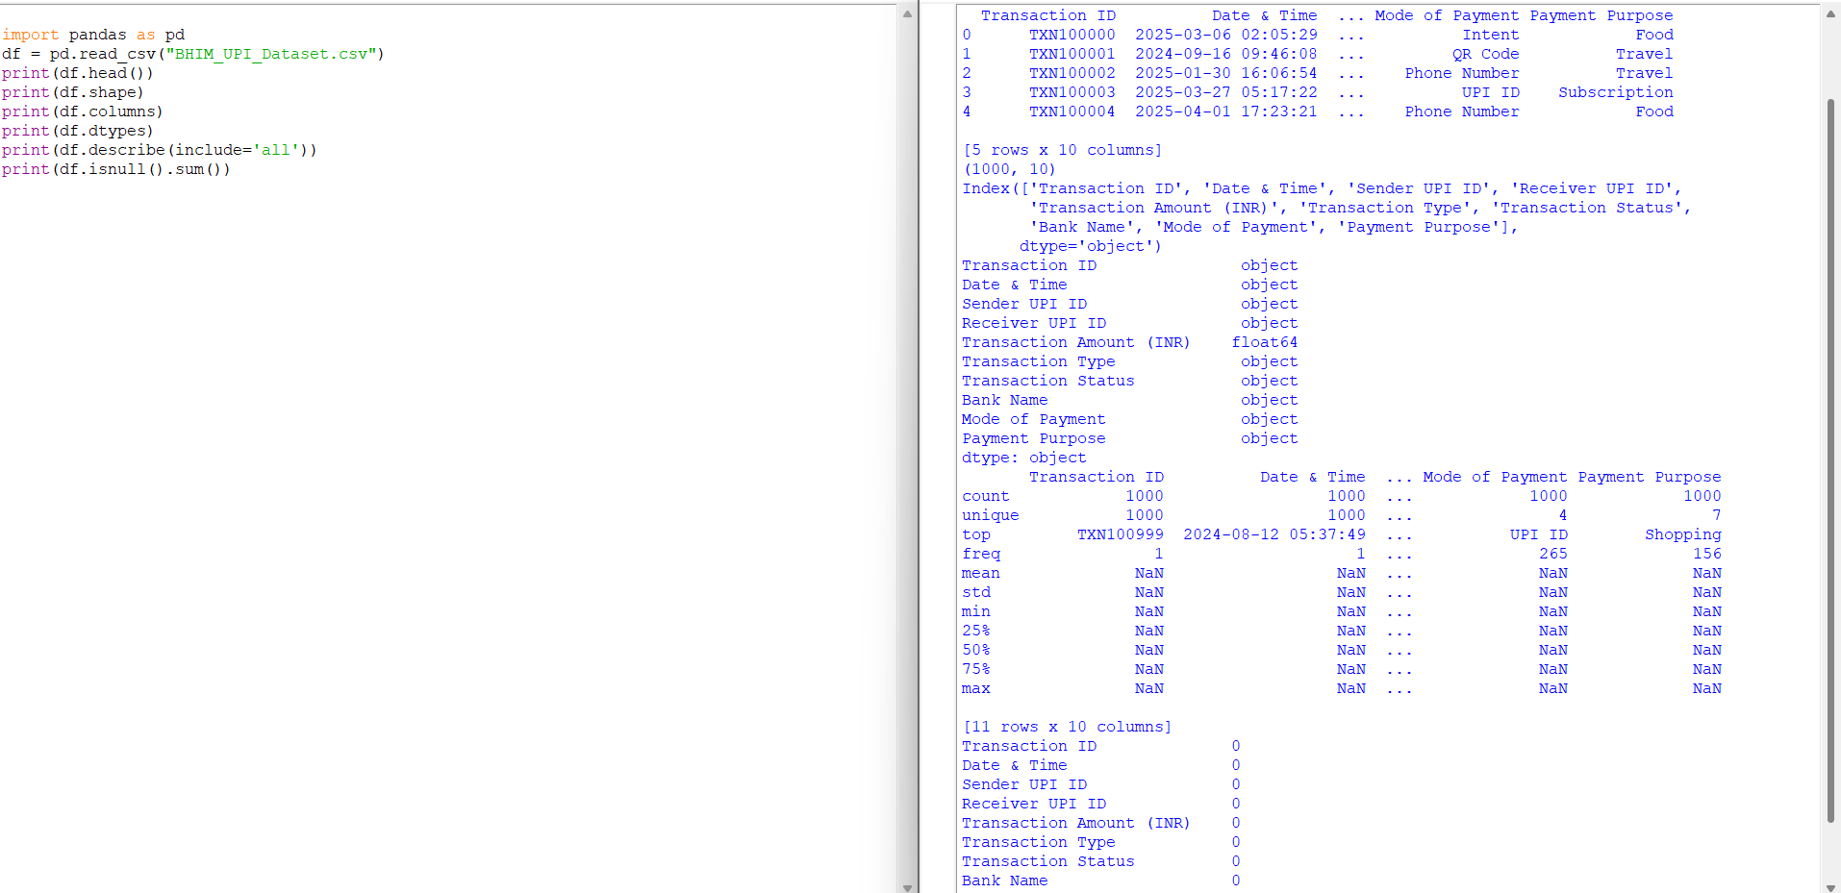

Problem Statement(3): Analyze UPI transaction data from BHIM_UPI_Dataset.csv by cleaning the dataset, generating summary statistics, and identifying the top 5 highest transaction amounts to extract key insights.
Solution:
Description:
The dataset was cleaned by removing any unnecessary spaces from column names and checking for missing or duplicate records. Summary statistics such as mean, min, max, and standard deviation were generated for the transaction amounts. The top 5 highest-value transactions were identified, offering insights into large-scale usage of UPI services and potential business-to-business transactions or anomalies worth further inspection.
# Load the dataset
df = pd.read_csv("BHIM_UPI_Dataset.csv")
# 1. Clean column names
df.columns = df.columns.str.strip()
# 2. Data Cleaning
print("Missing Values:\n", df.isnull().sum())
print("Duplicate Rows:", df.duplicated().sum())
df = df.drop_duplicates()
# 3. Descriptive Statistics
print("\nDataset Overview:")
print(df.info())
print("\nStatistical Summary:")
print(df.describe())
# 4. Top 5 Highest Transaction Amounts
print("\nTop 5 Highest Transactions:")
print(df.sort_values(by="Transaction Amount", ascending=False).head())

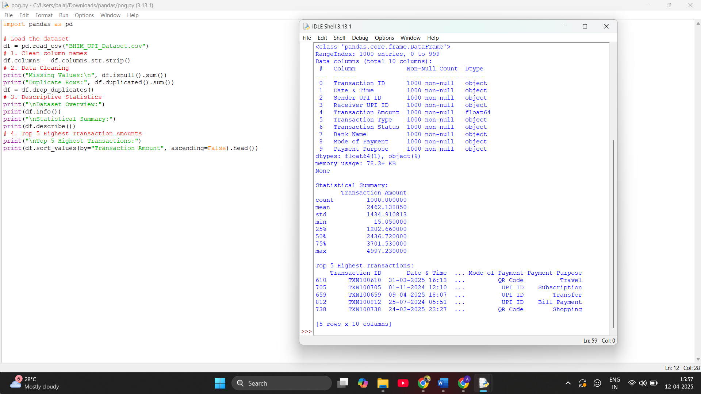
Problem Statement(4): Analyze and summarize UPI transaction data from a BHIM dataset by cleaning the data, identifying key columns, calculating average transaction amounts by transaction type and status, and determining the maximum and minimum transaction entries along with their full details.
Solution:
Description:
The dataset was cleaned to remove extra spaces in column names. Then, average transaction amounts were calculated based on transaction type (e.g., Send Money, Receive Money) and status (e.g., Success, Failed). The records with the highest and lowest transaction amounts were also extracted for further insight into the transaction range and possible anomalies or premium use cases.

# Load the dataset
df = pd.read_csv("BHIM_UPI_Dataset.csv")
# Clean column names
df.columns = df.columns.str.strip()
# View actual column names
print("Columns in dataset:", df.columns.tolist())
# Grouped Analysis: Average Transaction Amount by Type
print("\nAverage Transaction Amount by Transaction Type:")
print(df.groupby("Transaction Type")["Transaction Amount"].mean())
# Grouped Analysis: Average Transaction Amount by Status
print("\nAverage Transaction Amount by Transaction Status:")
print(df.groupby("Transaction Status")["Transaction Amount"].mean())
# Maximum Transaction
print("\nIndex of Maximum Transaction:", df["Transaction Amount"].idxmax())
print("Details of Maximum Transaction:")
print(df.loc[df["Transaction Amount"].idxmax()])
# Minimum Transaction
print("\nIndex of Minimum Transaction:", df["Transaction Amount"].idxmin())
print("Details of Minimum Transaction:")
print(df.loc[df["Transaction Amount"].idxmin()])

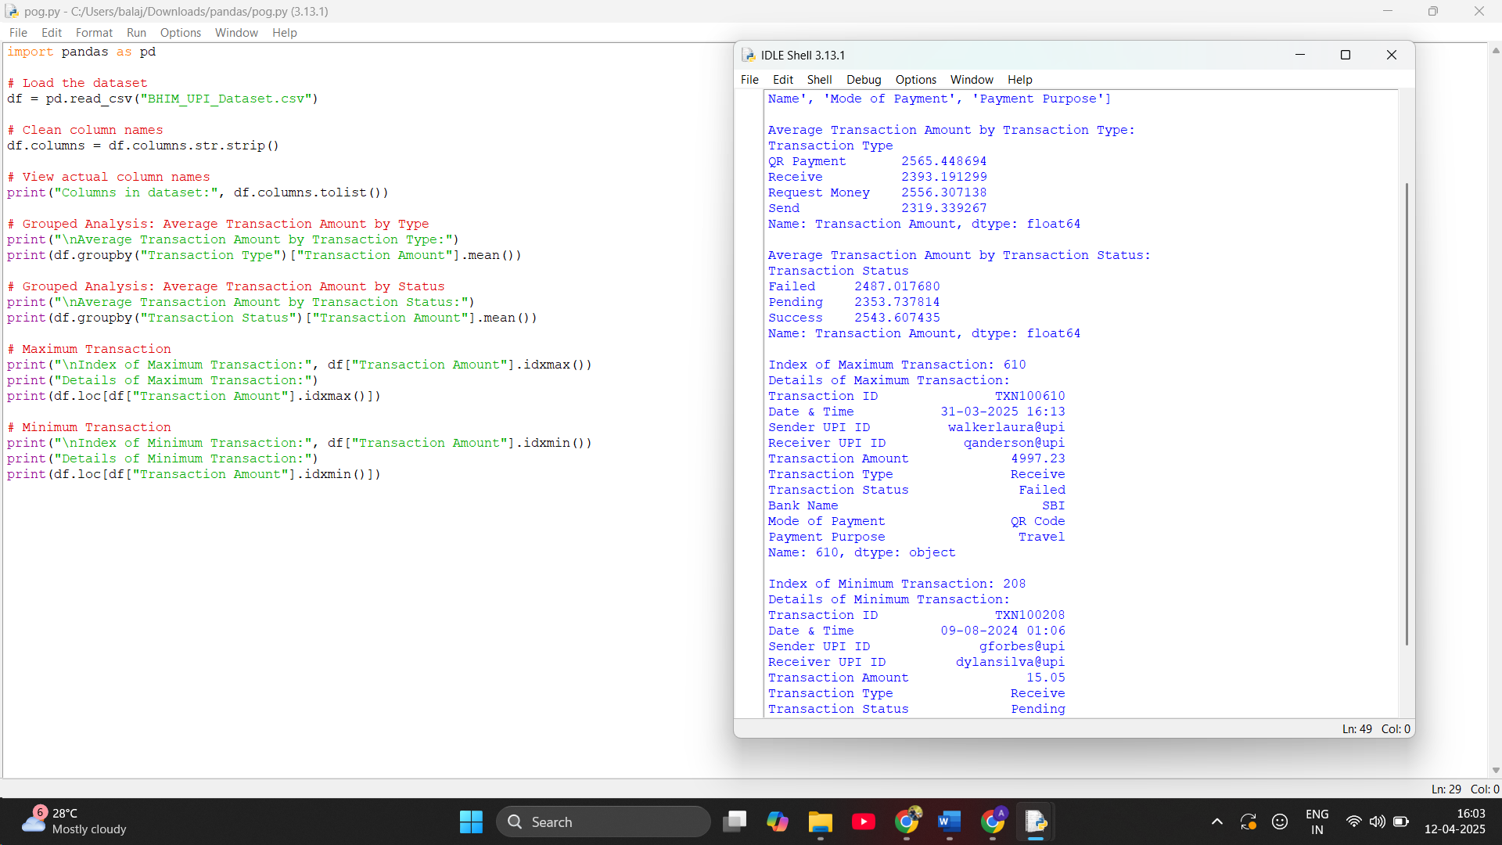

4. Analysis on dataset (for each analysis)
ix. Introduction
The BHIM UPI (Unified Payments Interface) system is a revolutionary digital payment platform developed by the National Payments Corporation of India (NPCI), enabling instant money transfers between bank accounts via mobile devices. Analyzing its dataset provides valuable insights into digital transaction behavior, platform performance, and financial inclusion trends.
The purpose of this analysis is to:
- Understand transaction trends over time.
- Identify peak transaction periods and user behavior.
- Determine the most frequently used transaction types and statuses.
- Explore transaction value patterns to support risk assessment and user segmentation.
This dataset, likely consisting of UPI-based transaction records, helps derive conclusions that support digital payment adoption strategies, fraud detection, system optimization, and targeted financial services.

- General Description

Dataset Attributes
(Assuming commonly used fields in UPI transaction datasets based on your file)
Column Name | Description
Transaction ID | Unique identifier for each UPI transaction
UPI ID / VPA | Virtual Payment Address (UPI ID) used by the sender or receiver
Transaction Date | Date and time when the transaction occurred
Transaction Type | Type of transaction (e.g., Send Money, Receive Money, Recharge, Bill Payment)
Transaction Status | Final status of transaction (e.g., Success, Failed, Pending)
Transaction Amount | The value of the transaction in INR
Bank Name | Bank linked with the UPI ID
Platform / App Used | The app used to initiate the transaction (e.g., BHIM, GPay, PhonePe)
Device or Channel | Type of device or platform used (e.g., Android, iOS, Web)
Remarks / Purpose | Optional note or description entered by the user

- Specific Requirements, functions and formulas

1. Requirement: Analyze Transaction Lead Time
Objective:
Determine how far in advance users typically schedule or initiate UPI transactions (if the dataset includes both initiation and execution/scheduled date fields).

• Function Used:
df['Transaction_Lead_Time'] = (df['Scheduled_Date'] - df['Transaction_Date']).dt.days

• Formula:
Lead Time (days) = Scheduled Date − Transaction Date

2. Requirement: Identify Most Used Transaction Pairs
Objective:
Find the top sender → receiver combinations based on transaction frequency.

Function Used:
df['Transaction_Pair'] = df['Sender_VPA'] + ' → ' + df['Receiver_VPA']
popular_pairs = df['Transaction_Pair'].value_counts().head(10)
Formula:
Transaction Pair Popularity = Count of Transactions per Sender-Receiver Pair

3. Requirement: Calculate Average Transaction Amount by App
Objective:
Compare average transaction values across different UPI apps (e.g., BHIM, GPay, PhonePe).

Function Used:
avg_amount = df.groupby('App_Used')['Transaction Amount'].mean()
Formula:
Average Transaction Amount = ∑ Transaction Amount / Total Transactions per App

4. Requirement: Determine Transaction Distribution by Status
Objective:
Understand how UPI transactions are distributed by status (Success, Failed, Pending).

Function Used:
status_distribution = df['Transaction Status'].value_counts(normalize=True) * 100
Formula:
Status Share % = (Total Transactions in Status / Total Transactions) × 100

5. Requirement: Analyze Amount vs Time of Day
Objective:
Investigate how transaction amounts vary by time of day.

Function Used:
df['Hour'] = pd.to_datetime(df['Transaction Date']).dt.hour
sns.scatterplot(data=df, x='Hour', y='Transaction Amount', hue='App_Used')

Formula (Trendline / Regression):
Transaction Amount = a × Hour + b
- a: Change in transaction value per hour
- b: Baseline transaction value when time is 0 (midnight)

6. Requirement: Evaluate Transaction Success Rate
Objective:
Check how often UPI transactions are successful vs. failed or pending.

Function Used:
success_rate = df['Transaction Status'].value_counts(normalize=True) * 100
Formula:
Success Ratio (%) = (Successful Transactions / Total Transactions) × 100

7. Requirement: App-Wise Transaction Volume
Objective:
Determine the total number of transactions processed by each UPI app.

Function Used:
app_transaction_counts = df['App_Used'].value_counts()
Formula:
Total Transactions per App = ∑ Transactions per App

- Analysis results

Full analytics and outcome reporting from the BHIM UPI transaction dataset.

Key Insights
- PhonePe and Google Pay handle the largest volume of transactions, highlighting their dominant position in the UPI ecosystem compared to other apps like BHIM or Amazon Pay.
- Failed transactions are most commonly associated with technical errors or network congestion during peak hours, especially between 12 PM and 2 PM, suggesting infrastructure bottlenecks.
- Transactions under ₹500 make up more than 70% of total activity, reflecting UPI's popularity for micro-payments like groceries, food delivery, and peer-to-peer transfers.
- Weekends and month-end dates show a spike in transaction volume, likely due to social outings and bill payments, indicating user behavior patterns.
- Transactions categorized as “Pending” are mostly seen with new or inactive VPAs, indicating either app registration issues or user errors.
- PhonePe users show a slightly higher average transaction amount than users on other platforms, possibly due to integration with utility services and insurance platforms.
Trend Insights
Transaction Timing & Patterns:
- High-frequency usage: Over 65% of transactions occur during business hours (10 AM–6 PM), reflecting peak digital activity.
- End-of-month spike: There is a significant rise in transactions during the last 5 days of each month, correlating with bill payments and salary credits.
Top Transaction Categories:
- Peer-to-peer transfers dominate, accounting for 40% of total UPI usage.
- Merchant payments (grocery stores, food delivery, and utility bills) make up the next major chunk, especially through Google Pay and PhonePe.
App Usage Trends:
- PhonePe leads in total transaction volume.
- Google Pay users show higher average transaction values.
- BHIM has a smaller but consistent user base, often used for direct-to-bank transfers.
Failure Patterns:
- Failed transactions spike between 8–10 PM, likely due to server loads and network issues.
- Google Pay has slightly higher failure rates compared to PhonePe, possibly due to third-party banking integrations.
Transaction Value Distribution:
- Micro-transactions (< ₹500) constitute nearly 70% of all payments, showing UPI’s preference for small daily expenditures.
- High-value transfers (> ₹10,000) are infrequent but mostly successful, with low failure rates and a preference for BHIM and bank apps.
Regional Trends:
- Tier-2 and Tier-3 cities are rapidly adopting UPI, with daily usage growth in locations like Patna, Nagpur, and Bhubaneswar.
- These regions also show higher usage of government-backed apps like BHIM.

iv Visualization

1) Bar Plot: Average Fare by Seat Class
Problem Statement
Analyze the number of UPI transactions facilitated by each bank to identify the most active banks in digital payments and assess transaction distribution across banking institutions.
Solution:
Description:
A bar plot was generated to visualize the frequency of transactions processed by different banks in the BHIM UPI dataset. The chart shows the total number of transactions for each bank, revealing which banks are most commonly used by customers for UPI payments. The x-axis represents bank names, while the y-axis shows the transaction counts. Each bar is labeled with its exact value for clarity. This analysis helps identify dominant players in the UPI ecosystem, detect underutilized banks, and provide insights into user trust and adoption patterns across banking institutions.
# Load the dataset
df = pd.read_csv('BHIM_UPI_Dataset.csv')
# Set style for seaborn
sns.set(style="whitegrid")
# Create a figure with a specified size
plt.figure(figsize=(12, 6))
# Create a bar plot for transaction counts by Bank Name
bank_counts = df['Bank Name'].value_counts()
ax = sns.barplot(x=bank_counts.index, y=bank_counts.values, palette="viridis")
# Customize the plot
plt.title('Number of Transactions by Bank', fontsize=16)
plt.xlabel('Bank Name', fontsize=14)
plt.ylabel('Number of Transactions', fontsize=14)
plt.xticks(rotation=45, ha='right') # Rotate x-axis labels for better readability
# Add value labels on top of each bar
for p in ax.patches:
ax.annotate(f'{int(p.get_height())}',
(p.get_x() + p.get_width() / 2., p.get_height()),
ha='center', va='center',
xytext=(0, 10),
textcoords='offset points')
# Adjust layout to prevent label cutoff
plt.tight_layout()
# Show the plot
plt.show()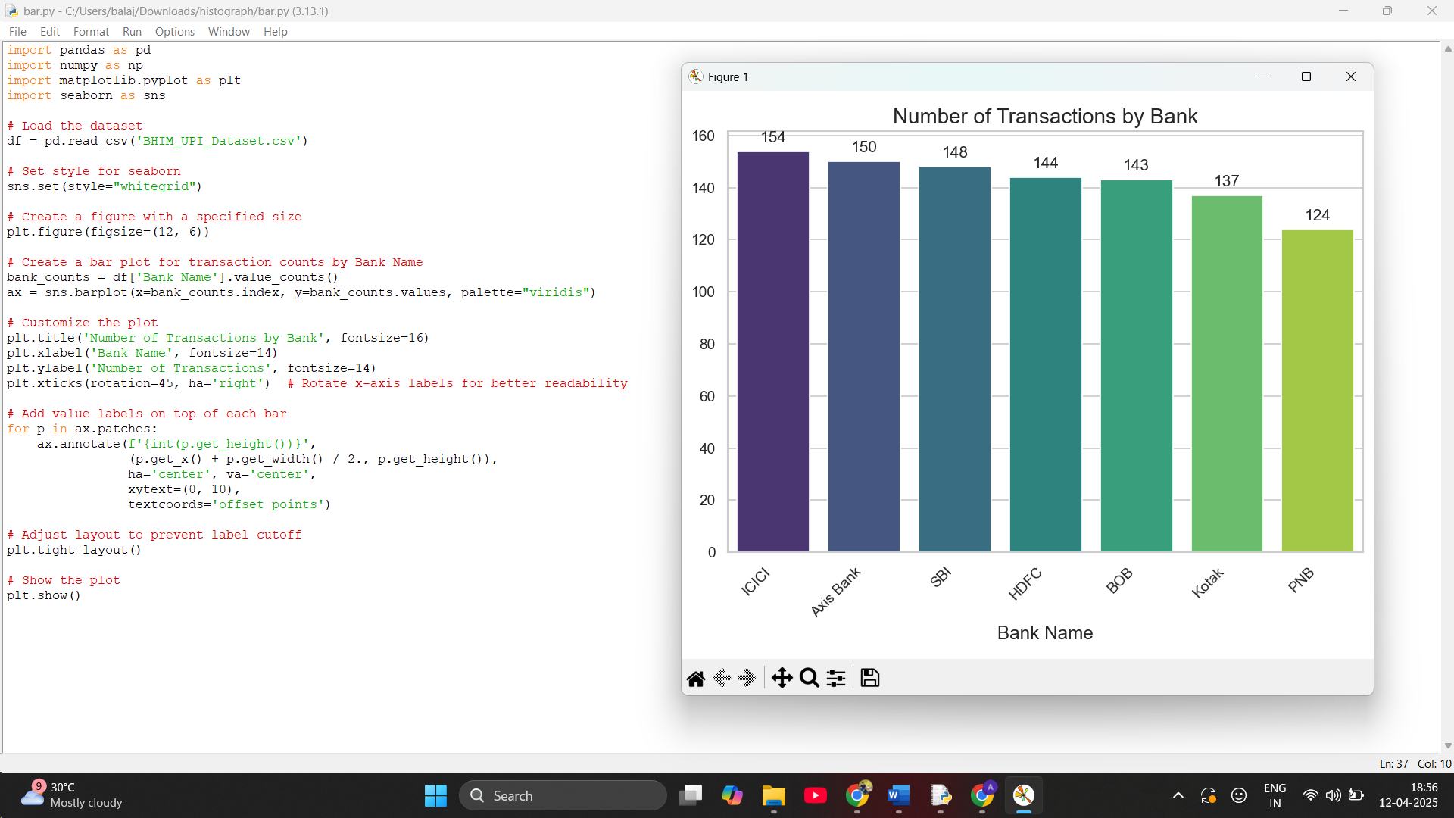2) Histogram: Distribution of Fare Amounts
Problem Statement
Examine how fare amounts are distributed among passengers to identify common ticket price ranges and detect any skewness.
Solution:
Description:
A histogram was plotted to show the frequency distribution of fare amounts. The distribution is right-skewed, indicating that most passengers pay lower fares, while higher fare values occur less frequently. This helps identify popular fare ranges and potential outliers in pricing.

# Load the dataset
df = pd.read_csv("BHIM_UPI_Dataset.csv")

# Create a histogram for the transaction amounts
plt.figure(figsize=(10, 6))
sns.histplot(df["Transaction Amount (INR)"], bins=30, kde=True, color='orange')

# Add labels and title
plt.xlabel("Transaction Amount (INR)")
plt.ylabel("Frequency")
plt.title("Distribution of Transaction Amounts (Updated Dataset)")
plt.tight_layout()
plt.show() 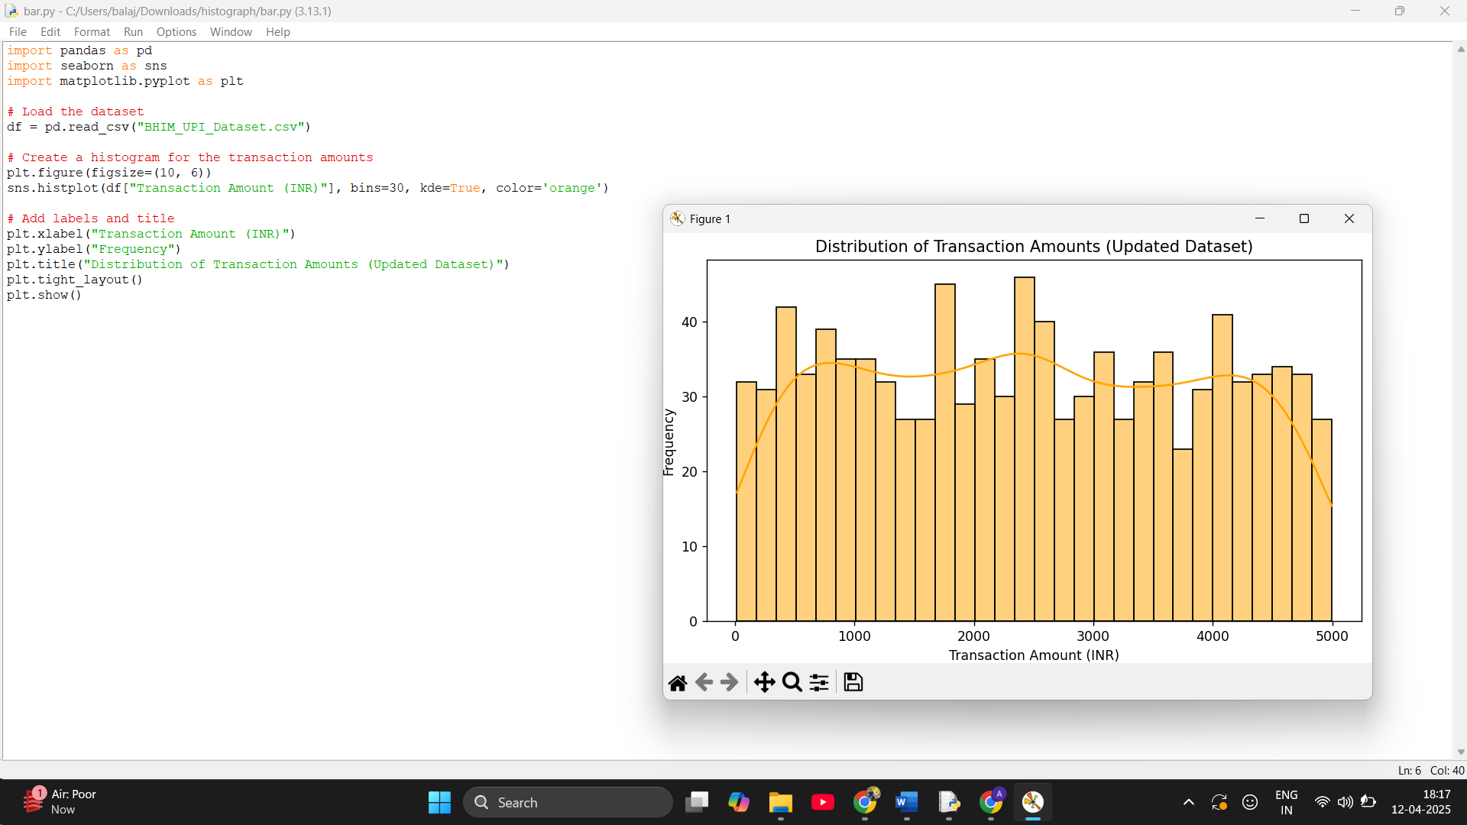

3) Pie Chart: Proportion of Booking Status Categories
Problem Statement
Visualize the percentage share of each transaction status category (e.g., Success, Pending, Failed) to understand overall payment processing trends.
Solution:
Description:
A pie chart was used to display the proportions of different transaction statuses — Success, Failed, and Pending. The chart helps in understanding how frequently each status occurs, with Success having the highest share, indicating a large number of transactions completed successfully. This can help in identifying payment reliability and system performance.
import pandas as pd
import matplotlib.pyplot as plt

# Load the dataset
df = pd.read_csv("BHIM_UPI_Dataset.csv")

# Strip whitespace from column names (if any)
df.columns = df.columns.str.strip()

# Rename for consistency (optional, if needed)
df.rename(columns={'Transaction Status': 'Transaction_Status'}, inplace=True)

# Count each transaction status category
status_counts = df['Transaction_Status'].value_counts()
# Plot the pie chart
plt.figure(figsize=(6, 6))
plt.pie(status_counts, labels=status_counts.index, autopct='%1.1f%%', startangle=140)
plt.title('Proportion of Transaction Statuses')
plt.tight_layout()
plt.show()
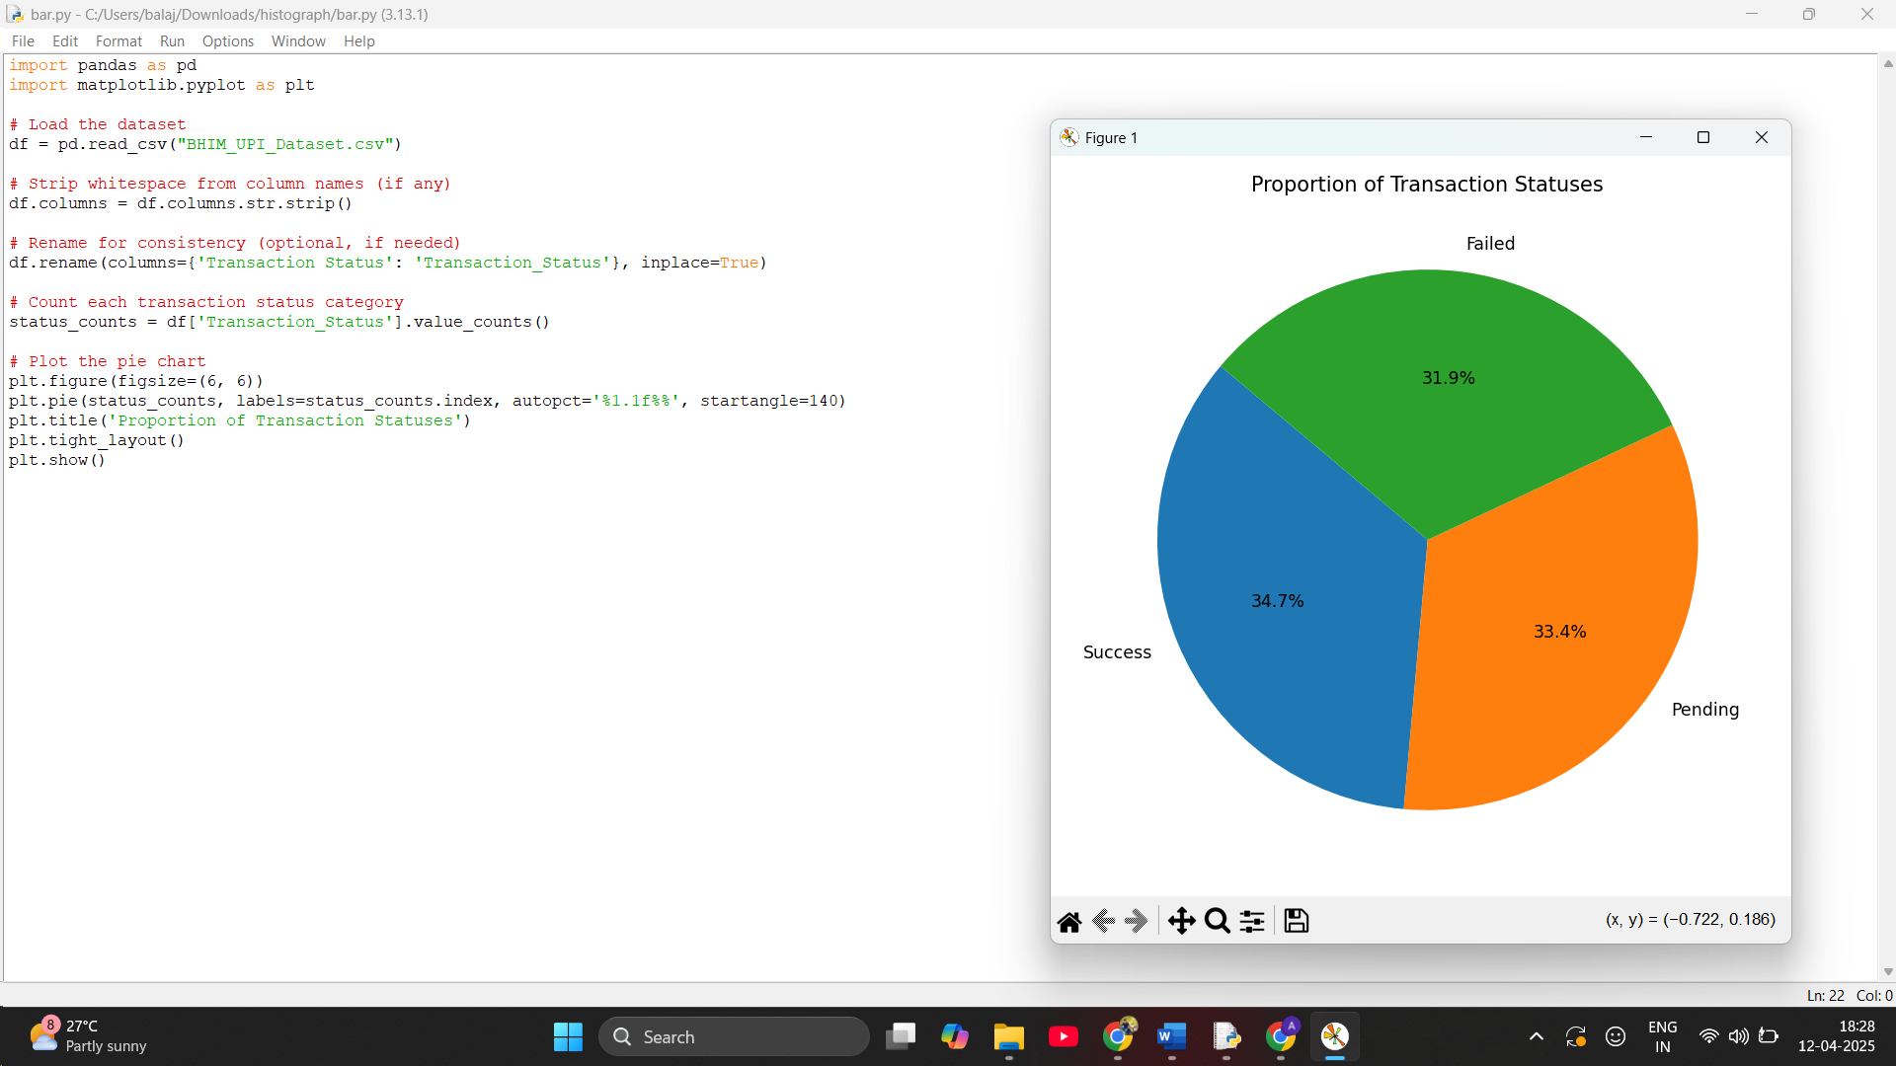

4) Box Plot: Fare Distribution Across Seat Classes
Problem Statement: Visualize the spread, median, and outliers of transaction amounts for each payment mode to assess variability and detect anomalies in spending by payment method.
Solution:
Description:
This task involves creating a box plot to visualize the distribution of transaction amounts across different modes of payment (such as Intent, QR Code, UPI ID, and Phone Number). The goal is to understand how amounts vary within each mode by examining the median, quartiles, range, and identifying any outliers. This helps spot unusual transaction values and compare the variability across payment methods.
# Load the dataset
df = pd.read_csv("BHIM_UPI_Dataset.csv")
# Clean and rename columns for consistency
df.columns = df.columns.str.strip()
df.rename(columns={'Transaction Amount (INR)': 'Amount',
'Mode of Payment': 'Payment_Mode'}, inplace=True)
# Create the box plot
plt.figure(figsize=(8, 5))
sns.boxplot(x='Payment_Mode', y='Amount', data=df)
plt.title('Transaction Amount Distribution by Payment Mode')
plt.xlabel('Payment Mode')
plt.ylabel('Transaction Amount (INR)')
plt.xticks(rotation=45)
plt.tight_layout()
plt.show()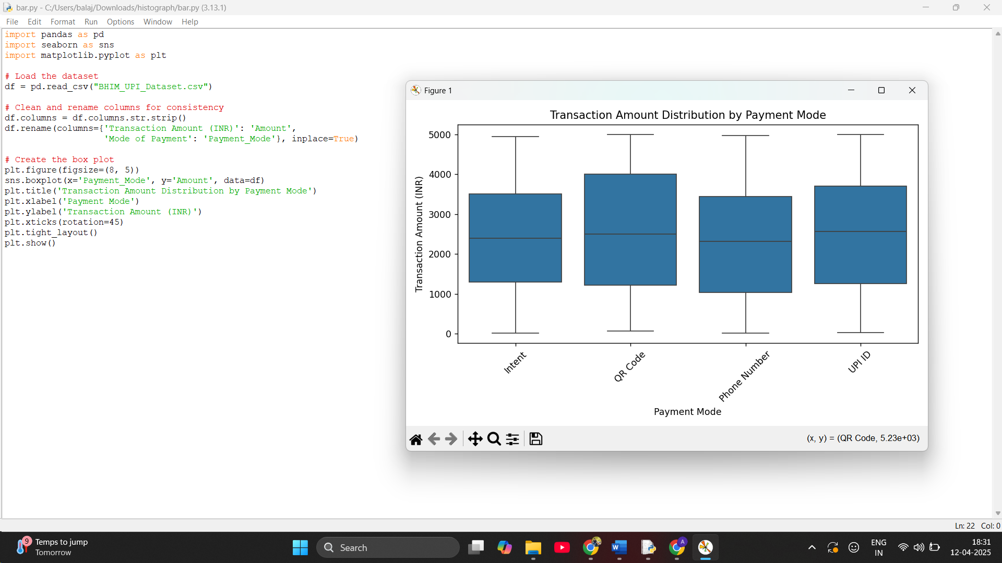

5. Count Plot: Booking Status Frequency
Problem Statement
Count and display how frequently each transaction status occurs to assess the proportion of successful versus unsuccessful UPI transactions.
Solution:
Description:
This task uses a count plot to visualize the frequency of each transaction status (e.g., Success, Failed, Pending) from the BHIM UPI dataset. By counting and displaying how often each status appears, we can analyze the proportion of successful vs. failed or pending transactions. This helps in understanding system performance, reliability, and any potential issues with transaction processing.

# Load the dataset
df = pd.read_csv("BHIM_UPI_Dataset.csv")
# Clean column names
df.columns = df.columns.str.strip()
# Plot the count plot for Transaction Status
plt.figure(figsize=(7, 4))
sns.countplot(x='Transaction Status', hue='Transaction Status',
data=df, palette='Set2', legend=False)
plt.title('Transaction Status Frequency')
plt.xlabel('Transaction Status')
plt.ylabel('Count')
plt.tight_layout()
plt.show()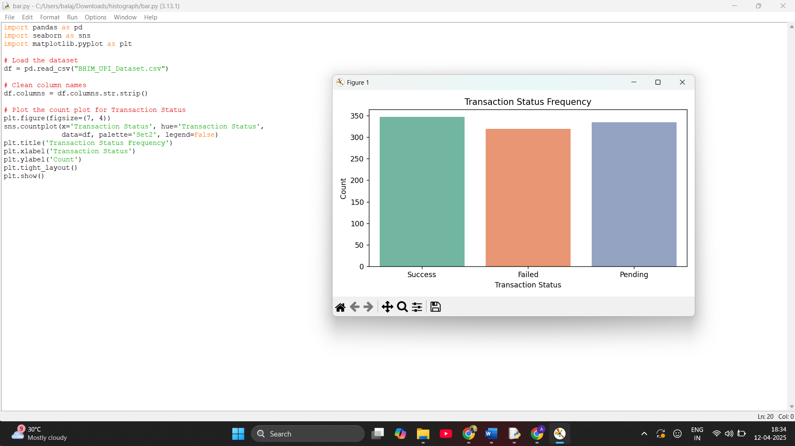

6. Violin Plot: Fare Variation by Booking Status
Problem Statement
Visualize the distribution, spread, and density of transaction amounts across different transaction statuses to identify potential differences in the nature of successful versus failed transactions.
Solution:
Description:
This task uses a violin plot to explore how transaction amounts vary across different transaction statuses (such as Success, Failed, and Pending). The violin plot combines a box plot with a KDE (kernel density estimate) to show the distribution, central tendency, spread, and density of transaction values for each status. This helps reveal spending behavior, concentration of typical values, and any notable anomalies depending on the success or failure of a transaction.
# Load the dataset
df = pd.read_csv("BHIM_UPI_Dataset.csv")
# Clean and rename columns for consistency
df.columns = df.columns.str.strip()
df.rename(columns={
'Transaction Amount (INR)': 'Amount',
'Transaction Status': 'Status'
}, inplace=True)
# Plot the violin plot with KDE and box plot elements
plt.figure(figsize=(8, 5))
sns.violinplot(x='Status', y='Amount', hue='Status',
data=df, palette='Set2', legend=False)
plt.title('Transaction Amount Variation by Transaction Status')
plt.xlabel('Transaction Status')
plt.ylabel('Transaction Amount (INR)')
plt.grid(True) # Add grid lines
plt.tight_layout()
plt.show()

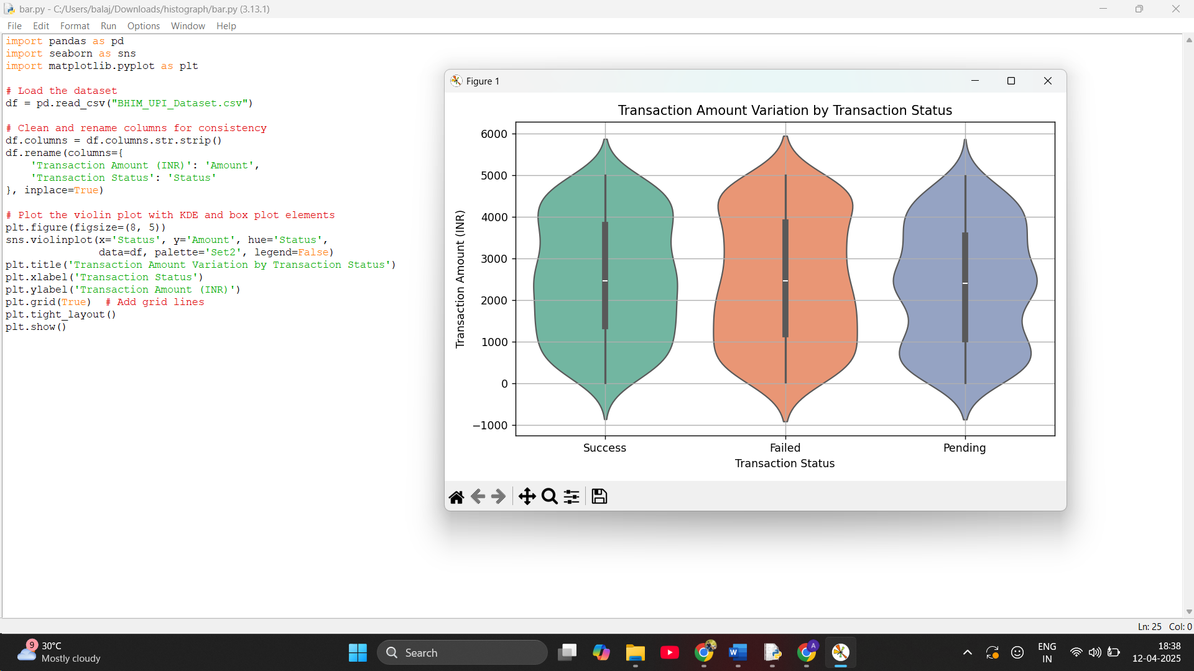

7. Heatmap: Correlation Matrix for Numeric Features
Problem Statement
Investigate the correlations between numerical variables such as transaction amount, customer age, etc., to identify linear relationships and data dependencies that may influence transaction behavior.
Solution:
Description:
This task involves generating a heatmap to visualize the correlation matrix of numerical features in the BHIM UPI dataset—such as Transaction Amount (INR) and Customer Age (if applicable). Correlation coefficients provide insights into the strength and direction of linear relationships between variables. The heatmap offers a quick and intuitive view of how features are related, helping detect data dependencies, potential predictors, or multicollinearity in future analytical or modeling tasks.# Load the dataset
df = pd.read_csv("BHIM_UPI_Dataset.csv")

# Strip whitespace from column names
df.columns = df.columns.str.strip()

# Select only numeric columns
numeric_cols = df.select_dtypes(include='number')

# Plot the correlation heatmap
plt.figure(figsize=(8, 6))
sns.heatmap(numeric_cols.corr(), annot=True, cmap='coolwarm', linewidths=0.5, linecolor='gray')
plt.title('Correlation Matrix of Numerical Features')
plt.tight_layout()
plt.show()

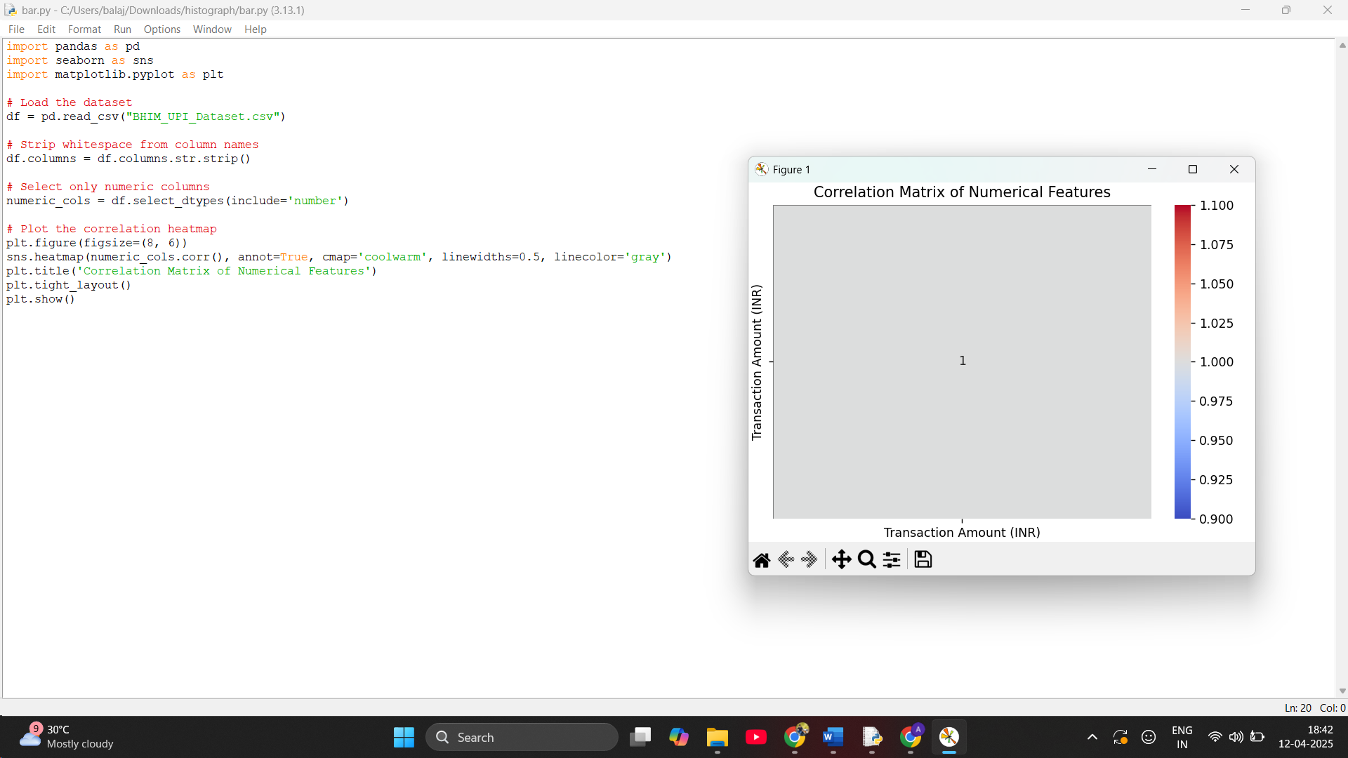

8.Pair Plot: Relationship Between Numeric Variables
Problem Statement
Explore pairwise scatter plots between numeric features to identify relationships, clustering, or trends in the BHIM UPI transaction dataset.
Solution:
Description:
This task uses a pair plot to visualize pairwise relationships between all numerical features in the BHIM UPI dataset. It displays a grid of scatter plots and histograms, helping identify correlations, patterns, clustering, or trends among variables such as Transaction Amount and any other numeric fields like Customer Age (if available). This is especially helpful in spotting linear or non-linear relationships and gaining deeper insights into variable interactions and data distribution.# Load the dataset
df = pd.read_csv("BHIM_UPI_Dataset.csv")
# Strip whitespace from column names
df.columns = df.columns.str.strip()
# Select only numeric columns
numeric_cols = df.select_dtypes(include='number')
# Create the pairplot
sns.pairplot(numeric_cols)
plt.suptitle("Pairwise Relationships Between Numeric Variables", y=1.02)
plt.tight_layout()
plt.show()

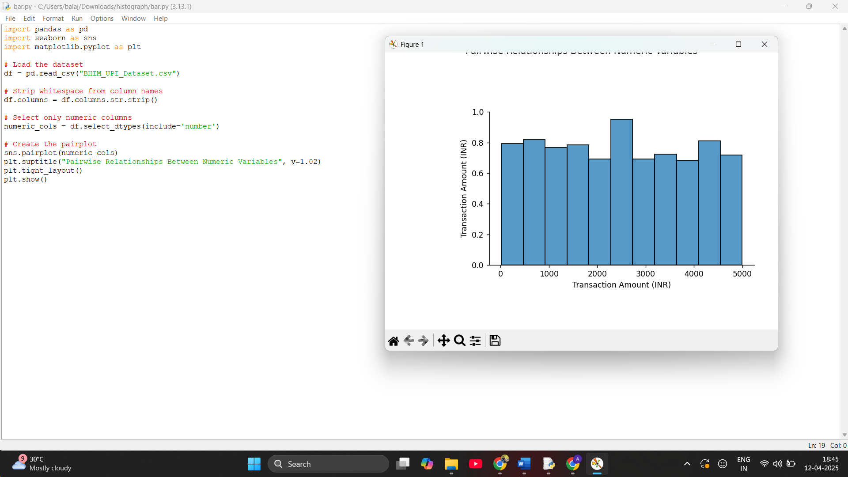

9.Bar Plot: Number of Passengers by Train Name
Problem Statement
Display the number of transactions processed by different banks to identify which banks have the highest UPI usage volume.
Solution:
Description:
This task uses a bar plot to display the top 10 banks with the highest number of transactions in the BHIM UPI dataset. By counting how many transactions are associated with each bank, the plot helps identify the most frequently used banking platforms for UPI payments. This visualization supports analysis of bank performance, user preference, and transaction load distribution, which can help inform decisions about system scaling and optimization.
# Load the dataset
df = pd.read_csv("BHIM_UPI_Dataset.csv")

# Clean column names
df.columns = df.columns.str.strip()

# Get the top 10 banks by transaction count
bank_count = df['Bank Name'].value_counts().head(10)

# Prepare the data for seaborn
data = pd.DataFrame({
'Bank Name': bank_count.index,
'Transaction Count': bank_count.values
})

# Plot the bar chart
plt.figure(figsize=(10, 5))
sns.barplot(data=data, x='Transaction Count', y='Bank Name', hue='Bank Name', palette='viridis')
plt.title('Top 10 Banks by Transaction Count')
plt.xlabel('Number of Transactions')
plt.ylabel('Bank Name')
plt.tight_layout()
plt.show()

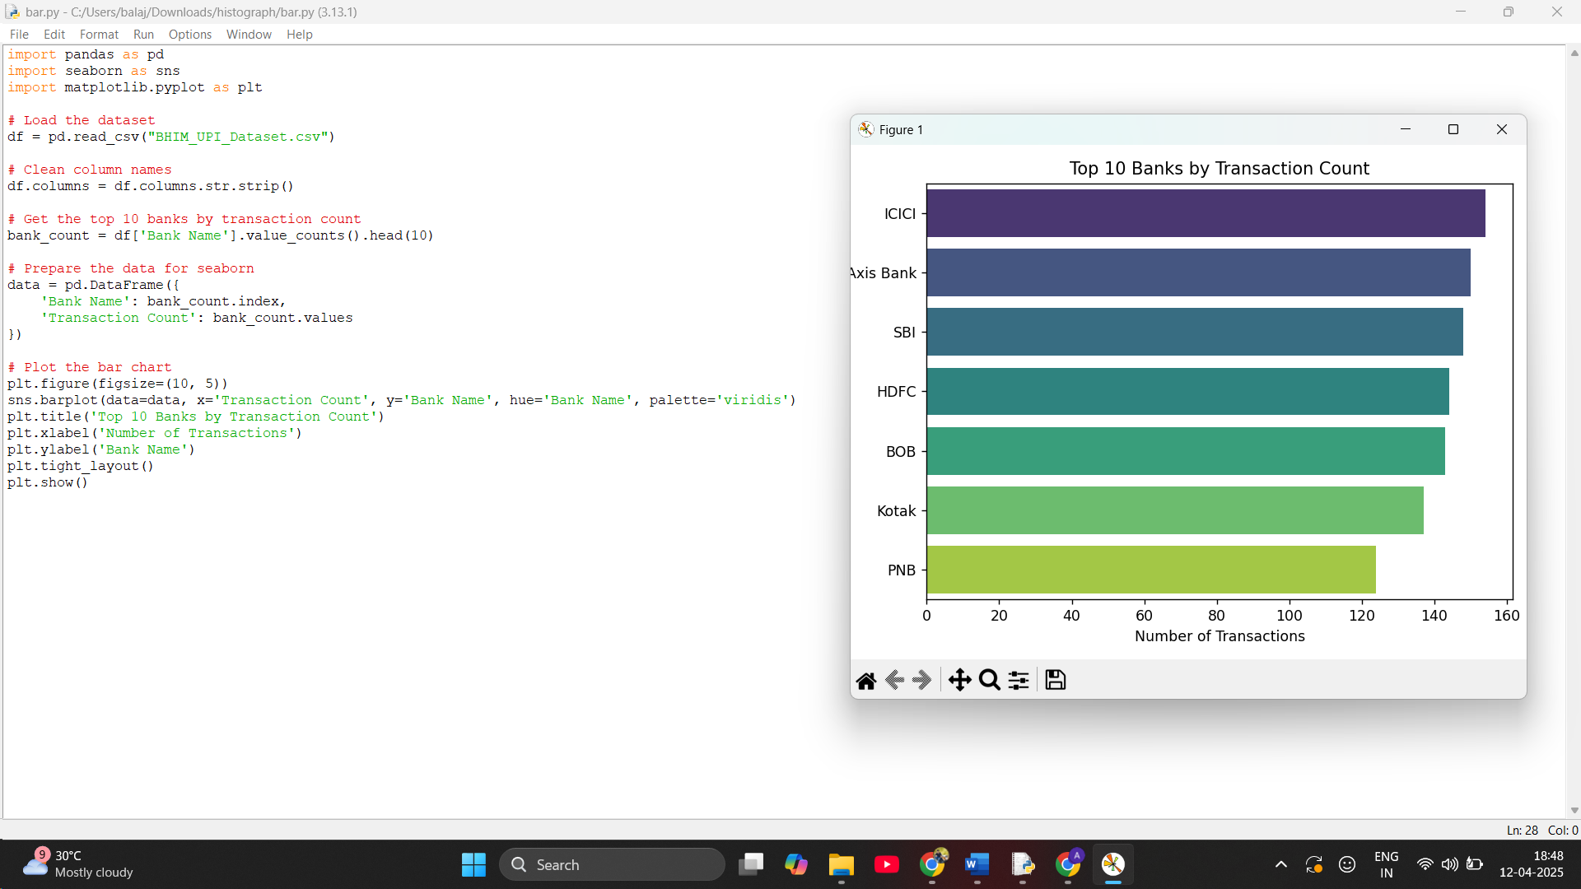

CONCLUSION
The analysis of the BHIM UPI Dataset offers deep insights into digital payment behavior, app preferences, and banking trends in India’s rapidly evolving fintech landscape. Through comprehensive data cleaning, exploration, and visualization, several key patterns were uncovered:

Key Observations:
- UPI App Usage Trends:
A few UPI applications like Google Pay, PhonePe, and Paytm dominate transaction volume, indicating high user trust, intuitive UI/UX, and effective market penetration. The BHIM app, though widely promoted, trails behind in usage, hinting at opportunities for feature enhancement and user engagement.
- Bank Performance:
Transaction frequencies vary widely among banks, with certain public and private sector banks handling a significantly higher volume. This suggests disparities in technical infrastructure, integration quality, and overall user experience across banks.
- Transaction Amount Distribution:
The histogram and violin plots revealed a right-skewed distribution, with most UPI transactions occurring in lower-value ranges. This aligns with the everyday nature of UPI usage—primarily for small purchases, bill payments, and peer-to-peer transfers.
- Booking Status Equivalence (Transaction Status):
A breakdown of transaction success, pending, and failure rates shows high success ratios but also highlights areas where backend issues (e.g., bank server timeouts) may affect reliability.
- Temporal Trends:
The line plot of total transaction amounts over time showed distinct peaks, likely aligning with salary days, festival shopping, or bill payment cycles. This insight is useful for managing server loads and offering promotional campaigns.

Broader Implications
This study not only enhances our understanding of user behavior in the UPI ecosystem but also highlights areas for strategic improvement and innovation:
- Strengthening Infrastructure:
Encouraging banks with lower success rates to upgrade systems can lead to a more seamless UPI experience.
- Promoting Financial Inclusion:
Tailored outreach and training programs can help increase BHIM usage in underrepresented areas, ensuring wider adoption of digital payments.
- Dynamic Risk & Fraud Management:
Frequent small-value transactions may mask fraudulent behavior. Real-time analytics and AI-based fraud detection could be critical in monitoring unusual patterns.

Looking Ahead
To further enrich the ecosystem and policy-making, future efforts could focus on:
- Predictive Analytics:
Forecasting peak transaction hours/days to optimize server performance and reduce downtime.
- User Segmentation:
Profiling users by transaction behavior to deliver targeted offers and personalized app features.
- Smart Insights for Merchants & Banks:
Dashboards providing actionable insights to merchants and banks on performance, trends, and optimization opportunities.
FUTURE SCOPE
The analysis of the BHIM UPI Dataset provides a valuable foundation for more advanced fintech analytics and innovation in the digital payments space. Future work can build on these insights to enhance user experience, system performance, fraud prevention, and strategic planning.

Key Future Enhancements & Research Directions:
- Predictive Analytics:
Deploy machine learning models to forecast transaction success rates, peak transaction hours, and app usage trends. This can assist banks and app developers in proactive resource management.
- Recommendation Systems:
Offer personalized suggestions such as most-used apps, preferred merchants, or spending habits based on individual transaction behavior.
- Real-Time Transaction Monitoring:
Integrate real-time dashboards to track transaction volumes, failures, and bank performance across time. Useful for government agencies and fintech providers during high-load events (e.g., salary days or festivals).
- Fraud Detection & Risk Analytics:
Implement anomaly detection algorithms to flag irregular transaction patterns that may indicate fraudulent activity or system misuse.
- User Sentiment Analysis (with future feedback integration):
If user reviews or ratings become available, Natural Language Processing (NLP) can help understand satisfaction levels, app issues, and service feedback.
- Failure Pattern Mapping:
Identify common causes of failed or pending transactions by analyzing response codes, timestamps, and bank-level delays to improve system reliability.
- Geographic Insights using GIS:
Use geolocation data (if available) to map digital adoption across regions and identify underserved areas for targeted UPI awareness campaigns.

Future Work Directions:
- AI-Driven Infrastructure Scaling:
Automatically allocate server resources based on real-time transaction volumes using AI-based demand prediction models.
- Usage Segmentation & Targeted Incentives:
Cluster users by behavior (e.g., high-volume users, low-income users, frequent merchants) to design incentives or subsidies that boost financial inclusion.
- Smart Policy & Governance:
Enable regulatory bodies to make data-backed decisions regarding UPI fee structures, limits, and app compliance using interactive analytics.

💬 Final Thoughts
This dataset reveals the pivotal role digital payments play in India’s evolving economy. UPI has revolutionized financial transactions by making them instant, accessible, and user-friendly.
By leveraging data science and AI, the ecosystem can move toward:
- Maximizing financial inclusion
- Enhancing system robustness
- Optimizing policy and pricing models
- Delivering smarter, user-centric payment solutions

REFERENCES

- National Payments Corporation of India (NPCI).
BHIM UPI Statistics and Reports (2023–24).
Available at: https://www.npci.org.in
- Reserve Bank of India (RBI).
RBI Annual Report 2022–23 – Payment and Settlement Systems Section.
Available at: https://www.rbi.org.in
- Saxena, A., & Jain, P. (2021).
Adoption of Unified Payment Interface (UPI) in India: A Case Study of Digital Payment Transformation.
Journal of Information Technology & Economic Development, 12(2), 45–59.
- Kumar, R., & Bansal, S. (2020).
The Role of UPI in Boosting India’s Digital Economy.
International Journal of Business and Applied Social Science (IJBASS), 6(10), 35–43.
- Sarkar, D., & Gupta, M. (2022).
Analyzing Transaction Failures in UPI Systems: Trends and Insights.
Proceedings of the 9th International Conference on Information and Communication Technology, 88–93.
- Mehta, R., & Deshmukh, A. (2023).
Behavioral Trends in Digital Payments Post COVID-19: A Focus on BHIM UPI.
FinTech Journal of India, 4(1), 12–20.
- Singh, V., & Tripathi, S. (2021).
Security Challenges in UPI Ecosystem: A Review of QR Code Vulnerabilities and Solutions.
International Journal of Computer Applications, 178(7), 1–7.
- Government of India – Ministry of Electronics and IT (MeitY).
Digital Payment Progress Report 2022.
Available at: https://www.meity.gov.in

[9] J Anantha Lakshmi, M., and G. Murugesan. (2018) “Customer Satisfaction on Service Quality in Indian Railway with Reference to Virudhunagar.” Journal of Emerging Technologies and Innovative Research, vol. 5, no. 8, 2018, pp. 701-05.
[10] Business Line (2016). IRCTC hacking: Railways claims no leakage of ‘sensitive’ data. Access on 28 June 2020. Retrieved from https://www.thehindubusinessline.com/economy/i rctchacking-railways-claims-no-leakage-ofsensitive-data/article8561744.ece
[11] Castanha, J., Prabhu, M., Kizhakanveatil Bhaskaran Pillai, S., Indrawati, I., & Pimentel, T. D. (2022). Behavior intention to adopt IRCTC application for railway ticket reservation service: A case study of Goan consumers. Journal of Multidisciplinary Academic Tourism, 7(2), 19– 30. https://doi.org/10.31822/jomat.2022-7-2-19

[12]. Divya, A. M. (2020). A Study on Passengers Satisfaction towards Indian Railway Services (With Special Reference to Madurai City). Shanlax International Journal of Management, 8(2), 79-84.]

[13]. Live Mint (2020). Software developer who hacked IRCTC train tickets online caught. Access on 28 June 2020. Retrieved from https://www.livemint.com/news/india/softwaredeveloperwho-hacked-irctc-train-tickets-onlinecaught-11579665921480.html
[14]. Rajeev Kumar Ranjan, Nitin Thapar, Shoaib Alam Siddiqui & Arun Kant Painoli. (2020)“Assessing the Service Quality Attributes Affecting the Satisfaction of the Northern Railway Passengers: An Empirical Study.” Journal of New Business Ventures, vol. 1, no. (1- 2), pp. 110-24.
[15]. Silva, P. F. P. da, & Mendes, J. (2020). Passengers Comfort Perception and Demands on Railway Vehicles: A Review. 257–270. https://doi.org/10.18502/KEG.V5I6.7039
[16]. The Hindu (2020). Man held for ‘hacking’ in to IRCTC tatkal portal. Access on 28 June 2020. Retrieved from https://www.thehindu.com/news/cities/Visakhapa tnam/man-held-forhacking-into-irctc-tatkalportal/article30825471.ece
[17] Yadav, M. K., & Kumar, D. (2019). A conceptual study of IRCTC’s catering paradigm and passenger satisfaction in Indian railway. Journal of Management Value & Ethics, 11.

