

Home › PDF to Word
PDF to Word Converter
Tools
Compress Convert Merge Edit
Log In


CHOOSE FILES
or drop files here

Convert PDFs to editable Word documents online for free. Our tool requires no sign-up and adds no watermarks.
 Convert PDFs to Word documents quickly and easily
Accessible on Mac, Windows, iOS, and Android
Join over 1.7 billion users

Quick PDF Conversion Without Sign-up
No sign-ups, no fuss! Turn a PDF file into a Microsok Word document in just seconds
—fast, free, and ready for download without any extra steps.

Safe Document Processing
Your file and data privacy is our priority. We use secure TLS connections, comply with GDPR regulations, and are ISO/IEC 27001 certified. All files are deleted automatically from our servers aker one

hour. Learn more about our commitment to privacy here.

PDF to Word Conversion on Any Operating System
Convert PDF files seamlessly across all devices and systems, like Mac, Windows, and Linux. Transform PDFs into Word files on iOS, Android, or use our desktop app for convenient oﬀline conversions anytime.

Online PDF Conversion Without Losing Quality
Converting PDFs to DOCX files doesn’t have to be diﬀicult. Thanks to our partnership with Solid Documents and Abby, we deliver outstanding accuracy, advanced functionality, and a seamless experience every time.

Scanned PDF to DOCX With OCR
With our OCR (Optical Character Recognition) technology, extracting text from a scanned PDF file is eﬀortless. Turn it into an editable Word document in seconds and access all our powerful PDF tools by trying our 7-day free Pro trial today!

How to Convert PDF to Word Online for Free
- Drag & drop your PDF into the converter at the top of this page.


- For scanned PDFs, select the ‘OCR’ option (Pro feature).
- Wait just a second as your PDF transforms to DOCX.
- Download or share your converted Word doc— done!

Convert PDF to Word FAQs

Can I convert PDFs to Word for free?
Yes! Smallpdf's PDF to Word converter is free to use. A Pro subscription unlocks unlimited conversions and access to over 30 additional PDF tools. Try it free for 7 days and cancel anytime during the trial.

Can I convert to other Microsok Oﬀice formats?
Absolutely! Our PDF converter eﬀortlessly handles conversions between Word (DOC, DOCX), Excel (XLS, XLSX), PowerPoint (PPT, PPTX), and various image formats.

Will my formatting be preserved when converting to Word?
Absolutely! Our collaboration with Solid Documents and ABBYY guarantees that your converted document will retain the original fonts, layouts, and formatting. Your document will appear identical to the original.

Can I convert PDFs to Word on the go?

The Smallpdf Mobile App allows you to use all Smallpdf tools, including PDF conversion, oﬀline. It is available for free on iOS and Android.

Is Smallpdf safe to use?
Smallpdf prioritizes your safety and privacy. We are GDPR and ISO/IEC 27001 compliant and secure all file transfers with advanced TLS encryption. Files are automatically deleted from our servers one hour aker processing, unless you save them to your Smallpdf account.

Can I convert a scanned PDF to DOCX?
Absolutely! Our Pro feature utilizes OCR (Optical Character Recognition) technology to easily extract text from scanned PDFs. While OCR is a Pro feature, you can convert your scans or images into editable Word documents and gain access to over 30 other powerful PDF tools through our free Pro trial.

PDF to Word Blog Articles

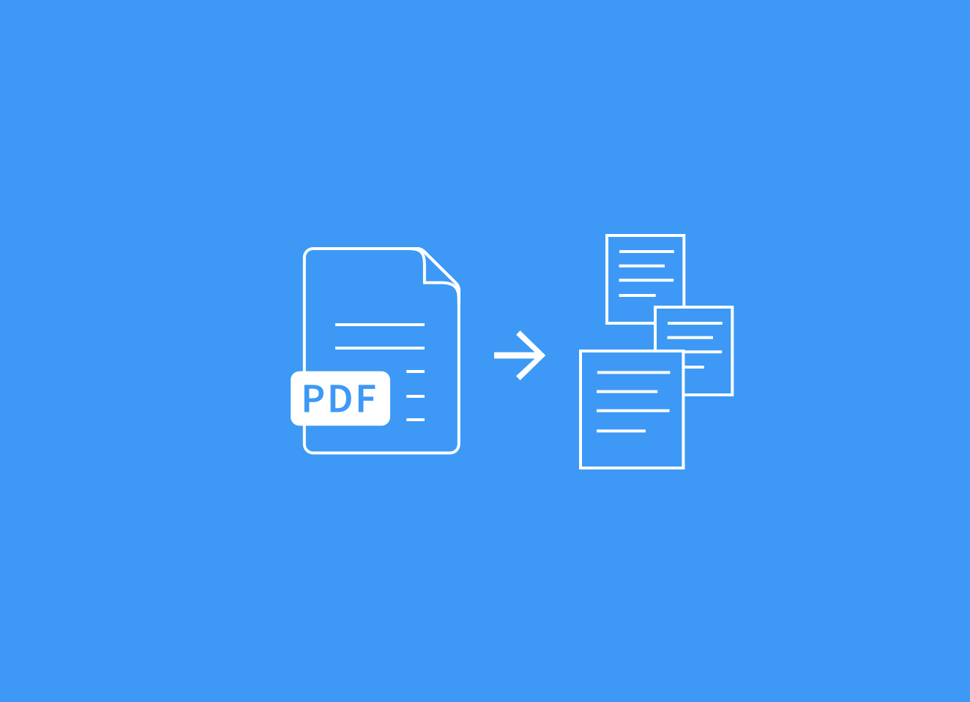

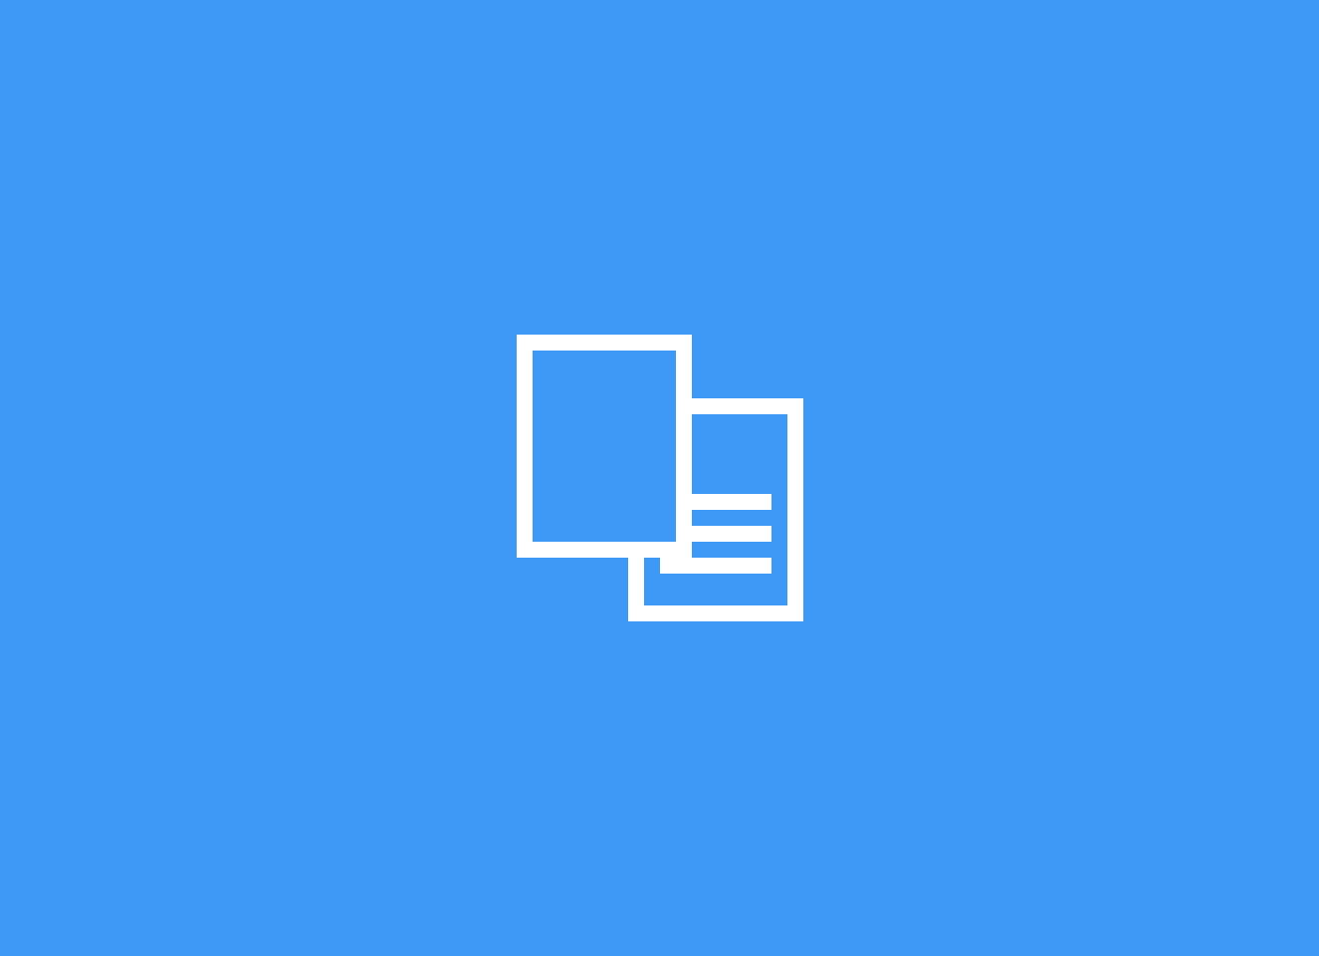
HOW TO CONVERT PDF TO WORD HOW TO CONVERT PDF TO WORD HOW TO CONVERT PDF TO WORD

PDF to Text: Convert PDF to Text Online for Free
Convert your PDF to text online for free in just a few clicks.
Extract and edit content quickly with no sign-up or sokware download needed.

How To Convert a Scanned PDF to Word Online
Convert scanned PDFs to editable Word files online with OCR. Upload from your device, Drive, Dropbox, or OneDrive and download a DOCX in seconds.

Convert PDF to Word on Mac for Free
Quickly convert PDF to Word documents on your MacBook for free without messing up formatting. No registration and no installation needed.



HOW TO CONVERT PDF TO WORD

How To Insert PDF Into Word
The easiest ways to insert a PDF into a Word document, either as an image or in an editable format, online or oﬀline.
HOW TO CONVERT PDF TO WORD

PDF2WORD—Convert PDF to Word Online for Free
You can use our PDF2WORD tool to save PDF documents into editable Word files seamlessly. Our online tool can process both scans and files created digitally.
HOW TO CONVERT PDF TO WORD

Online OCR for PDFs, Microsok Oﬀice Files, and Images
The Smallpdf online OCR converter can help you convert and process various file types to an editable document.

Show more articles

Compress Organize View & Edit

 Compress PDF Convert

PDF Converter
 Merge PDF  Split PDF

Rotate PDF
 Edit PDF

 PDF Annotator PDF Reader

AI PDF


 AI PDF Assistant  Chat with PDF

 AI PDF Summarizer  Translate PDF
AI Question Generator
 Delete PDF Pages  Extract PDF Pages Organize PDF
 Number Pages  Crop PDF

 Redact PDF  Watermark PDF
PDF Form Filler

 Share PDF
Convert from PDF Convert to PDF Sign


 PDF to Word  PDF to Excel  PDF to PPT
PDF to JPG
Word to PDF Excel to PDF PPT to PDF JPG to PDF

PDF OCR




More




Scan
Sign PDF

Request Signatures (Sign.com)

Unlock PDF Protect PDF Flatten PDF


PDF Scanner

We make PDF easy.

Solutions Sales Finance
Real Estate
Company About Help
Blog
Product Embed PDF Developers
Sign.com

Apps
Download Smallpdf PDF Scanner Windows App

Education PDF Statistics Compare Accessible PDF








Privacy Notice Terms & Conditions Imprint Contact Us  English

© 2026 Smallpdf AG — Made with for the people of the internet.

