SYNOPSIS

Project Group No: 175
Register No: 126006058 Name: Balaji M

Project Title: Vision-Based Hand Exercise Recognition and Feedback System for Rehabilitation
Name of the Guide: Dr. Nirmala Jegadeesan

Abstract
Hand paralysis is a common and life-altering complication experienced by stroke patients, often limiting their ability to perform daily activities independently. To address this issue, this project presents a vision-based hand exercise recognition and feedback system that supports rehabilitation without relying on wearable sensors. The proposed system uses a standard camera to capture hand movements and applies computer vision techniques for real-time hand landmark extraction. Using MediaPipe-based hand landmark detection, spatial features are extracted and classified using machine learning algorithms to recognize multiple predefined hand rehabilitation exercises, including wrist stretching, finger flexion, grip strengthening, thumb movements, and abduction–adduction motions. The system achieves high recognition accuracy while maintaining realtime performance. A hardware-based feedback module is integrated to provide real-time visual, auditory, and wireless feedback to the user, enhancing interaction and engagement during rehabilitation. The proposed system is non-invasive, and suitable for home-based rehabilitation environments. Experimental results demonstrate the effectiveness and reliability of the system for real-time hand exercise monitoring.

Specific Contribution
- Developed a vision-based hand exercise recognition system using OpenCV and MediaPipe for real-time hand tracking, Collected and organized a balanced dataset of 14 hand exercises with 100 images per class Implemented feature extraction using 21 hand landmarks (42 features) for accurate gesture representation.

- Trained and compared multiple ML models (KNN, Random Forest, XGBoost) and selected the best-performing model, Integrated real-time feedback system with custom UI and hardware components (Arduino, OLED, ESP8266, SD card), Designed a system that eliminates wearable sensors and provides low-cost rehabilitation support.
Specific Learning
- Gained practical knowledge in computer vision using OpenCV and MediaPipe, learned machine learning model training, evaluation metrics (Accuracy, Precision, Recall, F1-score), and model selection, Understood dataset creation, preprocessing, and feature normalization techniques.
- Acquired experience in real-time system development and inference, learned hardware-software integration using Arduino, ESP8266, and IoT platforms like Blynk, Developed skills in UI design for real-time monitoring and feedback systems.
Technical Limitations & Ethical Challenges faced
Technical Limitations:
- System performance is sensitive to lighting conditions and camera quality, requires proper hand positioning for accurate detection, difficulty in distinguishing similar gestures (e.g., flexion vs finger flexion), real-time processing may slightly vary depending on system performance, limited dataset size may affect generalization to diverse users.
Ethical Challenges:
- Ensuring user data privacy during image capture and processing, avoiding storage of personal or sensitive data, system should not replace professional medical advice or supervision, ensuring safe usage without encouraging incorrect or harmful movements.

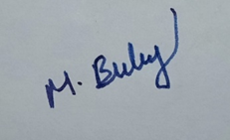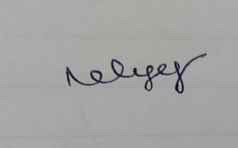
Signature of the Student Signature of Guide
Date: 27-04-2026

