**ECE – 6100**

**Cache Coherence**

**PROJECT REPORT**

**Balaji Mamidala**

**GTID - 903060531**

**Below I have attached the state-machines used to implement the protocols:**

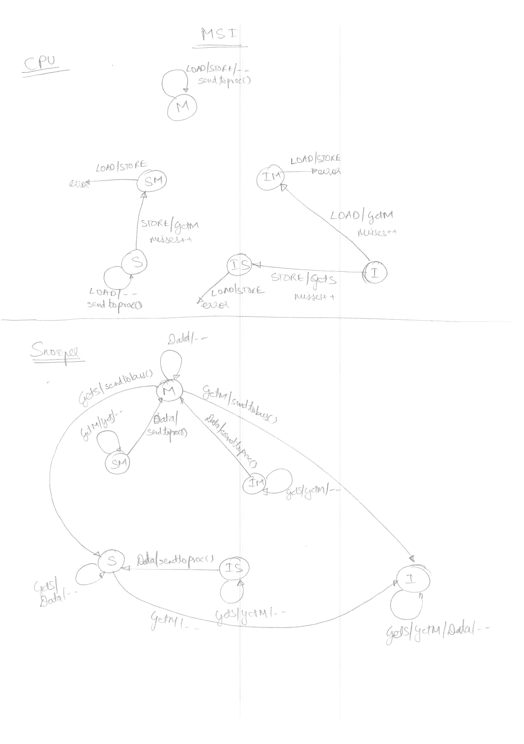

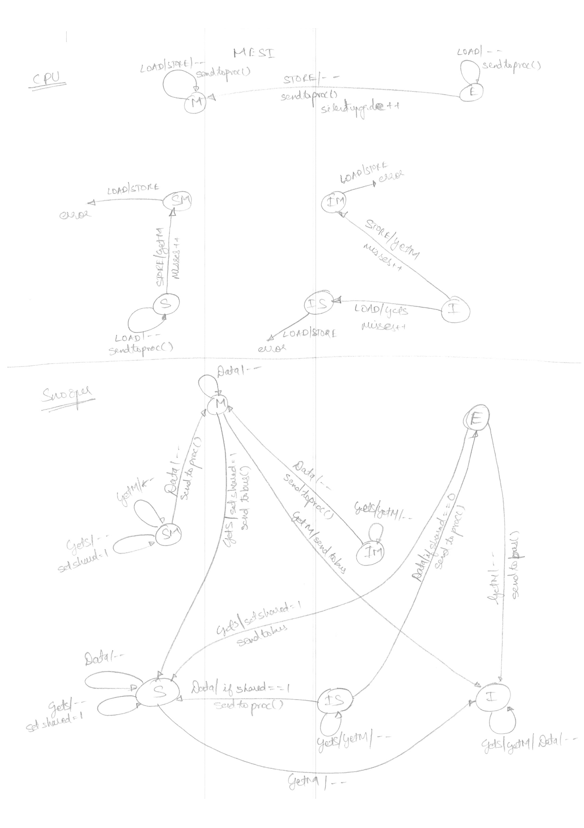

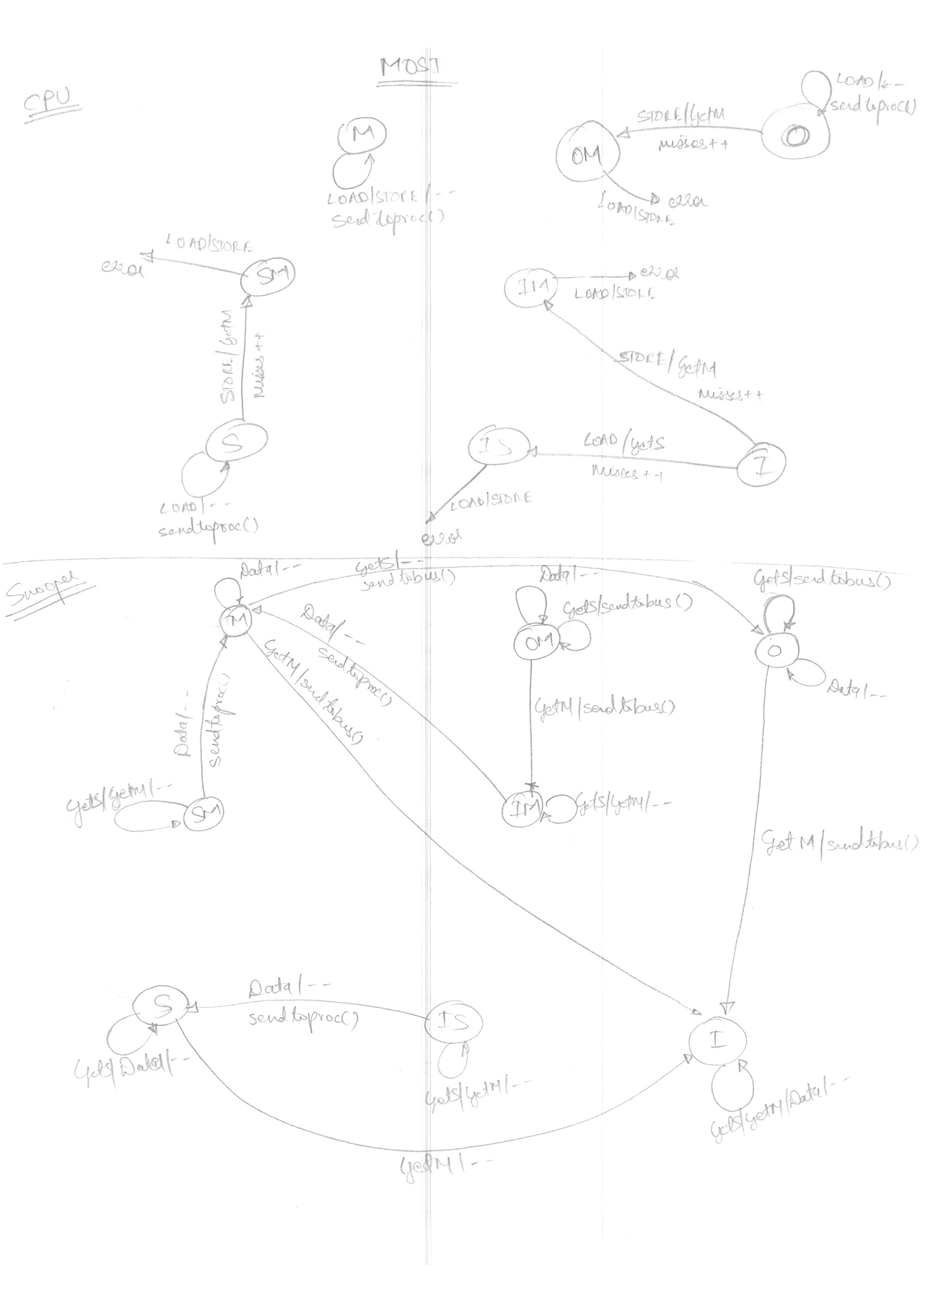

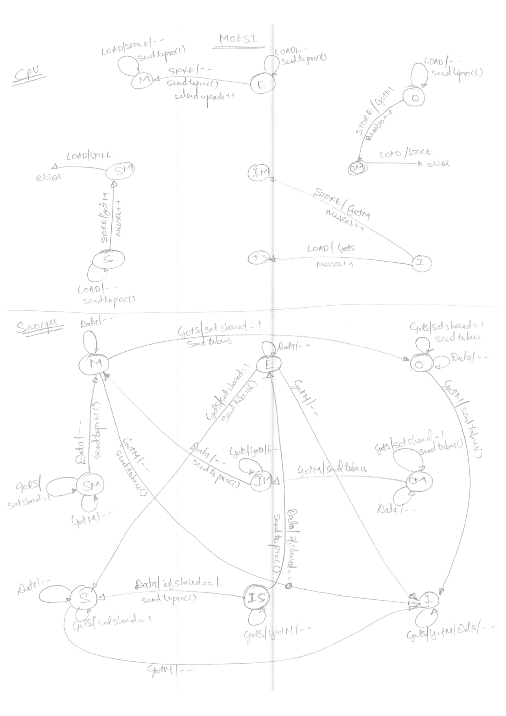

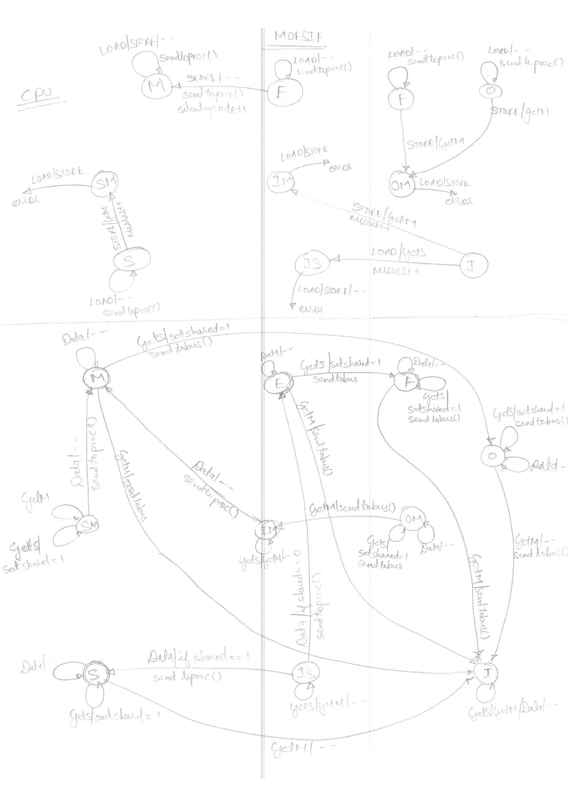

**EXPERIMENT#1**

|  |  |  |  |  |  |
| --- | --- | --- | --- | --- | --- |
| **Protocol** | **Run Time** | **Cache Misses** | **Cache Accesses** | **Silent upgrade** | **$-$ Transfers** |
| MI | 219 | 8 | 12 | 0 | 6 |
| MSI | 317 | 7 | 12 | 0 | 4 |
| MESI | 317 | 7 | 12 | 0 | 4 |
| MOSI | 217 | 7 | 12 | 0 | 5 |
| MOESI | 217 | 7 | 12 | 0 | 5 |
| MOESIF | 217 | 7 | 12 | 0 | 5 |

**Observations:**

1. MOSI protocol has the best run-time because of high $-$ transfers.
2. Performance of MSI is worse compared to MI as S-state does not allow $-$ transfers.
3. Adding Exclusive state to MSI doesn’t change the run-time. Thus, this trace doesn’t benefit from E-state which can be observed in the fact that MOESI and MOSI have the same run-time.
4. Adding owned state reduces run-time by increasing $-$ transfer by 1.
5. Adding F-state does not improve run-time.
6. As O gives significant improvement run-time this experiment might have write-shared property.

**EXPERIMENT#2**

|  |  |  |  |  |  |
| --- | --- | --- | --- | --- | --- |
| **Protocol** | **Run Time** | **Cache Misses** | **Cache Accesses** | **Silent upgrade** | **$-$ Transfers** |
| MI | 757 | 77 | 104 | 0 | 71 |
| MSI | 2367 | 30 | 104 | 0 | 7 |
| MESI | 2267 | 30 | 104 | 1 | 8 |
| MOSI | 1167 | 30 | 104 | 0 | 19 |
| MOESI | 975 | 31 | 104 | 1 | 22 |
| MOESIF | 683 | 34 | 104 | 1 | 28 |

**Observations:**

1. MOESIF protocol has the best run-time.
2. Performance of MSI is worse compared to MI as S-state does not allow $-$ transfers.
3. Adding Exclusive state to MSI doesn’t change the run-time drastically. Thus, this trace doesn’t benefit from E-state significantly which can be observed in the fact that MOESI and MOSI have very close run-time. Also, adding E-state only gives 1 silent upgrade hence the performance gain by adding E is not worth it.
4. Adding owned state reduces run-time significantly by increasing $-$ transfer. It can be observed in the fact that MSI had 7 $-$ transfers whereas MOSI had 19 $-$ transfers.
5. Adding F-state provides improvement in run-time by increasing $-$ transfers by 6.
6. Thus, MI requires very little states but gives very good performance. But MI also produces very large $-$ transfers. MOESIF has just 28 $-$ transfers and produces best performance. However, we could have eliminated E-state and had MOSIF as E-doesn’t add much performance. Note that adding more $-$ transfer increases the traffic on bus.
7. As O and E provide significant improvement this experiment probably has write-shared and read-only patterns.

**EXPERIMENT#3**

|  |  |  |  |  |  |
| --- | --- | --- | --- | --- | --- |
| **Protocol** | **Run Time** | **Cache Misses** | **Cache Accesses** | **Silent upgrade** | **$-$ Transfers** |
| MI | 1427 | 49 | 200 | 0 | 36 |
| MSI | 3723 | 56 | 200 | 0 | 20 |
| MESI | 2607 | 48 | 200 | 8 | 23 |
| MOSI | 3723 | 56 | 200 | 0 | 20 |
| MOESI | 2607 | 48 | 200 | 8 | 23 |
| MOESIF | 1425 | 48 | 200 | 8 | 35 |

**Observations:**

1. MI and MOESIF protocol has the best run-time.
2. Performance of MSI is worse compared to MI as S-state does not allow $-$ transfers.
3. Adding owned state to MSI doesn’t change the run-time drastically. Thus, this trace doesn’t benefit from O-state significantly which can be observed in the fact that MOESI and MESI have very close run-time.
4. Adding exclusive state reduces run-time significantly by increasing silent upgrades. It can be observed in the fact that adding E-state gives 8 silent upgrade.
5. Adding F-state provides significant improvement in run-time by increasing $-$ transfers by 12.
6. Thus, MI requires very little states but gives very good performance. Both MI and MOESIF produce roughly equal $-$ transfers, hence, MI is the best suited protocol for this experiment.
7. As E and F provide significant improvement this experiment probably has private and read-only patterns.

**EXPERIMENT#4**

|  |  |  |  |  |  |
| --- | --- | --- | --- | --- | --- |
| **Protocol** | **Run Time** | **Cache Misses** | **Cache Accesses** | **Silent upgrade** | **$-$ Transfers** |
| MI | 569 | 31 | 60 | 0 | 26 |
| MSI | 2265 | 27 | 60 | 0 | 5 |
| MESI | 1447 | 19 | 60 | 3 | 5 |
| MOSI | 1869 | 29 | 60 | 0 | 11 |
| MOESI | 851 | 19 | 60 | 3 | 11 |
| MOESIF | 551 | 19 | 60 | 3 | 14 |

**Observations:**

1. MI and MOESIF protocol has the best run-time. However, MI produces 26 $-$ transfers compared to 14 $-$ transfers in MOESIF protocol. Thus, if we are concerned about bus traffic then we should choose MOESIF protocol for this experiment.
2. Performance of MSI is worse compared to MI as S-state does not allow $-$ transfers.
3. Adding owned state reduces run-time significantly by increasing $-$ transfer. It can be observed in the fact that MSI had 5 $-$ transfers whereas MOSI had 11 $-$ transfers.
4. Adding exclusive state reduces run-time significantly by increasing silent upgrades. It can be observed in the fact that adding E-state gives 3 silent upgrade.
5. Adding F-state provides significant improvement in run-time by increasing $-$ transfers by 3.
6. In this experiment O, E and F states provide significant improvement in performance making MOESIF a justifiable choice.
7. As O, E and F provide significant improvement this experiment probably has write-shared and read-only and private patterns.

**EXPERIMENT#5**

|  |  |  |  |  |  |
| --- | --- | --- | --- | --- | --- |
| **Protocol** | **Run Time** | **Cache Misses** | **Cache Accesses** | **Silent upgrade** | **$-$ Transfers** |
| MI | 465 | 23 | 37 | 0 | 19 |
| MSI | 1661 | 21 | 37 | 0 | 5 |
| MESI | 1561 | 21 | 37 | 0 | 6 |
| MOSI | 1261 | 21 | 37 | 0 | 9 |
| MOESI | 1161 | 21 | 37 | 0 | 10 |
| MOESIF | 461 | 21 | 37 | 0 | 17 |

**Observations:**

1. MI and MOESIF protocol has the best run-time. Both MI and MOESIF produce roughly equal $-$ transfers, hence, MI is the best suited protocol for this experiment.
2. Performance of MSI is worse compared to MI as S-state does not allow $-$ transfers.
3. Adding owned and exclusive states improves performance by increasing $-$ transfers.
4. However, adding F-state provides significant improvement in run-time by increasing $-$ transfers by 7.
5. Thus MI is the best choice for this experiment.
6. As there is heavy dependent on F this experiment has read-only sharing pattern.

**EXPERIMENT#6**

|  |  |  |  |  |  |
| --- | --- | --- | --- | --- | --- |
| **Protocol** | **Run Time** | **Cache Misses** | **Cache Accesses** | **Silent upgrade** | **$-$ Transfers** |
| MI | 3307 | 190 | 747 | 0 | 161 |
| MSI | 7775 | 87 | 747 | 0 | 12 |
| MESI | 4925 | 62 | 747 | 25 | 15 |
| MOSI | 6975 | 87 | 747 | 0 | 20 |
| MOESI | 4125 | 62 | 747 | 25 | 23 |
| MOESIF | 3125 | 62 | 747 | 25 | 33 |

**Observations:**

1. MI and MOESIF protocol has the best run-time. However, MI produces 161 $-$ transfers compared to 33 $-$ transfers in MOESIF protocol. Thus, we should choose MOESIF protocol for this experiment as MI will cause a huge increase in bus traffic.
2. Performance of MSI is worse compared to MI as S-state does not allow $-$ transfers.
3. Adding owned state reduces run-time by increasing $-$ transfer. It can be observed in the fact that MSI had 12 $-$ transfers whereas MOSI had 20 $-$ transfers. However, adding E-state results in better performance compared to O-state for this experiment.
4. Adding exclusive state reduces run-time significantly by increasing silent upgrades. It can be observed in the fact that adding E-state gives 25 silent upgrade.
5. Adding F-state provides significant improvement in run-time by increasing $-$ transfers by 10.
6. In this experiment O, E and F states provide significant improvement in performance making MOESIF a justifiable choice.
7. As E and F provides significant improvement this experiment probably has private and read-only pattern.

**EXPERIMENT#7**

|  |  |  |  |  |  |
| --- | --- | --- | --- | --- | --- |
| **Protocol** | **Run Time** | **Cache Misses** | **Cache Accesses** | **Silent upgrade** | **$-$ Transfers** |
| MI | 3053 | 150 | 952 | 0 | 123 |
| MSI | 6459 | 79 | 952 | 0 | 17 |
| MESI | 3993 | 55 | 952 | 24 | 17 |
| MOSI | 5359 | 79 | 952 | 0 | 28 |
| MOESI | 2909 | 55 | 952 | 24 | 28 |
| MOESIF | 2909 | 55 | 952 | 24 | 28 |

**Observations:**

1. MI, MOESI and MOESIF protocols have the best run-time. However, MI produces 123 $-$ transfers compared to 28 $-$ transfers in MOESI and MOESIF protocols. Thus, we should choose MOESI protocol for this experiment as MI will cause a huge increase in bus traffic.
2. Performance of MSI is worse compared to MI as S-state does not allow $-$ transfers.
3. Adding owned state reduces run-time by increasing $-$ transfer. It can be observed in the fact that MSI had 17 $-$ transfers whereas MOSI had 28 $-$ transfers. However, adding E-state results in better performance compared to O-state for this experiment.
4. Adding exclusive state reduces run-time significantly by increasing silent upgrades. It can be observed in the fact that adding E-state gives 24 silent upgrade.
5. Adding F-state provides no improvement in run-time.
6. In this experiment O and E states provide significant improvement in performance making MOESI a justifiable choice.
7. As O and E provides significant improvement this experiment probably has private and write-shared pattern.

**EXPERIMENT#8**

|  |  |  |  |  |  |
| --- | --- | --- | --- | --- | --- |
| **Protocol** | **Run Time** | **Cache Misses** | **Cache Accesses** | **Silent upgrade** | **$-$ Transfers** |
| MI | 4193 | 118 | 800 | 0 | 79 |
| MSI | 9477 | 110 | 800 | 0 | 18 |
| MESI | 6441 | 92 | 800 | 19 | 30 |
| MOSI | 8477 | 110 | 800 | 0 | 28 |
| MOESI | 5241 | 92 | 800 | 19 | 42 |
| MOESIF | 4141 | 92 | 800 | 19 | 53 |

**Observations:**

1. MI, MOESI and MOESIF protocols have the best run-time. However, MI produces 79 $-$ transfers compared to 53 $-$ transfers in MOESIF protocols. Thus, we should choose MOESIF protocol for this experiment as MI will cause a huge increase in bus traffic.
2. Performance of MSI is worse compared to MI as S-state does not allow $-$ transfers.
3. Adding owned state reduces run-time by increasing $-$ transfer. It can be observed in the fact that MSI had 18 $-$ transfers whereas MOSI had 28 $-$ transfers. However, adding E-state results in better performance compared to O-state for this experiment.
4. Adding exclusive state reduces run-time significantly by increasing silent upgrades. It can be observed in the fact that adding E-state gives 19 silent upgrade.
5. Adding F-state provides significant improvement in run-time by increasing $-$ transfers by 11.
6. In this experiment E and F states provide significant improvement in performance making MOESIF a justifiable choice.
7. As E and F provides significant improvement this experiment probably has private and read-only pattern.

**Inferences:**

Below table summarizes experimentation results:

|  |  |  |
| --- | --- | --- |
| **Experiment#** | **Best suited protocol** | **Possible Sharing Pattern** |
| 1 | MOSI | write-shared |
| 2 | MOESIF | write-shared and read-only |
| 3 | MI | private and read-only |
| 4 | MOESIF | write-shared, read-only and private patterns |
| 5 | MI | read-only |
| 6 | MOESIF | private and read-only |
| 7 | MOESI | private and write-shared |
| 8 | MOESIF | private and read-only |