Question and Response:

- What is Encoder?

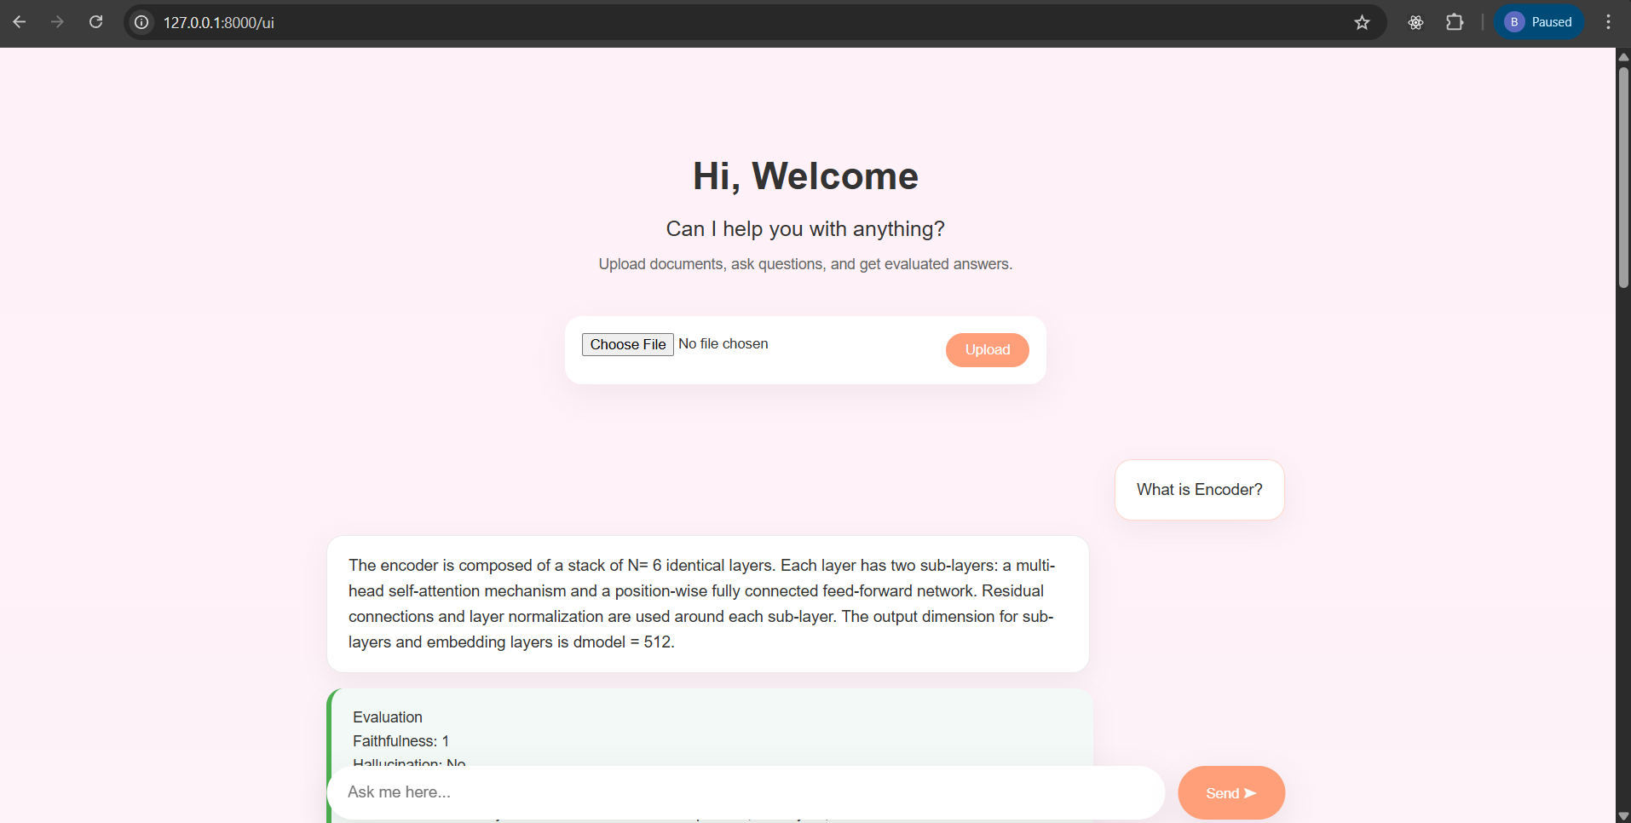

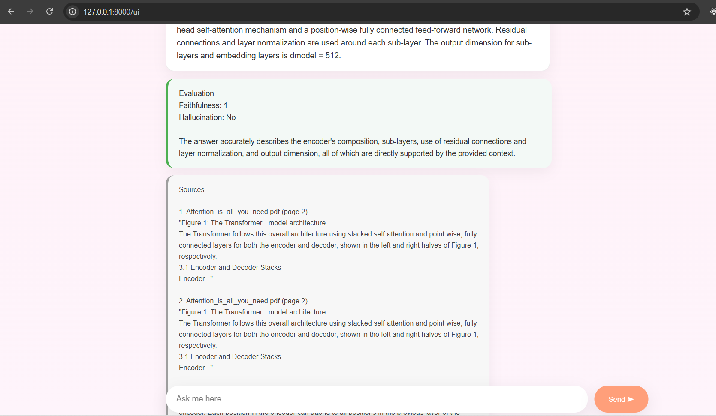

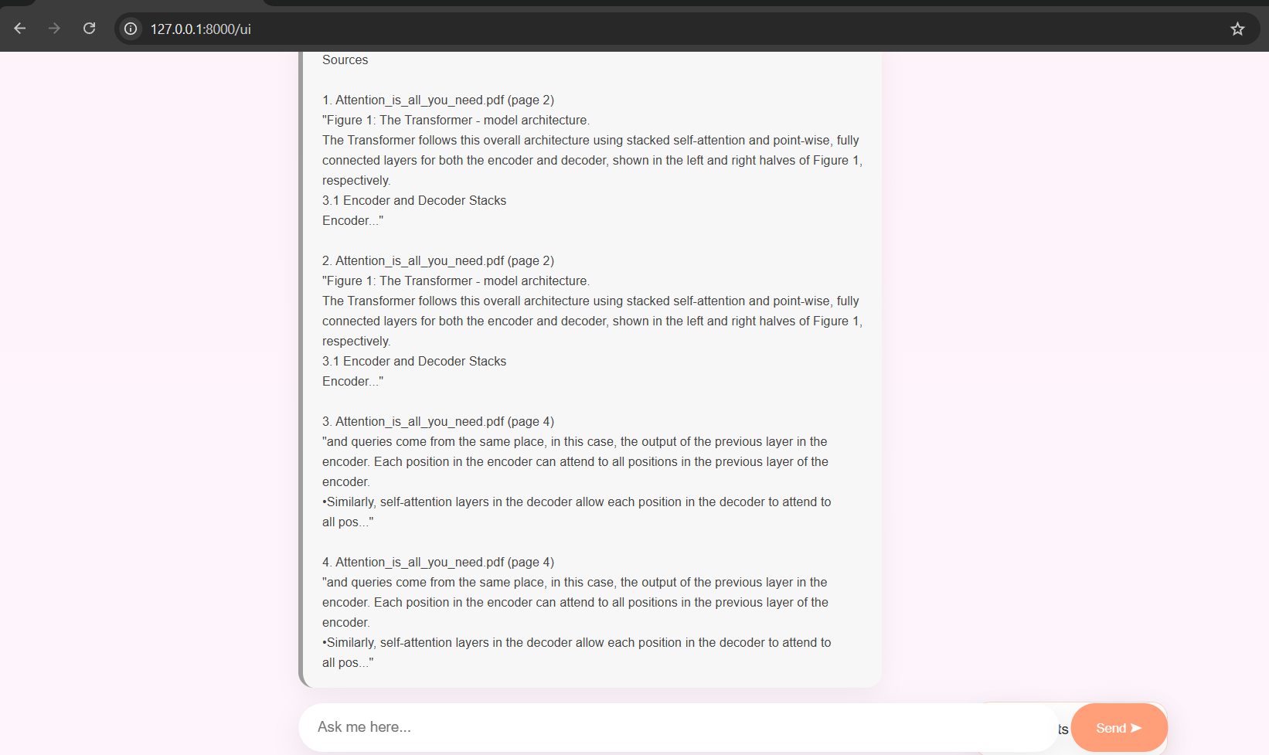

- what are its sub-layers?
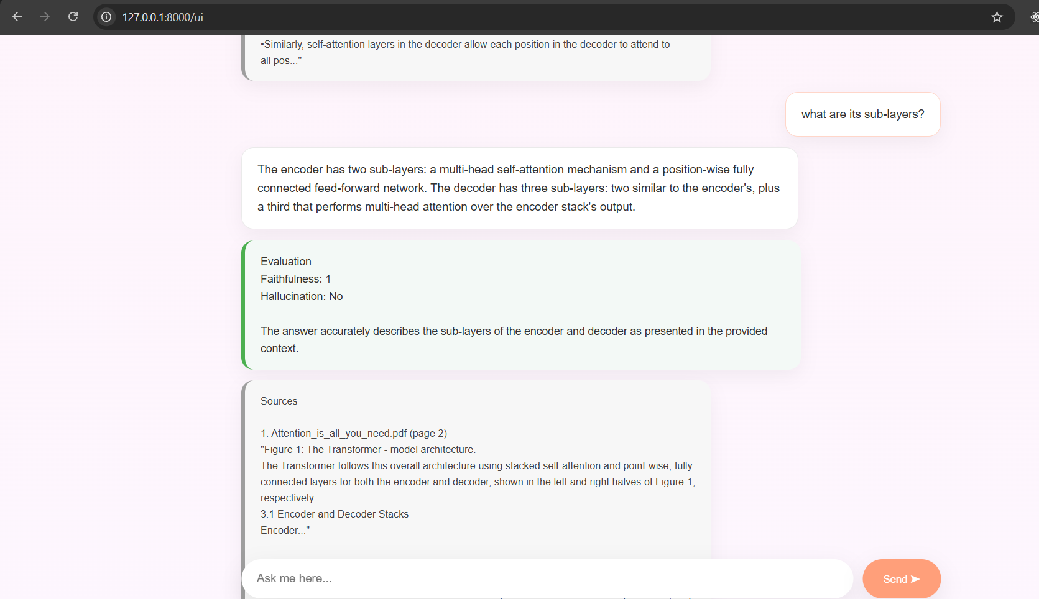

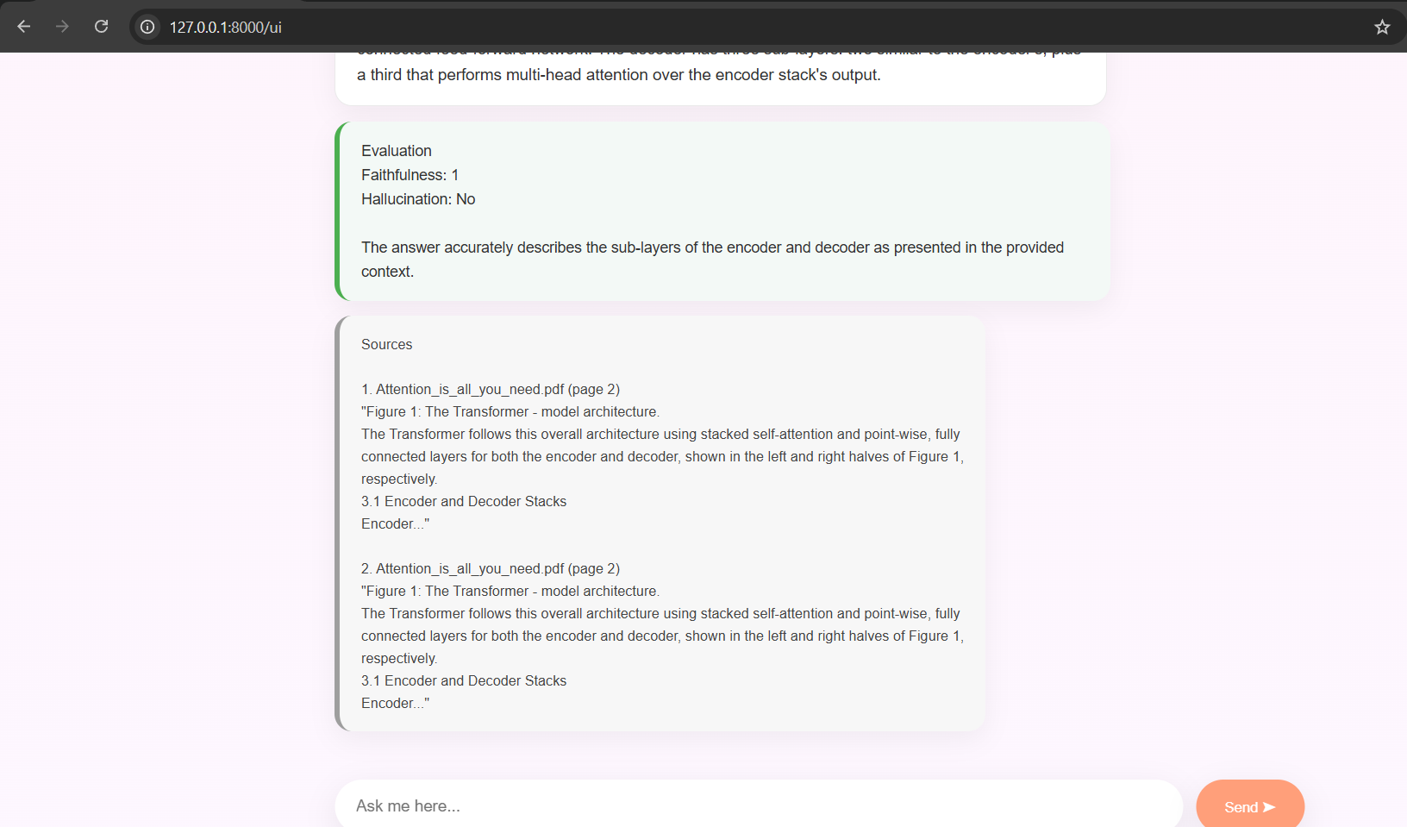

- What is the weather in Dublin today?
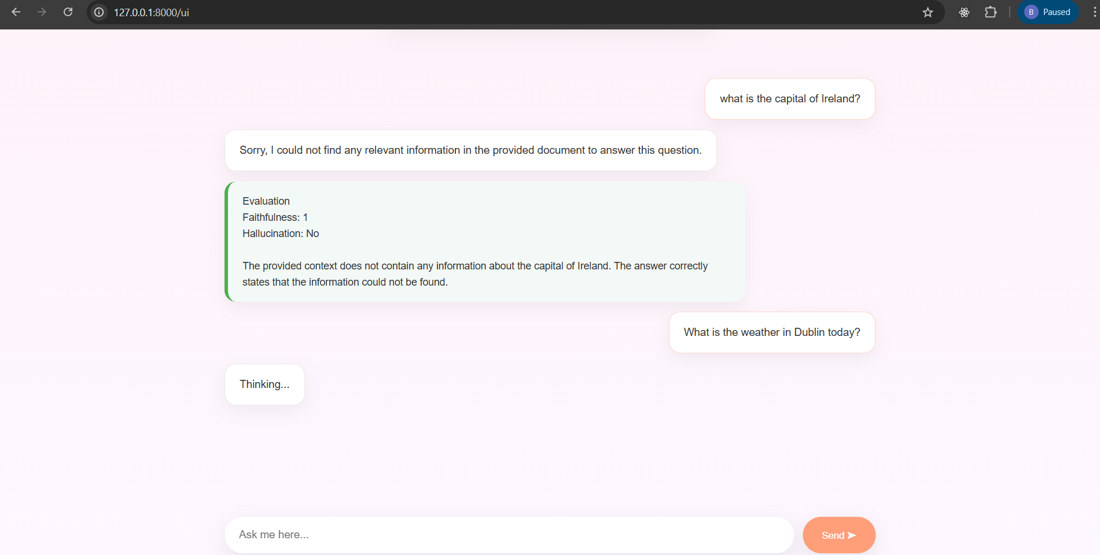

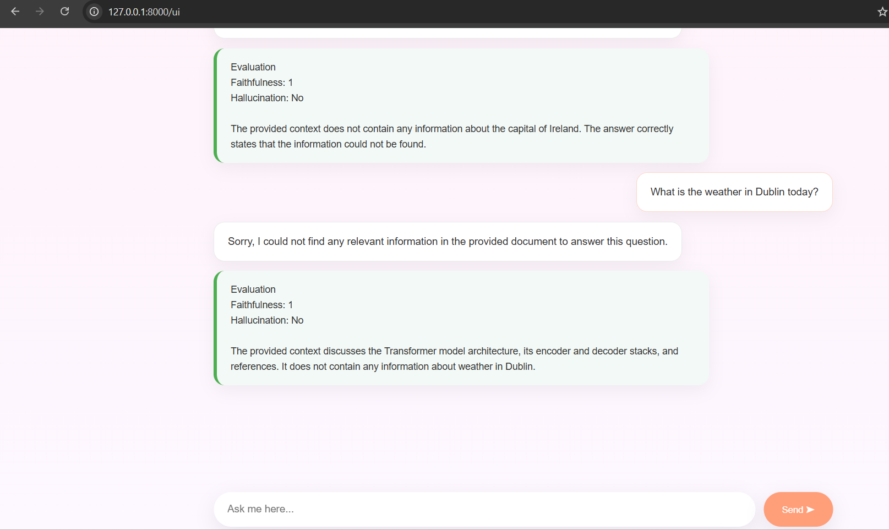

- Give me a 4 point summary for EU AI ACT

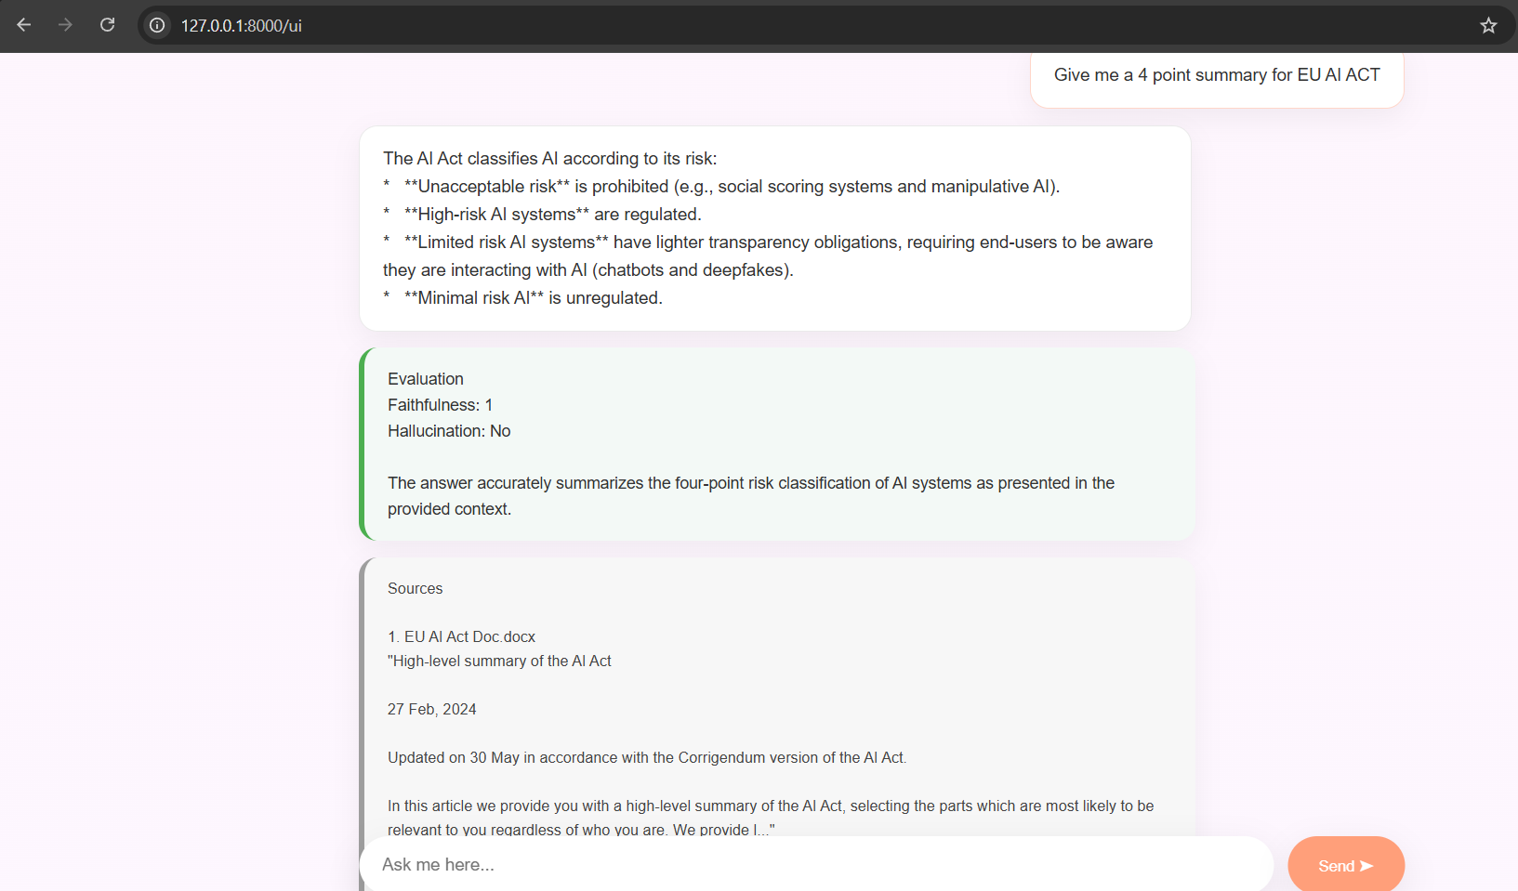

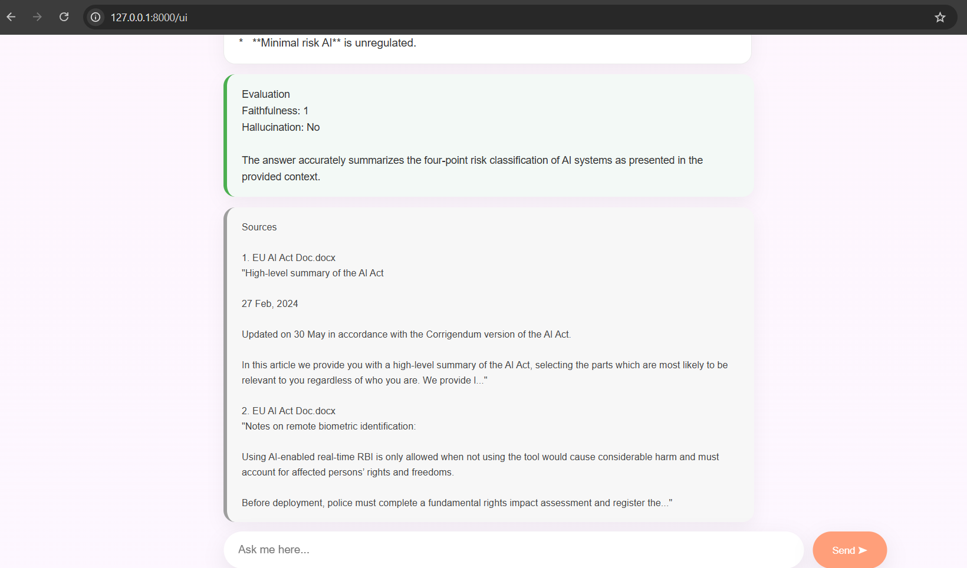

- what is the capital of Ireland?
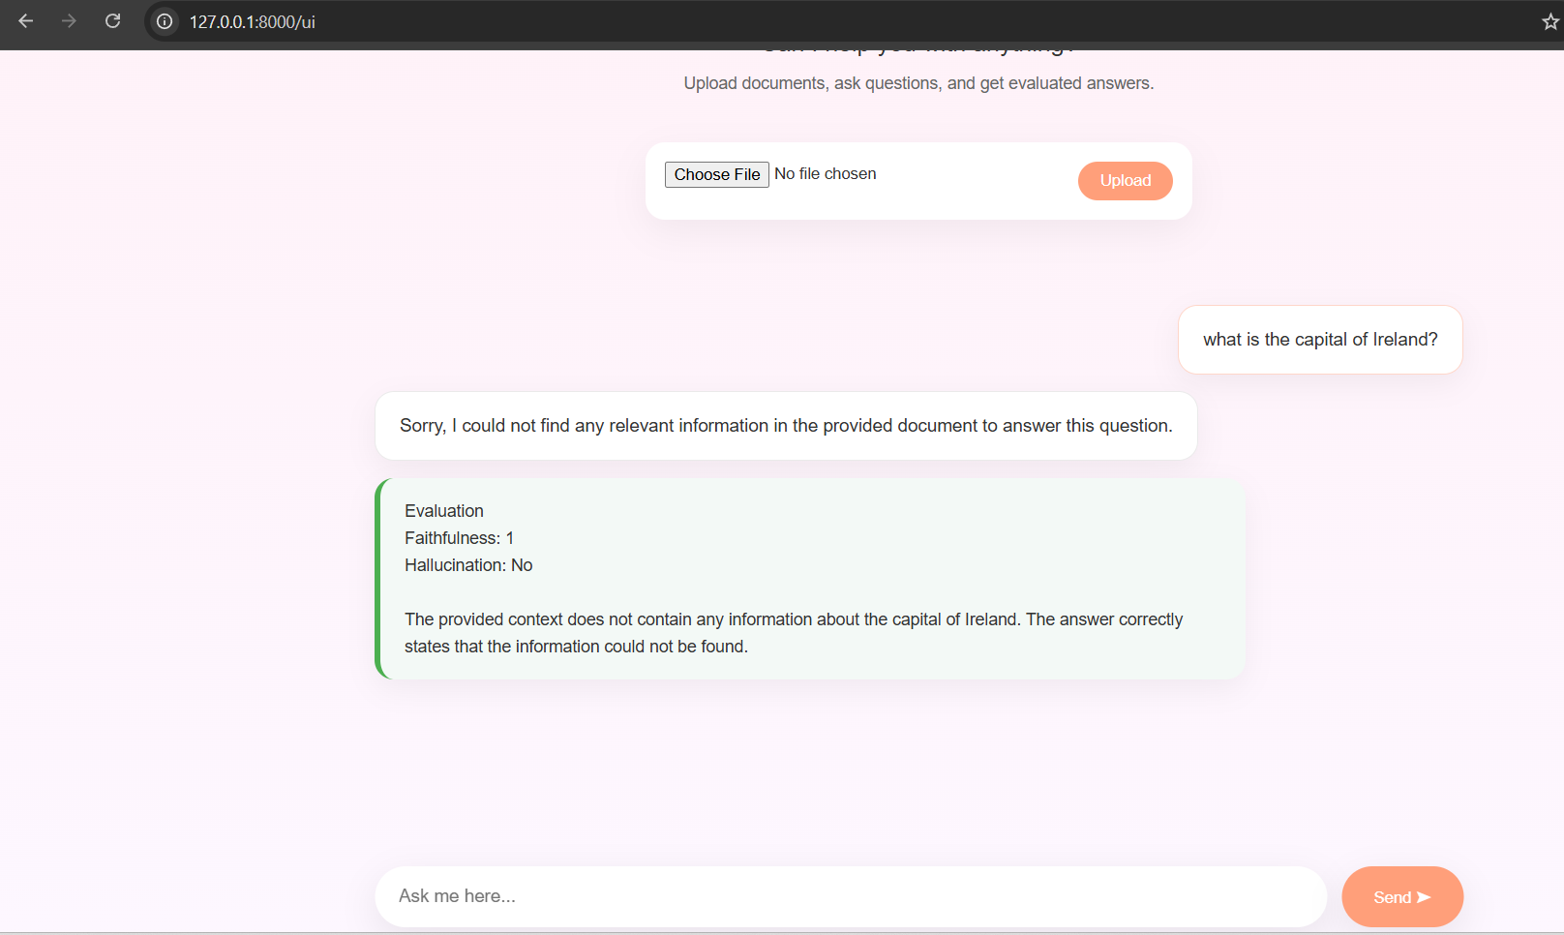

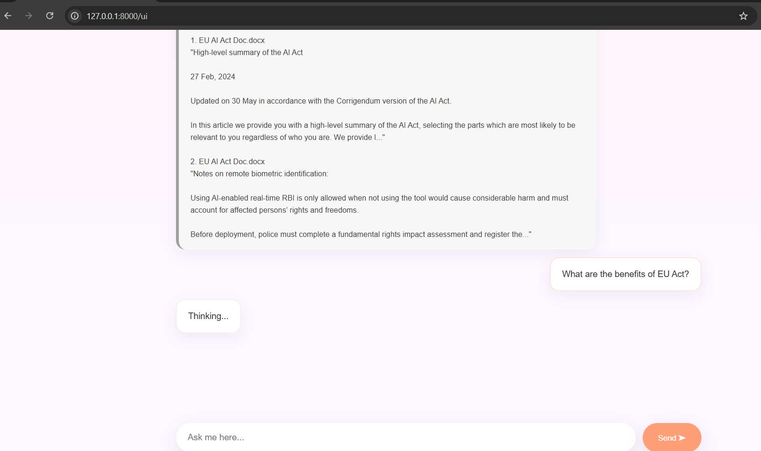

- Uploading the document:
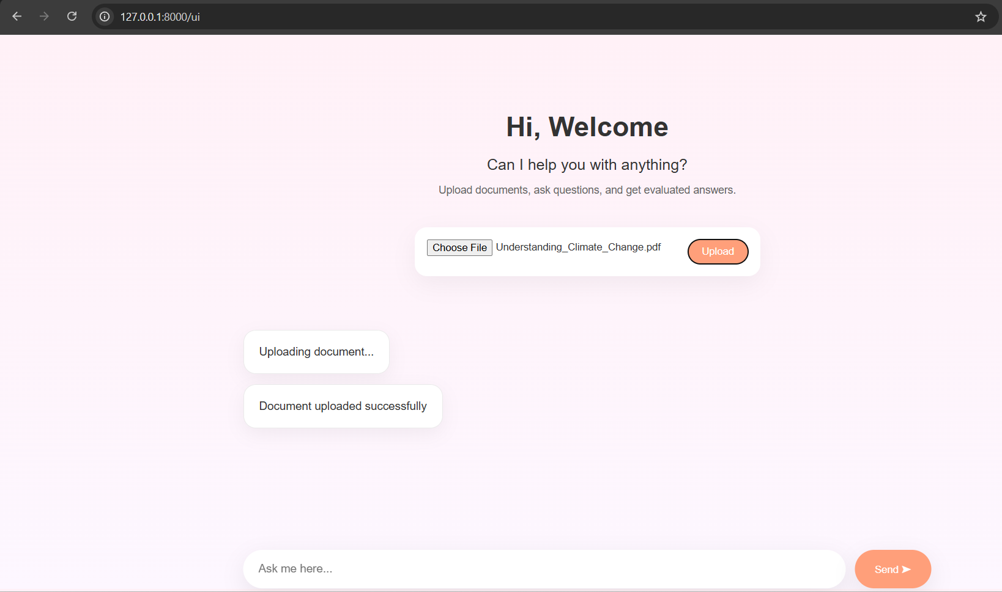

- Ambiguity Test:

Uploaded two documents.
Doc-A has “Sun rises in the east” and
Doc-B has “Sun rises in the west”.

When I ask “where does the sun rises?” it says,
“The provided documents contain conflicting information regarding the direction of the sunrise.
One document states: "Sun rises in the East".
Another document states: "Sun rises in t he west."
Therefore, the answer is ambiguous or disputed.”

