Component Size: 15

Classifier: Decision Trees

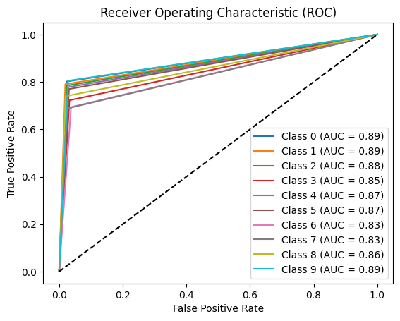

--------------------------------

Accuracy: 0.75732421875

Precision: 0.7575683712516268

Recall: 0.7573372249211566

F1-Score: 0.756865691644494

Confusion Matrix:

[[170 15 5 1 1 5 6 2 4 3]

[ 9 151 8 5 1 4 1 1 6 5]

[ 9 1 160 5 5 6 3 2 8 5]

[ 1 5 8 164 6 10 13 12 3 5]

[ 2 1 5 6 147 14 6 1 2 5]

[ 1 3 4 16 12 164 3 1 6 3]

[ 2 2 1 5 8 5 127 18 4 11]

[ 4 2 6 19 2 3 24 141 0 4]

[ 8 5 6 2 6 8 7 4 162 11]

[ 8 2 0 0 12 2 7 5 4 165]]

--------------------------------

Classifier: Random Forest

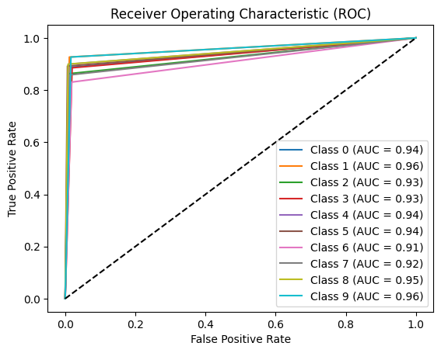

--------------------------------

Accuracy: 0.88720703125

Precision: 0.8882486430148288

Recall: 0.88720703125

F1-Score: 0.8873594160282301

Confusion Matrix:

[[188 10 3 1 0 0 1 1 3 5]

[ 7 177 0 2 1 1 1 1 0 1]

[ 5 4 176 8 2 0 2 0 4 3]

[ 1 3 4 201 1 1 9 5 0 2]

[ 0 0 0 2 170 4 4 1 2 6]

[ 0 1 1 10 7 190 1 0 2 1]

[ 2 0 1 7 2 3 152 12 1 3]

[ 2 2 8 5 0 0 10 176 0 2]

[ 3 2 0 1 3 3 1 2 197 7]

[ 0 0 0 0 2 0 5 5 3 190]]

--------------------------------

Classifier: Naive Bayes

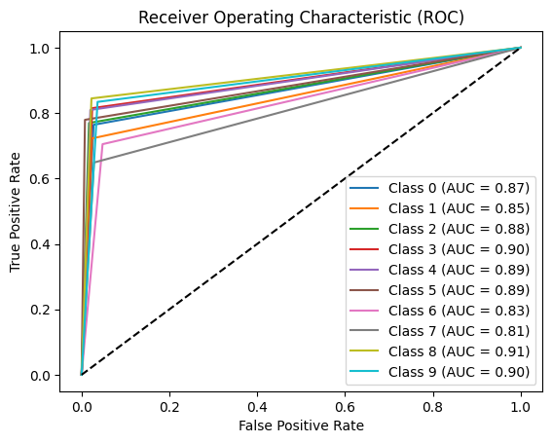

--------------------------------

Accuracy: 0.77099609375

Precision: 0.7770631954483078

Recall: 0.77099609375

F1-Score: 0.772155593599511

Confusion Matrix:

[[162 21 0 1 0 0 5 0 7 16]

[ 21 138 7 2 1 0 5 6 6 5]

[ 10 6 157 7 3 0 4 3 9 5]

[ 1 1 7 185 2 0 22 9 0 0]

[ 0 0 2 3 153 10 6 1 3 11]

[ 0 6 4 13 16 166 5 1 2 0]

[ 4 1 3 8 11 0 129 23 1 3]

[ 3 5 5 9 0 0 33 133 3 14]

[ 7 2 3 1 2 4 1 1 185 13]

[ 4 2 0 0 2 0 8 8 10 171]]

--------------------------------

Classifier: K-NN Classifier

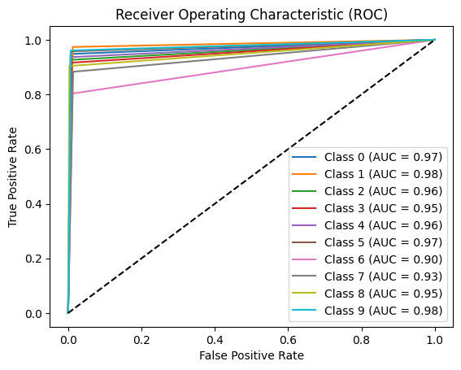

--------------------------------

Accuracy: 0.921875

Precision: 0.9221071492651752

Recall: 0.921875

F1-Score: 0.9215336361746722

Confusion Matrix:

[[201 8 1 0 0 0 0 0 1 1]

[ 1 186 0 2 1 1 0 0 0 0]

[ 4 2 189 0 1 2 3 0 1 2]

[ 1 4 2 208 2 1 5 3 0 1]

[ 2 1 0 1 177 5 1 0 0 2]

[ 0 1 1 3 3 204 1 0 0 0]

[ 0 2 1 8 2 1 147 21 1 0]

[ 1 3 7 3 2 0 8 181 0 0]

[ 2 2 1 1 2 5 1 0 198 7]

[ 1 0 0 0 0 0 3 1 3 197]]

--------------------------------

Classifier: SVM

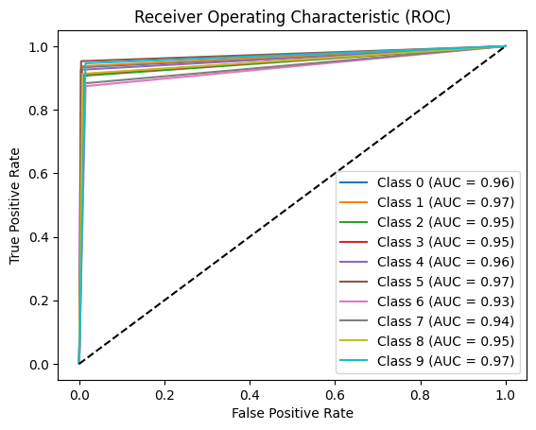

--------------------------------

Accuracy: 0.9189453125

Precision: 0.9196699893130049

Recall: 0.9189453125

F1-Score: 0.9190888162696864

Confusion Matrix:

[[198 4 3 0 0 0 0 0 2 5]

[ 5 179 2 1 0 0 2 1 1 0]

[ 4 1 185 3 2 0 1 0 5 3]

[ 1 0 3 207 1 0 9 5 0 1]

[ 1 1 0 1 175 3 3 0 0 5]

[ 0 0 2 5 0 203 2 0 1 0]

[ 0 0 1 8 2 1 160 8 1 2]

[ 0 4 5 4 0 1 6 181 2 2]

[ 1 2 0 1 2 3 1 0 200 9]

[ 1 0 0 0 0 0 4 4 2 194]]

--------------------------------

Component Size: 20

Classifier: Decision Trees

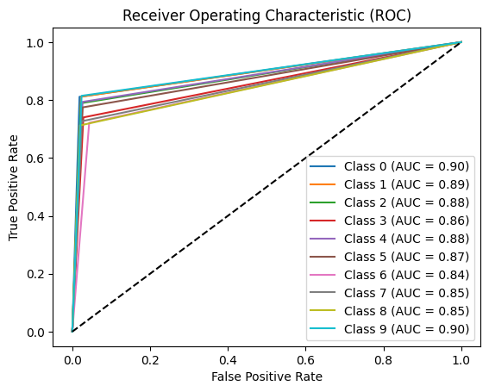

--------------------------------

Accuracy: 0.76904296875

Precision: 0.769894517626383

Recall: 0.76955452094677

F1-Score: 0.7688289017471215

Confusion Matrix:

[[172 15 3 3 2 2 1 3 8 3]

[ 9 155 8 5 3 4 3 2 1 1]

[ 7 6 161 7 5 3 7 0 6 2]

[ 3 6 7 168 4 12 18 8 1 0]

[ 0 1 0 4 150 14 7 1 4 8]

[ 1 0 4 14 16 165 4 2 3 4]

[ 1 3 2 6 6 2 132 22 3 6]

[ 3 3 6 11 3 2 22 149 1 5]

[ 6 6 10 1 5 9 5 6 156 15]

[ 4 2 1 1 5 1 14 1 9 167]]

--------------------------------

Classifier: Random Forest

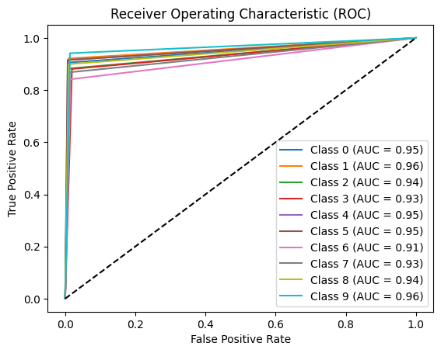

--------------------------------

Accuracy: 0.8974609375

Precision: 0.8978798258399832

Recall: 0.8974609375

F1-Score: 0.8974889546289782

Confusion Matrix:

[[192 8 2 1 0 0 0 0 5 4]

[ 7 176 0 4 1 0 0 2 0 1]

[ 5 3 180 9 0 1 2 0 2 2]

[ 1 2 6 200 2 1 8 6 0 1]

[ 0 0 0 2 173 4 2 1 3 4]

[ 0 2 0 6 6 195 2 0 2 0]

[ 2 0 1 7 2 3 154 10 1 3]

[ 1 1 6 5 0 2 9 178 2 1]

[ 3 1 2 1 2 2 1 1 197 9]

[ 0 1 0 0 1 0 4 3 3 193]]

--------------------------------

Classifier: Naive Bayes

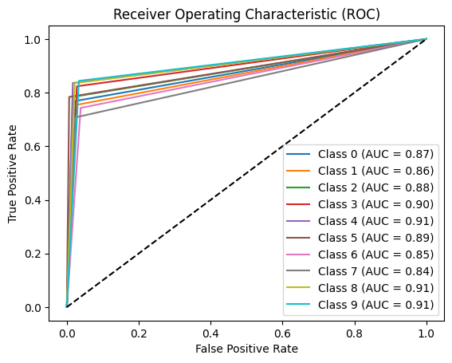

--------------------------------

Accuracy: 0.7890625

Precision: 0.7940178278727051

Recall: 0.7890625

F1-Score: 0.7899330644998067

Confusion Matrix:

[[163 17 2 0 0 0 4 2 8 16]

[ 18 144 7 4 1 0 3 4 6 4]

[ 6 10 160 7 3 0 6 0 9 3]

[ 1 1 7 187 2 0 17 10 0 2]

[ 0 1 1 4 158 6 3 2 4 10]

[ 1 7 2 14 12 167 6 1 3 0]

[ 4 1 2 8 9 1 136 16 2 4]

[ 3 5 6 12 0 1 20 145 2 11]

[ 8 3 4 1 3 4 1 0 183 12]

[ 3 2 0 1 1 0 12 7 6 173]]

--------------------------------

Classifier: K-NN Classifier

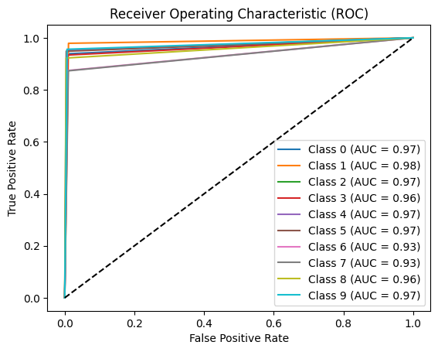

--------------------------------

Accuracy: 0.93310546875

Precision: 0.9333527475870238

Recall: 0.93310546875

F1-Score: 0.9329573487258566

Confusion Matrix:

[[199 7 0 0 0 0 0 1 3 2]

[ 0 187 1 0 1 1 0 1 0 0]

[ 3 1 194 1 3 0 1 0 1 0]

[ 2 2 2 212 3 1 0 5 0 0]

[ 3 1 0 1 180 2 0 0 0 2]

[ 0 1 0 3 4 202 3 0 0 0]

[ 0 0 2 7 1 0 160 11 0 2]

[ 0 5 6 3 1 1 10 179 0 0]

[ 3 3 0 1 1 3 0 0 202 6]

[ 2 0 0 0 0 0 3 1 3 196]]

--------------------------------

Classifier: SVM

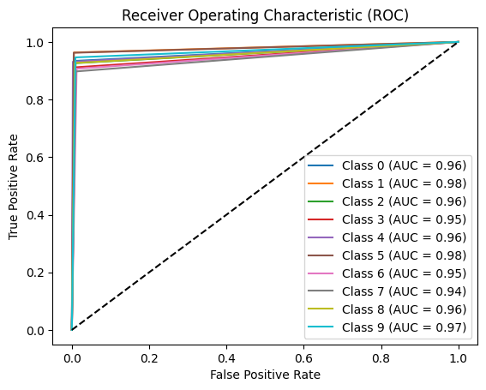

--------------------------------

Accuracy: 0.9306640625

Precision: 0.9310126615002489

Recall: 0.9306640625

F1-Score: 0.9307286596859029

Confusion Matrix:

[[198 4 3 1 0 0 0 0 3 3]

[ 3 184 1 1 0 0 0 2 0 0]

[ 3 1 189 3 1 0 1 0 4 2]

[ 1 0 4 207 1 1 8 5 0 0]

[ 0 1 0 1 176 4 1 0 1 5]

[ 0 0 1 4 0 205 2 0 1 0]

[ 0 0 1 6 0 1 166 7 1 1]

[ 1 2 5 1 0 1 8 184 2 1]

[ 1 2 3 0 2 2 0 1 203 5]

[ 1 0 0 0 1 0 3 4 2 194]]

--------------------------------

Component Size: 25

Classifier: Decision Trees

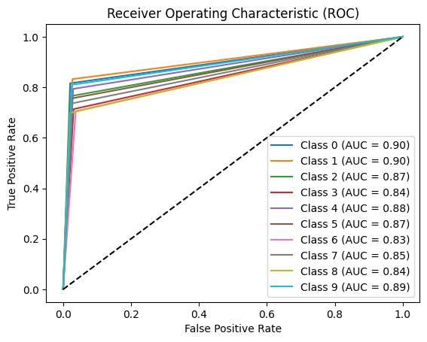

--------------------------------

Accuracy: 0.76171875

Precision: 0.7616711232455518

Recall: 0.7626269710291042

F1-Score: 0.7612424338154699

Confusion Matrix:

[[173 17 2 1 0 2 3 2 10 2]

[ 6 159 4 7 0 4 1 2 4 4]

[ 10 4 156 11 5 4 5 2 3 4]

[ 4 8 9 162 3 14 9 12 2 4]

[ 0 3 2 4 150 11 8 3 1 7]

[ 1 4 3 11 20 161 2 4 5 2]

[ 4 2 0 8 4 2 129 22 2 10]

[ 3 3 7 10 4 2 21 151 1 3]

[ 9 9 10 3 10 5 7 2 153 11]

[ 1 1 3 1 9 1 13 1 9 166]]

--------------------------------

Classifier: Random Forest

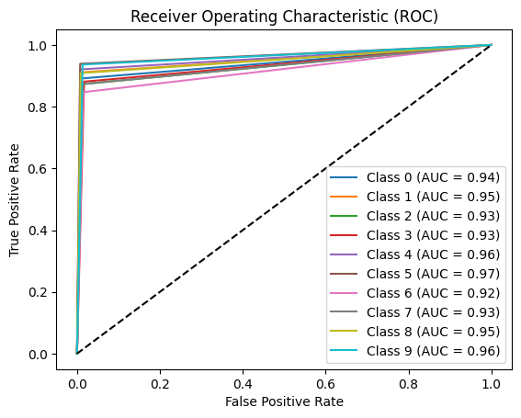

--------------------------------

Accuracy: 0.8984375

Precision: 0.8986474780454732

Recall: 0.8984375

F1-Score: 0.8984090097954187

Confusion Matrix:

[[189 9 3 0 0 0 1 0 4 6]

[ 9 174 0 4 1 0 1 1 1 0]

[ 5 3 178 8 1 0 2 0 4 3]

[ 1 2 5 200 2 2 7 8 0 0]

[ 0 0 0 1 174 4 2 3 1 4]

[ 0 2 0 4 4 200 2 0 1 0]

[ 1 0 2 8 3 3 155 7 1 3]

[ 1 1 7 5 0 2 8 179 1 1]

[ 3 1 1 1 2 3 1 0 199 8]

[ 1 0 0 0 1 0 4 4 3 192]]

--------------------------------

Classifier: Naive Bayes

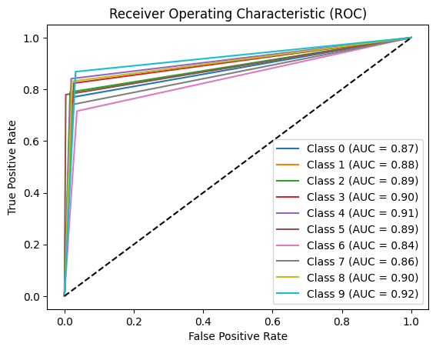

--------------------------------

Accuracy: 0.79541015625

Precision: 0.8006291278468516

Recall: 0.79541015625

F1-Score: 0.7962724806262557

Confusion Matrix:

[[163 19 0 0 0 0 5 1 8 16]

[ 17 150 7 3 1 0 0 2 6 5]

[ 5 7 161 9 2 0 5 0 12 3]

[ 1 1 6 187 3 0 17 11 0 1]

[ 0 1 2 4 159 4 3 2 4 10]

[ 1 8 1 12 15 166 6 1 3 0]

[ 2 1 3 9 11 0 131 20 1 5]

[ 3 5 6 11 0 0 19 152 3 6]

[ 7 4 4 1 3 3 1 1 182 13]

[ 2 2 1 0 1 0 11 7 3 178]]

--------------------------------

Classifier: K-NN Classifier

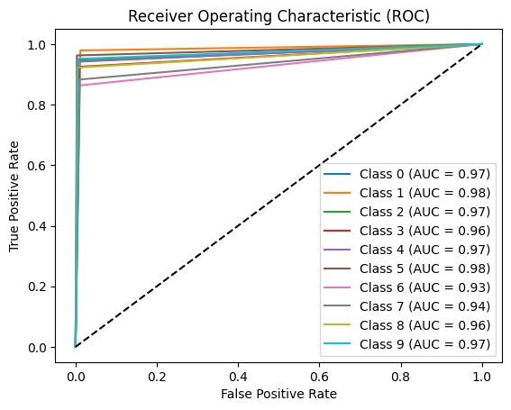

--------------------------------

Accuracy: 0.93212890625

Precision: 0.9324334426040921

Recall: 0.93212890625

F1-Score: 0.9320102776118899

Confusion Matrix:

[[200 8 0 0 0 0 0 0 2 2]

[ 1 187 2 0 0 1 0 0 0 0]

[ 2 3 193 1 2 0 2 0 1 0]

[ 2 2 3 210 2 0 3 5 0 0]

[ 0 2 0 2 178 3 1 0 1 2]

[ 1 0 0 3 3 205 1 0 0 0]

[ 0 0 3 8 0 0 158 13 0 1]

[ 2 4 4 3 2 0 8 181 0 1]

[ 3 3 1 1 2 2 0 0 202 5]

[ 2 0 0 0 0 0 3 1 4 195]]

--------------------------------

Classifier: SVM

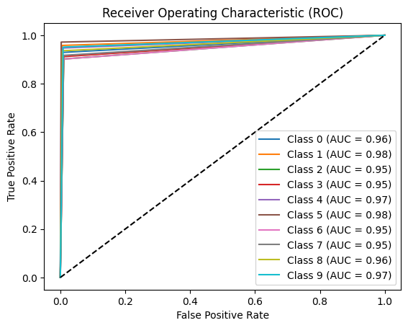

--------------------------------

Accuracy: 0.9326171875

Precision: 0.9327117258478316

Recall: 0.9326171875

F1-Score: 0.9326288431740015

Confusion Matrix:

[[197 4 3 0 0 0 0 0 3 5]

[ 3 183 1 1 1 0 0 2 0 0]

[ 7 1 184 4 1 0 2 0 3 2]

[ 0 1 5 207 1 1 6 6 0 0]

[ 0 1 0 1 179 2 1 0 1 4]

[ 0 0 0 3 1 207 1 0 1 0]

[ 0 0 1 7 0 1 165 7 1 1]

[ 2 2 5 2 1 0 4 188 1 0]

[ 1 1 3 1 2 1 0 1 205 4]

[ 0 0 1 0 0 0 4 3 2 195]]

--------------------------------

Component Size: 30

Classifier: Decision Trees

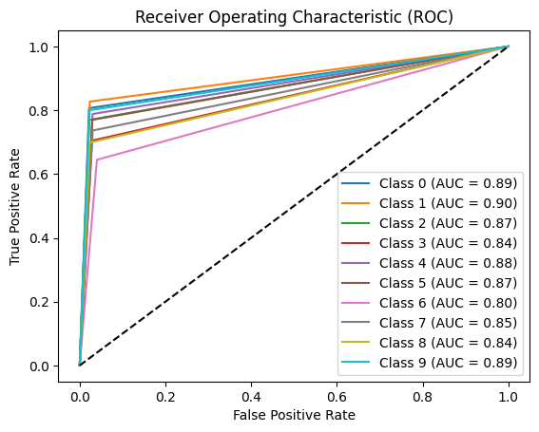

--------------------------------

Accuracy: 0.75439453125

Precision: 0.7536970190958561

Recall: 0.7546619648602525

F1-Score: 0.753604406555858

Confusion Matrix:

[[171 16 2 1 1 3 2 3 11 2]

[ 10 158 5 2 3 3 3 3 2 2]

[ 8 7 157 13 3 3 5 2 5 1]

[ 3 4 6 160 7 19 13 12 1 2]

[ 2 0 0 5 149 14 7 1 5 6]

[ 1 4 2 11 16 164 4 2 7 2]

[ 3 2 1 8 5 6 118 26 3 11]

[ 0 3 4 10 4 1 25 151 2 5]

[ 11 5 15 2 8 4 5 5 153 11]

[ 2 3 6 0 9 1 11 2 7 164]]

--------------------------------

Classifier: Random Forest

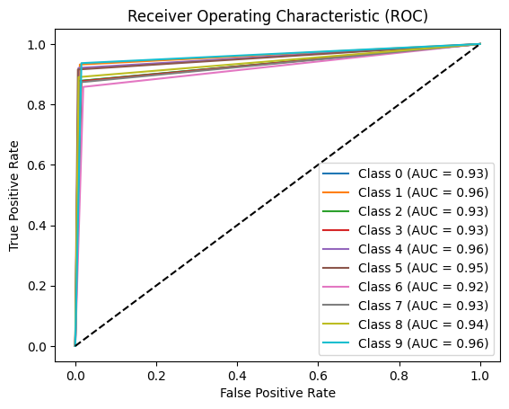

--------------------------------

Accuracy: 0.8955078125

Precision: 0.8965538641263482

Recall: 0.8955078125

F1-Score: 0.8956780144146902

Confusion Matrix:

[[186 14 2 0 0 0 3 0 2 5]

[ 6 178 0 3 1 1 1 0 0 1]

[ 6 0 179 7 1 0 4 0 3 4]

[ 1 2 4 199 4 1 9 7 0 0]

[ 0 0 0 1 174 3 3 2 2 4]

[ 0 2 0 6 5 195 2 0 3 0]

[ 2 0 2 6 2 2 157 8 1 3]

[ 1 2 6 4 0 1 9 179 1 2]

[ 4 1 1 1 2 4 1 1 195 9]

[ 1 0 0 0 0 0 5 4 3 192]]

--------------------------------

Classifier: Naive Bayes

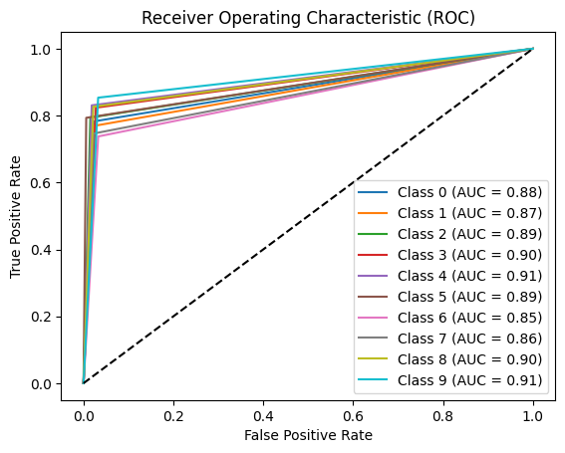

--------------------------------

Accuracy: 0.796875

Precision: 0.800972683757625

Recall: 0.796875

F1-Score: 0.7976320309840393

Confusion Matrix:

[[166 17 1 0 0 0 5 1 6 16]

[ 21 147 6 3 1 0 0 2 6 5]

[ 6 4 162 9 2 1 5 0 12 3]

[ 1 1 6 187 3 0 16 11 0 2]

[ 1 1 2 4 157 5 2 1 7 9]

[ 1 8 2 12 14 169 3 0 3 1]

[ 2 0 2 9 11 0 135 18 1 5]

[ 4 5 7 11 0 1 17 153 1 6]

[ 6 8 1 1 3 4 0 2 181 13]

[ 3 2 1 1 0 0 13 6 4 175]]

--------------------------------

Classifier: K-NN Classifier

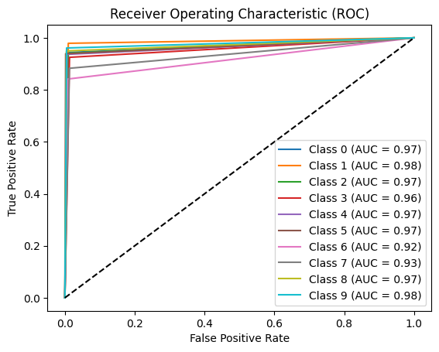

--------------------------------

Accuracy: 0.9306640625

Precision: 0.9310936370607545

Recall: 0.9306640625

F1-Score: 0.930547918996434

Confusion Matrix:

[[200 6 1 1 0 0 0 0 2 2]

[ 1 187 2 1 0 0 0 0 0 0]

[ 3 2 192 2 2 0 2 0 1 0]

[ 3 2 3 210 1 0 2 6 0 0]

[ 0 2 0 2 177 3 1 0 2 2]

[ 0 1 0 5 6 200 1 0 0 0]

[ 0 0 3 8 0 0 154 17 0 1]

[ 1 3 7 4 2 0 6 181 0 1]

[ 1 2 2 1 1 1 0 0 208 3]

[ 1 0 0 0 0 0 3 1 3 197]]

--------------------------------

Classifier: SVM

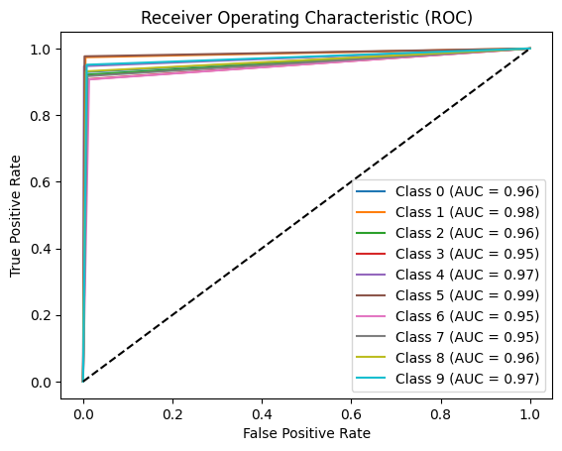

--------------------------------

Accuracy: 0.93603515625

Precision: 0.9364613737906275

Recall: 0.93603515625

F1-Score: 0.936114883233542

Confusion Matrix:

[[197 4 3 0 0 0 0 0 4 4]

[ 2 186 0 2 0 0 0 1 0 0]

[ 6 1 188 3 0 0 2 0 3 1]

[ 0 0 4 206 1 2 9 5 0 0]

[ 0 1 0 1 179 2 1 0 1 4]

[ 0 0 1 1 1 208 2 0 0 0]

[ 0 0 1 6 0 1 166 7 1 1]

[ 1 2 4 1 0 0 7 188 1 1]

[ 1 2 4 0 2 1 0 1 204 4]

[ 0 0 0 0 0 0 4 4 2 195]]