Bag of Words + Decision Trees
precision recall f1-score support

0 0.93 0.95 0.94 6472
1 0.93 0.91 0.92 4877

accuracy 0.93 11349
macro avg 0.93 0.93 0.93 11349
weighted avg 0.93 0.93 0.93 11349

[[6155 317]
[ 458 4419]]
ROC-AUC: 0.9285547934060457
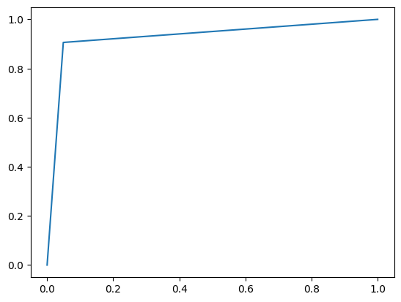
--------------------------------------------------
Bag of Words + Random Forest
precision recall f1-score support

0 0.93 0.96 0.94 6472
1 0.94 0.91 0.92 4877

accuracy 0.94 11349
macro avg 0.94 0.93 0.93 11349
weighted avg 0.94 0.94 0.94 11349

[[6190 282]
[ 449 4428]]
ROC-AUC: 0.9321814472868157
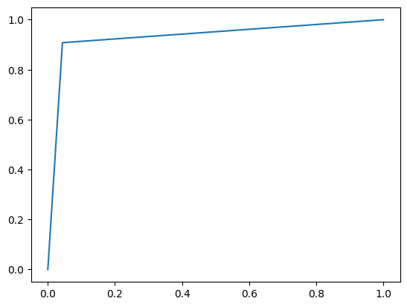
--------------------------------------------------
Bag of Words + Naive Bayes
precision recall f1-score support

0 0.95 0.90 0.93 6472
1 0.88 0.93 0.91 4877

accuracy 0.92 11349
macro avg 0.91 0.92 0.92 11349
weighted avg 0.92 0.92 0.92 11349

[[5856 616]
[ 318 4559]]
ROC-AUC: 0.9198083737570945
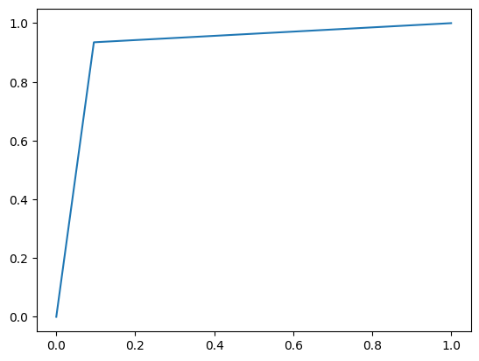
--------------------------------------------------
Bag of Words + K-NN
precision recall f1-score support

0 0.85 0.98 0.91 6472
1 0.97 0.77 0.86 4877

accuracy 0.89 11349
macro avg 0.91 0.88 0.89 11349
weighted avg 0.90 0.89 0.89 11349

[[6343 129]
[1104 3773]]
ROC-AUC: 0.8768496579514905
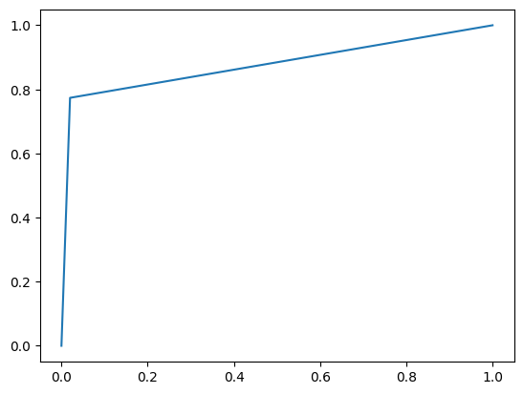
--------------------------------------------------
Bag of Words + SVM
precision recall f1-score support

0 0.93 0.98 0.95 6472
1 0.97 0.90 0.93 4877

accuracy 0.94 11349
macro avg 0.95 0.94 0.94 11349
weighted avg 0.94 0.94 0.94 11349

[[6319 153]
[ 493 4384]]
ROC-AUC: 0.9376364848448597
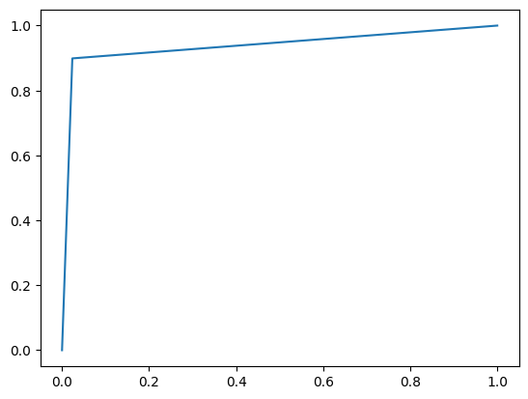
--------------------------------------------------
TF-IDF + Decision Trees
precision recall f1-score support

0 0.94 0.94 0.94 6472
1 0.92 0.92 0.92 4877

accuracy 0.93 11349
macro avg 0.93 0.93 0.93 11349
weighted avg 0.93 0.93 0.93 11349

[[6102 370]
[ 405 4472]]
ROC-AUC: 0.9298939004580669
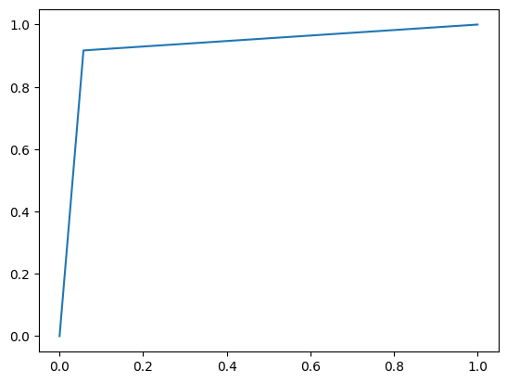

--------------------------------------------------
TF-IDF + Random Forest
precision recall f1-score support

0 0.94 0.95 0.94 6472
1 0.93 0.92 0.93 4877

accuracy 0.94 11349
macro avg 0.94 0.93 0.94 11349
weighted avg 0.94 0.94 0.94 11349

[[6153 319]
[ 401 4476]]
ROC-AUC: 0.934244038070781
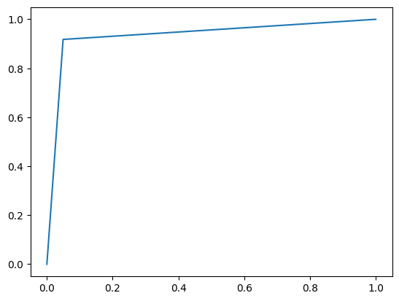

--------------------------------------------------
TF-IDF + Naive Bayes
precision recall f1-score support

0 0.93 0.93 0.93 6472
1 0.90 0.90 0.90 4877

accuracy 0.92 11349
macro avg 0.92 0.91 0.91 11349
weighted avg 0.92 0.92 0.92 11349

[[6011 461]
[ 487 4390]]
ROC-AUC: 0.9144568086928553
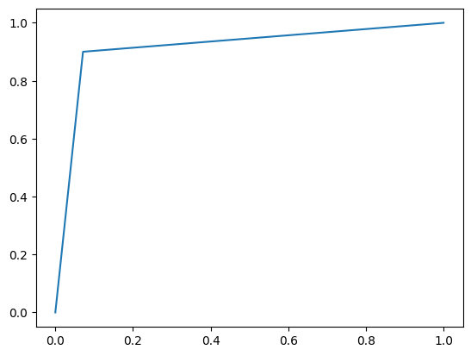

--------------------------------------------------
TF-IDF + K-NN
precision recall f1-score support

0 0.60 0.99 0.75 6472
1 0.93 0.13 0.23 4877

accuracy 0.62 11349
macro avg 0.76 0.56 0.49 11349
weighted avg 0.74 0.62 0.53 11349

[[6422 50]
[4242 635]]
ROC-AUC: 0.5612387032495051
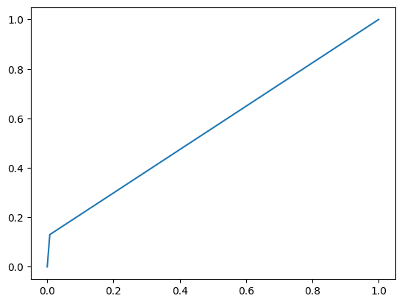

--------------------------------------------------

TF-IDF + SVM
precision recall f1-score support

0 0.93 0.98 0.95 6472
1 0.97 0.90 0.93 4877

accuracy 0.94 11349
macro avg 0.95 0.94 0.94 11349
weighted avg 0.94 0.94 0.94 11349

[[6325 147]
[ 500 4377]]
ROC-AUC: 0.9373823657778635
