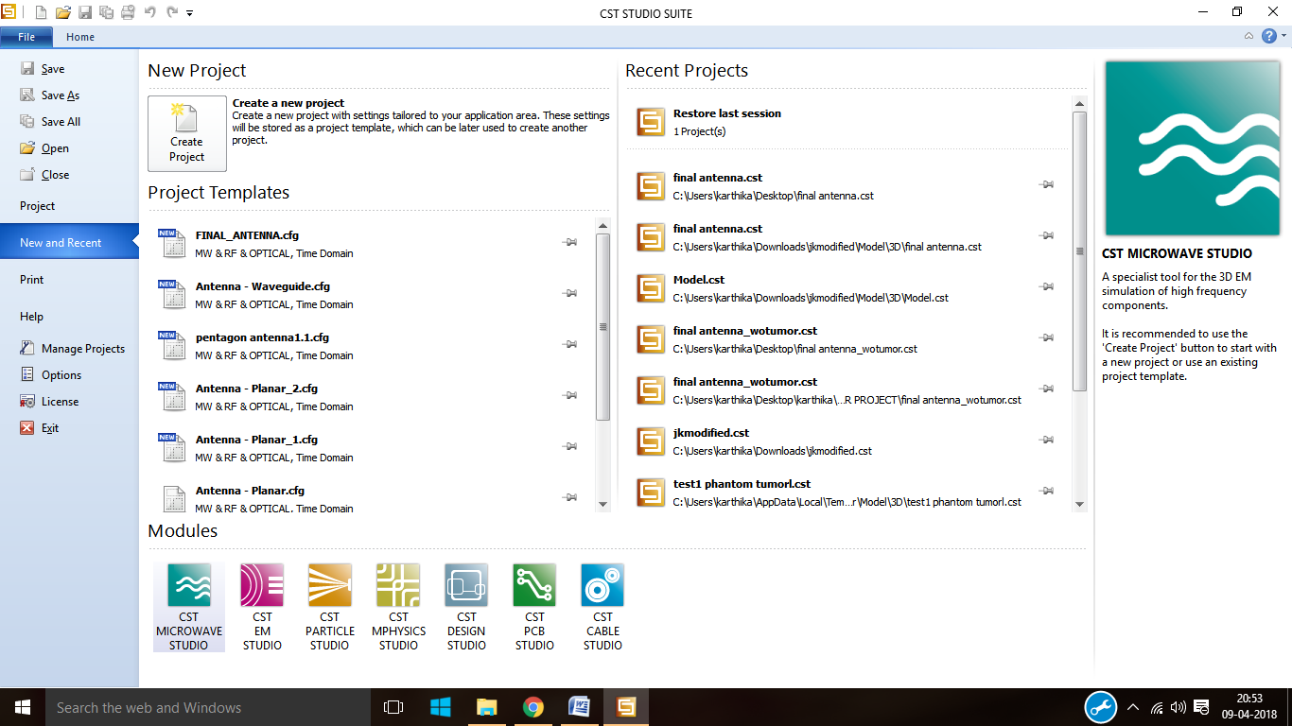

Step1: Open the CST studio suite and click on CST MICROWAVE STUDIO.

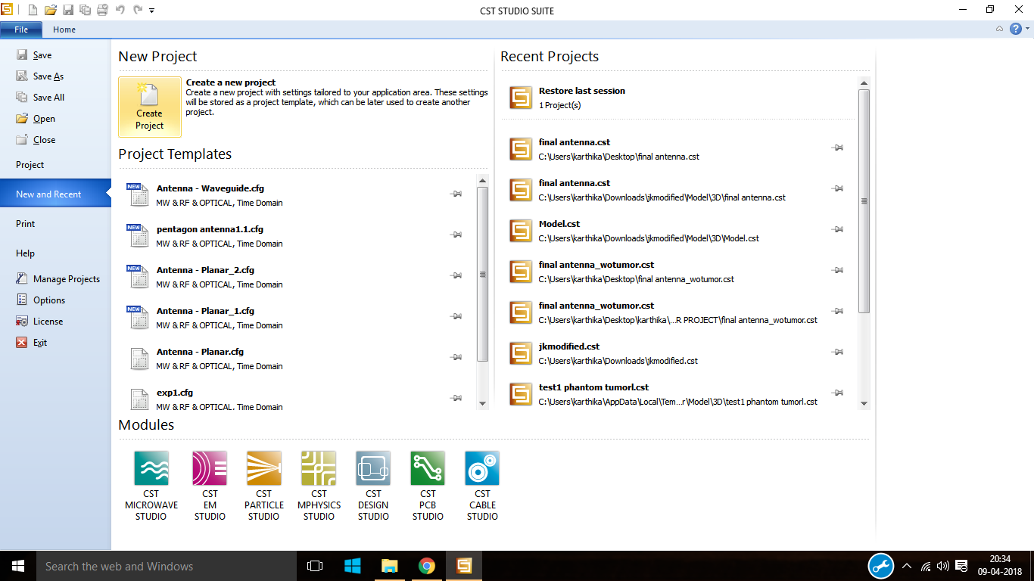

Step2: Click on create project from new project.

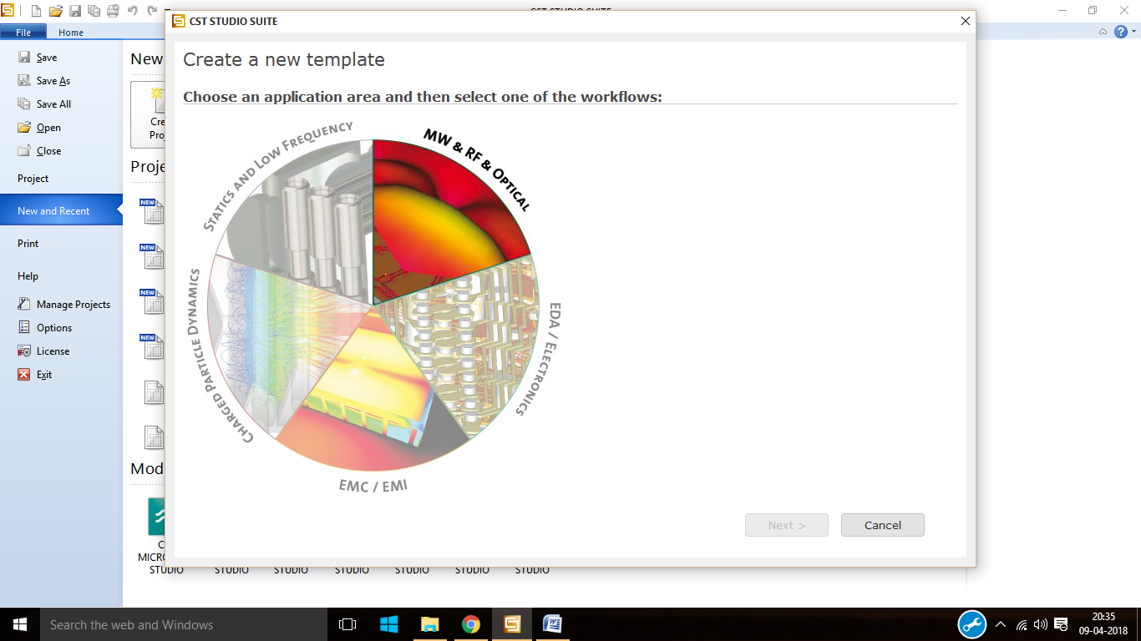

Step3: click on microwave and RF and Optical from create new template.

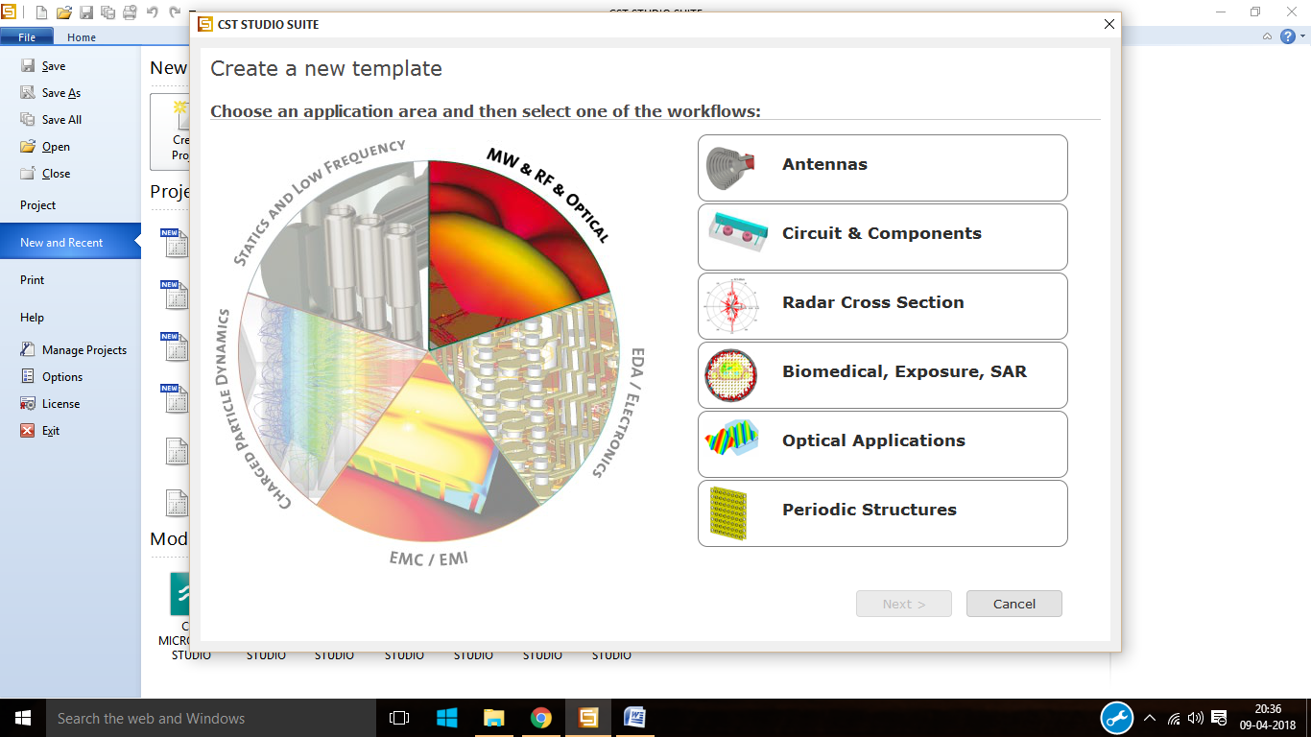

Step4: after that click on antennas.

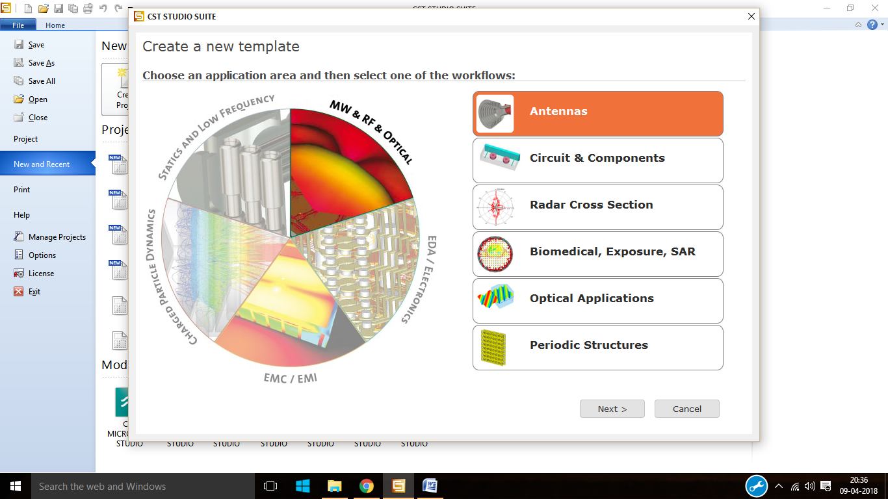

Step5: click on antenna and then click on OK.

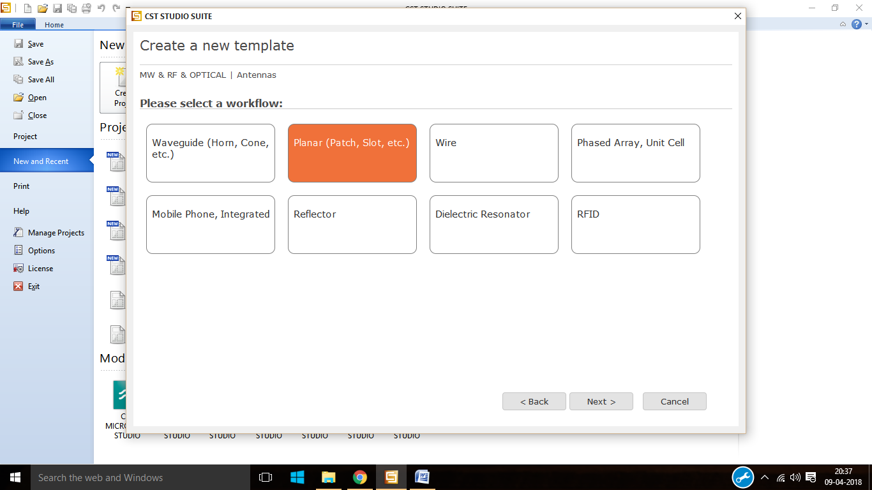

Step6: From the work flow click on planar.

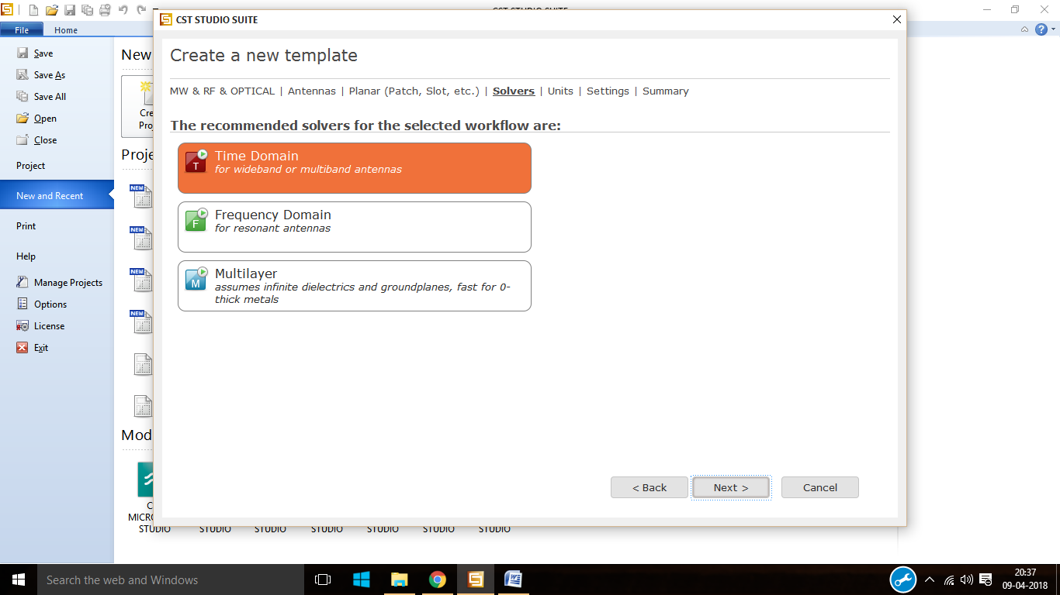

Step7: select time domain as the solver.

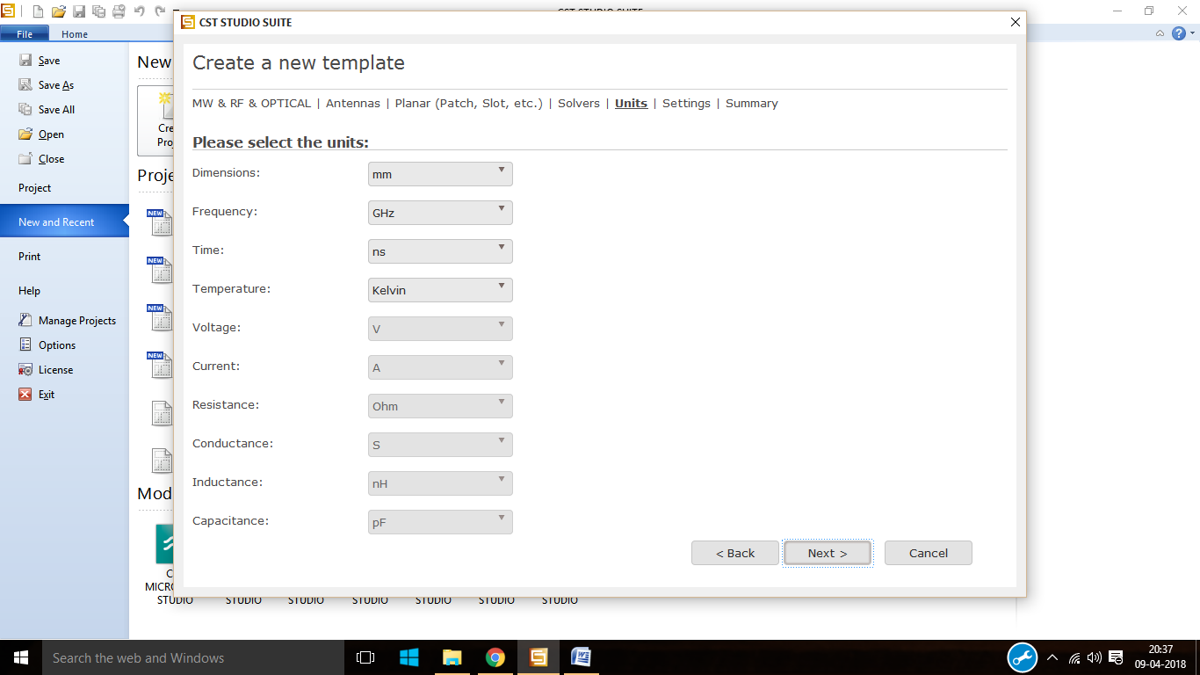

Step8: select the units and then click on next.

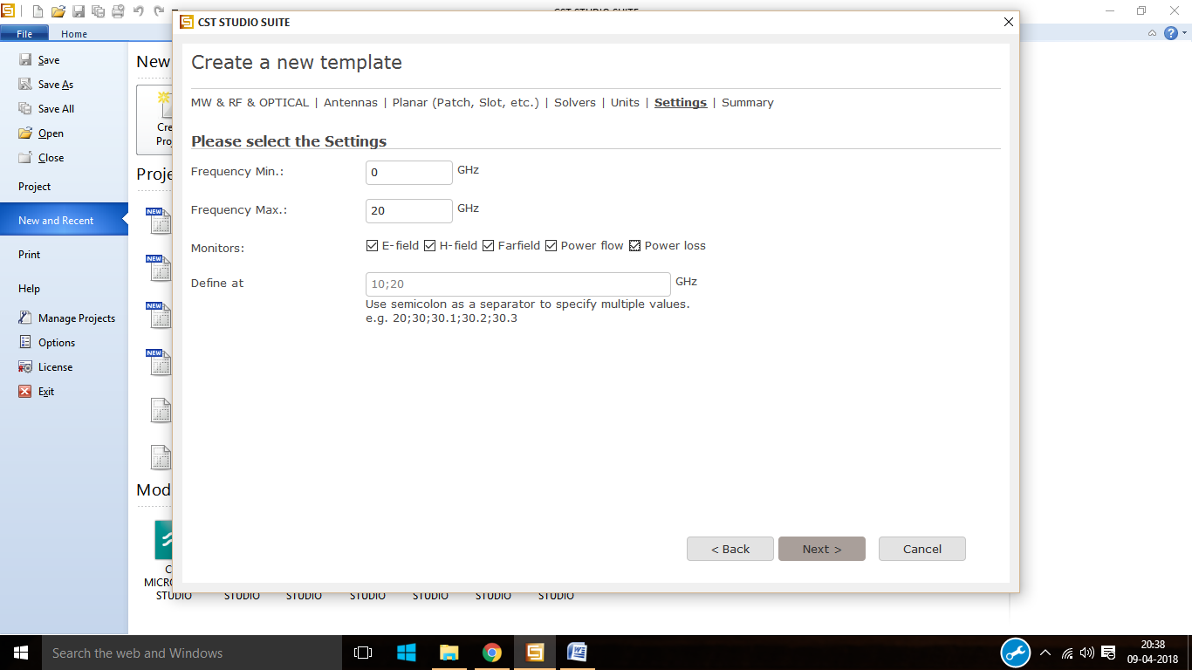

Step9: select the minimum and maximum frequency then select the required field monitors.

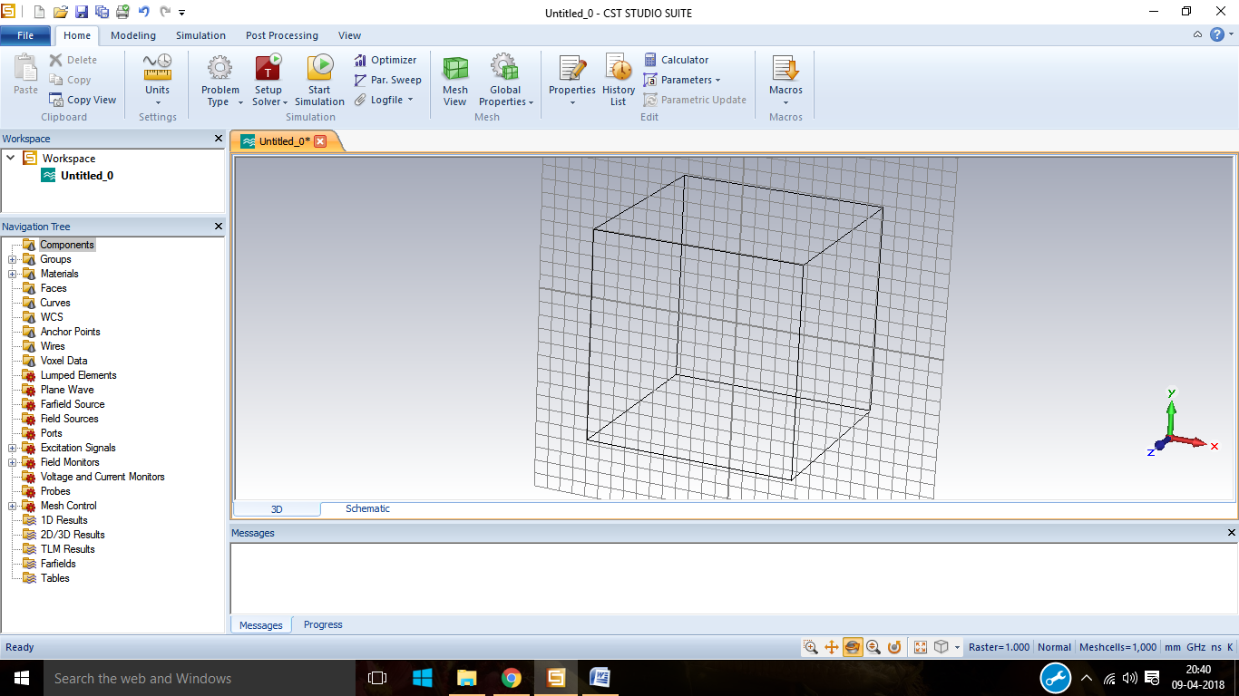

Step10: after all the initial setup is over the working plane appers.

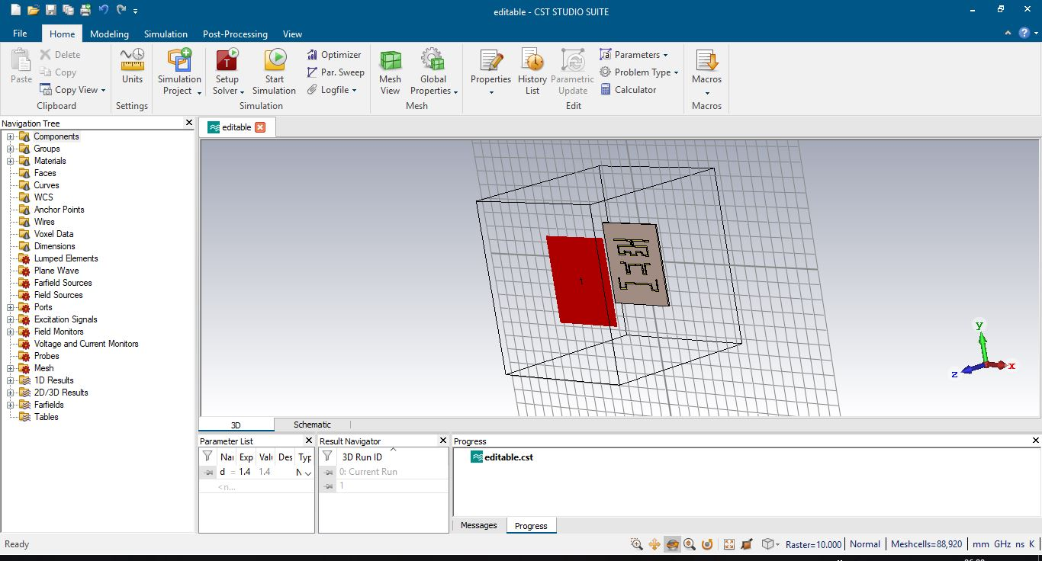

Step11: After creating the antenna it looks like this.

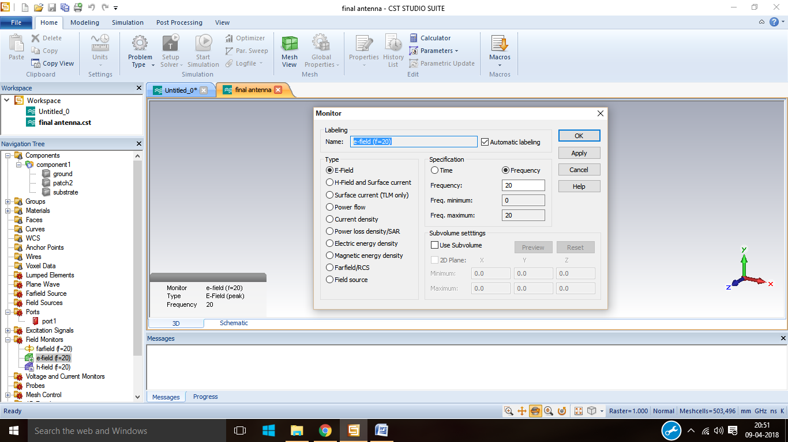

Step12: from the field monitor select E-Field and then click OK.

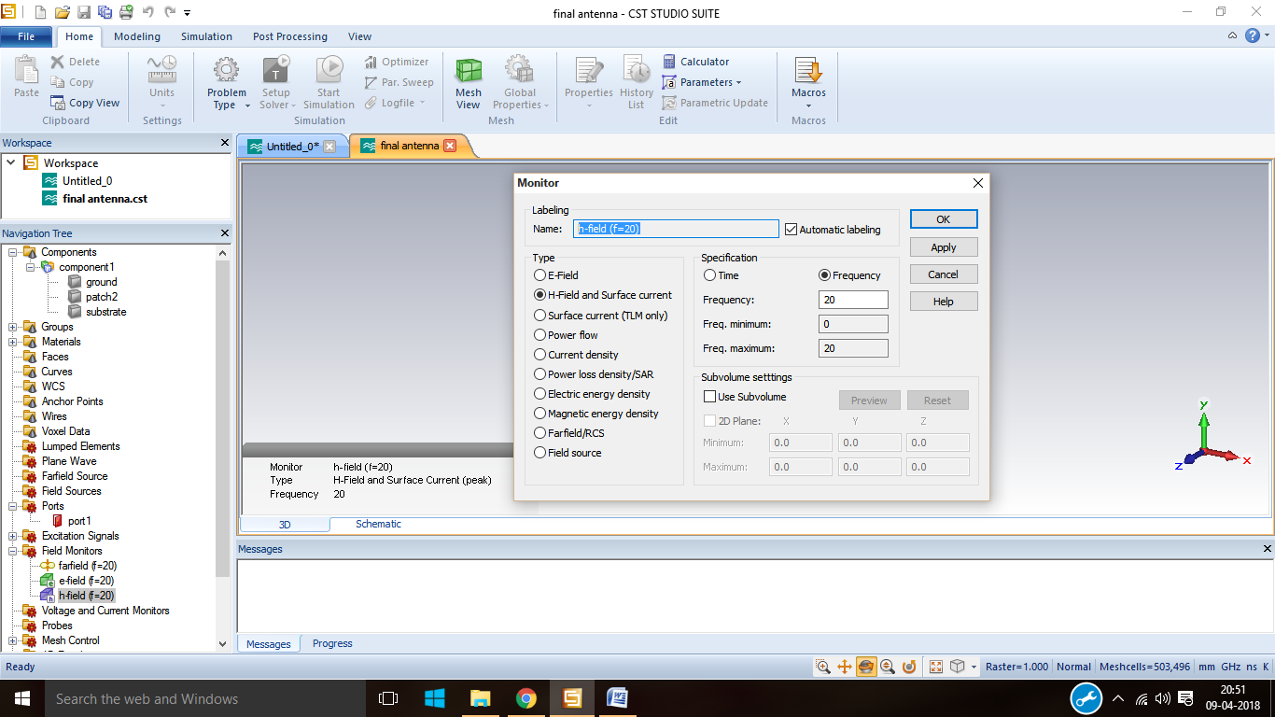

Step13: from the field monitor select H-Field and then click OK.

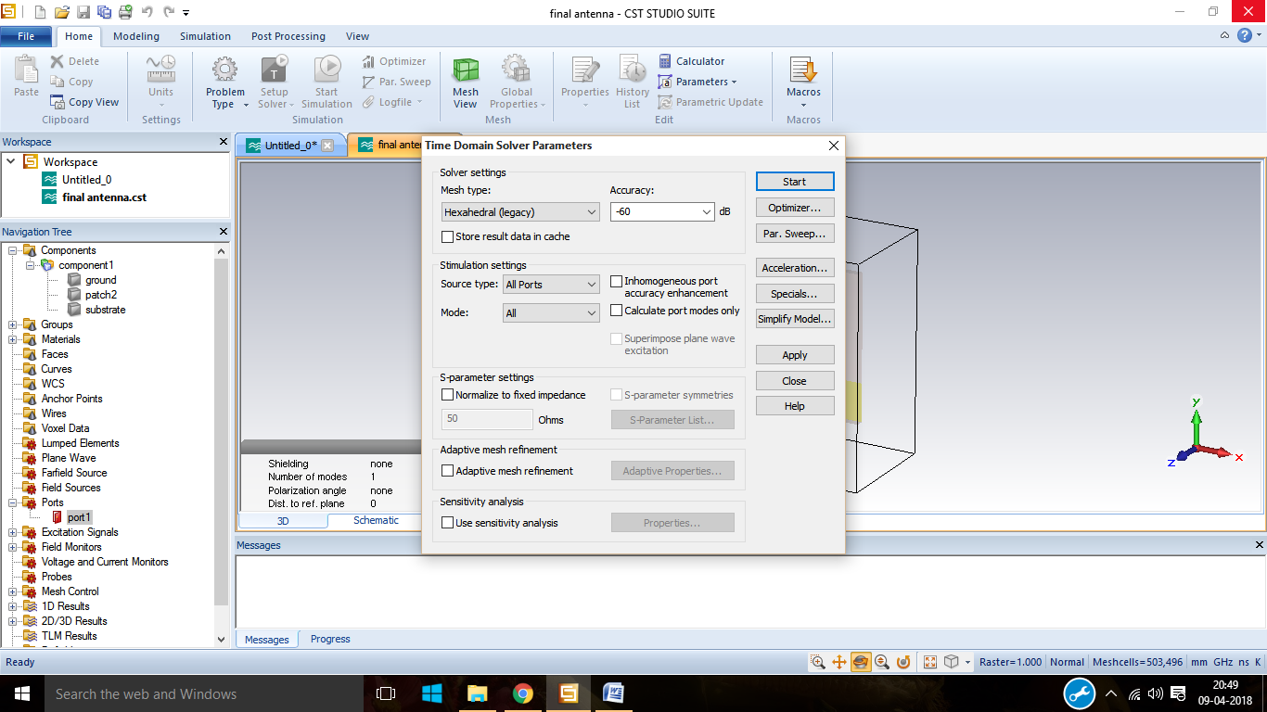

Step14: click on time domain solver and specify the mesh type, accuracy then click on start.

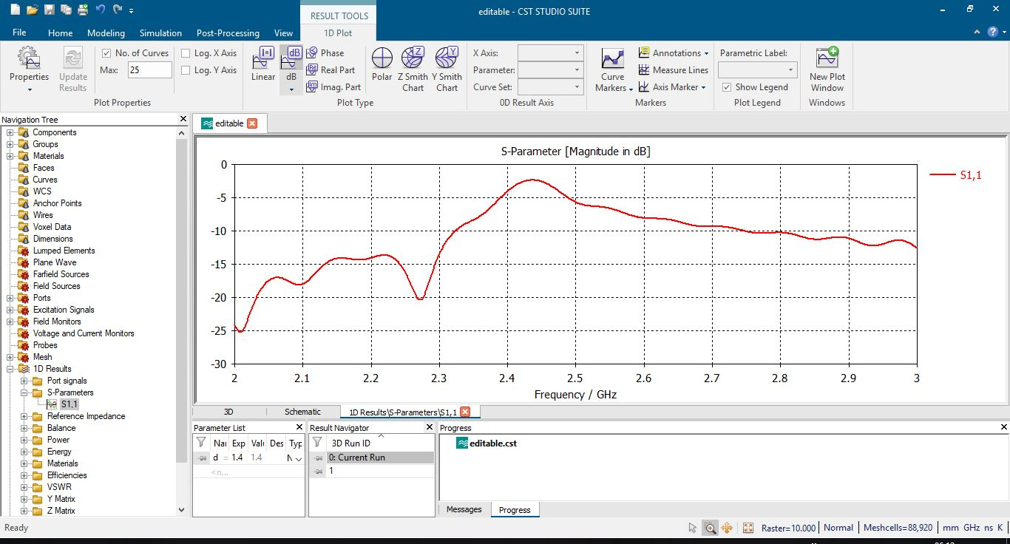

Step15: Click on stimulate to get the s-Parameter of the antenna.

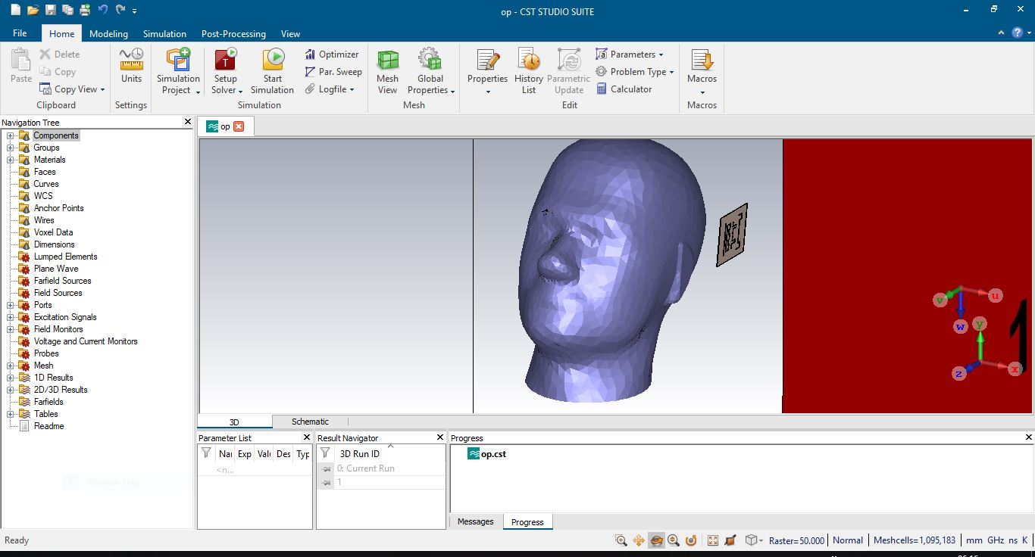

Step16: Now add the san phantom without tumour to the antenna.

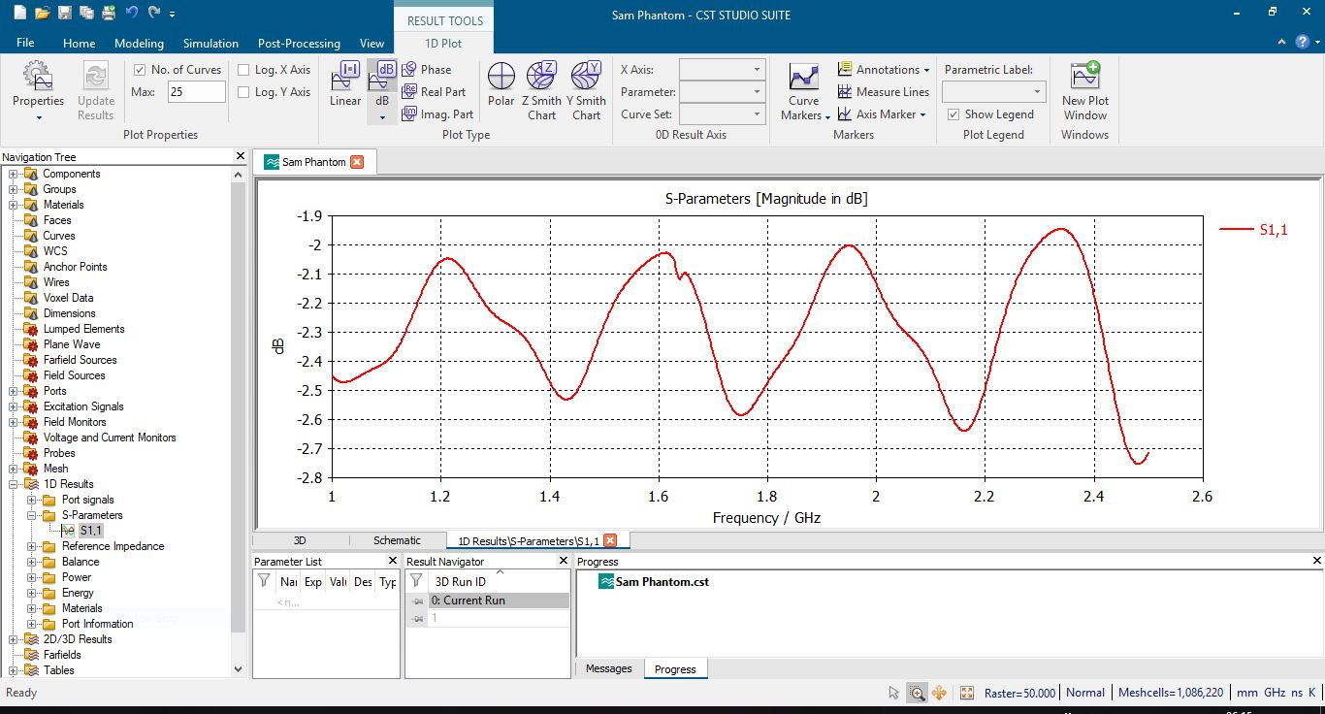

Step17: Click on stimulate to get the s-Parameter of the antenna without tumour.



Step18: Now add the san phantom with tumour to the antenna.

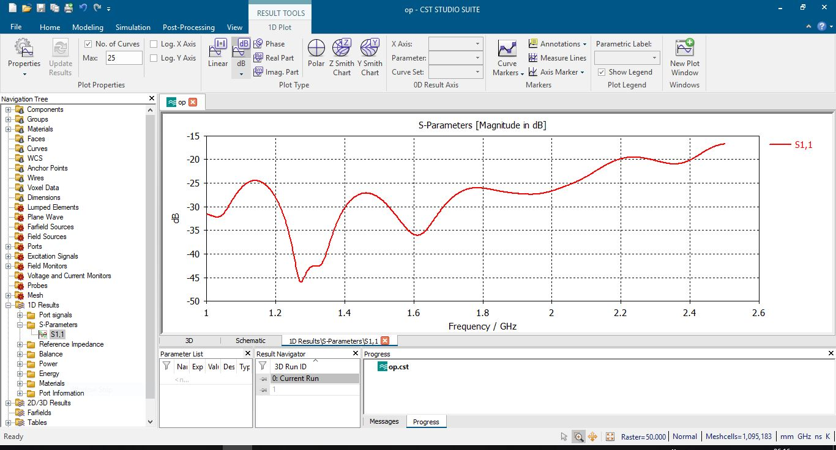

Step19:Stimulate the antenna to get the S-paramater with tumour.

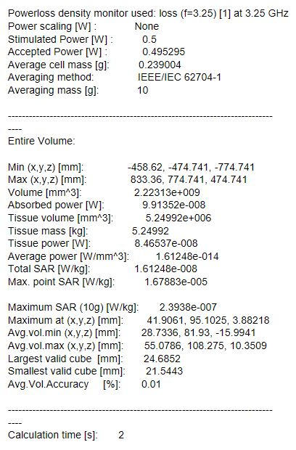

The above report is the result of stimulation of Sam phantom without tumour shows the SAR of the cells which observe the frequency of the designed antenna at resonant frequency.

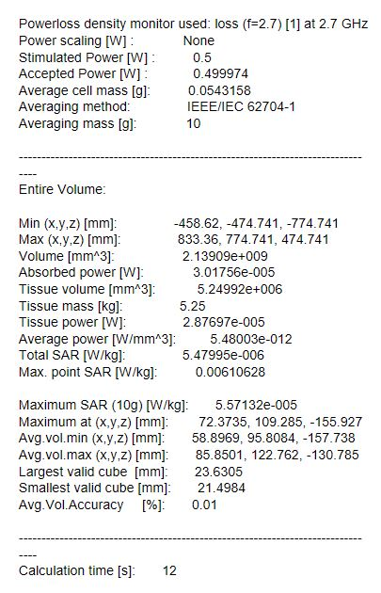

The above report is the result of stimulation of Sam phantom with tumour shows the SAR of the cells which observe the frequency of the designed antenna at resonant frequency.