**SMART ANTENNA FOR BRAIN TUMOUR APPLICATION**

Balaji.R, Balaji.V, Buvanesh.G

Under the Guidance : **S.KALAIVANI**, M.E.,,Professor, Department of Electronics and Communicaton Engineering, Rajalakshmi Institute of Technology,Chennai-124

**ABSTRACT**



In this method of detection of Brain Tumour using Smart Antenna, a 3D model of the human brain is taken as the input so that the exact shape of the tumour can be identified. This detection in Tumour is very important in many diagnostic and therapeutic applications. Because of high quantity data in MRI images and blurred boundaries, tumour identification, segmentation and classification are very hard. This model proposes a brain tumour detection method to increase the accuracy and decrease the diagnosis time as well as reducing the side effects of radiation. Accurate detection of brain tumour is done by Specific Absorption Rate of the normal cells and tumour cells plays a vital role in the diagnosis of tumour. The diagnosis method consists of three stages, Antenna testing and error calculation, Sam Phantom without tumour, Sam Phantom with tumour.

Images

**Step by step execution:**

**Step 1: Working and Error Check**

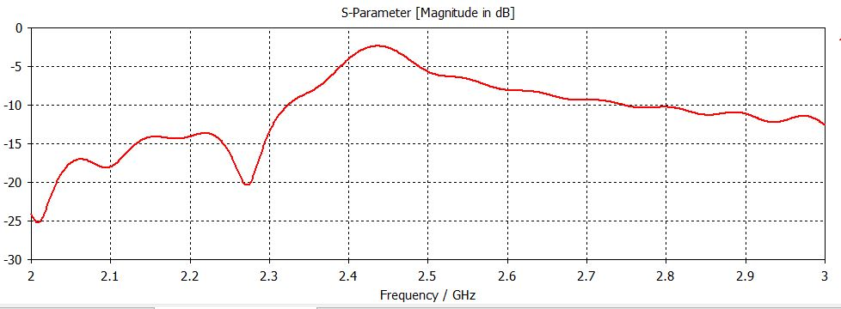 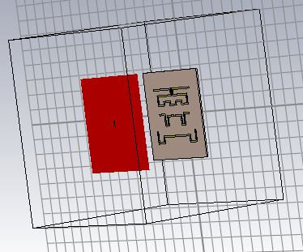

**Step 2: Without Tumour**

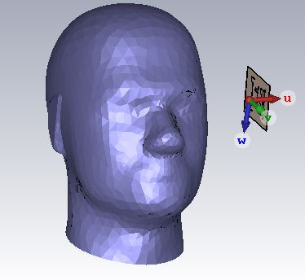

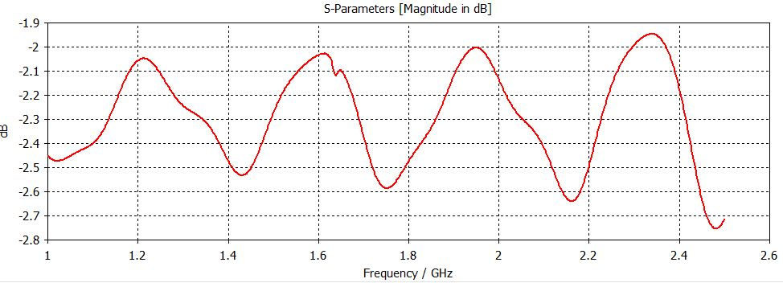**Keywords–** Brain Tumour, Sam Phantom, Specific Absorption rate, Microstrip patch

antenna, S-Parameter. .

**INTRODUCTION**

The proposed antenna is realized on Copper with PCB substrate with length=50mm, breath= 50mm and thickness h=2mm. The antenna is simulated using CST software. Microstrip patch antennas are fed by a variety of methods. This antenna is designed by using co-axial line feed as it is easier to fabricate. .

**METHODOLOGY**

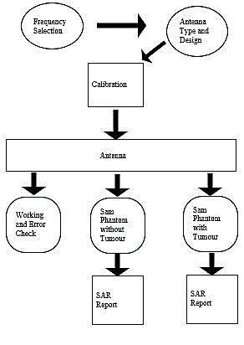

**on Engineering.**

A Microstrip Patch Antenna Image

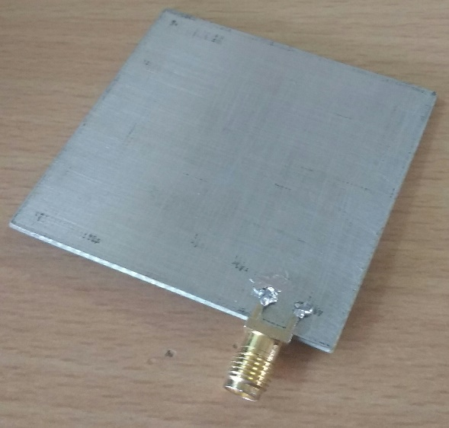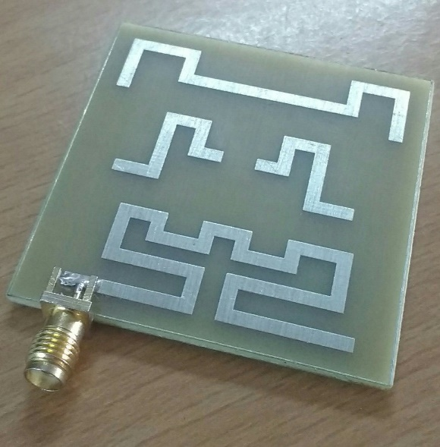**Step 3:With Tumour**

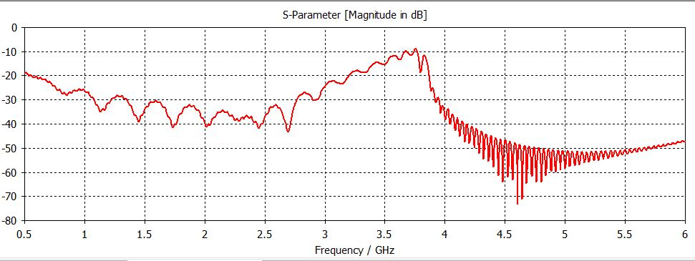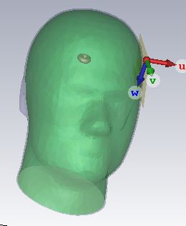

**CONCLUSION**

The human head phantom is designed with and without tumour, tested with the proposed antenna. The various response (with and without tumour) observed by the antenna and analyzed using CST software. From the response of simulated Specific absorption rate, we analyzed the statistical differences between the normal head and the head that contains tumor. From these results we were able to accurately find the presence of tumour

**Recognition: This work got selected for publication in International Conference conducted at Jawahar Engineering College.**