RESULT DOCUMENT:

1)Key generation function output:

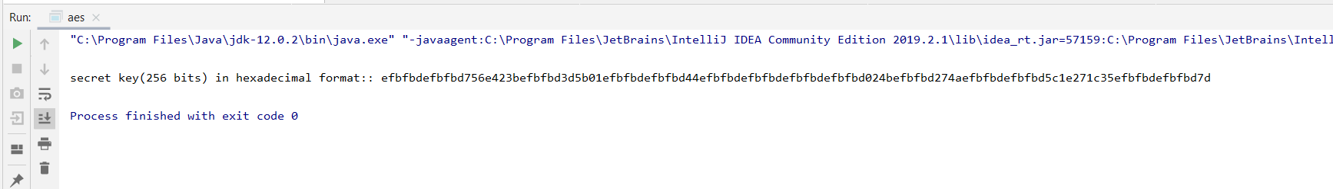

2)Encryption function code:

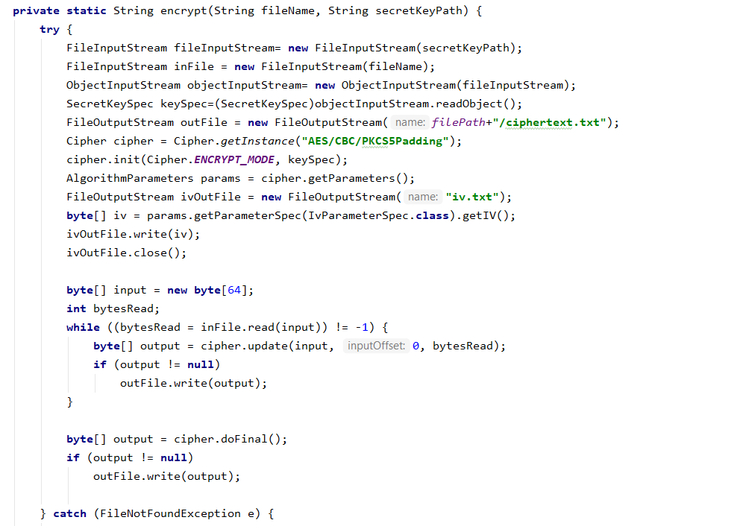

Output:

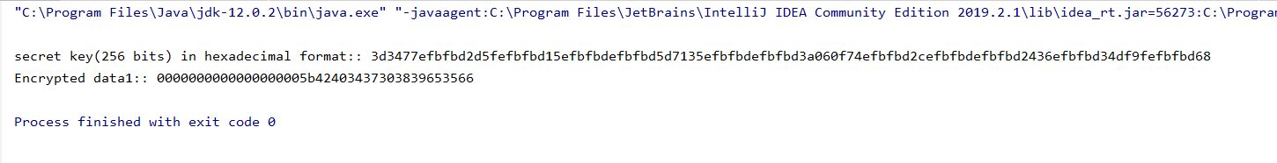

3) Decryption function:

Input file

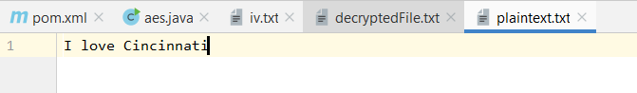

Ouput file

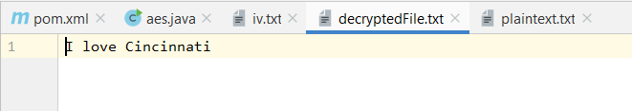

Decrypt function::

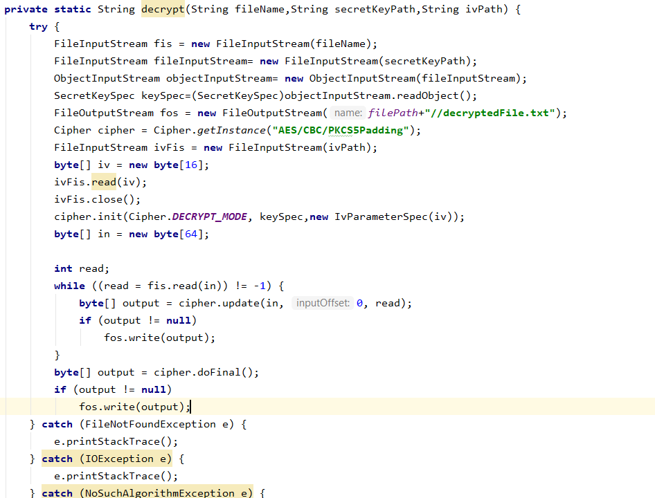

4)Different Encryption modes

The main difference between these two modes is when we encrypt plaintext using cbc it had different outputs and different time lapses compare to ebc, whereas in ebc we have same time lapse for encryption and even time lapse than cbc model.

Time lapse for encryption using cbc::13

Encrypted data1:: 0000000000000000005b42403463336534373930

Time lapse for decryption using cbc::2

time lapse for encryption using cbc::2

Encrypted data1:: 000000000000000000005b424033386363636566

Time lapse for decryption using cbc::2

time lapse for encryption using cbc::2

Encrypted data1:: 0000000000000000005b42403536373963366336

Time lapse for decryption using cbc::2

time lapse for encryption using cbc::2

Encrypted data1:: 0000000000000000005b42403237646464333932

Time lapse for decryption using cbc::2

time lapse for encryption using cbc::2

Encrypted data1:: 0000000000000000005b42403139653130323365

Time lapse for decryption using cbc::1

Time lapse for encryption using ecb::1

Encrypted data2:: 0000000000000000005b42403763656634653539

Time lapse for decryption using ecb::1

Time lapse for encryption using ecb::2

Encrypted data2:: 0000000000000000005b42403634623866386634

Time lapse for decryption using ecb::1

Time lapse for encryption using ecb::1

Encrypted data2:: 0000000000000000005b42403264623066366232

Time lapse for decryption using ecb::3

Time lapse for encryption using ecb::1

Encrypted data2:: 0000000000000000005b42403139393663643638

Time lapse for decryption using ecb::1

Time lapse for encryption using ecb::1

Encrypted data2:: 0000000000000000005b42403333333961643865

Time lapse for decryption using ecb::1