Analysis of createAgent Implementation

Overview
This document records the analysis of the createAgent method and its underlying implementation in the ReactAgent class.

Related Files

1. Core Implementation
Entry Point: libs/langchain/src/agents/index.ts
Main Class: libs/langchain/src/agents/ReactAgent.ts
State Definition: libs/langchain/src/agents/annotation.ts
State Manager: libs/langchain/src/agents/state.ts
Types: libs/langchain/src/agents/types.ts
Utilities: libs/langchain/src/agents/utils.ts

2. Graph Nodes
Directory: libs/langchain/src/agents/nodes/
- AgentNode.ts
- ToolNode.ts
- BeforeAgentNode.ts
- BeforeModelNode.ts
- AfterModelNode.ts
- AfterAgentNode.ts
- utils.ts

3. Middleware Infrastructure
Directory: libs/langchain/src/agents/middleware/
- types.ts
- utils.ts

createAgent Factory Function
Location: libs/langchain/src/agents/index.ts
Description: createAgent is a factory function responsible for instantiating the ReactAgent. It provides multiple overloads to support different responseFormat types such as Zod schemas, JSON schemas, ToolStrategy, and other structured output strategies.

ReactAgent Class
Location: libs/langchain/src/agents/ReactAgent.ts

Constructor Logic
The constructor orchestrates the creation of the agent's StateGraph.
- Validation: Ensures a model is provided and has no bound tools when passed as a string.
- Tool Setup: Merges tools from options.tools and middleware. Identifies returnDirect tools.
- State Definition: Creates a merged state schema using createAgentAnnotationConditional, combining user-defined state, middleware states, and internal agent state.
- Graph Initialization: Instantiates a StateGraph.

Node Addition
- Adds AGENT_NODE_NAME as the main agent execution node.
- Adds TOOLS_NODE_NAME when tools are present.
- Adds middleware nodes when configured:
  - beforeAgent
  - beforeModel
  - afterModel
  - afterAgent

Edge Connection
- Entry: Connects START to the first executable node (middleware or agent).
- Middleware Chain: beforeAgent → beforeModel → AGENT_NODE_NAME → afterModel → afterAgent.
- Agent → Tools: Uses #createModelRouter to route from the agent to tools when tool calls exist; otherwise routes to Exit.
- Tools → Agent: Uses #createToolsRouter to route from tools back to the agent (loop) or to Exit when a returnDirect tool is invoked.
- JumpTo Support: #createAfterModelRouter enables dynamic routing (jump behavior) from afterModel middleware.

Compilation
- Compiles the fully connected graph and stores it as this.#graph.invoke. **stream:** Delegates streaming execution to this.#graph.stream. **graph:** Getter that returns the compiled StateGraph`.

Key Methods
invoke: Initializes middleware state and delegates execution to this.#graph.invoke.
stream: Delegates streaming execution to this.#graph.stream.
graph: Getter that returns the compiled StateGraph.

Routing Logic
#createModelRouter: Inspects the AIMessage for tool calls. If structured response tool calls are detected (tool name starts with extract-), execution routes to Exit. If regular tool calls are present, execution routes to TOOLS_NODE_NAME. Otherwise, execution routes to Exit.
#createToolsRouter: If a returnDirect tool was called, execution routes to Exit (or back to the agent when a response format is defined). Otherwise, execution routes back to AGENT_NODE_NAME.

State Management in createAgent
This document analyzes how state is managed, initialized, and updated during the execution of an agent created with createAgent.

State Definition
The agent's state is a merged schema defined in src/agents/annotation.ts via createAgentAnnotationConditional. It combines:
- messages: Standard LangGraph MessagesZodState (array of BaseMessage).
- jumpTo: Optional control-flow field ("model_request" | "tools" | "end").
- structuredResponse: Optional string field (present when responseFormat is used).
- User / Middleware State: Custom fields defined in options.stateSchema or middleware[].stateSchema.

Schema Construction
createAgentAnnotationConditional:
- Merges all schemas into a single Zod object.
- Handles Zod v3 and v4 compatibility.
- Adds LangGraph metadata (jsonSchemaExtra) for UI integration.

State Initialization
When agent.invoke(state, config) is called:
- Input Validation: Input state is validated against the merged schema.
- Middleware Initialization: ReactAgent initializes middleware-related state when required.
- Graph Start: StateGraph is initialized with the validated state.

State Updates and Flow
State flows through graph nodes, each capable of reading and mutating it.

StateManager (src/agents/state.ts)
- Purpose: Manages state visibility for middleware.
- Mechanism: Maintains a registry of nodes (AgentNode, BeforeAgentNode, etc.) grouped by middleware name.
- getState(name): Aggregates the current state from all nodes associated with a specific middleware, enabling middleware hooks to access a consolidated view of their state.

Node Interactions
AgentNode:
- Reads messages to construct the prompt.
- Writes to messages (appends AIMessage).
- Writes to structuredResponse when applicable.
ToolNode:
- Reads messages (latest tool calls).
- Writes to messages (appends ToolMessage).
Middleware Nodes (BeforeAgent, BeforeModel, AfterModel, AfterAgent):
- Read and write custom state fields defined in their schemas.
- Can set jumpTo to alter control flow.

Control Flow State (jumpTo)
- Usage: Middleware sets jumpTo to redirect execution.
- Handling: Routers (e.g., #createAfterModelRouter) read jumpTo, perform the jump, and then clear it (jumpTo: undefined) to prevent infinite loops.
- Visibility: StateManager.getState() removes jumpTo so it does not leak into middleware hooks unexpectedly.

Data Flow Summary
- User Input (invoke({ messages: [...] })) → Graph State
- Pre-middleware → State updates / jumpTo set
- AgentNode → Generates AIMessage → Updates messages
- Router → Evaluates tool calls and jumpTo
- ToolNode → Executes tools → Appends ToolMessage
- Post-middleware → State updates / jumpTo set
- Final State → Returned to the user

Agent Orchestration Diagram
This document visualizes the internal orchestration of the createAgentmethod (specifically theReactAgentclass) in LangChain JS.
High-Level Flow The agent execution follows a graph-based workflow managed by StateGraph.

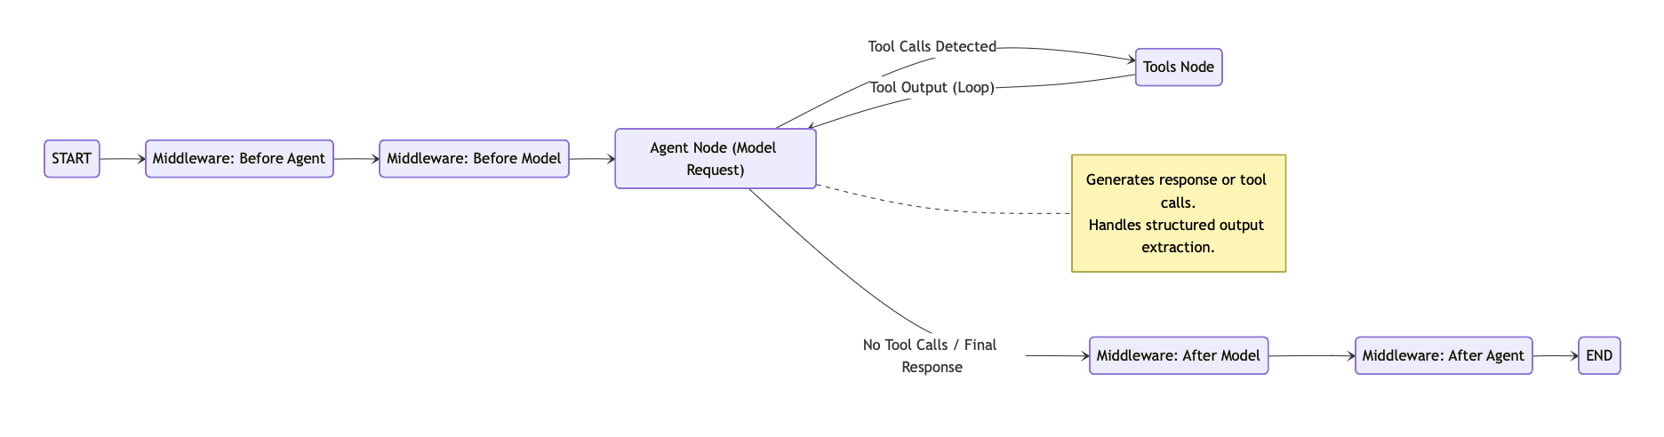

Detailed Orchestration Logic
This diagram details the specific routing logic, conditional edges, and middleware interactions.

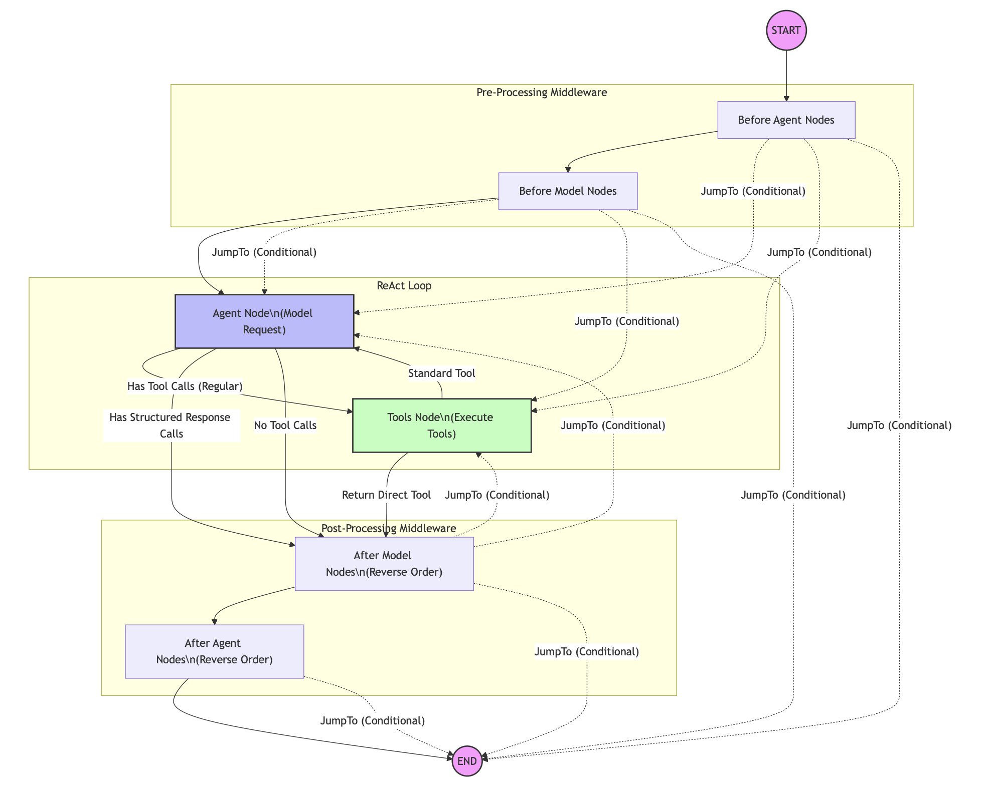

Routing & Decision Points
1. Entry Point
- Logic: Determines the first node to execute.
- Order: beforeAgent[0] → beforeModel[0] → AGENT_NODE_NAME.
2. Agent Node Router (#createModelRouter)
- Input: AIMessage generated by the model.
- Decisions:
  - Structured Response:
    - If tool calls match extract-*, they are handled internally.
    - Execution proceeds to Exit (AfterModel / End).
  - Regular Tool Calls:
    - If standard tool calls are present, execution routes to the Tools node.
  - No Tool Calls:
    - Execution routes to Exit (AfterModel / End).
3. Tools Node Router (#createToolsRouter)
- Input: Result of tool execution.
- Decisions:
  - Return Direct:
    - If the invoked tool has returnDirect: true, execution routes to Exit.
    - If a responseFormat is enforced, execution routes back to the Agent.
  - Standard:
    - Execution loops back to the Agent node.
4. Middleware Routers
- Before Agent / Before Model:
  - Can conditionally jump to AGENT, TOOLS, or END based on allowed destinations.
- After Model:
  - Can conditionally jump back to AGENT or TOOLS (forming a loop), or proceed to END.
- After Agent:
  - Can conditionally jump to END.

Summary: State-Sharing Approaches for createAgent() Customization

Option 1: State Projection (Recommended Default)
What it is:
The agent selectively exposes specific internal state fields to the parent graph via a controlled projection/mapping.
Key points:
- One-way state flow (agent → graph)
- Only selected fields are exposed
- Supports transformation and aggregation
- Agent internals remain private
Pros:
- Clean architecture and clear boundaries
- Strong type safety and maintainability
- Low coupling between agent and graph
- Flexible and backward compatible
Cons:
- Requires explicit projection configuration
- Snapshot-based (not real-time)
- Parent cannot modify agent state
Best for:
Standard orchestration, clean design, long-term maintainability.

Option 2: Streaming State Updates
What it is:
The agent emits real-time state update events that the parent graph subscribes to and reacts to.
Key points:
- Event-driven, real-time visibility
- Parent reacts to intermediate agent states
- Good for monitoring and debugging
Pros:
- Full observability of agent execution
- Ideal for logging, tracing, and auditing
- Fine-grained execution insights
Cons:
- Higher complexity and performance overhead
- Harder debugging and error handling
- Requires event/callback infrastructure
Best for:
Monitoring, debugging, analytics, or real-time observability needs.

Option 3: Shared State Namespace
What it is:
Agent and parent directly read/write to a shared section of the same state object.
Key points:
- Bidirectional state access
- No projections or events
- Single shared source of truth
Pros:
- Very simple to implement
- High performance (no copying or transformation)
- Allows parent to influence agent mid-execution
Cons:
- Tight coupling and reduced encapsulation
- Risk of state pollution and conflicts
- Harder to test and evolve safely
Best for:
Simple workflows, small teams, or performance-critical paths.

