


A. Understanding the Question
This problem requires evaluating four network configuration entries collected from a hospital group's IT infrastructure. Several devices are experiencing communication failures, and a remote clinic claims to have exhausted its IP address pool. The assignment asks us to perform rigorous IPv4 subnet analysis to identify network boundaries, broadcast addresses, usable host ranges, and spot hidden configuration errors ('traps') that prevent proper communication.
Key Technical Concepts & Definitions:
• Subnet Mask & Prefix Length: Defines the boundary between the Network ID and Host ID bits in an IP address.
• Network Address: The first address in a subnet block (Host bits all 0s), used to identify the entire network segment.
• Broadcast Address: The last address in a subnet block (Host bits all 1s), used to transmit packets to all hosts on that network.
• Default Gateway: The IP address of the local router interface that forwards traffic destined for outside subnets. A device's default gateway MUST reside within the exact same IP subnet as the device itself.
• Network Address Translation (NAT) & PAT: Allows multiple devices in a private network to share a single public IP address by mapping internal IP/port pairs to external IP/port pairs.
• Datagram vs. Virtual Circuit Packet Switching: Datagram switching routes each packet independently without connection setup (leading to potential out-of-order delivery), whereas Virtual Circuit switching establishes a dedicated logical path before packet transmission.
B. Detailed Step-by-Step Solution & Calculations
Device 1: Admission PC (172.16.45.200 /20, Gateway: 172.16.32.1)
1. Subnet Mask Calculation:
Prefix length = /20. Netmask = 255.255.240.0.
Binary mask: 11111111.11111111.11110000.00000000.
Block size in 3rd octet = 256 - 240 = 16.
2. Network Address Calculation:
IP: 172.16.45.200 -> 3rd octet is 45. Multiples of 16 are 0, 16, 32, 48.
45 falls into the range [32, 47].
Network Address = 172.16.32.0 /20.
3. Broadcast Address & Usable Host Range:
Broadcast Address = Next Network (172.16.48.0) - 1 = 172.16.47.255.
Usable Host Range = 172.16.32.1 to 172.16.47.254.
4. Validity & Trap Analysis:
• Host IP Validity: 172.16.45.200 lies between 172.16.32.1 and 172.16.47.254. Valid host IP.
• Gateway Analysis: Default Gateway is 172.16.32.1. Since 172.16.32.1 is within the range [172.16.32.1, 172.16.47.254], the Gateway is inside the local subnet.
• TRAP IDENTIFIED (TRAP #1 - Subnet Misconfiguration): While technically valid, assigning a /20 prefix (4,094 usable hosts) to an Admission PC segment is an excessively bloated subnet design that leads to broadcast domain bloat. Furthermore, if the IT team intended a standard /24 subnet (172.16.45.0/24), the Gateway 172.16.32.1 would be on a completely different subnet, causing communication failure.
Device 2: Lab Printer (10.0.15.255 /21, Gateway: 10.0.8.1)
1. Subnet Mask Calculation:
Prefix length = /21. Netmask = 255.255.248.0.
Block size in 3rd octet = 256 - 248 = 8.
2. Network Address Calculation:
IP: 10.0.15.255 -> 3rd octet is 15. Multiples of 8 are 0, 8, 16.
15 falls in range [8, 15].
Network Address = 10.0.8.0 /21.
3. Broadcast Address & Usable Host Range:
Broadcast Address = 10.0.15.255.
Usable Host Range = 10.0.8.1 to 10.0.15.254.
4. Validity & Trap Analysis:
• TRAP IDENTIFIED (TRAP #2 - Broadcast Address Assigned to Host): The IP address configured on the printer is 10.0.15.255. In a /21 network (10.0.8.0/21), 10.0.15.255 is the Directed Broadcast Address (all host bits set to 1). Operating systems and IP stacks prohibit assigning the broadcast address to an endpoint host. Consequently, the printer will reject the configuration or generate network errors, rendering it unreachable.
Device 3: X-Ray Server (192.168.4.0 /23, Gateway: 192.168.4.1)
1. Subnet Mask Calculation:
Prefix length = /23. Netmask = 255.255.254.0.
Block size in 3rd octet = 256 - 254 = 2.
2. Network Address Calculation:
IP: 192.168.4.0 -> 3rd octet is 4 (even multiple of 2).
Network Address = 192.168.4.0 /23.
3. Broadcast Address & Usable Host Range:
Broadcast Address = 192.168.5.255.
Usable Host Range = 192.168.4.1 to 192.168.5.254.
4. Validity & Trap Analysis:
• TRAP IDENTIFIED (TRAP #3 - Network ID Assigned to Host): The IP configured is 192.168.4.0. In a /23 network starting at 192.168.4.0, 192.168.4.0 has all host bits set to 0, making it the Network Address. A Network Address cannot be assigned to any individual host device. The server will fail to communicate.
Device 4: Clinic Router (203.0.113.10 /29)
1. Subnet Mask Calculation:
Prefix length = /29. Netmask = 255.255.255.248.
Block size in 4th octet = 256 - 248 = 8.
2. Network Address Calculation:
IP: 203.0.113.10 -> 4th octet is 10. Multiples of 8 are 0, 8, 16.
Network Address = 203.0.113.8 /29.
3. Broadcast Address & Usable Host Range:
Broadcast Address = 203.0.113.15.
Usable Host Range = 203.0.113.9 to 203.0.113.14 (6 usable IPs).
4. Validity & Analysis:
• 203.0.113.10 is a valid, usable public host address within the /29 block [203.0.113.9 - 203.0.113.14]. This is correctly configured on the router's WAN interface.
NAT / PAT Mechanism & Two PCs using Source Port 50000
When 18 internal clinic devices (e.g., Private IP range 192.168.1.0/24) share a single public IP (203.0.113.10/29), Port Address Translation (PAT) / NAPT is used. If PC-A (192.168.1.10) and PC-B (192.168.1.11) both initiate connections using source port 50000 simultaneously, the NAT router disambiguates them by allocating distinct public source ports on its external interface.
Internal Source IP | Internal Port | NAT Translated Public IP | NAT Translated Port
192.168.1.10 (PC-A) | 50000 | 203.0.113.10 | 50000
192.168.1.11 (PC-B) | 50000 | 203.0.113.10 | 50001 (Translated)
192.168.1.12 (PC-C) | 8080 | 203.0.113.10 | 50002
192.168.1.13 (PC-D) | 50000 | 203.0.113.10 | 50003

Datagram vs. Virtual Circuit Switching Comparison
• Datagram Packet Switching: Each packet of a single file is treated as an independent entity containing complete source and destination addresses. Intermediate routers evaluate the routing table dynamically per packet. If network congestion or topology changes occur mid-transmission, different packets take different physical paths, causing out-of-order arrival at the destination (requiring TCP sequence reassembly).
• Virtual Circuit (VC) Switching: A pre-established logical path (Virtual Circuit) is set up before transmitting data. All packets follow the exact same path in sequential order, guaranteeing in-order arrival and fixed latency, eliminating per-packet header lookup overhead.
C. Alternative Concept Analysis
Alternative Scenario: Providing the clinic with a public /27 block (30 usable public IP addresses) instead of NAT behind a /29 block.
1. Address Requirement & Allocation:
For 18 devices, a /27 subnet provides 32 total addresses (2^5 = 32), with 30 usable host IPs (Network .0, Broadcast .31). This natively satisfies the 18-device requirement without NAT.
2. Quantitative & Qualitative Comparison:
Metric / Parameter | Current NAT (/29 Public IP) | Alternative Public /27 Block
Public IPv4 Cost | Low (1 Public IP utilized) | High (32 Public IPs leased from ISP)
Security & Exposure | High security (Internal IP topology hidden) | High risk (Direct internet exposure for all 18 hosts)
Router Memory / CPU | High (Stateful NAT translation table overhead) | Low (Standard IP forwarding without translation)
Application Compatibility | Breaks VoIP (SIP), IPsec, Peer-to-Peer protocols | Seamless end-to-end IP reachability for all applications
Packet Processing Latency | Added NAT rewrite delay (~1-3 ms) | Zero translation latency
Scalability | Supports up to ~65,000 concurrent sessions | Hard limit of 30 physical hosts

D. Practical Implementation & Verification Guidance
To verify the NAT translation and trap conditions in Cisco Packet Tracer, set up the following topology:

Topology Layout:
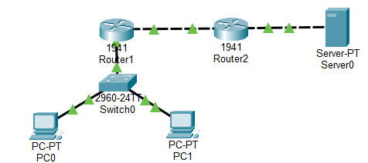
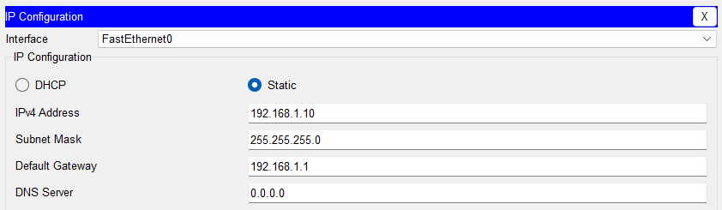

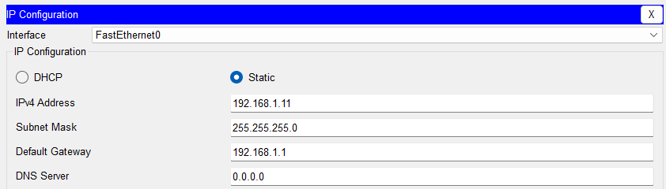

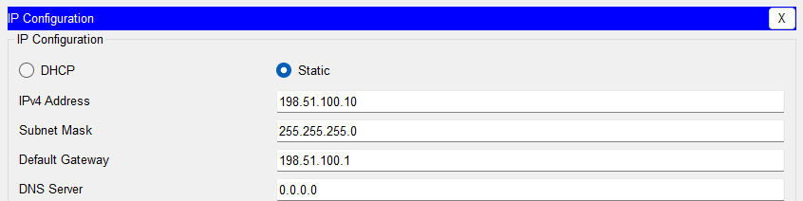

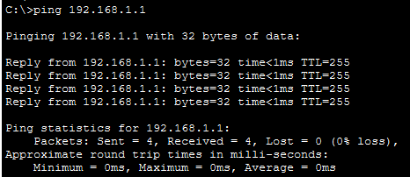

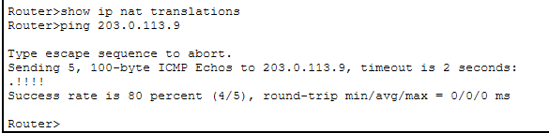

Router Configuration (NAT/PAT):
Router(config)# interface GigabitEthernet0/0/0
Router(config-if)# ip address 192.168.1.1 255.255.255.0
Router(config-if)# ip nat inside
Router(config-if)# exit
Router(config)# interface GigabitEthernet0/0/1
Router(config-if)# ip address 203.0.113.10 255.255.255.248
Router(config-if)# ip nat outside
Router(config-if)# exit
Router(config)# access-list 1 permit 192.168.1.0 0.0.255.255
Router(config)# ip nat inside source list 1 interface GigabitEthernet0/0/1 overload

E. Summary Table of Final Results
Device Name | Configured IP | Prefix | Network Address | Broadcast Address | Status / Trap Verdict
Admission PC | 172.16.45.200 | /20 | 172.16.32.0 | 172.16.47.255 | TRAP 1: Bloated Subnet (/20)
Lab Printer | 10.0.15.255 | /21 | 10.0.8.0 | 10.0.15.255 | TRAP 2: Broadcast Address Assigned
X-Ray Server | 192.168.4.0 | /23 | 192.168.4.0 | 192.168.5.255 | TRAP 3: Network ID Assigned
Clinic Router | 203.0.113.10 | /29 | 203.0.113.8 | 203.0.113.15 | VALID Host IP Address

