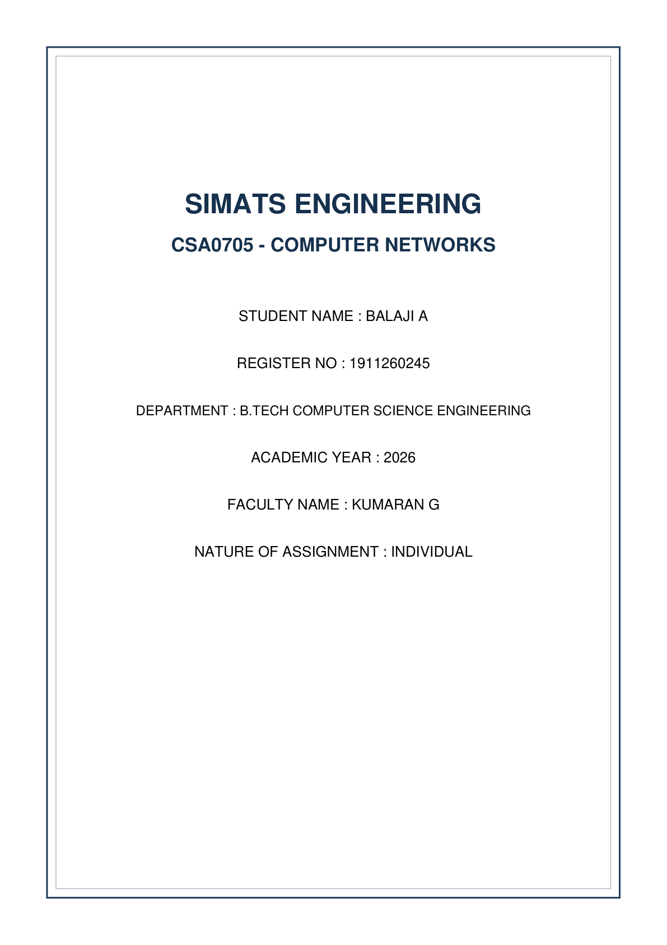


A. Understanding the Question
This problem requires designing IP subnetting plans for an engineering college campus allocated the base network address 192.168.10.0/24 (256 total IP addresses). The initial departmental requirements are:
1. Laboratories: 100 host addresses
2. Staff: 50 host addresses
3. Library: 25 host addresses
4. Point-to-Point WAN Link: 2 host addresses
The assignment demands evaluating two distinct subnetting approaches:
• Equal-Size Subnetting (Fixed Length Subnet Masking - FLSM)
• Variable Length Subnet Masking (VLSM)
Furthermore, we must solve two critical analytical traps:
1. The Hostel Trap: Six months later, a new Hostel network requiring 60 hosts is introduced. We must determine if it fits within the remaining VLSM address space without renumbering existing subnets.
2. Route Summarisation & Trap: Summarize four city campus subnets (172.16.8.0/24 through 172.16.11.0/24) into a single CIDR block, and demonstrate the routing breakdown when 172.16.12.0/24 is added under an overly broad summary (/21).
B. Detailed Step-by-Step Solution & Calculations
1. Equal-Size Subnetting (FLSM) Design
To support 4 distinct requirements with equal-sized subnets, we must divide 192.168.10.0/24 into 4 equal blocks (2^2 = 4).
• Prefix Length: /24 + 2 = /26 (Subnet Mask: 255.255.255.192).
• Block Size per Subnet: 256 / 4 = 64 addresses.
• Usable Hosts per Subnet: 64 - 2 = 62 hosts.
FLSM Analysis & Bottleneck:
• Laboratories need 100 hosts, but FLSM provides only 62 usable addresses per subnet! Therefore, FLSM FAILS immediately for the Laboratories department.
• WAN link needs only 2 hosts, but receives 64 addresses, wasting 60 IP addresses (96.8% waste).

Subnet Name | Req. Hosts | Allocated Network | Prefix | Subnet Mask | Usable Host Range | Broadcast IP
Subnet 0 (Labs) | 100 | 192.168.10.0 | /26 | 255.255.255.192 | 192.168.10.1 - 10.62 | 192.168.10.63
Subnet 1 (Staff) | 50 | 192.168.10.64 | /26 | 255.255.255.192 | 192.168.10.65 - 10.126 | 192.168.10.127
Subnet 2 (Library) | 25 | 192.168.10.128 | /26 | 255.255.255.192 | 192.168.10.129 - 10.190 | 192.168.10.191
Subnet 3 (WAN Link) | 2 | 192.168.10.192 | /26 | 255.255.255.192 | 192.168.10.193 - 10.254 | 192.168.10.255

2. Variable Length Subnet Masking (VLSM) Design
VLSM assigns block sizes matched to host requirements (sorted largest to smallest):
1. Laboratories (100 hosts): Needs 100 + 2 = 102 IPs. Next power of 2 is 128 (2^7). Prefix: /25 (Mask: 255.255.255.128).
• Network: 192.168.10.0 /25. Usable Range: 192.168.10.1 - 192.168.10.126. Broadcast: 192.168.10.127.
2. Staff (50 hosts): Needs 50 + 2 = 52 IPs. Next power of 2 is 64 (2^6). Prefix: /26 (Mask: 255.255.255.192).
• Network: 192.168.10.128 /26. Usable Range: 192.168.10.129 - 192.168.10.190. Broadcast: 192.168.10.191.
3. Library (25 hosts): Needs 25 + 2 = 27 IPs. Next power of 2 is 32 (2^5). Prefix: /27 (Mask: 255.255.255.224).
• Network: 192.168.10.192 /27. Usable Range: 192.168.10.193 - 192.168.10.222. Broadcast: 192.168.10.223.
4. Point-to-Point WAN Link (2 hosts): Needs 2 + 2 = 4 IPs (2^2). Prefix: /30 (Mask: 255.255.255.252).
• Network: 192.168.10.224 /30. Usable Range: 192.168.10.225 - 192.168.10.226. Broadcast: 192.168.10.227.
5. Remaining Free Unallocated Space: 192.168.10.228 to 192.168.10.255 (28 total IP addresses).

Department | Req. Hosts | Allocated Network | Prefix | Subnet Mask | Usable Host Range | Broadcast IP
Laboratories | 100 | 192.168.10.0 | /25 | 255.255.255.128 | 192.168.10.1 - 10.126 | 192.168.10.127
Staff | 50 | 192.168.10.128 | /26 | 255.255.255.192 | 192.168.10.129 - 10.190 | 192.168.10.191
Library | 25 | 192.168.10.192 | /27 | 255.255.255.224 | 192.168.10.193 - 10.222 | 192.168.10.223
WAN Link | 2 | 192.168.10.224 | /30 | 255.255.255.252 | 192.168.10.225 - 10.226 | 192.168.10.227
Unallocated | N/A | 192.168.10.228 | /27 (Part) | N/A | 192.168.10.228 - 10.255 | 28 IPs Free

3. The Hostel Trap Analysis
• Hostel Requirement: 60 host addresses. Needs 60 + 2 = 62 IP addresses -> Smallest power-of-two block is 64 addresses (/26 prefix).
• Current Available Space: Only 28 addresses remain (192.168.10.228 to .255).
• Question: Can it be fitted into the remaining space of the VLSM plan without renumbering?
ANSWER: NO. 28 available addresses is strictly less than the 64 required addresses.
• Smallest Change to Make it Fit (Minimal Renumbering / Expansion):
1. Expand the original parent allocation from 192.168.10.0/24 to 192.168.10.0/23 (providing 192.168.10.0 - 192.168.11.255).
2. Assign the Hostel to 192.168.11.0/26 (Host range 192.168.11.1 - 192.168.11.62, Broadcast 192.168.11.63), completely leaving existing subnets untouched!
4. Route Summarisation & Summarisation Trap Analysis
Given Subnets:
• 172.16.8.0/24 -> Binary 3rd octet: 00001 000
• 172.16.9.0/24 -> Binary 3rd octet: 00001 001
• 172.16.10.0/24 -> Binary 3rd octet: 00001 010
• 172.16.11.0/24 -> Binary 3rd octet: 00001 011
1. Correct Summary Route Calculation:
The first 22 bits are identical across all 4 networks (16 bits from first two octets + 6 bits '000010' in 3rd octet).
Summary Route = 172.16.8.0 /22 (Subnet Mask: 255.255.252.0), covering range 172.16.8.0 - 172.16.11.255.
2. The Summarisation Error Trap (Adding 172.16.12.0/24 and summarizing as 172.16.8.0/21):
• 172.16.8.0/21 covers 172.16.8.0 to 172.16.15.255.
• What goes wrong? This summary advertises routes for 172.16.13.0/24, 172.16.14.0/24, and 172.16.15.254, which might belong to entirely different remote sites or internet locations! Traffic destined for those unassigned/other locations will be incorrectly blackholed or misrouted to the City Campus router.
C. Python 3 Verification Program
import ipaddress
def vlsm_calculator():
base_net = ipaddress.IPv4Network('192.168.10.0/24')
requirements = [
('Laboratories', 100),
('Staff', 50),
('Library', 25),
('WAN Link', 2)
]
# Sort requirements largest to smallest
requirements.sort(key=lambda x: x[1], reverse=True)
current_addr = base_net.network_address
print(f"=== VLSM Allocation for Base Network: {base_net} ===")
for name, hosts in requirements:
# Calculate needed prefix length
needed_ips = hosts + 2
for prefix in range(32, -1, -1):
if (2 ** (32 - prefix)) >= needed_ips:
break
subnet = ipaddress.IPv4Network((current_addr, prefix))
first_host = list(subnet.hosts())[0]
last_host = list(subnet.hosts())[-1]
print(f"Subnet: {name:15} | Req: {hosts:3} | Network: {subnet.network_address}/{subnet.prefixlen:<2} | "
f"Mask: {subnet.netmask} | Range: {first_host} - {last_host} | Broadcast: {subnet.broadcast_address}")
current_addr = subnet.broadcast_address + 1
print(f"Next Free Unallocated IP: {current_addr} (Remaining IPs: {256 - int(current_addr - base_net.network_address)})")
# Testing Hostel addition
print("\n=== Testing Hostel Addition (60 Hosts) ===")
hostel_hosts = 60
hostel_needed = hostel_hosts + 2
if (256 - int(current_addr - base_net.network_address)) < hostel_needed:
print("RESULT: ERROR - Insufficient remaining IP addresses in /24 space!")
print("SOLUTION: Expand to 192.168.10.0/23 and allocate 192.168.11.0/26 for Hostel.")
if __name__ == "__main__":
vlsm_calculator()

Output:
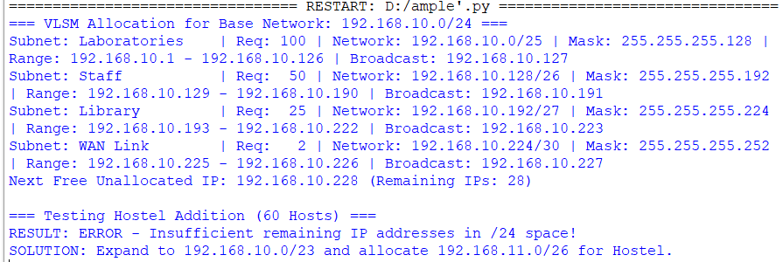

D. Alternative Concept Analysis
Alternative Scenario: Redoing the college plan starting from the smallest subnet first (WAN Link -> Library -> Staff -> Laboratories).
Why Smallest-First Allocation Fails:
1. Misalignment of IP Boundaries: Subnets in IP routing MUST align on natural bit boundaries equal to their block size (2^n). A /25 subnet (128 hosts) MUST start on a binary boundary divisible by 128 (e.g., .0 or .128).
2. Overlapping & Fragmented Space: If we allocate WAN Link at 192.168.10.0/30 (occupying .0 to .3), the next available IP is 192.168.10.4. If we then attempt to place Laboratories (/25, requiring 128 block size), it CANNOT start at 192.168.10.4! It would have to jump all the way to 192.168.10.128, leaving a massive fragmented unallocated gap from .4 to .127.
3. Conclusion: VLSM MUST always allocate subnets from largest to smallest to guarantee boundary alignment without creating unusable holes.
E. Practical Verification & Screenshot Guidance
Network Topology
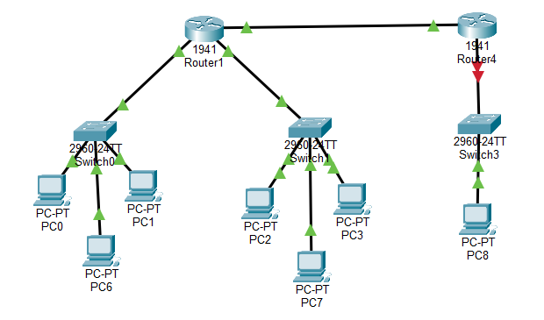

Lab IP Configuration
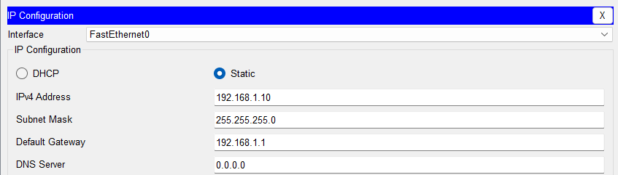
Staff IP Configuration
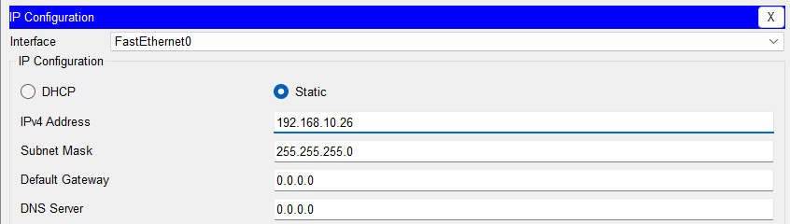

Library IP Configuration
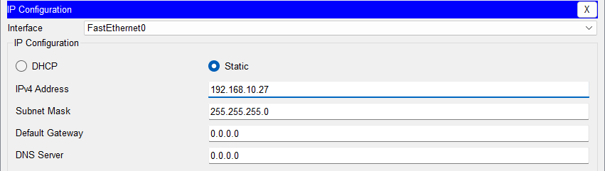

Router1 Configuration
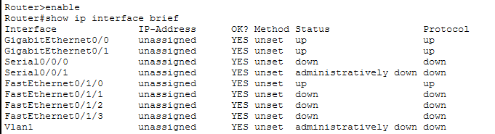

Router4 Configuration
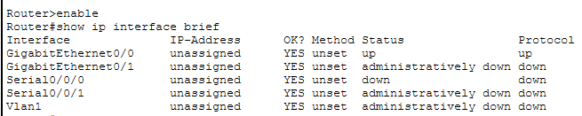

Router1 routing table
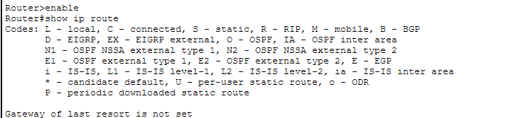

Router4 routing table


