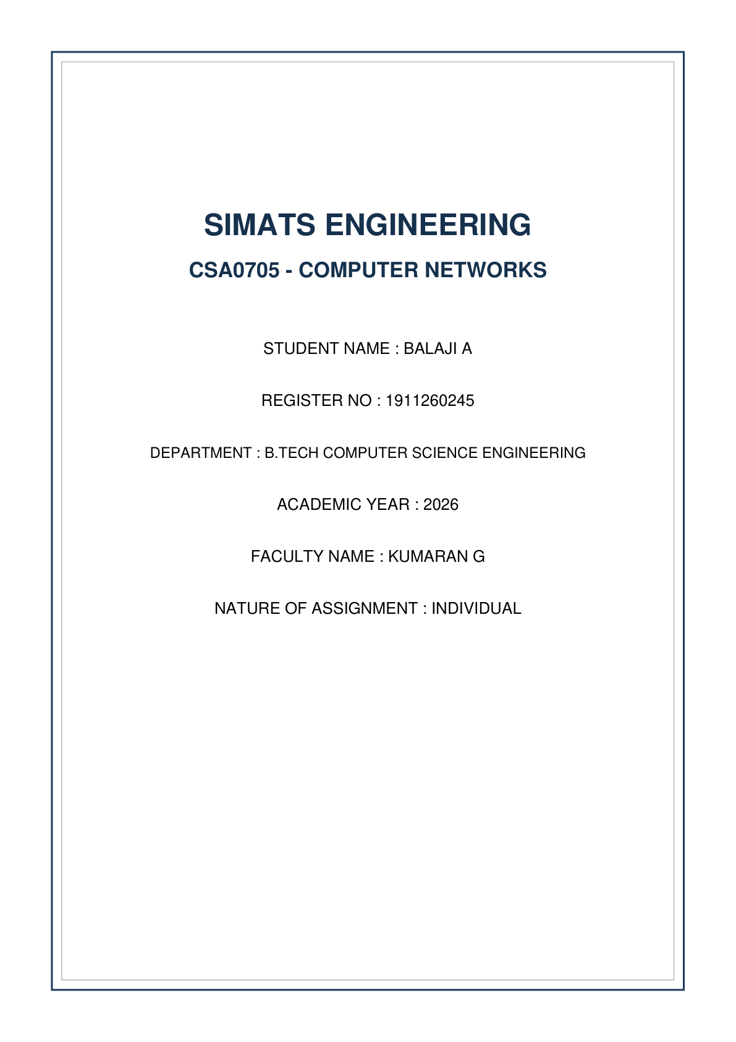


A. Understanding the Question
This question evaluates how IP routers make forwarding decisions using static routing tables and the fundamental **Longest Prefix Match (LPM)** rule. We are provided with a router's existing routing table containing multiple static routes with overlapping IP address ranges and a default route.
Given Routing Table:
• 10.0.0.0/8 via 192.0.2.1 (S)
• 10.1.0.0/16 via 192.0.2.5 (S)
• 10.1.2.0/24 via 192.0.2.9 (S)
• 10.1.2.128/25 via 192.0.2.13 (S)
• 0.0.0.0/0 via 198.51.100.1 (S - Default Route)
We are required to:
1. Determine the exact next-hop IP address for packets destined to: 10.1.2.200, 10.1.2.100, 10.1.9.9, 10.7.7.7, and 8.8.8.8, and state the governing rule.
2. Build a two-campus network (Main Campus R1 & City Campus R2) in Cisco Packet Tracer with primary and backup serial links, implementing a **Floating Static Route** (Administrative Distance 200).
3. Demonstrate link failover when the primary link is shut down.
4. Test and record the impact of removing clock rate configuration on the DCE serial interface.
B. Detailed Step-by-Step Solution & Calculations
1. Longest Prefix Match Rule & Next-Hop Evaluation
Governing Routing Rule: When an IP router receives a packet, it compares the destination IP address against all network prefixes in its routing table. If multiple routes match the destination IP, the router selects the route with the **longest prefix length (most specific mask)** because it represents the narrowest, most accurate network segment.
Destination IP | Matching Routing Table Entries | Selected Route (LPM) | Next Hop IP | Justification / Evaluation
10.1.2.200 | 10.0.0.0/8, 10.1.0.0/16, 10.1.2.0/24, 10.1.2.128/25 | 10.1.2.128/25 | 192.0.2.13 | /25 is more specific than /24, /16, /8. Range: .128-.255.
10.1.2.100 | 10.0.0.0/8, 10.1.0.0/16, 10.1.2.0/24 | 10.1.2.0/24 | 192.0.2.9 | .100 is outside /25 (.128-.255). /24 is longest match.
10.1.9.9 | 10.0.0.0/8, 10.1.0.0/16 | 10.1.0.0/16 | 192.0.2.5 | Does not match /24 or /25. Matches /16.
10.7.7.7 | 10.0.0.0/8 | 10.0.0.0/8 | 192.0.2.1 | Does not match /16, /24, /25. Matches broad /8.
8.8.8.8 | 0.0.0.0/0 | 0.0.0.0/0 | 198.51.100.1 | No 10.x.x.x route matches. System falls back to Default Route.

2. Cisco Packet Tracer Practical Configuration
Router R1 (Main Campus) Full IOS Commands:
! Router R1 Configuration
enable
configure terminal
hostname R1
! LAN Interface Setup
interface GigabitEthernet0/0/0
ip address 192.168.10.1 255.255.255.0
no shutdown
exit
! Primary WAN Serial Link (DCE side)
interface Serial0/0/0
ip address 10.0.0.1 255.255.255.252
clock rate 64000
no shutdown
exit
! Backup WAN Link
interface Serial0/0/1
ip address 10.0.0.5 255.255.255.252
clock rate 64000
no shutdown
exit
! Static Routes to City Campus LAN (192.168.20.0/24)
! Primary Static Route (Default AD = 1)
ip route 192.168.20.0 255.255.255.0 10.0.0.2
! Floating Static Route via Backup Link (AD = 200)
ip route 192.168.20.0 255.255.255.0 10.0.0.6 200
end
write memory

Router R2 (City Campus) Full IOS Commands:
! Router R2 Configuration
enable
configure terminal
hostname R2
! LAN Interface Setup
interface GigabitEthernet0/0/0
ip address 192.168.20.1 255.255.255.0
no shutdown
exit
! Primary WAN Serial Link (DTE side)
interface Serial0/0/0
ip address 10.0.0.2 255.255.255.252
no shutdown
exit
! Backup WAN Link
interface Serial0/0/1
ip address 10.0.0.6 255.255.255.252
no shutdown
exit
! Reverse Static Routes to Main Campus LAN (192.168.10.0/24)
ip route 192.168.10.0 255.255.255.0 10.0.0.1
ip route 192.168.10.0 255.255.255.0 10.0.0.5 200
end
write memory

3. DCE Clock Rate Removal & Failover Analysis
• Effect of Removing Clock Rate on DCE Interface:
If `no clock rate` is executed on R1's Serial0/0/0 interface (DCE end), the serial line driver cannot generate the hardware clocking pulse required to synchronize serial transmission. The interface line protocol immediately transitions to `Serial0/0/0 is up, line protocol is down` or `down/down`. Serial communication ceases completely.
• Floating Static Route Failover Operation:
1. Under normal operation, `show ip route` displays: `S 192.168.20.0/24 [1/0] via 10.0.0.2`.
2. When Serial0/0/0 is shut down (`shutdown`), the primary route is removed from the Routing Information Base (RIB).
3. R1 automatically installs the floating static route into the active routing table: `S 192.168.20.0/24 [200/0] via 10.0.0.6`. Ping connectivity between PC1 and PC2 is preserved across the backup link.
C. Alternative Concept Analysis
Alternative Scenario: Replacing all manual static routes with dynamic OSPF (Open Shortest Path First) routing across both campuses.
1. Configuration Line Complexity Comparison:
• 2 Campuses: Static routing requires ~2-4 route statements per router. OSPF requires ~3 commands (`router ospf 1`, `network...`). Both are comparable in small setups.
• 5 Campuses (Mesh Topology): Static routing requires N * (N-1) = 20 individual static route entries per router (100 total lines across 5 routers). Maintenance becomes unsustainable. OSPF requires only 1 or 2 network wildcard statements per router (10 total lines across network) regardless of full-mesh expansion!
2. Failover & Convergence Time Comparison:
• Static Routing with Floating Route: Link failure detection relies on physical carrier loss. Convergence takes ~1-3 seconds.
• OSPF Routing: Automatically detects link state changes via LSAs (Link State Advertisements) and recalculates Shortest Path First (SPF) tree. Convergence occurs in sub-second to ~1 second range without manual administrative distance tuning.
D. Screenshot Guidance for Submission
Network Topology:
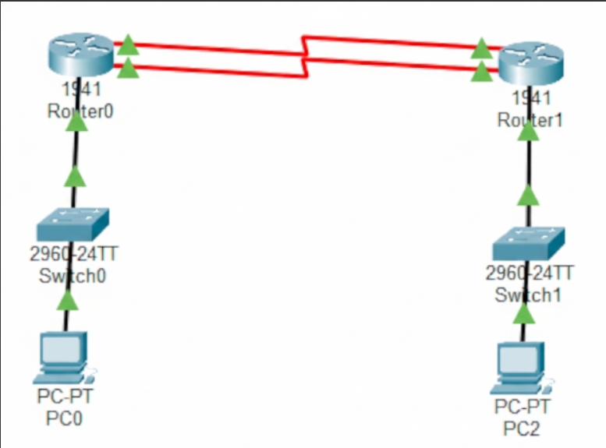

Router IPv6 Routing Table Output:


