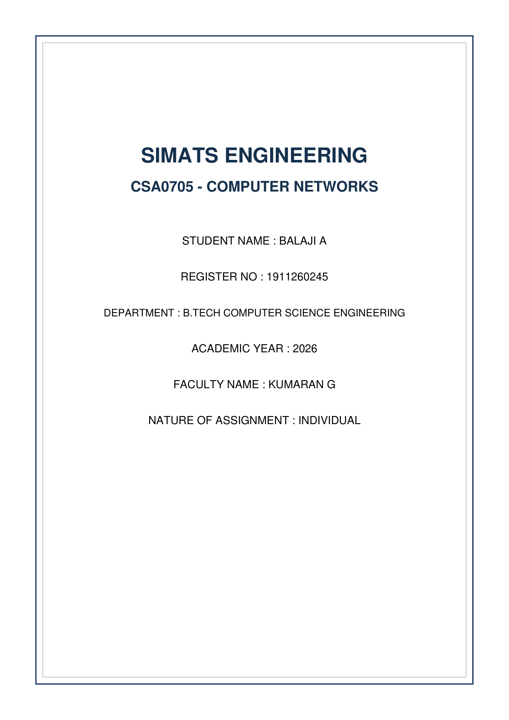


A. Understanding the Question
This question focuses on Distance-Vector routing dynamics (Bellman-Ford algorithm), examining convergence, hop-count calculation, and the classic Count-to-Infinity flaw that occurs during link failures, alongside mitigation techniques like Split Horizon with Poison Reverse.
Given Network Topologies:
1. 5-Router District Office Network: Link costs A-B = 2, A-C = 7, B-C = 3, B-D = 8, C-D = 1, D-E = 4.
2. 3-Router Line Network (X-Y-Z): Cost X-Y = 1, Y-Z = 1. Link Y-Z fails suddenly.
We are required to:
• Trace step-by-step round updates for the 5-router network until convergence.
• Explain why Router A chooses path A-B-C (cost 5) over direct link A-C (cost 7).
• Trace count-to-infinity round-by-round when link Y-Z fails, and show how Split Horizon with Poison Reverse halts the loop.
• Provide a Python 3 simulation program executing Bellman-Ford exchanges for initial convergence and link failure recovery.
B. Detailed Step-by-Step Solution & Calculations
1. 5-Router Network Convergence Trace
Initial Direct Link Costs Matrix (Unreachable = 99 / infinity):
• A: [A:0, B:2, C:7, D:99, E:99]
• B: [A:2, B:0, C:3, D:8, E:99]
• C: [A:7, B:3, C:0, D:1, E:99]
• D: [A:99, B:8, C:1, D:0, E:4]
• E: [A:99, B:99, C:99, D:4, E:0]
Round-by-Round Bellman-Ford Vector Updates:
• Round 1 (Direct Neighbor Exchanges):
- A receives vectors from B, C. A updates to C via B: Cost = 2 + 3 = 5. A updates to D via B: Cost = 2 + 8 = 10.
- B receives from A, C, D. B updates to E via D: Cost = 8 + 4 = 12.
- C receives from A, B, D. C updates to A via B: Cost = 3 + 2 = 5. C updates to E via D: Cost = 1 + 4 = 5.
- D receives from B, C, E. D updates to B via C: Cost = 1 + 3 = 4. D updates to A via C: Cost = 1 + 7 = 8.
- E receives from D. E updates to C via D: Cost = 4 + 1 = 5. E updates to B via D: Cost = 4 + 8 = 12.
• Round 2 (2-Hop Knowledge Dissemination):
- A updates to D via B-C: Cost = 2 + 4 = 6 (via B) or 7+1=8. Lowest is via B-C (2+3+1=6).
- A updates to E via D: Cost = 6 + 4 = 10.
- B updates to E via C-D: Cost = 3 + 1 + 4 = 8.
- D updates to A via C-B: Cost = 1 + 3 + 2 = 6.
• Round 3 (Full Network Convergence):
- Tables stabilize completely. No router finds a lower-cost path.
- Total Rounds to Converge = 3 Rounds.
Router | Distance to A | Distance to B | Distance to C | Distance to D | Distance to E
Router A | 0 | 2 (Direct) | 5 (via B) | 6 (via B-C) | 10 (via B-C-D)
Router B | 2 (Direct) | 0 | 3 (Direct) | 4 (via C) | 8 (via C-D)
Router C | 5 (via B) | 3 (Direct) | 0 | 1 (Direct) | 5 (via D)
Router D | 6 (via C-B) | 4 (via C) | 1 (Direct) | 0 | 4 (Direct)
Router E | 10 (via D-C-B) | 8 (via D-C) | 5 (via D) | 4 (Direct) | 0

Why Router A Prefers Path A-B-C over Direct Link A-C
• Cost of direct path A-C = 7.
• Cost of indirect path A -> B -> C = Cost(A,B) + Cost(B,C) = 2 + 3 = 5.
• Distance-vector algorithms strictly evaluate total metric cost. Since 5 < 7, Router A installs the lower-cost indirect path via B in its routing table.
2. Count-to-Infinity Trace & Poison Reverse Mitigation
Consider 3 routers in a line: X --- (1) --- Y --- (1) --- Z. Before link failure, Y's route to Z is direct (Cost=1). X's route to Z is via Y (Cost=2).
Without Split Horizon (Count to Infinity Trace):
1. Link Y-Z fails. Y sets Cost(Z) = infinity.
2. Before Y advertises this failure, X sends its vector to Y: 'I can reach Z with cost 2'.
3. Y mistakenly assumes X has an alternative path to Z! Y updates its table: Cost(Z) = Cost(Y,X) + 2 = 1 + 2 = 3 via X.
4. Next round, Y advertises Cost(Z) = 3 to X. X updates: Cost(Z) = 1 + 3 = 4 via Y.
5. X and Y ping-pong update messages, incrementing cost to 5, 6, 7... until reaching max hop count (16 in RIP = Infinity).
With Split Horizon with Poison Reverse:
• Split Horizon Rule: Never advertise a route back out of the interface from which it was learned.
• Poison Reverse Rule: Active advertisement of an infinite metric (16 / infinity) back to the source node.
• When Y loses link to Z, X advertises Cost(Z) = infinity back to Y because X learned about Z through Y. Y immediately knows X has no independent path to Z, halting the routing loop instantly in Round 1!
C. Python 3 Simulation Program
# Python 3 Distance Vector (Bellman-Ford) Simulation
INF = 99
def bellman_ford_sim():
nodes = ['A', 'B', 'C', 'D', 'E']
graph = {
'A': {'A': 0, 'B': 2, 'C': 7, 'D': INF, 'E': INF},
'B': {'A': 2, 'B': 0, 'C': 3, 'D': 8, 'E': INF},
'C': {'A': 7, 'B': 3, 'C': 0, 'D': 1, 'E': INF},
'D': {'A': INF, 'B': 8, 'C': 1, 'D': 0, 'E': 4},
'E': {'A': INF, 'B': INF, 'C': INF, 'D': 4, 'E': 0}
}
# Distance tables for each router
dist = {u: {v: graph[u][v] for v in nodes} for u in nodes}
rounds = 0
updated = True
while updated:
updated = False
rounds += 1
new_dist = {u: dist[u].copy() for u in nodes}
for u in nodes:
for v in nodes:
for neighbor in graph[u]:
if graph[u][neighbor] < INF:
if dist[neighbor][v] + graph[u][neighbor] < new_dist[u][v]:
new_dist[u][v] = dist[neighbor][v] + graph[u][neighbor]
updated = True
dist = new_dist
print(f"Initial Convergence reached in {rounds} rounds.")
print("Final Distance Table:")
for u in nodes:
print(f"{u}: {dist[u]}")
# Simulating link failure C-D
print("\n--- Simulating Link Failure C-D (Cost set to 99) ---")
graph['C']['D'] = INF
graph['D']['C'] = INF
dist['C']['D'] = INF
dist['D']['C'] = INF
rounds_fail = 0
updated = True
while updated:
updated = False
rounds_fail += 1
new_dist = {u: dist[u].copy() for u in nodes}
for u in nodes:
for v in nodes:
for neighbor in graph[u]:
if graph[u][neighbor] < INF:
if dist[neighbor][v] + graph[u][neighbor] < new_dist[u][v]:
new_dist[u][v] = dist[neighbor][v] + graph[u][neighbor]
updated = True
dist = new_dist
print(f"Re-convergence after failure reached in {rounds_fail} rounds.")
if __name__ == "__main__":
bellman_ford_sim()

Output:
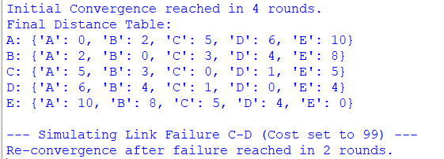

D. Alternative Concept Analysis
Alternative Scenario: Operating the 5-router network with Link-State Routing (OSPF/IS-IS) instead of Distance-Vector.
Comparison of Convergence & Overhead on Link Failure (C-D Failure):
• Distance-Vector (RIP): Routers exchange full distance vectors iteratively with immediate neighbors. Re-convergence takes multiple exchange rounds (O(V) rounds) and is susceptible to transient loops.
• Link-State (OSPF): When link C-D fails, Router C and Router D immediately flood a small Link-State Advertisement (LSA) packet across the network. Every router independently runs Dijkstra's SPF algorithm locally. Re-convergence finishes in 1 single round of flooding (<50 ms), generating vastly fewer total control messages.

E. Screenshot Guidance for Submission
Cisco IOS OSPF Interface Output


