

QUESTION 6: IPV6, ICMP, MULTICAST AND SDN IN A SMART CITY
A. Understanding the Question
This question evaluates modern networking technologies designed for a smart city environment connecting 2 million IoT sensors, high-definition traffic camera streams, and centralized Software-Defined Networking (SDN).
Key Sub-questions:
1. Abbreviate an uncompressed IPv6 address and construct an EUI-64 interface identifier from a MAC address.
2. Explain how traceroute uses the IPv4 TTL field and ICMP Time Exceeded messages.
3. Calculate the multicast MAC address for IP 239.1.2.3 and explain video stream multicast delivery.
4. Evaluate OpenFlow SDN flow table rules for incoming HTTP and SSH traffic.
B. Detailed Step-by-Step Solution & Calculations
1. IPv6 Abbreviation & EUI-64 Address Construction
• IPv6 Abbreviation:
Uncompressed IPv6: 2001:0db8:0000:0000:0000:ff00:0042:8329
Step 1 (Remove leading zeros): 2001:db8:0:0:0:ff00:42:8329
Step 2 (Compress longest zero sequence with '::'): 2001:db8::ff00:42:8329
• EUI-64 Construction from MAC 00:1A:2B:3C:4D:5E:
Step 1: Split MAC into two halves: 00:1A:2B and 3C:4D:5E.
Step 2: Insert FF:FE in the middle: 00:1A:2B:FF:FE:3C:4D:5E.
Step 3: Invert the 7th bit (Universal/Local bit). First octet 00 = 00000000 in binary -> Inverting 7th bit gives 00000010 (02 hex).
Resulting EUI-64 Identifier: 021A:2BFF:FE3C:4D5E
Full Link-Local IPv6: fe80::21a:2bff:fe3c:4d5e
2. ICMP Time Exceeded & Traceroute Mechanism
Traceroute operates by sending UDP or ICMP probes with sequentially increasing TTL values:
1. Probe 1 (TTL = 1): Reaches Router 1, TTL decrements to 0. Router 1 drops packet and sends ICMP Type 11 (Time Exceeded) back. Sender logs Hop 1 IP.
2. Probe 2 (TTL = 2): Passes Router 1, reaches Router 2, TTL decrements to 0. Router 2 returns ICMP Time Exceeded. Sender logs Hop 2 IP.
3. Process repeats until destination host is reached, mapping every intermediate router.
3. Multicast MAC Mapping & Camera Streaming
• Multicast IP given: 239.1.2.3
• Mapping Rule: The lower 23 bits of the IPv4 multicast address are mapped into the Ethernet multicast MAC prefix 01:00:5E:00:00:00.
IP 239.1.2.3 -> Low 23 bits in hex: 01:02:03.
Calculated Multicast MAC Address: 01:00:5E:01:02:03.
• Video Multicast Efficiency: The camera publishes one video stream to a multicast group. Network switches replicate packets at branch points using IGMP Snooping, sending data only to subscribed control rooms without duplicating traffic at the camera.
4. OpenFlow SDN Flow Table Evaluation
Given OpenFlow Rules:
• Rule 1 (Priority 200): dst 10.5.0.0/16 -> Forward out Port 3
• Rule 2 (Priority 100): TCP port 80 -> Send to Controller
• Rule 3 (Priority 0): Any -> Drop
Evaluations:
1. HTTP Packet to 10.5.1.1 (TCP Port 80): Matches Rule 1 and Rule 2. Rule 1 has higher priority (200 vs 100). Action: Forwarded out Port 3.
2. SSH Packet to 10.6.1.1 (TCP Port 22): Does not match Rule 1 or 2. Matches Rule 3 (Priority 0). Action: Dropped.
SDN Decision: Highly recommended for Smart City due to centralized real-time traffic control and dynamic network slice management.
C. Alternative Concept Analysis (Native IPv6 vs. Dual-Stack vs. 6in4 Tunneling)
6in4 Encapsulation Overhead Calculation:
• Sensor Payload: 100 Bytes | IPv6 Header: 40 Bytes | Outer IPv4 Header: 20 Bytes | Total: 160 Bytes
• Tunnel Overhead Percentage = (20 / 160) * 100 = 12.5% wasted overhead per packet.
Recommendation: Smart City should deploy Dual-Stack for legacy server transition and Native IPv6 for sensors to eliminate encapsulation overhead.

D. Screenshot Guidance for Submission
Network Topology
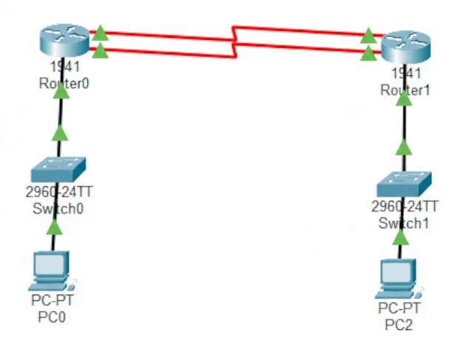

Cisco IPv6 Routing Table output for 'show ipv6 route' command.



