Bioindicators of Strawberry Creek[1]

# Things To Do Before Lab

1. **Read** this lab introduction BEFORE coming to lab and familiarize yourself with the all of the instructions listed below. **Bring a copy (in some format) of this introduction to lab.**
2. **Bring a calculator (or device with those functions)** to this lab.

# Lab Goals

The goal of this lab is to introduce you to the following concepts:

• biological organisms as indicators of ecosystem health

• use of identification keys

• calculation of metrics of biological diversity

• use of statistical tests to determine if two assemblages of organisms are different

# Introduction

Biological organisms are commonly used to indicate ecosystem health. In streams, aquatic macroinvertebrates are often used by the U.S. Environmental Protection Agency (EPA) and foreign regulatory agencies to assess the biological condition of the ecosystem. Examples of macroinvertebrates in streams include insects, crustacea, worms, clams, and snails. These organisms are useful because they are diverse, easy to sample, and have a wide range of tolerance to pollution. In addition, aquatic macroinvertebrates can give a long-term view of stream conditions because of their long life-cycles. By contrast, chemical and physical measurements only reflect the conditions when samples or measurements are taken.

In streams, biological condition is strongly influenced by water chemistry and habitat quality. Low dissolved oxygen, high bacterial, nitrate or phosphorous concentrations, and low pH, are associated with reduced water quality. Good habitat quality is generally characterized by a heterogeneous habitat with both slow and fast moving water, woody debris, substrate variety, and well-vegetated, stable banks. Impairment of habitat and/or water chemistry can lead to reduced diversity of aquatic macroinvertebrates.

# Biological Measures

There are several approaches to measure biodiversity in biological communities and the different measures each can provide different insights into ecosystem health.

## Taxon Richness (R)

Richness refers to the number of unique taxa within a sample. Taxon richness is calculated by simply totaling the number of unique taxa within a sample. A higher richness typically implies higher *habitat* diversity and better water quality conditions. Taxon richness at one location is referred to as alpha (𝛼) diversity. The difference in taxon richness between two sites is beta (𝛽) diversity, which we will explore later in lecture.

## % EPT

The insect orders Ephemeroptera, Plecoptera, and Trichoptera (EPT), are often found in clean, pollution-free streams, because the majority of these taxa are very sensitive to poor water quality. The % EPT metric is calculated as the % of the individuals in a sample that belong to the aquatic insect orders Ephemeroptera, Plecoptera, & Trichoptera.

$$\% EPT Abundance = \frac{Total \# of EPT individuals}{Total \# of individuals in the entire sample (n)}$$

## % Filterers

Measures that assess types of feeding or trophic dynamics provide information on the balance of feeding strategies (food acquisition and morphology) in the benthic invertebrate assemblages. Each of the two following metrics is calculated as:

$$\% FFG = \frac{Total number of individuals of the functional feeding group}{Total number of individuals in the sample (n)}$$

Filtering organisms use their body (in the case of the blackfly Simuliidae) or construct nets (in the case of the caddisfly family Hydropsychidae) to filter particles of organic matter out of the stream water. The predominance of filterers may reflect an unbalanced community response to an overabundance of a particular food source.

## % Predators

Predators represent a higher trophic level than filterers and grazers, and thus play an important ecological role. Predators also tend to be larger and longer-lived organisms; thus, they are more susceptible to short-term or infrequent disturbances.

## Biotic Index

The Biotic Index is a measure that is representative of the tolerance of organisms to pollution. Tolerance values on a 0 (sensitive to pollution) to 10 (tolerant of pollution) scale are assigned to different invertebrate taxa. The biotic index you use in this lab is based on the Family Biotic Index (FBI) developed by the U.S. Environmental Protection Agency originally to detect the effects of organic pollution. The FBI is the average tolerance for the community, weighted by the number of individuals in each family. FBI is calculated by the following formula:

$$FBI= \sum_{i=1}^{z}{p_{i}*t_{i}}$$

Where, *z* = number of families (taxa) represented in the sample

*x*i = number of individuals in a taxon

*n* = number of individuals in the sample

*pi* = xi/n = proportion of individuals of the *i*thtaxon or species

*t*i = tolerance value of a taxon

In another form, this formula looks like:

FBI = (*p*1 * t1) + (*p*2 * t2) + (*p* 3 * t3) …+ (*p*z * tz), *where,* 1= taxon1, 2=taxon2, 3=taxon3, … and *pi*= xi/n.

Lower FBI values imply better water quality:

**Family Biotic Index Water Quality Degree of Organic Pollution**

0.00-3.75 Excellent Organic pollution unlikely

3.76-4.25 Very Good Possible slight organic pollution

4.26-5.00 Good Some organic pollution probable

5.01-5.75 Fair Fairly substantial pollution likely

5.76-6.50 Fairly Poor Substantial pollution likely

6.51-7.25 Poor Very substantial pollution likely

7.26-10.0 Very Poor Severe organic pollution likely

## Diversity Index

As you will learn in class, in addition to taxon richness, the relative abundance of different taxa, termed evenness, is also an important aspect of biological diversity. One commonly used metric that combines taxon richness and evenness in one measure is the Shannon Diversity Index (*Hʹ*). This index was originally developed to quantify information content (entropy) in strings of text. In a string of text with more different letters and more similar relative abundance of letters, it becomes more difficult to predict the next letter in a sequence. This difficulty is a measure of diversity of letters. Likewise, in a biological sample of organisms, with more taxa and more similar relative abundance of taxa, it is more difficult to predict the identity of the next taxon in the sample, and thus the sample has higher diversity. As with other metrics, higher diversity is typically associated with better water quality.

$${Shannon Diversity Index, H}^{'}=- \sum_{i=1}^{R}{ p_{i} ln p_{i}}$$

where, *R* = number of taxa represented (taxon richness), *pi* = proportion of individuals of the *i*thtaxon or species, and ln is the natural logarithmic function. Including a logarithm in the formula weights the higher percentages less heavily. Don’t forget the “-” sign in front of the sum.

In another form, this formula looks like:

*Hʹ* = - ( (*p*1 * ln*p*1) + (*p*2 * ln*p*2) + (*p*3 * ln*p*3) …+ (*p*R * ln*p*R) ), *where,* 1= taxon1, 2=taxon2, 3=taxon3, … .

# Using Keys

Keys are a frequently used method for identifying plants and animals. In **dichotomous** keys a series of statements are organized in **couplets**, each comprising two descriptions (usually labeled “a.” and “b.”) that represent mutually exclusive choices. Beginning at the first couplet of the dichotomous key, read **both** options and decide which description matches the organism you are trying to identify. At the end of the descriptions are numbers that indicate the next couplet to advance to. This process is repeated until an identification is made. At this point a verification step is important: compare the specimen with any details in the description and/or any available figures. If the description seems satisfactory, a correct identification probably has been achieved. If the description is not satisfactory in one or more important particulars, back up to some earlier couplet and start over, questioning each decision more carefully.

With the use of computers and on-line resources, it is becoming increasingly common to see keys presented as a list of statements and/or images, of which the user selects those that pertain to the organisms of questions, and then the computer directs the user to more and more specific characters. In addition, identification of images on-line or with apps is now common, through efforts of citizen scientists, or experts, as with the on-line resources *iNaturalist* or *eBird*, or through artificial intelligence (AI).

# Assignment

You will use aquatic macroinvertebrates that live in streams to assess water quality of the North and South Forks of Strawberry Creek. You will determine whether the invertebrate community from each fork contains relatively more pollution sensitive organisms or if it is dominated by pollution tolerant organisms. Because of the impact of sampling on the creek by a large class such as ours, insect samples were already taken and are stored in ethanol for preservation. You will assume that South Fork samples are taken from Strawberry Canyon (east of the football stadium) and that North Fork samples are taken from the North Gate area of campus. First, look at the map and consider where each fork is located also consider any historical information provided and think about potential causes of differences in water quality between the two forks. Then, with your group, state your hypothesis about the relative water quality between the North and South Forks.

Using resampling methods in a Jupyter Notebook, you will determine if the measures describing aquatic insects found in the two forks of Strawberry Creek are significantly different between the North and South Forks. For each metric you will test the hypothesis that the water quality in the two forks is different. The null hypothesis (H0) for each test is that there is no difference in water quality between the two forks. Your group will complete a lab write-up to report your findings and explain your conclusions with respect to the data and your hypothesis. Follow the guidelines for lab write-ups to complete this assignment. Before lab familiarize yourself with the methods described below.

## Methods for Biological Assessment

1. Each group should identify 50 organisms from both the North Fork and South Fork of Strawberry Creek. Each flask contains 5 organisms; thus, your group will need to examine 10 flasks from each fork. Identify all of the organisms in a flask before beginning the next flask. In order to ensure there are enough flasks available, each group should only take 5 flasks at any time.
2. Use a dissecting microscope to examine the organisms. Some of the features are difficult to see with your naked eye.
3. Select one organism to identify using the dichotomous key. At the beginning of the key (couplet 1), decide which of the statements (a. or b.) matches the organism you are looking at. At the end of the descriptions are numbers that indicate the next couplet to advance to. Repeat this process until an identification is made. Record the name of the taxa on the appropriate worksheet (North Fork or South Fork).
4. As you identify more invertebrates, keep a tally of the number of organisms of each taxa you find in each vial on the data sheet.
5. Once you have identified 50 organisms, use the worksheet to calculate the biological metrics 1-6 as described above. When you are done, write your results for all five metrics on the chalkboard or in the excel spreadsheet.
6. In the Jupyter Notebook, you will use data from the last 3 years and resampling tools to determine if there is a significant difference in each of the metrics between the North Fork and South Forks.

## Common Insect Terms

**head capsule** - a clearly differentiated and hardened head segment.

**prolegs** - little nubbed legs, without joints (like on a caterpillar).

**labium** - lower lip, as seen from underside of head.

**caudal filament** - long, slender tails of end of abdomen.

**gills** - respiratory organs that can appear as small bunches or as long plate like structures (Figs. 1-3).

**tarsal claws** - claws on very end of legs.

# Insect Morphology

dorsal anterior

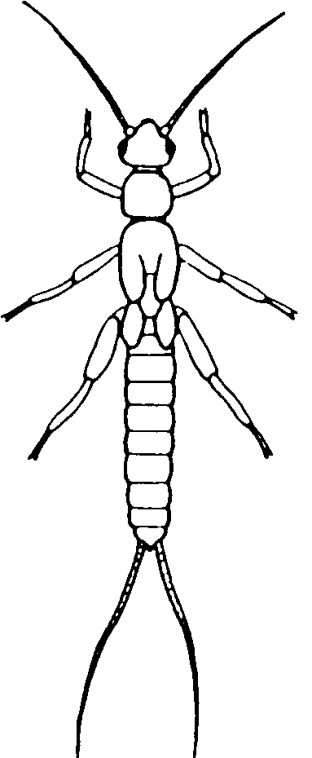

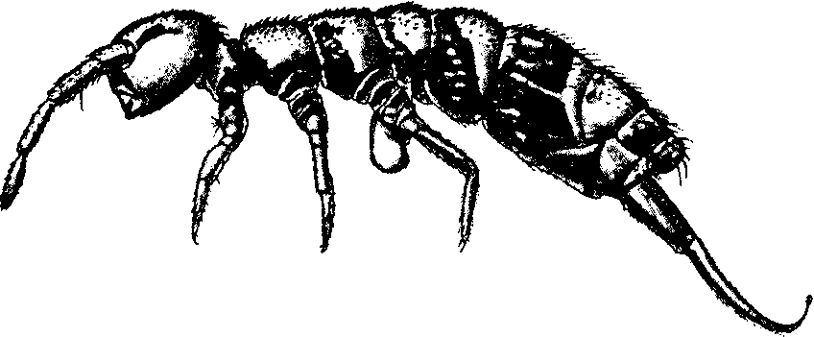

posterior lateral medial lateral

ventral posterior



# Taxonomy, Biotic Index Scores, and Functional Feeding Groups of Invertebrates in Strawberry Creek

***(tolerance score and functional feeding group given in parentheses)***

Phylum Annelida

Class Oligochaeta – aquatic earthworms (8, C)

Phylum Arthropoda

Class Crustacea

Order Amphipoda – scuds (4, C)

Class Insecta

Order Odonata

Suborder Anisoptera - dragonflies (3, P)

Order Ephemeroptera – mayflies

Family Ephemerellidae (1, C)

Order Plecoptera – stoneflies

Family Perlidae (1, P)

Order Megaloptera

Family Corydalidae – hellgrammites (0, P)

Order Trichoptera – caddisflies

Family Hydropsychidae (4, F)

Order Diptera

Family Simuliidae – black flies (6, F)

Family Tipulidae – crane flies (3, S)

Order Coleoptera

Family Psephenidae – water pennies (4, G)

Phylum Mollusca

Class Gastropoda – snails (7, G)

Class Bivalvia – clams (8, F)

**Key to the Functional Feeding Groups**

C = Collector

F = Filterer

G = Grazer

S = Shredder

P = Predator

# Dichotomous key to the Benthic Invertebrates of Strawberry Creek

1. a. With a hard, calcareous shell 2

b. Without a shell 3

2. a. Shell spiral-shaped Mollusca-Gastropoda

b. Shell with two halves Mollusca-Bivalvia

3. a. Thorax with more than 6 jointed legs Crustacea- Amphipoda

b. Thorax with 6 or fewer legs 4

4. a. 6 jointed legs and distinct head, thorax and abdomen 5

b. No legs 10

5. a. Abdomen with 2 or 3 tail-like projections (Fig.1) 6

b. Abdomen without a tail or with 1 single projection 7

6. a. Abdomen with 2 tail-like projections, thorax with gill tufts between the bases of the legs (Fig. 2) Plecoptera-Perlidae

b. Abdomen with 3 tail-like projections, paddle-like gills on abdominal segments (Fig. 3) Ephemeroptera-Ephemerellidae

7. a. Body disk-shaped with hardened plates covering the head and legs Coleoptera- Psephenidae

b. Body not disk-shaped 8

8. a. Abdomen lacks hardened plates, and has gill tufts on ventral abdominal segments (Fig.4) Trichoptera-Hydropsychidae

b. Abdomen with hardened plates (Fig. 5)…………….…………………………...………... 9

9. a. Abdominal segments with 1 long lateral filament on each side per segment (Fig.5) Megaloptera-Corydalidae

b. Lacks abdominal filaments, body thick and stout Odonata-Anisoptera

10. a. Body with a distinct head, fan-like feeding structures (Fig.6), bulbous posterior abdomen Diptera-Simuliidae

b. Body with indistinct or retracted head 11

11. a. Maggot-like body with fleshy protrusions at end of abdomen (Fig.7) Diptera- Tipulidae

b. Worm-like body with many segments Annelida-Oligochaeta

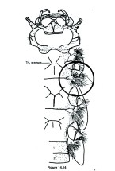

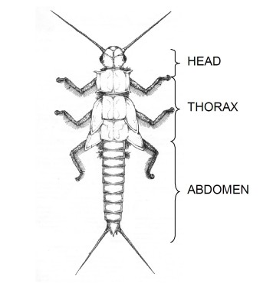

Fig.1. Tail-like projections (dorsal view)

Fig. 2. Gill tufts between the legs (ventral view)

Fig. 3. Paddle-like gills on abdominal segments (dorsal view)

Fig. 4. Gill tufts on ventral abdominal segments (lateral view)

Fig. 5. Hardened abdominal plates and lateral filaments

on abdomen (dorsal view)

Fig. 6. Fan-like feeding structures on head capsule (dorsal view)

on abdomen (dorsal view)

Fig.7. Fleshy protrusions at end of abdomen (lateral view)

1. Developed by Vincent Resh and Emily Betts, revised by Maggie Groff and Matt Cover (April 2007), George Roderick, Jupyter Team (Dec 2019)