**List**

1. The lists are ordered.
2. The element of the list can access by index.
3. The lists are the mutable type.
4. A list can store the number of various elements.

**Indexing and slicing :**

**Indexing:** Selection of single element

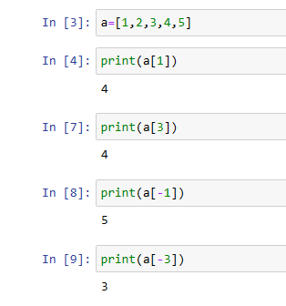

**Slicing:**

Selection of multiple elements

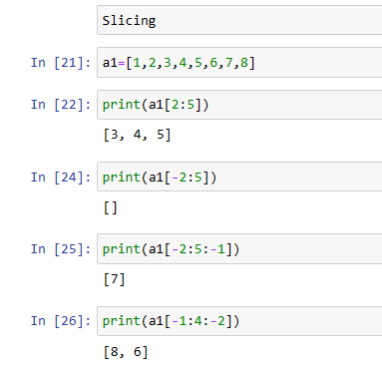

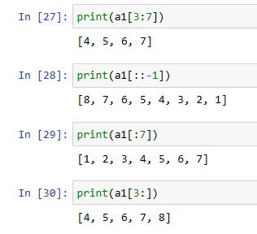

**Built in Functions:**

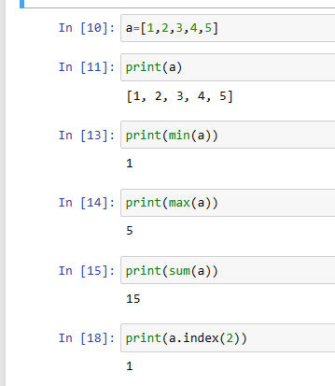

**Extend:**

Multiple elements will add in the end of the list

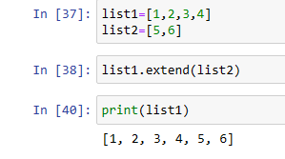

**Append:**

Single element will add in the end of the list

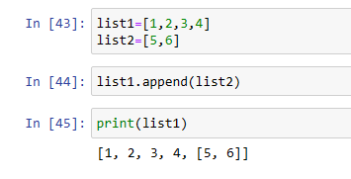

**INSERT:**

**POP: -** it removes last element.

- It removes the element based on index

How to remove last item:

How to remove 1st index position item:

**CLEAR: it empties the list**

**REMOVE: it removes an item from the list**

**REVERSE:**

**SORT:**

Sort the list numerically

Sort the list alphabetically

Sort the list in Ascending order

Sort the list in descending order: