**Dictionary**

1. Dictionaries are written with curly brackets
2. **A dictionary in Python** is a data structure that stores the value in key: value pairs.

1. Keys can’t be repeated and must be *immutable*.

1. Whereas Values in a dictionary can be of any data type and can be duplicated,

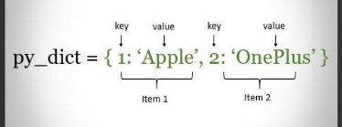

**Built-in Functions**

**Keys:**

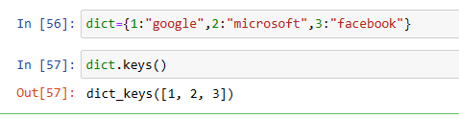

**Values:**

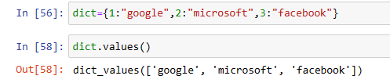

**Items:**

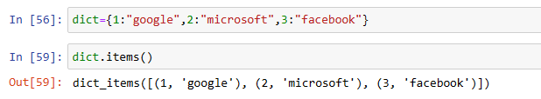

**Copy :**

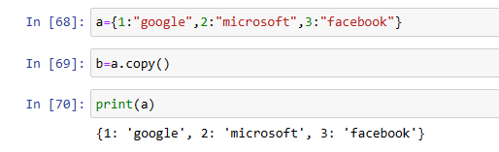

**Get**: to get the value associated with key

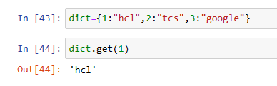

**Update:** Updates dictionary with specified key-value pairs

1st method:

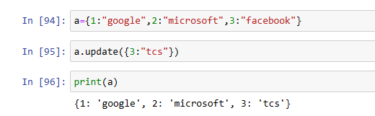

2nd method:

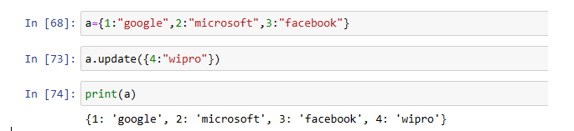

**Pop:**

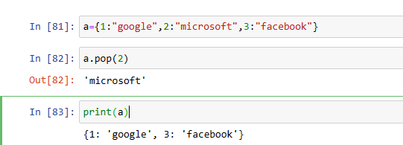

**Pop item:**

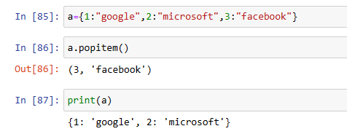

**Clear:** it removes all the elements from the dictionary

