DATABASE MANAGEMENT SYSTEM AND IMPLEMENTATION

PROJECT – PHASE – 2
Group - 6
Balaji Chandrasekaran – 1208948451
Tharani Venkata Narayanan – 1208798808
Vimal Khanna Vadivelu - 1209203043

Abstract

MiniBase is a database management system in java. This assignment deals with the understanding of the same. It is a relational database which was designed for the purpose of giving hands on experience for the students in which they can further enhance the same. The MiniBase that has been given is made of several parts, they are a buffer manager, disk manager, heap and index storages, b+ tree structure and Iterator for data scan, Query Processor, Optimizer and parser, Execution planner. All these components paves way for the management of the data and for processing queries.
OS: Ubuntu 14.04
Introduction:
This test report deals with Information on the implementation of phase 2 of the project in which we were asked to implement spatial object into the minibase and as well spatial index for the spatial objects using the R-Tree mechanism similar to the B-Tree.

We divided the phase two of the project into two major parts:-
1) Implementation of spatial Data into Minibase.
2) Implementation of R-Tree for indexing purpose of the spatial object.
Implementation of Spatial Data:
In this part we implemented Spatial data object for representing Rectangle and Circle and for processing them, similar to the implementation of int and string in the Minibase.
Files modified or created for the purpose:
- Convert.java
- Sdo_geometry.java
- Tuple.java
- TupleUtils.java
- FileScan.java
- Projection.java
- sortMerge.java
- BTTest.java
- CTSTest.java
- STSTest1.java
- STSTest2.java
- STSTest3.java
Tests Description:
In this Test we verify the implementation of spatial data in Minibase. We carry out the required Tests asked to carry out in the project description, which involves the following tests:

Test1: Create Table For Accomadating Spatial Data:
- In this test we create a table in which one of the column consists of type spatial data object in which we can store spatial objects like rectangle and circle.

Ex: Query Executed:-
CREATE TABLE cola_markets (
mkt_id NUMBER PRIMARY KEY,
name VARCHAR2(32),
shape SDO_GEOMETRY)

- The above query is executed which creates a schema of a table of cola_markets which consists of three columns which are one primary key column of number type, one name column of varchar and one column of sdo_geometry type.
Test2: Inserting Records Into the Table That was created in The previous step:
- In this test we try to insert spatial objects i.e rows into the table that was created in the previous step of the spatial data implementation process.
- Query Executed:
INSERT INTO cola_markets VALUES(1,'cola_a',SDO_GEOMETRY(RECTANGLE,{1.0, 1.0, 2.0, 3.0}))
INSERT INTO cola_markets VALUES(1,'cola_b',SDO_GEOMETRY(CIRCLE,{0.5, 0.5, 3.0, 3.0}))
- Thus the above two queries are executed i.e implemented, which created two tuples i.e two rows, each row containing a spatial data object.
- The first row in cola_markets thus consists of a sd o_geometry object named as cola_a and is of type Rectangle with the corresponding coordinates given.
- The second row in cola_markets thus consists of a sd o_geometry object named as cola_b and is of type Circle with the corresponding coordinates given.

Test3: Find the Area of a Sdo_geometry shape present in the table:
- In this test we test the implemented function for calculating the area of the sdo_geomtry shape that is present in the table, for this pupose we choose to calculate the are of the circle that is present in the table.
- Query Executed:
SELECT c_a.name, SDO_AREA(c_b.shape, 0.005)
FROM cola_markets c_a, cola_markets c_b
WHERE c_a.name = 'cola_b'
- The above query when processed selected the shape from the table whose name is “cola_b” and returns the name and area of the corresponding one.
Test4: Find the Intersection of Two geometry shapes present in the table:
- In this test we try to find the intersection of the two shapes that is present in the sdo_geometry table.
- The following query is being executed:
SELECT c.name, SDO_INTERSECTION(c_a.shape,c_b.shape,0.005)
FROM cola_markets c_a, cola_markets c_b
WHERE c_a.name = 'cola_a' and c_b.name = 'cola_b'
- This query when excuted returns if there is a intersection and type of the same.
- For the above shape that is for a rectangle and circle when executed returns a rectangle wth intersection i.e shape of it.
- We convert the Circle into rectangle with the help of inbuilt ellipse2d function which when called gives a stricter bound of the circle, i.e gives a rectangle withing which the circle can be enclosed tightly.
- After obtaining the bounds by using the getbounds() function in the ellipse2d we use the same to match it with the other rectangle shape that is present inorder to find the intersection of both of them using the inbuilt function in the rectangle2d class in java which returns the intersection of two rectangles.
Test4: Find the Distance Between Two geometry shapes present in the table:
- In this test we intially modify the input data that is present in the table, i.e the spatial objects present in the table so that there is no intersection.
- Query: SELECT c.name, SDO_DISTANCE(c_a.shape,c_b.shape,0.005) FROM cola_markets
- With the help of a query similar to the above one we find out the distance between the two shapes that is present in the table.
- The distance is calculated with the help of inbuilt function present in the rectangle2d class which returns the distance of the two shapes. For ease of understanding we take both the shapes to be rectangle and find their distance between them in this case.
Thus, All of the above tests helps in verifying the correctness of the implementation of the spatial data support for the Minibase.
The second part of phase two was much trickier than this part and consumed a lot of time.This part of implementation involves implementation of spatial index i.e indexing of spatial data.
Screen Shots:
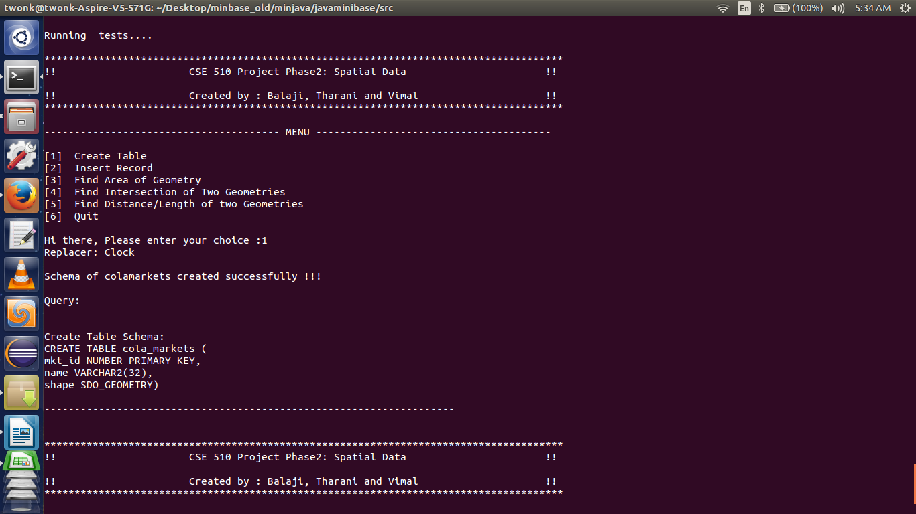

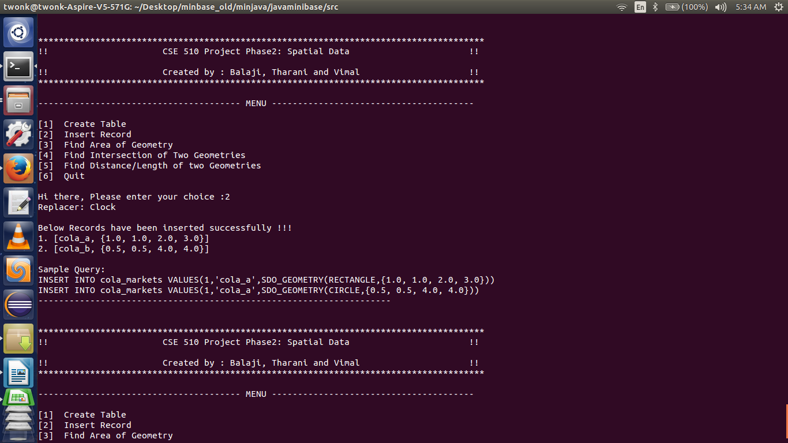

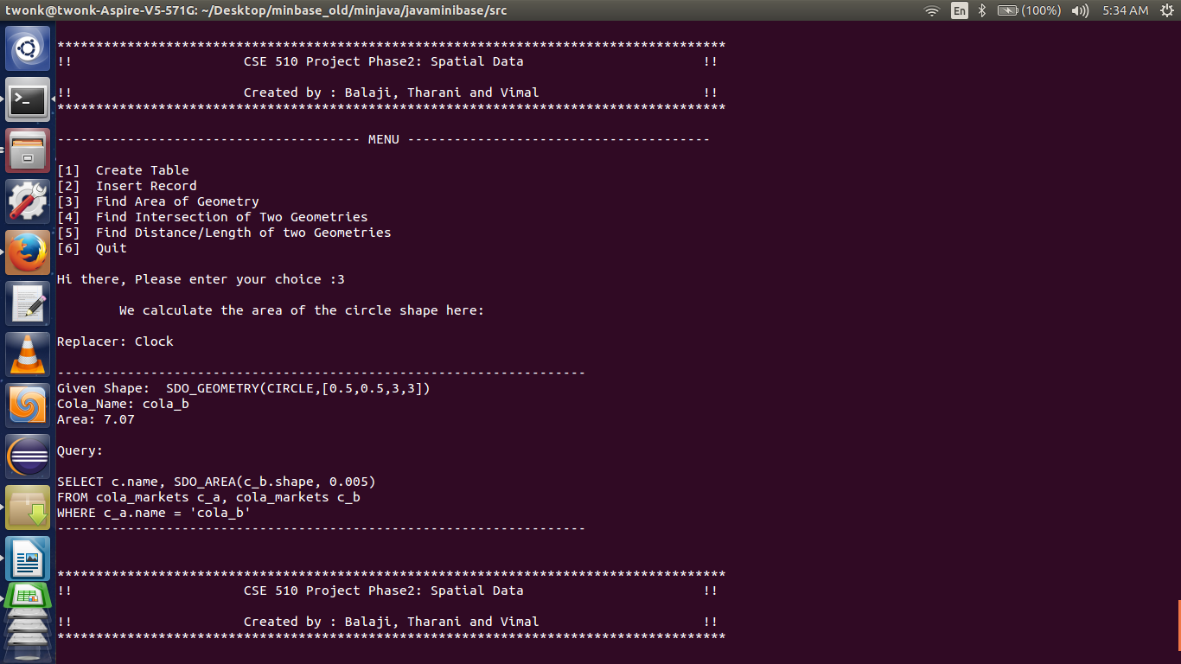

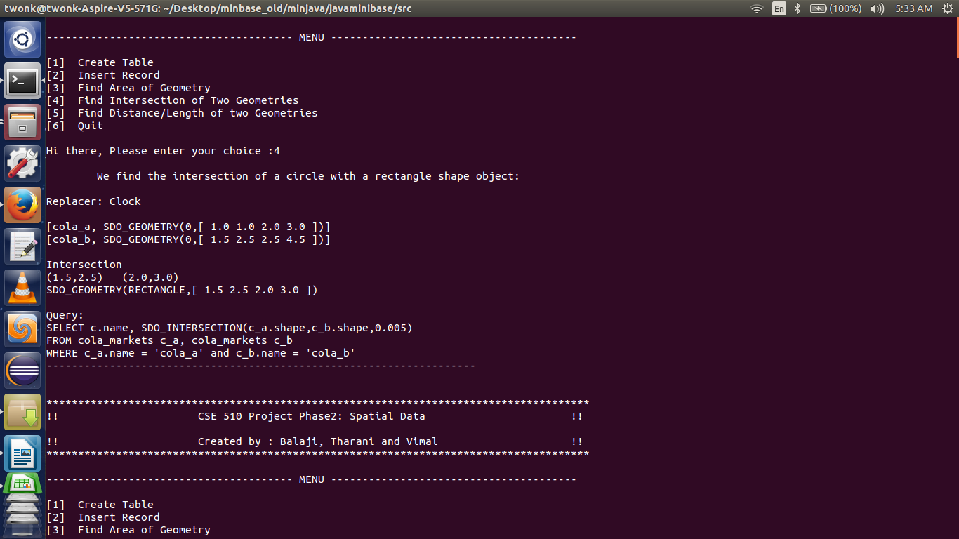
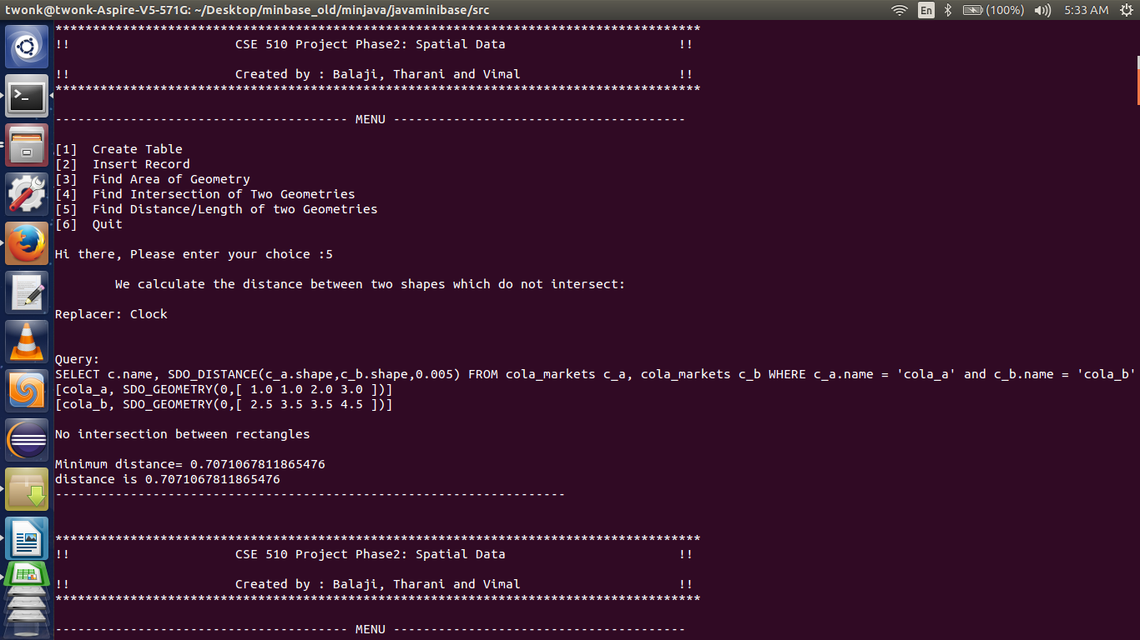
Implementation of R-Tree for indexing purpose of the spatial object.
In this part of the project we implemented the R-tree similar to the b-tree for the indexing pupose of the spatial data object.
This part of the project was very interesting and helped in gaining new knowledge on a whole new paradigm of concept R-tree which helps in indexing even the spatial data objects from rectangle to point.
R-trees are tree data structures used for spatial access methods, i.e., for indexing multi-dimensional information such as geographical coordinates, rectangles or polygons.
A common real-world usage for an R-tree might be to store spatial objects such as restaurant locations or the polygons that typical maps are made of: streets, buildings, outlines of lakes, coastlines, etc. and then find answers quickly to queries such as "Find all museums within 2 km of my current location", "retrieve all road segments within 2 km of my location" (to display them in a navigation system) or "find the nearest gas station" (although not taking roads into account). The R-tree can also accelerate nearest neighbor search for various distance metrics, including great-circle distance.
Ex R-Tree of 2D Rectangles:
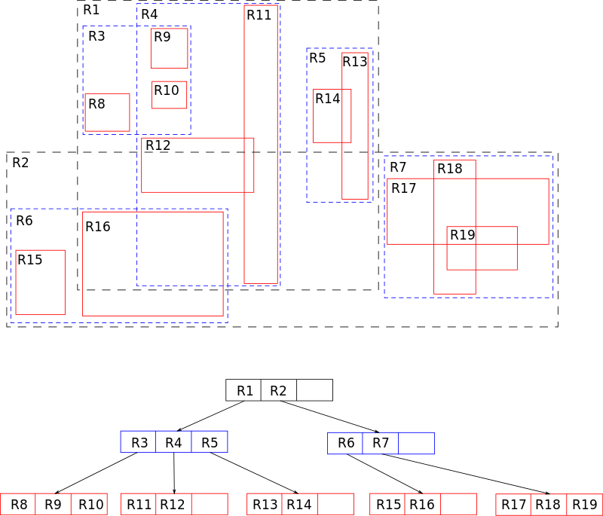

We have implemented R-Tree for the above purpose, we have created a generalized R-tree which can hold any kind of sdo_geometry obect.
Files modified or created for the purpose:
- Rtree.java
- SpatialIndexTest.java
Tests Description:
In this we create and run several simple test for the purpose of verifying the implementation of Spatial Indexing using Rtree.
Test1: Inserting a point into the R-Tree
- In This test we try to enter a point into the R-tree as a point is also a spatial object.

Test2: Inserting a Rectangle into the R-Tree
- In this test we try to insert a spatial object whose shape is a rectangle and check if its inserted properly.

Test3: Inserting a Negative Coordinate into the R-Tree
- In this test we try to insert a negative coordinate into the R-tree and check if its inserted properly. Negative Coordinates are also part of spatial data objects.

Test4: Test for Emptiness of the R-Tree
In this test we try to check for the emptiness of a R-Tree and first in this test we check an empty R-tree and then we insert a object and remove it and again check for the emptiness which is the reason there are two Prints in the output.

Test5: Spatial Index Test for Splitting small nodes in R-Tree
In this test we split small node in R-tree and check for its correctness with the node before splitting.

Test6: Removing all nodes from R-Tree
- In this test we first insert 100 records and then remove all of the indexing from the R-Tree and verify whether all the nodes from the R-Tree are removed completely.

Test7: Spatial Index Test for Splitting small nodes in R-Tree
In this test we split larger nodes in R-tree and check for its correctness with the node before splitting. In case of larger nodes splitting we have to account for the overflowing of the R-tree which is taken care and I verified in this test.

Test8: Deleting nodes from the R-Tress
In this test we try to delete the nodes that are present in the R-Tree, we delete the nodes by selecting one of them and verify that the R-Tree gets balanced and check that the removing of node does not affect the R-Tree.

Test9: Spatial Index Test for Inserting Circle in R-Tree
In this test we insert a circle into the R-tree verify the same.

Screen Shots:
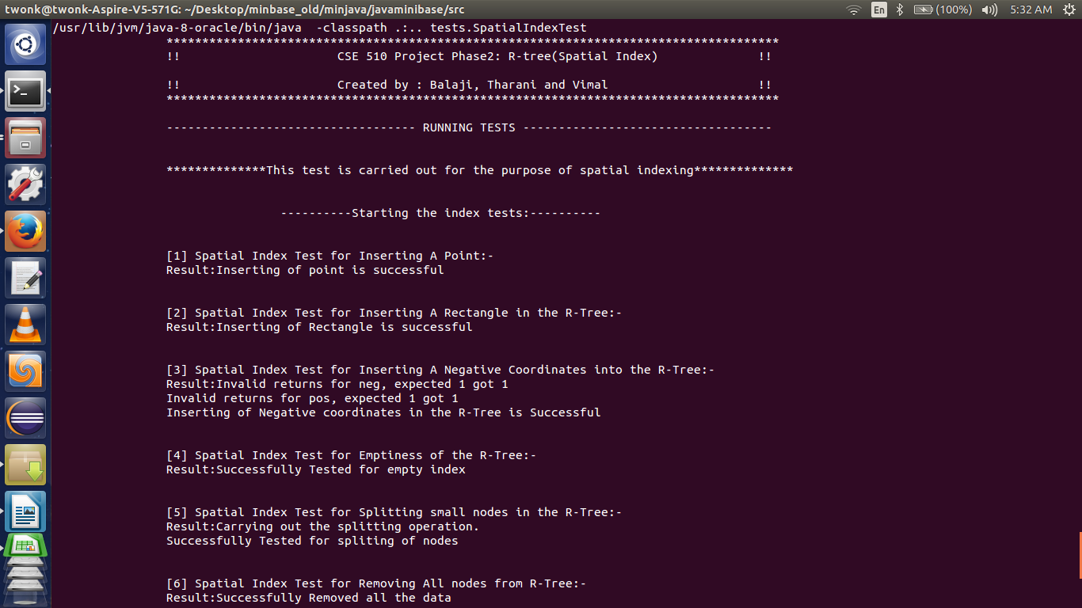

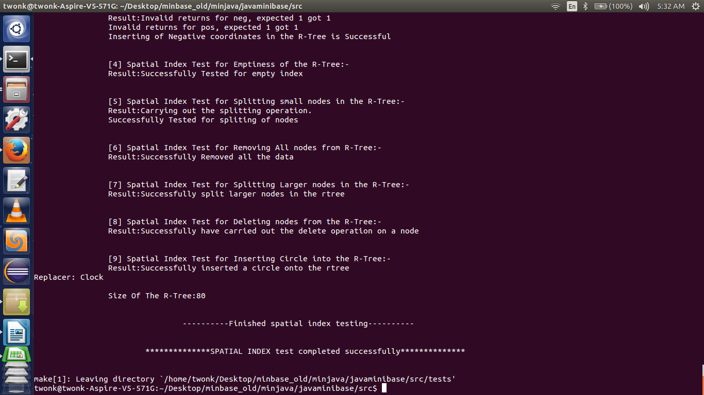

Conclusion:

Thus in the second phase of the project we have implemented spatial data object in Minibase, thus now Minibase is capable of handling the Spatial data objects and we have also implemented indexing for the spatial data objects in this phase, which helped in gaining great insight about the represtation and processing of spatial data in real life scenarios.

