Lab 4 Digital Image Classification using R (20 points)

1. Objective
To implement digital image classification with R

2. Theory
Since the advent of space-borne digital remote sensing, the land surface is essentially scanned as digital images whose brightness is proportional to the reflected energy in a predetermined spectrum in a wall-to-wall manner. Multispectral images are composed of multiple such images, each of which is generated from a different spectrum, such as Landsat TM/ETM+/OLI imagery contains such images from 6 difference ranges of wavelengths (also called channels or bands). Percent energy reflected in a particular wavelength is an inherent physical properly of the land surface features. Therefore, it is possible to sort the land surface into different features based on the percentage energy returned from the land surface in different spectrum. This process is called digital image classification. It is one of the most common applications of optical remote sensing. Therefore numerous algorithms have been developed in literature. It is impossible to review all of them in a single laboratory exercise. In general, there are two kinds of algorithms: (1) those based on image statistics, and (2) those based on machine learning. The machine learning algorithms, such as CART (Classification and Regression Trees), artificial neural networks, Random Forest, and support vector machine, more or less function as a black box. Users usually do not have a clear idea for how the work gets done. Because the classification is based on learning, no statistical parameters are used, thus they are also called the nonparametric algorithms. Since no statistical parameters (e.g. the mean and variance) are used in the classification, there is no need to assume that image data follows a particular statistical distribution (e.g. normal distribution). This is a big advantage of machine learning algorithms.

3. Classification Steps
3.1 Data Needed

- We will use a Landsat8 OLI image for the classification. The image covers a portion of Shanghai city, China. The acquisition date for this image is August 3 2015. The Landsat image can be downloaded from the glovis website (https://glovis.usgs.gov) or Earthexplorer (https://earthexplorer.usgs.gov/). For this lab, we will only use a spatial subset of this landsat image. It’s available in the lab4 folder [landsat.tif].
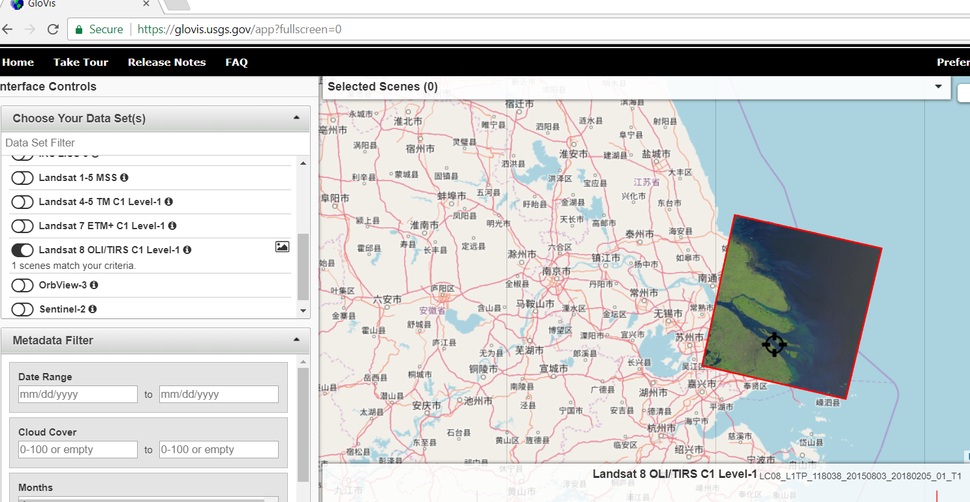

3.2 Collect training data
- Training sets are areas that you delineate in the image with known land-cover types. The computer will use the training sets as examples for each of the classes you specify and classify the rest of the image into these classes. A training set can be all pixels within a polygon, all pixels along a line, or a collection of points. Depending on the classifier you choose for the classification, these data will be used differently. Normally you would use ArcGIS/QGIS/ENVI software to draw training areas/polygons for each land cover class. For this lab, we will use a shapefile [trainingdata.shp] provided by my collaborators in Shanghai to simplify your task. The shapefile is available in your lab4 folder.

- Start ArcMap and take a quick look at trainingdata polygons and their attributes. You should see several land cover classes: urban, cropland, forest/shrub, and water.

- Start Rstudio and use a R script/Markdown for this lab. Key steps are list below:

Step1: Import trainingdata polygon and landsat image using readOGR() and raster() function, respectively. Note landsat.tif includes 6 spectral bands or layers. You can import specific band/layer using:
band1<-raster('landsat.tif',band=1) #read band1
band2<-raster('landsat.tif',band=2) #read band2
…
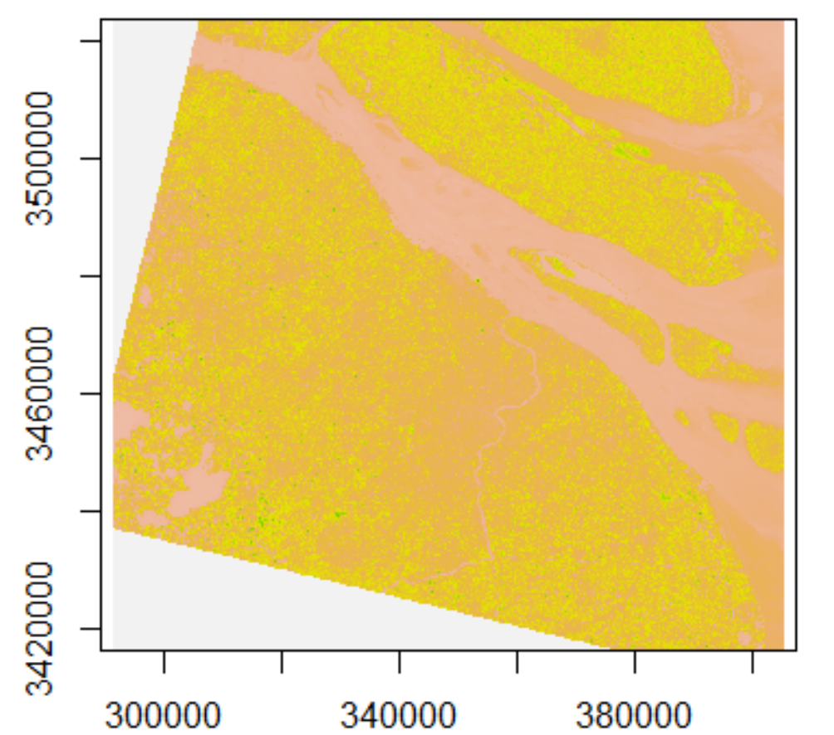

Step2: Rasterize the trainingdata polygon using rasterize() function. You may use one of the landsat band as a template for the task. Through this step, all polygons will be converted to raster pixels and land cover classes are represented as different pixel values.
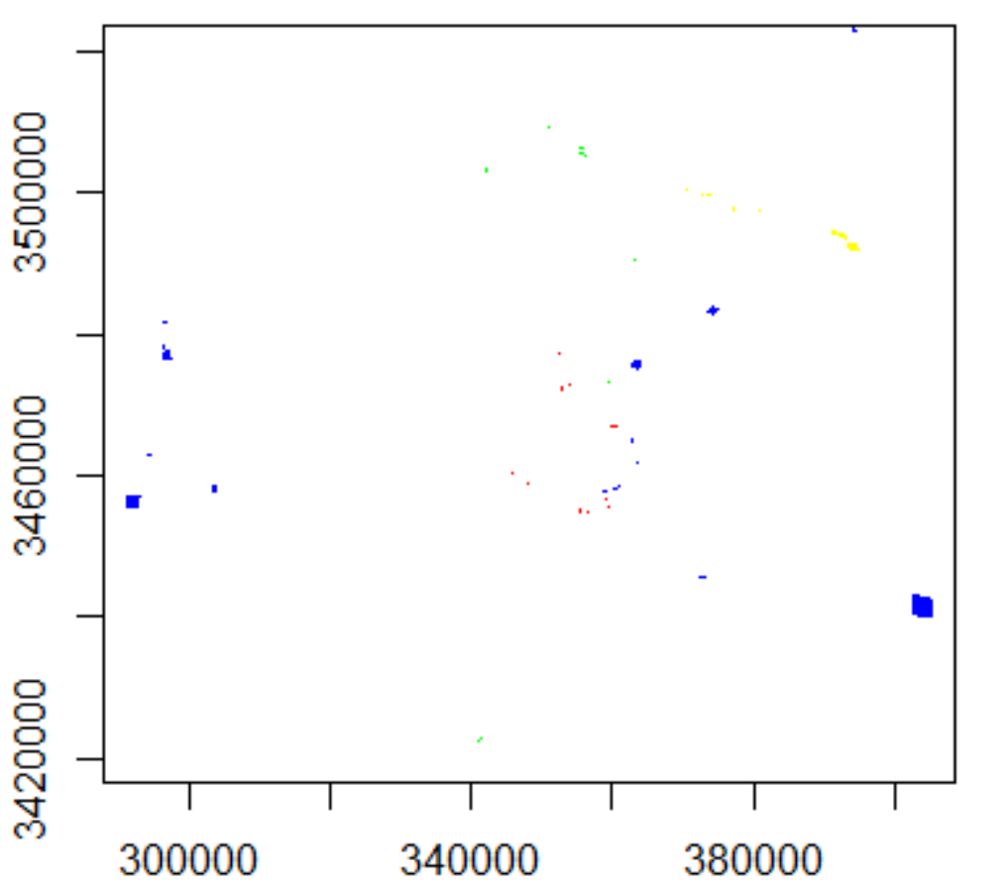

Step3: Now you need to prepare training dataset for image classification.

train_band1<-band1[t_raster>0]
train_band2<-band2[t_raster>0]
……
Where t_raster is a raster object you just created in step2 of rasterization.

y<-t_raster[t_raster>0]
Where y is a vector of land cover class labels.

Put training data together as a R dataframe.

alltraining<-data.frame(y,band1=train_band1,band2=train_band2,……)

- Build a random forest classifier using the alltraining dataset you just created.
The Random forest algorithm is an extension of classification and regression trees (CART). It grows a large number of decision trees and then takes an ensemble approach to obtain final predictions (Breiman, 2001). The random forest algorithm is now increasingly used in the remote sensing community due to its good balance of generalization ability with ease of implementation. Compared to other machine learning algorithms such as neural networks and support vector machines, the RF requires less parameter adjusting or tuning.

You need R randomForest package for this step. So please use install.packages() function to install randomForest library. After installation, you may use the following command to build a random forest classifier.

rfmodel <- randomForest(as.factor(y) ~. , data = alltraining)

Note that as.factor() function is included to convert y variable to R factors. We need to categorize y value to four land cover classes, otherwise y will be treated as continuous values (1-4).

- Perform classification for the entire study site
We need to prepare a dataframe (alldata_df) that includes all pixels (and bands) from the landsat data. Please refer to step 3 for R commands on how to generate a R dataframe.

When you have alldata_df dataframe ready, you may predict land cover classes for all pixels.
rf_pred <- predict(rfmodel, alldata_df)

The predicted value can be saved in a Raster object using band1 (or any other bands) as the template.
output <- setValues(band1, rf_pred)

Additional notes:
For this lab, you are asked to use all 6 bands of Landsat data as inputs for your classification task.

Your classification result should be similar to the following example. Feel free to use a different color scheme though.
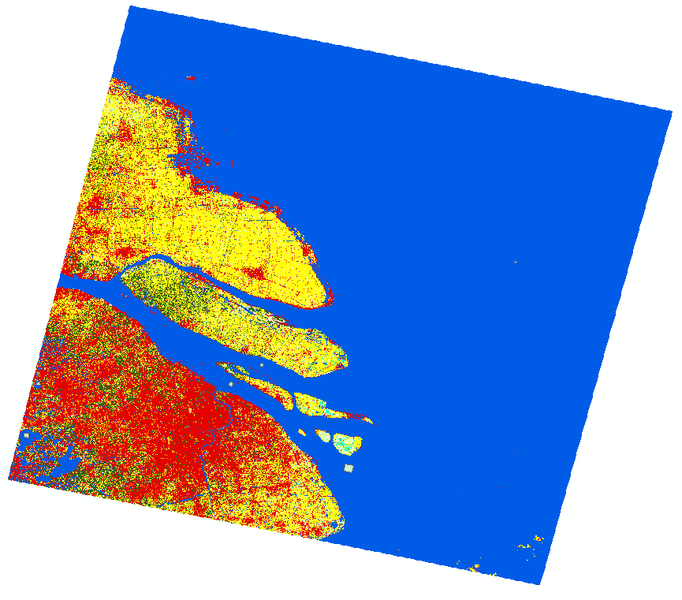

If you are not satisfied with your initial classification results, for example, many water pixels have been classified as urban, you may edit your trainingdata shapefile and re-run the classification algorithm. Feel free to use ArcGIS/ENVI/QGIS to add more training polygons (e.g., water) and re-run your R program.

Deliverables
- Generate a landcover map using Random Forest algorithm, upload this landcover map to canvas.
- Based on your landcover map, please complete the following table:
 | Urban | Cropland | Forest | water
Total area (km2) | 3927.806 | 2797.004 | 1371.084 | 2803.647

- Upload your rscript to canvas

- For graduate students, please also try caret package for the same image classification task. Upload rscript_caret.R to canvas site.

