SE_B10_WK1_DAY1_Assigment
Microsoft Visual Studio Code ( VS Code)
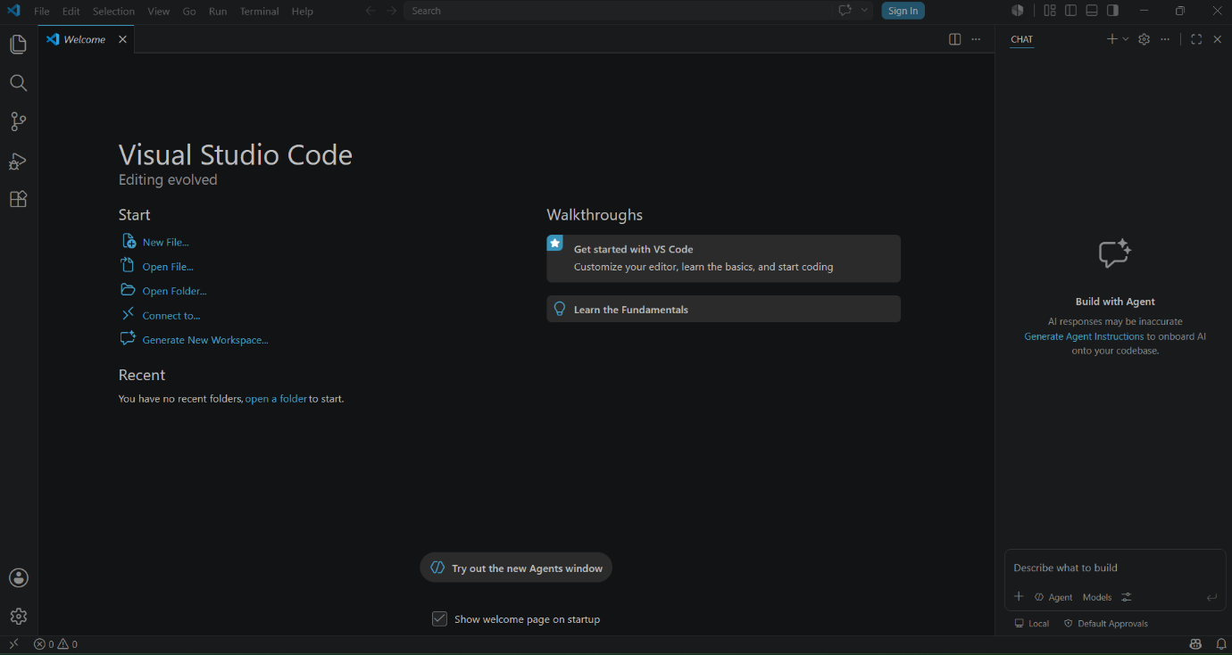

Python:
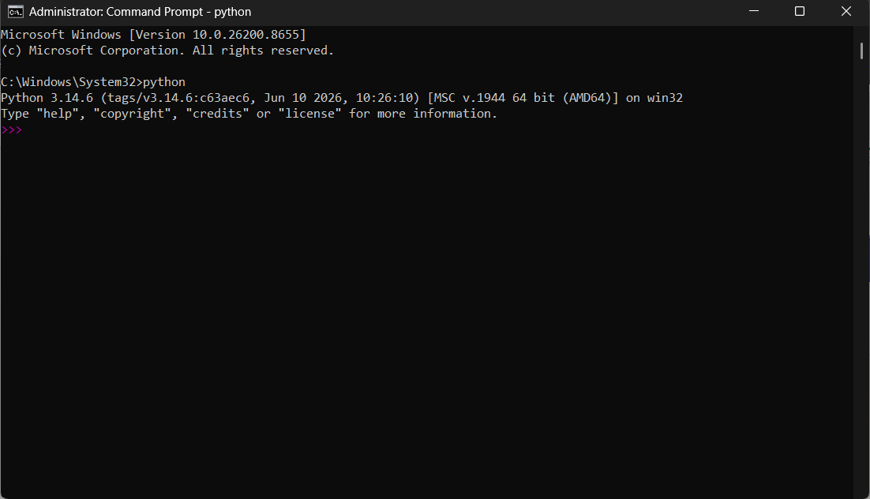

GitHub
