Scenario 1:

Delivery Time Analysis for an E-commerce Company

An e-commerce company tracks delivery times (in minutes) for 15 orders:
[25, 30, 35, 40, 45, 50, 55, 60, 65, 70, 75, 80, 85, 90, 95]
The company wants to analyze the delivery performance using percentiles and detect if there are any unusual delivery times.

Question 1: Calculate Q1 and Q3
- Q1 (25th Percentile) → 25% of the data is below this value
- Q3 (75th Percentile) → 75% of the data is below this value
- Q1 = 4th value → 40
- Q3 = 11th value → 75

Question 2: Find the IQR
- Interquartile Range (IQR) measures the spread of the middle 50% of data.
- IQR=Q3−Q1=75−40=35IQR = Q3 - Q1 = 75 - 40 = 35IQR=Q3−Q1=75−40=35
Question 3: Detect Outliers
- Outliers are extreme values.
- Use these formulas to find boundaries:
- Lower Bound=Q1−1.5×IQR\text {Lower Bound} = Q1 - 1.5 \times IQR Lower Bound=Q1−1.5×IQR Upper Bound=Q3+1.5×IQR\text {Upper Bound} = Q3 + 1.5 \times IQR Upper Bound=Q3+1.5×IQR
- Lower Bound = 40−1.5×35=−12.540 - 1.5 \times 35 = -12.540−1.5×35=−12.5 → No lower outliers
- Upper Bound = 75+1.5×35=127.575 + 1.5 \times 35 = 127.575+1.5×35=127.5 → No upper outliers.

Scenario 2:
Ramishahope Artificial Intelligence Pvt Ltd
36, Old Anandas, SG Arcade, Marudhamalai Main Road, Vadavalli, Coimbatore -641041.
+91 6385383227 | www.hopelearning.net | mdaravind@hopelearning.net | 33AAMCR3722R1ZU
A teacher is analyzing the mathematics scores of students in her class. The scores are:
[45, 50, 55, 60, 60, 62, 63, 65, 90, 95]
Question:
- Calculate the mean, median, and mode of the scores.
- Explain why the median might be a better representation than the mean in this case.
Answer:
- Mean: 45+50+55+60+60+62+63+65+90+9510=65.5\frac {45 + 50 + 55 + 60 + 60 + 62 + 63 + 65 + 90 + 95}{10} = 65.51045+50+55+60+60+62+63+65+90+95​=65.5
- Median: = 61
- Mode: 60 (Occurs twice)
Explanation:
- The median is a better measure here because the high outliers (90 and 95) skew the mean. The median is not affected by extreme values, providing a better reflection of student performance.

Scenario 3:
A grocery store manager tracks how many customers visit the store daily for a month:
[5, 10, 8, 15, 20, 5, 12, 14, 10, 18]
Question 1:
- Create a frequency distribution table for this data.
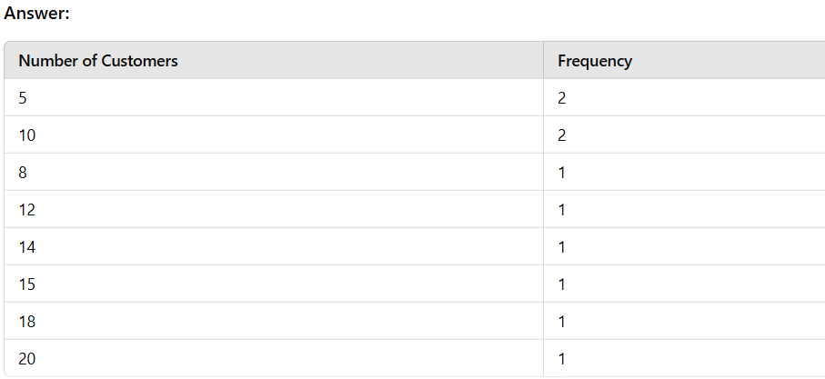
Scenario 4:
A real estate model has three variables:
- House Size
- Number of Rooms
Ramishahope Artificial Intelligence Pvt Ltd
36, Old Anandas, SG Arcade, Marudhamalai Main Road, Vadavalli, Coimbatore -641041.
+91 6385383227 | www.hopelearning.net | mdaravind@hopelearning.net | 33AAMCR3722R1ZU
- Number of Bathrooms
Question 1:
- How can you detect multicollinearity?
Logic:
- Calculate the Variance Inflation Factor (VIF).
- VIF > 10 indicates multicollinearity.
- Answer: High VIF means the variables are correlated, impacting model accuracy.
Scenario 5:
A company made a new medicine to lower blood pressure. They gave it to one group and gave a fake pill (placebo) to another group.

Question 1:
How can the company check if the new medicine works?

Solution:
- Make a guess (Hypothesis):
  - H0: The medicine doesn’t lower blood pressure.
  - H1: The medicine lowers blood pressure.
- Do a T-Test:
  - Find the p-value (a number that shows how likely the result happened by chance).
  - If p-value < 0.05, it means the medicine likely works.
- Final Answer:
  - If the p-value is small, the medicine is effective.
Scenario 6:
Identifying Outliers in Sales Data
A company wants to find any unusual spikes in sales.
Question 1:
How can the company detect outliers in their sales data?
Logic:
- Step 1: Calculate the Interquartile Range (IQR).
- Step 2: Identify outliers using the formula
- Outliers=(Data<Q1−1.5×IQR) or (Data>Q3+1.5×IQR) Outliers = (Data < Q1 - 1.5 \times IQR) \text {or} (Data > Q3 + 1.5 \times IQR) Outliers=(Data<Q1−1.5×IQR) or (Data>Q3+1.5×IQR)
Scenario 7:
Understanding Customer Satisfaction
A restaurant conducted a survey to rate customer satisfaction on a scale of 1 to 5:
[5, 4, 4, 5, 3, 4, 5, 2, 4, 3]
Question 1: How can the restaurant summarize the overall satisfaction?
Answer:
- Find the Mode to see the most common rating.
- Calculate the Mean and Median for further insights.
- If most ratings are 4 or 5, satisfaction is generally high.

