SMART WASTE COLLECTION AND ROUTE OPTIMIZATION PLATFORM
ASSESSMENT TOOL 2
Architecture Design Analysis and Software Architecture Design Report

Submitted in the partial fulfilment for the Course of
CSA1012 - SOFTWARE ENGINEERING
to the award of the degree of
BACHELOR OF ENGINEERING
IN
ARTIFICIAL INTELLIGENCE AND DATA SCIENCE
Submitted by
BALAJI.K (192324255)
Under the Supervision of
ANITADAVAMANI K

SIMATS ENGINEERING
Saveetha Institute of Medical and Technical Sciences
Chennai - 602105

Table of Contents
1. Introduction
2. Analysis of System Requirements
3. Selection of Suitable Software Architecture
4. Software Architecture Diagram
5. Architectural Components and Interactions
6. System Workflow
7. Quality Attribute Analysis
8. Justification of Architectural Decisions and Trade-offs
9. Support for Future Enhancements and Long-Term Maintainability
10. Conclusion
11. References

1. Introduction
This report presents an Architecture Design Analysis for the Smart Waste Collection and Route Optimization Platform. Building on the requirement analysis and SRS produced in Assessment Tool 1, this document analyses the requirements that drive architectural decisions, selects and justifies a suitable software architecture, presents an architecture diagram, describes each component and its interactions, evaluates key quality attributes, and justifies the architectural choices made, including their trade-offs and support for future growth.
The platform must continuously ingest telemetry from thousands of IoT-enabled bins, run AI-driven route optimisation, notify stakeholders of urgent conditions, and serve web, mobile, and public-facing clients — all while remaining secure, scalable, and maintainable over a multi-year municipal deployment. These characteristics directly shape the architectural style selected in Section 3.

2. Analysis of System Requirements

2.1 System Objectives
- Continuously monitor waste bin fill levels, temperature, and humidity across the city.
- Detect overflow and abnormal conditions (fire, vandalism) and alert stakeholders promptly.
- Dynamically compute and re-optimise vehicle collection routes using AI algorithms.
- Track collection vehicles in real time and provide accurate ETAs to drivers and supervisors.
- Predict future waste generation trends to guide bin placement and staffing.
- Provide administrators with operational analytics, dashboards, and reports.
- Scale to thousands of connected sensors and multiple sanitation zones securely and reliably.

2.2 How Requirements Influence the Architecture
The functional and non-functional requirements captured in the SRS (Assessment Tool 1) impose specific architectural constraints, summarised below.
Requirement Characteristic | Architectural Implication
Real-time telemetry ingestion at scale (thousands of sensors) | Requires an asynchronous, message-driven ingestion path rather than direct synchronous calls; favours event-driven / pub-sub communication.
AI-driven route optimisation, recomputed dynamically | Needs an independently scalable, computationally isolated service so a heavy optimisation job does not block other operations.
Multi-channel notification (SMS, email, push) | Favours a decoupled notification service triggered by events rather than being embedded inside every producing module.
Multiple heterogeneous clients (web dashboard, driver app, citizen portal, 3rd-party ERP) | Requires a single, consistent API entry point (gateway) so each client does not need to know internal service topology.
Independent, frequently evolving modules (routing, analytics, notification) | Favours loosely coupled deployable units so one module can be updated without redeploying the whole system.
Long operational lifecycle with growing bin count and city zones | Requires horizontal scalability per module and clear component boundaries to add capacity where load actually occurs.

2.3 Key Quality Attributes
Quality Attribute | Why It Matters for This System
Scalability | Independently scale ingestion, routing, and analytics services as bin count and city coverage grow, without over-provisioning the whole system.
Maintainability | Isolate frequently changing logic (routing algorithms, notification rules) into separate services with clear APIs to simplify updates.
Reliability | Tolerate intermittent IoT connectivity and service failures without losing telemetry or silently dropping alerts.
Availability | Keep core monitoring, routing, and notification paths available around the clock through redundancy, since bins overflow continuously.
Performance | Deliver near real-time dashboard updates and route recomputation within a few seconds of a triggering event.
Security | Protect sensor data, location data, and citizen-submitted data in transit and at rest, with strict role-based access control.

3. Selection of Suitable Software Architecture

3.1 Architectural Style Selected
The proposed system adopts a Hybrid Microservices Architecture with an Event-Driven communication backbone, fronted by an API Gateway. Bounded-context services (bin monitoring, device management, route optimisation, predictive analytics, notification, tracking, reporting, and user management) are independently deployable, while IoT telemetry and inter-service events flow asynchronously through an MQTT broker and an event bus (message queue).

3.2 Comparison of Candidate Architectural Styles
Candidate Style | Strengths for This System | Why It Was Not Selected / Selected
Layered (n-tier) Architecture | Simple, well understood, easy for small teams. | Poor fit for independent scaling of IoT ingestion vs. routing vs. reporting; a change in one layer risks a full redeploy.
Pure Client-Server | Straightforward for a single client type. | Cannot cleanly support many heterogeneous clients (dashboard, mobile, portal, ERP) or asynchronous IoT event flows.
Monolithic MVC | Fast initial development. | Becomes a scaling and deployment bottleneck once telemetry volume and AI workloads grow; a bug in one module risks the whole app.
Pure Serverless (FaaS only) | Very low idle cost, automatic scaling. | AI route optimisation involves longer-running, stateful computation that fits poorly with strict function timeouts; harder to reason about end-to-end latency.
Microservices + Event-Driven (Hybrid) — SELECTED | Independent scaling and deployment per capability; natural fit for asynchronous IoT telemetry and inter-service notifications; resilient to partial failure. | Higher operational complexity than a monolith; requires careful API and event-schema governance.

3.3 Justification
- Independent scalability: bin telemetry ingestion (thousands of sensors) and AI route optimisation (compute-heavy, bursty) have very different load profiles; microservices allow each to scale on its own without over-provisioning the rest of the system.
- Natural fit for real-time IoT data: an event-driven backbone (MQTT for device telemetry, a message queue for service-to-service events) matches the asynchronous, high-frequency, loosely-timed nature of sensor readings far better than synchronous request/response chains.
- Fault isolation: if the predictive analytics service is slow or temporarily unavailable, bin monitoring, routing, and notifications continue to function, which is critical for a 24/7 municipal service.
- Independent deployability: sanitation policy or routing-algorithm changes can be shipped by updating the Route Optimisation Service alone, without redeploying the dashboard or notification logic — well suited to the Agile Scrum delivery model already adopted for this project.
- Heterogeneous client support: a single API Gateway gives the admin dashboard, driver app, citizen portal, and any future ERP integration one consistent, secured entry point regardless of how many internal services exist behind it.

4. Software Architecture Diagram
The diagram below illustrates the six logical layers of the platform: the client layer, the API gateway, the microservices layer, the messaging/event-driven backbone, the data layer, and the edge/IoT and external-systems layer. Solid arrows indicate synchronous request paths (client to gateway to service); dashed arrows indicate asynchronous, event-driven data flow (service to message backbone to data store).
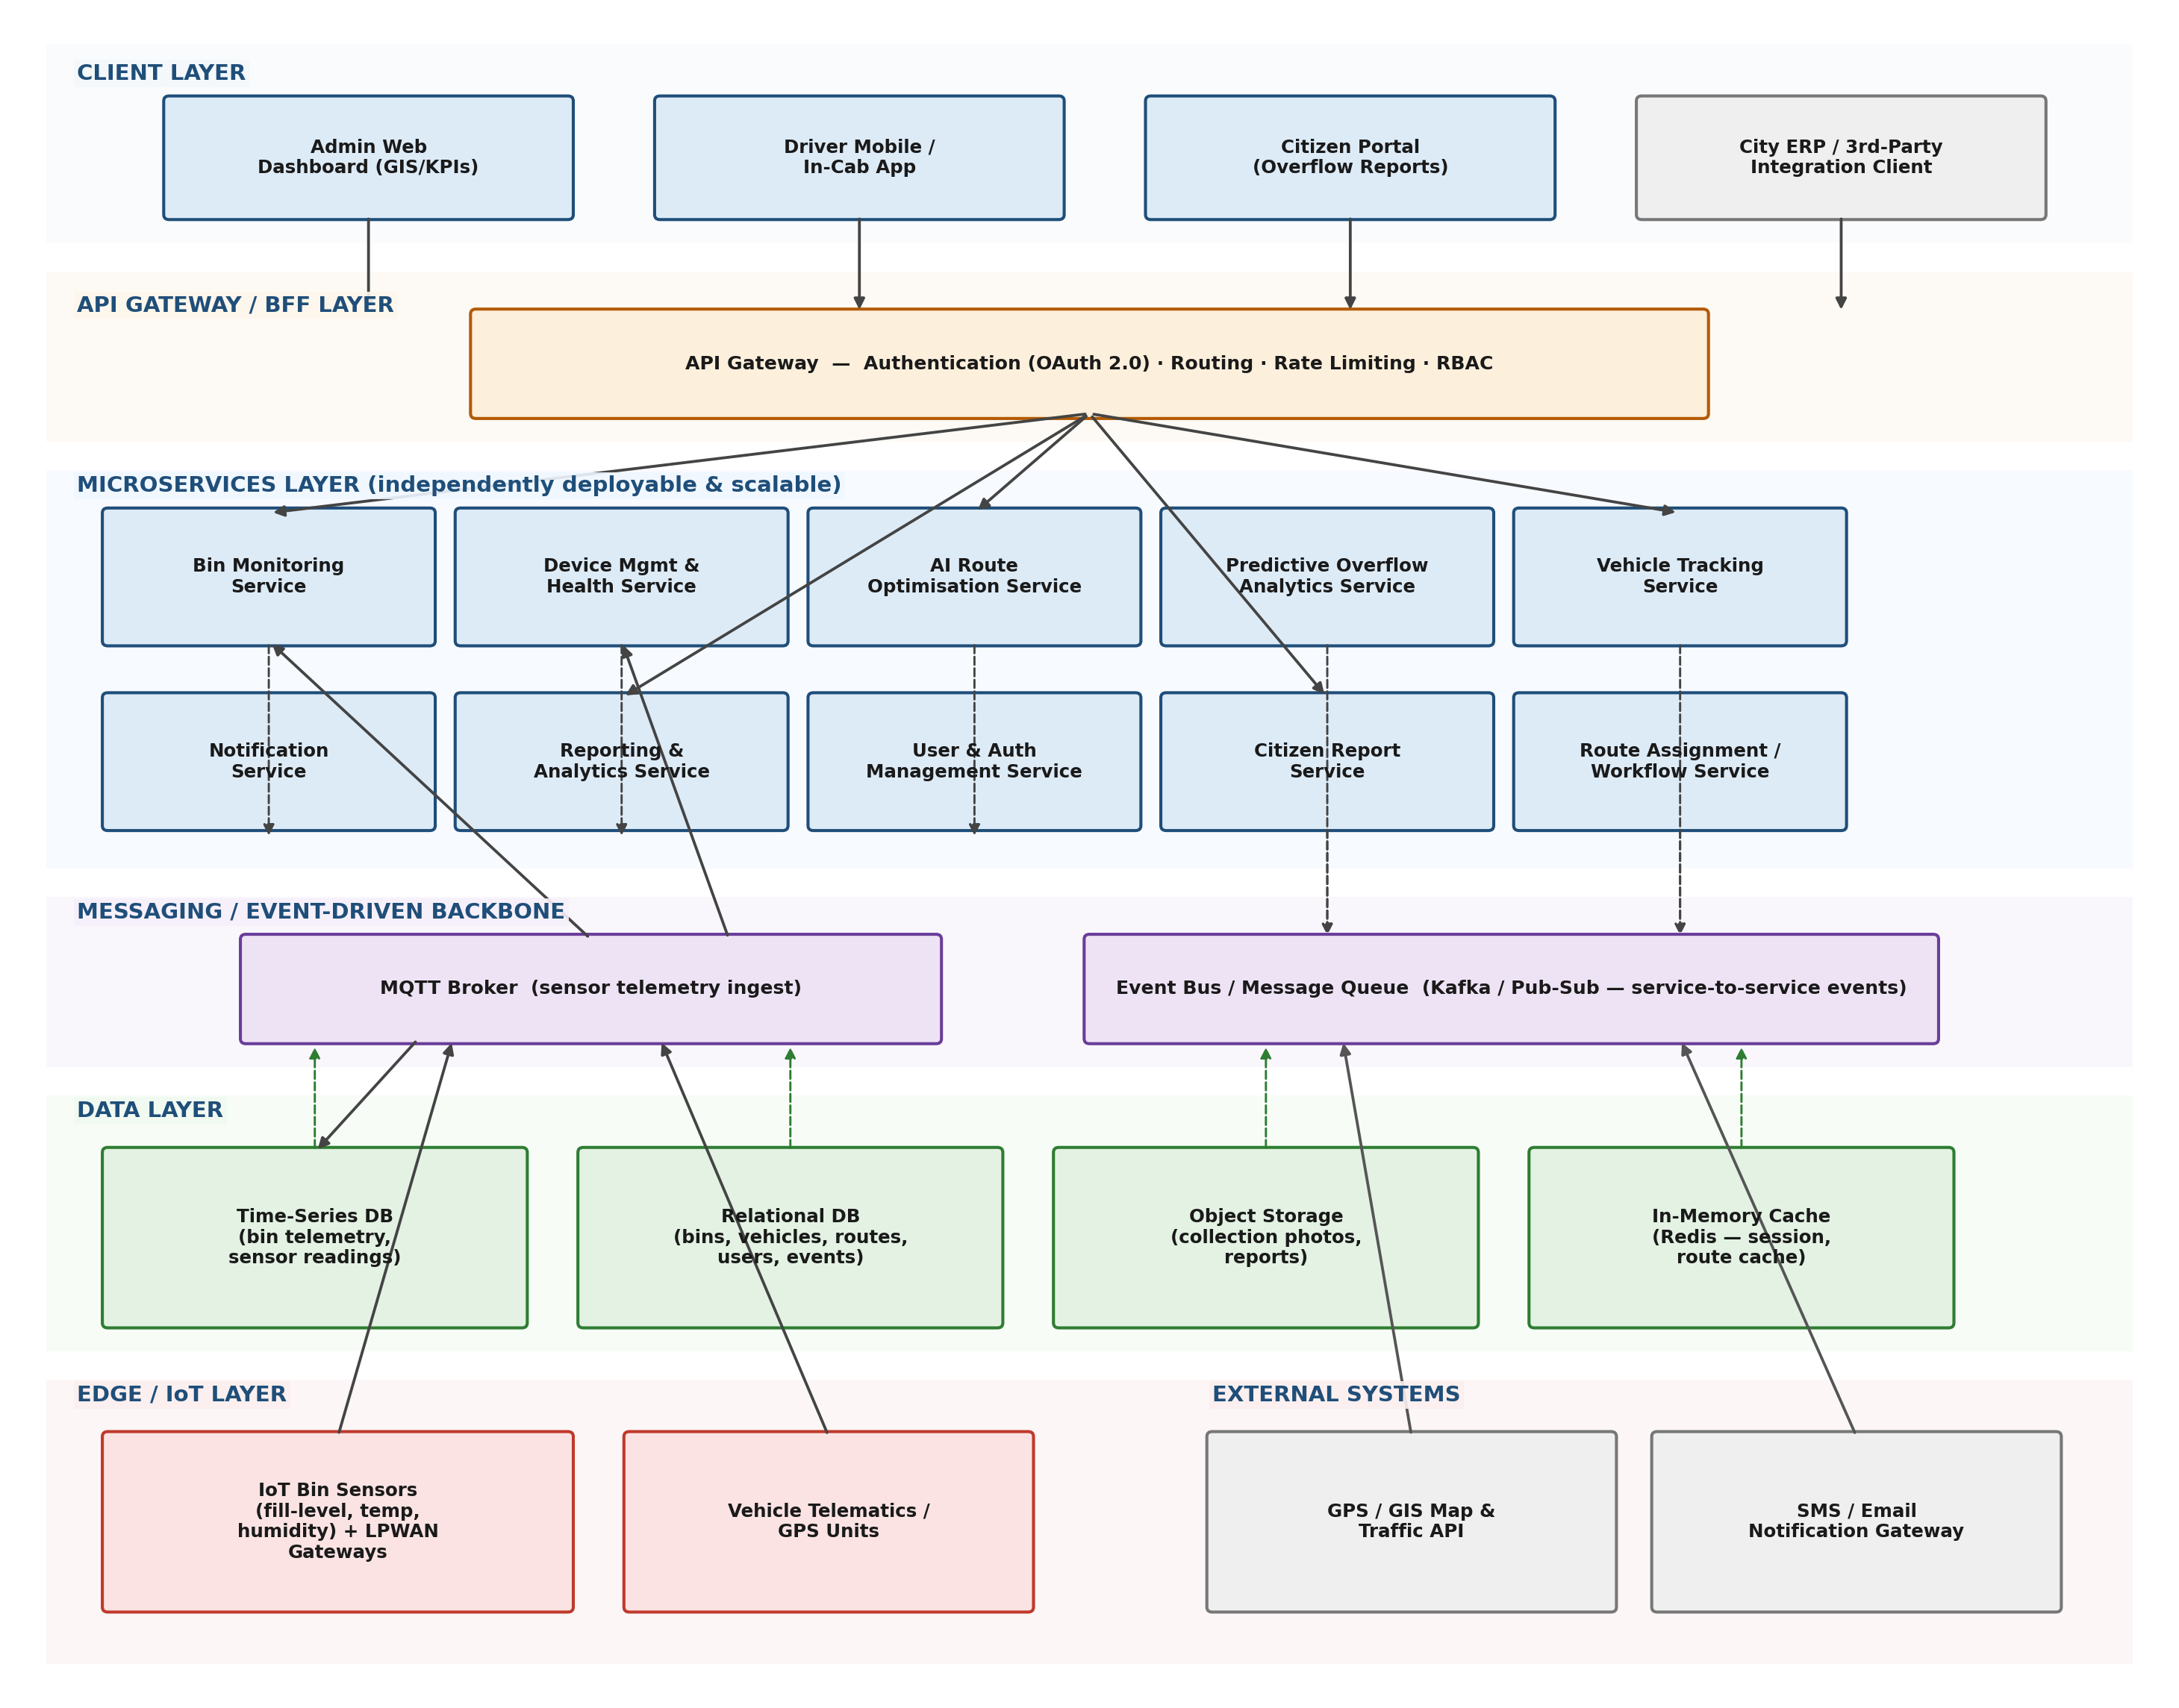
Figure 1: Layered Microservices + Event-Driven Architecture of the Smart Waste Collection and Route Optimization Platform

5. Architectural Components and Interactions

5.1 Component Responsibilities
Component | Layer | Purpose / Responsibility
Admin Web Dashboard | Client | GIS map visualisation of bin/vehicle status, KPI widgets, threshold configuration, and report generation for city administrators.
Driver Mobile / In-Cab App | Client | Displays the optimised route, turn-by-turn navigation, and lets drivers confirm collections and report field issues.
Citizen Portal | Client | Lightweight public interface for citizens to report overflowing or damaged bins.
API Gateway | Gateway | Single entry point authenticating requests (OAuth 2.0), enforcing RBAC and rate limits, and routing calls to the correct backend service.
Bin Monitoring Service | Microservice | Consumes validated telemetry, maintains current bin status, and drives the dashboard's real-time map markers.
Device Management & Health Service | Microservice | Registry of sensors/gateways; tracks battery, signal strength, firmware; raises maintenance alerts for offline or faulty devices.
AI Route Optimisation Service | Microservice | Solves the capacitated vehicle routing problem to generate and dynamically recompute optimal collection routes.
Predictive Overflow Analytics Service | Microservice | Applies time-series forecasting to historical fill-rate data to predict future overflow events.
Vehicle Tracking Service | Microservice | Ingests live GPS data from vehicles and computes ETAs for each stop.
Notification Service | Microservice | Subscribes to alert events and dispatches SMS, email, and push notifications to the correct role.
Reporting & Analytics Service | Microservice | Aggregates operational data into KPI reports (fuel usage, distance, bins serviced) for administrators.
User & Auth Management Service | Microservice | Manages accounts, roles, and credentials; issues tokens validated by the API Gateway.
Citizen Report Service | Microservice | Receives and stores citizen-submitted overflow/damage reports and links them to the nearest registered bin.
Route Assignment / Workflow Service | Microservice | Coordinates vehicle-to-route assignment and manual supervisor overrides.
MQTT Broker | Messaging | Lightweight publish/subscribe broker that ingests high-frequency sensor telemetry from LPWAN gateways.
Event Bus / Message Queue | Messaging | Carries inter-service events (e.g., 'bin critical', 'route reassigned') so services remain decoupled and resilient to partial failure.
Time-Series Database | Data | Stores high-volume bin telemetry optimised for time-based queries and trend analysis.
Relational Database | Data | Stores structured master and transactional data: bins, vehicles, routes, users, and events.
Object Storage | Data | Stores unstructured content such as collection-confirmation photos and generated report files.
In-Memory Cache | Data | Caches session tokens and recently computed routes to reduce latency on repeated reads.
IoT Bin Sensors & LPWAN Gateways | Edge | Ultrasonic and environmental sensors inside bins; gateways forward readings to the MQTT broker over LoRaWAN/NB-IoT.
Vehicle Telematics / GPS Units | Edge | On-vehicle hardware reporting live location to the Vehicle Tracking Service.
GPS / GIS Map & Traffic API | External System | Third-party mapping, geocoding, and live-traffic data consumed by the routing and navigation components.
SMS / Email Notification Gateway | External System | Third-party service used by the Notification Service to deliver outbound alerts.

5.2 Communication Mechanisms
- Client-to-Gateway: synchronous HTTPS/REST calls, authenticated with OAuth 2.0 bearer tokens; the gateway performs routing, RBAC checks, and rate limiting before forwarding requests.
- Gateway-to-Microservice: synchronous internal REST/GraphQL calls for request/response operations such as fetching a dashboard view or submitting a manual route override.
- Sensor-to-Platform: asynchronous publish/subscribe over MQTT; edge gateways publish telemetry topics that the Bin Monitoring and Device Management services subscribe to.
- Service-to-Service: asynchronous events published to the Event Bus (for example, 'bin.critical', 'route.reassigned', 'sensor.offline'); interested services subscribe independently, so producers and consumers are decoupled and can evolve separately.
- Service-to-Data: each microservice owns and accesses only its relevant data store(s) directly (database-per-service style) to avoid tight coupling through a shared schema.
- Platform-to-External: outbound calls to the GPS/GIS API for routing/navigation data, and to the SMS/Email gateway for outbound notifications, both over authenticated HTTPS APIs.

6. System Workflow
The following end-to-end workflow illustrates how the components interact for the most critical scenario — detecting and responding to an overflowing bin.
- An IoT bin sensor measures a rising fill level and publishes a telemetry reading to the MQTT broker.
- The Bin Monitoring Service consumes the reading, updates the bin's current status, and stores it in the time-series database.
- When the fill level crosses the configured critical threshold, the Bin Monitoring Service publishes a 'bin.critical' event to the Event Bus.
- The AI Route Optimisation Service consumes the event and recomputes the affected vehicle's route, factoring in current vehicle position, capacity, and time windows.
- The updated route is pushed (via the API Gateway) to the Driver Mobile App and simultaneously to the Route Assignment/Workflow Service, which updates the assignment record in the relational database.
- The Notification Service, also subscribed to the 'bin.critical' event, sends an SMS/email/push alert to the Sanitation Supervisor through the external notification gateway.
- The Admin Web Dashboard, polling/subscribing through the API Gateway, reflects the updated bin status and route in near real time via the Bin Monitoring and Reporting services.
- Once the driver empties the bin and confirms collection in the app, a 'collection.completed' event updates the bin status back to normal and feeds the Predictive Overflow Analytics Service for future forecasting.

7. Quality Attribute Analysis
The table below evaluates how the selected hybrid microservices and event-driven architecture directly addresses each required quality attribute.
Quality Attribute | How the Architecture Addresses It
Scalability | Each microservice (ingestion, routing, analytics, notification) scales horizontally and independently behind the API Gateway; the MQTT broker and event bus are clustered to absorb growth from a pilot zone of 50 bins to a citywide deployment of thousands.
Security | OAuth 2.0 authentication and role-based access control are enforced centrally at the API Gateway; all data in transit uses TLS 1.2+ and telemetry/location data at rest is encrypted with AES-256; database-per-service limits the blast radius of any single service compromise.
Performance | Time-critical reads (dashboard status, cached routes) are served from the in-memory cache and time-series database tuned for fast range queries; the event-driven backbone avoids synchronous chains that would otherwise add latency to telemetry processing.
Reliability | Edge gateways buffer telemetry locally during connectivity loss and forward it once reconnected; the event bus provides at-least-once delivery with retry, so a temporary service outage does not silently drop critical alerts.
Maintainability | Clear service boundaries and documented REST/GraphQL and event-schema contracts let a team update the routing algorithm or notification rules independently, without touching unrelated services — directly supporting the project's Agile Scrum sprint cadence.
Availability | Core services (monitoring, routing, notification) are deployed with multi-instance, multi-zone redundancy behind the gateway; the messaging backbone decouples producers and consumers so a slow consumer does not block telemetry ingestion, supporting the 99.9% uptime target for critical subsystems.

8. Justification of Architectural Decisions and Trade-offs

8.1 Rationale Summary
The architecture was chosen to directly satisfy the requirement characteristics identified in Section 2: high-volume asynchronous IoT ingestion, independently scalable AI computation, decoupled multi-channel notification, and support for several heterogeneous client types through one governed entry point. Each major decision was weighed against a simpler alternative, and the trade-off accepted is recorded below.

8.2 Trade-offs Considered
Decision | Trade-off | Why It Was Accepted
Microservices vs. Monolith | Operational overhead of deploying and monitoring many services vs. simplicity of a single deployable unit. | Accepted the added operational complexity because independent scaling of IoT ingestion and AI routing is a hard requirement that a monolith cannot satisfy without over-provisioning.
Event-Driven vs. Synchronous-Only | Eventual consistency and harder end-to-end debugging vs. simpler, immediately-consistent request/response flows. | Accepted eventual consistency for telemetry and notifications because sub-second global consistency is not required, while resilience to partial failure and decoupling are essential.
Database-per-service vs. Shared Database | Some data duplication and the need for careful event-based synchronisation vs. simpler joins on one schema. | Accepted the duplication because a shared schema would recreate the tight coupling microservices are meant to remove, and would make independent deployment impossible.
MQTT + Message Queue (two brokers) vs. a Single Broker | Slightly more infrastructure to operate vs. one simpler broker for everything. | Accepted the extra component because MQTT is purpose-built for lightweight, high-frequency, battery-constrained IoT telemetry, while a general-purpose event bus better serves richer service-to-service business events.

9. Support for Future Enhancements and Long-Term Maintainability
- New capabilities as new services: features such as Edge Computing pre-processing at gateways, or a Digital Twin simulation module, can be added as new microservices that subscribe to existing events, without modifying already-running services.
- System integration: the API Gateway and published event schemas give third-party municipal ERP or asset-management systems a stable, versioned integration surface, insulating external partners from internal refactoring.
- Independent technology evolution: individual services can adopt new tools (for example, replacing the forecasting model in the Predictive Overflow Analytics Service) without requiring a platform-wide migration.
- Incremental scaling: as the municipality expands from a pilot zone to citywide coverage, only the services experiencing real load growth (typically ingestion and routing) need additional capacity, keeping infrastructure cost proportional to actual usage.
- Alignment with Agile Scrum delivery: bounded, independently deployable services map naturally onto sprint-sized units of work, allowing the development team to ship and validate one capability at a time based on pilot feedback, consistent with the Agile methodology adopted for this project.

10. Conclusion
The Smart Waste Collection and Route Optimization Platform is best served by a hybrid microservices architecture built on an event-driven communication backbone, fronted by a single API Gateway. This design directly reflects the system's core requirement drivers — high-volume asynchronous IoT telemetry, independently scalable AI-based routing, decoupled multi-channel notification, and support for multiple client types — while satisfying the required quality attributes of scalability, security, performance, reliability, maintainability, and availability. The trade-offs accepted, primarily increased operational complexity in exchange for independent scalability and resilience, are appropriate for a platform expected to grow from a small pilot to a citywide, multi-year municipal deployment.

11. References
[1] L. Bass, P. Clements, and R. Kazman, Software Architecture in Practice, 4th ed. Addison-Wesley, 2021.
[2] S. Newman, Building Microservices: Designing Fine-Grained Systems, 2nd ed. O'Reilly, 2021.
[3] M. Richards and N. Ford, Fundamentals of Software Architecture: An Engineering Approach. O'Reilly, 2020.
[4] T. Ali, M. Irfan, and A. S. Alwadie, “IoT-based smart waste bin monitoring and municipal solid waste management system for smart cities,” Arab. J. Sci. Eng., vol. 45, no. 12, pp. 10185-10198, 2020.
[5] N. Kaur and S. Sood, “Predictive analytics for smart waste management in IoT-enabled smart cities,” IEEE Access, vol. 7, pp. 68382-68394, 2019.
[6] MQTT.org, “MQTT: The Standard for IoT Messaging,” OASIS Standard, 2019.

