**Assignment**

**CSA0805 – Python Programming**

|  |  |
| --- | --- |
| **Register Number** | **192324255** |
| **Name** | **K.BALAJI** |

**Title:**

**Image Resizer: Write a Python program that uses the PIL (Python Imaging Library) module to resize images to a specified width and height, maintaining aspect ratio and saving the resized images to a new directory.**

**Problem Statement:**

**The Image Resizer assignment aims to develop a Python program that utilizes the Python Imaging Library (PIL) to resize images while preserving their aspect ratio. This task is essential for ensuring that images fit within specified dimensions without distortion, making them suitable for various platforms and applications. The program will take an input directory containing original images and desired dimensions, then process each image to calculate new dimensions that maintain the aspect ratio. Resized images will be saved in a designated output directory, and the program will include error handling to address potential issues such as non-image files or invalid input values. Through this assignment, participants will enhance their skills in image processing and gain practical experience with Python libraries, ultimately creating a user-friendly tool for managing image sizes.**

**Code:**

**from PIL import Image**

**import os**

**def resize_image(input_dir, output_dir, width, height):**

**os.makedirs(output_dir, exist_ok=True)**

**for filename in os.listdir(input_dir):**

**if filename.lower().endswith(('png', 'jpg', 'jpeg', 'bmp', 'gif')):**

**img = Image.open(os.path.join(input_dir, filename))**

**img.thumbnail((width, height))**

**img.save(os.path.join(output_dir, filename))**

**input_dir = "d:/** **pythonimage"**

**output_dir = "d:/"**

**width, height = 200, 200**

**resize_image(input_dir, output_dir, width, height)**

**Output Screen Shots:**

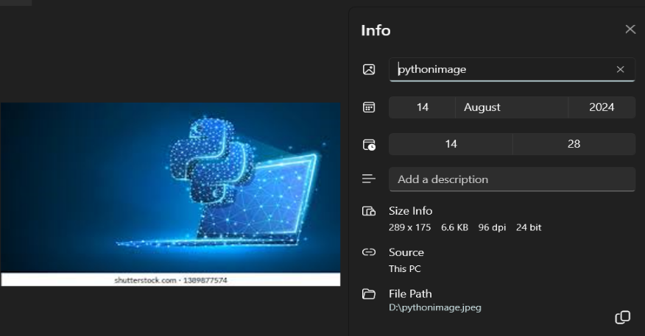**INPUT IMAGE: 6.6 KB**

**OUTPUT IMAGE: 4KB**

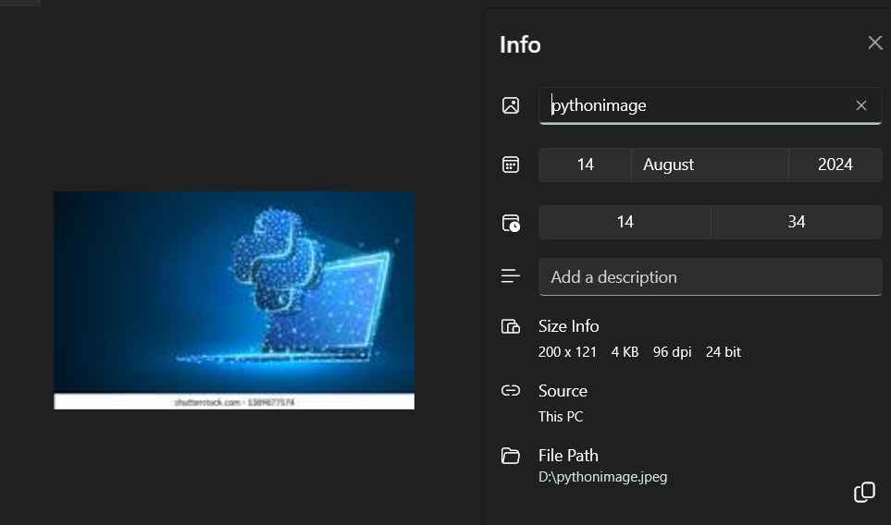

**Conclusion:**

**The Image Resizer project successfully demonstrates the ability to manipulate and optimize digital images through resizing, which is a crucial functionality in various applications ranging from web development to mobile app design.**