ASSESSMENT TOOL-01
AI-Based Smart Food Supply Chain
Traceability and Quality Monitoring Platform
Leveraging Artificial Intelligence, IoT, Blockchain and Cloud Computing
for End-to-End Food Safety and Transparency
SUBMITTED BY:
Balaji K
192511404
Under the Guidance of
Dr. R. Latha
B.E CSE
Saveetha School of Engineering, SIMATS
2026

Abstract
The global food supply chain is a complex, multi-tier network involving farmers, processors, distributors, retailers, and consumers. Lack of visibility across these stages leads to contamination, spoilage, counterfeit products, and delayed recalls, resulting in significant financial losses and health risks. This project proposes an AI-Based Smart Food Supply Chain Traceability and Quality Monitoring Platform that integrates Artificial Intelligence, Internet of Things (IoT) sensors, Radio Frequency Identification (RFID), Blockchain, and Cloud Computing to deliver real-time, tamper-proof visibility into food movement and condition.
The platform continuously monitors environmental parameters such as temperature, humidity, and transportation conditions using IoT sensor networks, and applies machine learning models to predict spoilage risk and remaining shelf life before quality degrades beyond safe limits. Blockchain-based ledgers record every transaction and handoff along the chain, enabling verifiable proof of product origin and authentic chain-of-custody. Automated compliance reports are generated for regulatory bodies, and real-time alerts are pushed to stakeholders whenever a quality threshold is breached, allowing corrective action before spoiled or unsafe products reach consumers.
The proposed system is designed to reduce food waste, minimize recall costs, strengthen regulatory compliance, and build consumer trust through transparent, verifiable information about the food they purchase. This report presents the problem context, objectives, literature survey, proposed system architecture, technology stack, module-wise design, AI methodology, implementation approach, and expected outcomes of the platform.

Keywords
Food Traceability, Artificial Intelligence, IoT, Blockchain, RFID, Cold Chain Monitoring, Spoilage Prediction, Supply Chain Transparency, Machine Learning, Smart Agriculture.

1. Introduction

1.1 Industry Context
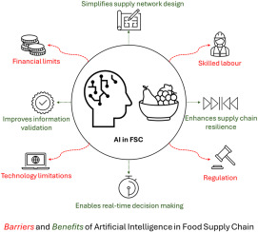
The food industry is under increasing pressure to guarantee safety, quality, and transparency across globally distributed supply chains. Consumers today expect to know where their food comes from, how it was grown or processed, and under what conditions it travelled before reaching their plate. Regulatory authorities, in parallel, demand verifiable records to enforce food-safety standards and to trace the source of contamination quickly when outbreaks occur.
Emerging technologies — Artificial Intelligence, the Internet of Things, Blockchain, RFID, and Cloud Computing — are converging to make true end-to-end traceability practical at scale. Sensors capture real-time environmental data, AI models interpret that data to predict risk, blockchain provides an immutable audit trail, and cloud platforms make the resulting insights accessible to every stakeholder in the chain.

1.2 Motivation
Traditional food tracking relies on manual record-keeping, paper trails, and disconnected systems that offer only partial, delayed visibility. When contamination is discovered, it can take days or weeks to trace the affected batch back to its source, by which time the product has already reached thousands of consumers. A digital, sensor-driven, AI-powered traceability platform can compress this response time from weeks to minutes, directly protecting public health and reducing economic loss.

1.3 Scope of the Project
This project covers the design of a traceability and quality-monitoring platform spanning farm/source, storage, transportation, and retail stages. It includes real-time environmental monitoring, AI-based spoilage prediction, blockchain-backed origin verification, automated compliance reporting, and stakeholder notification. Hardware procurement and full-scale field deployment are outside the scope of this report, which focuses on system design, architecture, and a working prototype approach.

2. Problem Statement
Food contamination, improper storage, and lack of traceability lead to product recalls, financial losses, and serious health risks. Traditional tracking methods — largely manual and paper-based — provide limited visibility across the supply chain, making it difficult to answer basic questions in real time: Where is this product right now? What conditions has it been exposed to? Is it still safe to consume?
An effective solution must continuously monitor storage and transport conditions, verify the authenticity of origin claims, predict spoilage before it happens rather than reacting after the fact, and generate the documentation regulators require — all while remaining usable by stakeholders with varying levels of technical expertise, from smallholder farmers to large distribution centres.

2.1 Key Challenges Addressed
- Fragmented, siloed data across farmers, processors, distributors, and retailers.
- Delayed detection of temperature/humidity excursions that cause spoilage.
- Inability to verify claimed origin or organic/certification status.
- Manual, error-prone, and slow compliance reporting.
- Reactive (rather than predictive) recall processes that occur after harm is done.
- Significant food waste due to inefficient cold-chain and inventory management.

3. Objectives
The project is guided by the following objectives:
- Monitor food quality continuously across every stage of the supply chain using IoT sensors.
- Track food products throughout the supply chain using RFID/QR-based identification and blockchain ledgers.
- Predict food spoilage using AI models trained on environmental and product-specific data.
- Verify product origin through tamper-proof, blockchain-anchored provenance records.
- Generate automated compliance reports aligned with food-safety regulations.
- Optimize cold storage management through predictive analytics and dynamic alerts.
- Reduce food waste by enabling early intervention before spoilage occurs.
- Improve overall food safety and strengthen consumer confidence through transparency.

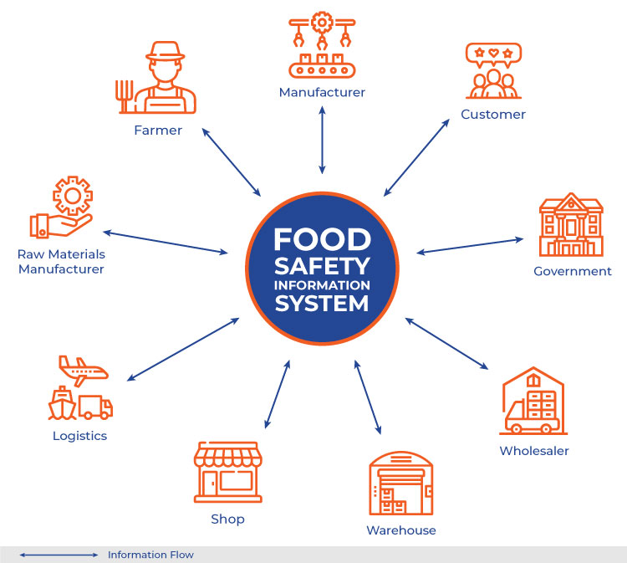
4. Literature Survey
Existing research and industry initiatives have explored individual pieces of the traceability puzzle. IoT-based cold-chain monitoring systems demonstrate that continuous sensing of temperature and humidity can detect excursions in real time, but many implementations stop at alerting and do not incorporate predictive analytics. Blockchain-based traceability pilots, including consortium efforts among large retailers and food producers, show that distributed ledgers can compress traceback time from days to seconds, though adoption is often limited to a single tier of the chain rather than farm-to-fork coverage.
Machine learning approaches to spoilage prediction typically use time-series models — such as regression, decision trees, and recurrent neural networks — trained on temperature/humidity histories combined with product-specific decay curves, achieving useful accuracy in estimating remaining shelf life. RFID-based tracking is well established in logistics for asset visibility but is rarely combined with AI-driven quality prediction in a single unified platform. This project builds on these individual strands by integrating IoT sensing, RFID/QR tracking, blockchain provenance, and AI-based prediction into one cohesive system, addressing the gap between isolated pilots and a genuinely end-to-end solution.

4.1 Summary of Related Approaches
Approach | Strength | Limitation
IoT cold-chain sensors | Real-time environmental visibility | No predictive intelligence, reactive alerts only
Blockchain traceability pilots | Tamper-proof, verifiable records | Usually limited to one supply-chain tier
ML spoilage prediction models | Estimates remaining shelf life | Rarely integrated with live tracking data
RFID logistics tracking | Accurate location/asset visibility | No quality or condition awareness

5. Proposed System Architecture
The platform follows a layered architecture consisting of a Sensing Layer, a Connectivity Layer, a Data & AI Layer, a Blockchain Layer, and an Application Layer. Data flows from physical sensors and tags at the source, through gateways to the cloud, where AI models analyze it and blockchain records anchor critical events, ultimately surfacing insights to stakeholders through dashboards and mobile applications.

5.1 Architecture Layers
Layer | Description
Sensing Layer | IoT sensors (temperature, humidity, gas/ethylene, GPS, shock) and RFID/QR tags attached to produce, packaging, or transport units.
Connectivity Layer | Edge gateways, LoRaWAN/NB-IoT/GSM modules, and MQTT protocol transmitting sensor data to the cloud in real time.
Data & AI Layer | Cloud data pipeline that stores time-series data and runs machine learning models for spoilage prediction, anomaly detection, and demand/quality forecasting.
Blockchain Layer | Distributed ledger recording every custody transfer, quality check, and certification as an immutable transaction, enabling origin verification.
Application Layer | Web and mobile dashboards, alerting/notification engine, and automated compliance report generator used by farmers, logistics providers, retailers, regulators, and consumers.

5.2 Data Flow Overview
Sensor and RFID data is captured at the point of harvest or packaging and at each subsequent checkpoint (storage facility, transport vehicle, distribution centre, retail store). Each checkpoint reading is transmitted to the cloud, timestamped, and hashed into a blockchain transaction linked to the product's unique identifier. The AI engine continuously evaluates incoming readings against product-specific safe ranges and predictive spoilage models, triggering alerts and updating a live quality score that is visible to every authorized stakeholder for that product.

5.3 Stakeholder Roles
Stakeholder | Role in the Platform
Farmer / Producer | Registers product batches, records harvest and certification details.
Logistics Provider | Monitors transport conditions, updates custody status at each checkpoint.
Warehouse / Cold Storage Operator | Manages storage conditions, receives optimization recommendations.
Retailer | Verifies incoming batch quality and origin before shelving products.
Regulator | Accesses compliance reports and traceability records for audits.
Consumer | Scans product code to view verified origin, journey, and quality score.

6. Technology Stack
Category | Technologies
IoT Hardware | DHT22/SHT31 temperature-humidity sensors, MQ-series gas sensors, GPS modules, RFID tags & readers, ESP32/Raspberry Pi edge devices
Connectivity | MQTT, LoRaWAN, NB-IoT, 4G/5G, Wi-Fi
Backend | Python (FastAPI/Django) or Node.js, REST/GraphQL APIs
AI / Machine Learning | Python, TensorFlow/PyTorch, Scikit-learn, Pandas, time-series forecasting (LSTM, ARIMA), classification models
Blockchain | Hyperledger Fabric or Ethereum (private/consortium network), Solidity smart contracts
Database | PostgreSQL / MongoDB for operational data, InfluxDB for time-series sensor data
Cloud & DevOps | AWS / Azure / GCP, Docker, Kubernetes, CI/CD pipelines
Frontend | React.js / Flutter for web and mobile dashboards
Notifications | Firebase Cloud Messaging, Twilio SMS, email/webhook alerts

6.1 Hardware Requirements
Component | Specification
Microcontroller / Edge Device | ESP32 / Raspberry Pi 4 (Wi-Fi + Bluetooth enabled)
Temperature & Humidity Sensor | DHT22 or SHT31 (accuracy ±0.3°C, ±2% RH)
Gas / Ethylene Sensor | MQ-series sensor for ripening/spoilage gas detection
GPS Module | NEO-6M or equivalent for real-time location tracking
RFID Reader & Tags | UHF RFID reader with passive/active tags per batch
Connectivity Module | LoRaWAN / NB-IoT / GSM module for remote transmission
Power Supply | Rechargeable battery pack with solar backup for field units

6.2 Software Requirements
Component | Specification
Operating System | Linux (server-side), Android/iOS (mobile app)
Programming Languages | Python, JavaScript/TypeScript, Solidity
AI/ML Framework | TensorFlow / PyTorch / Scikit-learn
Database | PostgreSQL, MongoDB, InfluxDB
Blockchain Platform | Hyperledger Fabric / Ethereum test network
Cloud Platform | AWS / Microsoft Azure / Google Cloud Platform
Development Tools | VS Code, Docker, Git/GitHub, Postman

7. System Modules

7.1 Product Registration & Origin Verification Module
Allows farmers/producers to register a batch with source details (location, date, certification), generating a unique digital identity (QR/RFID) anchored to the first blockchain transaction for that product.

7.2 Real-Time Environmental Monitoring Module
Collects continuous temperature, humidity, and other condition data from IoT sensors attached to storage units and transport vehicles, streaming readings to the cloud for analysis.

7.3 AI Spoilage Prediction Module
Applies trained machine learning models to sensor histories and product-specific decay characteristics to estimate remaining shelf life and flag elevated spoilage risk before visible degradation occurs.

7.4 Blockchain Traceability Module
Records every custody transfer, inspection, and condition checkpoint as an immutable ledger entry, enabling any stakeholder to trace a product's complete journey and verify its authenticity.

7.5 Compliance Reporting Module
Automatically compiles sensor logs, quality checks, and chain-of-custody records into standardized reports aligned with food-safety regulations (e.g., HACCP, FSSAI, FDA FSMA), ready for regulatory submission.

7.6 Alert & Notification Module
Monitors live data against safe thresholds and predictive risk scores, instantly notifying relevant stakeholders (via SMS, email, or app push) when a quality issue or condition breach is detected.

7.7 Cold Storage Optimization Module
Analyzes storage utilization, energy consumption, and environmental stability to recommend optimal storage conditions and scheduling, reducing spoilage and operational cost.

7.8 Stakeholder Dashboard Module
Provides role-based web and mobile interfaces for farmers, logistics providers, retailers, regulators, and consumers to view traceability history, quality scores, and compliance status for any product.

8. AI Techniques and Algorithms
Task | Technique | Purpose
Spoilage / shelf-life prediction | LSTM / regression on time-series sensor data | Estimate remaining safe shelf life from temperature-humidity history
Anomaly detection | Isolation Forest / statistical thresholding | Detect abnormal sensor readings indicating equipment failure or tampering
Quality classification | Random Forest / SVM | Classify product batches as safe, at-risk, or spoiled
Demand & waste forecasting | ARIMA / Prophet | Forecast demand to reduce overstocking and waste
Image-based quality inspection | CNN (optional extension) | Visual grading of produce freshness from camera images

The spoilage prediction pipeline is trained on historical sensor data labelled with known outcomes (spoiled/not spoiled, actual shelf life), using features such as cumulative temperature exposure, humidity variance, and time since packaging. Model outputs feed directly into the alerting and dashboard modules, converting raw predictions into actionable, easy-to-understand risk indicators for non-technical stakeholders.

Methodology / Workflow
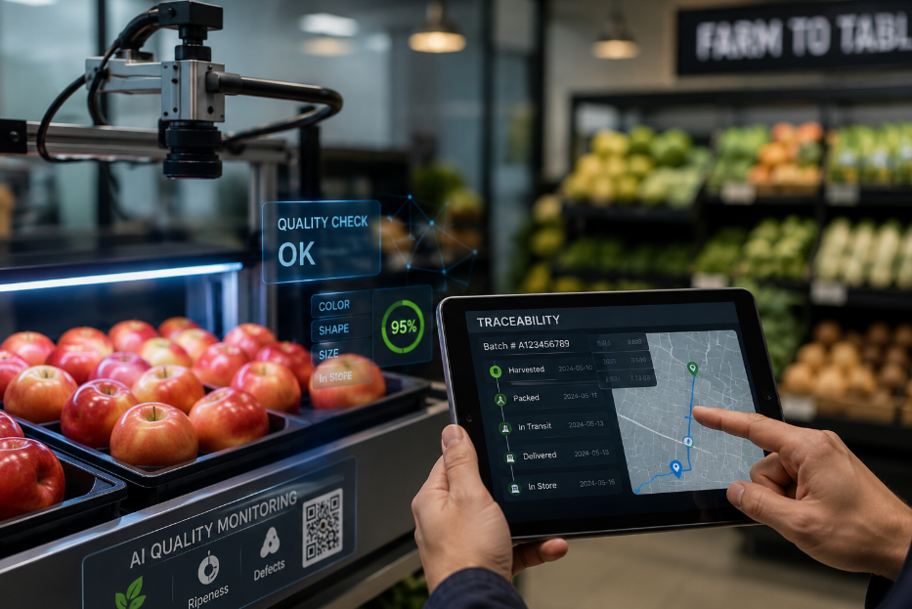

- Sensor and RFID/QR tags are deployed at the source, storage facility, and transport vehicle for each product batch.
- Each checkpoint reading (location, temperature, humidity, timestamp) is transmitted via the connectivity layer to the cloud platform.
- Incoming data is validated, stored in the time-series database, and simultaneously hashed into a new blockchain transaction linked to the product ID.
- The AI engine evaluates the updated data against safe thresholds and predictive spoilage models, refreshing the product's live quality score.
- If a threshold breach or high spoilage risk is detected, the alerting module notifies relevant stakeholders in real time.
- At each stage of the journey, the compliance module logs the relevant checks needed for regulatory reporting.
- Consumers and regulators can scan the product's QR/RFID code to view its complete, verified journey and current quality status on the dashboard.

9.1 Process Flow Summary
Registration → Sensing → Transmission → AI Analysis → Blockchain Recording → Alerting → Reporting → Stakeholder Access. This closed loop ensures that data captured at the farm is verifiable all the way to the consumer's point of purchase, with AI continuously reassessing risk at every step rather than only at fixed checkpoints.

10. Database Design (Overview)
The platform uses a hybrid storage approach: a relational/NoSQL database for structured operational data (products, stakeholders, certifications) and a time-series database for high-frequency sensor readings, complemented by the blockchain ledger for tamper-proof event records.
Entity | Key Attributes | Storage
Product Batch | batch_id, source, harvest_date, certification | Relational DB
Sensor Reading | sensor_id, batch_id, temp, humidity, timestamp | Time-series DB (InfluxDB)
Custody Transaction | batch_id, from_party, to_party, timestamp, hash | Blockchain ledger
Stakeholder | user_id, role, organization, contact | Relational DB
Compliance Report | report_id, batch_id, regulation_type, status | Relational DB / Document store
Alert Log | alert_id, batch_id, type, severity, timestamp | Relational DB

11. Implementation Approach

11.1 Prototype Strategy
A phased prototype is recommended: first simulate sensor data streams and validate the AI spoilage-prediction pipeline; next integrate a small blockchain testnet (e.g., a local Hyperledger Fabric network) to record simulated custody events; finally connect a basic web dashboard to visualize product journeys and alerts end-to-end before moving to real hardware deployment.

11.2 Key Implementation Steps
- Set up cloud infrastructure (compute, storage, messaging queue).
- Develop APIs for device data ingestion and stakeholder access.
- Train and validate AI models on historical or synthetic spoilage datasets.
- Deploy blockchain smart contracts for custody and certification events.
- Build role-based dashboards and mobile notification integration.
- Conduct pilot testing with a limited set of products/sensors before scaling.

12. Testing and Validation
Testing Type | Focus Area | Objective
Unit Testing | Individual modules (AI model, API endpoints) | Verify correctness of isolated components
Integration Testing | Sensor-to-cloud-to-blockchain pipeline | Ensure seamless data flow across layers
Model Validation | AI spoilage prediction accuracy | Compare predictions against known outcomes
Load Testing | High-frequency sensor data ingestion | Confirm system scales to many concurrent devices
Security Testing | Blockchain and API access control | Prevent tampering and unauthorized access
User Acceptance Testing | Dashboards and alerts | Confirm usability for non-technical stakeholders

13. Expected Outcomes
- Improved food traceability through end-to-end, verifiable product journeys.
- Reduced food spoilage via early, AI-driven risk detection.
- Enhanced consumer confidence through transparent, scannable product histories.
- Better supply chain transparency across all participating stakeholders.
- Increased regulatory compliance through automated, accurate reporting.
- Lower operational losses from faster, targeted recalls instead of blanket recalls.
- Improved overall food quality through proactive cold-chain management.
- More sustainable food distribution with reduced waste and optimized logistics.

14. Advantages, Applications, and Future Scope

14.1 Advantages
- Real-time, continuous visibility instead of periodic manual checks.
- Predictive rather than reactive spoilage management.
- Tamper-proof records that build trust among all stakeholders.
- Faster, targeted recalls that reduce cost and health risk.
- Automated compliance reduces manual administrative burden.

14.2 Applications
- Fresh produce and perishable goods supply chains.
- Dairy, meat, and seafood cold-chain logistics.
- Pharmaceutical cold-chain monitoring (temperature-sensitive medicines).
- Organic and premium food certification verification.
- Retail and e-commerce grocery supply chains.

14.3 Limitations
- Initial hardware and blockchain infrastructure investment can be significant.
- Requires reliable connectivity in remote farming/rural areas.
- AI model accuracy depends on the availability of quality training data.

14.4 Future Scope
- Integration of computer-vision-based freshness grading using product images.
- Expansion to a fully decentralized, multi-organization blockchain consortium.
- Predictive route optimization to minimize transport-related spoilage.
- Integration with national food-safety regulatory databases for automated submission.
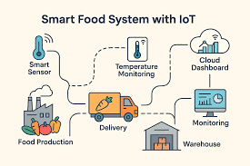

14.5 Risk and Mitigation Matrix
Risk | Impact | Mitigation
Sensor/connectivity failure | Loss of monitoring during transit | Redundant sensors, offline data buffering with sync-on-reconnect
Inaccurate AI predictions | False alerts or missed spoilage | Continuous model retraining with real-world outcome data
Blockchain network downtime | Delayed record confirmation | Multi-node consortium network with failover nodes
Stakeholder resistance to adoption | Incomplete supply-chain coverage | Simple mobile UI, farmer training, incentive programs
Data privacy concerns | Reluctance to share business data | Role-based access control and permissioned data sharing

15. Conclusion
The AI-Based Smart Food Supply Chain Traceability and Quality Monitoring Platform addresses a pressing industry need: transforming fragmented, reactive food-safety practices into a connected, predictive, and transparent system. By combining IoT sensing, AI-driven spoilage prediction, blockchain-based provenance, and automated compliance reporting, the platform gives every stakeholder — from farmer to consumer — real-time, verifiable insight into food quality and origin.
The result is a supply chain that not only reacts faster when problems occur, but actively prevents many of them, reducing waste, protecting public health, and strengthening consumer trust in the food system. This report has outlined the problem context, objectives, architecture, technology stack, module design, AI methodology, and expected outcomes that together form the foundation for building and deploying this platform.

References
- Food and Agriculture Organization (FAO) — Reports on global food loss and waste.
- IBM Food Trust — Blockchain-based food traceability initiative documentation.
- IEEE research papers on IoT-based cold-chain monitoring systems.
- Scikit-learn, TensorFlow, and PyTorch official documentation for machine learning implementation.
- Hyperledger Fabric documentation for permissioned blockchain networks.
- FSSAI / FDA FSMA regulatory guidelines on food-safety compliance.
- Research articles on machine-learning-based shelf-life and spoilage prediction.

