Create table command used :

CREATE TABLE facebook(userid INT, age INT, dob_day INT, dob_year INT, dob_month INT, gender VARCHAR(10), tenure INT, friend_count INT, friendships_initiated INT, likes INT, likes_received INT, mobile_likes INT, mobile_likes_received INT, www_likes INT, www_likes_received INT) ROW FORMAT DELIMITED FIELDS TERMINATED BY ','

LINES TERMINATED BY '\n'

STORED As TextFile

tblproperties(

"skip.header.line.count"="1"

Command used to move files from local to hdfs path

hdfs dfs -copyFromLocal /home/mavricbdhnov0117/pseudo_facebook.csv /user/$USER/facebo

ok/



Command Used :

LOAD DATA INPATH 'facebook/pseudo_facebook.csv' INTO TABLE facebook;

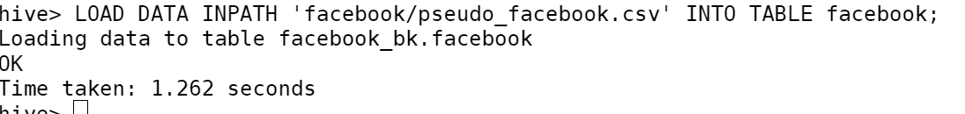

1ST Question:

Command used :

select count(distinct userid) from facebook;

Answer:  
99003

Question 2:

Command used :

select count(*) from facebook where age >25;

Answer:

56676

3rd Question:

Command used :

select gender, AVG(friend_count) from facebook where gender IN ('male', 'female') group by gender;

Answer :

Female

Question 4:

Command used : select CASE when age < 30 then 'young' else 'old' end as age_group, SUM(likes_received) as total_likes_received FROM facebook group by age<30;

Answer : Young people

Question 5:

Command used : select dob_month, count(*) from facebook where dob_month IS NOT NULL group by dob_month order by dob_month;

Question 6:

select 'Young' as age_group,SUM(mobile_likes) as mobile_likes,SUM(www_likes) as computer_likes FROM facebook_sk_db.facebook where age <= 25 group by 'Young';

Question 7:

select 'Adult' as age_group,SUM(mobile_likes) as mobile_likes,SUM(www_likes) as computer_likes FROM facebook_sk_db.facebook where age <= 25 group by 'Adult';