**Steps to install Apache Ambari**

**Assumptions:**

I have tested this on a MAC OS X with 16GB RAM.

The virtual machines are configured to have CentOS 6.5 and 4GB RAM each.

* Edit the /etc/hosts file to include hostnames for virtual machines we are going to set up. (This can be found in the hosts file provided in this folder)  
    
  192.168.70.101 ambari1.nvent.galvanize ambari1

192.168.70.102 ambari2.nvent.galvanize ambari2

192.168.70.103 ambari3.nvent.galvanize ambari3

* Start the cluster by doing `vagrant up` in the folder where the Vagrantfile is present.  
   **➜ ambari** vagrant up
* Open a web browser and go to **ambari1.nvent.galvanize:8080** for the Ambari web login. The default username and password are *admin*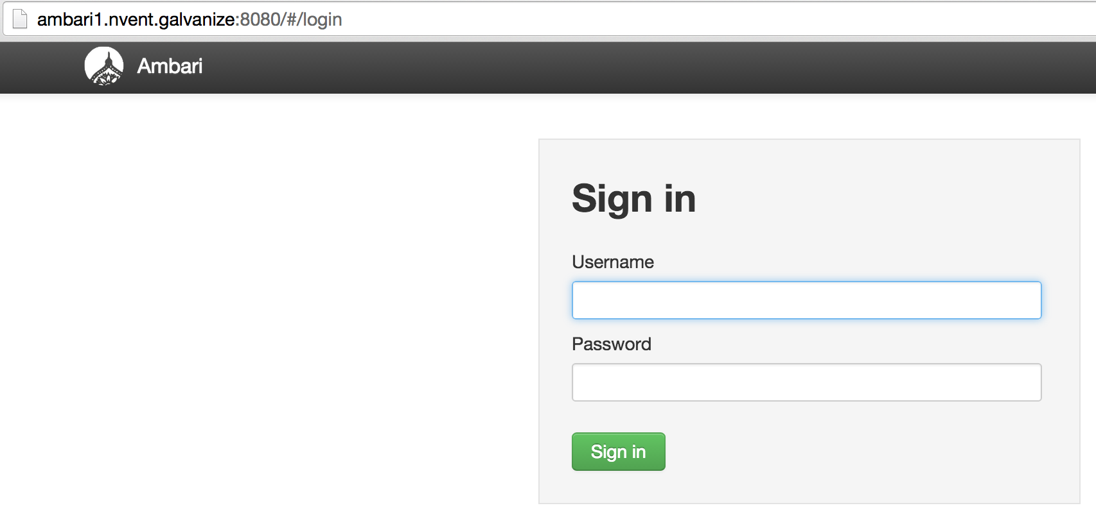
* Then Launch the Install Wizard. Name your cluster in Step 0.  
  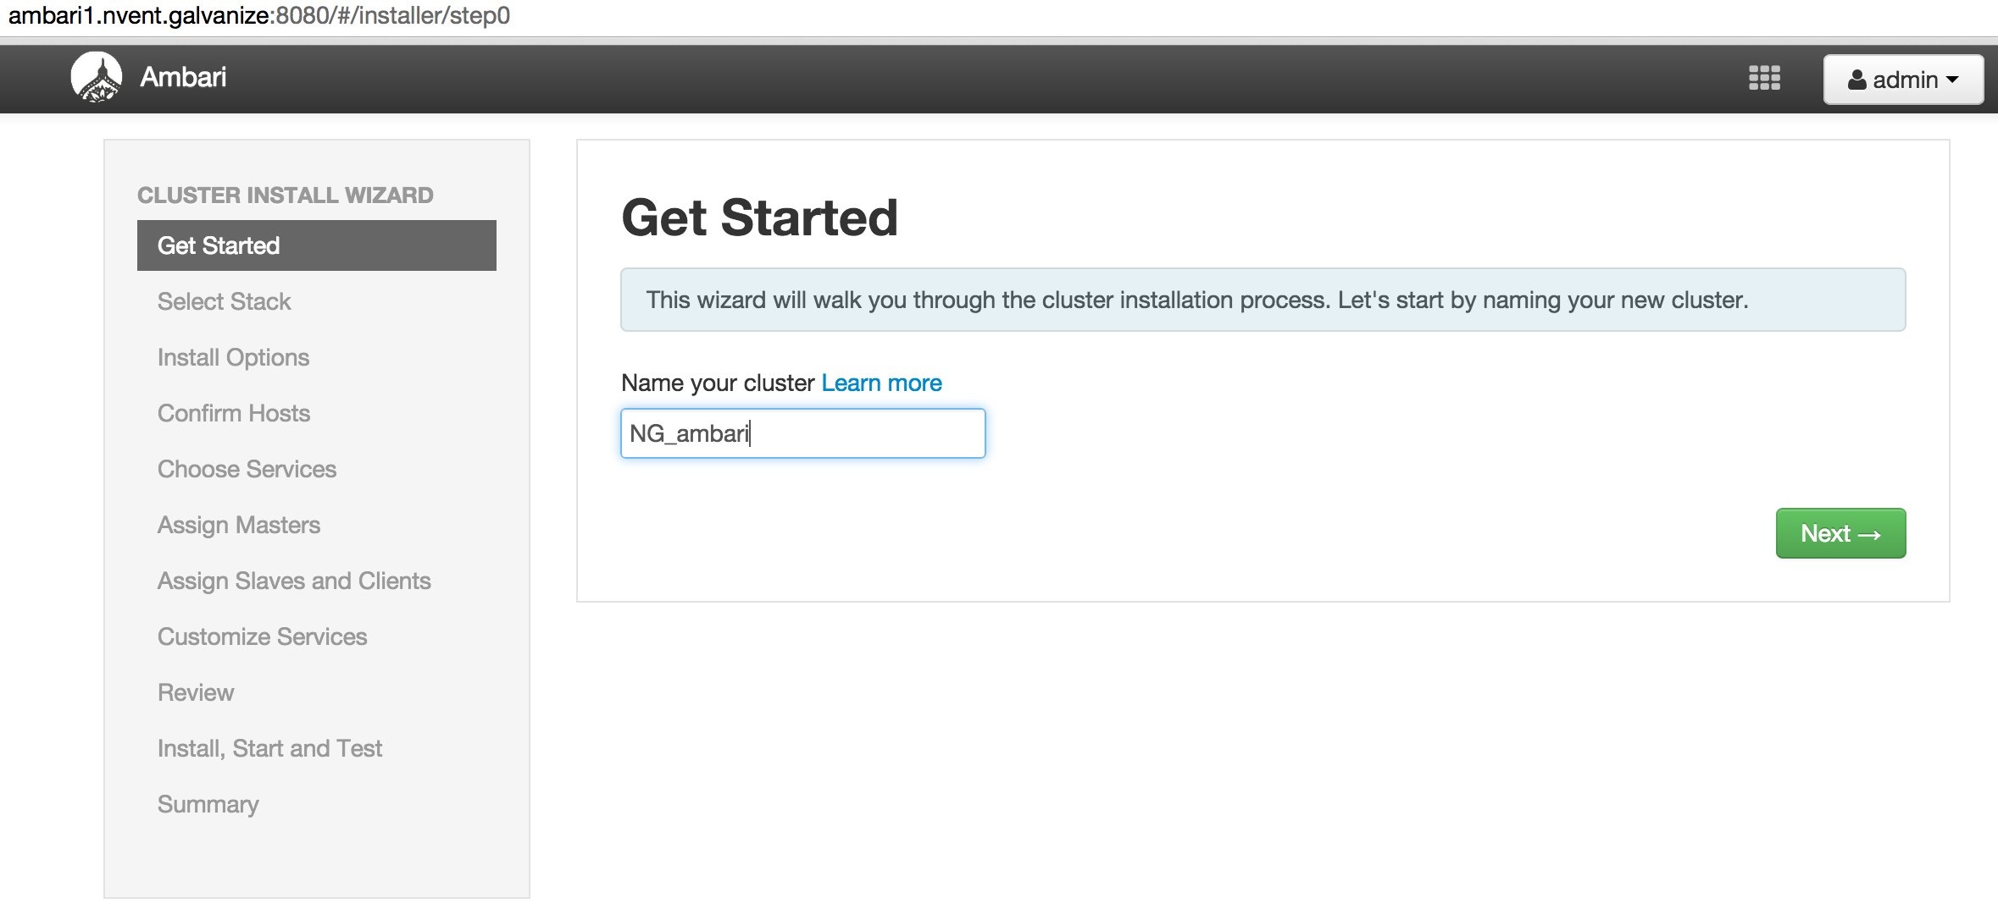
* Select the Hadoop Stack in Step 1.  
  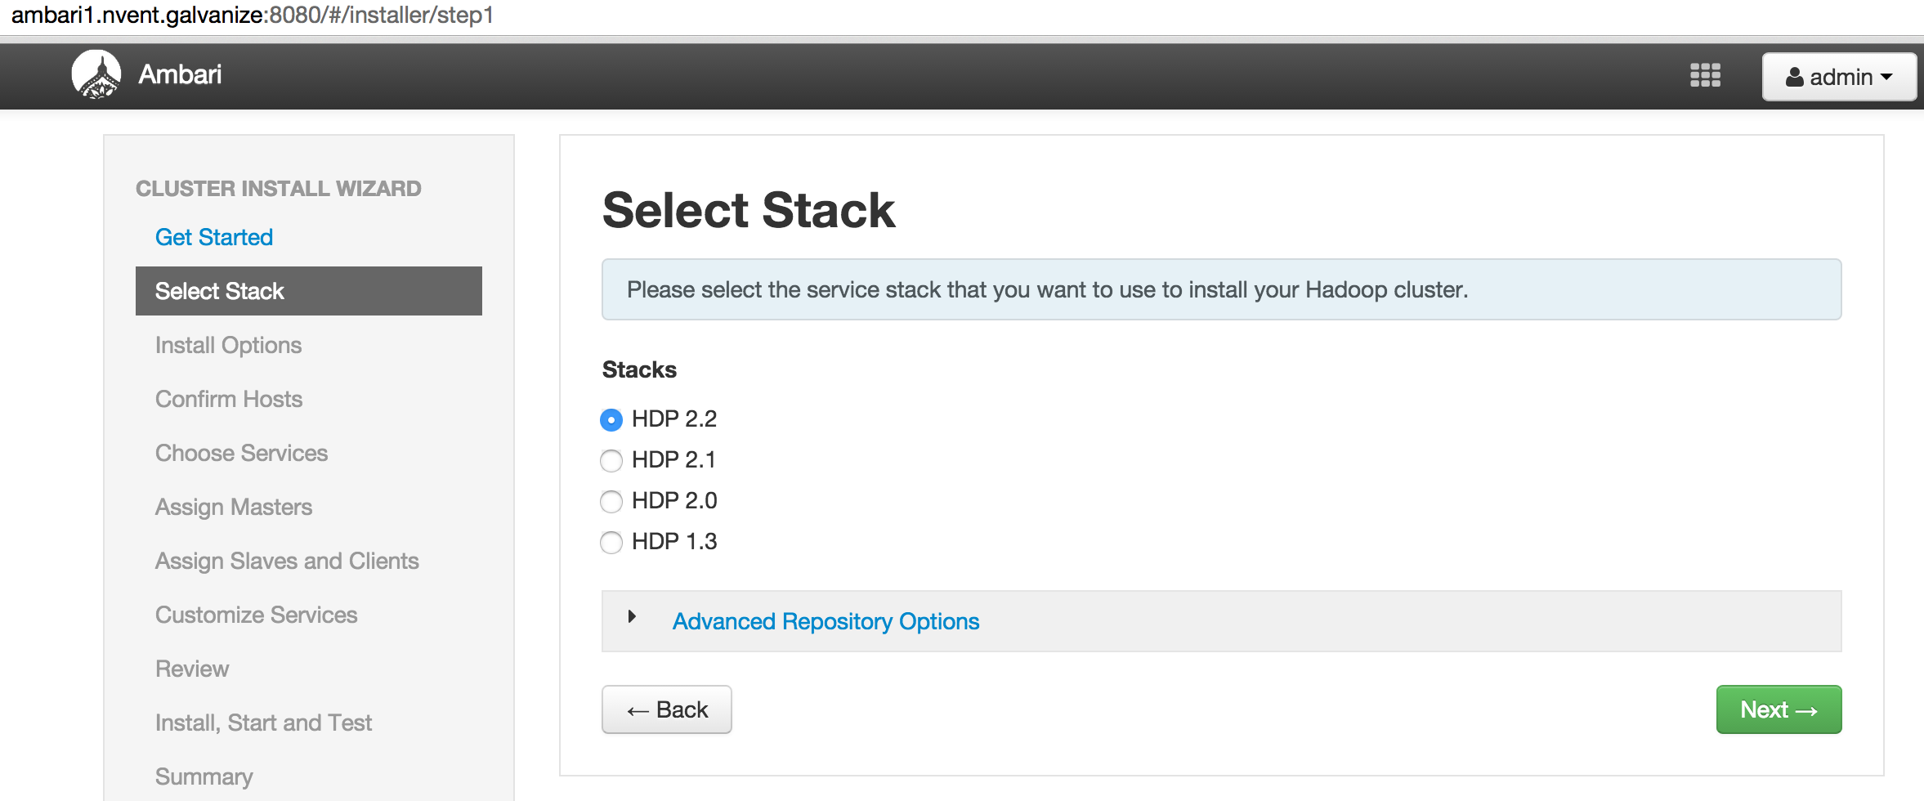
* In Step2, specify the hostnames and insert the private key `id_rsa` provided in this folder.  
  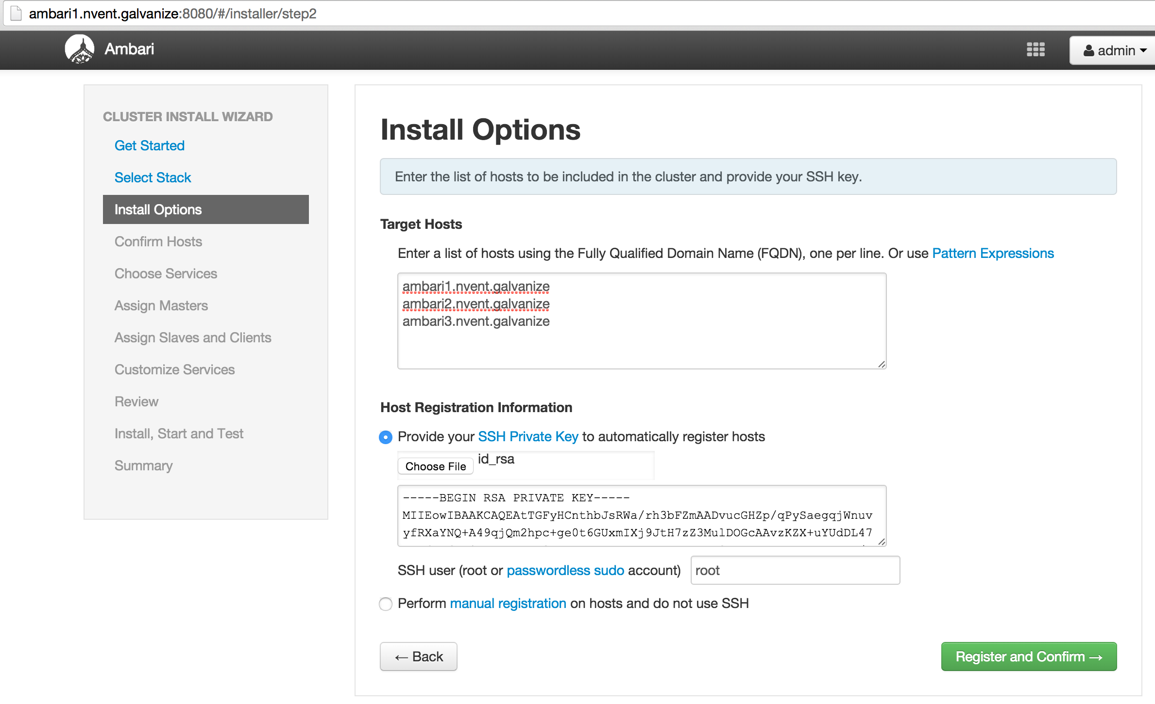
* The hosts are confirmed in step3. This should work if the same private key present in all the hosts of the cluster.  
  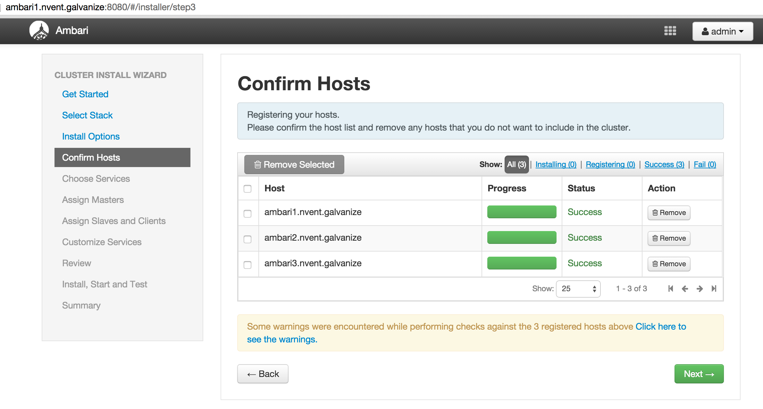
* You can select the services to install in Step4. By default, all are selected.  
  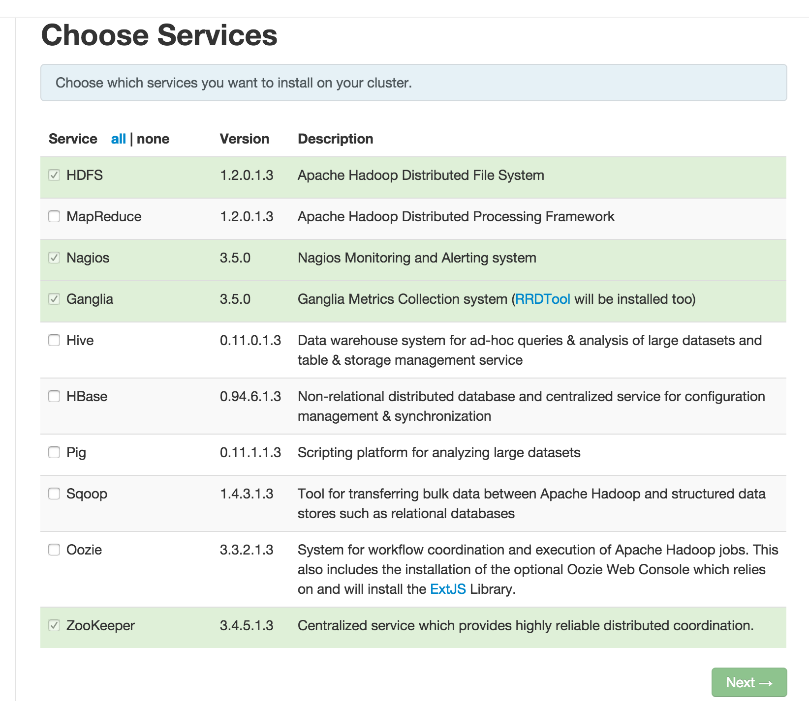
* Masters and Slaves are assigned in Step 5 and 6. Ambari has some default suggestions for this.  
  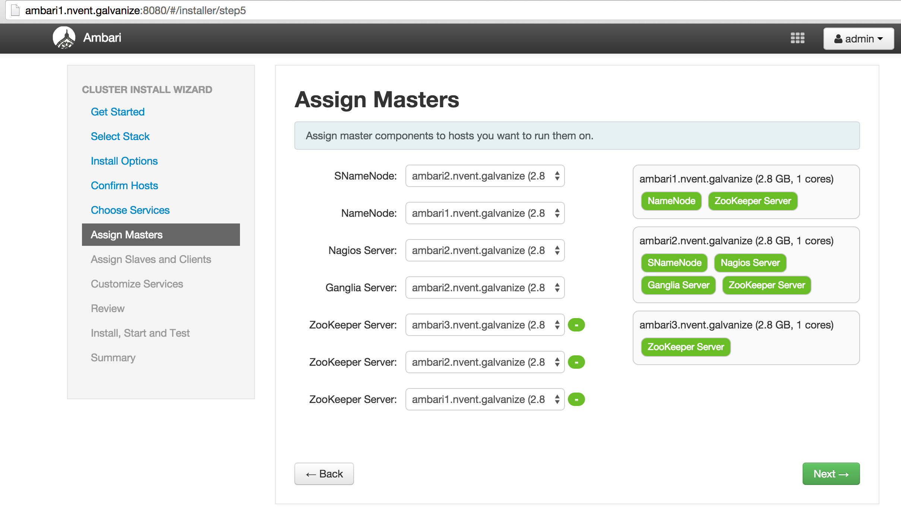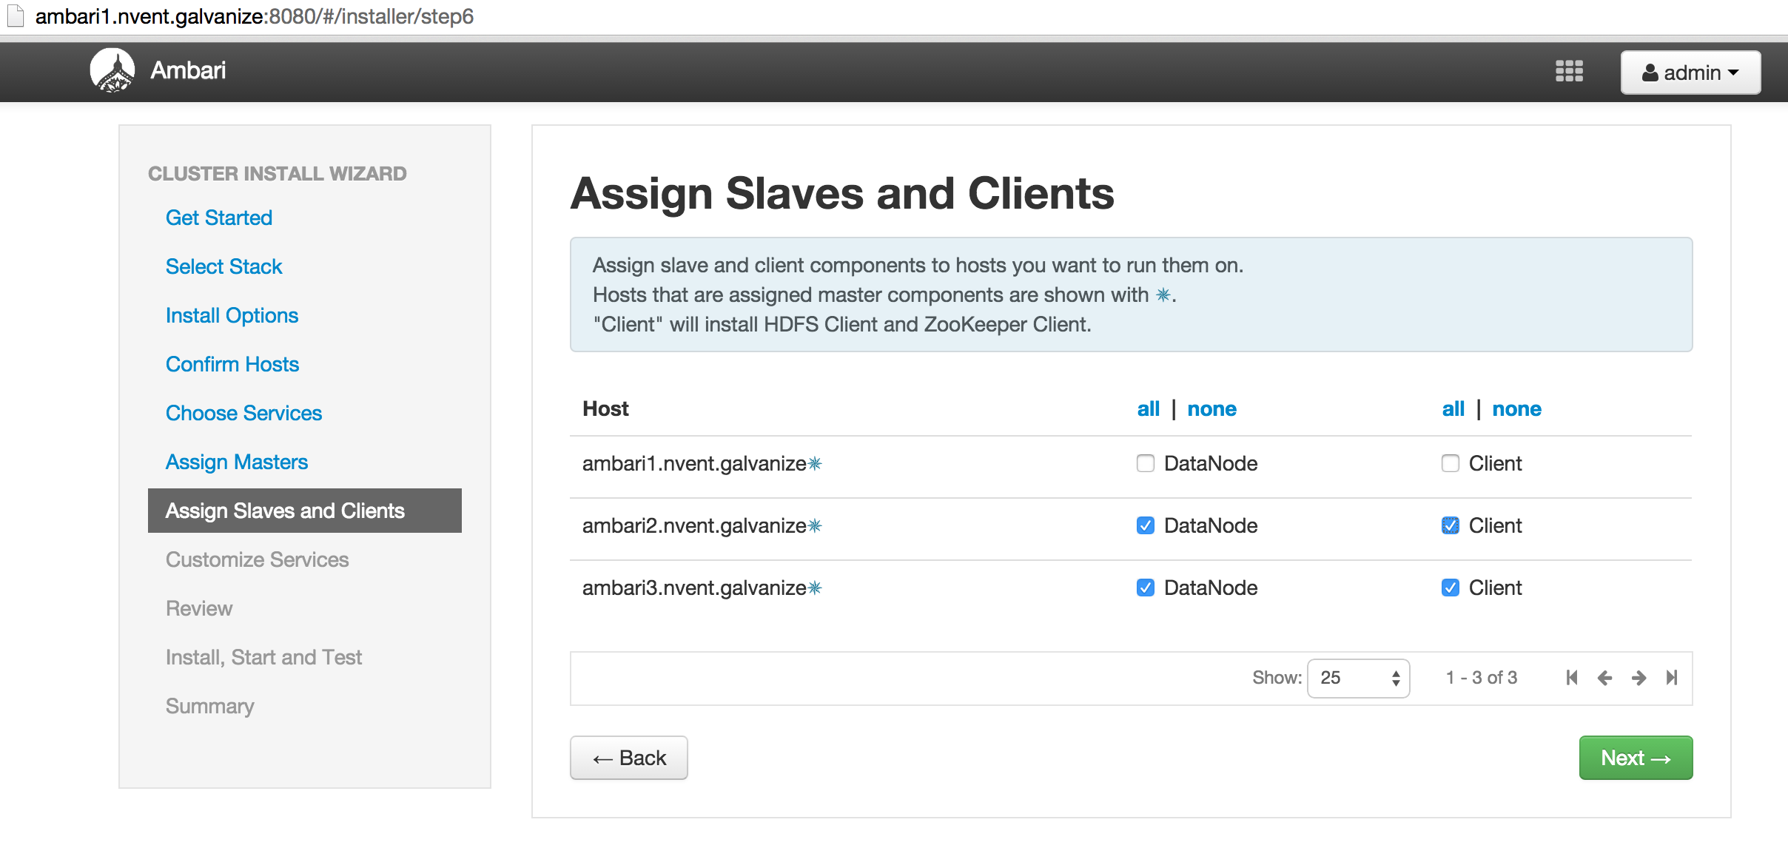
* Services can be customized in Step 7. This includes setting up passwords, choosing databases, setting up emails etc.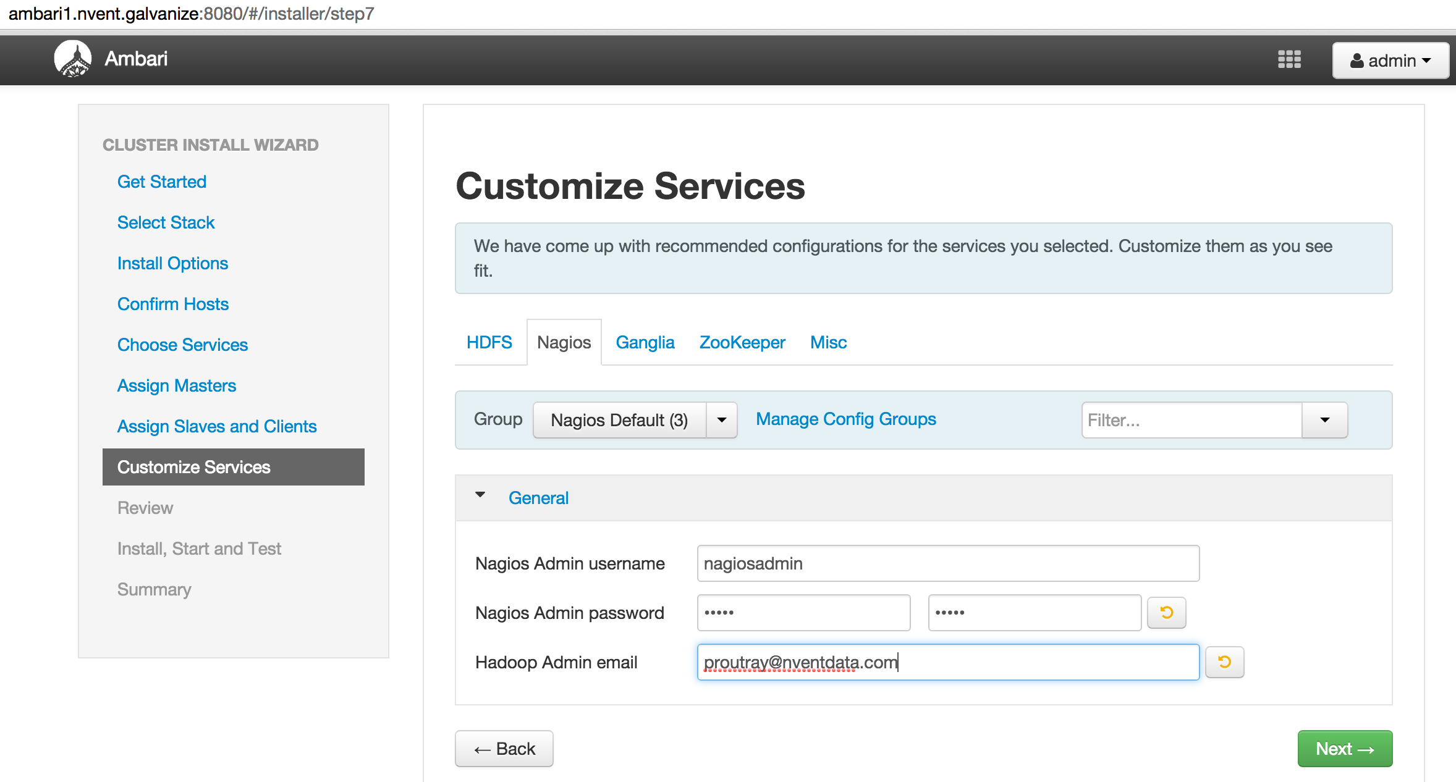
* Review the choices in Step 8. In step 9, the installation starts. Make sure your Internet connection is proper for download of large files.  
  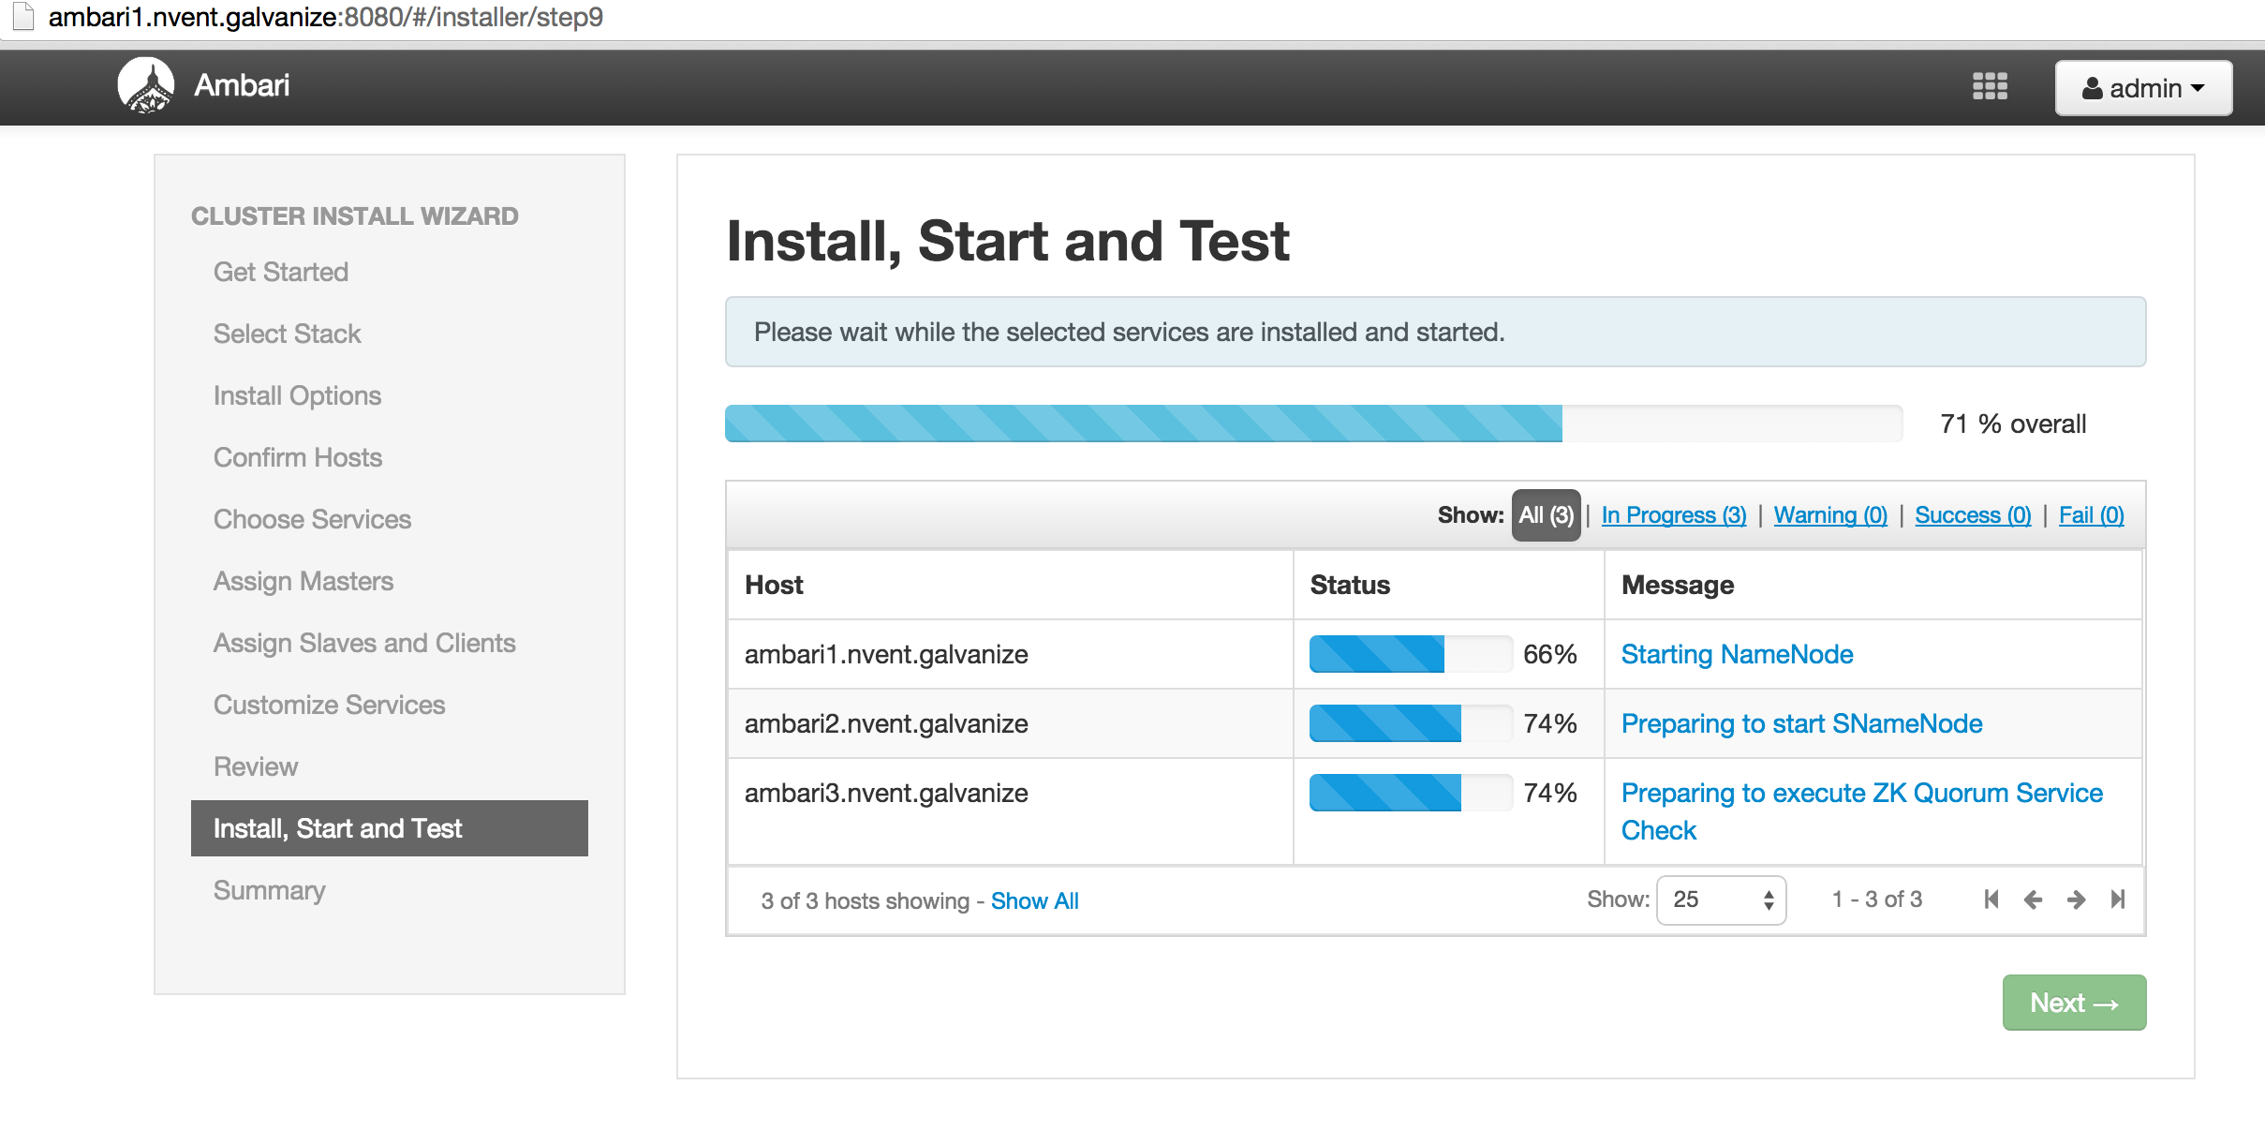
* Successful installation leads you to the Summary page.  
  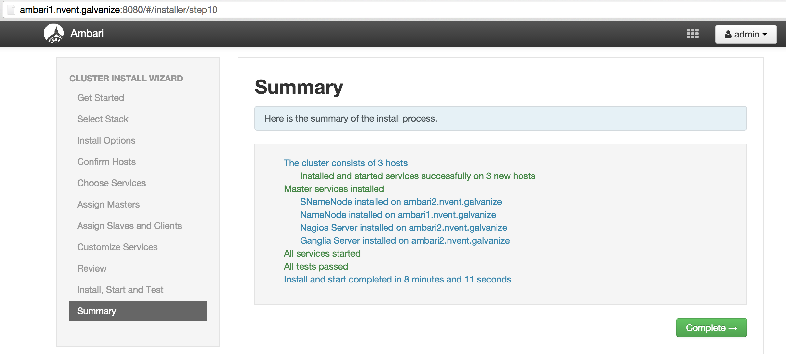
* Upon completion you can go to the Ambari home page where you may add or remove services in future, as needed.

