Visual Mapping to Assist Fault Localization
Using Output Influences.

Aditi Noata and Balaji Ganesan
Department of Computer Science,
University of Arizona, Tucson.
aditi, balaji @ cs.Arizona.edu

Abstract:

<Abstract to be added>

Keywords – Data Flow Testing, Output Slices, Statement Coverage.

1. Introduction

The software debugging process consumes 50%-80% of the software’s development and maintenance effort. Many tools have been developed to assist the programmer in the fast development and debugging of his program. The Visual mapping tool developed by James A Jones, Mary Jean Harrold and John Stasko in their paper “Visualization of test information to assist fault localization” helps the developer in identifying the suspicious statements in a program by coloring the statements according to their participation in testing.

The visualization technique discussed in the above paper considers a statement as covered merely by its presence in the execution trace for a particular test case. This increases the number of suspicious statements that need to be analyzed to find the buggy statements. This is because many statements may be spuriously marked as suspicious simply because they were exercised by many failed test cases while they may not have actually contributed to the failure.

Our project is aimed at refining this coverage criterion by selecting only those statements, which are influencing the program’s output. This is as discussed in the paper “Rigorous Data Flow Testing through Output Influences” by Evelyn Duesterwald, Rajiv Gupta and Mary Lou Soffa. This paper proposes the use of output slices to determine whether the statement contributed to the program’s output. Our refinement to the coverage criterion reduces the number of statements that are marked suspicious.

Formal Problem Statement:

“To incorporate the notion of output influences in the Visualization technique in order to reduce the number of statements marked suspicious so that the developer can locate the faulty statement faster.”

The organization of the paper is as follows. In the next section, we discuss the previous work done in this field based on which we have developed our approach. In section 3, we discuss in detail the approach we have used to solve the aforementioned problem. In sections 4 and 5, we present our experiments and analyze the results. Finally we present the conclusions of our work in section 5 and also discuss some future work.

2. Related work:

In prior work [1, 2], the concept of using Visualization technique to help the developer to locate the faulty statements and the use of Output Influences for rigorous Data flow testing have been discussed in detail.

Visualization Technique:

<To be added>

Using Output Influences:

<To be formatted>

The underlying principle behind using Output Influences for data flow testing is as follows: “A program component to be considered tested must have demonstrated evidence of correctness through its contribution to the program output.”

- OI is used to refine previous data flow testing criteria by requiring that an exercised def-use pair influences the computation of atleast one correct output value to be considered tested
- All-du vs. OI-all-du criterion
- Use slicing to capture output influencing def-use pairs
- What are output slices ?
- Contain statements that directly or indirectly affect the computation of output values
Static output slice is good enough but yields conservative information for arrays and pointers – use dynamic slice for them
- Static slicing:
  - Iteratively solving a set of data flow equations over the control flow graph
  - Program dependence graph – slicing reduces to a vertex reachability problem
- Dynamic slicing:
  - Solving data flow equations over the generated execution trace
  - Based on dependence graphs – dynamic slice is not an executable subset of the program
- This paper follows the dependence graph based approach.
- Slice is an executable subset of the program.
- Existing dynamic dependence graphs form dynamic expansion of a static graph.
- But our interest is to use dynamic dependence info for arrays and pointers.
- Use dynamic subset of the static graph with respect to a specific execution.

- An output slice is extracted from a program’s dependence graph.
- Dependence graph represents the control and data dependences among statements.
- Major portion of slicing technique is the construction of the dependence graph
- Control dependence information – program structure.
- Data dependence – three methods

- Control dependence
  - s1 is control dependent on s2, if s2 is a control predicate and control reaches s1 depending on the result of evaluating s2.
- Data dependence
  - Statically data dependent
    - s1 on s2 if s2 contains a definition of a variable v and s1 uses v and control may reach s1 after s2
  - Dynamically data dependent
    - s1 on s2 with respect to program input I if, during the execution on I, s2 computes a value used in s1

- Why should we combine ?
  - Move as much work to compile time as possible.
- Static dependence graph is constructed partially at compile time and dynamic info is added at run-time.
- Set of variables V in a program is partitioned into two sets V1 and V2.
  - Static data flow info for V1.
  - Dynamic dependence edges of V2.
- How to partition V ?

  - Array references in one and scalar variables in other
  - Pointers and the variables they point to in one and the rest in the other

- Static output-slice of P wrt S à subprogram P’ of P that when executed computes the same values in S as P does.
- Dynamic output slice à subprogram P’’ that when executed on Input I, computes the same values in S as P does.
- Extract slices from respective dependence graphs.
- Subgraph:
  - n1 is reachable from n2 à path from n2 to n1.
  - e = (n1, n2) is reachable from n à path starting at n containing e.
- Given dependence graph G = (N,E) for program P and a set of output nodes S in G, the output slice is the subgraph G/S = (N’,E’) where.
- Goal: cover as many def-use pairs as possible
- Infeasible def-use pairs à no test case exists
- Two critical issues:
  - Appropriate test case generation
  - Accurate data flow coverage determination
For program P and test case t,

Cover(t):
  - Subset of the potential def-use pairs in P.
  - Contains only pairs that had influence on the computation of atleast one correct output value produced by t.

- Three approaches to compute cover set:
  - Static output slices and cover set.
  - Dynamic output slices and cover set.
  - Combined static and dynamic output slices.

- Introduced the concept of output influence as a refinement to existing data flow testing criteria.
- It allows for a more rigorous approach to data flow testing.
- Presented several techniques based on slicing to compute output influencing def-use pairs in a test case.

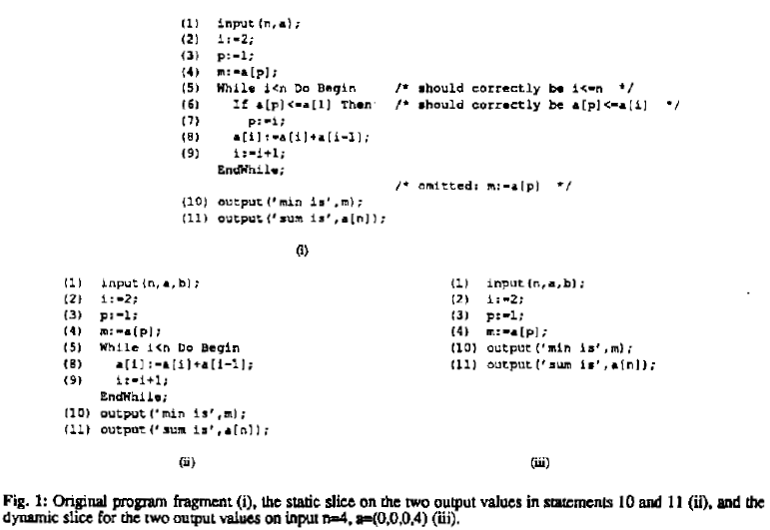

Fig 1: – Static Output Slice.

3. Our approach:

< To be made into proper sentences>

- We use the Aristotle tool to obtain the code coverage information for the given Siemens test suite and the program.

- We initially use the information obtained above to color the statements in the program based on the coloring criteria discussed in Visualization paper. We are writing a tool similar to TARANTULA for this purpose.

- We use the dependence graph obtained from the Aristotle tool to refine the coverage information obtained in step 1 so that only those statements, which actually influenced the output, are considered as covered.

- Now the coloring tool will color the statements according to the new coverage information obtained in step 3.

- We will then conduct a series of experiments to verify the effectiveness of our approach in reducing the percentage of suspicious statements in comparison to the existing technique.

Color Mapping Equation:

All three inputs: source code, test suite and the refined code coverage result are provided to the coloring module which colors the program statements according the following equation:
Color(s) = low color (red) +
( % passed(s) /
( % passed(s) + % failed(s) ) )
* color range

- Color(s) - Color for the statement s in the source code S.
- Low color - Value assigned to the red color (lowest) in the spectrum as 0.
- % Passed(s) – Number of passed test cases for the statement(s) / total number of the passed test cases in the entire test suite T.
- % Failed(s) – Number of failed test cases for the statement(s) / total number of the failed test cases in the entire test suite T.
- Color range - the difference in the value of the highest color (green/120) and the lowest color (red/0).

Example program:

Consider the following example program, which computes the sum of the elements and the minimum element in the given input array. This is a simplified version of the example discussed in [2]. This program for a given test input n=4 and a=(0,0,0,4), produces a correct output despite the presence of the bug.

(1) input (n,a);
(2) i := 2;
(3) p := 1;
(4) m = a[p];
(5) while i<n do begin /* should correctly be i<=n */
(6) if a[p] <= a[i] then
(7) p := i;
(8) a[i] := a[i] + a[i -1];
(9) i := i + 1;
EndWhile
(10) m := a[p];
(11) output(‘min is’ m);
(12) output(‘sum is’ a[n]);

Using the existing approach for the above program, we will have all the statements marked as covered. However if we incorporate the notion of output influence by considering only those statements in the dynamic output slice as below, we will only mark statements 1,2,3,4,10 and 11 as covered.

(1) input (n,a);
(2) i := 2;
(3) p := 1;
(4) m = a[p];
(10) output (‘min is’ m);
(11) output (‘sum is’ a[n]);

<is the output slice correct>

<Example needs to be explained>

4. Experiments

For our experiments we used five c programs of varying complexity each of which had one or more known bugs.

Coverage Information:

We used the Aristotle tool [3] to obtain the Statement coverage Information. We generated the statement numbers covered in each execution of a program by generating its instrumented code and running this instrumented code for each test case. The steps involved in generating the instrumented code and obtaining the statement numbers that are covered is as explained in [5].

It involves running the cfe analyzer provided in Aristotle to generate the control flow and the dependence graph information. We then run the branch trace instrumenter on the input program to obtain the Instrumented code. We then run this instrumented code and generate its trace. The trace information thus generated for all the test runs is collected to generate the trace history. This trace history will then be read by the ‘Visual Mapping to tool’ and the statement coverage will be displayed using the color mapping discussed above.

Output Slice:

<Unravel procedure needs to be explained>

Visual Mapping:

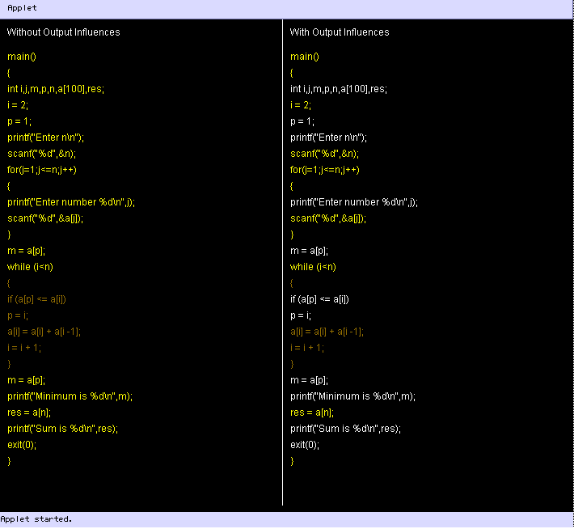

Fig 2: - The output of the Visual Mapping Tool.

5. Results:

Program | Previous Approach | Our Approach | % reduction
flavors.c | 28 | 12 | 57.14
sum.c | 26 | 15 | 42.30
mid.c | 12 | 9 | 25.00

Table 1: Table showing the number of statements marked as suspicious by both approaches and the percentage reduction in the number of suspicious statements while using our approach.

<A graph To be added>

6. Conclusions and Future work:

Utilized the concept of output influence as a refinement to the existing visualization technique. This method results in the reduction of number of statements reported as suspicious. The highest reduction we observed was 57%

Increase the automation so that the Visualization tool gets the coverage information directly from Aristotle and the Unravel tool.

Acknowledgements:

We wish to acknowledge the immense support we received from Prof. Neelam Gupta, who guided us all along the project.

References:

[1] James A. Jones, Mary Jean Harrold, John Stasko. Visualization of Test Information to Assist Fault Localization. In Proceedings of the 24th International Conference on Software Engineering. Pages: 467 – 477, 2002

[2] Evelyn Duesterwald, Rajiv Gupta, Mary Lou Soffa. Rigorous Data Flow Testing through Output Influences. In 2 nd Irvine Software Symposium, Irvine CA, Pages 131-145, Mar. 1992.

[3] Aristotle Analysis System, a system that provides program analysis information, and supports the development of software engineering tools. http://www.cc.gatech.edu/aristotle/Tools/aas.html

[4] Unravel, a prototype program slicing tool that can be used to statically evaluate ANSI C source code
http://hissa.nist.gov/project/unravel.html

[5] Subject Infrastructure Repository. Site for information on how to use Aristotle tool for coverage information.
http://csce.unl.edu/~galileo/sir/

