Axis WebService with maven build:

1. Import the project in eclipse. And Run as maven build.

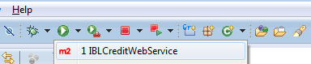

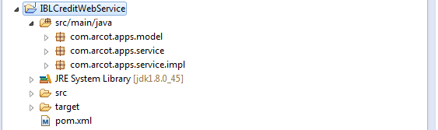

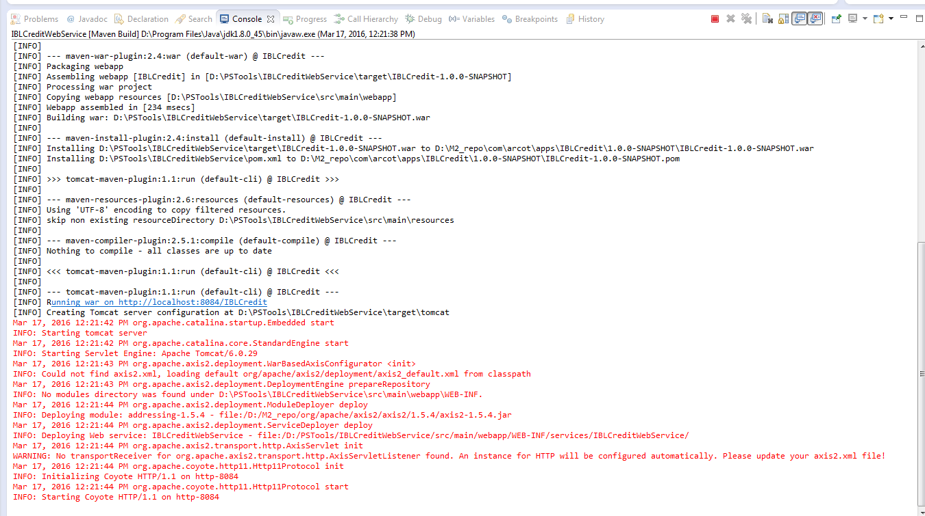

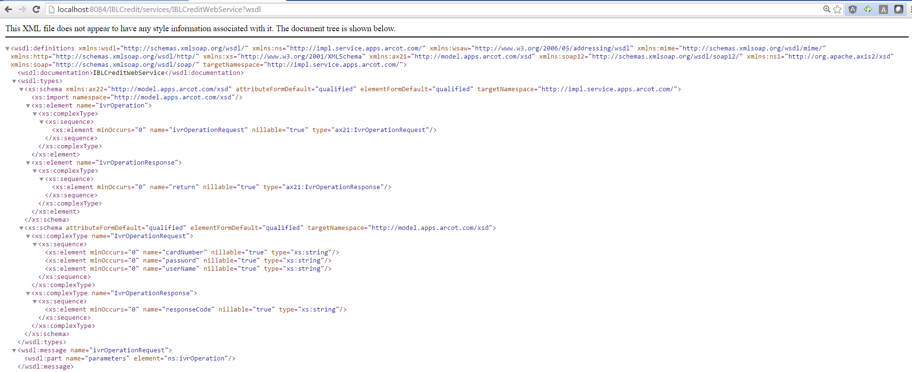

SOAP UI:

