**AWS- Project**

**How to Build Load Balancer HTTPS Setup with Route 53**

Step 1: First buy your own Custom domain.

Step 2: Login to AWS Management Console and navigate to EC2 Instance.

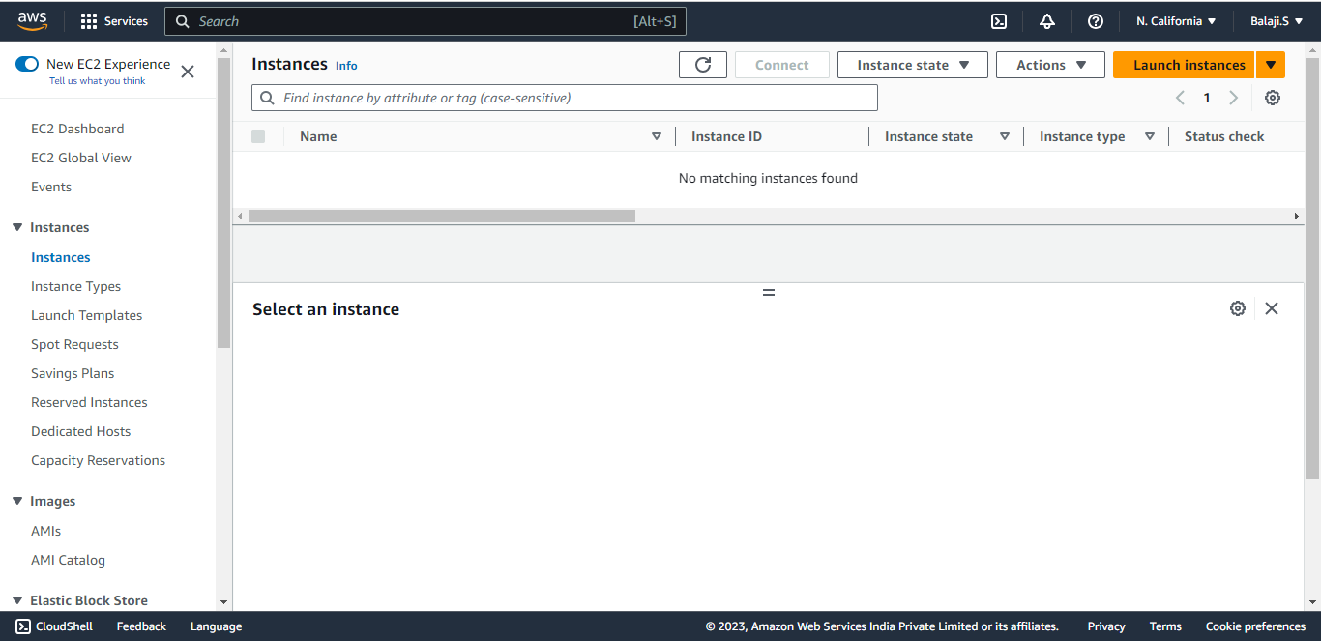

Step 3: Create a Linux EC2 Instance, for better usage try to allocate elastic IP to your Ec2 Instance.

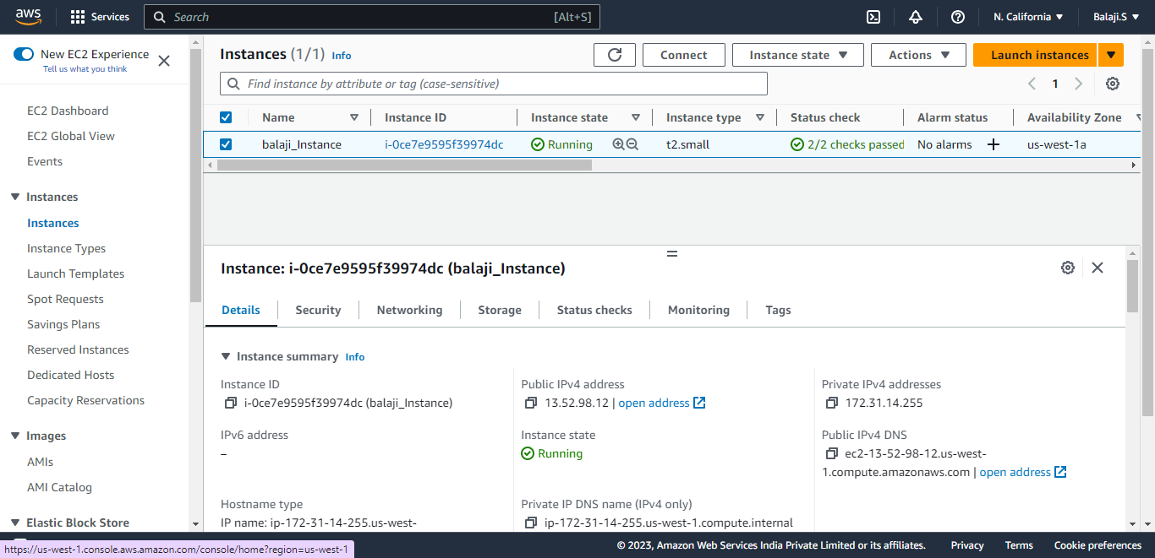

Step 4: Click on Connect.



Step 5: To connect to the Linux machine, click Connect.

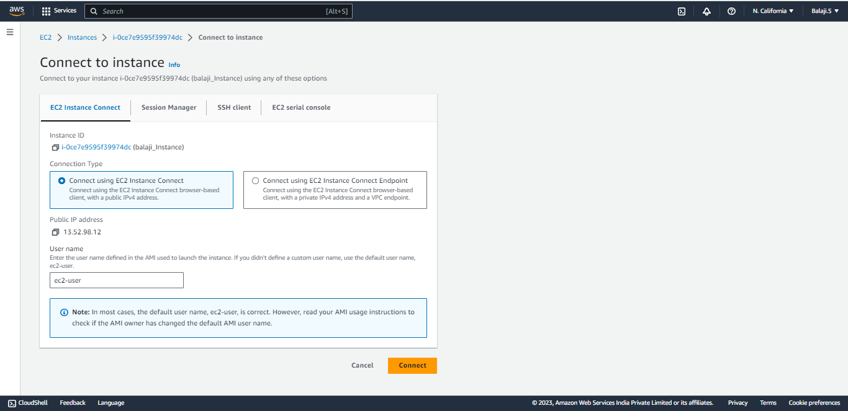

Step 6: It will Redirect to Linux Machine.

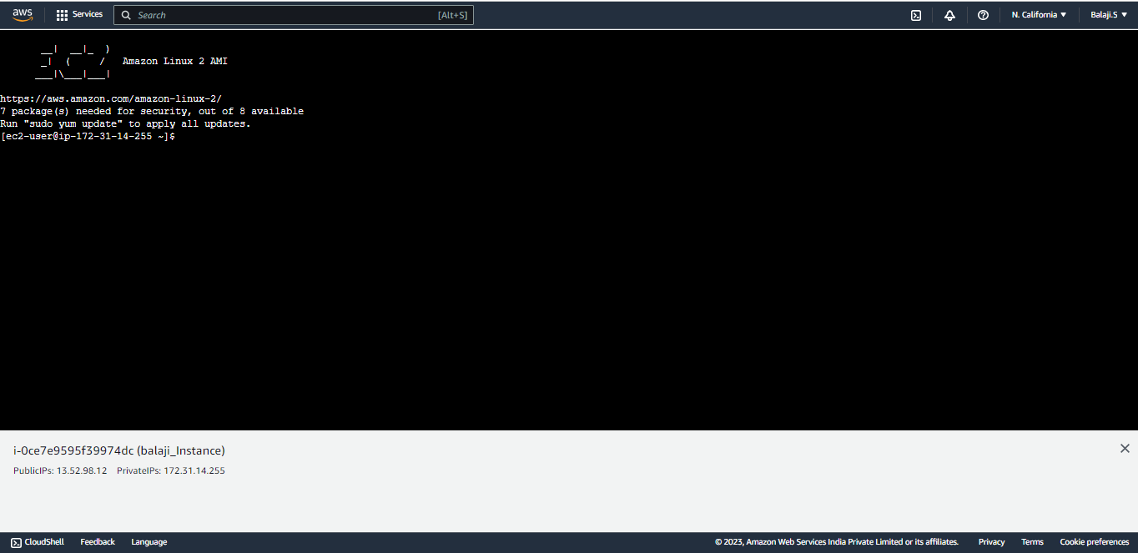

Step 7: Enter These Command,

~ sudo su = Access to Admin privilege.

~ yum update –y = To upgrade the installed packages to the latest version.

~ yum install httpd = To Install apache web-server.

~ systemctl start httpd = To Start httpd.

~ systemctl enable httpd = To Enable httpd.

~ cd /var/www/html = Type this path to change the directory.

~ vi index.html = To create a file in vi (vi is an editor).

**Step 8:** Enter the below script and save it.

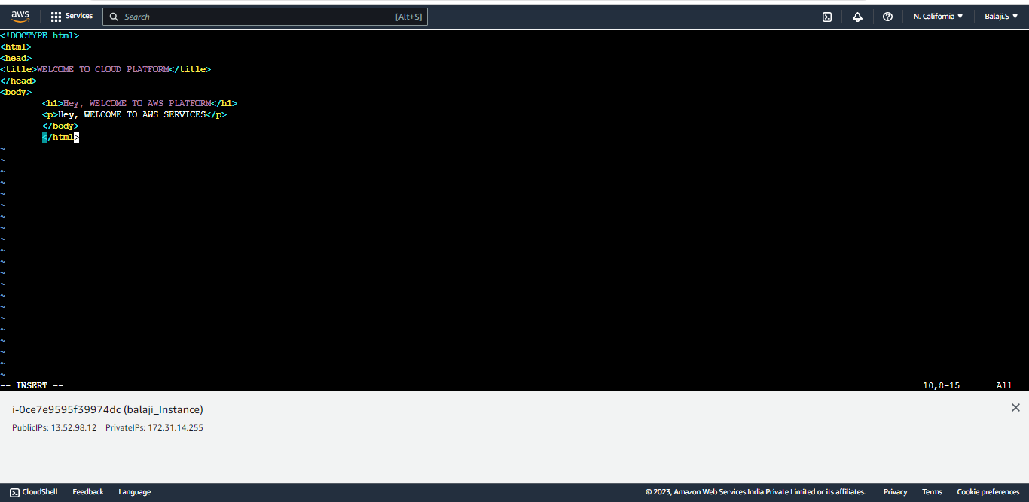

**Step 9:** Go to EC2 instance and copy the public IP Address and paste it in Browser try to access the html page.

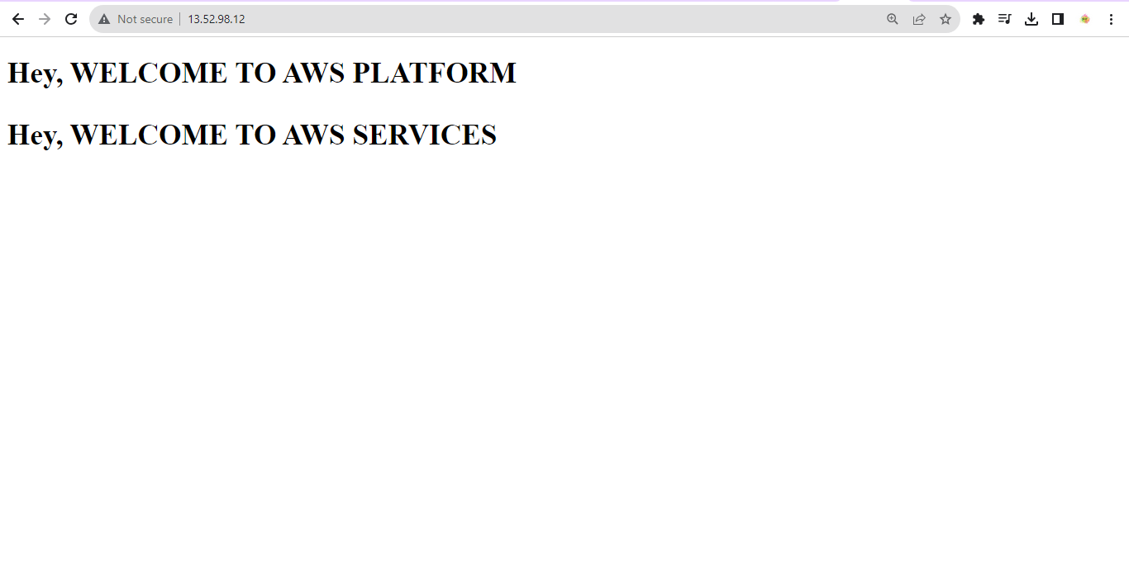

Step 10: Go to Load Balancer and Create a ALB(Application Load Balancer)

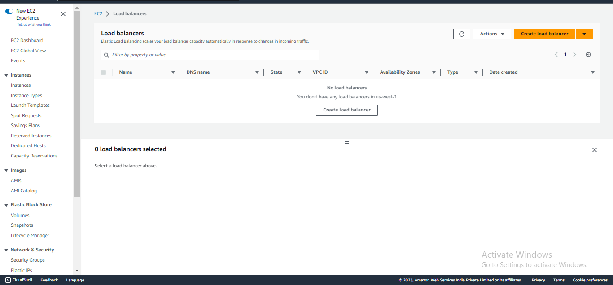

Step 11: Select the ALB(Application load balancer) and click on create.

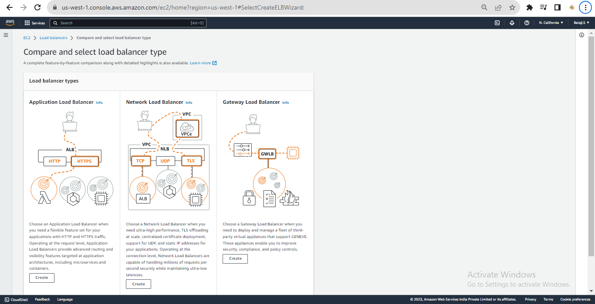

Step 12: Mention load balancer Name, Scheme and IP address type.

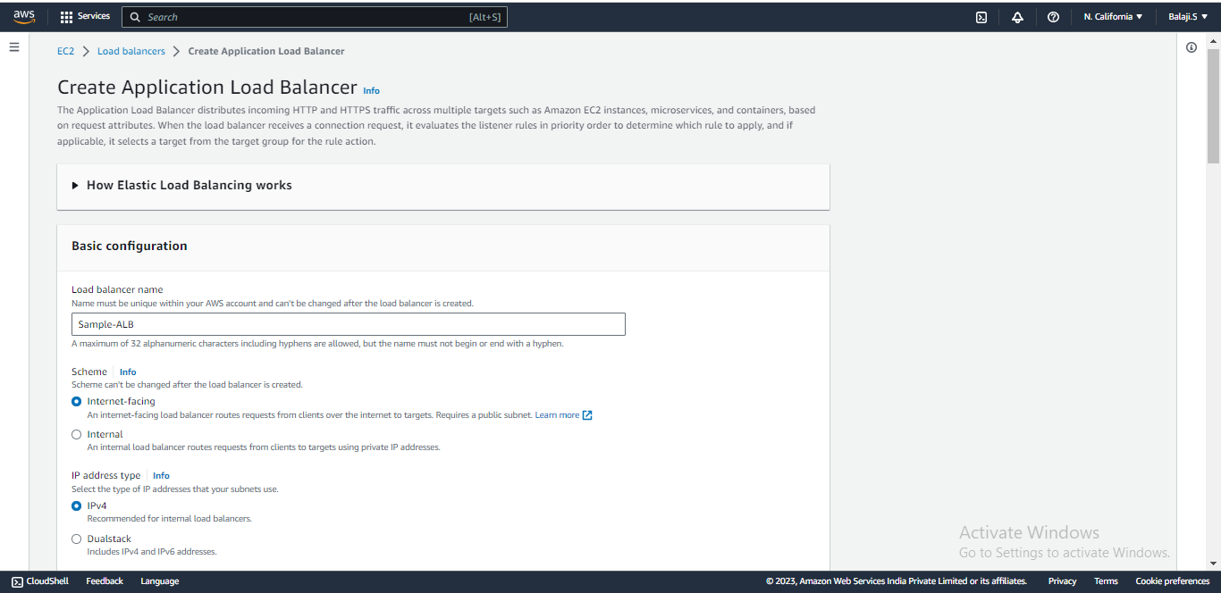

Step 13: In Network mapping by Default VPC, Mapping select all availability zones.

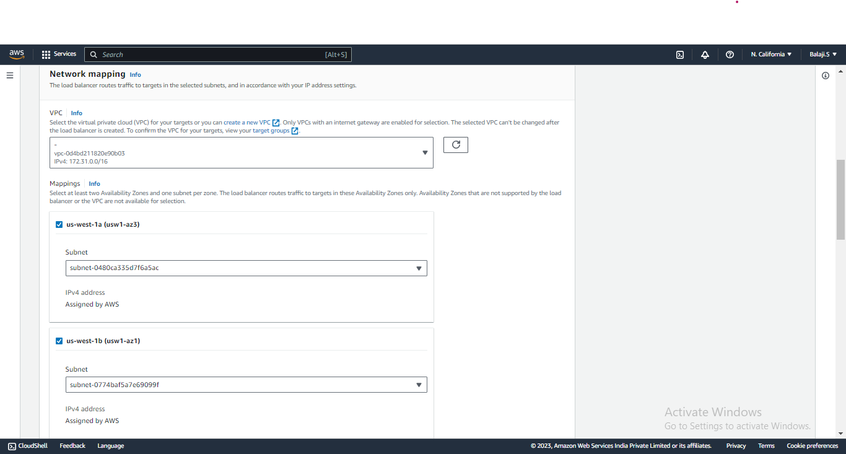

Step :14 Create a new security group add inbound rule HTTP and click on create a Security group.

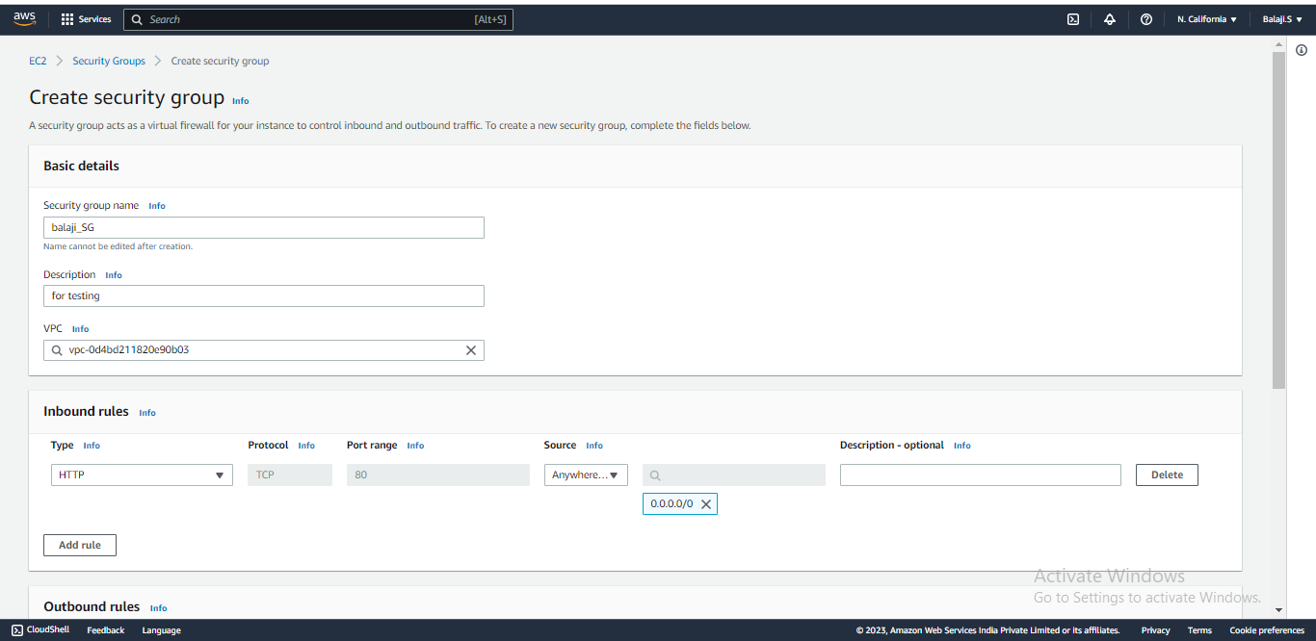

Step 15: Select the created security group in ALB and click on create a target group.

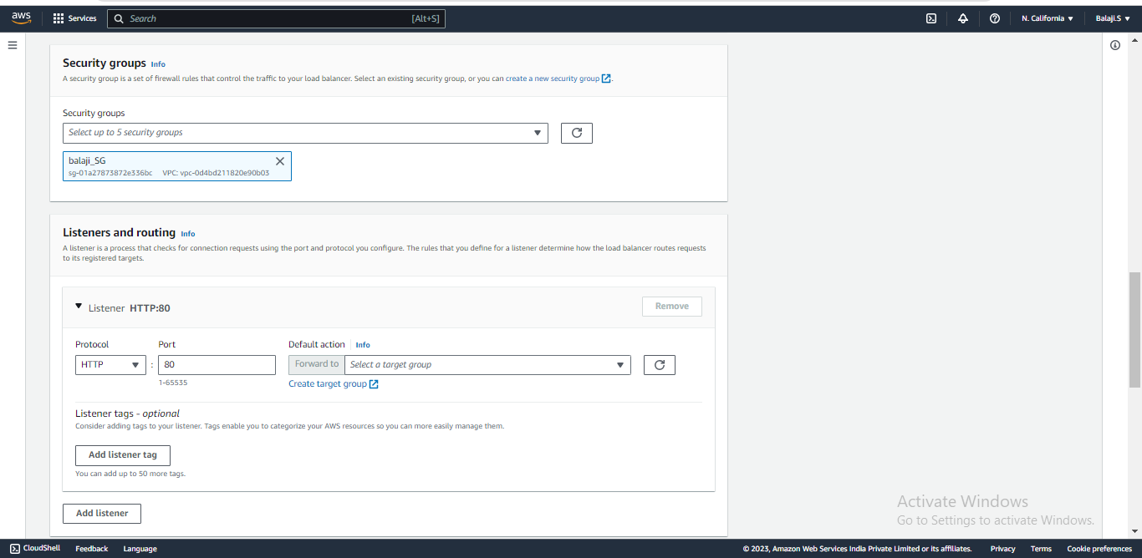

Step 16: Once you click on target group it will redirect to another page.

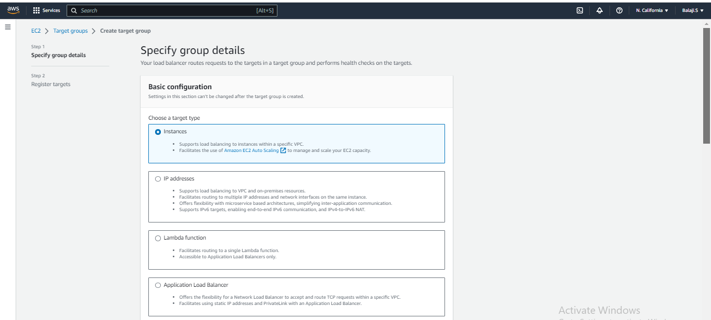

Step 17: Enter Target Group name, Then Protocol, VPC and Protocol Version are by default.

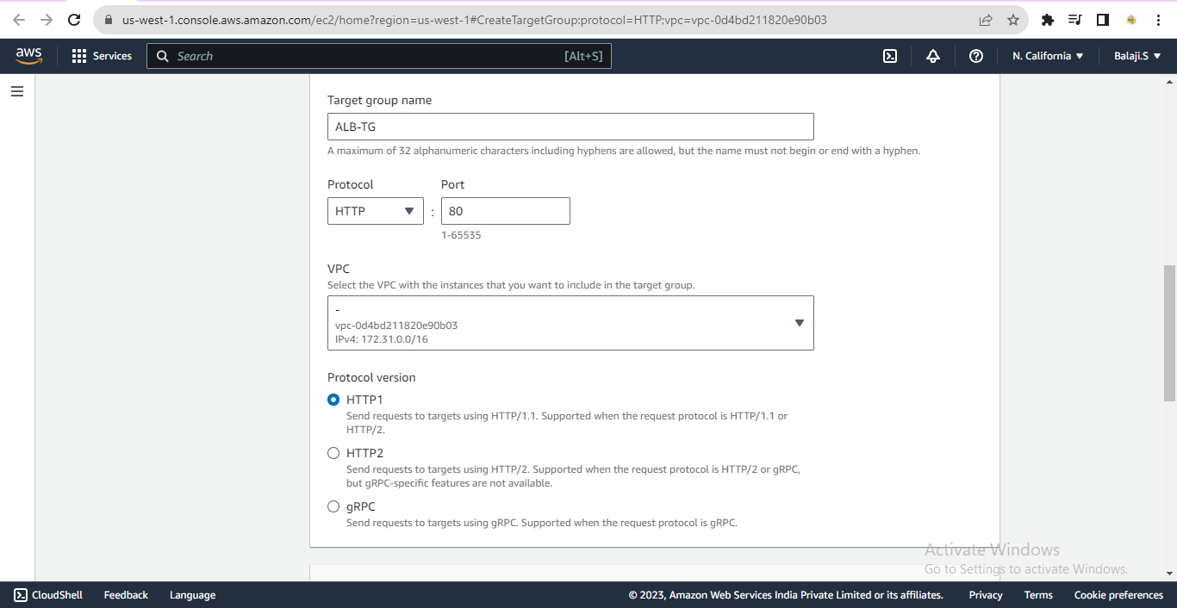

Step 18: In, health check by default HTTP and Enter health check path is “/index.html” and click on next.

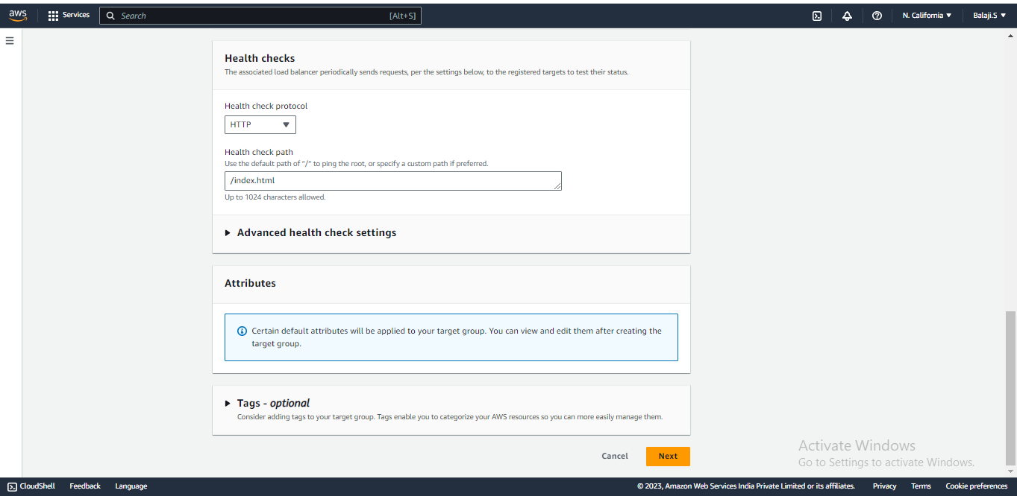

Step 19: In available instance select the EC2 instance which we created and click on include as pending below It will be added to target, click on create target group.

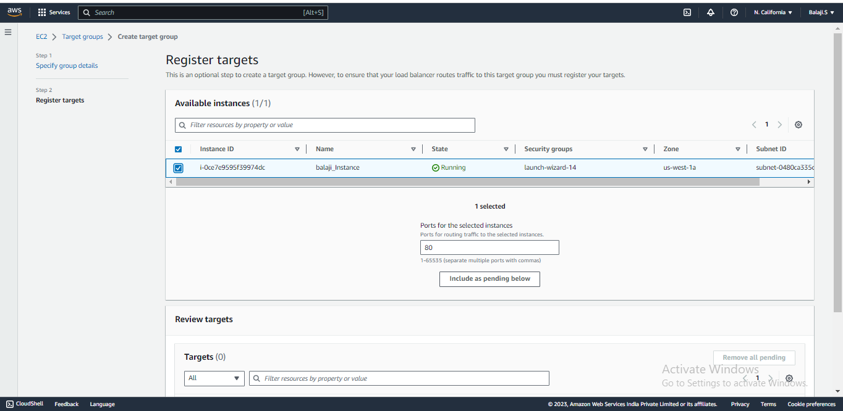

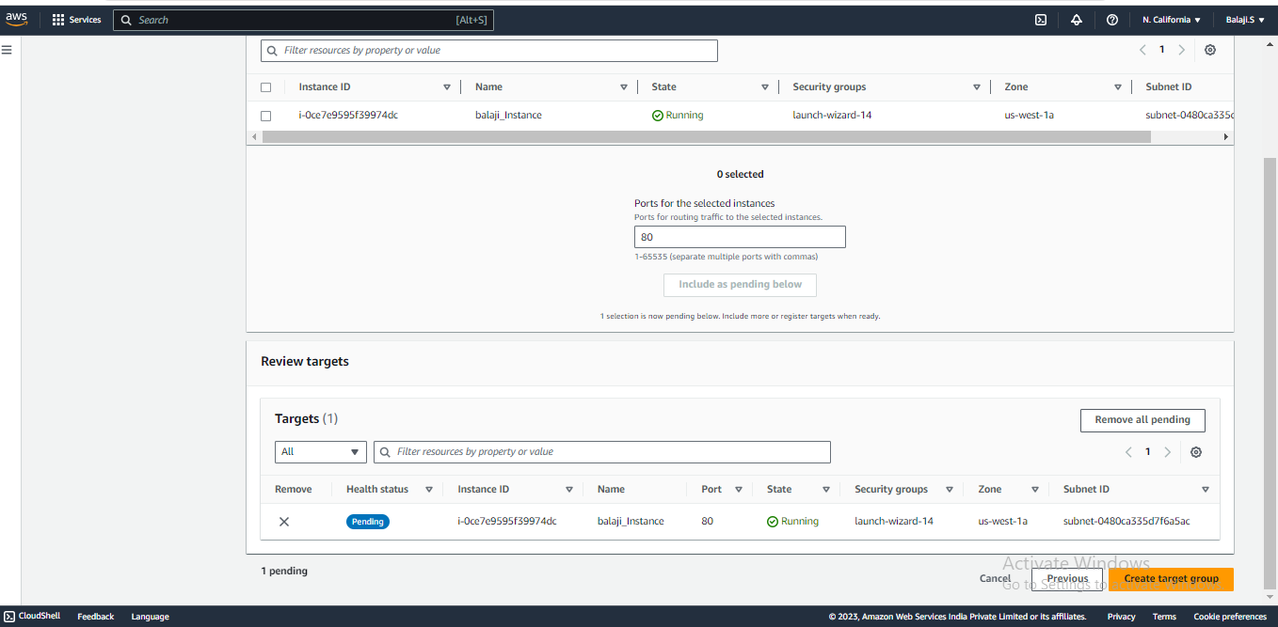

Step 20: In ALB select the target group.

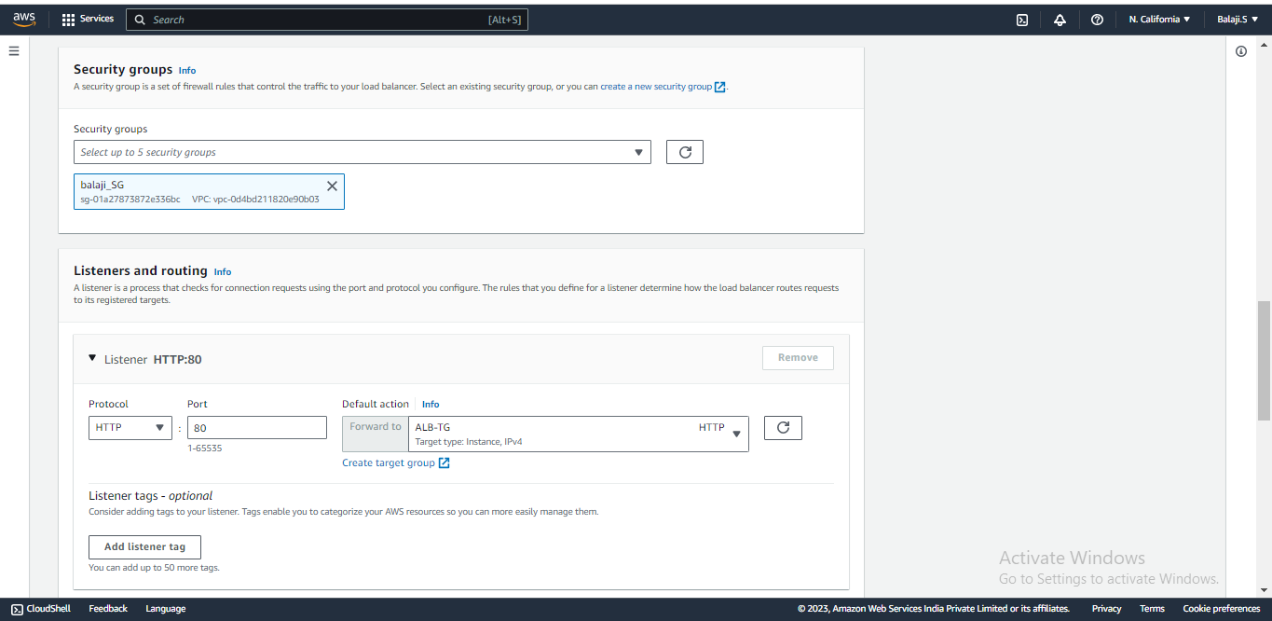

Step 21: Click on create load balancer.

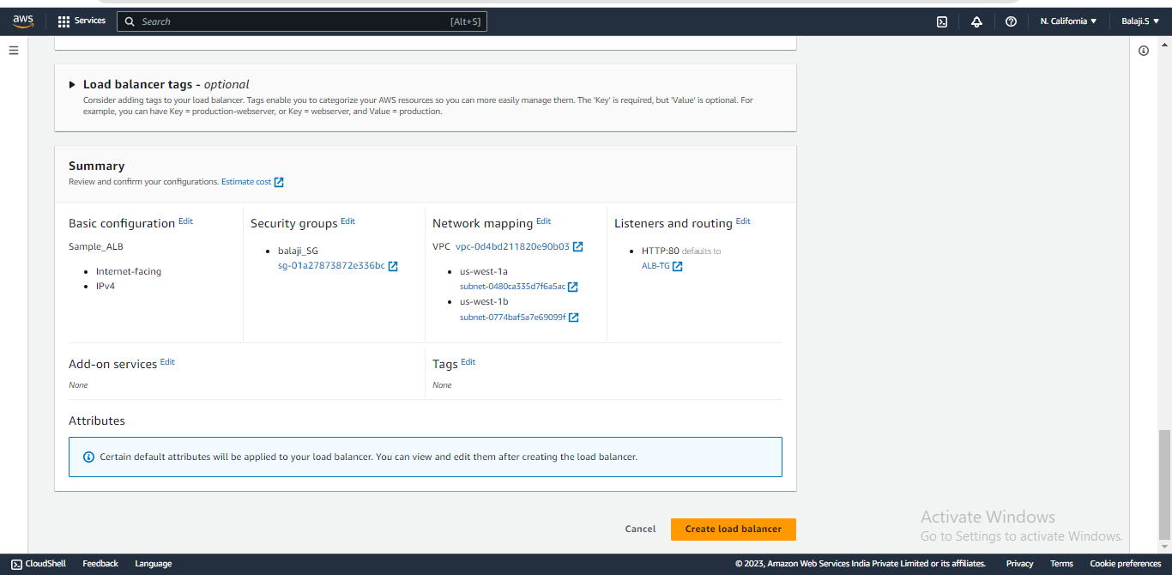

Step 21: Load balancer will be created it is in provisioning status wait for few min to show active.

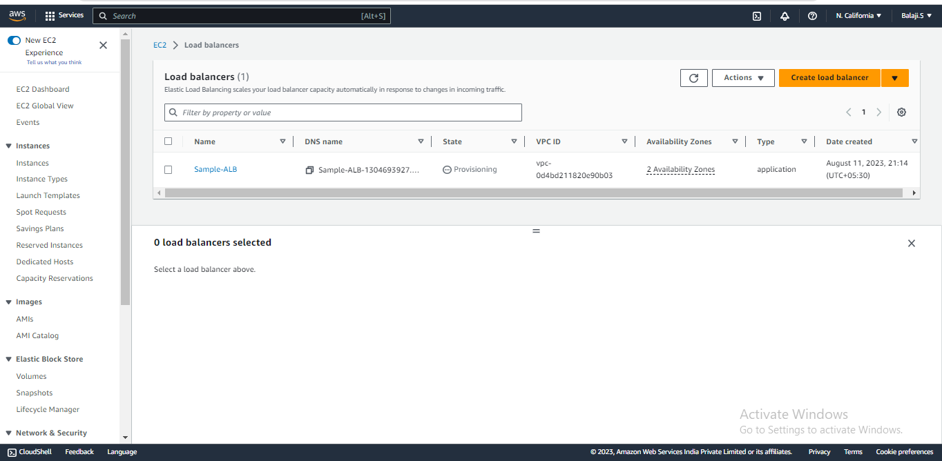

Step 22: Then, it will show active status.

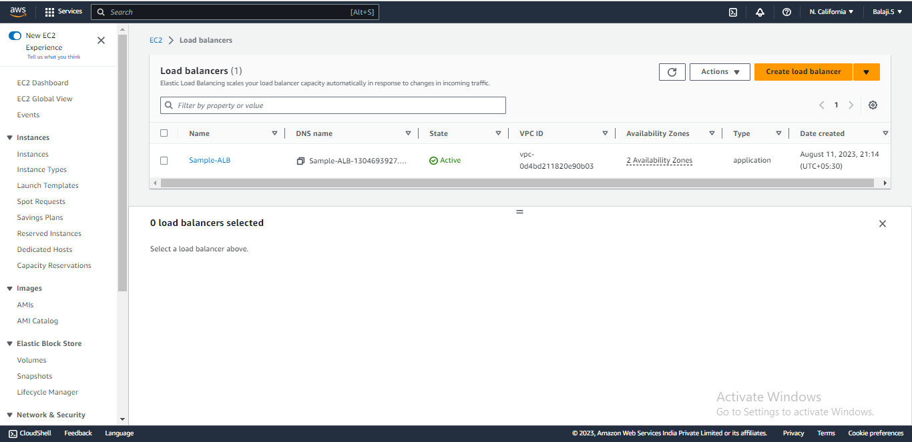

Step 23: select the load balancer and copy the DNS name paste the URL in browser you must get html page.

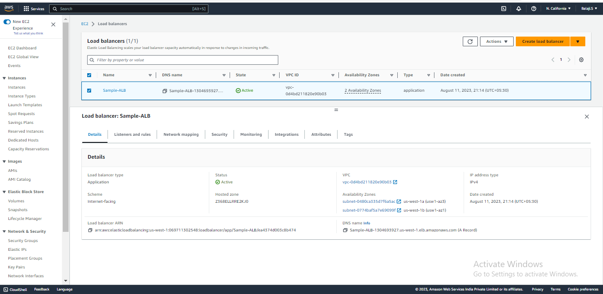

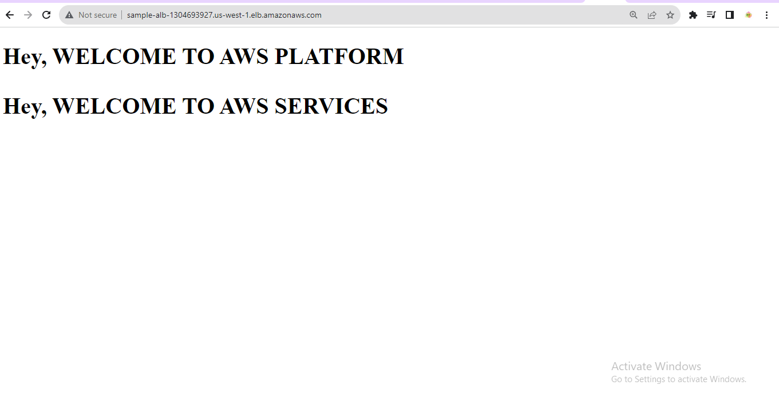

Step 24: Successfully we get the html page in load balancer DNS-URL and even with EC2 Public IP address, both ways should work.

Step 25: Either both Public IP address and Load balancer DNS-URL, how we can use our own domain name and it should display our index.html page which we created before steps we can use configure route53 and we can do it.

Step 26: Go to Route53 service in AWS console then, click on hosted zone and click on create hosted zone.

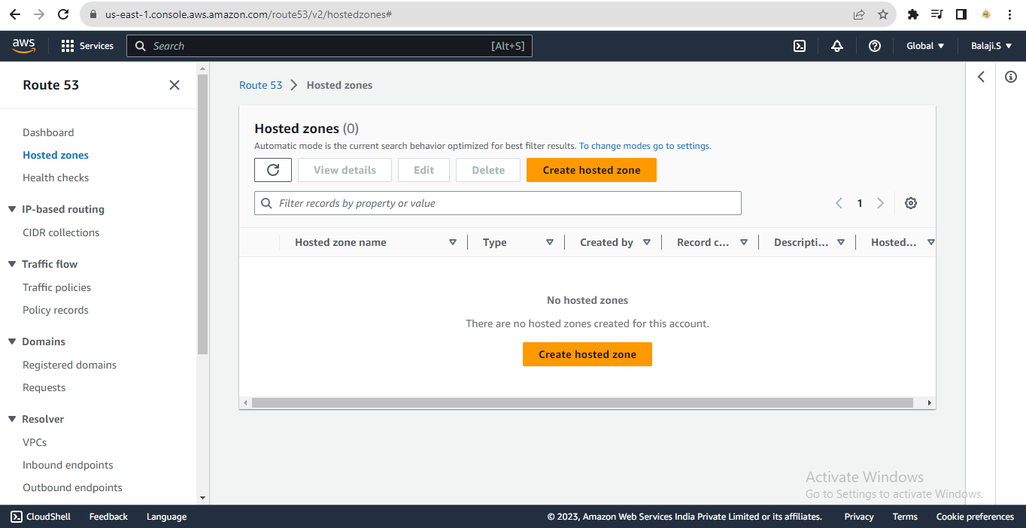

Step : 27 : Enter our own domain name, description, Type is public hosted zone and click on create hosted zone.

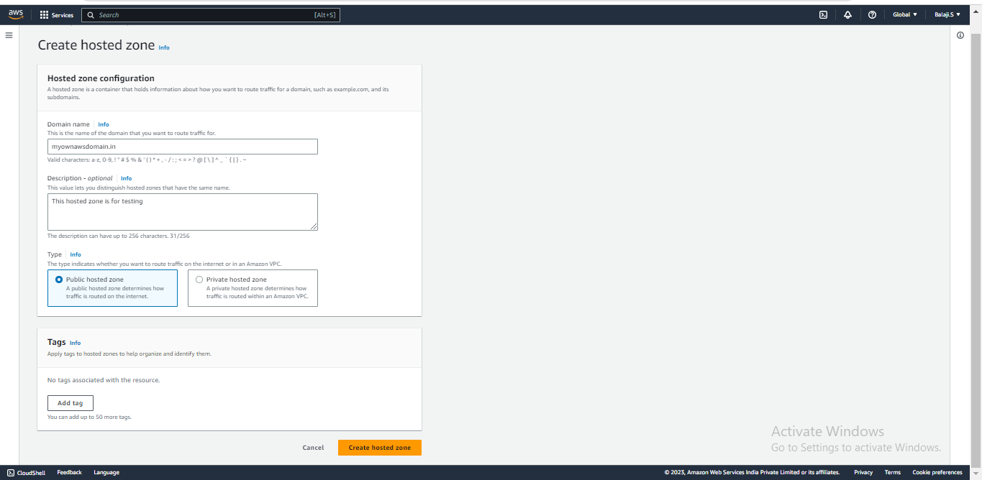

Step 28: To create a hosted zone it wait take some time to create wait for it.

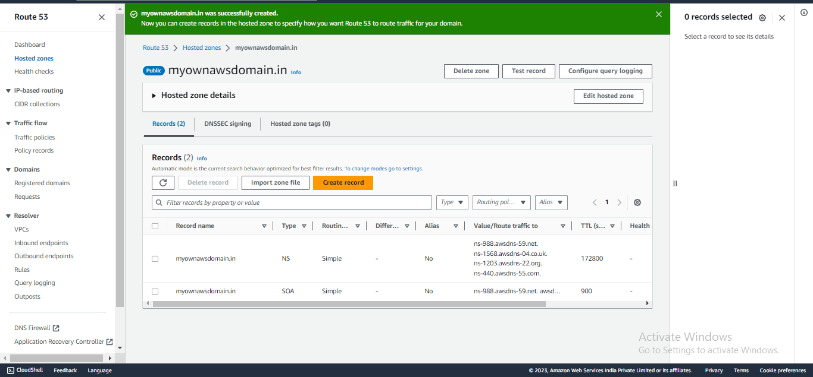

Step 29: After created the hosted zone, then need to change the DNS name servers of your domain with your hosted zone name servers. Copy all the name servers of your hosted zone on your domain name servers (domain name servers be find on the platform from where you bought your domain Eg: Go Daddy or route53 etc..)



Step 31: Go to Go-Daddy website and go to DNS and click on name servers and click on change name servers.

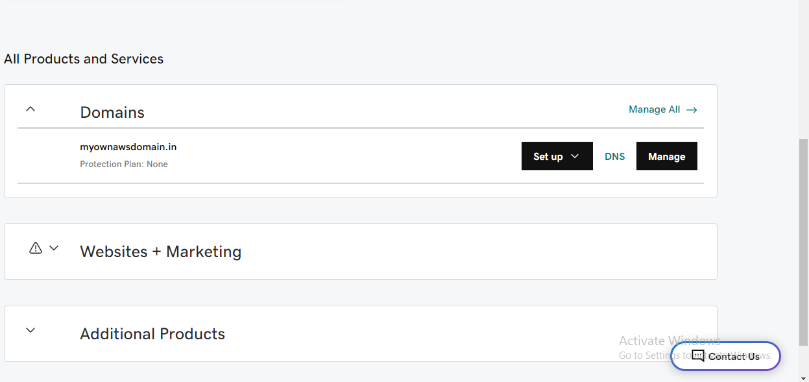

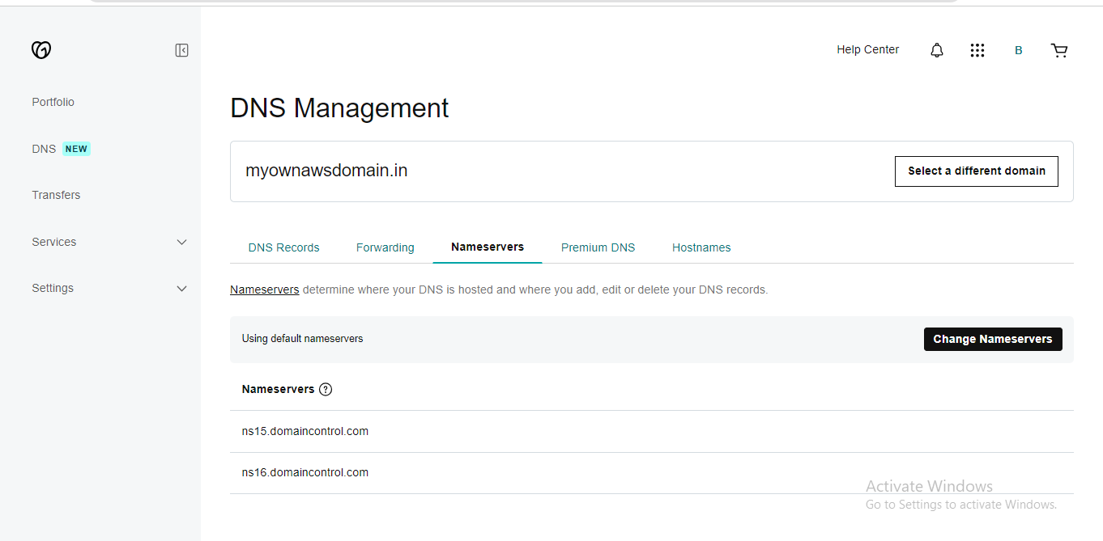

Step 32: Paste the name server URL and click on save.

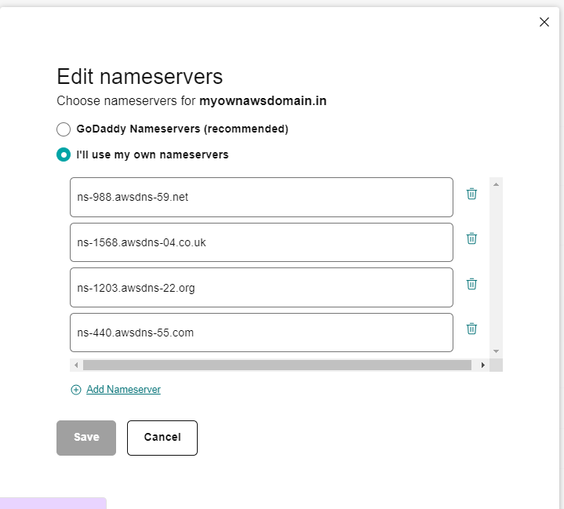

Step 33: Click on create record.

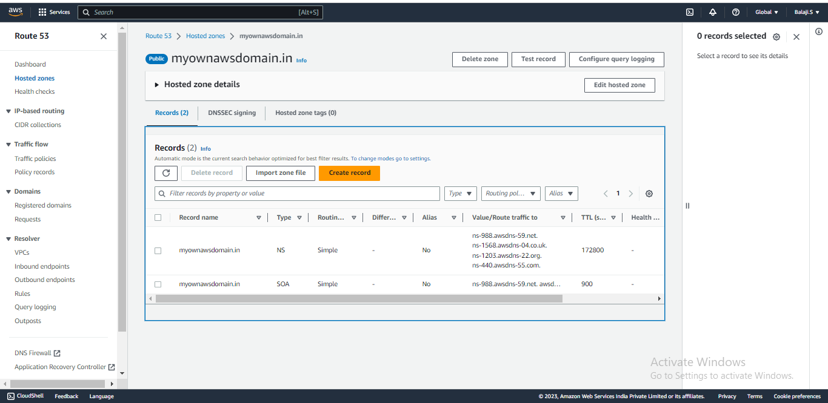

Step 34: create a record and click on create record.

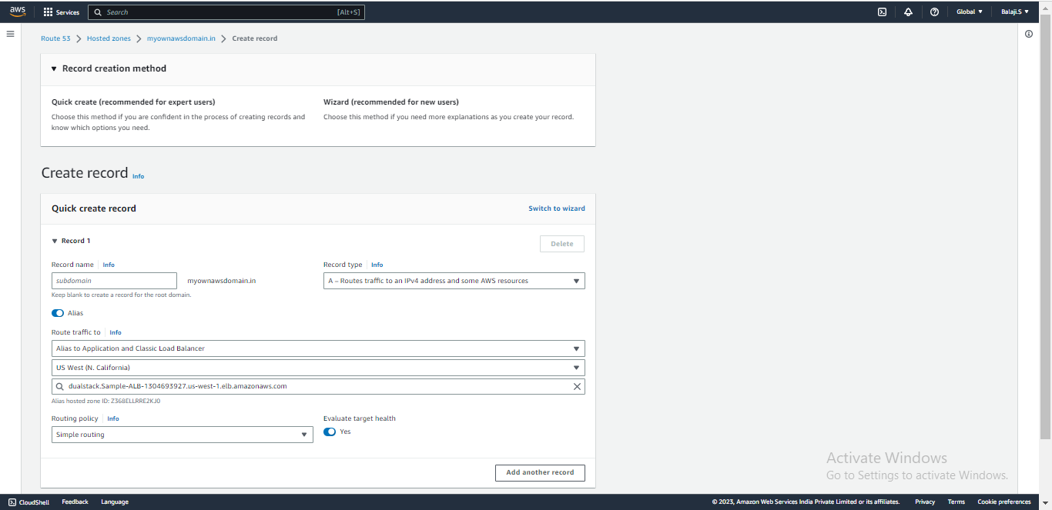

Step 35: Then records has been created now then, Go to Our Own domain website and press enter it will show index.html website.

Step 36: Wait for the changes it will take some much time wait for it.

Step 37 : Successfully it is changed and I got the index.html website on my own domain website.

**Final Output of this Project :**

