

W. P. CAREY SCHOOL OF BUSINESS HONOR CODE MASTER’S PROGRAMS

We, the students of the W.P. Carey Master’s programs are committed to maintaining the highest levels of honesty, integrity, and professional courtesy for ourselves and amongst our classmates. We believe that ethical behavior is not only the cornerstone of a good academic program, but of good business as well. As such, we are steadfast in our commitment to the following principles:

- Academic Integrity – We view the W.P. Carey Academic Integrity Policy as a living, breathing document, not just concepts on a page. As such, we are resolute in ensuring that we abide by the principles contained within, both in letter and in spirit. Furthermore, we will hold our classmates to the same high standards to which we hold ourselves.

- Consideration of Others – As W. P. Carey students, we believe that we should treat others as we wish to be treated. To this end, we will be considerate of classmates, professors, and recruiters in all aspects. Furthermore, we will constructively add to the collaborative environment by helping and encouraging others.

- Professionalism – As W. P. Carey students, we believe that the behaviors we practice today will become habit in the future. To that end, we are committed to act in a professional manner in all school settings, including classes, networking events, and interviews. We will be cognizant of the fact that we are representing the program and our classmates at all times.

Full Name: __________Arpan Goyal______________________________________
Signature:Arpan Goyal Date 04/24/2024

Full Name: __________Aangi Desai______________________________________

Signature: Aangi Desai Date 04/24/2024

Full Name: ___________Balaji Raj Veluchamy_____________________________________

Signature: Balaji Raj Veluchamy Date 04/24/2024

Full Name: ___________Divya Katragadda_____________________________________

Signature: Divya Katragadda Date 04/24/2024

Full Name: ____________Helen Chen____________________________________

Signature: Helen Chen Date 04/24/2024

Onsite MSBA Applied Project Report

Spring 2024

W.P. Carey, ASU

Topic | Optimizing Excess Inventory Process to Mitigate Financial Risk
Team | Team 441
Team Members | Aangi Nimesh Desai, Balaji Raj Veluchamy, Arpan Goyal, Helen Chen, Divya Katragadda
Client information | Company - Teradyne, Division – Supply Chain Management  Full Name – Hrushikesh Mantri, Contact Information - hrushikesh.mantri@teradyne.com

Executive Summary

Teradyne, a leading American automatic test equipment (ATE) designer and manufacturer has an SBM (Supply Base Management) group who are on a mission to optimize inventory management through enhancements to its excess inventory approval portal. Currently, the portal relies heavily on subjective judgments from Commodity Managers (CMs) and upper-level managers, potentially introducing bias and inconsistency into the approval process. Historical demand volatility has exacerbated the issue, leading to increased unwanted inventory and impacting targeted levels and financial aspects.

Recognizing the need for a more informed decision-making process, the SBM group seeks to conduct a descriptive analysis of excess inventory approved under various conditions. The ultimate goal is to modify the algorithm to reduce excess inventory, and reduce the financial risks, while also allowing for constructive feedback to continually improve the approval process.

The expected outcomes of the project include a deeper understanding of the factors influencing the excess inventory approval process, leading to better control over inventory levels. This informed decision-making process is anticipated to result in cost savings reflected on the profit and loss (P&L) statement, as well as more efficient use of cash on the balance sheet (B/S), reducing the cash tied up in inventory due to demand volatility.

The Inventory Management capstone project is tackling the critical challenge of excess inventory management. By leveraging smart algorithms and data analysis based on 18 months of historical demand, parts, and inventory data, we're mitigating financial risks through replacing guesswork with objective mathematical calculations. Our Python-powered system enables smarter decisions, adapts to market changes, and streamlines approval processes, ultimately leading to less leftover stock and increased profitability.

By taking a proactive approach to excess inventory, we're not only saving money but also optimizing capital usage and ensuring the stability of the supply chain. Through collaboration and innovation, we're paving the way for more efficient inventory management practices that benefit both Teradyne and its stakeholders.

For the future, enabling the usage of more necessary and important variables from the data into the algorithm, can build a more holistic and robust system to deal with the inventory management issues,since the current algorithm only uses a few variables, like Lead Time, Number of Open Order and On Hand orders, and Purchase Order price.

Background

Excess inventory is a common challenge for businesses, especially for the ones in the manufacturing industry, as they constantly are posed with the problem of dealing with demand volatility and uncertainty. Excess inventory can have negative impacts on the business performance, such as increased storage costs, lower profit margins, and higher inventory carrying costs. Reducing excess inventory can improve the efficiency and profitability of the business, as well as the customer satisfaction and loyalty. To reduce excess inventory, the business needs to adopt a data-driven and proactive approach to inventory management, using descriptive analysis and best practices from the industry.

Problem Statement

The problem at hand is that Teradyne's SBM (Supply Base Management) group is facing challenges with their excess inventory approval process. The current system relies heavily on metrics and subjective judgments, which may introduce bias into the decision-making process. Additionally, historical demand volatility has led to the accumulation of unwanted inventory, negatively impacting the company's targets and financial performance.

Importance of Solving the Problem:
It is crucial to address this problem from both a business and social standpoint. From a business perspective, excess inventory ties up capital and storage space, resulting in increased costs and reduced profitability. It also affects the company's ability to meet its targets and financial goals, potentially leading to missed opportunities and decreased competitiveness in the market. From a social standpoint, inefficient inventory management practices can have broader economic implications, affecting job stability, resource allocation, and environmental sustainability.

Users of the Solution:
The solution to this problem will primarily be utilized by Teradyne's SBM group, including Commodity Managers and upper-level managers responsible for inventory approval. These individuals play a critical role in the decision-making process and will benefit from access to an upgraded excess inventory approval portal that facilitates more informed and unbiased decisions. Additionally, stakeholders across various departments within the company, such as finance, operations, and procurement, may also interact with the solution to monitor inventory levels and track performance metrics.

Scoping the Problem and Assumptions:
The problem scope encompasses upgrading the existing excess inventory approval portal, modifying algorithms to support informed decision-making, and ultimately reducing excess inventory levels. Assumptions made in addressing this problem include:
1. The upgraded portal will effectively mitigate bias introduced by subjective judgments, leading to more objective decision-making.
2. Algorithm modifications will address historical demand volatility by optimizing inventory levels and reducing the accumulation of unwanted stock.
3. The solution will yield tangible benefits, such as improved financial performance, operational efficiency, and enhanced competitiveness in the market.
4. Users will actively engage with the solution and provide constructive feedback for continuous improvement, leading to iterative enhancements over time.
By addressing these assumptions and implementing an effective solution, Teradyne's SBM group aims to optimize inventory management practices, mitigate financial risks associated with excess inventory, and foster a culture of continuous improvement within the organization.

Methods

For this project, as was elaborated above, we addressed the critical challenge of excess inventory management by working together with their SBM (Systems Business Unit Management) group.
The methodology employed in this analysis encompasses the collection and analysis of historical inventory data spanning 17 months, which includes information on demand, excess inventory, and lead time. Initially, the collected data underwent rigorous data cleaning procedures, involving column removal, standardization of variable names, and date format standardization.

We're cutting financial risks by ditching guesswork and using solid numbers and objective mathematical calculations. This means less leftover stock and more profit. Our Python-powered system makes decisions smarter, adjusts to market changes, and speeds up approval processes. By being proactive about excess inventory, we're saving money, making better use of capital, and keeping the supply chain steady.

The final business process that our algorithm was built around works as follows:
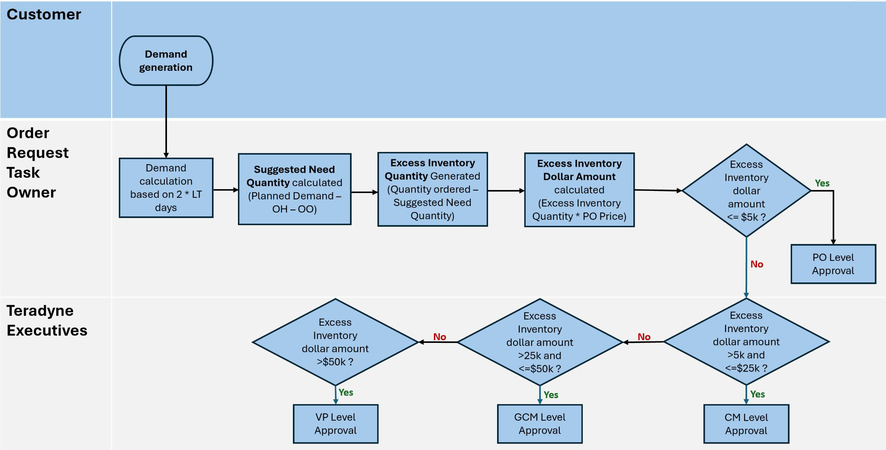

A detailed EDA was conducted to understand how the various variables and the respective data points worked with respect to the project scope.
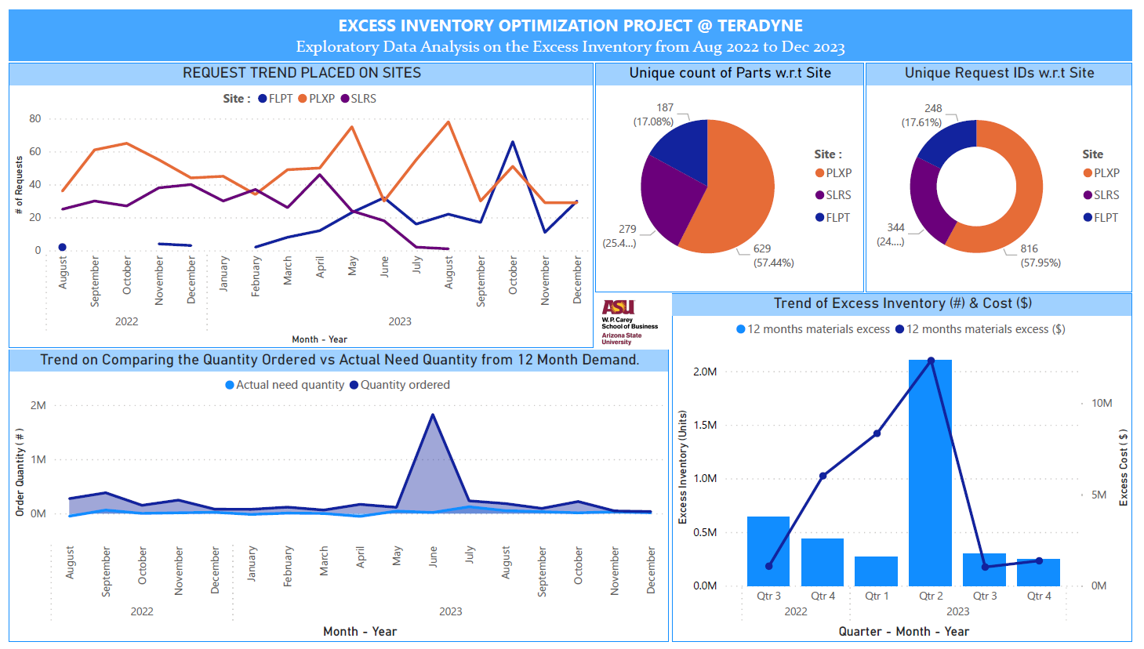
File A :
Excess Inventory Purchase: # of Requests : 1408, # of Sites : 3, # of Part Number : 1064

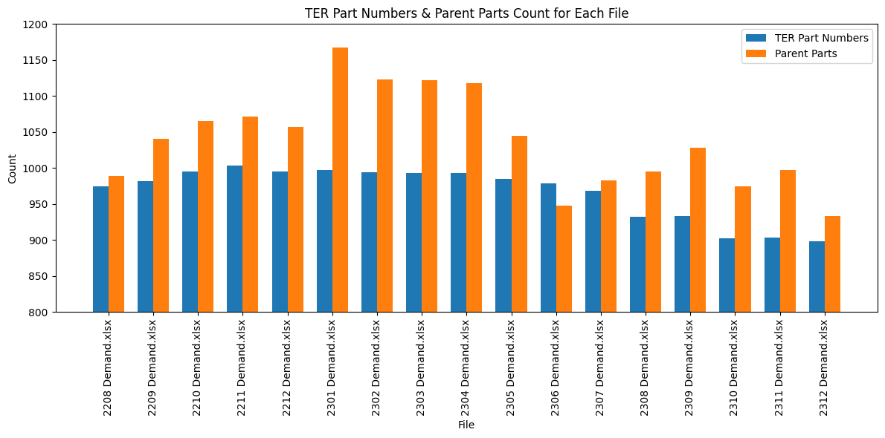
Files B : Demand (17 Files)
Selected Columns : Site, TER Part Number, Due Date, Planned Demand, Parent Site, Parent Part.

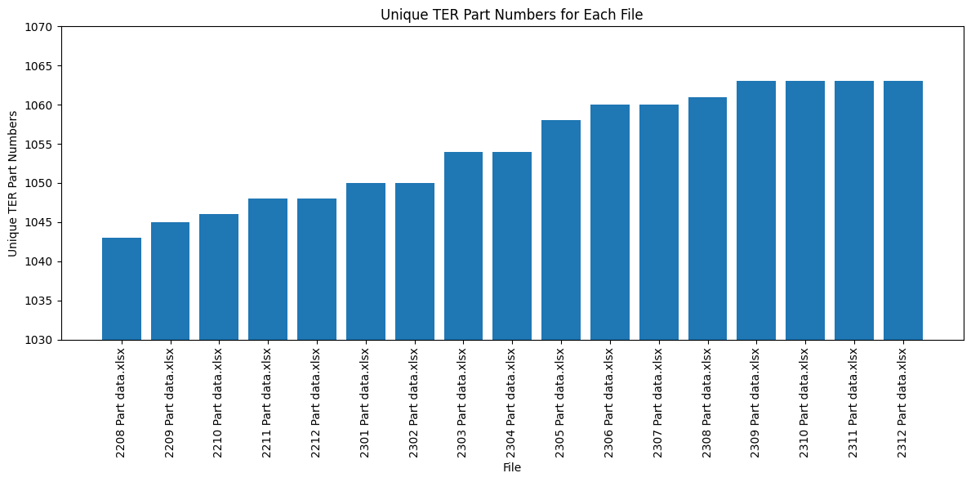
Files C : Part Data (17 Files)
Selected Columns : Site, TER Part Number, cum lt wks

A few columns were removed from the Excess Inventory file to stay in line with the scope of the project. They are as follows: 'Status', 'EMS Part Number', 'Description', 'Supplier Name', 'EMS comments', 'Reason for MOQ Excess Request', 'TER/EMS Sister Site Stock', 'Add the req qty to existing open PO?', 'Open Market checked?', 'Got quotes from Suppliers?', 'Task Owner', 'TER comments', 'Manufacturer name', 'TER safety stock', 'Excess Inventory WF', 'EMS total excess', 'Modified', 'Div', 'Management Hold', 'ClosedDate', 'Aging'. The remaining columns were used for the analysis. From the Parts file, we have extracted the 'Site', 'TER Part Number', and 'cum lt wks' columns and from the Demand file we have extracted the 'TER Part Number', 'Site', 'Due Date', 'Planned Demand', 'Parent site', and 'Parent part' columns. Using these variables, we created three different files for understanding the Excess Inventory in three different time points (2022 H2, 2023 H1, 2023 H2) which contained the following variables: ‘Request ID’, ‘Requested date’, ‘TER Part Number’, ‘Site’, ‘cum lt wks’, ‘Adjusted date’, ‘LT (days)’, ‘New LT (days)’, ‘New Adjusted date’, ‘Planned Demand’, ‘12 months demand’, ‘OH’, ‘Open order’, ‘Suggested_Need_Quantity’, ‘Actual need quantity’, ‘Quantity ordered’, ‘Potential_Excess_Inventory’, ‘12 months materials excess’, ‘PO Price’, ‘Total Potential Excess Inventory($)’, ‘12 months materials excess ($)’, ‘Parent site’, ‘Parent part’, ‘Month’, ‘Year’. These files were used as the final files.

The Python code was developed by defining various functions to help in calculating the planned demand, preceded by the segmentation of lead time data into categories of below 182 days, between 182 to 365 days, and above 365 days.The calculated planned demand served as a basis for determining the suggested quantity needed, which was then compared with the actual quantity required. The comparison between suggested and actual quantities allowed for the identification of potential excess inventory. Given below is a step by step process of the same:
- Adjusted Date : Requested Date + Cum Lt weeks * 2 * 7
- Segment New LT Days (Timeline) as <182, 182-365 and >365 days
- Calculate Demand: Aggregate the Planned Demand up to the Adjusted date on Due date.
- Calculate Suggested Need Quantity: Aggregated Planned Demand - OH - OO
- Calculate Potential Excess Inventory: Suggested Needed Quantity - Quantity Ordered
- Calculate Total Potential Excess Cost: Potential Excess Quantity * Purchase Order Price

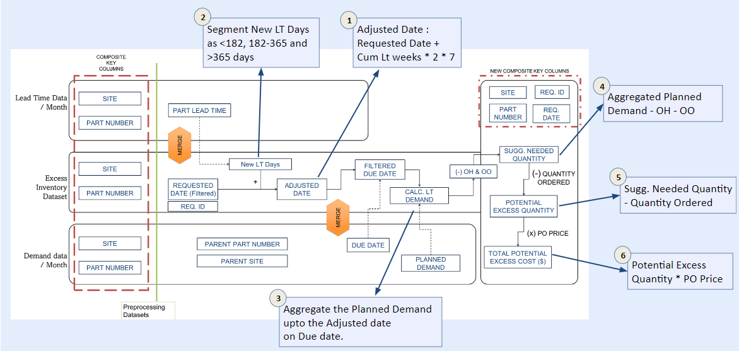

The total excess inventory cost thus calculated, was further evaluated by comparing it with total excess inventory cost over the previous 12 months. This thorough examination offers valuable insights into inventory management practices and identifies opportunities for optimization. The methodology also involved conducting a thorough literature review of industry practices to inform the analysis framework. This framework was augmented by Python-based visualization tools, which aided in generating graphical representations for insightful analysis and informed decision-making processes.

Results and Conclusions

Key Results:
The key results of the proposed solution include a significant increase in the efficiency of the excess inventory approval process. This is reflected in the higher number of requests being sent to higher management for approval within the process approval limit cap. There was on an average 8% increase in the number of requests being sent out for higher management approval which would led, 7% of total excess inventory spent in 2022 H2 and similarly 43% and 55% in 2023 H1 and 2023 H2 respectively. Thus, this new process would provide closer review of some of the key requests with higher spend by upper management which can reduce the possibility of approval, or informative approval.

The solution also correlates with a reduction in excess inventory spending, with notable decreases projected for the future periods (2022 H2, 2023 H1, and 2023 H2). These results indicate improved control over inventory levels and spending, which can lead to potential cost reductions and increased capital efficiency.

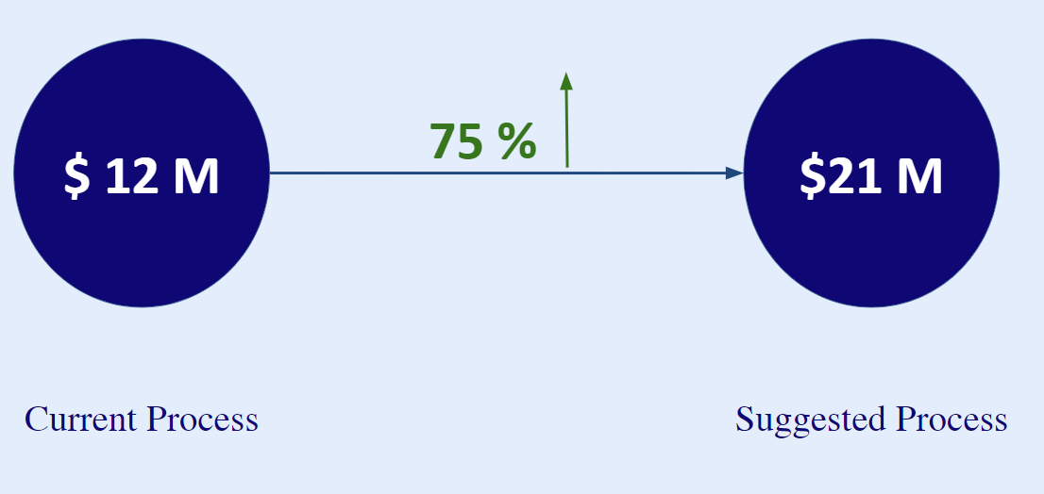

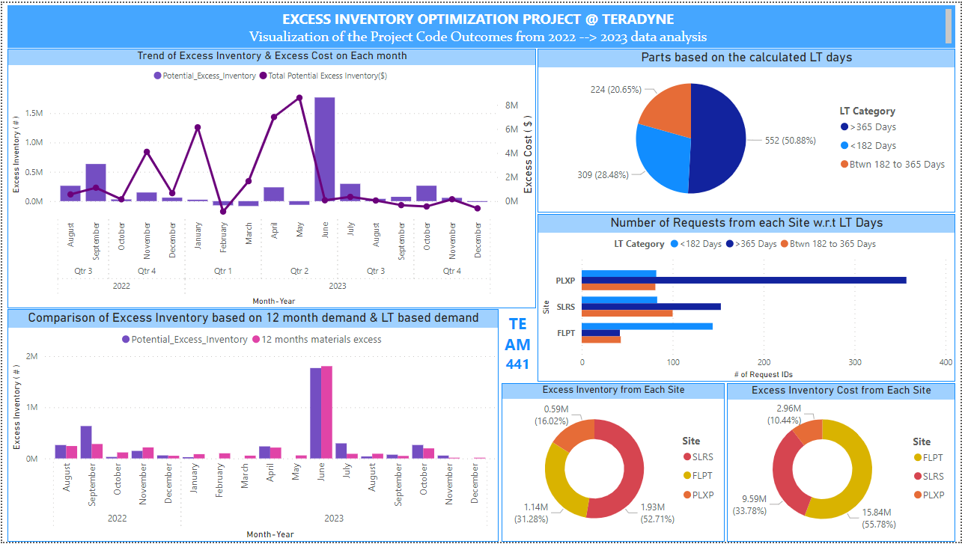
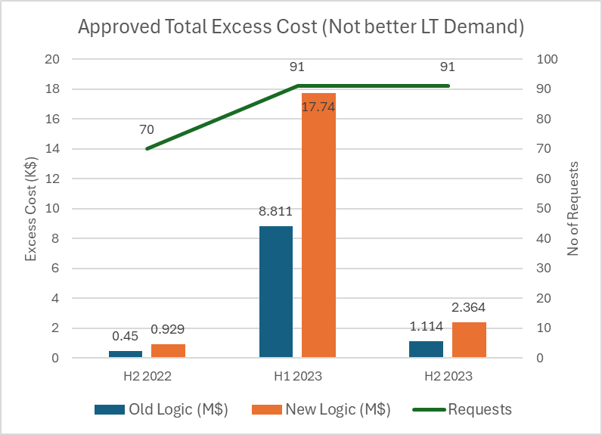
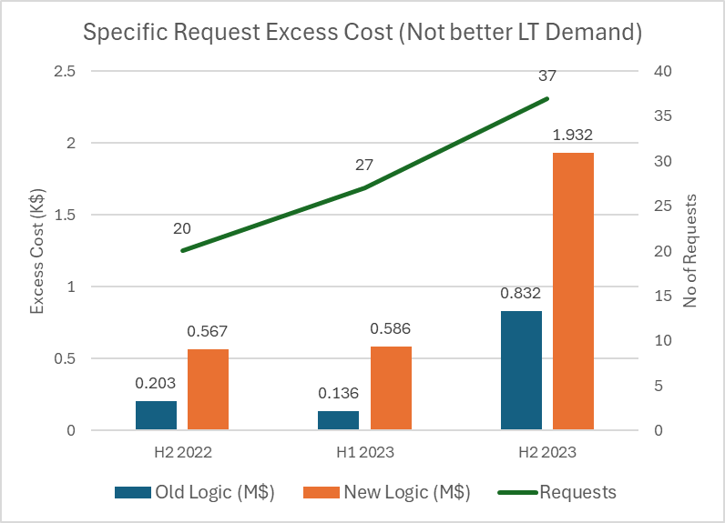

Excess Cost approved for particular requests within 365 days

Importance from a Business or Social Standpoint:
These results are important from a business standpoint as they directly contribute to cost reduction and capital efficiency. By optimizing the excess inventory approval process, the company can minimize unnecessary spending on excess inventory, leading to improved financial performance and profitability. From a social perspective, efficient inventory management practices contribute to resource conservation and sustainability, aligning with broader economic and environmental goals.
Users of the Solution:
The solution will primarily benefit stakeholders involved in the excess inventory approval process within Teradyne, including Commodity Managers, upper management responsible for approval decisions, and finance teams monitoring inventory spending. These users will leverage the upgraded approval portal to review and approve requests more effectively, resulting in reduced excess inventory and improved financial outcomes.
Limitations of the Solution:
Some limitations of the solution may include:
- Data limitations: The effectiveness of the solution relies on the availability and quality of historical demand data and inventory metrics.
- Scope limitations: The solution may be tailored to specific inventory management processes within Teradyne and may not address broader supply chain challenges.
- Assumption dependencies: The solution's success is contingent upon the accuracy of assumptions made about demand volatility and inventory optimization.
Future Extensions:
To extend this work in the future, considerations could include:
- Comprehensive Supplier Performance Metrics:
Develop and implement a comprehensive set of supplier performance metrics, including lead times, on-time delivery rates, quality assessments, and responsiveness to demand fluctuations. Leverage this data to identify areas for improvement and establish collaborative relationships with strategic suppliers.
- Advanced Demand Forecasting and Inventory Planning:
Enhance demand forecasting accuracy by leveraging advanced analytics and machine learning algorithms. Incorporate historical data, market trends, and customer insights to refine forecasting models and optimize inventory planning. Evaluate the impact of demand variability on inventory levels and adjust strategies accordingly.
- Integrated Inventory Turnover and MOQ Optimization:
Integrate inventory turnover analysis with Minimum Order Quantity (MOQ) optimization strategies. Analyze the relationship between inventory turnover ratios, supplier MOQs, and cost-effectiveness. Implement dynamic MOQ adjustments based on demand patterns and supply chain performance metrics to minimize excess inventory and carrying costs.
- Real-time Stockout Rate Monitoring and Management:
Implement real-time monitoring of stockout rates to identify and address inventory shortages promptly. Utilize predictive analytics to anticipate potential stockouts and adjust inventory levels proactively. Optimize replenishment strategies to maintain optimal inventory levels and enhance customer satisfaction.
- Customer-Centric Inventory Management Practices:
Incorporate customer satisfaction metrics into inventory management practices. Gather feedback on product availability, lead times, and order fulfillment to align inventory strategies with customer expectations. Develop agile inventory management processes that prioritize customer needs and preferences.
- Cost of Capital Analysis and Optimization:
Conduct a comprehensive analysis of the cost of holding excess inventory, including storage costs, depreciation, and opportunity costs. Use this analysis to inform inventory optimization strategies and prioritize initiatives that maximize capital efficiency.
- Supply Chain Risk Assessment and Mitigation:
Conduct regular supply chain risk assessments to identify potential disruptions and vulnerabilities. Evaluate supplier reliability, geopolitical risks, and natural disaster impacts on inventory management. Implement risk mitigation strategies and contingency plans to minimize disruptions and reduce the likelihood of excess inventory buildup.
By implementing these comprehensive recommendations, Teradyne's SBM group can establish a holistic approach to inventory management optimization, improve operational efficiency, reduce costs, and enhance supply chain resilience. These initiatives align with broader business objectives and contribute to sustainable growth and customer satisfaction.

References

- https://lutpub.lut.fi/bitstream/handle/10024/164723/masterthesis_halilovic_emir.pdf?sequence=1&isAllowed=y
- https://www.orbitskyline.com/mastering-efficiency-best-practices-in-semiconductor-inventory-management/
- https://www.eazystock.com/uk/blog-uk/reduce-excess-obsolete-inventory/
- https://www.sourcengine.com/blog/excess-electronic-component-inventory-management#:~:text=To%20prevent%20excess%
- https://www.mckinsey.com/~/media/McKinsey/Business%20Functions/Marketing%20and%20Sales/Our%20Insights/EBook%20Big%20data%20analytics%20and%20the%20future%20of%20marketing%20sales/Big-Data-eBook.ashx
- https://www.newstreaming.com/how-does-just-in-time-delivery-work-for-ecommerce/
- https://www.deskera.com/blog/mistakes-demand-forecasting/

Appendix – Reproduction of Results

Location or Links to Data Sources:

Resource Description | Location | Access | Need | Constraints
The spreadsheet contains information about “Excess Inventory Purchase” and it is 523 Kb in size. | Google Sheet | It is accessible by all the team members | Data was provided to us on the 8th January, 2024 | The only constraint at the moment is not having the data dictionary
The folder has 17 files, approx. 1.8mb in total containing information about the Lead Time for different parts. | Google Sheet | It is accessible by all the team members | Data was provided to us on the 8th January, 2024 | The only constraint at the moment is not having the data dictionary
The folder has 17 files, approx. 68mb in total containing information about the demand for different parts. | Google Sheet | It is accessible by all the team members | Data was provided to us on the 8th January, 2024 | The only constraint at the moment is not having the data dictionary

Tools/Platform used to run analysis:
Python for data analysis: https://colab.research.google.com/drive/18Hca2SD2LKjAX5D4gqqTUBTdYdwqk4-6?usp=sharing

List of scripts that were used to run the analysis:
- Script 1: FinalCode_Teradyne, Location: Google Colab, link provided above

Guidance on how to run the scripts:
- Download Scripts: Get the required script(s) from the designated folder on Google Colab.
- Open in IDE: Use Colab or Jupyter to open the script file(s).
- Install Dependencies: Ensure all necessary libraries are installed using pip or install.packages().
- Review Comments: Understand each code block's purpose by reading the provided comments.
- Prepare Data: Have all required data files ready in the correct directories.
- Execute Scripts: Run the script(s) in the specified sequence.
- Monitor Execution: Check for errors or warnings during execution.
- Review Results: Examine the generated results after execution completes.

Details about the links:
Final presentation: https://docs.google.com/presentation/d/1G6LnURz9qs5wQsvO8HO3MvqBtzVy0Pyt/edit?usp=sharing&ouid=114106980909845274784&rtpof=true&sd=true

Google Colab for Python coding: [same link as above “Python for data analysis”]
https://colab.research.google.com/drive/18Hca2SD2LKjAX5D4gqqTUBTdYdwqk4-6?usp=sharing

