First go the page which you want to edit
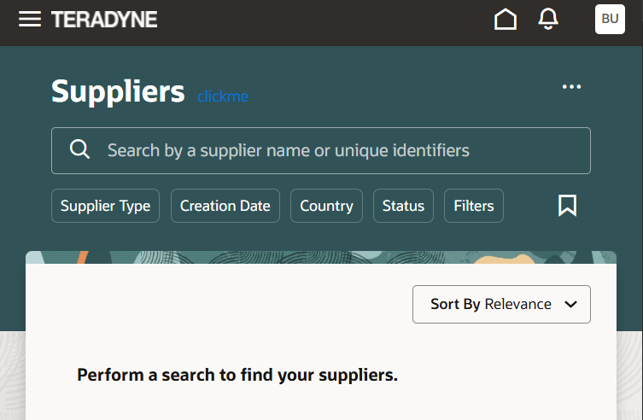

Then select the place and then click on inspect and in the element click on the position.
Once it is done then click on the three dots as shown in the image .
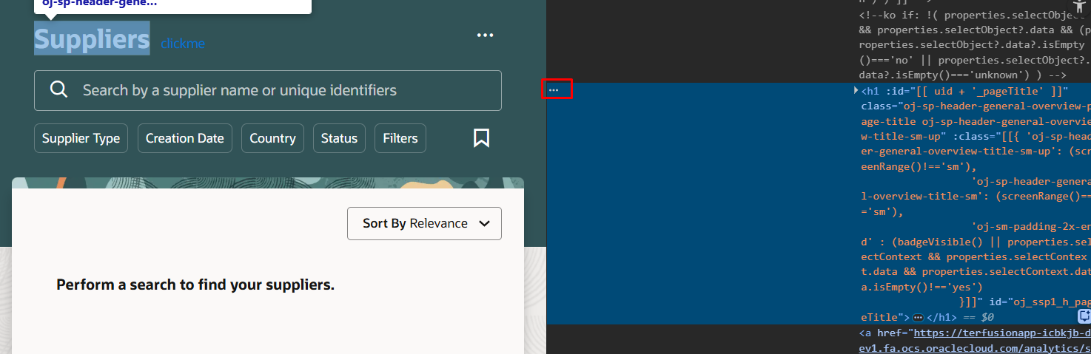
And go to the copy and then click on the copy outerHTML option and then use chat gpt

