
Experiment : 5
Date:
CLASS DIAGRAM AND TIME SEQUENCE
Aim:
To apply software engineering principles by implementing the class diagram and time sequence diagram

Class diagram
A UML class diagram shows the structure of a system by displaying its classes, their attributes, methods, and the relationships between them. It helps the team understand how the system is organized and how components interact.

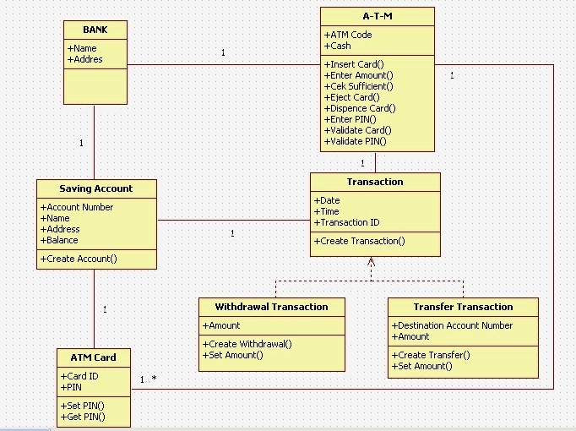

Time sequence diagram
In software engineering, a sequence diagram shows process interactions arranged in time sequence. This diagram depicts the processes and objects involved and the sequence of messages exchanged as needed to carry out the functionality.
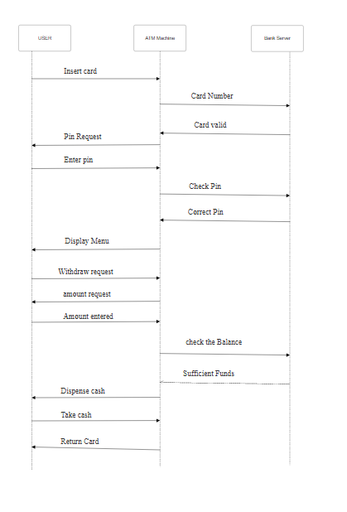
Conclusion:
This experiment proves that Software Engineering principles by designing these diagrams to represent system architecture and behavioral flow.

