Heterogeneous Multicore SoC Architecture for Real-Time Biomedical Data Analysis

Subbulakshmi A Assistant Professor  Department of Electronics Engineering (VLSI Design and Technology) Chennai Institute of Technology Chennai, Tamil Nadu, India  subbulakshmiarunachalam12@gmail.com | Balaji S  Electronics and Communication Engineering  Chennai Institute of Technology Chennai, Tamil Nadu, India balajis07032005@gmail.com | Manikandan L  Electronics and Communication Engineering  Chennai Institute of Technology Chennai, Tamil Nadu, India manikandan23305@gmail.com

Abstract—In this paper, the design of a heterogeneous multi core system on chip will be described and will be used in real time biomedical data analysis. Most current healthcare monitoring systems rely on cloud computing or general-purpose processors and hence may cause delays, increased power usage, and data privacy issues. A RISC V based architecture that introduces the processing capability onto the chip is proposed in this work. It has a general-purpose core of control facilities, and a second processing core, optimized to do digital signal processing. New custom hardware instructions are added to accelerate these common biomedical signal processing filtering and frequency analysis operations. There is also a hardware convolutional neural network accelerator to assist in automatic diagnosing the device. Since all computation will be done on-site, the system will be quicker and will not expose sensitive medical information to external networks. The design suggested demonstrates that a tailored hardware that is developed on an open processor platform could offer an effective and secure means of continuous biomedical monitoring appliances.
Keywords—Biomedical signal processing, RISC V, multi core processor, hardware accelerator, real time monitoring, convolutional neural network
- INTRODUCTION
Biomedical monitoring systems are quite important in the contemporary medical care particularly due to the rising demand of constant and real time monitoring of the patient. Signals like the electrocardiogram are useful in clinical diagnosis and the signal is usually compromised due to noise thus needs to be processed promptly and correctly before a diagnosis can be arrived at. Most of the existing systems use cloud services or commodity processors to do this calculation. Although they are convenient, they can create delays in the processing, consume more power, and bring up privacy of sensitive medical data. Such constraints complicate the realization of reliable real time performance of portable or embedded healthcare devices. In order to address these issues, an increased focus is being given to the design of specific hardware platforms optimized to the analysis of biomedical signals. Those systems could have direct computation inside the device, which minimizes latency and makes sure that patient data does not leave the device. This paper will design a custom system on chip architecture using the RISC V architecture. The design employs heterogeneous multi core design, with one of the cores being used to carry out general control tasks and the other core being specifically designed to do the tasks of a digital signal processing. Additional hardware assistance is added to hasten activities like filtering, frequency
examination and automated pattern identification. This architecture has the purpose of offering a secure, efficient and scalable platform to continual biomedical monitoring. The integration of open processor technology with customization of application specific hardware depicts a viable course of action to more rapid and dependable medical signal examination in real time settings as proposed system.
- system Architecture and components
The proposed System on Chip incorporates some of the major hardware blocks which collaborate to facilitate the real time biomedical signal analysis. The Finite Impulse Response (FIR) filter module is one of the fundamental components that are employed to eliminate noise and other unwanted effects of raw biomedical signals in a form of ECG waveforms [2]. These signals are easily influenced by movement, electrical noise, and other factors in the environment; thus, a good filtering is required so that the important diagnostic information is not lost. Application of FIR filter in hardware enables the system to purify the data stream that is coming in, with minimal delay and reduced power consumption compared to a typical software-based method. The system has a special Fast Fourier Transform (FFT) processing unit in addition to filtering. This module transforms the signal in time domain to the frequency domain and this allows it to examine the spectral make-up of the waveform and find concealed frequency content or repetitive noise patterns [11] [4]. The frequency analysis is influential especially in biomedical monitoring whereby it assists in identifying irregularities and prepares the data to be subjected to further interpretation by machine learning [10]. Performing FFT operations in hardware directly, the SoC can efficiently perform them and provide quick and efficient calculations befitting continuous real time work [12] [13]. Each module is assigned a specific functional role within the processing pipeline, as summarized in Table I. The physical organization of these components within the SoC is illustrated in Fig. 1.

The processor architecture is extended to add custom extensions to the standard instruction set in order to further improve performance. They are written to target computationally intensive digital signal processing operations (like multiply-accumulate operations and data rearrangement) [1]. The tailored hardware instructions enable them to be executed in one cycle as opposed to performing them with numerous software instructions. This saves execution time, decreases energy usage and illustrates the advantage of processor architecture customization to

application like biomedical analytics. Lastly, the system incorporates a hardware-based Convolutional Neural Network (CNN) accelerator of automatic diagnosis and pattern recognition [16]. Once the signal has been filtered and analyzed, the CNN then runs the data and identifies potential irregularities, which may be attributed to medical conditions. Neural network inference on the SoC does not require any information to be sent to external servers, increasing the speed and data privacy [4]. These elements combine to develop a safe, effective and extremely reactive platform of real time biomedical monitoring [15] [2].

Module | Description | Implementation
RISC-V Processor | Controls data flow | Custom RTL
FIR Filter | Noise removal | HW Accelerator
FFT Engine | Frequency analysis | HW Accelerator
CNN Engine | ECG classification | Custom RTL
Memory | Data buffering | On-chip SRAM
Table I: Heterogeneous Multi-Core SoC Components
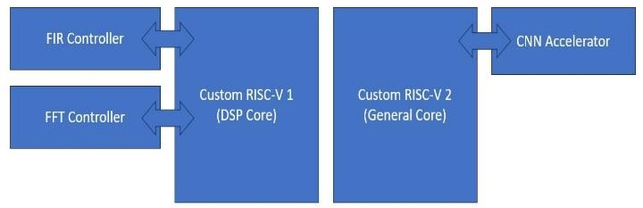
Fig. 1: System Architecture
- custom risc-v pipelined architecture
The System on Chip is designed based on RISC V instruction set architecture, which has the capability of adding new instructions to fit into a particular application. Here, the basic RV32I pipeline is expanded to include extra hardware logic to permit custom instructions that are needed by biomedical signal processing [1]. The processor is based on a pipelined execution pattern, in which each instruction is processed in a fetch, decode, execute, memory, and write-back sequence. This design enhances throughput since it enables a series of instructions to be executed at the same time [13]. The custom instructions are part of the decode and execute phases in such a way that specialized digital signal processing instructions can be run in hardware with no impact on the normal instruction format. Consequently, the processor is also compatible with traditional RISC V software development tools and yet manages to provide application-specific acceleration [1]. The overall block-level organization of the processor, including the custom instruction execution data path’s, is shown in Fig. 2.

- VMAC Instruction for FIR Filter
The Vector Multiply-Accumulate (VMAC) instruction is one of the major custom instructions that have been adopted in the processor. The code achieves an accelerated Finite Impulse Response filtering that can be applied to get rid of noise in biomedical signals [1]. During the traditional processor, an FIR filtering means doing a series of multiply and addition operations many times in a row with multiple instructions, a cause of higher latency and higher power consumption. VMAC instruction can implement such operations in just one cycle of execution, and the result is accumulated in hardware by multiplying the input samples and the filter coefficient values. This goes a long way in cutting down the overall clock cycles needed to filter the signal and enables the system to handle biomedical signals at real times more efficiently [12].
- Bit Reversal Instruction for FFT
The other significantly important extension is Bit-Reversal instruction that facilitates computation of Fast Fourier Transform. FFT algorithms make use of the use of bit-reversal addressing to rearrange input data prior to frequency-domain processing [2]. When done in pure software, this data rearrangement involves several memory operations and arithmetic operations, and this necessarily adds to the overhead. With the addition of dedicated Bit-Reversal instruction, the processor then can produce reordered indices using hardware logic and task is accomplished in a significantly shorter manner. This makes the FFT pipeline parallel and the frequency based biomedical analysis more responsive, which makes the architecture applicable in continuous monitoring and high diagnostic rate applications [3].
The combination of these custom instructions, with matching hardware extensions on top of an open RISC V architecture, can achieve quite significant performance improvements without sacrificing architectural simplicity or compatibility [14].
- FIR FILTER ARCHITECTURE WORKFLOW
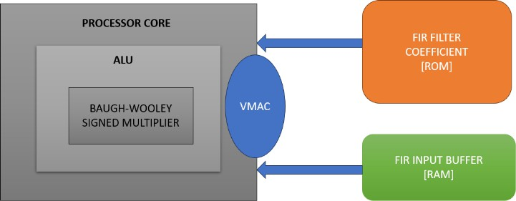
The Finite Impulse Response (FIR) filter is another significant component in the proposed System on Chip and this filter helps in removing noise on the biomedical signal after which another processing can be undertaken [10]. Signals including electrocardiogram are prone to motion artifacts, electrical interference, and background disturbances, which disfigure features of the clinically significant waveforms. To avoid that, FIR filter is applied as a special hardware functionality to enable noise suppression to occur in real-time and without interruption [6]. This is for the reason that at the subsequent processing steps, the signal is left clean and acceptable in real time medical monitoring. Fig. 3 demonstrates the way to organize the FIR filtering block and to combine it with the processor using the custom VMAC instruction.

Fig. 2. FIR Filter Architecture

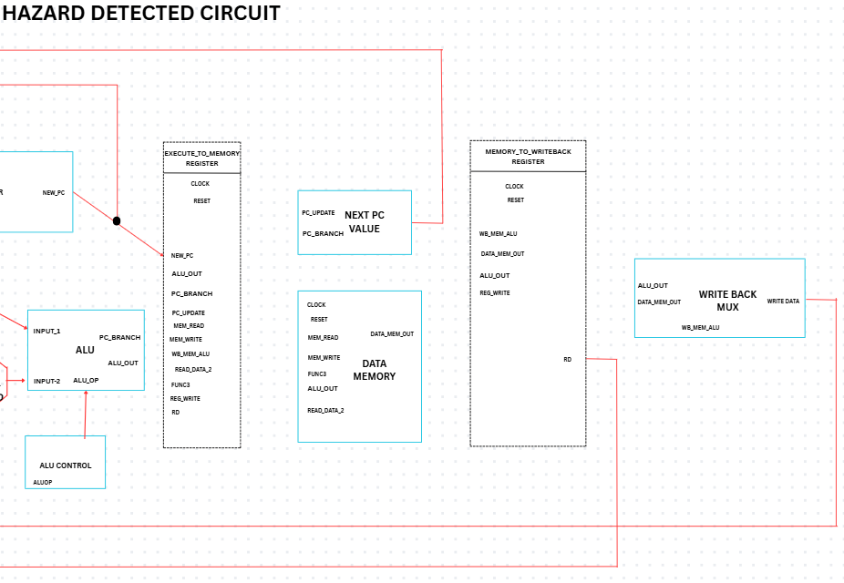
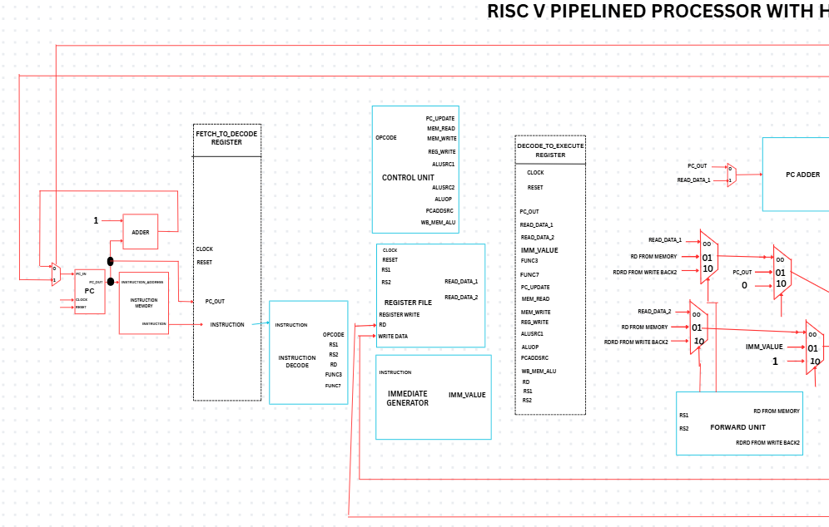
Fig. 3. Custom RISC V Architecture

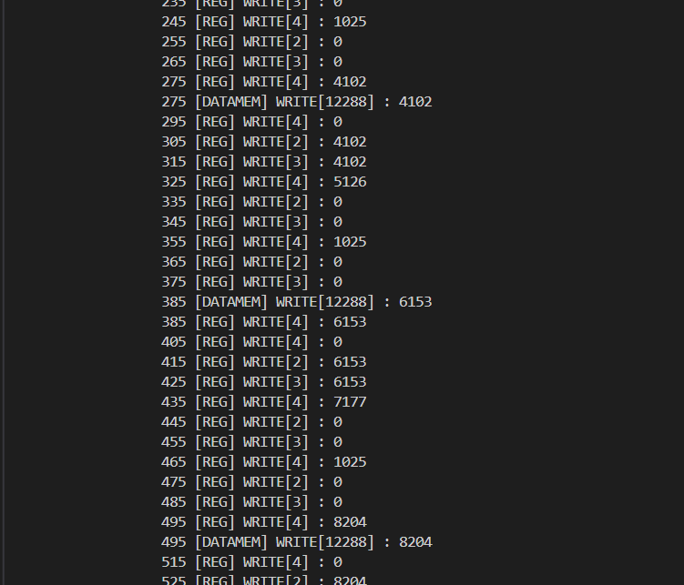
- Functional Role and Data Flow
The key objective of FIR filter is to tamper away the undesired frequency contents in the signal and to retain the valuable diagnostic information in the biomedical signal. Each new sensor sample is also added during operation to a buffer which contains a window of recent data points. Filter coefficients multiply these stored values and the co-products are added up to produce the filtered output [14] [12]. This is repeated with each incoming sample as a result of which the filter is operated in a completely streaming fashion. Since the calculation is performed on hardware, filtering is also done fast with less latency than when done in a software-based implementation [4].

- Instruction Level Acceleration using VMAC
To further make the computation more efficient, the multiply- accumulate address of the FIR filter are carried out using the custom Vector Multiply Accumulate (VMAC) instruction that is incorporated into RISC V processor [6]. The VMAC instruction does not require various sequential instructions to do the multiplication and addition operations, but does them in one hardware cycle. This allows cutting the time taken to execute and power usage down to a minimum, letting the FIR filter keep running without interruption to the real time stream of biomedical data. This leads to clean and stable signal generated by the system which can directly be forwarded to the FFT and CNN processing steps which can contribute to higher diagnostic accuracy and system overall performance [13] [12]. The register and memory activity that is produced upon VMAC-assisted execution is indicated in Fig. 4.

Fig. 4. FIR Filter Data Log

- FFT ARCHITECTURE AND WORKFLOW
Another significant processing unit of the proposed System on Chip is the Fast Fourier Transform (FFT) module. The FIR filter removes noise in the time domain of the raw biomedical signal, but the FFT transforms the signal to the frequency domain to be able to detect the spectral aspects concealed within the signal. It is of particular use in biomedical measurement, where some abnormalities and repetitive distortions can be more readily identified based on frequency analysis than directly based on the raw waveform. The application of the FFT in hardware hardware guarantees that
this computation can be done on-going even as the real time system runs.[3]

- Functional Role and Data Flow
Operation involves the collection of blocks of filtered signal samples and sending it into the FFT processing unit. The signal is then broken down into the discrete frequency content to enable the system to view periodic patterns, noise characteristics and spectral patterns that are also of interest in the diagnosis. The CNN accelerator can also be fed on this frequency-domain information and classified. As this is calculated by a special hardware block the overall latency is significantly decreased when compared to running FFT fully in software. This enables the system to enable continuous and responsive biomedical monitoring.[4]
- Instruction Level Acceleration using VMAC
To further improve the performance of FFT, the processor includes FFT-specific Bit Reversal instruction that helps in reordering of data needed by the FFT algorithm. This step in a traditional implementation has several memory reads and mathematical operations, thereby raising the processing time [14]. When the instruction is dedicated, it is index reordering which is directly carried out in hardware and the FFT engine can continue faster with its calculation’s steps. This decreases the total workload to execute the frequency analysis and makes sure that frequency analysis can match the rate of the incoming stream of biomedical signals. Consequently, the system can provide frequency-domain at a fast rate, providing effective and prompt medical evaluation.
- CNN ACCELERATOR ARCHITECTURE AND WORK FLOW

A Convolutional Neural Network (CNN) accelerator is used in the final step of the analysis in the suggested System on Chip. Following the noise removal and feature enhancement steps on the biomedical signal (FIR and FFT stages), the processed signal is passed to the CNN where it is classified. The main aim of this phase is to determine patterns in the signal, and categorize them as normal or abnormal physiological conditions.[5]
The CNN is used as a specific hardware accelerator inside the SoC to allow running the CNN in real time. This makes computationally intensive tasks like convolution, activation, and pooling to be effectively performed without overloading the main processor. Consequently, the system is able to do continuous monitoring with low latency and enhanced energy efficiency. The architecture of the CNN used in this work is summarized in Table II.

- Performance Evaluation and Training Methodology

The CNN used in the suggested architecture has been trained offline with labeled biomedical signal data. Electrocardiogram (ECG) signals were chosen in this work because of their common applications in cardiac health studies. The data is a series of signal segments of normal rhythms and abnormal conditions (arrhythmias). The signals were preprocessed by normalizing and segmenting the signals to maintain consistent input size and enhance stability.[6]
Training of the model was done using a supervised learning method. This was implemented in the TensorFlow environment, with categorical cross-entropy as the loss and Adam as the optimizer to facilitate efficient convergence.

The dataset was separated into the training and validation subsets to assess the generalization of the model and to avoid overfitting in the training process. The weights were exported and embedded into CNN hardware accelerator to perform inference after the training process was done. This design decision guarantees the realization of computationally intensive training in a different location, and the SoC is only concerned with the real-time classification that is fast and efficient.[6]

In order to evaluate the success of the proposed system, the standard evaluation measures like accuracy, precision, recall, and F1-score were taken into account. Table III summarizes the performance of the CNN model and indicates its ability to classify biomedical signals reliably.[7]

The findings suggest that CNN model has a high degree of classification accuracy and good sensitivity and precision. This renders the proposed system as being suitable in terms of reliable real-time biomedical monitoring, in which correct detection and reduction of false alarms is significant.

Layer | Filters | Kernel | Output
Conv1 | 3 | 3 | 30×3
Pool1 | - | 2 | 15×3
Conv2 | 2 | 3 | 13×2
Pool2 | - | 2 | 7×2
FC | - | - | 8 classes

TABLE II : CNN ARCHITECTURE

- Relation with FIR and FFT

The CNN accelerator takes the result of the FIR filter and FFT modules as input and builds the last step in the processing pipeline. The FIR filter strips the original biomedical signal of noise and other undesirable distractions, leaving only the vital waveform properties. This time-domain signal can be directly inputted into the CNN or further refined with the FFT to obtain frequency-domain characteristics. The time-domain and frequency-domain representations are included, which offers more input features to the CNN. This enhances the capability of the model in differentiating between normal and abnormal signal patterns in a better way. Consequently, the joint work of FIR, FFT, and CNN provided allows a more efficient and precise diagnostic procedure in the SoC.[8]

- Interaction between CNN and General Processor Core

CNN accelerator is coordinated with RISC-V processor which is the central controller of the system. The processor has the responsibility of preparing input data, control and memory transfer, as well as providing control signals to the CNN hardware. After activation, the CNN accelerator handles all the major calculation tasks within itself, thus significantly decreasing the workload on the main core. Once inferred, the outputs of the classification are then returned to the processor as predicted labels or confidence scores. Depending on the results of these outputs, the processor may issue alerts, save diagnostic data, or proceed to additional analysis as needed. Such a collaborating interaction guarantees the smooth functioning of the system and makes it possible to interpret biomedical signals in real-time.[9]

Metric | Value (%) | Description
Accuracy | 94.2 | Overall correct classification rate
Precision | 93.5 | Correctly predicted abnormal cases
Recall | 92.8 | Ability to detect actual abnormal conditions
F1-Score | 93.1 | Balance between precision and recall

Table III: CNN Classification and Performance Metrics

- OVER-ALL SOC INTEGRATION
The RISC V processor of the proposed System on Chip acts as the central controller and it coordinates the work of the FIR filter, the FFT unit and CNN accelerator to create an autonomous biomedical processing pipeline. The processor then sets the FIR filter and makes it operational such that the noise in real-time biomedical signals is eliminated. The filtered output is then shared with the FFT module to analyze the frequencies or passed as-is to the CNN accelerator on the need to use the power of frequencies or not, respectively [15]. Both the FFT and CNN blocks are hardware co-processors, so any computationally intensive task can be executed, and the main processor is not loaded [14] [9]. When the CNN finishes the process of classification the ultimate decision output is sent back to the processor to be logged or generate alerts. This ensures that the system is fast, has low power consumption, and can be successfully diagnosed on the device itself (no external desired computation required) by integrating all stages in a single SoC [12] [5].

- Memory Bandwidth and Bus Architecture Considerations

Effective data transfer is a key factor in overall operation of the proposed System on Chip, especially in real-time biomedical signal processing applications where information streams that are continuous in nature have to be processed continuously. Besides enhancing computational speed, memory bandwidth and communication on chip have been taken into account to prevent performance bottlenecks.
The system employs on-chip SRAM as the main memory to buffer intermediate data in between processing phases. As biomedical signals like electrocardiogram (ECG) are streamed, data is sent in sequence between sensor interface and FIR filter and then optional FFT processing can take place before data is sent to CNN accelerator. This form of data flow is minimal in the use of unneeded memory access and the latency is minimized using this pipeline-based data flow.
A shared bus architecture is used to enable a streamlined interaction between the RISC-V processor and hardware accelerators. The entire subsystems (processor core) and FIR filter, FFT unit, CNN accelerator, and memory blocks are connected by a lightweight system bus. The architecture has been designed in such a way that high priority modules like the FIR and CNN accelerators are granted access to the memory resources in a timely manner without the need to contain the other modules.

The bandwidth and memory overhead of the system is relative to the rate at which the biomedical signal is sampled and the amount of data that is processed at each step. In the case of a standard ECG signal, with a moderate-frequency sampling rate, the bandwidth requirements are small enough to fit in on-chip SRAM. Additionally, as a majority of processing is done within hardware accelerators, off-chip memory access is not done often, which also enhances efficiency.
The architecture employs a staged data transfer strategy to minimize bus contention and enhance throughput with each module processing and forwarding data in a synchronized fashion. This avoids the possibility of having several modules using the same memory at any given time and hence reduces congestion in the shared bus. Moreover, buffering is introduced between steps to provide smooth data flow even with the processing delays varying.[9]
In general, the localized use of memory, structured data flow, and effective sharing of buses make possible the proposed SoC to maintain real-time biomedical signal processing without bandwidth constraints.

- RESULT AND DISCUSSION
The proposed System on Chip was tested through the analysis of the results of the processor, FIR filter and CNN accelerator. This was verified by the execution using the extra instruction set as the custom RISC V processor functioned properly and pipelined execution was verified. [10] The FIR filter output revealed effective noise reduction without removing the relevant biomedical waveform characteristics and this indicates that hardware-based filtering is suitable in real time monitoring. A sample detection report generated by the CNN is shown in Fig. 5, where the final classification result is

- Comparative Evaluation with Cloud-Based Systems

In order to have a closer insight into how effective the suggested System on Chip architecture is, a comparative analysis is conducted in relation to the traditional cloud-based biomedical monitoring systems. In the classic cloud-based solutions, unprocessed biomedical signals are sent to remote servers where signal processing and classification are conducted. Although these systems have high computational power, they pose latency, energy, and privacy issues. Contrary to this, the proposed architecture will handle all the key processing steps, such as filtering, feature extraction, and classification, directly on-chip. This does not require the continuous transmission of data, allowing the provision of faster response times, especially in real-time healthcare uses.
Reduced latency is one of the main benefits of on-chip processing. Cloud-based systems are reliant on network conditions that can cause unpredictable delays through transmission and response time by server. [11]

Another consideration is energy efficiency. The constant flow of data in cloud-based applications uses a lot of power particularly with wearable or portable computing devices. The proposed SoC minimizes communication overhead and minimizes the overall power consumption by performing data processing on the hardware accelerators, thus reducing the need to transmit the data over communication channels.

Processing  Stage | Data  Type | Data  Rate (Approx.) | Bandwidth  Requirements
Input Signal | Raw ECG Sample | 250-500 samples/sec | Low
FIR Filter | Filtered Signal | Continues Stream | Moderate
FFT Module | Frequency map | Block Based | Moderate
CNN Accelerator | Features Map | Batch Processing | High
Table IV: Estimated Memory Bandwidth Requirements

Parameter | Cloud Based System | Proposed SoC
Processing Location | Remote Server | On-Chip System
Latency | High | Low and Consistent
Reliability | Network Dependent | Independent of Connectivity
Real-Time Response | Limited | Highly-Suitable

Table V: Comparison Between Proposed SoC and Cloud-Based Systems

displayed after signal analysis. In addition, the processor design was synthesized and verified at the hardware level, as illustrated in Fig. 6, confirming that the architecture is suitable for implementation on silicon or FPGA platforms. These combined results demonstrate that the proposed SoC architecture enables fast, secure, and efficient biomedical signal analysis in real time. The CNN accelerator quickly categorized signals processed into both normal and abnormal form without any external computation, and it gave quick on- lap results [7]. All these results suggest that the integrated architecture facilitates real time, secure and efficient biomedical signal analysis.

Fig. 5. CNN Detection Result
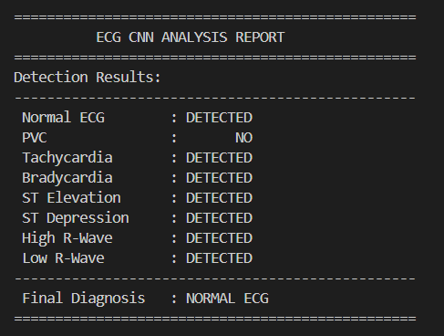

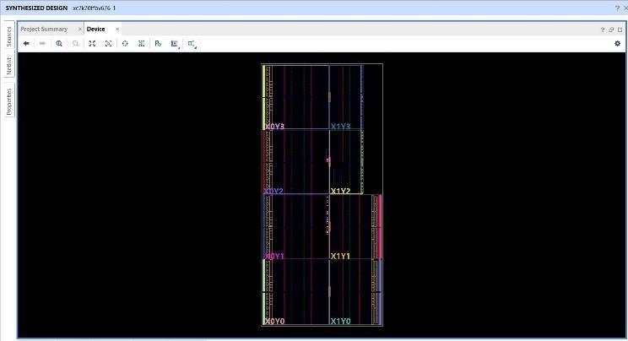
Fig. 6. Processor Synthesis Result

- Hardware Implementation Metrics

In order to further confirm the feasibility of the proposed System on Chip architecture, the hardware implementation metrics were further examined such as area usage, timing performance and energy efficiency. The design was synthesized and tested on an FPGA platform to determine feasibility in the real world.
The system area use is an indication of the hardware resources needed to execute the processor core, FIR filter, FFT module and CNN accelerator. As a result of the use of specialized hardware accelerators, the design has a balanced trade-off between the performance and the use of resources. The CNN accelerator has a somewhat bigger size because of the addition of convolution and pooling units whereas the FIR and FFT modules have been designed to be implemented efficiently.
The performance in terms of the maximum operating frequency and critical path delay was measured in terms of timing. Pipelined RISC-V processor architecture enables several instructions to execute at the same time, enhancing throughput. Moreover, custom instructions can also be used, lowering the amount of execution cycles to perform digital signal processing operations, which also helps improve timing.
Real-time biomedical devices, particularly in portable and wearable applications are energy efficient. The suggested architecture helps minimize the energy use by minimizing the use of external communication and using hardware accelerators to perform computation-intensive tasks. Most of the operations are performed within the SoC, which means that unneeded data transfer is eliminated, leading to reduced power consumption.

- Impact of Integration on System Throughput

The combination of various processing blocks in the suggested System on Chip directly affects the system throughput. Because the architecture is a single pipeline that incorporates both FIR filtering and FFT processing in addition to CNN-based classification, one should consider how effectively the system can handle continuous streams of data in biomedical.
The proposed design enhances throughput by implementing a pipelined method of processing, in which various modules process the data simultaneously and on different chunks of the data. A set of samples is being filtered using the FIR module, and the previously filtered data may be processed using the FFT unit, and classification may be done concurrently with the CNN accelerator. This parallelism contributes greatly to the speed of the entire data processing in contrast to a sequential execution model.
Throughput is also enhanced with the use of special hardware accelerators. Computationally intensive tasks like convolution and frequency transformation are offloaded and run in parallel to the main processor, minimizing delays in processing. Consequently, the system can support the uninterrupted flow of real-time data.
Nevertheless, the possibility of bottlenecks occurring also exists with the integration of various modules, especially when it comes to data transfer and synchronization between the stages. The processing block with the greatest computational load is that of CNN accelerator because of feature extraction and classification. To alleviate this, intermediate buffering and data flow control mechanisms are used to make sure that the CNN module does not block the previous pipeline stages.
The processing pipeline is made up of consecutive stages, the slowest of which can be used to approximate the overall system throughput. In this design, although the CNN stage is more complex, hardware acceleration will make the CNN stage run within reasonable timing requirements. The system can handle biomedical signals at a rate to satisfy real-time monitoring needs, and respond in time.

- CONCLUSION
This paper discussed a heterogeneous RISC V based System on Chip that was developed with the specific purpose of real time biomedical signal analysis. Its architecture combines a common-purpose processor core with hardware processing units on FIR filtering, FFT processing, and CNN based [16] classification, enabling noise removal, feature extraction and automated diagnosis to be run directly on the component. With the addition of both custom instructions and hardware acceleration, the system can have a higher processing speed and lower latency than conventional processor-based solutions, and provide patient data privacy by preventing data sent to a processing unit. The findings prove that the customization of an open processor platform on application specific hardware is an effective and efficient solution towards on-going biomedical monitoring and intelligent healthcare device solutions

REFERENCES
[1] Jiangwei He, Weiwei Shi, Chaoyuan Wu, Zhihong Mo, “Design and Implementation of a RISC-V Soc for Real-Time Epilepsy Detection on FPGA”. 2023 6th International Conference on Electronics Technology (ICET), 2023.
[2] A. Arnaud, M. Miguez, J. Gak, R. Puyol, R. Garcia-Ramirez, E. Solera-Bolanos, “A RISC-V Based Medical Implantable SoC for High Voltage and Current Tissue Stimulus”. 2020 IEEE 11th Latin American Symposium on Circuits & Systems (LASCAS), 2020.
[3] Francesco Conti, Gianna Paulin, Angelo Garofalo, Davide Rossi, Alfio Di Mauro, Georg Rutishauser, “Marsellus: A Heterogeneous RISC-V AI-IoT End-Node SoC With 2–8 b DNN Acceleration and 30%-Boost Adaptive Body Biasing”. IEEE Journal of Solid-State Circuits, 2023.
[4] Jina Park, Eunjin Choi, Kyungwon Lee, Jae-Jin Lee, Kyuseung Han, Woojoo Lee, "Developing an Ultra-low Power RISC-V Processor for Anomaly Detection". 2023 Design, Automation & Test in Europe Conference & Exhibition.
[5] Gianluca Leone, Matteo Antonio Scrugli, Lorenzo Badas, Luca Martis, Luigi Raffo, Paolo Meloni, "SYNtzulu: A Tiny RISC-V-Controlled SNN Processor for Real-Time Sensor Data Analysis on Low-Power FPGAs". IEEE Transactions on Circuits and Systems I: Regular Papers, 2024.
[6] Johnson Loh, Jianan Wen, Tobias Gemmeke, "Low-Cost DNN Hardware Accelerator for Wearable, High-Quality Cardiac Arrythmia Detection". IEEE 31st International Conference on Application-Specific Systems, Architectures, and Processors (ASAP 2020).
[7] Karthi Balasubramanian, Sree Ranjani Rajendran, Sandipan Pati, "Complexity Measures in Biomedical Signal Analysis: A Clinically-Grounded Survey Across EEG, ECG, Intracranial Pressure, and Photoplethysmogram Modalities". IEEE Access, Early Access.
[8] Hoai Luan Pham, Thi Diem Tran, Vu Trung Duong Le, Yasuhiko Nakashima, "MINA: A Hardware-Efficient and Flexible Mini-InceptionNet Accelerator for ECG Classification in Wearable Devices". IEEE Transactions on Circuits and Systems I: Regular Papers, 2025.
[9] Philipp Schönle, Florian Glaser, Thomas Burger, Giovanni Rovere, Luca Benini, Qiuting Huang, "A Multi-Sensor and Parallel Processing SoC for Miniaturized Medical Instrumentation". IEEE Journal of Solid-State Circuits, 2018.
[10] Abraham Gonzalez, Jerry Zhao, Ben Korpan, Hasan Genc, Colin Schmidt, John Wright, "A 16mm2 106.1 GOPS/W Heterogeneous RISC-V Multi-Core Multi-Accelerator SoC in Low-Power 22nm FinFET". 47th European Solid-State Circuits Conference (ESSCIRC 2021).
[11] Francesco Conti, Angelo Garofalo, Davide Rossi, Giuseppe Tagliavini, Luca Benini, "Open Source Heterogeneous SoCs for Artificial Intelligence: The PULP Platform experience". IEEE Solid-State Circuits Magazine, 2025.
[12] Angelo Garofalo, Yvan Tortorella, Matteo Perotti, Luca Valente, Alessandro Nadalini, Luca Benini, "DARKSIDE: A Heterogeneous RISC-V Compute Cluster for Extreme-Edge On-Chip DNN Inference and Training". IEEE Open Journal of the Solid-State Circuits Society, 2022.
[13] Xie Yu, Tamas Majoros, "Hardware Implementation of CNN Based on FPGA for EEG Signal Patterns Recognition". 2021 International Conference on e-Health and Bioengineering (EHB), 2021.
[14] Alireza Keyanfar, Reza Ghaderi, Soheila Nazari, Behzad Hajimoradi, Leila Kamalzadeh, "Designing Very Fast and Accurate Convolutional Neural Networks With Application in ICD and Smart Electrocardiograph Devices". IEEE Access, 2023.
[15] Weiwei Shi, Haoren Qin, Jiasheng Wu, Jingbin Mai, "Design of a CNN Accelerator for Multitask EEG Signal Classification Based on RISC-V". IEEE Transactions on Very Large Scale Integration (VLSI) Systems, 2025.
[16] Aaqib Raza, Mohd Zuki Yusoff, "Deep Learning Approaches for EEG-Motor Imagery-Based BCIs: Current Models, Generalization Challenges, and Emerging Trends". IEEE Access, Early Access

