Report on the Smart Solar Parking Lot Project
Authors: Wenhan He, Sumit Ghodke, Samuel Sushanth, Balaji Sai
Department: Industrial and Systems Engineering
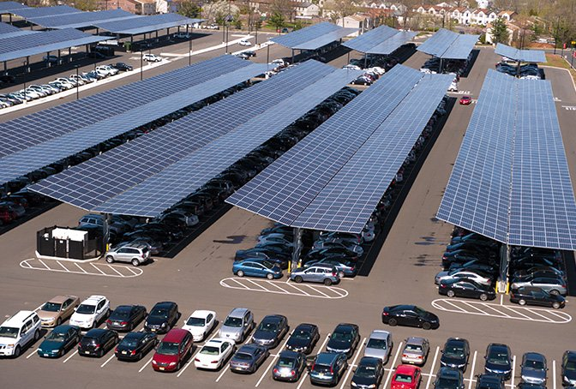

Executive Synopsis-
This study presents a summary of the Smart Solar Parking Lot project, an innovative endeavor aimed at transforming Parking Lot 64 into a technologically advanced, solar-powered facility. In order to promote sustainable urban growth and improve parking efficiency, this idea combines solar energy with smart technology. The solar canopy, the smart parking app, and the infrastructure for charging electric vehicles are the essential parts.

Mission Project -
The goal is to plan and build a solar-powered smart parking lot that will provide a range of services, such as EV charging and real-time parking management. The project is intended to serve as an example of ecologically benign and commercially feasible sustainable urban infrastructure.

Project Specifics: Design Synopsis
In order to provide most of the energy needed for the nearby buildings and the charging stations, the plan calls for erecting a solar canopy over Parking Lot 64. The property will have the following features: • 1,960 solar panels in a variety of configurations, producing a sizable amount of power.
• Supporting Structures: Stability and durability are ensured by steel cross-beams, columns, and other supports.
• Smart Technology: Combining smart technologies and Internet of Things devices to effectively manage parking and vehicle charging.
"Making a Difference: One Planet" is the title of the slide, which is accompanied by an image of Earth from space that suggests a global or environmental viewpoint.
Project Description: The goal of the "Smart Solar Parking Lot" project is to use Internet of Things (IoT) technology to deliver novel services. The primary goals are to use solar energy and provide electric vehicle charging stations for the benefit of people. The slide talks about covering "Parking Lot 64" with a solar canopy, which will provide almost all of the energy needed for the nearby buildings.
Features and Technology:
Intelligent Parking Management: This will work in tandem with the charging of electric vehicles to guarantee effective parking space management and utilization.
Localization and Rapid Charging: The project's main goals will be to provide methods for rapid charging and systems that make them easier to find parking spots effectively.
Smart Parking App: To improve user experience, a specific app will be available that provides access to charging stations and real-time parking information.
Objectives and Effects:
The project will highlight the financial feasibility and environmental advantages of smart solar parking systems while serving as an example of sustainable urban development.
It highlights its potential benefits in smart technology integration and sustainable development with the goal of inspiring similar projects worldwide.

- THE GANT CHART

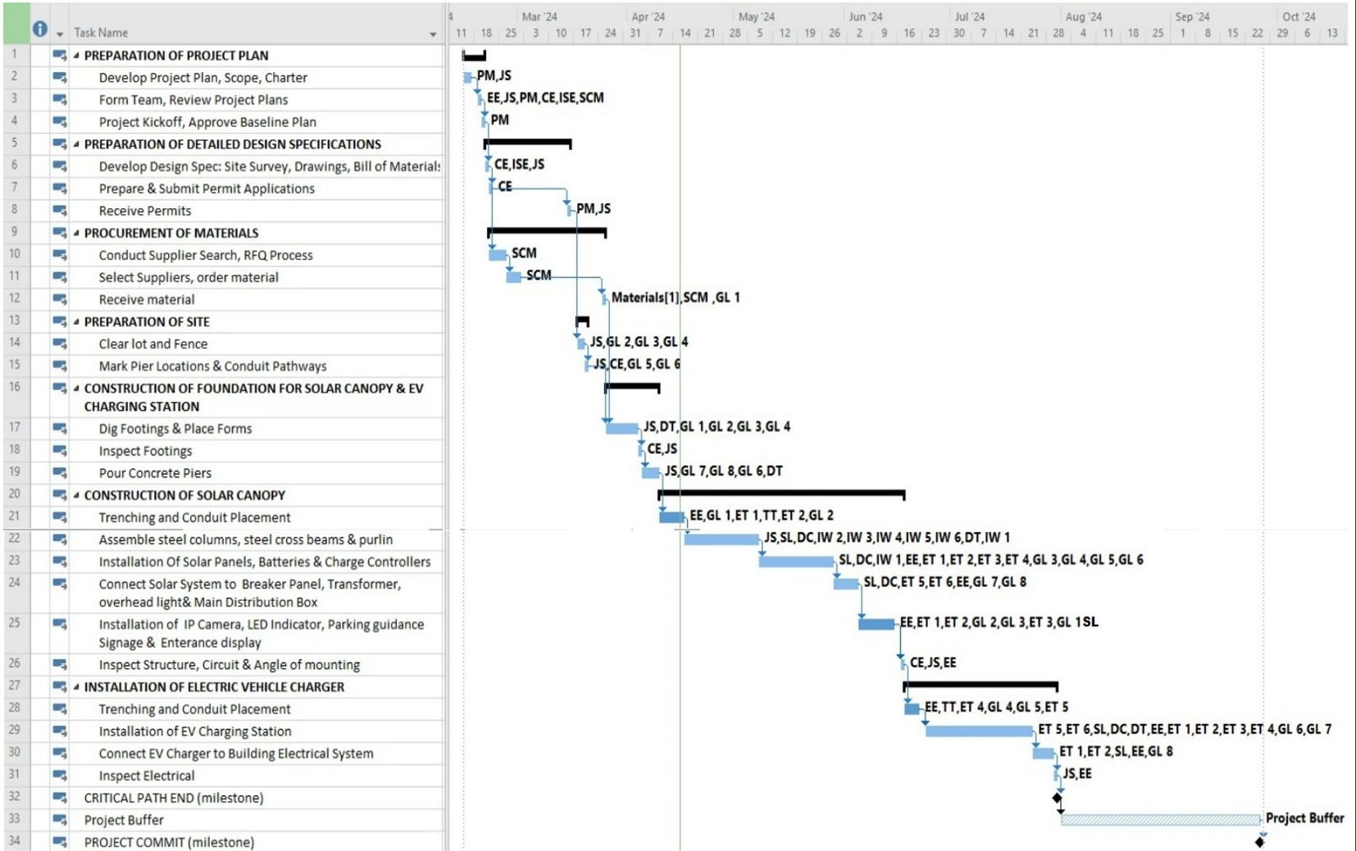

As stated in the tasks, the Gantt chart you shows the timetable and important tasks for a project that is probably connected to building and setting up an electric vehicle (EV) charging station and solar canopy. Below is an explanation of the many phases and important tasks shown in the chart:
1. Project Plan Preparation: Create a project plan, scope, and charter to lay out the fundamental parameters and goals of the endeavor.
- Assemble Team, Examine Project blueprints: Put together the project team and go over the blueprints to ensure they are correct and workable.
- Project Kickoff, Approve Baseline Plan**: Declare the project officially underway and accept the first plan as the accepted version.
2. Drafting Comprehensive Design Specifications
- Develop Design Spec: Provide comprehensive specifications that include a bill of materials, drawings, and site surveys.
- Get Ready and Send In
**Permit Applications**: Manage the documentation required to get legal authorizations.
- Get Permits: Acquire the necessary permissions in order to move further.

3. Purchasing Supplies
• Find possible suppliers and obtain bids through the RFQ process.
- Choose Suppliers, Place Material Orders: Make material orders and select suppliers.
- Receive Material: Take receipt of any supplies delivered for the project.
4. Site Preparation - Clear Lot and Fence: Clear and secure the area to make it ready for use.
- Mark Pier Locations and Conduit Pathways: Indicate the locations of structural and electrical elements.
5. Building the Solar Canopy and EV Charging Station Foundation
- Place forms and dig footings to get the foundation for the constructions ready.
Examine the footings: Verify the accuracy and stability of the foundations.
Pour Concrete Piers: Use concrete to fortify the foundation.

6. Building a Solar Canopy - Trenching and Conduit Positioning: Get ready for power connections.
- Assemble the purlin, steel cross beams, and steel columns to construct the canopy's framework.
- Installing Solar Panels, Batteries, and Charge Controllers: Assemble the solar canopy's primary working components.
- Connect the solar system to the main distribution box, transformer, overhead light, and breaker panel. This completes the integration of the solar system into the nearby electricity grid.
- Installation of an entrance display, parking guidance signage, an LED indicator, and an IP camera: Add further functions for monitoring and guidance.
Examine the structure, circuit, and mounting angle to make sure everything is securely mounted and fitted.
7. Setting Up an Electric Car Charger
- Trenching and Conduit Lay outing: Get the foundation ready for the wiring.
- EV Charging Station Installation: Assemble the charging stations.
- Attach EV charger to building's electrical system System: Connect the charger to the building's electrical supply.
- Examine the Electrical System to Make Sure Everything Is Correct and Safe.

8.Critical path end milestones: These are important markers that signify the conclusion of a major project phase.
- Project Buffer: Extra time allocated for unanticipated problems or delays.
- Project Commit: Most likely a formal pledge to carry out the project according to schedule or a final evaluation.
9.Participation of the Team
A abbreviation for each team member or role—for example, PM stands for project manager, EE for electrical engineer, and JS for job supervisor—is included in the chart. The project's intended timeline, which spans from late March to early October, is illustrated by the precise start and end dates assigned to each activity.
With its comprehensive job outline, dependencies, and list of participants, this Gantt chart is an excellent tool for project management that helps to guarantee that the project is finished on schedule and within budget.

10. Roles and Stakeholders
• Project Manager: Responsible for overseeing resource allocation, scope management, and project execution.
• Project Sponsor: Offers funding and assistance while guaranteeing alignment with overarching company objectives.
• Solar Technology Expert: Provides knowledge on efficiency enhancements and solar technologies.
• Faculty and University Administration: Support academics and help with app development.
Estimating Costs
• Personnel Costs: $1,240,000 is the estimated cost for a variety of engineering and management positions.
• Material Costs: An estimated $556,500 will be spent on solar panels, supporting structures, and other parts.

- STAKEHOLDERS

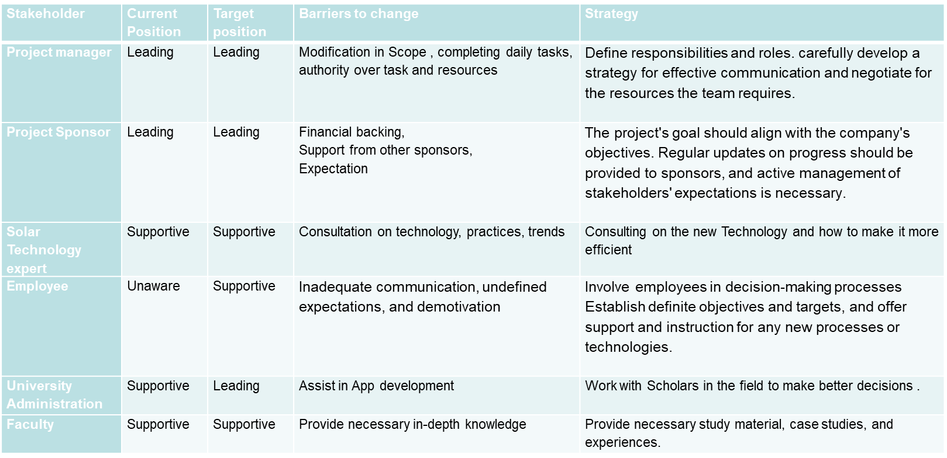

The above table offers an organized summary of the main project participants, emphasizing their responsibilities, difficulties, and tactical methods to increase their involvement and efficiency. The following succinctly outlines the strategy and function of each stakeholder:
Project manager
Function: Key figure in charge of daily operations and the project's overall success.
Strategy: To stay in charge, the project manager must establish roles and duties precisely, improve communication, and bargain with other stakeholders to obtain the resources that are required.
Sponsor of the Project:
Function: Offers the project's essential high-level support and financial resources.
Strategy: The project sponsor should manage expectations from other sponsors and stakeholders, connect project goals with corporate objectives, and offer regular progress updates in order to guarantee ongoing leadership and support.
Solar Technology Expert- Function: Provides knowledge and assistance with the project's technological components.
Strategy: Continue to be a productive supporter by keeping abreast of technology developments and industry best practices. You can also provide advice on how to improve the project's technology deployment.
Worker:
Function: Performs a variety of project-related activities, possibly without being fully aware of all strategic objectives.
The plan is to change the culture from one of ignorance to one of support, involve staff members more in decision-making, make their goals and roles clear, and give them the required training and incentives to use new technologies.
Faculty of University Administration:
Function: Usually offers scholarly knowledge and perception into the creation of applications or research.
Strategy: To advance to a leadership position, particularly in application development, work with academics and incorporate their findings into well-informed, strategic decisions.
All things considered, this table clearly indicates where each stakeholder should be aware of where they are now, where they should be going, the obstacles in their way, and the steps that need to be taken strategically to go over them in order to ensure a well-coordinated effort towards the project's success.

Solar Parking lot Layout-
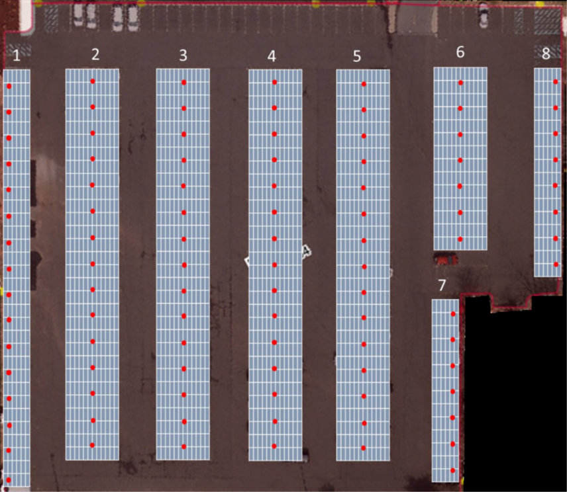
- Rows of solar panels that are positioned over the parking spaces cover the parking lot. In addition to producing electricity, these panels are positioned on supports that raise them above the cars, offering protection and shade.
- There are multiple rows of solar panels (From 2 to 6). Multiple modules are arranged side by side in each row, indicating a sizable installation intended to optimize solar energy capture.
- The red dots that are visible on the solar panels could be lights or sensors that are part of the panel arrangement for functional uses like safety signaling or performance monitoring.
- Access and Gaps: Each row of panels has a gap between them that most likely acts as a driveway for cars to move around and enter and exit.

2. COST ESTIMATION-

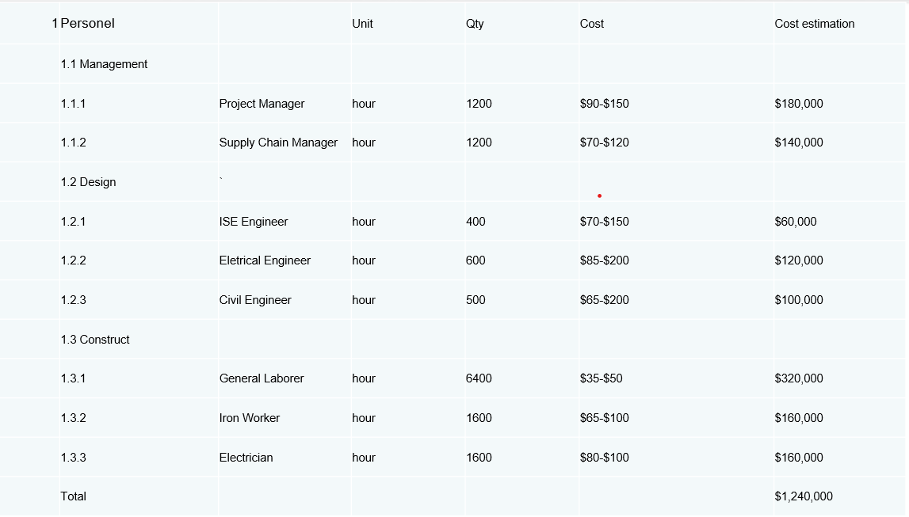
In the context of project management, the image above is probably utilized for financial forecasting and budget planning. It guarantees that financial resources are scheduled in accordance with the requirements of the project and assists stakeholders in understanding how labor costs are distributed across various roles. The successful completion of the project depends on every human category, with prices that correspond to the level of expertise needed as well as the volume of work that is anticipated. The skills and duties that come with each function have a considerable impact on the billing rates.This thorough cost analysis helps maintain open lines of communication with project participants by making sure they all know how money is being spent.
Material
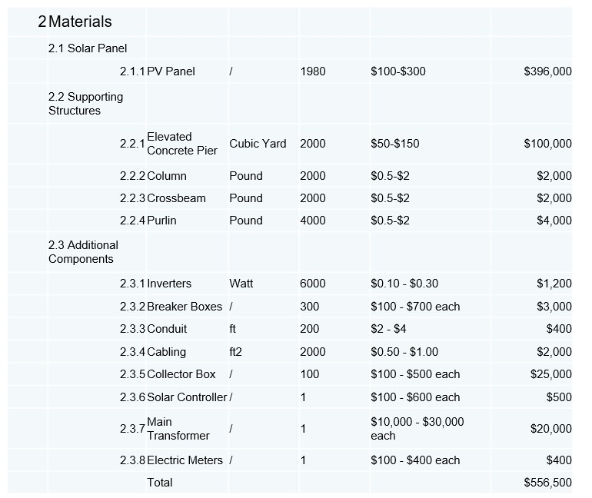
Total Amount Spent: $556,500
This chart offers a thorough analysis of all the supplies and expenses related to assembling the solar panel system, including the primary energy-producing components, electrical parts, and structural supports. The thorough listing aids in budgetary planning and budgeting for the installation. Additional Information is given below-
Elevated Concrete Pier (Optional): This is an optional foundation that can be used to increase the stability and height of the structure.
Column: The vertical supports that uphold the entire structure.
Crossbeam: Horizontal supports that connect the columns, providing horizontal stability.
Purlin: A series of bars mounted on the crossbeams to offer additional support for the solar panels.
PV Panel: Photovoltaic solar panels that capture sunlight and convert it into electrical energy.

RENTAL EQUIPMENTS
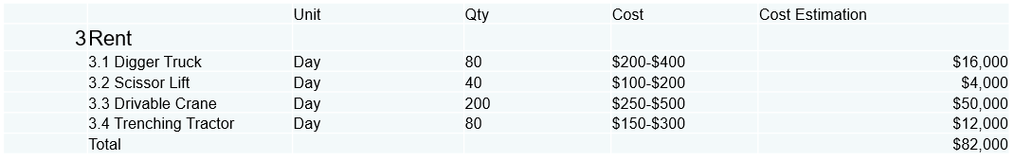
The Total cost of all rentals-$82,000
This table is helpful for managing and planning budgets for various project situations. It is especially helpful for figuring out how to allocate resources and determine whether renting machines is feasible for a construction or engineering project. The varying prices reflect the various types of machinery and the number of days needed to operate them.

Digger Truck: Equipped with a powerful boom and digging tool, it's ideal for excavation tasks, digging holes, and setting foundations or poles, crucial for preparing the ground for construction or utility installations.

Scissor Lift: Offers vertical elevation in a stable platform, perfect for accessing high areas safely, such as installing or maintaining overhead structures, lighting, or solar panels.

Drivable Crane: Provides mobility and lifting capability for heavy materials, useful for transporting and placing large items like steel beams, solar panels, or equipment across the construction site efficiently.

Trenching Tractor: Specialized in creating narrow trenches for laying underground cables, pipes, or conduits, essential for electrical wiring, drainage systems, or any sub-surface installations required by the project

CONCLUSION
Total cost for the project should be $1878500.
Estimated total power for 1980 solar panel put in lot 64 should be around 1723.7 MW

3. EXECUTION

Construction:
- Site Preparation:
  - Clear the site of any obstacles or debris that may hinder construction or installation activities.
  - Preparing the construction site by excavating, purchasing and delivery of materials and equipment as per engineering specifications.
  - Installation of temporary facilities (site office and storage).
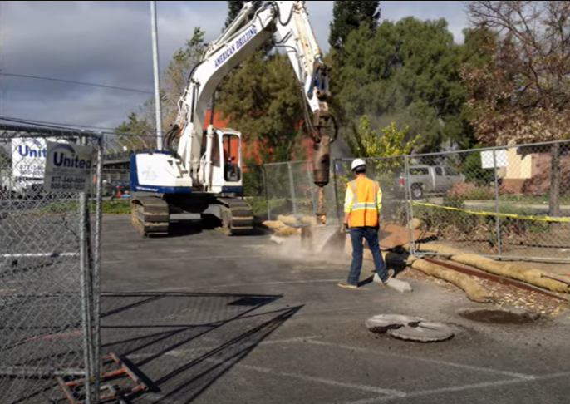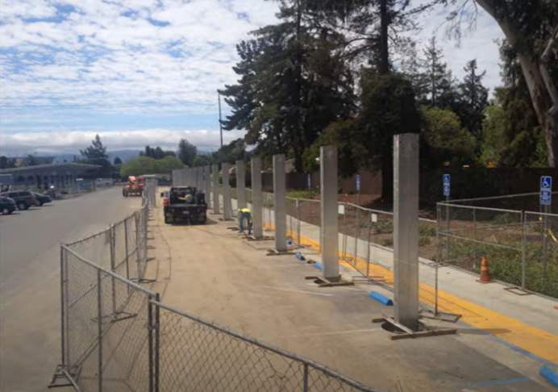

- Infrastructure Development:
  - The Columns are raised and cemented in position, on which the Crossbeams are fitted and bolted in place.
  - Electrical infrastructures are installed (transformers, inverters, Solar controller etc)
  - Installation of Fences and Rainwater collection, if necessary.
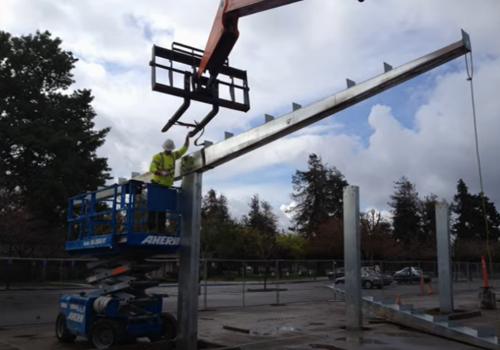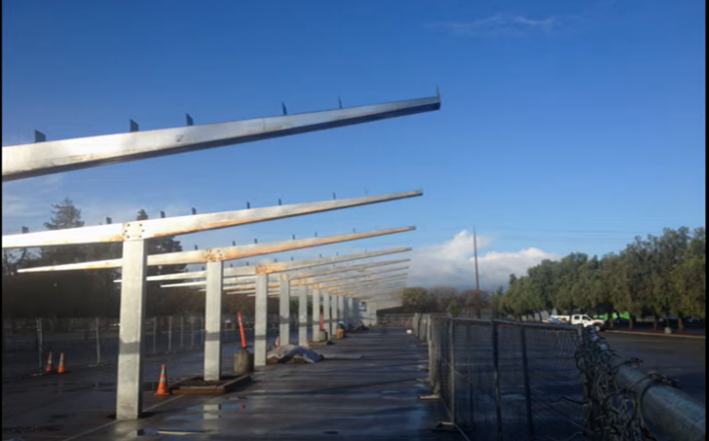
- Solar Panel Installation:
  - Sliding the solar panels on mounted Crossbeams structure and are connected.
  - The panels are connected through electrical wiring to the grid for power distribution.
  - Testing and commissioning solar panel installations.
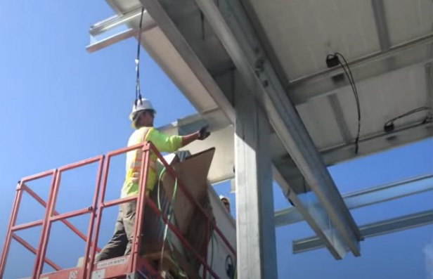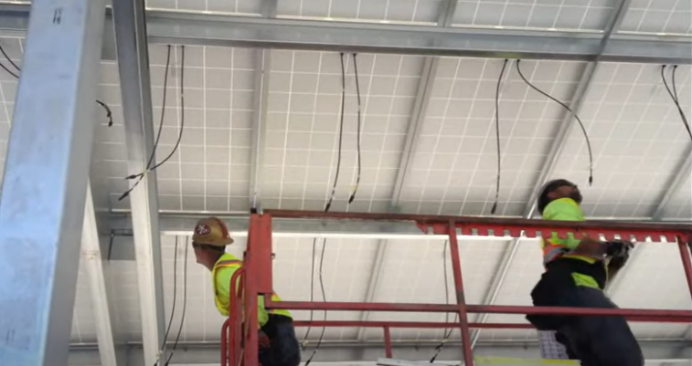
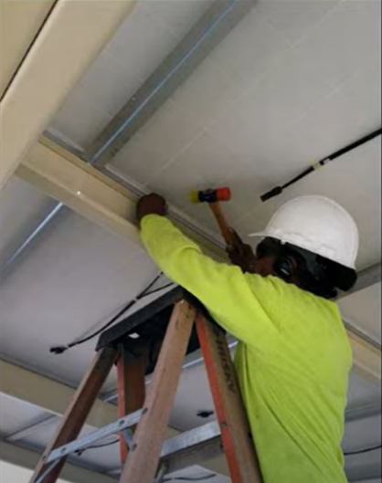
- Final Testing and Commissioning:
  - Complete testing of all systems and infrastructure.
  - Performance testing under different settings (day and night, weather changes) to verify the functionality and output of the solar power system.
  - Certification and regulatory approval.
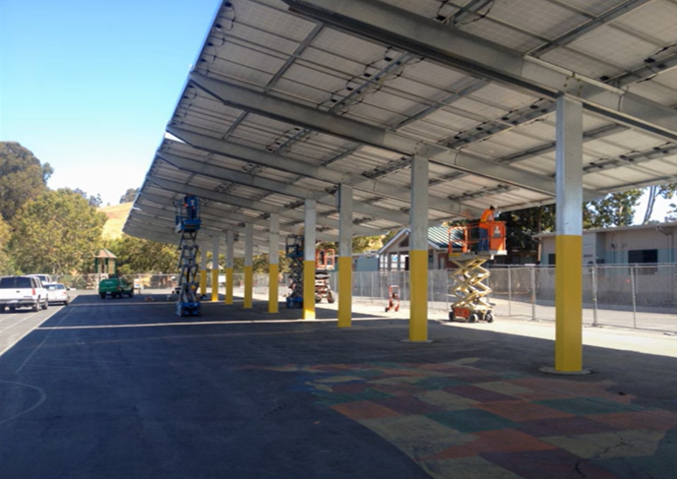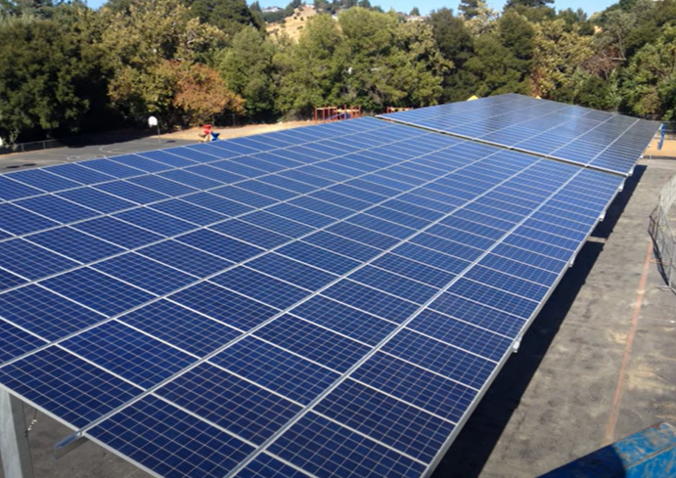
- Smart Technology Deployment:
  - Purchase and installation of smart monitoring and control systems.
  - Testing and calibration of smart technologies.
  - Implement solutions for real – time monitoring for parking spaces, occupancy management etc.
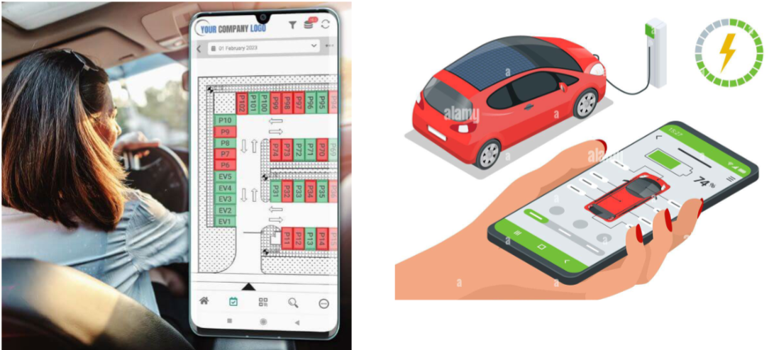

- Handover and Training:
  - Training sessions for maintenance professionals and end users on smart technology.
  - Provide user manuals, guidelines, and support resources to ensure smooth operations and effective utilization of smart features.
  - Handover documentation, including manuals, warranties, and certifications. Final inspection and approval.
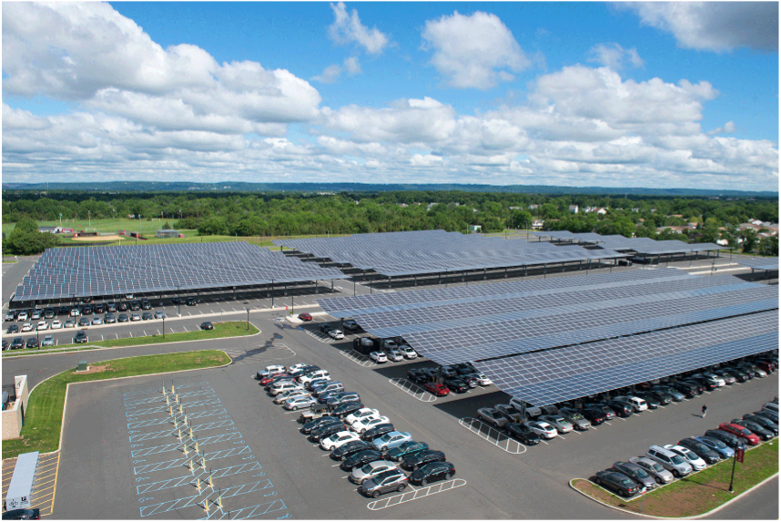

4. Risk Assessment:
- Technical Perils:

  - Equipment Failure: Inverters, solar panels, or other components that are faulty or of poor quality may cause reduced performance.
Solution: Proper testing of equipment.

  - Integration Issues: Difficulties combining solar panels with the parking lot's framework or the electrical systems.
Solution: Correct framework for parking lot design.

  - Battery Performance: If energy storage is to be incorporated into the project, the longevity and efficiency of batteries are essential.
Solution: Proper maintenance of solar panels.

- Financial Risks:

  - Overspending at the expense: unplanned cost increases resulting from changes in labour or material pricing or from unforeseen circumstances.
Solution: Assigning a skilled project manager to oversee the installation process through research and detailed cost estimation.

  - Revenue Shortfall: The money spent on building the plant will not be recovered due to lower energy production output.
Solution: Value engineering to optimize expenses.

- Operational and Maintenance Risks:

  - Overspending on repairs, replacements, and upkeep is known as maintenance expenditures.

  - Solution:
    - Using high-quality solar panels, mounting structures and other equipment from reputable manufacturers.
    - Allocate a dedicated budget for ongoing maintenance.
    - Conduct regular inspections and audits of the solar parking lot.

- Damage due to other factors:

  - Solar panels often face damage, or its performance decreases due to natural factors as shown below –

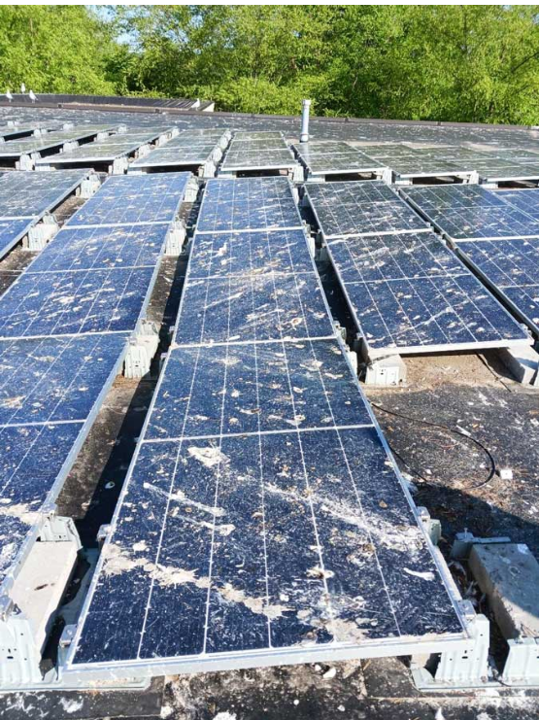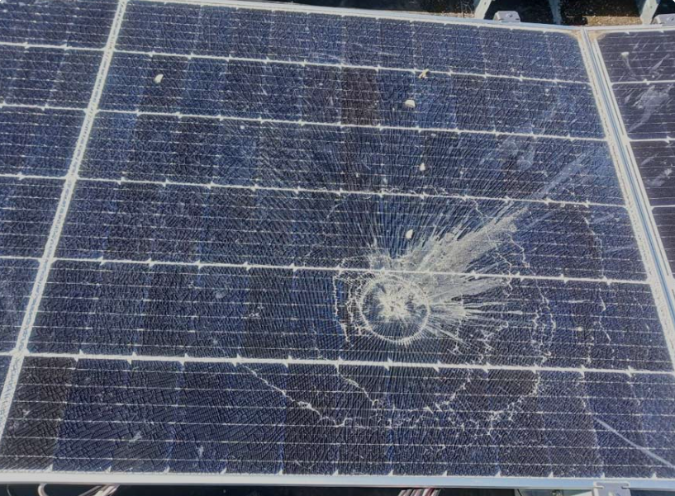
Damage due to Hail.
Damage due to Animals.
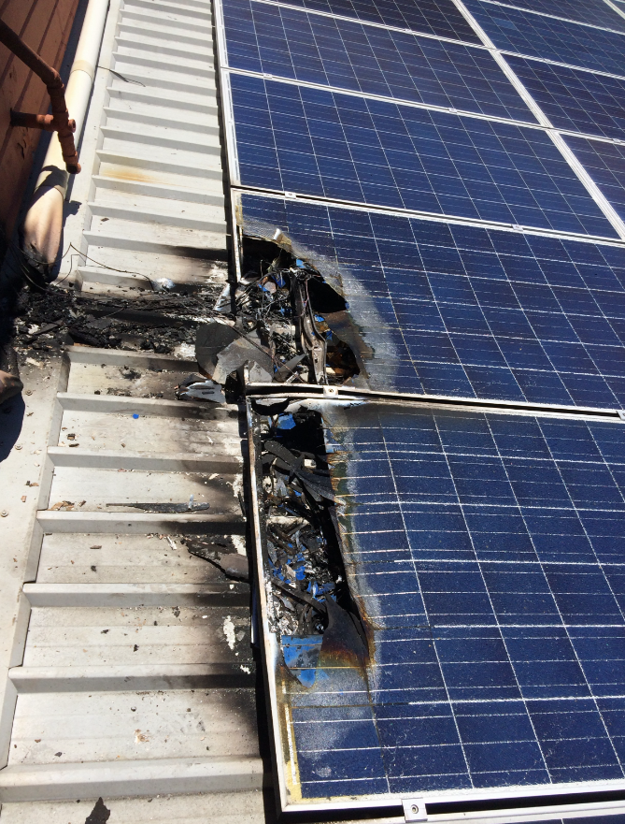
Damage due to Degradation.
Damage due to DC arc fault.
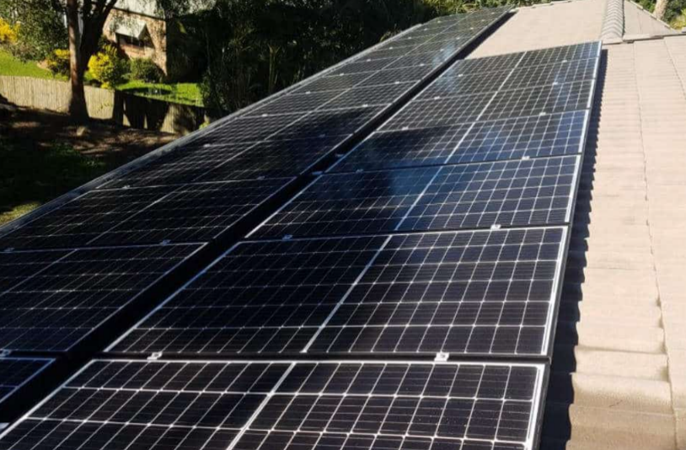
Damage due to Shading/Obstruction.

Risk Analysis:
RISK | LIKELIHOOD | IMPACT | RISK LEVEL
Technical perils | Low | High | High
Financial risks | High | High | High
Degradation/Maintenance risk | Medium | High | High
Electrical fault | Low | Medium | Medium
Natural risks (weather) | Low | High | High

- Smart Parking App-

Hardware:

- Parking Space IP Cameras: These will be needed to recognize license plate information of vehicles as they enter and occupy spaces.

- LED Indicators: To indicate the availability status of parking spots.

- Parking Guidance Signage: For guiding drivers to available parking spaces.

- Entrance Display: To show the number of available parking spaces at each level as vehicles enter the lot.

- Sensors and IoT Devices: To detect the presence of cars in parking spots and integrate with the app for real-time data.

- Electric Charging Stations: Equipment for electric vehicle charging.

- Networking Equipment: Routers, switches, and other networking hardware to ensure connectivity of IoT devices.

- Servers: For processing data, managing the app backend, and storing information securely.

Power Supply and Backup: Reliable power sources like solar panels what we implemented so that, the lot generates its own energy.

2. Software:
- Mobile App Platform: The user interface for interaction, which includes the following features:
- Remote login functionality.
- Verification of parking permits/permissions.
- Real-time display of available parking and lot maps.
- Automatic vehicle identification.
- Tracking of vehicle lot usage.
- Display of energy generated by the lot (if applicable).
- Display of available charging stations and metered electric charging.
- Reporting feature for lot issues.

- Database Management System (DBMS): To store and manage data such as user accounts, parking availability, vehicle information, energy generation, and usage data.
- License Plate Recognition Software: To process images from IP cameras for vehicle identification.
- Real-Time Data Processing System: For processing information from sensors and IoT devices to update parking availability.
- Payment Processing System: For handling parking and charging payments.
- APIs: To facilitate communication between the app, hardware sensors, payment gateways, and other services.
- Cloud Infrastructure or On-Premises Hosting: Depending on the scale and security requirements, cloud services like AWS, Azure, or on-premises data centers may be
- Cybersecurity Measures: Security protocols to protect user data and prevent unauthorized access.
- Analytics and Reporting Tools: For monitoring usage patterns, generating reports, and optimizing lot management.

3. Agile Project Plan: Developing Smart Parking App
1. Project Kick-off:
The project kick-off for Rutgers Smart Lot App will set the foundation for the project, beginning with a clear presentation of objectives and scope. Then will align on using Agile methodologies to ensure iterative progress and adaptability. Engagement with stakeholders will ensure project goals are in sync with expectations and user needs.
This stage will define success criteria, establish communication plans, and lay out the framework for regular check-ins and updates, ensuring a shared vision and understanding amongst all involved parties.

SCOPE & OBJECTIVES
The scope of the Rutgers Smart Lot project involves developing a mobile app and IoT- enabled parking infrastructure to facilitate space availability, automated vehicle identification, permit verification, and energy management.
It will integrate real-time parking guidance, electric charging stations, and a user-feedback mechanism, aiming to enhance the parking experience and optimize lot utilization.
The objective of the Rutgers Smart Lot project is to create a technologically advanced parking solution that improves space utilization.
Offers real-time parking data, supports electric vehicle charging, and integrates with a user-friendly mobile application for a seamless parking experience all using solar power.

User Stories
1.As Emily, a commuter with an electric vehicle, I want to be informed of available charging stations upon entering the parking lot **s o that** I can efficiently plan
where to park and charge my car.

2. As John, a frequent visitor to the Rutgers parking lot, I want to have my vehicle recognized automatically at the entrance **so that** my entry and exit processes are expedited, making my visits more convenient.

3. As Lisa, a tech-savvy driver, I want to access real-time parking availability through a mobile app **so that** I can quickly find an open spot without wasting time driving around.

4. As Derek, the parking lot manager, I want to** access data analytics on lot usage and energy management **so that** I ca n optimizes the parking operations and support sustainability initiatives.

5. As Ava, a user who values safety, I want to report any maintenance or safety issues directly through the app **so that** they can be addressed quickly to maintain a secure parking environment.

6. As Carlos, a new user of the Rutgers Smart Lot App, **I want to** easily navigate through the app’s interface **so that** my initial experience is straightforward and
stress-free.

7. As Sofia, someone who often forgets her parking spot, **I want to** get directions back to my car using the app **so that** I can locate it quickly and without hassle.

8. As Alex, a user who values convenience, **I want to** receive timely alerts about my parking session nearing its end **so that** I can extend my parking time through the app if necessary, avoiding any penalties.

9. As Naomi, a user interested in environmental impact, **I want to** see detailed information about the energy the parking lot generates **so that** I can feel confident about using a facility that promotes environmental sustainability.

These user stories, featuring Emily, John, Lisa, Derek, Ava, Carlos, Sofia, Alex, and Naomi, aim to address specific functionalities and benefits of the Smart Lot App from diverse user perspectives.

ESTIMATION FOR THE SMART APPLICATION-

+ + + +
- | Cost Item | Minimum Estimate ($) Maximum Estimate ($)|
- | IP Cameras 100 300
- | Sensors and IoT Devices 50 200
- | LED Indicators and Signage 100 500
- | Entrance Display Panels 2,000 5,000
- | Electric Charging Stations 6,000 12,000
- | Networking Equipment 10,000 30,000
- | Servers and Storage 5,000 20,000
- | Mobile App Development 50,000 200,000
- | Backend Infrastructure 25,000 100,000
- | License Plate Recognition Software 10,000 30,000
- | Payment Processing Integration 5,000 15,000
- | Cloud Hosting and Services 500 2,000 per month
- | Project Management 20,000 50,000
- | Design 10,000 40,000
- | Installation and Setup 10,000 50,000
- | Maintenance and Support 1,000 per month 5,000 per month
|
- | Testing 5,000 25,000
- | Legal, Compliance, and Security 10,000 30,000
- | Training and Documentation 3,000 10,000
- | Total Estimated Cost 270,150 | 1,120,500 |

COST DISTRIBUTION BY CATEGORY



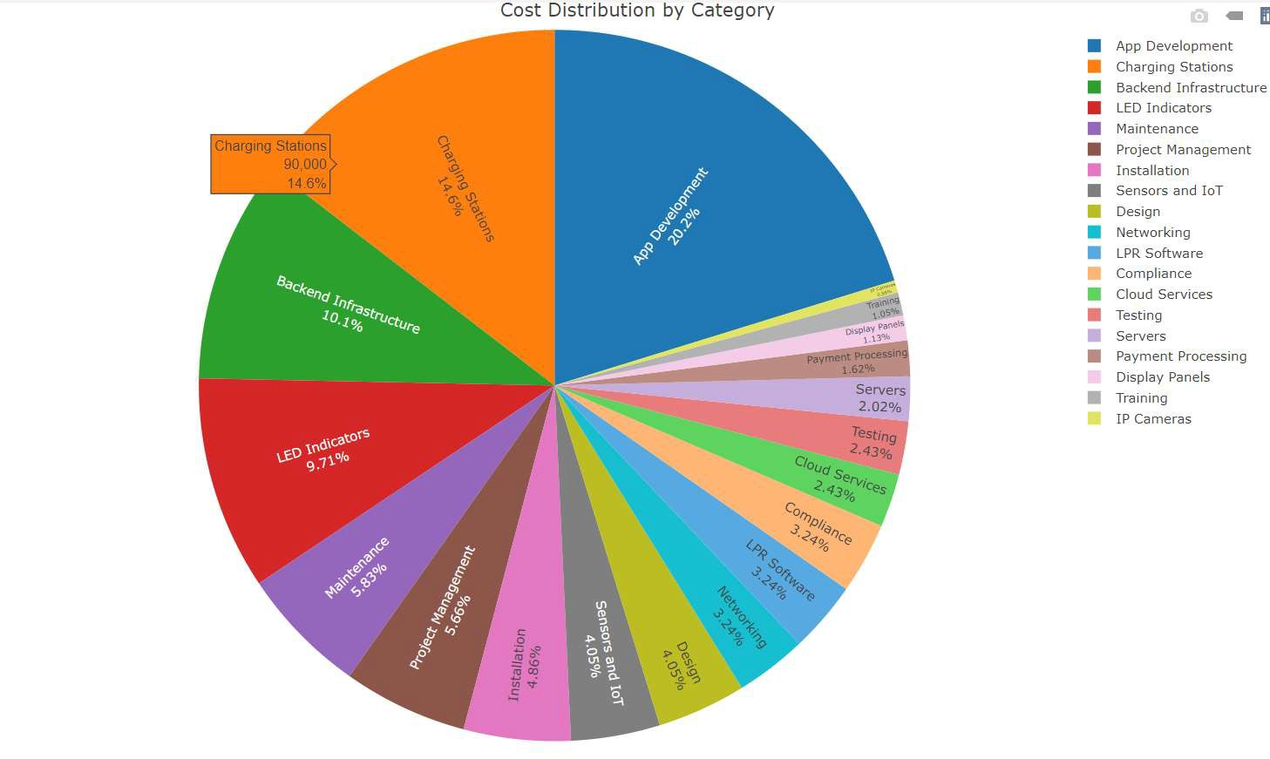

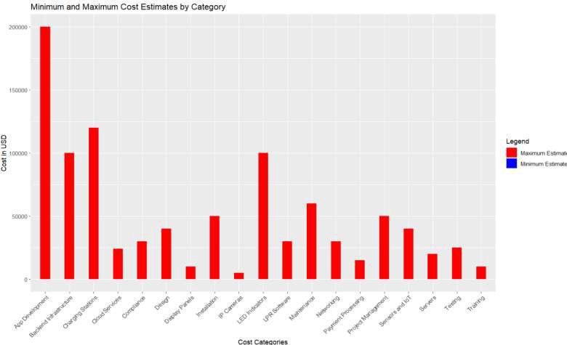

Sprint Planning
- Identification of user stories and features for the Smart Parking App.
- Prioritization of user stories based on business value and customer feedback.
- Selection of sprint duration and sprint backlog creation.

Smart Solar Parking Lot Project: Agile Development Plan

1.Sprint: App Design and Prototyping (Duration: 2 weeks)
- Develop wireframes and UI/UX designs for the parking app.
- Create clickable prototypes for user testing and feedback.
- Conduct usability testing to validate design concepts and user flows.
2. Sprint 2: Basic Functionality Implementation (Duration: 3 weeks)
- Implement core functionalities such as user registration, parking spot availability, and payment processing.
- Integrate APIs for real-time data updates on parking availability and charging stations.
- Conduct iterative testing to ensure functionality meets user requirements.
3. Sprint 3: Integration and Testing (Duration: 2 weeks)
- Integrate backend systems with the mobile app for data synchronization.
- Rigorous testing of the app, including unit tests, integration tests, and user acceptance testing (UAT).
- Perform cross-platform testing on various devices and operating systems.
- Address any bugs or issues identified during testing and ensure app stability

4. Sprint 4: Additional Features Implementation (Duration: 3 weeks)
- Implement additional features such as vehicle recognition, energy consumption tracking, and reporting functionalities.
- Enhance user experience with geolocation-based services for navigation to available parking spots.
- Conduct user acceptance testing to validate new features and gather feedback for further improvements.

5. Sprint 5: Optimization and Refinement (Duration: 2 weeks)
- Optimize app performance and responsiveness for smooth user experience.
- Refine UI/UX based on user feedback and usability testing results.
- Conduct final rounds of testing to ensure readiness for deployment.

6. Sprint Review and Retrospective:
- Review completed user stories and deliverables with stakeholders.
- Gather feedback from the development team on process improvements and lessons learned.
- Identify areas for optimization and adjust project plan as needed for future sprints.

7. Continuous Deployment and Maintenance:
- Deploy the Smart Parking App to production environment.
- Monitor app performance and user feedback for ongoing improvements.
- Implement agile practices for continuous integration and delivery of new features.

8. Stakeholder Engagement:
- Regular demos and updates to stakeholders to showcase progress and gather feedback.
- Collaboration with stakeholders to prioritize features and address changing requirements.

9. Collaboration and Communication:
- Daily stand-up meetings to discuss progress, blockers, and plans for the day.
- Use of agile project management tools for task tracking, collaboration, and communication.

Integration:
- Integration of the hardware and software components will be crucial for seamless operation.
- The app should be able to communicate with the hardware in real-time.
- Use of standard protocols like MQTT or HTTP for IoT device communication.
- Ensuring scalability to handle peak times and growth in the number of users and vehicles.

This interim report outlines the preliminary details and requirements for the Smart Solar Parking Lot & App project. Further progress will be detailed in subsequent reports and presentations.

