FACE RECOGNITION FOR BANKING

PRESENTED BY
Balaji Shanmugam (balaji.shanmugam@epita.fr)
Siva Sithamparappillai (siva.sithamparappillai@epita.fr)
Anothkhanth Mahendran (mahendran.anothkanth@epita.fr)
Jenoh Johnson (jenoh.johnson@epita.fr)
Kathyayani Arulprakash (kathyayani.arulprakash@epita.fr)

“People don’t need banks anymore, what they need is banking”.

Abstract:
With the rapid growth in multimedia contents, among such content face recognition has got much attention especially in past few years. Face as an object consists of distinct features for detection; therefore, it remains most challenging research area for scholars in the field of computer vision and image processing. In this report, we have tried to address the reasons why Facial Recognition technology is important for financial institutions.

Issue:
Despite an increase in the use of EMV cards (Europay, MasterCard, Visa) coupled with password creation policies, there has been a surge in banking fraud cases. As a result of the billions that are lost by major banking institutions, there has been a call to switch to facial recognition to curb this issue. It means that banking software will rely on face scans which it then compares with similar ones that were uploaded by the bank’s personnel into their system so as to verify the customer’s identity. The aim is to authenticate the identity and only allow a transaction to go through if the account owner’s identity is positively identified. This customer ID authentication process is known as KYC (Know Your Customer).
People create passwords based on what they know. So it is easy for a hacker to employ a number of tactics to crack the password. Another major flaw is that people can have too many passwords eg. for social media accounts, emails, and e-wallets as well. Also, creating a complex password can make it easier to forget and when a banking customer requests for a temporary code via email to reset it, then a hacker can intercept the inbox.

Purpose:
Using facial recognition means that the banking customer has only one face which can allow them access to all their bank accounts. In cybercrime, a hacker can infiltrate a person’s social media profile and learn key information which can enable them to answer security questions such as ‘what was the name of your first pet?’ The biometric software only authenticates a customer based on who they are. A hacker can only manage to access a bank account based on what they know about the customer. So this makes it easier for a banking customer to transact online on a mobile device by using a device that has authorized access and secondly by using a live facial image of themselves via the phone’s camera.

Facial Recognition software has a liveness detection which prevents hackers from using a picture of the customer for impersonation purposes. It also applies to other biometric modalities such as fingerprints where the liveness detection does exactly that – it assesses the ‘liveness’ of the facial image to guarantee that it is a live image and not a (still) picture or a spoof as it is known. The recognition system also allows customers to access their bank accounts from computers. It is possible via the webcams which are built-in particularly in laptops. While logging into their account, facial biometrics is an additional layer of security.
So any service that we sign up for today, we would expect these kind of characteristics. … Since customer expectations are growing at these angles, I think banks need to step up their game to provide this kind of 24/7 accessible, instant, transparent, personalized service.”
For implementing the face recognition system, there are three stages as below,
- Data acquisition
- Input processing
- Face image verification and decision making

How it works:
- It recognizes faces using gray levels.
- Each image is mapped to a long vector of gray levels.
- Several views of each person are collected in the database during implementation.
- During recognition a vector corresponding to unknown face is compared with all the vectors available in the database.
- The face from the database which is closest to the unknown face is declared as a recognized face.
- K-NN algorithm will be used for both classification and regression.

Results:
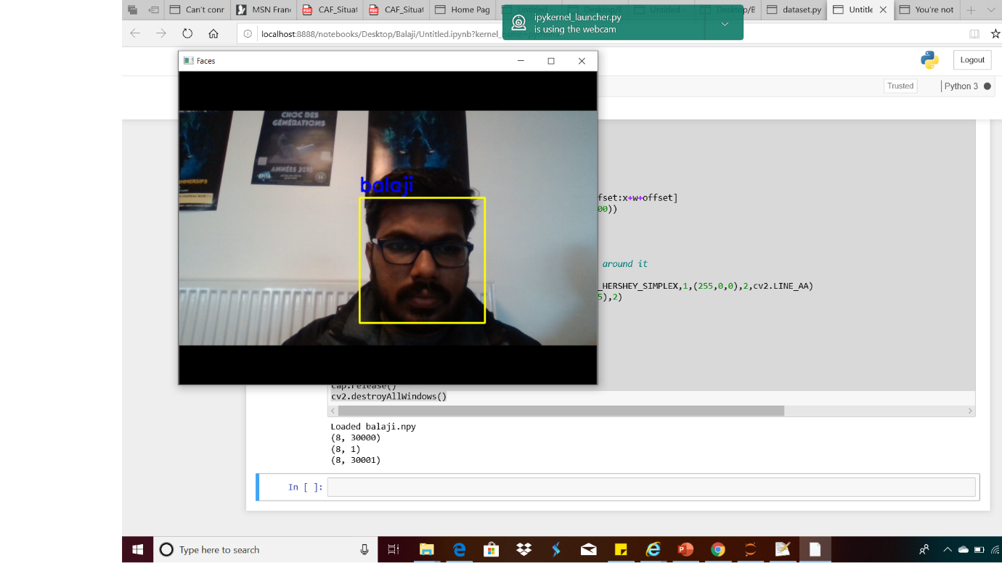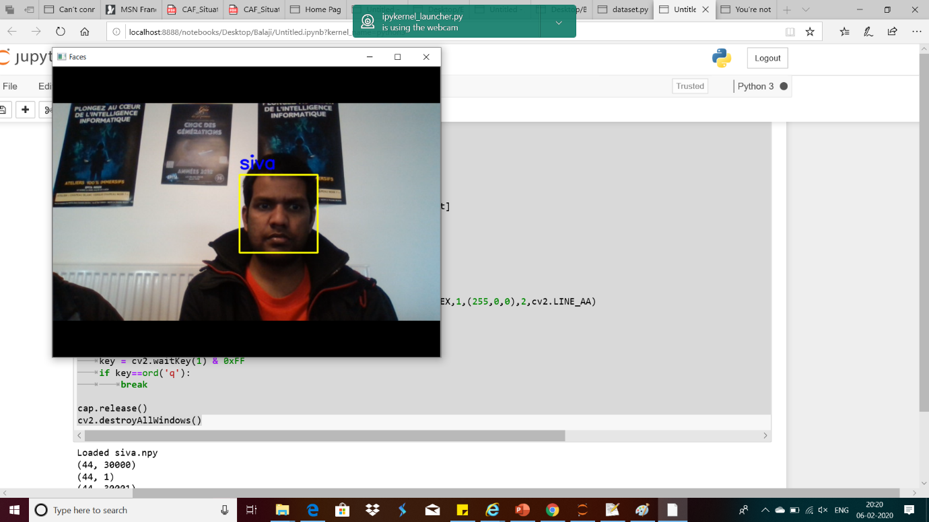

Conclusion:
The facial-recognition software helps minimize fraud where online hackers unlawfully use passwords and other data to steal from banking institutions. The software verifies a person’s identity by facial recognition before processing any transaction.

Future Work:

- To improve face detection and feature extraction algorithms.
- To enhance the system to track multiple faces.

References:

- Datacamp: building face classifier
https://www.datacamp.com/community/news/introduction-to-k-nearest-neighbors-simplified-with-implementation-i-wcj2hsrbat
- Codingblocks.com: applying knn to find face match
https://codingblocks.com/resources/machine-learning-webinar/
- Github: Codes for Haarcascade
https://github.com/opencv/opencv/tree/master/data/haarcascades
- An Accurate System for Face Detection and Recognition
https://www.researchgate.net/publication/334770252_An_Accurate_System_for_Face_Detection_and_Recognition

