**ALF issues**

1. Co-ordinate module

1] Unable to modify patients details

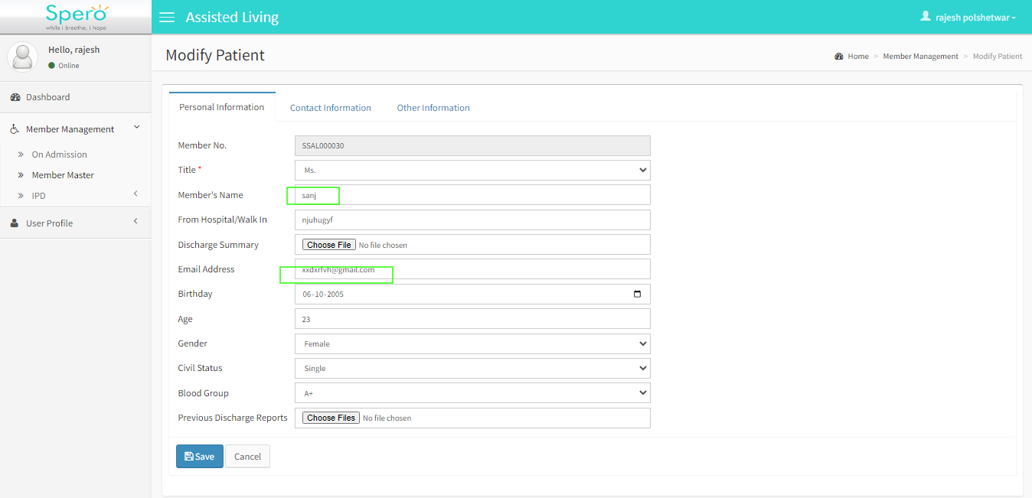

2] In pre assessment medications medicine information are not submitted successfully

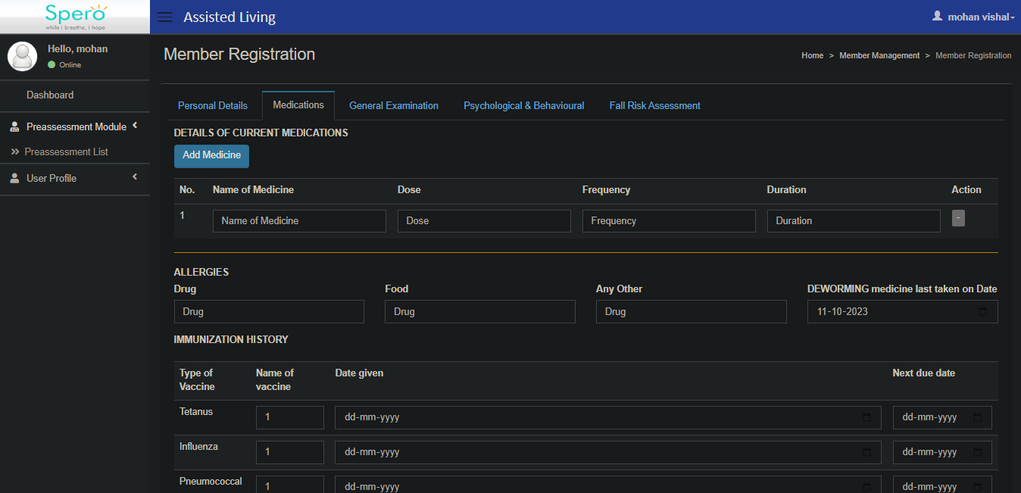

3] (Suggestion) When we fill pre assessment form first of all we fill the personal details then user have fill the medication form so it should be automatic when we submit personal details form then automatic goes on next form

4]