**ALF issues**

1. Co-ordinate module

1] Unable to modify patients details

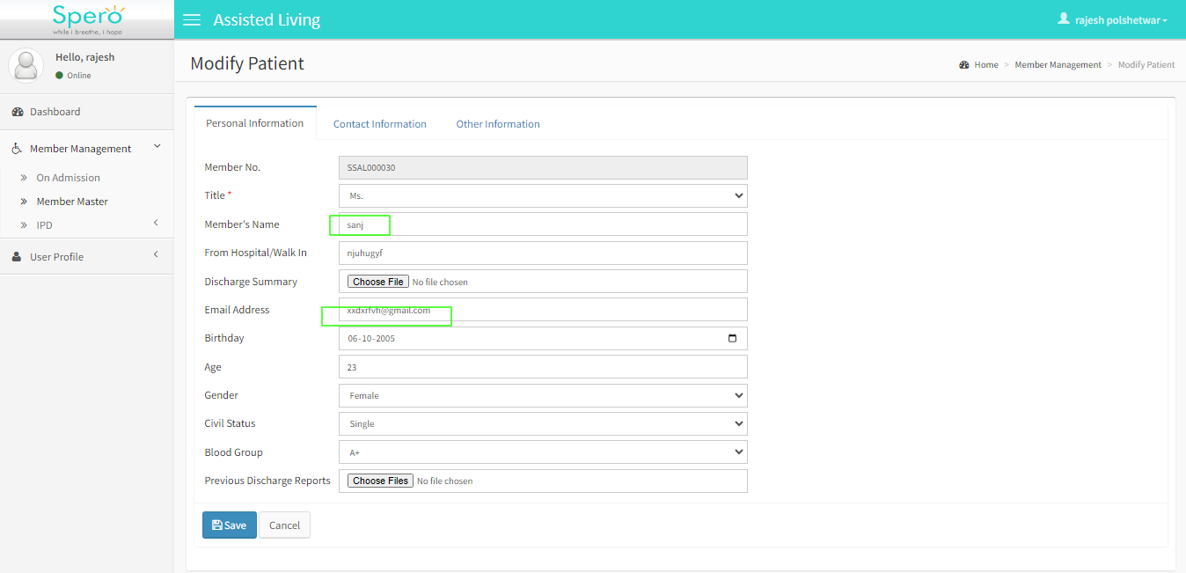

2] In pre assessment medications medicine information are not submitted successfully

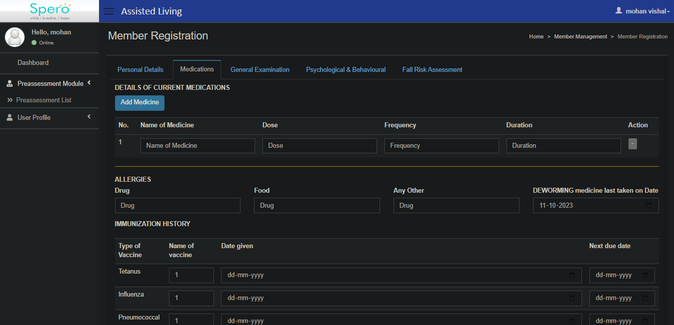

3] (Suggestion) When we fill pre assessment form first of all we fill the personal details then user have fill the medication form so it should be automatic when we submit personal details form then automatic goes on next form

4] In lab module – dashboard give the search button.

# 5] Member Registration form – medications form kindly correct the UI and responsive

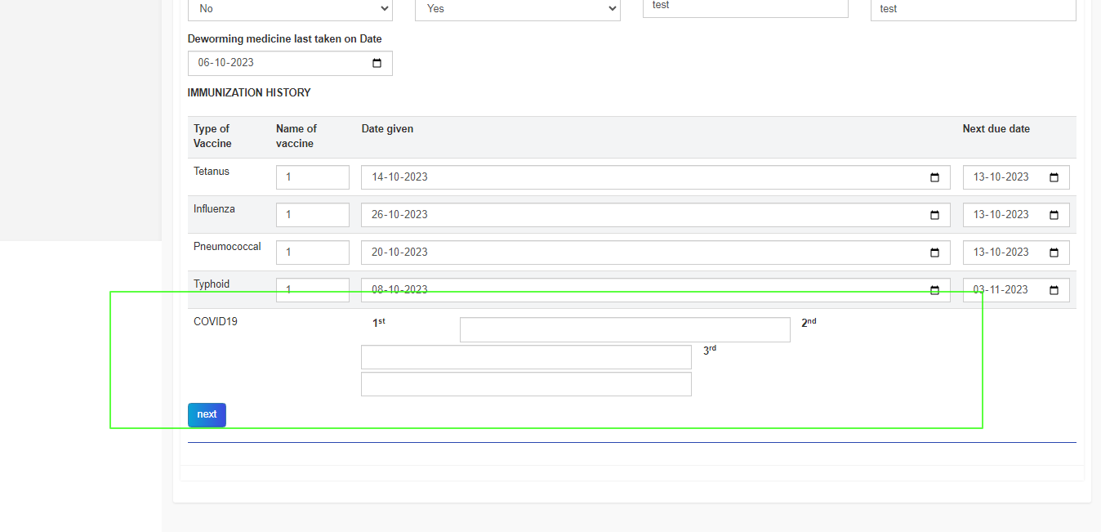

6] When we modify the member information unable to edit information this error are occurs 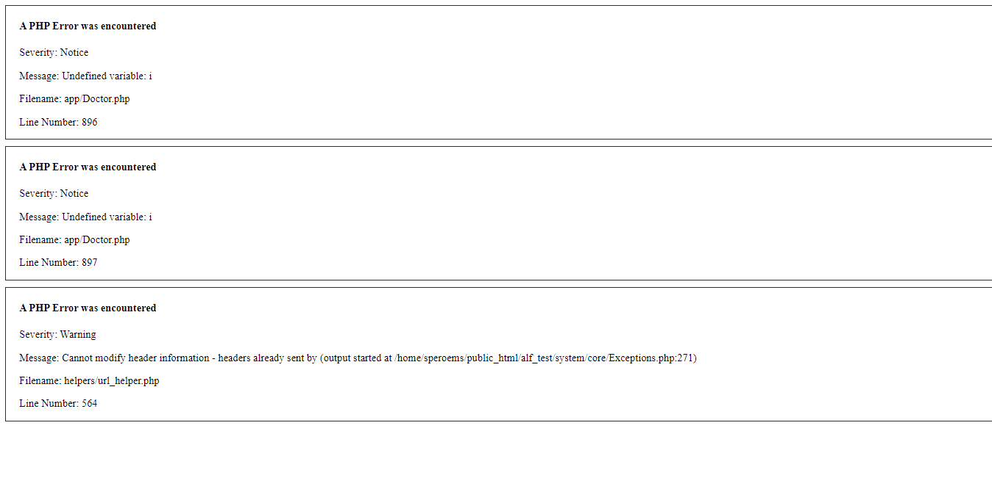

7] correct horizonatl lines alignment .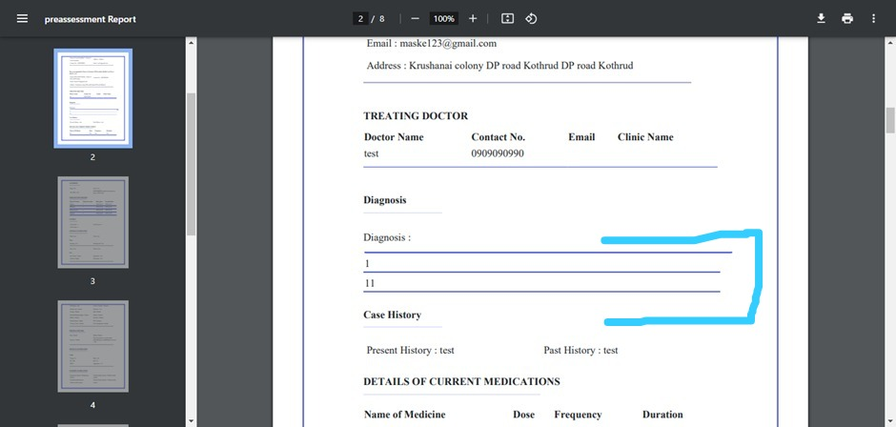

8] when we search member vai member ID its not working only its able to seacrch by name check once

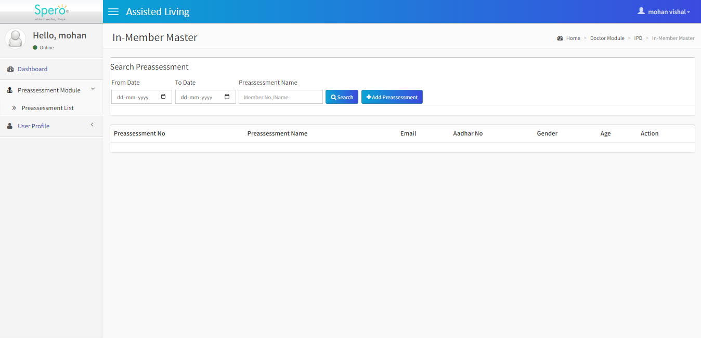

9] Kindly validate Contact Number it should accept only 10 digit but it accept more than 12 to 15 digits 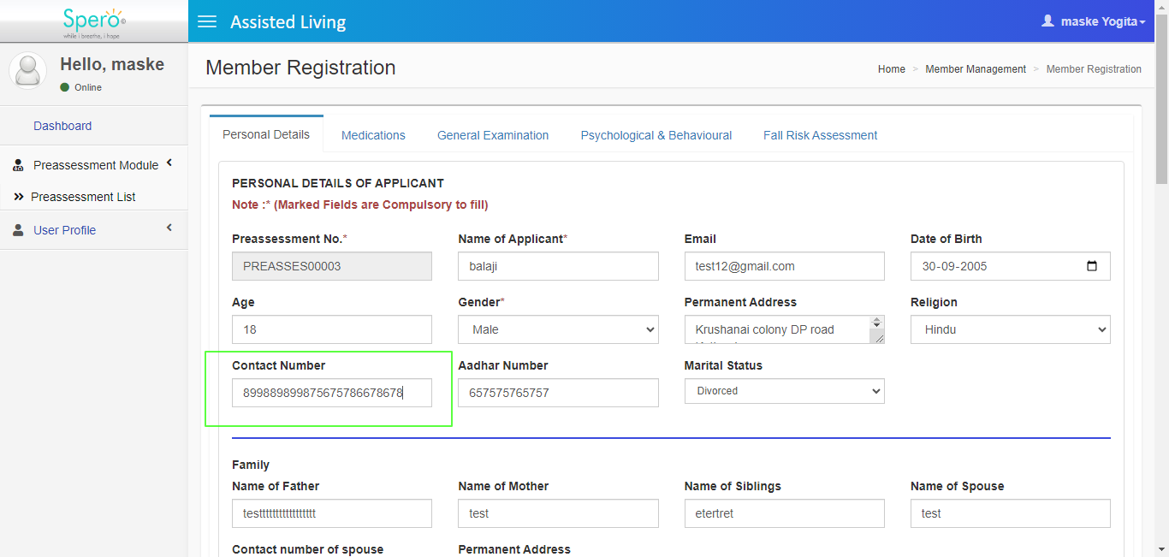

10] Validate the score field it should accept only digits.

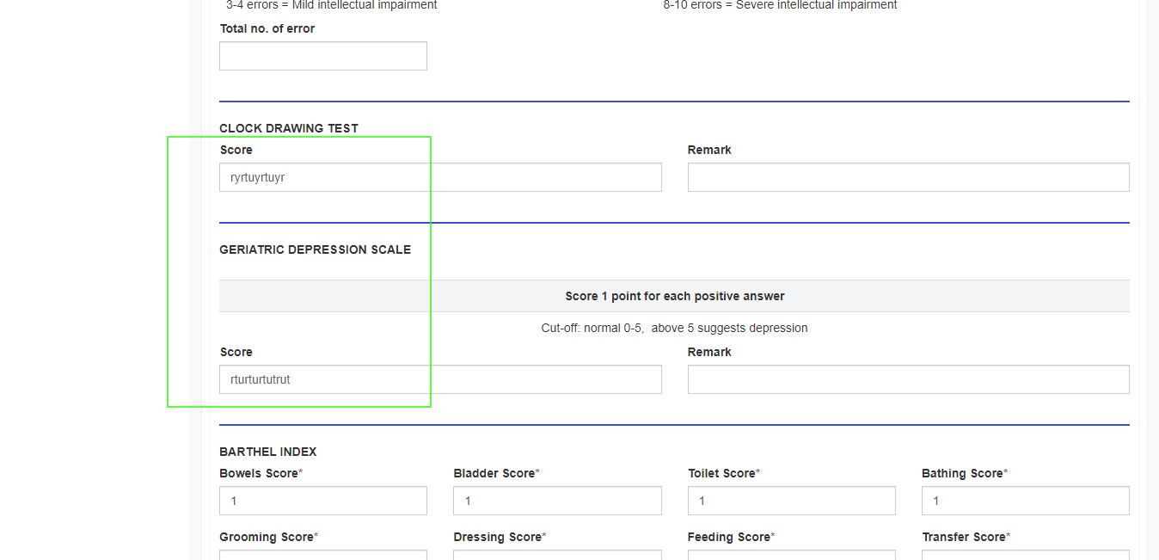

11] Correct the UI of that details of children

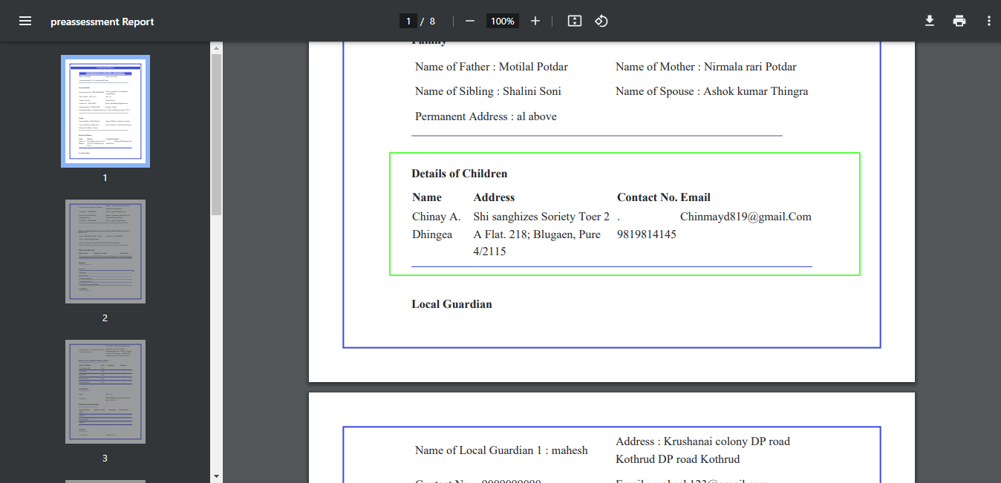

12] In report treating doctor information correct the UI of that.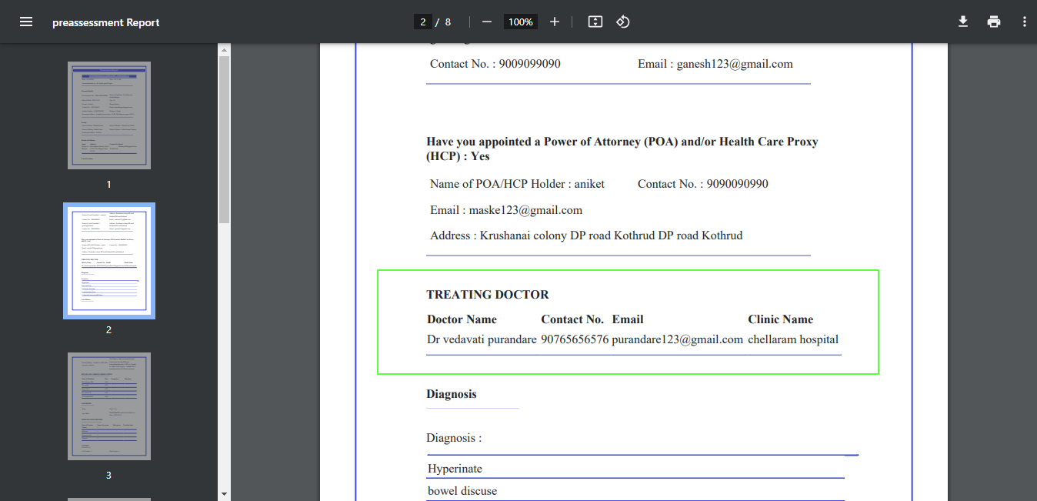

13] Align horizontal line in diagnoses

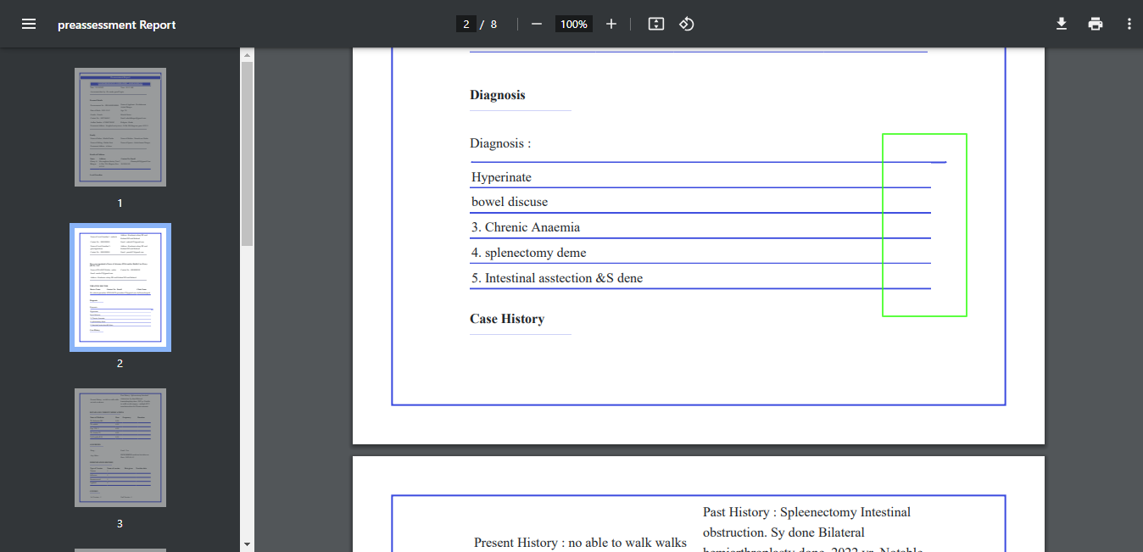

14]when I am add new member those members entry shows two time in doctor module kindly check it (on priority).

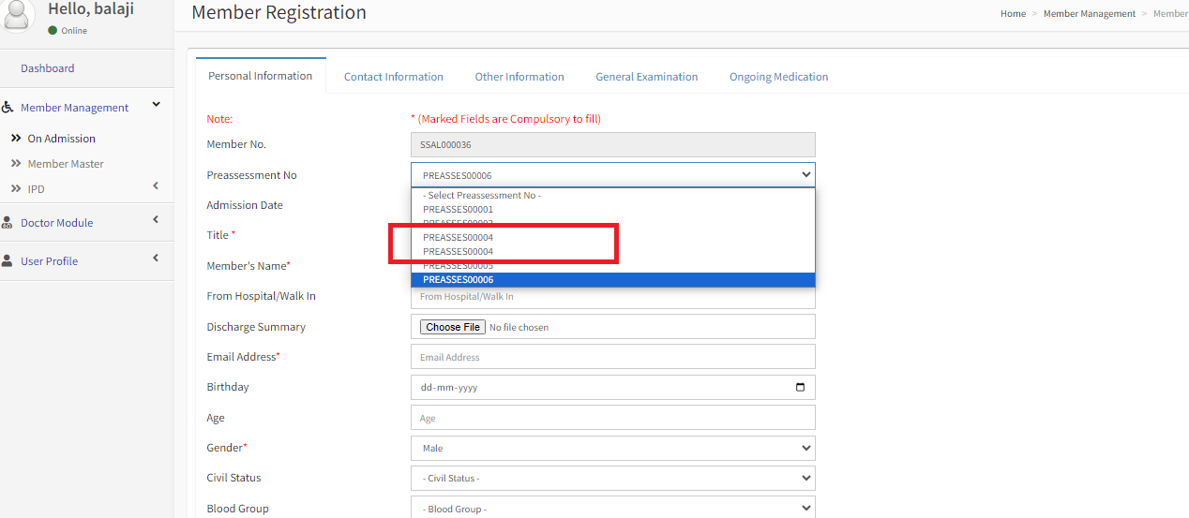15] Sometimes I am trying to add new member but when I am seeing this ID in doctor module it’s not showing. kindly check it.