SYNOPSIS
The project titled "MEDICARE", is a web-based healthcare prediction project. The project is designed to help users assess their risk of heart disease and cancer by analysing the information they provide through prediction forms. The project consists of a user module that allows individuals to register, log in and securely access the prediction services. After authentication, users can enter their health-related details to obtain risk predictions for heart disease and cancer using machine learning models. Once the prediction is generated, the system presents the result along with a pie chart visualization that illustrates the risk distribution. Based on the prediction outcome, the system also provides personalized health suggestions to help users understand their health status and encourage preventive measures. Additionally, the system maintains a prediction history, allowing users to view their previous prediction results through their profile page. This feature enables users to monitor their health assessments over time and compare past results. Overall, this project offers a simple, secure and user-friendly platform for early disease risk assessment, helping users become more aware of their health and promoting timely medical consultation when necessary.

SYSTEM REQUIREMENTS
The system requirements define the necessary hardware and software components required to efficiently run and maintain the application. These requirements ensure optimal performance, security and compatibility with the chosen technology stack.

2.1 HARDWARE REQUIREMENTS
To ensure smooth functionality and performance, the following hardware specifications are recommended
Processor : AMD Athlon Silver 7120U with Radeon Graphics Speed : 2.50 GHz
RAM : 8.00 GB
Hard Disk : 280 GB
These specifications provide sufficient processing power and storage capacity to handle application development, testing and execution.

2.2 SOFTWARE REQUIREMENTS
The software requirements outline the essential tools and platforms necessary for the development and deployment of the application.
Operating System : Windows 11
Front-end : HTML,CSS and JavaScript
Back-end : Flask(Python)
HTML, CSS and JavaScript are used for front-end development to create an interactive, responsive and user-friendly web interface. Flask, a lightweight python web framework, is used as the back-end to handle application logic, user authentication, database connectivity and machine learning model integration. MySQL serves as the database management system for storing user accounts, prediction history and other application data. the application is developed using Visual Studio Code and runs on the Flask development server, making it efficient, scalable and easy to maintain.

SYSTEM DESCRIPTION
3.1 OPERATING SYSTEM
Windows 11 is the latest major release of Microsoft’s Windows NT operating system, released on October 5, 2021. It succeeded Windows 10 (2015) and is available for free for any Windows 10 devices that meet the new Windows 11 system requirements.
Windows 11 features major changes to the Windows shell influenced by the cancelled Windows 10x, including a redesigned start menu, the replacement of its "live tiles" with a separate "widgets" panel on the taskbar, the ability to create tiled sets of windows that can be minimized and restored from the taskbar as a group and new gaming technologies inherited from Xbox Series X and series S such as Auto HDR and Direct storage on compatible hardware. Internet Explorer (IE) has been replaced by the chromium-based Microsoft Edge as the default web browser, like its predecessor, Windows 10 and Microsoft Teams is integrated into Windows shell. Microsoft also announced plans to allow more flexibility in software that can be distributed via the Microsoft Store and to support Android apps on Windows 11 (including a partnership with Amazon to make its app store available for the function).
Citing security considerations, the system requirements for Windows 11 were increased over Windows 10. Microsoft only officially supports the operating system on devices using an eighth-generation Intel Core CPU or newer (with some minor exceptions), a second-generation AMD Ryzen CPU or newer, or a Qualcomm Snapdragon 850 ARM system-on-chip or newer, with UEFI and Trusted Platform Module (TPM) 2.0 supported and enabled. Although there are some exceptions to these requirements. While the OS can be installed on devices with unsupported configurations, Microsoft does not guarantee the availability of updates. Furthermore, Windows 11 completely removes support for 32-bit x86 and ARM CPUs.
Windows 11 has received a mostly positive reception. Pre-release coverage of the operating system focused on its stricter hardware requirements, with discussions over whether they were legitimately intended to improve the security of Windows or as a ploy to upsell customers to newer devices and over the e-waste associated with the changes. Upon release, it was praised for its improved visual design, window management and stronger focus on security, but was criticized for various modifications to aspects of its user interface
that were seen as worse than its predecessor; some were seen as an attempt to dissuade users from switching to competing applications.
As of May 2024, Windows 11, at 25.65% worldwide, is the second most popular Windows version in use, with its predecessor Windows 10 at 2.5 times the market share. Windows 11 has an estimated 19.75% share of all PCs (the rest being other Windows editions and other operating systems such as mac OS and Linux) and an estimated 7.8% share of all devices (including mobile, tablet and console) are running Windows 11.
To comply with the Digital Markets Act, Microsoft is allowing users in the European Economic Area to remove the Edge browser, Bing search engine and advertisements to comply with users' interests.
- Touch screen for hybrid devices.
- Full control over Windows 10
- Lighter and faster operating system.
- Possible privacy problems.

A redesigned user interface is present frequently throughout the operating system, building upon the Fluent Design System; translucency, shadows, a new color palette and rounded geometry are prevalent throughout the UI. A prevalent aspect of the design is an appearance known as "Mica", described as an "opaque, dynamic material that incorporates theme and desktop wallpaper to paint the background of long-lived windows such as apps and settings”. Much of the interface and start menu takes heavy inspiration from the now-cancelled Windows 10X.The Segoe UI font used since Windows Vista has been updated to a variable version, improving its ability to scale between different display resolutions.
The taskbar's buttons are center aligned by default and it is permanently pinned to the bottom edge of the screen; it cannot be moved to the top, left, or right edges of the screen as in previous versions of Windows without manual changes to the registry. The notifications sidebar is now accessed by clicking the date and time, with other Quick Actions toggles, as well as volume, brightness and media playback controls, moved to a new settings pop-up displayed by clicking on the system tray. The "Widgets" button on the taskbar displays a panel with Microsoft Start, a news aggregator with personalized stories and content (expanding upon the "news and interests" panel introduced in later builds of Windows 10 Microsoft Teams is similarly integrated with the taskbar, with a pop-up showing a list of recent conversations.
Citing security considerations, the system requirements for Windows 11 were increased over Windows 10. Microsoft only officially supports the operating system on devices using an eighth-generation Intel Core CPU or newer (with some minor exceptions), a second-generation AMD Ryzen CPU or newer, or a Qualcomm Snapdragon 850 ARM system-on-chip or newer, with UEFI and Trusted Platform Module (TPM) 2.0 supported and enabled. Although there are some exceptions to these requirements. While the OS can be installed on devices with unsupported configurations, Microsoft does not guarantee the availability of updates. Furthermore, Windows 11 completely removes support for 32-bit x86 and ARM CPUs.
The Start menu has been significantly redesigned, replacing the "live tiles" used by Windows 8.x and 10 with a grid of "pinned" applications and a list of recent applications and documents. File Explorer was updated to replace its ribbon toolbar with a more traditional toolbar, while its context menus have been redesigned to move some tasks (such as copy and paste) to a toolbar along the top of the menu and hide other operations under an overflow menu.
Task View, a feature introduced in Windows 10, features a refreshed design and supports giving separate wallpaper to each virtual desktop. The window snapping functionality has been enhanced with two additional features; hovering over a window's maximize button displays pre-determined "Snap Layouts" for tiling multiple windows onto a display and tiled arrangement of windows can be minimized and restored from the taskbar as a "snap group". When a display is disconnected in a multi-monitor configuration, the windows that were previously on that display will be minimized rather than automatically moved to the main display. If the same display is reconnected, the windows are restored to their prior location.
At the 2015 Ignite conference, Microsoft employee Jerry Nixon stated that Windows 10 would be the "last version of Windows”. The operating system was a service, with new builds and updates to be released over time. PC World argued that the widely reported comment was, however, taken out of context, noting that the official event transcript marks it only as a segue rather than a core part of the talk. It argues that Nixon was referring to the fact that he could talk freely at the event because 10 was the last version in current development.
In october 2019, Microsoft announced "Windows 10X", a future edition of Windows 10 designed exclusively for dual-touchscreen devices such as the then-upcoming surface Neo. It featured a modified user interface designed around context-sensitive "postures" for different screen configurations and usage scenarios and changes such as a centered taskbar and updated Start menu without Windows 10's "live tiles". Legacy Windows applications would also be required to run in "containers" to ensure performance and power optimization. Microsoft stated that it planned to release Windows 10X devices by the end of 2020.
In May 2020, during the COVID-19 pandemic, Panos Panay, Microsoft's chief product officer for Microsoft Windows and Microsoft Office, stated that "as we continue to put customers' needs at the forefront, we need to focus on meeting customers where they are now" and announced that Windows 10X would only launch on single-screen devices at first and that Microsoft would "continue to look for the right moment, in conjunction with our OEM partners, to bring dual-screen devices to market".
In October 2020, reports emerged that Microsoft was working on a user interface refresh for Windows 10 codenamed "Sun Valley", scheduled to be included in a late-2021 feature update codenamed "cobalt". Internal documentation stated that the aim for "sun valley" was to "reinvigorate[e]" the Windows user interface and make it more "fluid", with a more consistent application of Win UI, while reports suggested Microsoft planned to adapt UI elements seen in Windows 10X. In january 2021, it was reported that a job listing referring to a "sweeping visual rejuvenation of Windows" had been posted by Microsoft.
By december 2020, Microsoft had begun to implement and announce some of these visual changes and other new features on Windows 10 insider preview builds, such as new system icons (which also included the replacement of shell resources dating back as far as Windows 95), improvements to Task View to allow changing the wallpaper on each virtual desktop, x86-64 emulation on ARM and adding the Auto HDR feature from Xbox Series X.
On May 18, 2021, Head of Windows Servicing and Delivery John Cable stated that Windows 10X had been cancelled and that Microsoft would be "accelerating the integration of key foundational 10X technology into other parts of Windows and products at the company". Windows 11, the first major Windows release since 2015, builds upon its predecessor by revamping the user interface to follow Microsoft's new Fluent Design guidelines. The redesign, which focuses on ease of use and flexibility, comes alongside new productivity and social features and updates to security and accessibility, addressing some of the deficiencies of Windows 10.
The Microsoft Store, which serves as a unified storefront for apps and other content, is also redesigned in Windows11. Microsoft now allows developers to distribute Win32, progressive web applications and other packaging technologies in the Microsoft Store, alongside Universal Windows Platform apps. Microsoft also announced plans to allow third-party application stores (such as Epic Games Store) to distribute their clients on Microsoft Store Windows 11 supports x86-64 software emulation on ARM-based platforms.
The collaboration platform Microsoft Teams is integrated into the Windows 11 user interface and is accessible via the taskbar. Skype will no longer be bundled with the OS by default. In early 2023, the Phone Link app gained limited support for iMessage.
Microsoft claims performance improvements such as smaller update sizes, faster web browsing in "any browser", faster wake time from sleep mode and faster Windows Hello authentication.
Windows 11 ships with the Chromium-based Microsoft Edge web browser (for compatibility with Google Chrome web browser) and does not include or support Internet Explorer Its rendering engine MSHTML (Trident) is still included with the operating system for backwards compatibility reasons and Edge can be configured with Group Policy to render whitelisted websites in "IE Mode" (which still uses IE's rendering engine MSHTML, instead of Blink layout engine). Windows 11 is the first version of Windows since the original retail release of Windows 95 to not ship with Internet Explorer. To comply with the Digital Markets Act, Microsoft is allowing users in the European Economic Area to remove the Microsoft Edge browser, Microsoft Bing search engine and advertisements to comply with users' interests.
The updated Xbox app along with the Auto HDR and Direct Storage technologies introduced by the Xbox Series X and Series S, will be integrated into Windows 11; the latter requiring a graphics card supporting DirectX 12 and an NVMe solid-state drive.

3.2 FRONT-END
A redesigned user interface is present frequently throughout the operating system, building upon the Fluent Design System; translucency, shadows, a new color palette and a rounded geometry are prevalent throughout the UI. A prevalent aspect of the design is an appearance known as "Mica", described as an "opaque, dynamic material that incorporates theme and desktop wallpaper to paint the background of long-lived windows such as apps and settings. Much of the interface and start menu takes heavy inspiration from the now-cancelled Windows 10X. The Segoe UI font used since Windows Vista has been updated to a variable version, improving its ability to scale between different display resolutions.
The taskbar's buttons are center-aligned by default and it is permanently pinned to the bottom edge of the screen; it cannot be moved to the top, left, or right edges of the screen as in previous versions of Windows without manual changes to the registry. The notifications sidebar is now accessed by clicking the date and time, with other Quick Actions toggles, as well as volume, brightness and media playback controls, moved to a new settings pop-up displayed by clicking on the system tray. The "Widgets" button on the taskbar displays a panel with Microsoft Start a news aggregator with personalized stories and content (expanding upon the "news and interests" panel introduced in later builds of Windows 10). Microsoft Teams is similarly integrated with the taskbar, with a pop-up showing a list of recent conversations.
The Start menu has been significantly redesigned, replacing the "live tiles" used by Windows 8.x and 10 with a grid of "pinned" applications and a list of recent applications and documents. File Explorer was updated to replace its ribbon toolbar with a more traditional toolbar, while its context menus have been redesigned to move some tasks (such as copy and paste) to a toolbar along the top of the menu and hide other operations under an overflow menu.
Task View, a feature introduced in Windows 10, features a refreshed design and supports giving separate wallpaper to each virtual desktop. The window snapping functionality has been enhanced with two additional features; hovering over a window's maximize button displays pre-determined "Snap Layouts" for tiling multiple windows onto a display and tiled arrangement of windows can be minimized and restored from the taskbar as a "snap group". When a display is disconnected in a multi-monitor configuration, the windows that were previously on that display will be minimized rather than automatically moved to the main display. If the same display is reconnected, the windows are restored to their prior location.
As part of the minimum system requirements, Windows 11 only runs on devices with a Trusted Platform Module 2.0 security coprocessor, albeit with some exceptions, see System requirements for details. According to Microsoft, the TPM 2.0 coprocessor is a "critical building block" for protection against firmware and hardware attacks. In addition, Microsoft now requires devices with Windows 11 to include virtualization-based security (VBS), hypervisor-protected code integrity (HVCI) and Secure Boot built-in and enabled by default. The operating system also features hardware-enforced stack protection for supported Intel and AMD processors for protection against zero-day exploits.
Windows 11 is available in two main editions; the Home edition, which is intended for consumer users and the Pro edition, which contains additional networking and security features (such as BitLocker), as well as the ability to join a domain. Windows 11 Home may be restricted by default to verified software obtained from Microsoft Store ("S Mode"). Windows 11 Home requires an Internet connection and a Microsoft account in order to complete first-time setup. This restriction is also applied to Windows 11 Pro since version 22H2 as it was announced in February 2022, although a Microsoft account isn't required if it's not for personal use.
Windows 11 SE was announced on November 9, 2021, as an edition exclusively for low-end devices sold in the education market; it is intended as a successor to Windows 10 S and also competes primarily with ChromeOS. It is designed to be managed via Microsoft Intune. Based on feedback from educators, Windows 11 SE has multiple UI differences and limitations, including Snap Layouts not containing layouts for more than two applications at once, all applications opening maximized by default and Widgets being removed. It is bundled with applications such as Microsoft Office for Microsoft 365, Minecraft Education Edition and Flipgrid, while OneDrive is used to save files by default. Windows 11 SE does not include Microsoft Store; third-party software is provisioned or installed by administrators. To target organizations migrating from Google Chrome, Microsoft Edge is configured by default to enable the installation of extensions from the Chrome Web Store.

3.2.1 HTML

HTML (Hyper Text Markup Language) is the standard markup language used to create and structure web pages on the World Wide Web. It provides the basic framework for displaying text, images, hyperlinks, tables, forms and other multimedia elements in a web browser. HTML uses a collection of predefined tags, known as elements, to organize and present content in a meaningful and structured manner.
HTML was first introduced in 1991 by Tim Berners-Lee and has since evolved into the foundation of modern web development. The latest version, HTML5, offers advanced features such as semantic elements, multimedia support, graphics and improved form controls, making it easier to develop responsive and interactive websites.
HTML works together with CSS (Cascading Style Sheets) and JavaScript to build complete web applications. While HTML defines the structure and content of a webpage, CSS is used to control its appearance and JavaScript adds interactivity and dynamic functionality.
One of the major advantages of HTML is its simplicity and ease of learning, making it suitable for both beginners and experienced web developers. HTML documents are lightweight, platform-independent and supported by all modern web browsers without requiring additional software. It also provides excellent compatibility with other web technologies such as CSS, JavaScript, Bootstrap and various back-end frameworks. In the MEDICARE project, HTML plays a vital role in organizing webpage elements, ensuring proper navigation and creating an accessible interface that enhances the overall user experience. Its structured approach contributes to the development of a responsive, reliable and maintainable web application.

In the MEDICARE project, HTML is used to design the user interface by creating web pages for user registration, login, disease prediction forms, result pages, profile management and navigation. Its simplicity, flexibility and compatibility with all modern web browsers make HTML an essential technology for developing efficient and user-friendly web applications.

3.2.1.1 EVOLUTION OF HTML
The history of HTML began in 1991, when Tim Berners-Lee, a scientist at CERN, introduced the first version of HTML. This initial version contained only a small set of tags that allowed users to create simple web pages with headings, paragraphs, lists and hyperlinks.
As the World Wide Web expanded, HTML continued to evolve with new features and improvements:

- HTML 2.0 (1995): The first standardized version, which established common rules for creating web pages.
- HTML 3.2 (1997): Introduced support for tables, scripting, applets and improved formatting options.
- HTML 4.01 (1999): Added support for stylesheets (CSS), scripting, multimedia and improved accessibility, making websites more interactive and visually appealing.
- XHTML (2000): A stricter version of HTML based on XML, designed to improve code consistency and compatibility.
- HTML5 (2014): Introduced modern features such as semantic elements (<header>, <section>, <article>), native audio and video support, canvas graphics, local storage and enhanced form controls, reducing reliance on external plugins.

3.2.2 CSS
CSS (Cascading Style Sheets) is a stylesheet language used to describe the presentation and visual appearance of HTML documents. It controls the layout, colors, fonts, spacing, animations and overall design of web pages, allowing developers to separate the content from its presentation. This separation improves code readability, maintainability and reusability.
CSS was first introduced by the World Wide Web Consortium (W3C) in 1996 to overcome the limitations of HTML in handling webpage design. Over the years, CSS has evolved significantly, with CSS3 introducing advanced features such as animations, transitions, gradients, shadows, flexbox, grid layouts and media queries for responsive web design.
CSS works seamlessly with HTML and JavaScript to create attractive and interactive web applications. While HTML provides the structure of a webpage and JavaScript adds dynamic functionality, CSS enhances the visual appearance and ensures a consistent user experience across different devices and screen sizes.
In the MEDICARE project, CSS is used to design an intuitive and responsive user interface for pages such as user registration, login, heart disease prediction, cancer prediction, profile management and result visualization. It helps create an appealing layout, improves readability and ensures that the application is accessible and user-friendly on desktops, tablets and mobile devices.
One of the major advantages of CSS is its ability to maintain a consistent design across multiple web pages using a single stylesheet. It reduces code duplication, simplifies website maintenance and improves loading performance. By utilizing modern CSS features the MEDICARE application delivers a professional appearance

3.2.3 JAVASCRIPT
JavaScript is a high-level, interpreted programming language used to add interactivity and dynamic functionality to web pages. It enables developers to create responsive user interfaces, validate user inputs, manipulate webpage content, handle events and communicate with servers without requiring the page to be reloaded. JavaScript is one of the core technologies of modern web development, alongside HTML and CSS.
JavaScript was created by Brendan Eich in 1995 and has since become one of the most widely used programming languages for web development. Over the years, it has evolved significantly through the ECMAScript standard, introducing modern features such as arrow functions, classes, modules, promises, async/await and improved performance, making it suitable for developing complex and scalable web applications.
JavaScript works together with HTML and CSS to create interactive and user-friendly websites. While HTML provides the structure of a webpage and CSS defines its appearance, JavaScript adds dynamic behavior by responding to user actions such as button clicks, form submissions, keyboard input and mouse events. It also enables real-time updates, animations and data validation, enhancing the overall user experience.
In the MEDICARE project, JavaScript is used to perform client-side form validation, improve user interaction, manage dynamic webpage elements and display prediction results in graphical formats such as pie charts. It also enhances navigation, provides instant feedback to users and ensures a smooth and responsive interface throughout the application. One of the key advantages of JavaScript is its ability to execute directly within web browsers without requiring additional software or plugins. It supports asynchronous programming, integrates seamlessly with HTML and CSS and is compatible with all modern browsers. These features make JavaScript an essential technology for developing efficient, interactive and responsive web applications like the MEDICARE disease prediction system.
3.3 BACK-END
The backend is the server-side component of a web application that is responsible for processing user requests, executing application logic, interacting with the database and generating responses for the frontend. It acts as the bridge between the user interface and the database, ensuring that data is processed securely and efficiently. The backend handles essential operations such as user authentication, data validation, database management, business logic implementation and communication with machine learning models or external services. It ensures that user inputs are correctly processed and that the requested information is retrieved, updated, or stored in the database. In the MEDICARE project, the backend is developed using Flask, a lightweight Python web framework. Flask receives user input from the HTML forms, validates the data, processes it using the trained heart disease and cancer prediction models, stores user information and prediction history in the SQLite3 database and returns the prediction results to the frontend for display. This enables seamless communication between the user interface, the database and the machine learning models, providing a secure and efficient web application.
3.3.1 INTRODUCTION TO FLASK (PYTHON)
Flask is a lightweight and open-source web framework developed in Python for building web applications. It provides developers with a simple and flexible framework for creating dynamic websites and web-based systems. Flask follows the WSGI (Web Server Gateway Interface) standard and offers essential features such as URL routing, template rendering, session management and request handling while allowing developers to add additional functionalities through extensions.
Flask was created by Armin Ronacher in 2010 and has become one of the most popular Python web frameworks due to its simplicity, flexibility and ease of use. Unlike full-stack frameworks, Flask follows a minimalistic approach, giving developers greater control over the application's architecture and enabling them to integrate only the components required for their projects.
Flask integrates seamlessly with HTML, CSS, JavaScript and databases such as MySQL, making it an ideal choice for developing secure and scalable web applications. It also supports integration with machine learning libraries such as Scikit-learn, TensorFlow and Pandas, allowing developers to deploy intelligent applications with predictive capabilities.
In the MEDICARE project, Flask serves as the back-end framework responsible for processing user requests, handling user authentication, connecting to the MySQL database and integrating the heart disease and cancer prediction machine learning models.
One of the major advantages of Flask is its lightweight architecture, which makes application development faster and more efficient. It supports modular programming, RESTful APIs, secure session management and easy deployment. Flask's compatibility with Python's extensive ecosystem of libraries makes it an excellent framework for developing machine learning–based web applications such as the MEDICARE disease prediction system.
3.3.2 INTRODUCTION TO SQLITE3
SQLite3 is a lightweight, open-source, relational database management system (RDBMS) that stores the entire database in a single file. Unlike traditional database systems, SQLite3 does not require a separate server process, making it simple to install, configure and maintain. It is widely used in desktop applications, mobile applications, embedded systems and web applications where a compact and efficient database solution is required.
SQLite was first developed by D. Richard Hipp in 2000 with the goal of providing a fast, reliable and self-contained database engine. It supports standard SQL (Structured Query Language) commands for creating, retrieving, updating and deleting data while maintaining high performance and data integrity. SQLite3 is platform-independent, highly portable and capable of handling multiple tables, indexes, views and transactions.
SQLite3 integrates seamlessly with Python through the built-in sqlite3 module, allowing developers to perform database operations without installing additional database software. Its compatibility with Flask makes it a popular choice for developing small to medium-sized web applications and prototype systems.
In the MEDICARE project, SQLite3 is used as the database management system to store user registration details, login credentials, prediction history and other application-related information. Flask communicates with the SQLite3 database to retrieve and manage data efficiently, ensuring secure storage and quick access to user records.
One of the major advantages of SQLite3 is its simplicity, reliability and minimal resource consumption. It requires no server setup, supports ACID (Atomicity, Consistency, Isolation and Durability) transactions and offers excellent performance for applications with moderate database requirements. These features make SQLite3 an ideal database solution for web applications like the MEDICARE disease prediction system.

SYSTEM DESIGN
The System Flow Diagram illustrates the sequence of operations performed by the proposed heart disease and cancer prediction System. It shows how data flows through the system, starting from user interaction to the final prediction result. The diagram provides a clear understanding of how different modules communicate with each other to predict heart disease and cancer using machine learning.
Working of the System Flow Diagram
Step 1: User Access
The process begins when the user opens the web application through a web browser. The user logs into the system using valid credentials or registers a new account if required.
Step 2: User Authentication
The system verifies the user's login credentials. If authentication is successful, the user is redirected to the dashboard. Otherwise, an appropriate error message is displayed.
Step 3: Input Network Data
The user enters the required health details through the web interface. These input values represent the features required by the machine learning model for heart disease and cancer.
Step 4: Data Validation
The entered data is validated using JavaScript on the client side and Flask on the server side. This ensures that the input data is complete, accurate, and in the correct format before processing.
Step 5: Request Processing
After validation, the input data is sent to the Flask backend. Flask receives the request and forwards the data for further processing.

Step 6: Data Preprocessing
Python preprocesses the received input data by converting it into the required format expected by the trained machine learning model. This step may include feature scaling, encoding, or data transformation.
Step 7: Machine Learning Prediction
The pre-processed data is passed to the trained Scikit-learn model. The model analyses the network traffic patterns and predicts.
Step 8: Store Prediction Result
The prediction result, along with user information and input details, is stored in the SQLite3 database. This allows future analysis, reporting, and record maintenance.
Step 9: Display Result
The Flask application sends the prediction result back to the frontend. The result is displayed on the webpage, allowing the user to view whether their prediction history.
Step 10: Logout or Exit
After viewing the result, the user can continue using the application, perform another prediction, or log out of the system securely.

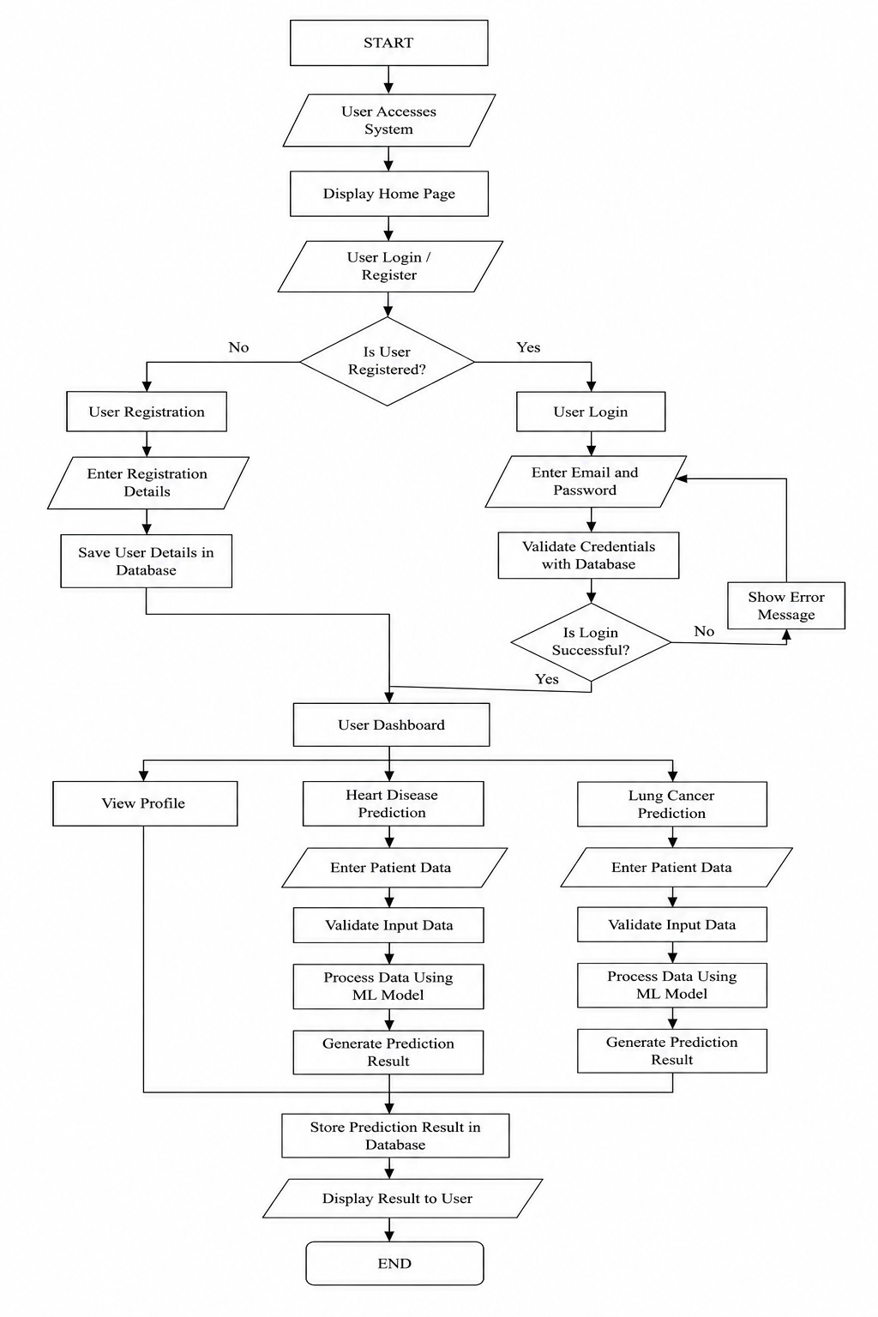
4.1 SYSTEM FLOW DIAGRAM

4.2 DATABASE DESIGN
Table: 4.2.1 User (Register Schema)
Field Name | Data Types | Description
id (Primary Key) | Integer | Unique user identifier
email | String | User email address (unique)
Password_hash | String | Hashed password of the user
created_at | String | Account creation timestamp

Table: 4.2.2 Profile (Register Schema)
Field Name | Data Types | Description
id (Primary Key) | Integer | Unique profile identifier
user_id (Foreign key) | Integer | Reference to user table (id)
created at | String | Profile creation timestamp
age | Integer | User age
sex | String | User gender
height | Real | Height in cm
weight | Real | Weight in kg
resting_bp | Real | Resting blood pressure
cholesterol | Real | Cholesterol level
fasting bs | Real | Fasting blood sugar level
exercise_minutes | Integer | Daily exercise in minutes
sleep hours | Real | Daily sleep in hours
stress level | Integer | Stress level (1-10)

Table: 4.2.3 Heart Disease Prediction Record
Field Name | Data Types | Description
id (Primary Key) | Integer | Unique prediction record identifier
user_id (Foreign Key) | Integer | Reference to USER table (id)
Created_at | String | Prediction timestamp
age | Integer | Age at prediction time
sex | String | Gender
chest_pain | String | Chest pain type
resting_bp | Real | Resting blood pressure
cholesterol | Real | Cholesterol level
fasting_bs | Real | Fasting blood sugar
resting_ecg | String | Resting ECG results
max_hr | Integer | Maximum heart rate achieved
exercise_angina | String | Exercise induced angina (Yes/No)
oldpeak | Real | ST depression induced by exercise
st_slope | String | Slope of the peak exercise ST segment
prediction | String | Model prediction (0 or 1)
message | String | Prediction message
risk_class | String | Risk category (Low/Moderate/High)

Table: 4.2.3 Cancer Prediction Record
Field Name | Data Types | Description
id (Primary Key) | Integer | Unique cancer prediction record identifier
user_id (Foreign Key) | Integer | Reference to USER table (id)
created at | String | Prediction timestamp
AGE | Integer | Age of the user
GENDER | String | Gender of the user
SMOKING | String | Smoking habit (Yes/No)
FINGER_DISCOLORATION | String | Finger discoloration (Yes/No)
MENTAL STRESS | String | Mental stress (Yes/No)
EXPOSURE TO_POLLUTION | String | Exposure to pollution (Yes/No)
LONG TERM ILLNESS | String | Long term iliness (Yes/No)
ENERGY LEVEL | Integer | Energy level (1-100)
IMMUNE WEAKNESS | String | Immune weakness (Yes/No)
BREATHING ISSUE | String | Breathing issue (Yes/No)
ALCOHOL CONSUMPTION | String | Alcohol consumption (Yes/No)
THROAT DISCOMFORT | String | Throat discomfort (Yes/No)
OXYGEN SATUIFATION | Real | Oxygen saturation level (1-100)
CHEST_TIGHTNESS | String | Chest tightness (Yes/No)
FAMILY HISTORY | String | Family history of cancer (Yes/No)
SMOKING FAMILY_HISTORY | String | Family history of smoking (Yes/No)
STRESS IMMUNE | String | Stress affects immunity (Yes/No)
prediction | String | Model prediction (0 or 1)
message | String | Prediction message
risk_class | String | Risk category (Low/Moderate/High)

SYSTEM IMPLEMENTATION
System implementation is the process of developing, testing and deploying a system to ensure it functions as intended in a real-world environment.
5.1 MODULE DESCRIPTION
The system entitled as “ MEDICARE” has been developed using HTML,CSS and Javascript as the frontend and Flask(python) as the backend. The system has only one modules:
- Authentication Module
- User Module
- Remainder Module

5.1.3 AUTHENDICATION MODULE
The Authentication module is responsible for providing secure access to the MEDICARE application by verifying the identity of users before they access the system. It manages the processes of user registration, login, session management, and logout, ensuring that only authorized users can access disease prediction services and personal health records. During registration, users are required to provide basic information such as their email address and password. The system validates the entered details and checks whether the email address is already registered. If the information is valid, the user account is created and securely stored in the SQLite3 database. for login, users enter their registered email address and password. The Flask back-end verifies the credentials against the stored records in the database. Upon successful authentication, the user is redirected to the dashboard. If invalid credentials are entered, the system requests the user to try again. the Authentication module also includes a logout feature that securely terminates the active user session. This prevents unauthorized access to personal information. Overall, this module ensures data security, protects user privacy, and provides a reliable authentication mechanism for accessing the MEDICARE system.

5.1.2 USER MODULE
The user module contains the following submodules:
- User Management
- Heart disease prediction Module
- Cancer prediction Module
- Prediction Module
5.1.2.1 USER MANAGEMENT MODULE

The user Management module is responsible for handling user registration. New users can create an account by providing the required personal information through the registration page. The system validates the entered details and securely stores the user information in the SQLite3 database. Existing users can log in using their registered email and password. Upon successful authentication, users are redirected to the application dashboard, where they can access the heart disease and cancer prediction modules.
The module also provides a profile section that allows users to view their account information and access their prediction history, health dashboard. Additionally, a logout feature is included to securely terminate the user session and protect user data from unauthorized access.

5.1.2.2 HEART DISEASE PREDICTION MODULE
The Heart Disease Prediction module is designed to assess a user's risk of developing heart disease using a trained machine learning model. This module enables users to enter various health-related parameters through a user-friendly web form and receive an instant prediction based on the provided information.
The prediction form collects essential medical attributes such as age, gender, chest pain type, resting blood pressure, cholesterol level, fasting blood sugar, resting electrocardiographic (ECG) results, maximum heart rate achieved, exercise-induced angina, ST depression (Old peak), ST slope, energy level, stress immunity, oxygen saturation and stress level. After the user submits the form, JavaScript performs client-side validation to ensure that all required fields contain valid values.
The validated input data is sent to the Flask back-end, where it is preprocessed and passed to the trained heart disease prediction model. The model analyzes the input features and predicts whether the user is at low risk or high risk of heart disease. Along with the prediction, the system calculates the corresponding risk percentage.
The prediction result is then displayed on the results page with a pie chart illustrating the risk distribution and personalized health suggestions based on the outcome. Finally, the prediction details are stored in the SQLite3 database, allowing users to view their previous prediction results through the Prediction History section.

5.1.2.3 CANCER PREDICTION MODULE
The Cancer Prediction module is designed to estimate a user's risk of developing cancer by analyzing demographic, lifestyle and health-related information using a trained machine learning model. This module provides a simple and interactive interface where users can enter the required details and obtain an instant prediction.
The prediction form collects essential information such as age, gender, smoking status, alcohol consumption, body mass index (BMI), physical activity, family history of cancer, chronic diseases, environmental exposure, dietary habits and other relevant health parameters. Before the data is submitted, JavaScript performs client-side validation to ensure that all mandatory fields are completed with valid values.
Once the form is submitted, the input data is sent to the Flask back-end for preprocessing. The processed data is then passed to the trained cancer prediction model, which analyzes the input features and predicts whether the user is at low risk or high risk of developing cancer. The system also calculates the corresponding risk percentage based on the model's prediction.
The prediction result is displayed on the results page along with a pie chart that visually represents the risk level and personalized health suggestions to help users understand their health status and adopt preventive measures. The prediction details are securely stored in the SQLite3 database, enabling users to access their previous prediction records through the Prediction History section.
The Cancer Prediction module offers users an efficient and convenient way to assess their potential cancer risk, promoting early awareness, preventive healthcare practices and timely medical consultation when required.

5.1.2.4 PREDICTION MODULE
The Prediction History module enables users to view and manage their previously generated prediction results. This feature maintains a record of all heart disease and cancer predictions made by the user, allowing them to monitor their health assessments over time.
Whenever a user completes a heart disease or cancer prediction, the system securely stores the prediction details in the SQLite3 database along with relevant information such as the prediction type, result, risk percentage and the date and time of the prediction. These records are linked to the user's account, ensuring that only the respective user can access their prediction history.
The Prediction History page displays the stored records in a clear and organized format, making it easy for users to review their previous assessments. By maintaining a history of predictions, users can compare their results over time, observe any changes in their health risk and keep track of their overall health status.
This module enhances the usability of the MEDICARE application by providing users with a convenient way to access their past prediction records. It also encourages continuous health monitoring and supports informed decision-making by allowing users to review their previous prediction outcomes whenever required.
5.1.3 REMAIDER MODULE
The Reminder module is designed to help users maintain healthy habits by providing timely reminders related to their health and wellness. This module encourages users to follow preventive healthcare practices and supports them in maintaining a healthy lifestyle after receiving their disease prediction results. the system allows users to receive reminders for activities such as taking performing regular physical exercise, maintaining a healthy diet, by monitoring their health periodically. These reminders help users remain consistent with their daily health routines and promote long-term well-being. the Reminder module can be customized according to the user's preferences, enabling them to set reminder dates and times based on their individual schedules. The reminder information is securely stored in the SQLite3 database and is associated with the respective user's account. by integrating personalized health reminders with disease prediction results, the Reminder module enhances user engagement and encourages preventive healthcare. This feature supports users in adopting healthier lifestyles and assists them in reducing the risk of future health complications.

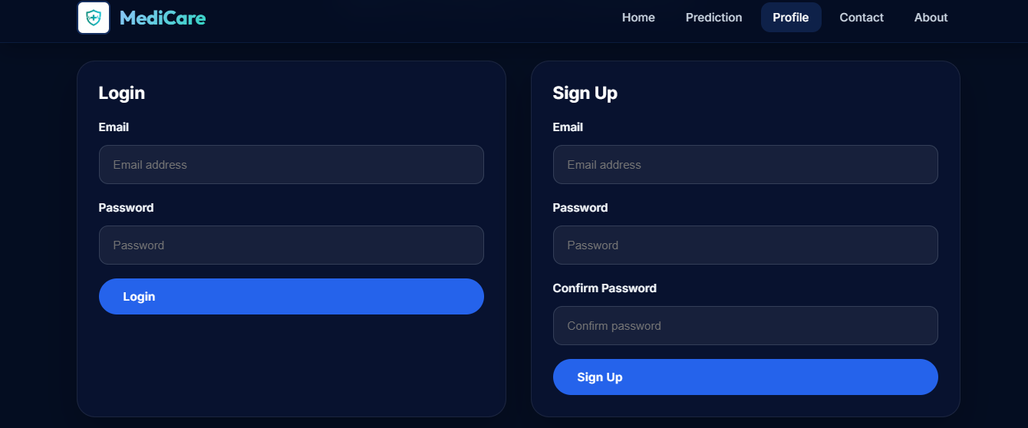
5.2 SCREENSHOTS

Figure : 5.2.1 Login and Register
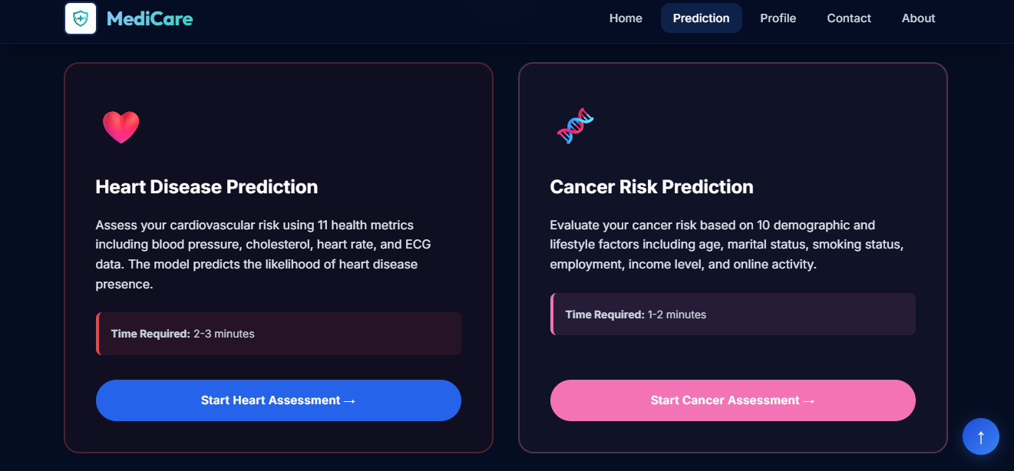

Figure : 5.2.2 Heart Disease and Cancer prediction

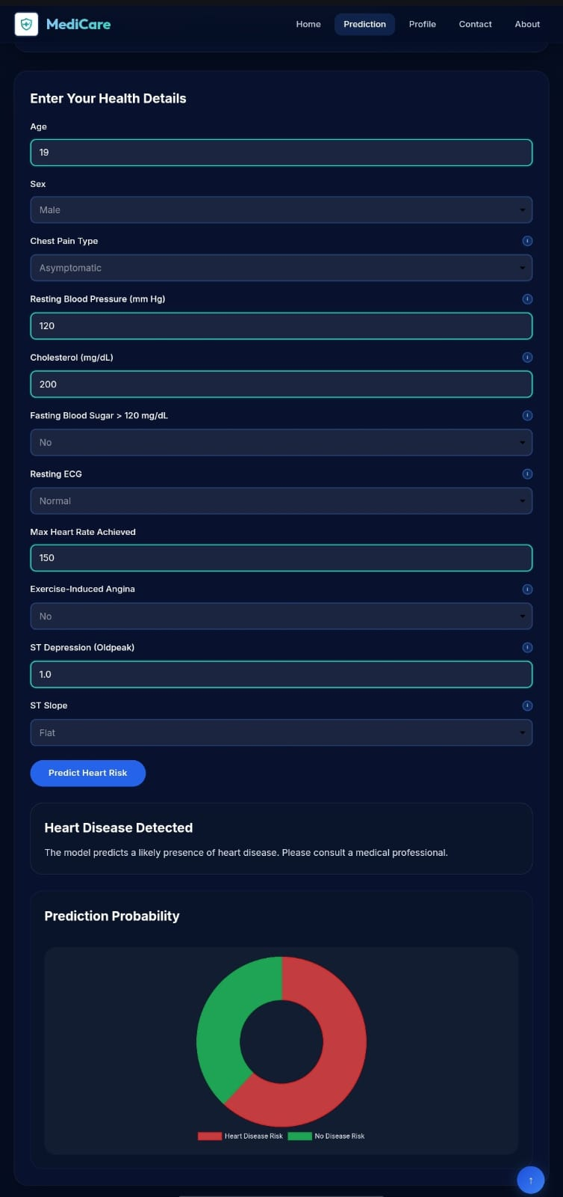
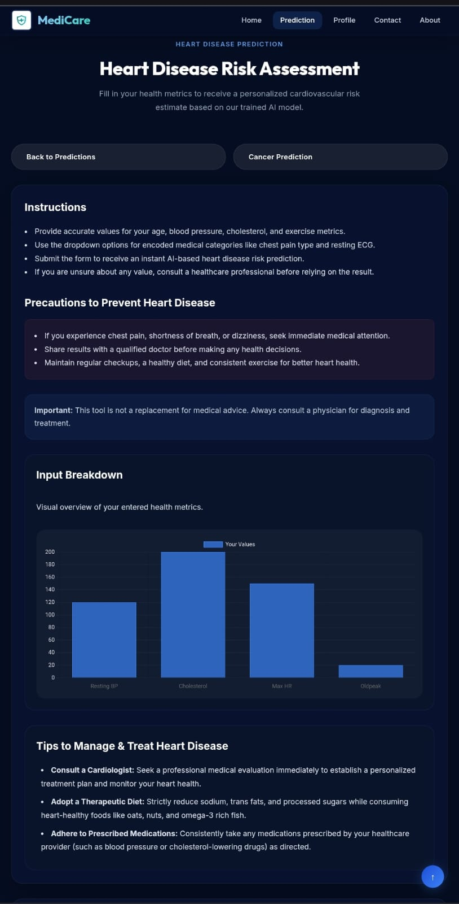

Figure : 5.2.3 Heart disease prediction

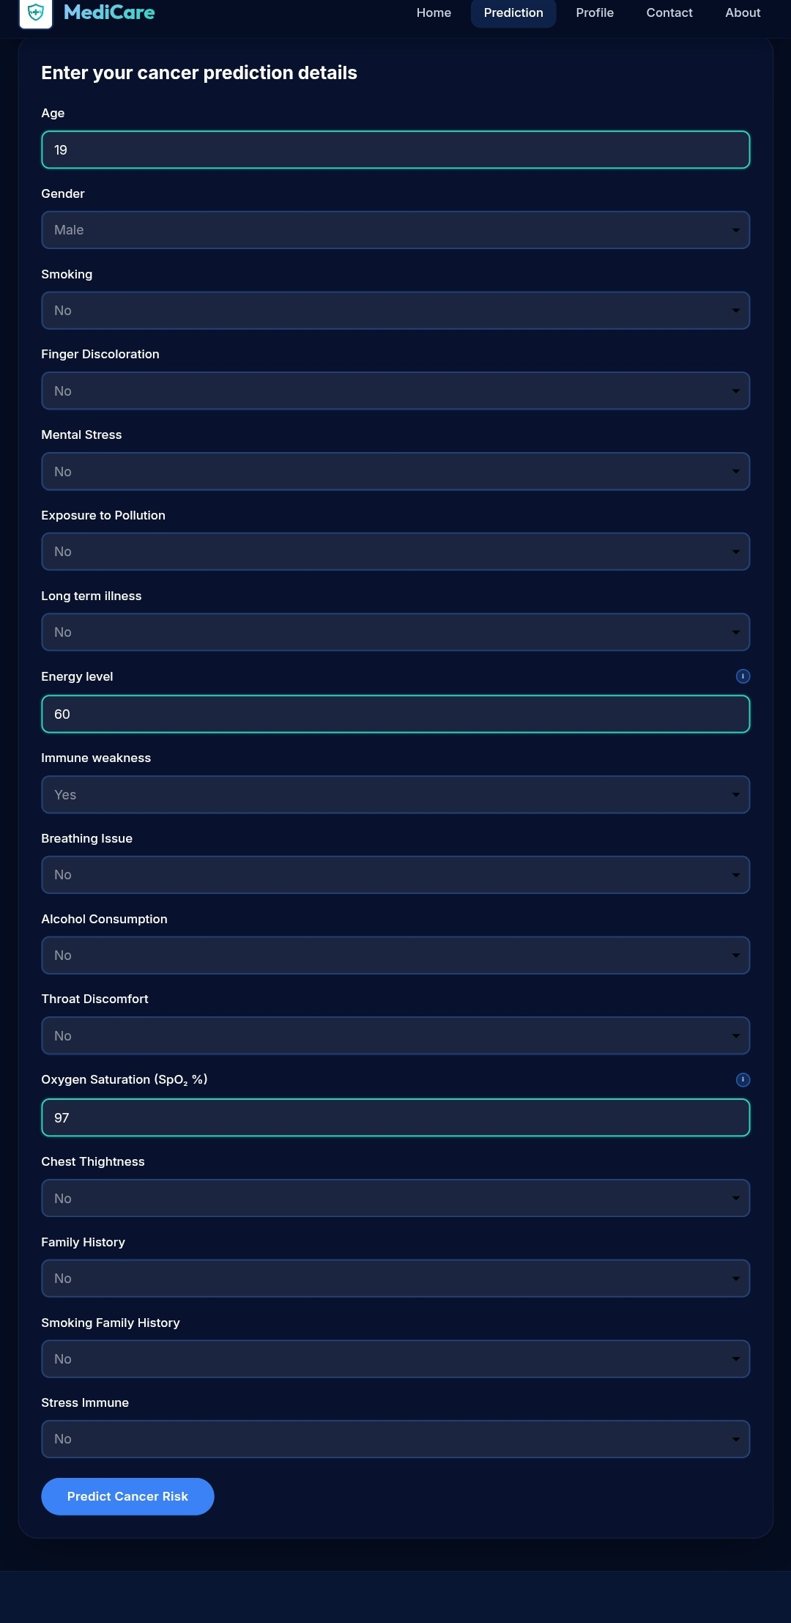
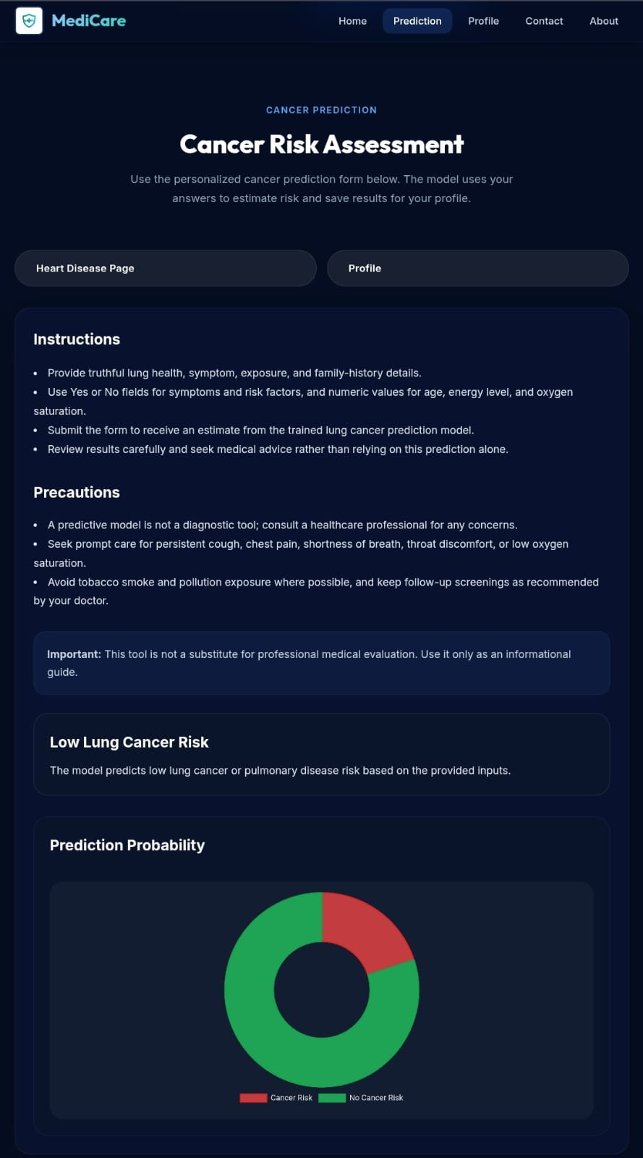

Figure : 5.2.4 Cancer prediction

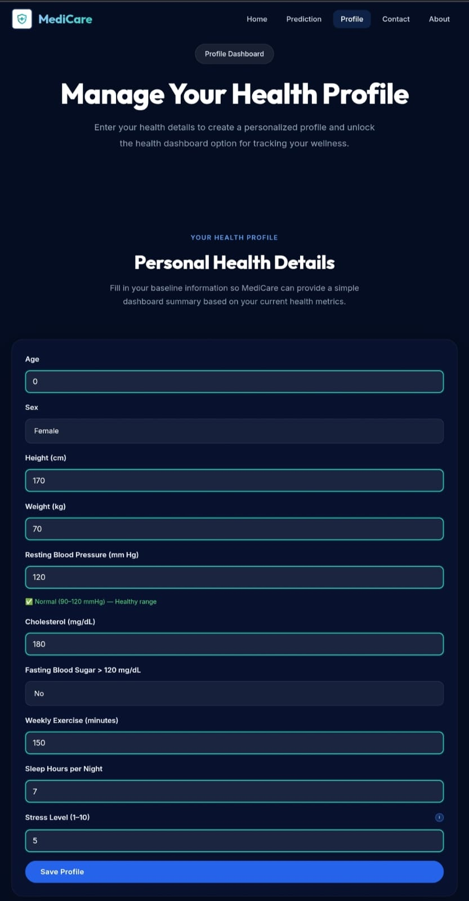
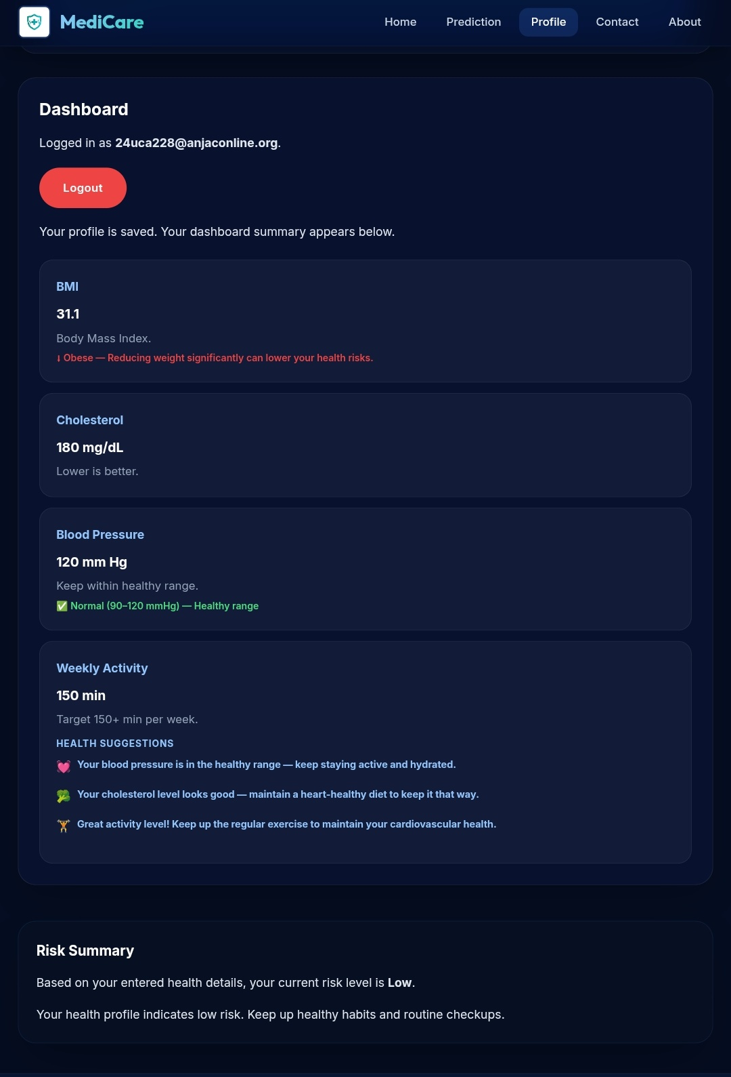

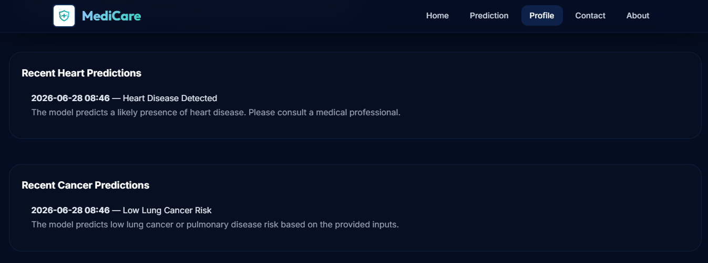
Figure : 5.2.5 Profile page

Figure : 5.2.6 Prediction History
CONCLUSION
The system entitled "MEDICARE" is an intelligent and user-friendly web application designed to assist users in assessing their risk of heart disease and cancer through machine learning–based predictions. It provides a secure, efficient and interactive platform where users can register, log in, perform disease risk assessments and monitor their prediction history. The application is organized into functional modules, including user management, heart disease prediction, cancer prediction and prediction history, ensuring a seamless and well-structured user experience. The heart disease and cancer prediction modules analyse user-provided health information using trained machine learning models to generate accurate risk predictions. The system presents the results with risk percentages, pie chart visualizations and personalized health suggestions, enabling users to better understand their health status and encouraging early preventive care. In addition, the prediction history feature allows users to review their previous assessments, helping them monitor changes in their health over time. Overall, MEDICARE successfully achieves its objective of providing an accessible and reliable platform for early disease risk assessment. By integrating modern web technologies with machine learning, the application promotes health awareness, supports informed decision-making and encourages users to seek timely medical consultation whenever necessary.

BIBLIOGRAPHY
REFERRED BOOKS

[G 21] | J. D. George, Mastering Flask Web Development, 1st Edition, BPB Publications, 2021, New Delhi, India.
[I 18] | Ivan Bayross, Web Enabled Commercial Application Development Using HTML, CSS, JavaScript, DHTML and PHP, 5th Edition, BPB Publications, 2018, New Delhi, India..
[M 06] | Mike Owens, The Definitive Guide to SQLite, 1st Edition, Apress, 2006, Berkeley, California, USA.
[M 13] | Max Kuhn, Applied Predictive Modeling, 1st Edition, Springer, 2013, New York, USA.
[S 26] | S. Sridhar, Machine Learning, 2nd Edition, Oxford University Press India, 2026, New Delhi, India.
[W 22] | William S. Vincent, Flask for Beginners: Build a CRUD Web App with Python, Flask and SQLite, 4th Edition, WelcomeToCode, 2022, Washington, D.C., USA.

REFERRED WEBSITES
- https://www.kaggle.com/search
- https://flask.palletsprojects.com/en/stable/
- https://sqlite.org/
- https://machinelearningmastery.com/start-here/
- https://scikit-learn.org/stable/
- https://pandas.pydata.org/

