Getting Started

Kathez is a java project developed using Maven build tool.
Kathez-playground is a play area where you can do any experiment.
Currently there is a simple search engine experiment available for reference.
The search engine will search for the searcheable object from a repository based on a search criteria.

The following are the initial project setup using eclipse

You should have the JDK 1.7 (Java 7) installed in your local machine

Open Eclipse

Go to File -> import
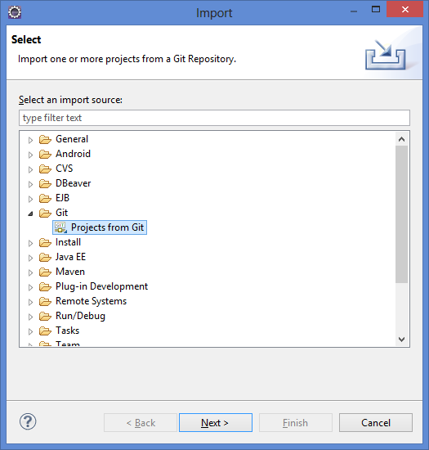
select Git and click Projects from Git and click Next
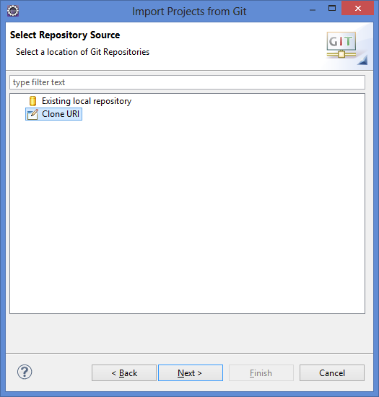
Select Clone URI and click Next

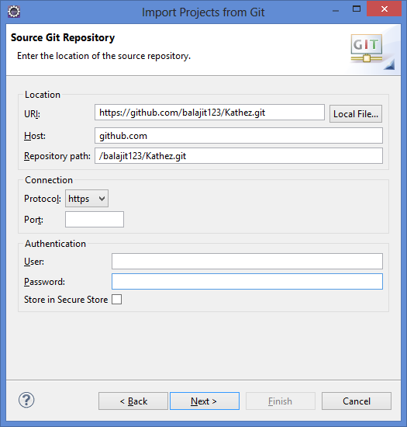
Enter https://github.com/balajit123/Kathez.git in the URI and click Next

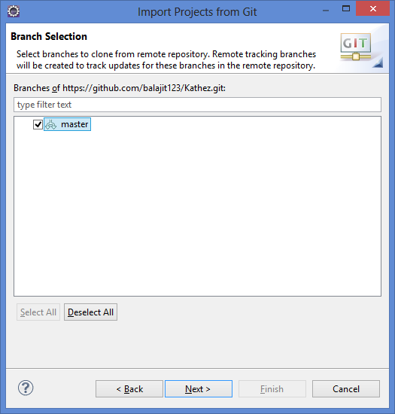
Select master and click Next

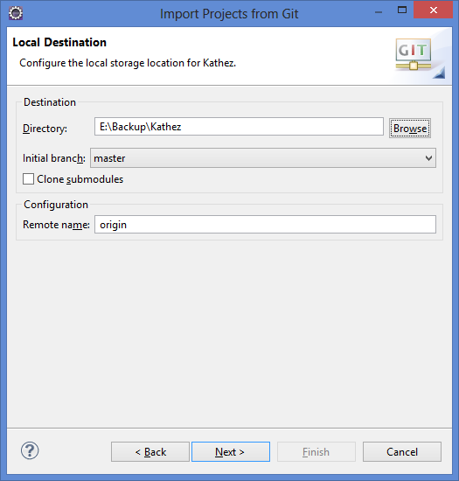
Enter any of the local directory and click Next

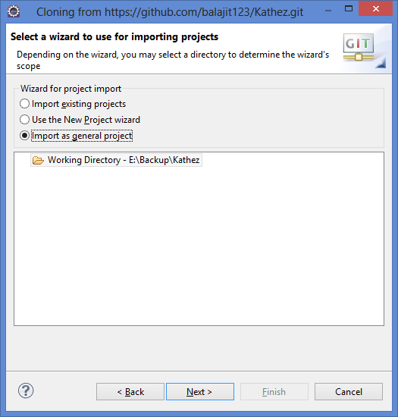
Select Import as general project and click Next

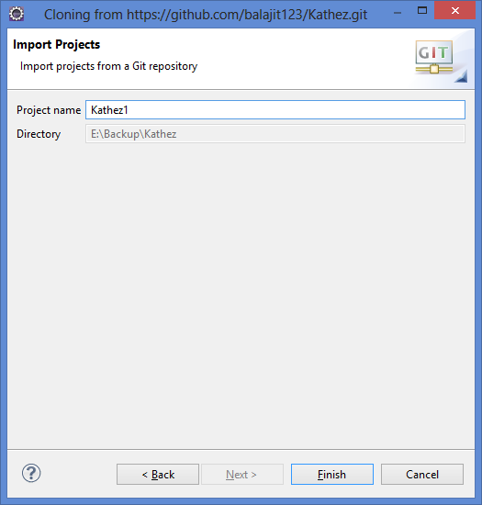
Give the desired project name and click Finish.

Now you have imported the project to your local system

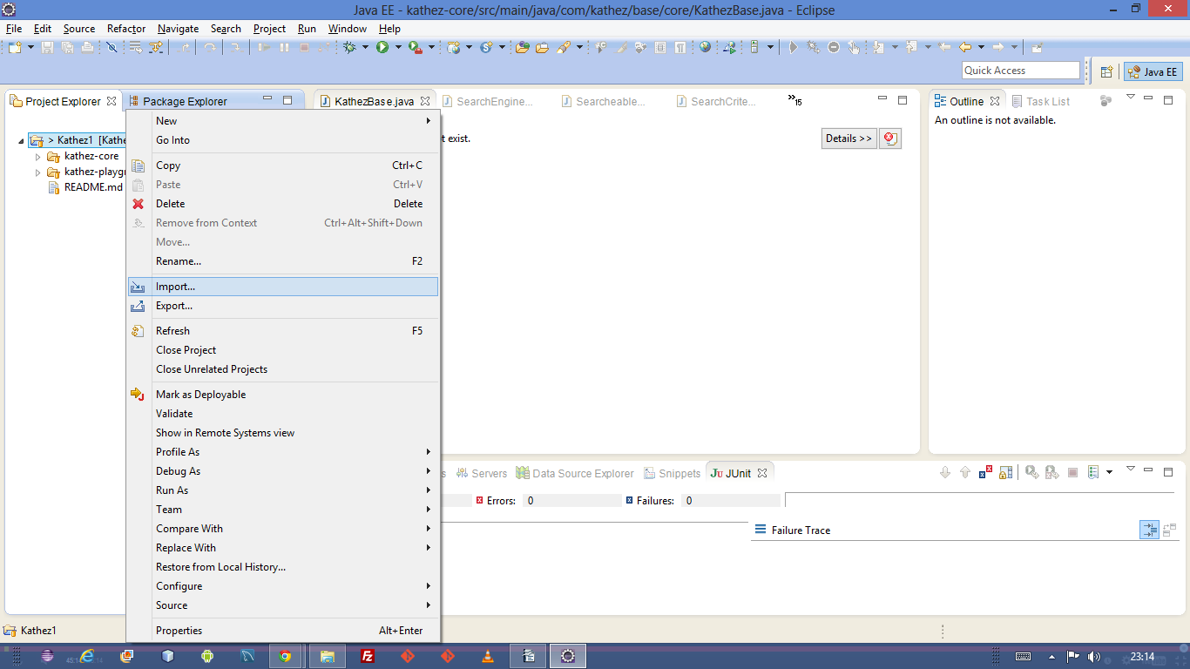

Right click on the project and click import

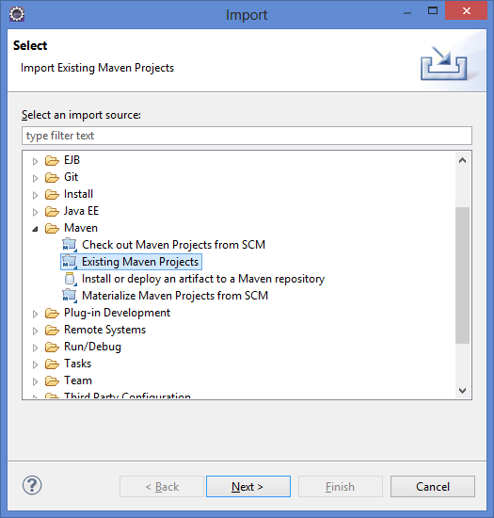
Select Maven, Click on Existing Maven Projects, click Next

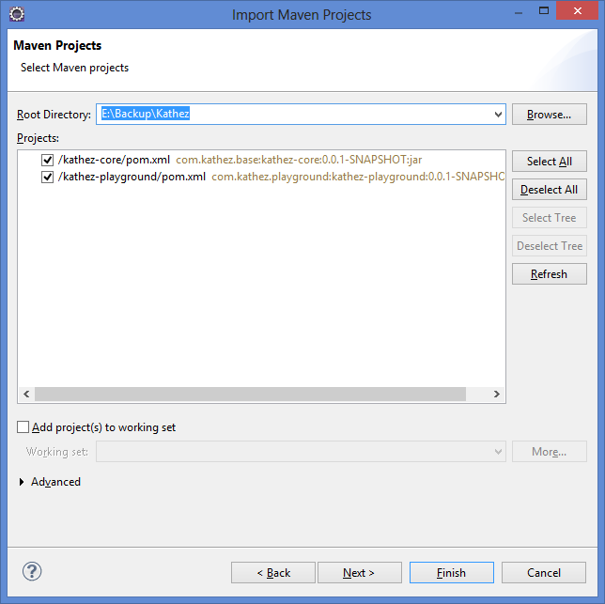
The above screen is shown, click Finish.
Now you have imported the maven projects

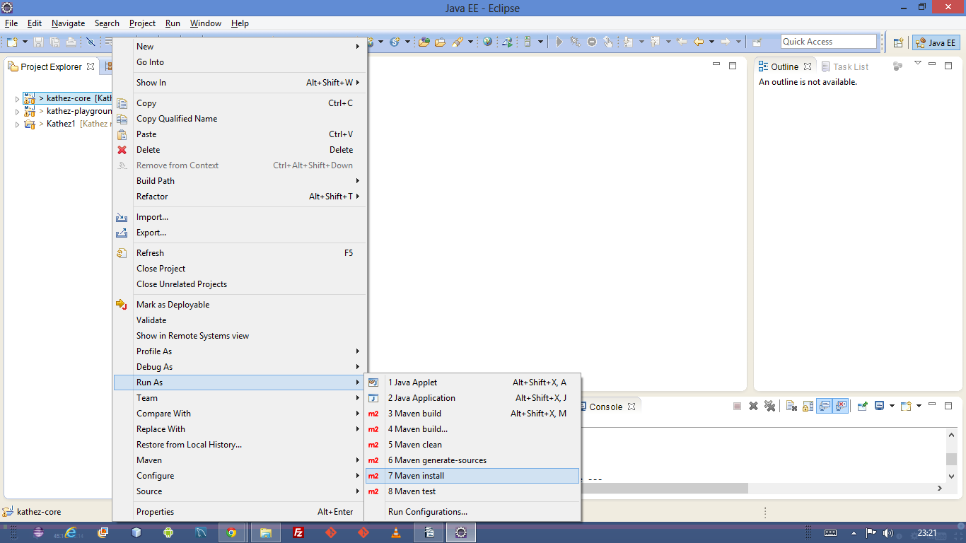
Right Click on kathez-core, select Run As, click Maven install.
It will build the kathez-core project

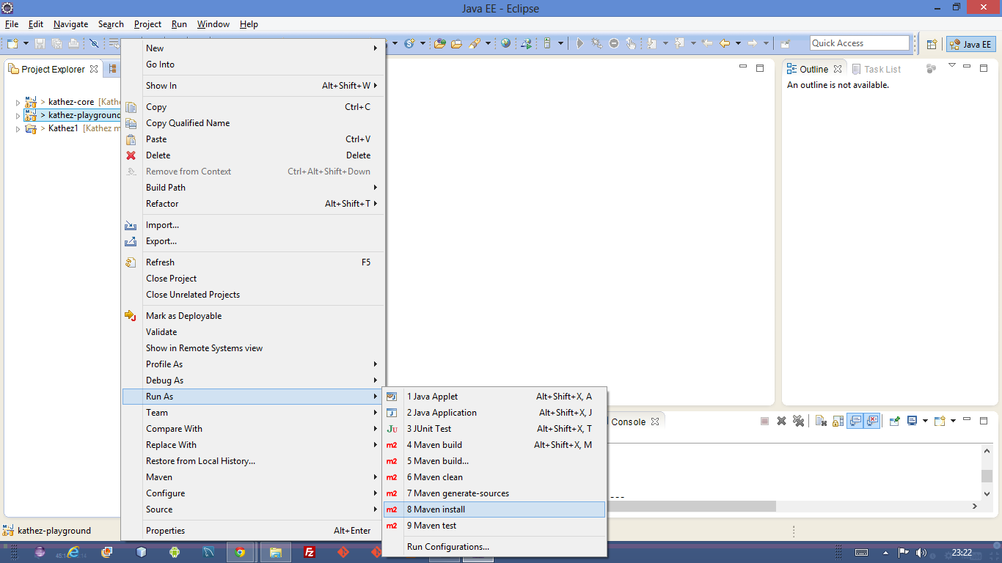
Right click on kathez-playground, Select Run As, click Maven install
This will build the kathez-playground project

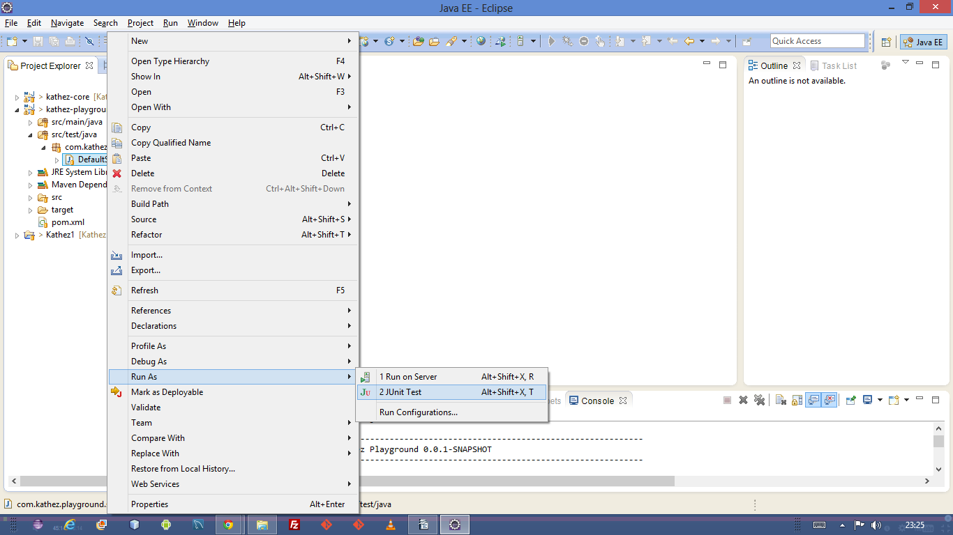
Now right click on kathez-playground->src/test/java->com.kathez.playground.searchengine->DefaultSearchEngineTest.java, select Run As, click Junit Test

This will run the test case class. It will give you test results. If all tests are passed, a green bar will be shown else a red bar will be shown.
You can see the error by clicking it.

Thats all! You have to go through the code to understand the logic

These are all pure java code

