|  |  |  |
| --- | --- | --- |
| **ipn** | **INSTITUTO POLITÉCNICO NACIONAL**  **ESCUELA SUPERIOR DE CÓMPUTO** |  |

**CRYPTOGRAPHY**

**“Title”**

Ravrange Character

**By:**

**Allan Ulises Zepeda Ibarra**

Professor:

M. en C. NIDIA ASUNCIÓN CORTEZ DUARTE

February2014

**Index**

Contenido

Problem: 3

Hypothesis: 3

Software (libraries, packages, tools): 3

Procedure: 3

Results (Data): 3

Conclusions: 3

Code 4

# Problem:

# Knowing that a character in this computing languages ​​consisting of 8 bits in binary 00000000, 76543210 sorted by weight, you want to change the order of these bit so that it is in the following order 03,654,127.

# Hypothesis:

To achieve resolve this problem we have to take the moving bit shifts each bit to the rightful position to get the order described above.

# Software (libraries, packages, tools):

The language on which the solution is C language is developed as the bit-level operation is easy and allows us to print a character in many formats without a problem

# Procedure:

First attach the original string to an auxiliary variable to hold the string unchanged after operate to accommodate the original bits and re assign the auxiliary to the original and operate again until we finish to accommodate everything.

# Results (Data):

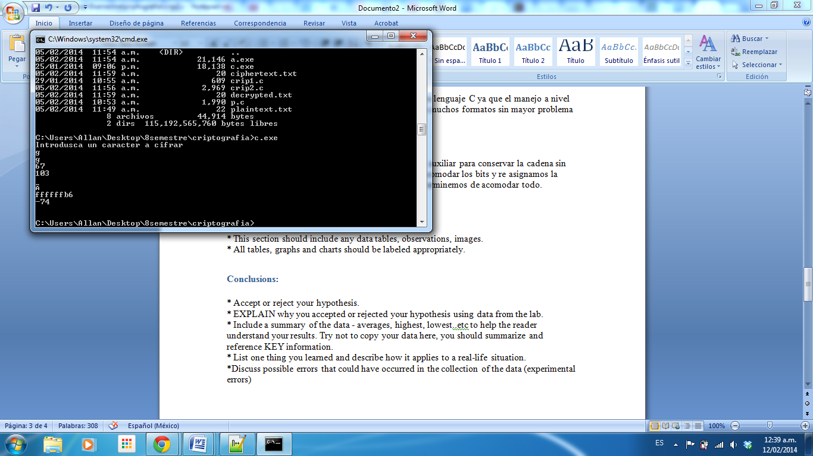

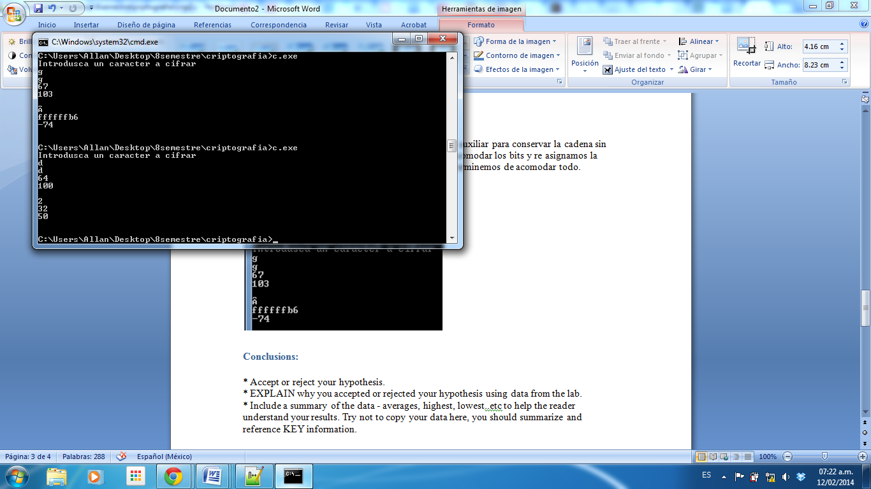

# Conclusions:

# Well the bit shift is an operation that seems very easy, but it is not because we might think that the shift is cyclical but at least in c language is not so because over the edges filled with c 0 which lack generating a loss of information which is difficult for this reason it is important auxiliary variable used for operations, and understanding this problem the rest is easy.

# Code

#include<stdio.h>

int main(void)

{

char a='d',b,c,d;

printf("Introduzca un caracter a cifrar \n");

scanf("%c",&a);

printf("%c \n",a);

printf("%x \n",a);

printf("%d \n\n",a);

b=b|(a<<7);

b=b|(a>>7);

c=a<<6;

c=c>>7;

c=-c;

c=c<<2;

b=b|c;

c=a<<5;

c=c>>7;

c=-c;

c=c<<1;

b=b|c;

c=a<<4;

c=c>>7;

c=-c;

c=c<<6;

b=b|c;

c=a<<3;

c=c>>7;

c=-c;

c=c<<3;

b=b|c;

c=a<<2;

c=c>>7;

c=-c;

c=c<<4;

b=b|c;

c=a<<1;

c=c>>7;

c=-c;

c=c<<5;

b=b|c;

printf("%c \n",b);

printf("%x \n",b);

printf("%d \n\n",b);

}