***ECOMMERCE SYSTEM***

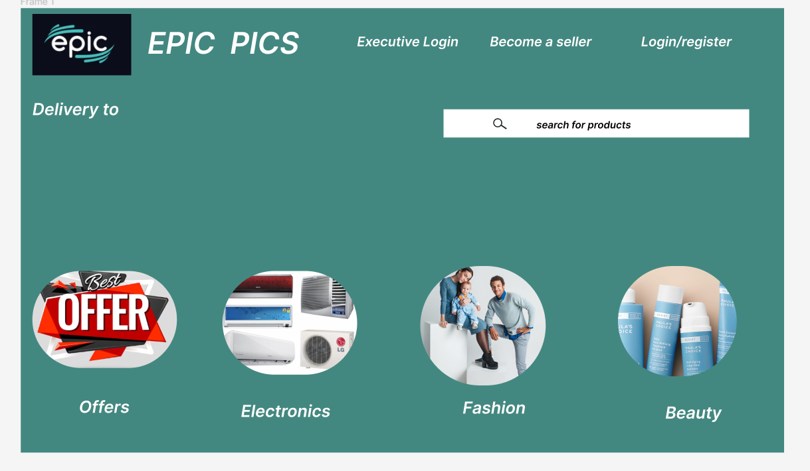

Here there are three logins

1.Customer login

2.Seller login

3.Executive login



Seller Register(@PostMapping("/signup")

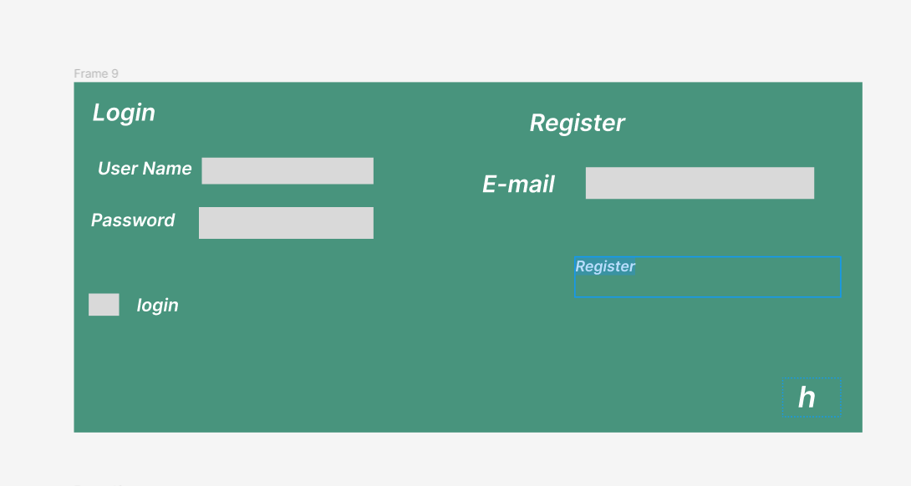

@PostMapping("/customer/add")

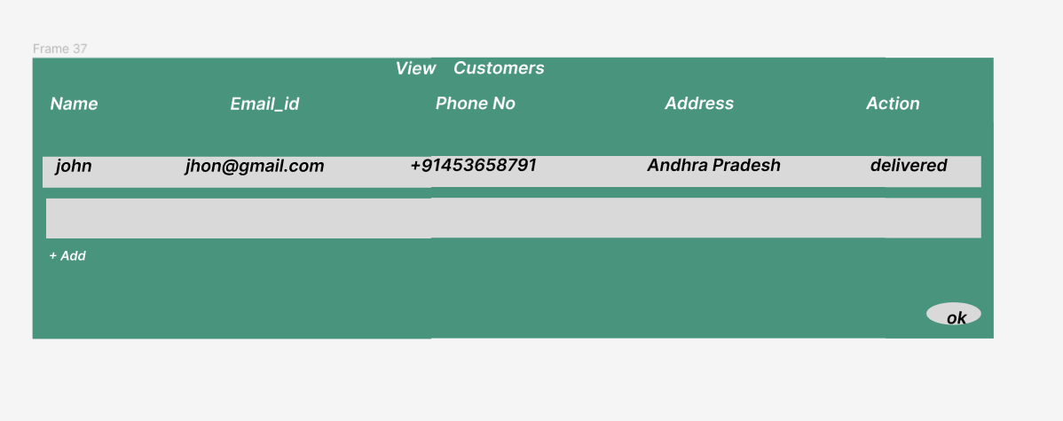

(@GetMapping("/customer/one/{id}")

@GetMapping("/customer/all")

For Deleting @DeleteMapping("/customer/delete/{id}")

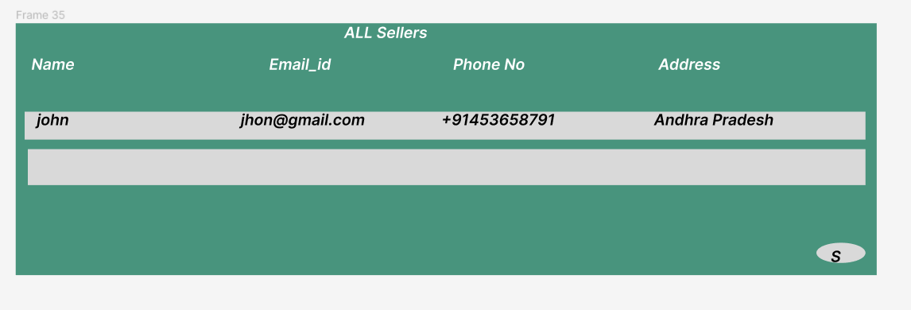

Getting all seller (@GetMapping("/all")

Delete a seller @DeleteMapping("/delete/{id}")

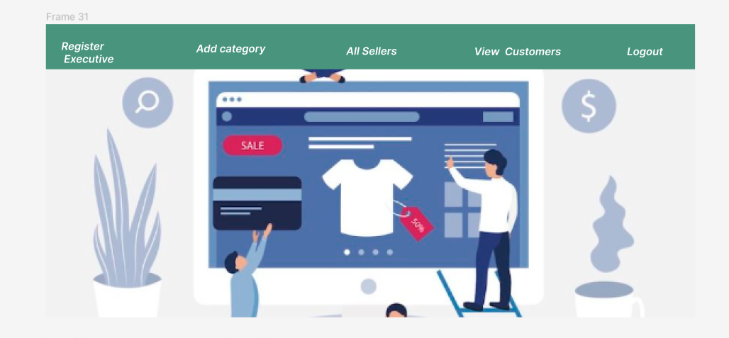

TO DELETE A CATEGORY @DeleteMapping("/category/delete/{id}")

TO VIEW ALL CATEGORY@GetMapping("/category/getall")

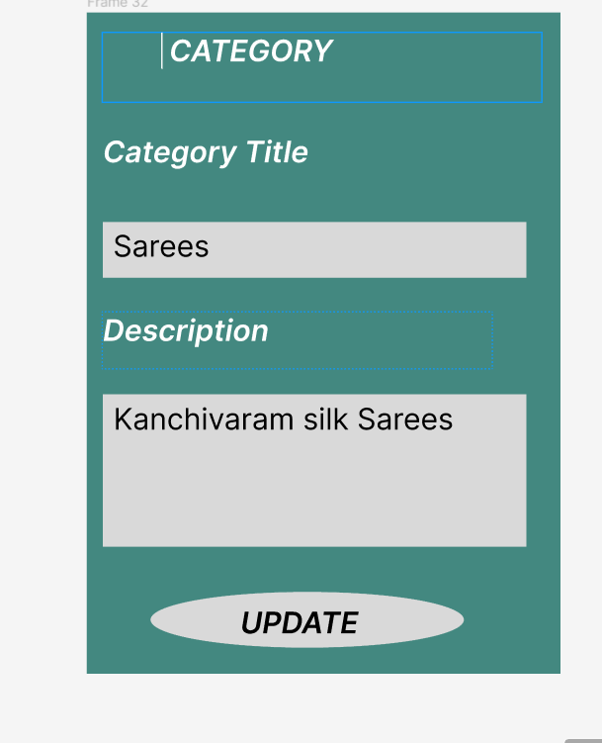

@PostMapping("/category/add")