.EPIC PICS

3 roles Executive, Seller, Customer

=================================================================================

1)CUSTOMER

i)POST API TO ADD CUSTOMER

ii)GET API FOR SELECTING THE CATEGORY

iii)GET API FOR LISTING THE PRODUCTS ACCORDING TO THE CATEGORY

iv)GET API TO LIST ALL THE ORDERS THAT ADDED

V) UPDATE API TO UPDATE DETAILS

vi)CUSTOMER CAN ADD AN REVIEW

vii) CUSTOMER CAN VIEW THE REVIEWS OF THE PRODUCT

2)SELLER

i)POST API FOR SIGNUP

ii)LOGIN (Get API)

ii)API FOR ADDING PRODUCTS BY CATEGORY

iii)SELLER CAN DELETE THE PRODUCTS BY FETCHING THEIR ID

iv)SELLER SHOULD SEE THE ORDERS FROM CUSTOMERS REGARDING THEIR PRODUCT ORDERS

v)SELLER CAN UPDATE THEIR DETAILS

3)EXECUTIVE

i)LOGIN EXECUTIVE

ii)ADDING EXECUTIVE

iii)To GET ALL INFORMATION OF THE SELLER

iv)ADDING THE CATEGORY

v) SHOULD SEE ALLTHE CUSTOMER DETAILS

vi) ALL ORDERS VIEW



1)Executive Login @GetMapping("/executive/login/{id}")

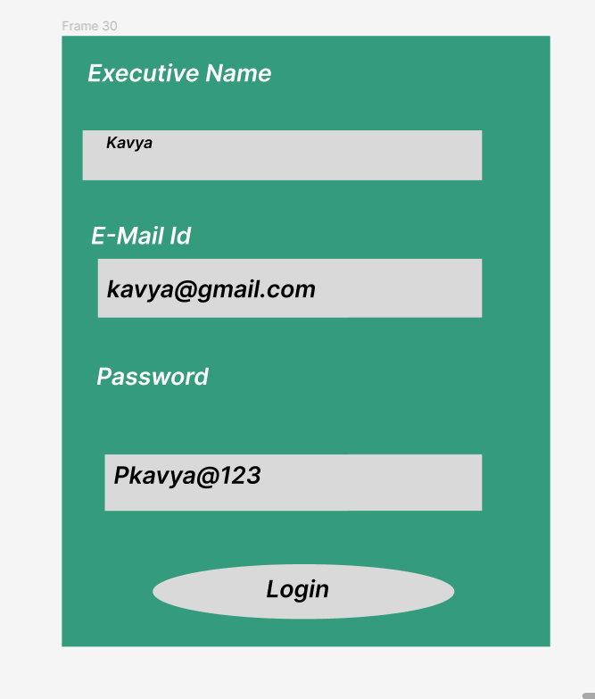

Executive Dashboard

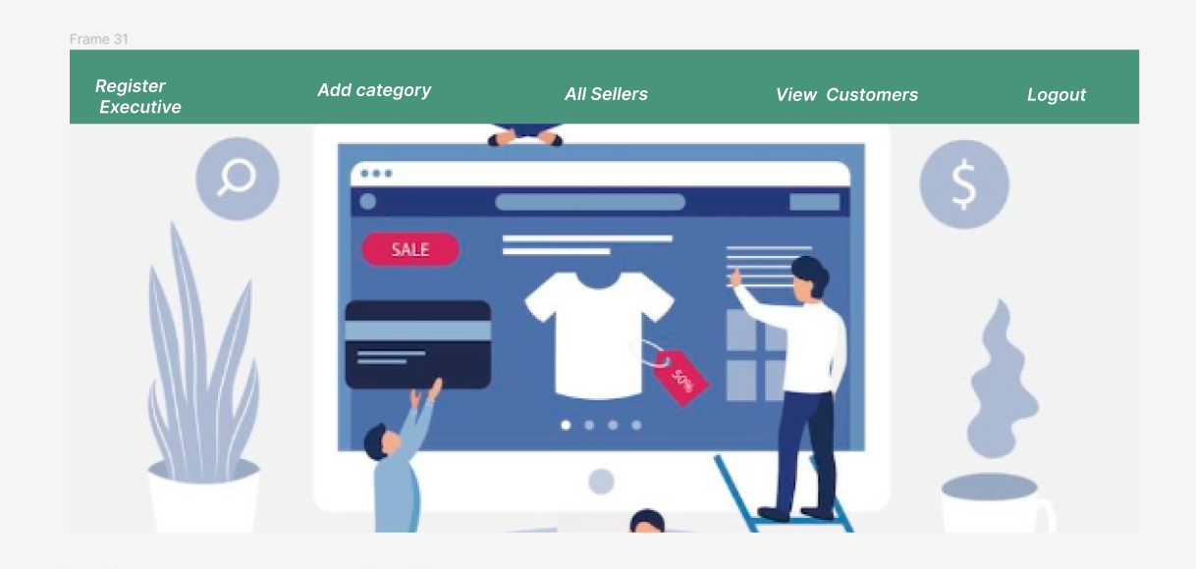

1)Register Executive @PostMapping("/executive/signup")

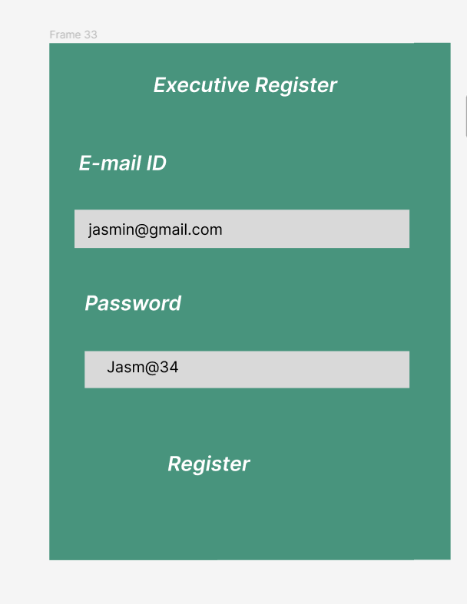

2)Add a Category @PostMapping("category/add")

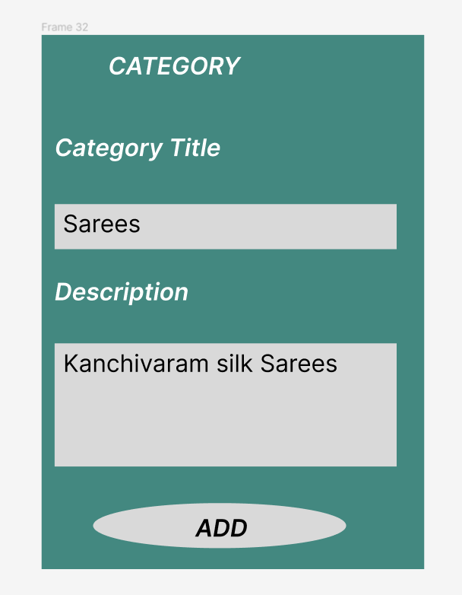

3) All sellers view

To See all the sellers @GetMapping("/seller/view/all")

To delete a seller @DeleteMapping("/delete/{sid}")

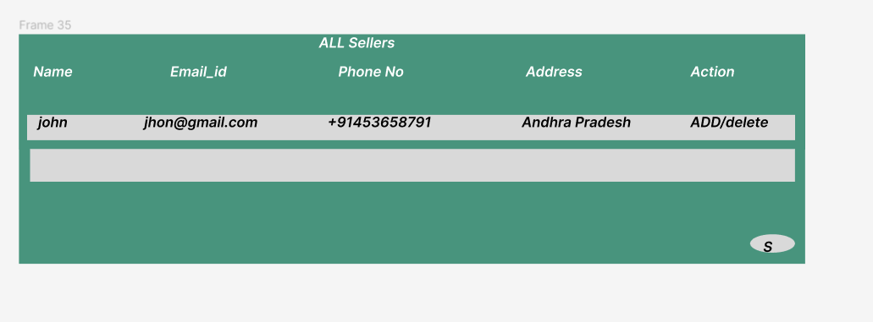

4) All Customer view all customers @GetMapping("/customer/all")

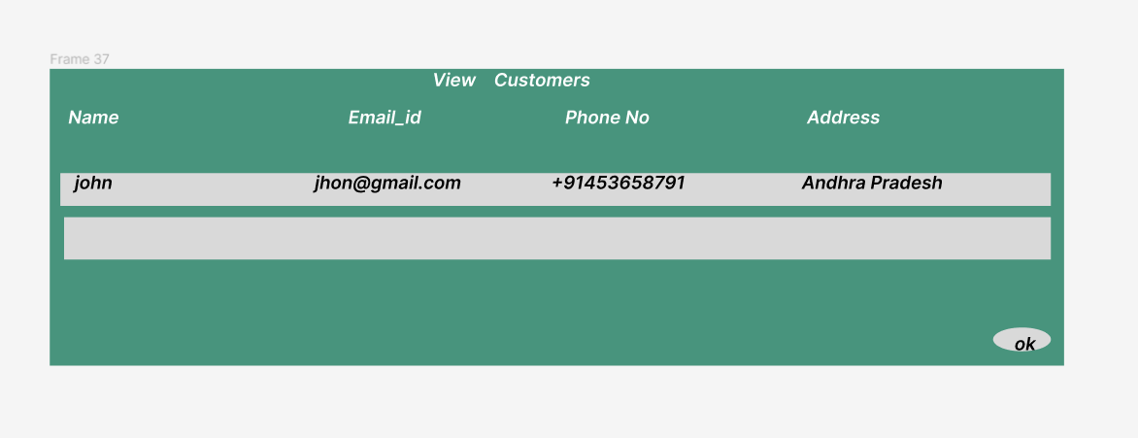

SELLER



1)Register seller @PostMapping("/signup")

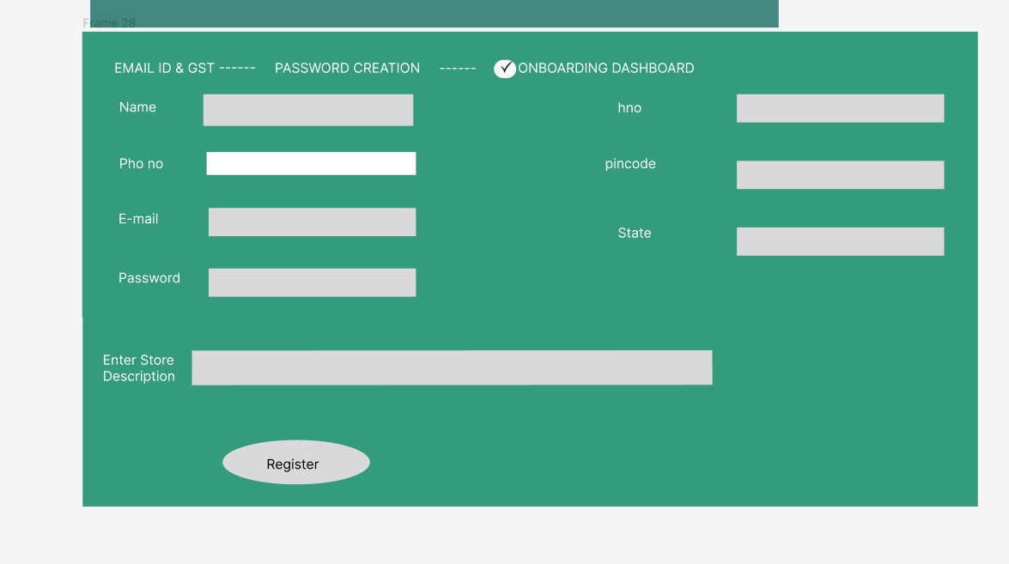

2) Login of the Seller @GetMapping("/login/{sid}")

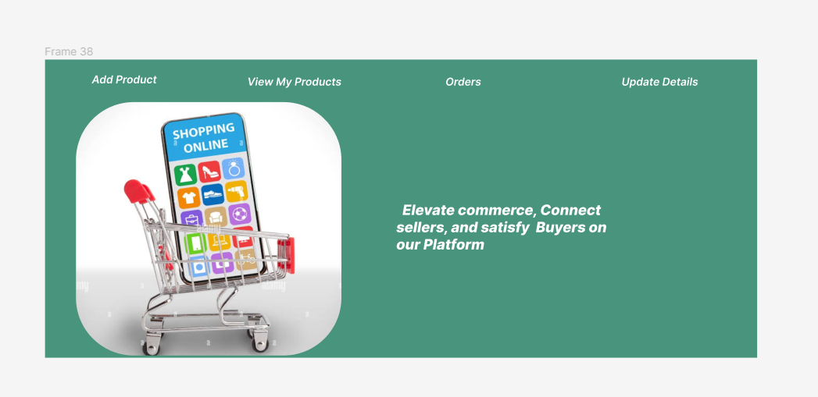

iii)Adding the Product by seller in the category present in category list @PostMapping("/product/add/{sid}/{cid}")

iv) To view all products by seller Id

@GetMapping("/product/seller/{sid}")

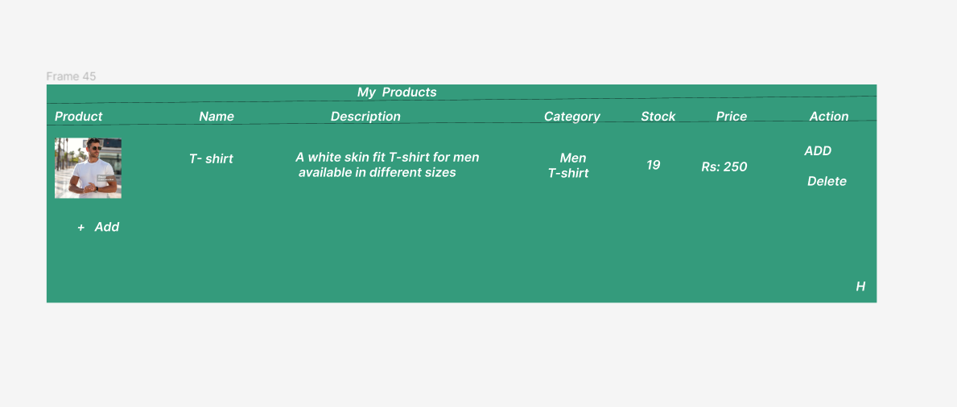

Vii) Sellers can update their details@PutMapping("/update/{id}")

3)Customer

i)Customer Registration@PostMapping("/customer/signup")

ii)Customer Login @GetMapping("/customer/all")

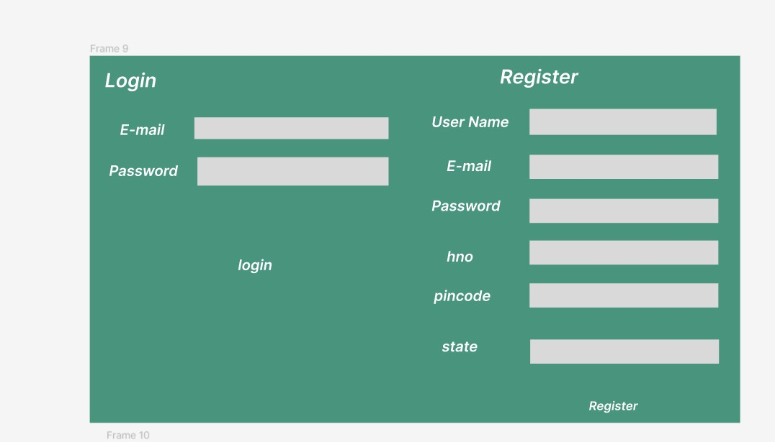

iii)Dash Board of Customer

 vi) To see all the Categories

@GetMapping("/category/getall")

vii)To view the products in the category ( products to be seen by the customer according to the category)

@GetMapping("/product/category/{cid}")

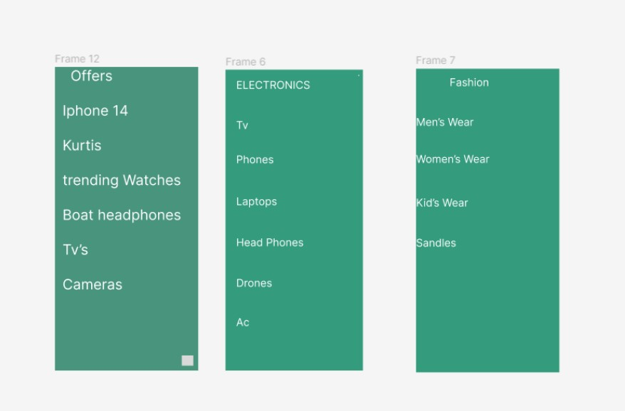

vii)Customer can update the details @PutMapping("/customer/update/{id}")

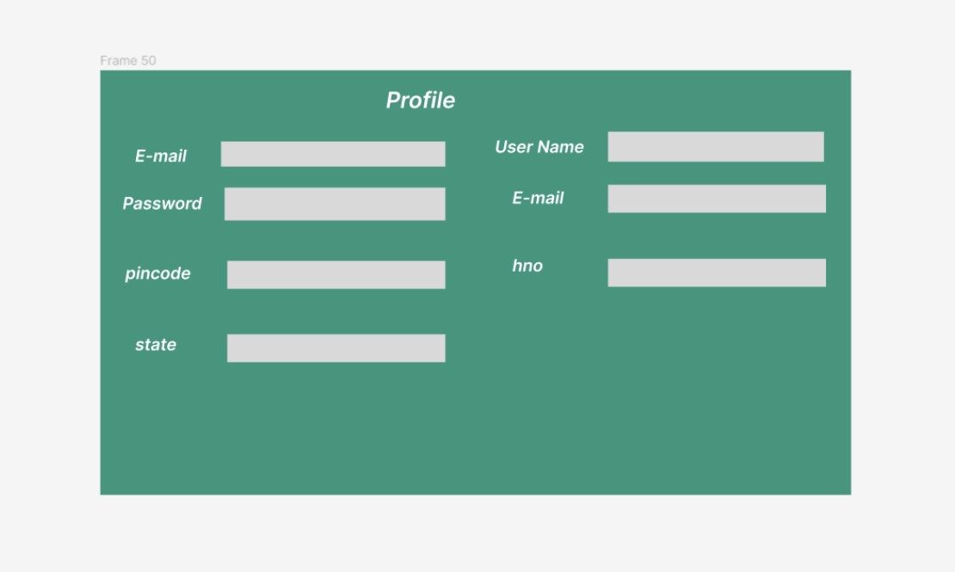

Reviews

viii)Customers can add the review and ratings by taking the product Id

@PostMapping("/review/{cid}/{pid}")

Xi) Customers can see the reviews of the products

@GetMapping("/review/getall/{page}/{size}")

4.Executive can delete the review

@DeleteMapping("/review/delete/{id}")