**727721EUIT020_D9_CE BALAKAVI B**

**TASK-01:Design and execute a calculator logic which checks all the mathematical operations.**

**CODE:-**

@Test(dataProvider = "dp")

**public** **void** add(Integer n, Integer n1) {

System.***out***.println(n+n1);

}

@Test(dataProvider = "dp")

**public** **void** sub(Integer n, Integer n1) {

System.***out***.println(n-n1);

}

@Test(dataProvider = "dp")

**public** **void** mul(Integer n, Integer n1) {

System.***out***.println(n*n1);

}

@Test(dataProvider = "dp")

**public** **void** div(Integer n, Integer n1) {

System.***out***.println(n/n1);

}

@DataProvider

**public** Object[][] dp() {

**return** **new** Object[][] {

**new** Object[] {10,2},

**new** Object[] {9,3},

};

}

**OUTPUT:-**

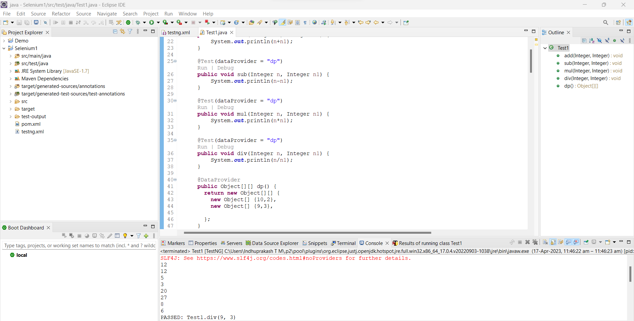

**TASK-02 AND 03:-**

**CODE:-**

@Test

**public** **void** f() {

WebDriverManager.*chromedriver*().setup();

WebDriver driver;

ChromeOptions co = **new** ChromeOptions();

co.addArguments("--remote-allow-origins=*");

driver=**new** ChromeDriver(co);

driver.get("https://www.godaddy.com/en-in");

driver.manage().window().maximize();

String actualTitle="Domain Names, Websites, Hosting & Online Marketing Tools - GoDaddy IN";

String extractedTitle=driver.getTitle();

AssertJUnit.*assertEquals*(actualTitle, extractedTitle);

String actualURL="https://www.godaddy.com/en-in";

String extractedURL=driver.getCurrentUrl();

AssertJUnit.*assertEquals*(actualURL, extractedURL);

System.***out***.println("Hello");

//driver.quit();

//driver.manage().timeouts().implicitlyWait(10, TimeUnit.SECONDS);

}

@Test

**public** **void** f1() {

WebDriverManager.*chromedriver*().setup();

WebDriver driver;

ChromeOptions co = **new** ChromeOptions();

co.addArguments("--remote-allow-origins=*");

driver=**new** ChromeDriver(co);

driver.get("https://www.godaddy.com/en-in");

driver.manage().window().maximize();

driver.manage().timeouts().~~implicitlyWait~~(5, TimeUnit.***SECONDS***);

driver.findElement(By.*xpath*("//*[@id=\"id-631b049a-e9c0-4d24-8710-c504745206dd\"]/div[2]/div[1]/ul/li[1]/button")).click();

driver.findElement(By.*linkText*("Domain Name Search")).click();

//driver.quit();

}

**TESTNG.XML:-**

<?xml version="1.0" encoding="UTF-8"?>

<!DOCTYPE suite SYSTEM "https://testng.org/testng-1.0.dtd">

<suite name="Suite" parallel="methods">

<test thread-count="5" name="Test">

<classes>

<class name="com.selenium.test1.Selenium1.AppTest"/>

<class name=".Test1"/>

</classes>

</test> <!-- Test -->

</suite> <!-- Suite -->

**OUTPUT:-**

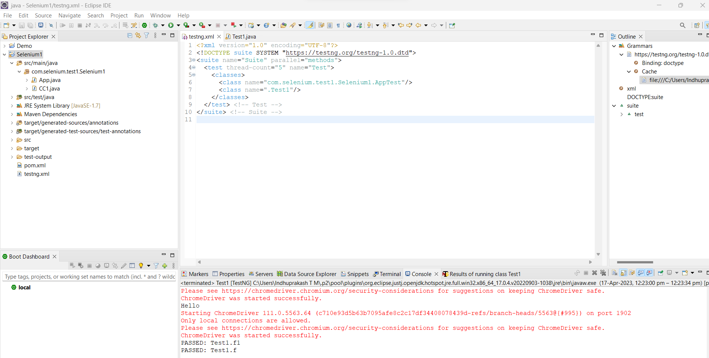

**TASK-04:Selection of browser through the XML file.**

**CODE:-**

WebDriver driver;

@Test

**public** **void** f() **throws** Exception {

Thread.*sleep*(3000);

WebElement uname=driver.findElement(By.*name*("username"));

WebElement pwd=driver.findElement(By.*name*("password"));

WebElement submit=driver.findElement(By.*xpath*("//*[@class='oxd-button oxd-button--medium oxd-button--main orangehrm-login-button']"));

uname.sendKeys("Admin");

pwd.sendKeys("admin123");

submit.click();

}

@Parameters("browser")

@BeforeMethod

**public** **void** beforeMethod(String browser1) {

**if**(browser1.equals("chrome"))

{

WebDriverManager.*chromedriver*().setup();

ChromeOptions co = **new** ChromeOptions();

co.addArguments("--remote-allow-origins=*");

driver=**new** ChromeDriver(co);

driver.manage().window().maximize();

String url="https://opensource-demo.orangehrmlive.com/web/index.php/auth/login";

driver.get(url);

driver.manage().window().maximize();

}

**else** **if**(browser1.equals("edge"))

{

WebDriverManager.*edgedriver*().setup();

//FirefoxOptions co = new FirefoxOptions();

//co.addArguments("--remote-allow-origins=*");

driver=**new** EdgeDriver();

driver.manage().window().maximize();

String url="https://opensource-demo.orangehrmlive.com/web/index.php/auth/login";

driver.get(url);

driver.manage().window().maximize();

}

}

@AfterMethod

**public** **void** afterMethod() {

driver.close();

}

**TESTNG.XML:-**

<?xml version="1.0" encoding="UTF-8"?>

<!DOCTYPE suite SYSTEM "https://testng.org/testng-1.0.dtd">

<suite name="Suite" parallel="false">

<parameter name="browser" value="edge"></parameter>

<test thread-count="5" name="Test">

<classes>

<class name="com.selenium.test1.Selenium1.AppTest"/>

<class name=".Test1"/>

</classes>

</test> <!-- Test -->

</suite> <!-- Suite -->

**OUTPUT:-**

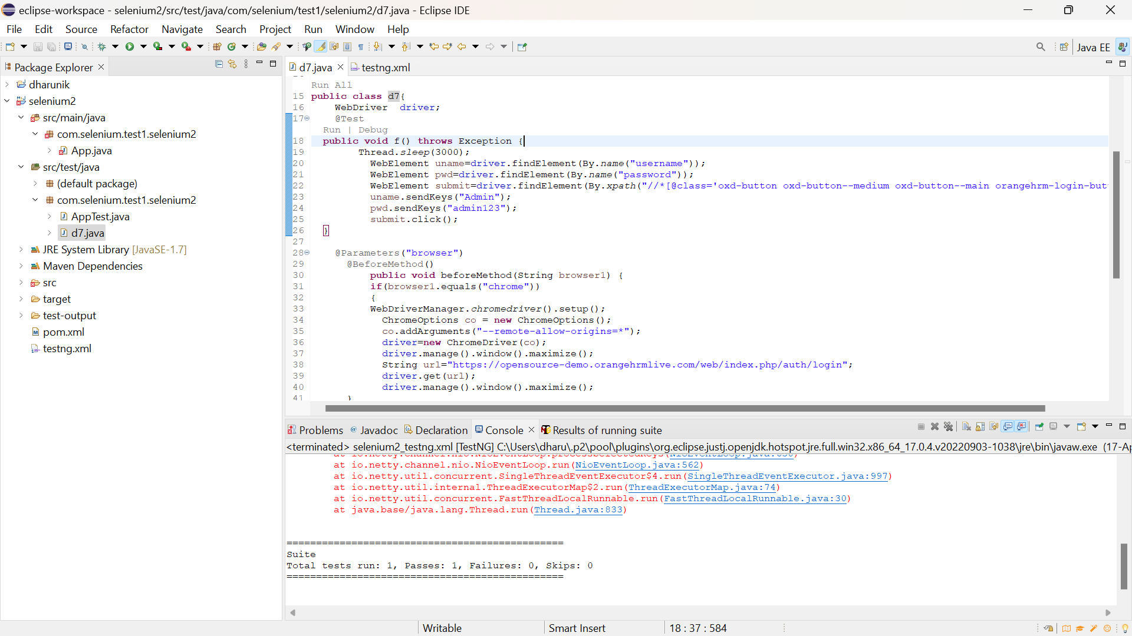

**TASK-05:-**

**CODE:-**

WebDriver driver;

@Test

**public** **void** f() **throws** Exception {

String url="https://opensource-demo.orangehrmlive.com/web/index.php/auth/login";

driver.get(url);

Thread.*sleep*(3000);

WebElement uname=driver.findElement(By.*name*("username"));

WebElement pwd=driver.findElement(By.*name*("password"));

WebElement submit=driver.findElement(By.*xpath*("//*[@class='oxd-button oxd-button--medium oxd-button--main orangehrm-login-button']"));

uname.sendKeys("Suvitha");

pwd.sendKeys("12345");

submit.click();

String url1="https://opensource-demo.orangehrmlive.com/web/index.php/dashboard/index";

}

@BeforeMethod

**public** **void** beforeMethod() {

WebDriverManager.*chromedriver*().setup();

ChromeOptions co = **new** ChromeOptions();

co.addArguments("--remote-allow-origins=*");

driver=**new** ChromeDriver(co);

}

@AfterMethod

**public** **void** afterMethod() {

driver.close();

}

**TESTNG.XML:-**

<?xml version="1.0" encoding="UTF-8"?>

<suite parallel="false" name="Suite">

<test name="Test">

<listeners>

<listener class-name="com.selenium.test1.selenium2.d7">

</listener>

</listeners>

<classes>

<class name="com.selenium.test1.selenium2.d9"/>

</classes>

</test> <!-- Test -->

</suite> <!-- Suite -->

**JAVA.XML:-**

**package** com.selenium.test1.selenium2;

**import** org.testng.ITestContext;

**import** org.testng.ITestListener;

**import** org.testng.ITestResult;

**public** **class** d7 **implements** ITestListener {

**public** **void** onTestStart(ITestResult result) {

// **TODO** Auto-generated method stub

System.***out***.println("on Test Start :"+result.getName());

}

**public** **void** onTestSuccess(ITestResult result) {

// **TODO** Auto-generated method stub

System.***out***.println("on Test success :"+result.getName());

}

**public** **void** onTestFailure(ITestResult result) {

// **TODO** Auto-generated method stub

System.***out***.println("on Test fail :"+result.getName()); }

**public** **void** onTestSkipped(ITestResult result) {

// **TODO** Auto-generated method stub

System.***out***.println("on Test skip :"+result.getName()); }

**public** **void** onTestFailedButWithinSuccessPercentage(ITestResult result) {

// **TODO** Auto-generated method stub

System.***out***.println("on Test fail :"+result.getName()); }

**public** **void** onTestFailedWithTimeout(ITestResult result) {

// **TODO** Auto-generated method stub

System.***out***.println("on Test fail :"+result.getName()); }

**public** **void** onStart(ITestContext context) {

// **TODO** Auto-generated method stub

System.***out***.println("on start");

}

**public** **void** onFinish(ITestContext context) {

// **TODO** Auto-generated method stub

System.***out***.println("on Test finish");

}

}

**OUTPUT:-**

