## 

Weekly Newsletter

**Goals and Vision**

The primary objective was to create a smart operations solution which augments the current solder paste inspection solution to assist in eliminations of false positives thereby increasing operational efficiency of the electronics manufacturing line in Twinsburg, OH. A secondary objective was to better understand the underlying technologies to build a closed loop machine learning solution in the industrial space such that these capabilities could be adopted by the Rockwell solution portfolio.

**Thank You TEAM!**

This project cut across many organizations, many countries and truly demonstrated the ONE Microsoft approach to accomplish an objective. Without the full support of all participants we would not have the level of impact that we had

From the CSE org we had: David Crook, Bill Berry, Pamela Cortez, David Ruttka, Tony Angell, Ian Davis, Annie Bougie, Kevin Wittkopf, Mike Zawacki, Annie Bubinski, Tao Yang, & Ayako Omori.

From the account team we had: Balamurugan Balakreshnan, Stephen Chelack, Jose Valls, Gordon Blackwell, Tylor Merck, Mark Tanin, Ed Luck, Kari Bolger, Lenore Mccarthy, Michael Walton, Beth Humpreys, Stephen Philip and Eddy Saad.

From the various product groups we had: Alex Newman, Jiri Apple and Pierre Cauchois.

From Rockwell Automation, we had: Francisco Maturana, Gregory Vance, Mikica Cvijetinovic, Troy Mahr, Robert F. Trinnes, Matthew Rismeyer, Fatime Ly Seymore and Chirayu S. Shah.

**Special Call Outs**

Balamurugan Balakreshnan – For initial concept and push through for over 1 year.

Bill Berry – For sheer perseverance and strength of will to make it work on the latest industrial hardware from Rockwell.

Francisco Maturana – For the strong technical partnership, and co-ordination on the Rockwell side.

**By the Numbers**

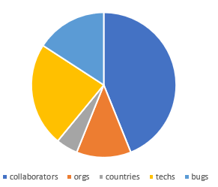

36 collaborators from 2 companies

10 organizations spread across 4 countries

> 19 technologies with 13 new bugs logged

Of the 13 bugs logged, 7 are adoption blockers.

5 adoption blockers in Azure ML

2 adoption blockers in Azure IoT Suite

**The Differentiator**

The deep partnership across the 2 companies and 10 organizations was truly required in this scenario due to the deep level of integration and change that had to occur to bring this solution to life.

*“QUOTE*.” – PERSON, COMPANY – POSITION

*“QUOTE.”* – PERSON, COMPANY - POSITION

**The Solution**

***Abstract*** – Ball grid array electronics components (BGAs) are a high cost component should a failed component escape down the line. That cost results in additional time spent on downtime as well as potential relationship costs should it escape the factory entirely. The current solutions in place do not meet the tight quality requirements of the modern factory. This solution aims to solve that problem in a live factory setting.

***The Solution –*** The solution is comprised of a few parts. The first is a fundamental shift in *how* solder paste analysis is done for BGA components, the second is a Human Machine Interface (HMI) or monitor to display the results of the new approach to the factory workers and the third component is all of the plumbing to physically make this happen.

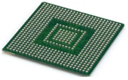The fundamental shift in analysis is to analyze *all* solder paste applications for a single component holistically. Today, the machinery analyzes applications independently, however due to variations in height, volume and offsets; a component could settle incorrectly thereby not creating a proper mechanical bond across all pins.

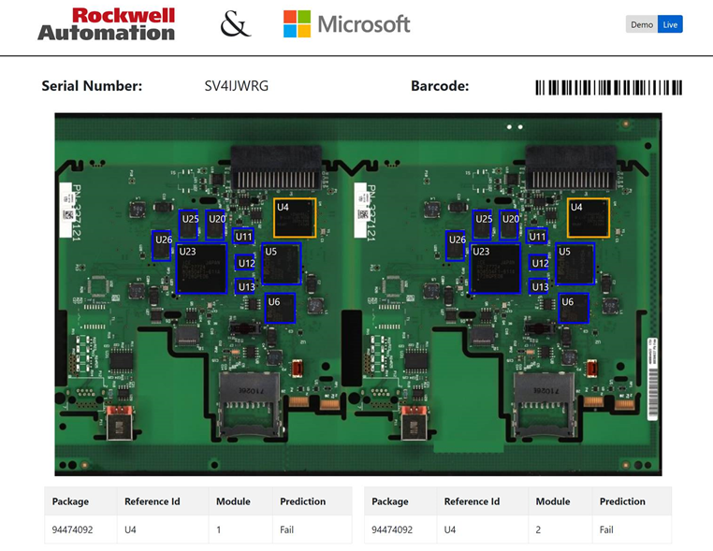

The industrial controllers run the analysis algorithm on the controller as well as the visual interface seen above. As a mother board progresses down the line, it will grab the serial number, render as a scannable barcode and display blue for good component and yellow for a predicted failure.

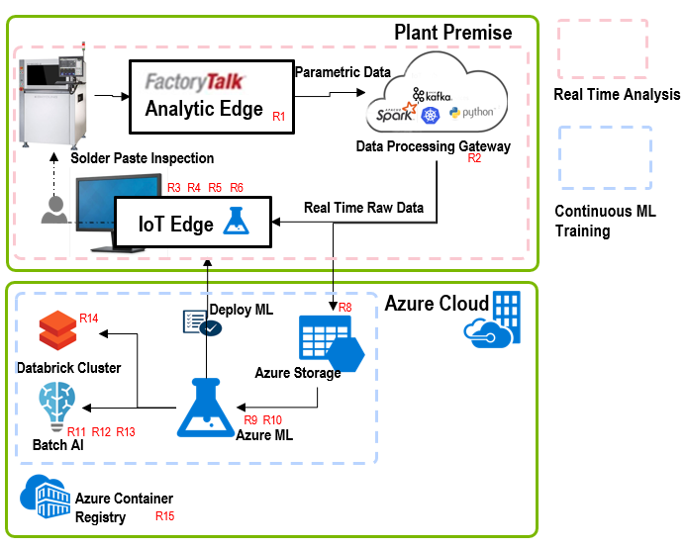

The surrounding plumbing is a massive paradigm shift across many fronts.

* All analysis and deep neural networks run on industrial controllers in a closed loop fashion never leaving the factory floor.
* Out of band continuous training of the models happens in the cloud and deployments are governed.
* Deployment of the software stack: HMI, Data Pipelines and Algorithms are all orchestrated cloud side and deployed via containers.

**Automation Fair Reception**

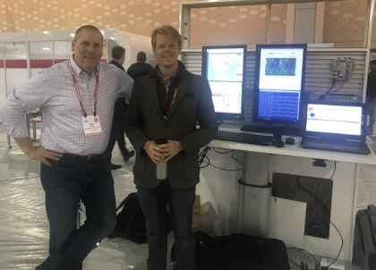The week of Nov 12, the project was shown at Automation Fair to garner interest and discover landing zones for the capabilities. There was an excess of 10,000 attendees. Public media, Rockwell Investor Groups, Customers as well as C-Suite all stopped by the booth with positive reaction and reception.

The event was a huge success. Not only did we accumulate new practical industrially aligned machine learning and vision projects, but through the interest and meetings arranged made progress on getting the buy in required to take the project to the next step, commercialization.

**Commercialization Strategy**

There were several key learnings from this project which are driving the recommended path forward for commercialization.

* Anything is possible with 36 great collaborators; however, those resources are few and not scale-able.
* Long-Term maintenance of a solution of this nature is very costly and non-scale-able.
* A standard combination of simple configurable tools which can be leveraged by an SI partner network will reduce time to market, stand up costs, maintenance costs and be scale-able across a broader market of customers.

Rockwell Automation already has multiple capabilities within their “Factory Talk Innovation Suite powered by PTC” which we will be pursuing as the recipients of the required capabilities to deliver solutions of this nature in a cost effective, scale-able manner. Those capabilities are: Common Gateway Platform (CGP), Factory Talk Analytics Edge (FTA-E), Factory Talk Data Flow ML (FTA-DFML) and Factory Talk Data View (FTA-DV). The required upgrades within those include but are not limited to:

* CGP: Upgrade to support Azure IoT Edge and containerized workloads.
* FTA-E: Upgrade to work with the upgraded CGP.
* FTA-DFML: Upgrade to generate containerized ML solutions which can integrate into the upgraded FTA-E.
* FTA-DV: Upgrade such that it can deploy containerized data views onto the upgraded FTA-E.

The above modifications within Rockwell’s technology stack will also require multiple upgrades within Microsoft’s technology stacks. The key areas where modifications will need to be made are in the Microsoft IoT Suite, Microsoft On Premise, as well as the Microsoft Machine Learning Suite.

***Key Stake Holders*** – To execute on the above strategy, several key stake holders will be required. On the Rockwell side of the house, we will need: Chirayu, Francisco, Pradeep, Scott Miller and Kevin Chao. From the Microsoft side, we will need: Stephen Chelack, David Crook, Sam George and Eric Boyd.

The reasoning for such high-level resources as stake holders is due to the deep level of partnership required to pull off the commercialization phase.

**Growth Mindset**

This project could not have happened without taking risks and thinking growth mindset first. None better showcased this than Balamurugan Balakreshnan, from our account team who requested to be held responsible for training one of the deep neural networks which is currently deployed into the solution.

Balamurugan Balakreshnan –

*“By actively listening and learning from the customer’s SMEs, I was able to build a model that yielded better results and enable the customer to achieve more. “*

**Summary**

This project showcased what can happen when you have strong cross company partnerships combined with cross organizational partnerships. The final mile stones of bringing this to commercial viability with a joint go to market plan will require the same level of commitment and partnership to be successful.

Should this succeed, the very face of manufacturing will be changed through an intelligent cloud and intelligent edge.