Linux HandsOn

Commands:-
PWD - adminuser@6CLN6L3:~$ pwd
/home/adminuser
adminuser@6CLN6L3:~$
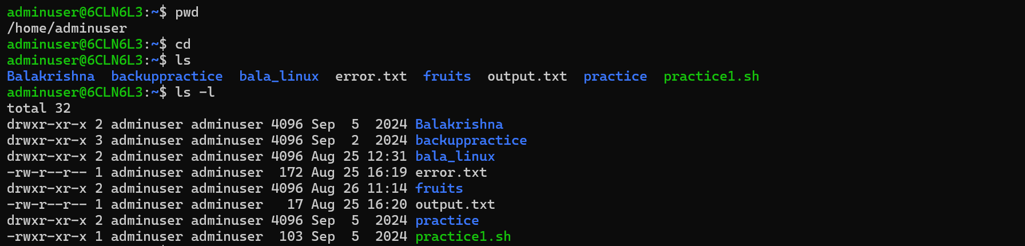

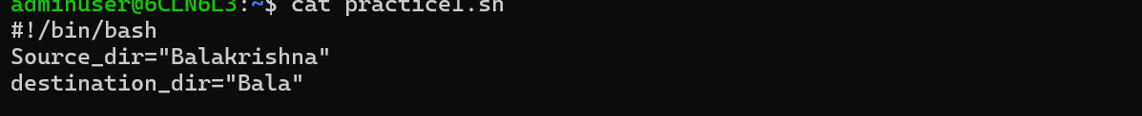
Linux commands are case sensitive

pwd Displays the present working directory.
cd Changes the current directory.
ls Lists directory contents.
cat Concatenates and displays files.
man Displays the online manual.
clear Clears the screen.
exit Exits the shell or your current session.
-t sort by time, newest first; see --time

-T, --tabsize=COLS
assume tab stops at each COLS instead of 8

-u with -lt: sort by, and show, access time; with -l: show access time and sort by name; otherwise: sort by access
time, newest first

-U do not sort; list entries in directory order

-v natural sort of (version) numbers within text

-w, --width=COLS
set output width to COLS. 0 means no limit

-x list entries by lines instead of by columns

-X sort alphabetically by entry extension

-Z, --context
print any security context of each file

-1 list one file per line. Avoid '\n' with -q or -b

--help display this help and exit

--version
output version information and exit

adminuser@6CLN6L3:/etc$ cd /bin
adminuser@6CLN6L3:/bin$ ls
NF fold nroff ss
'[' free nsenter ssh
aa-enabled ftp nslookup ssh-add
aa-exec fuser nstat ssh-agent
aa-features-abi fusermount nsupdate ssh-argv0
add-apt-repository fusermount3 ntfs-3g ssh-copy-id
addpart gapplication ntfs-3g.probe ssh-keygen
addr2line gawk ntfscat ssh-keyscan
apport-bug gdbus ntfscluster stat
apport-cli geqn ntfscmp static-sh
apport-collect getconf ntfsdecrypt stdbuf
apport-unpack getent ntfsfallocate strace
apropos getkeycodes ntfsfix strace-log-merge
apt getopt ntfsinfo streamzip
apt-add-repository gettext ntfsls strings
apt-cache gettext.sh ntfsmove strip
apt-cdrom ginstall-info ntfsrecover stty
apt-config gio ntfssecaudit su
apt-extracttemplates gio-querymodules ntfstruncate sudo
apt-ftparchive git ntfsusermap sudoedit
apt-get git-receive-pack ntfswipe sudoreplay
apt-key git-shell numfmt sum
apt-mark git-upload-archive objcopy sync
apt-sortpkgs git-upload-pack objdump systemctl
ar glib-compile-schemas od systemd
arch gold oem-getlogs systemd-analyze
as gpasswd on_ac_power systemd-ask-password
awk gpg openssl systemd-cat
b2sum gpg-agent openvt systemd-cgls
base32 gpg-connect-agent pager systemd-cgtop
base64 gpg-wks-server partx systemd-cryptenroll
basename gpg-zip passwd systemd-delta
basenc gpgcompose paste systemd-detect-virt
bash gpgconf pastebinit systemd-escape
bashbug gpgparsemail patch systemd-hwdb
bootctl gpgsm pathchk systemd-id128
busctl gpgsplit pbget systemd-inhibit
busybox gpgtar pbput systemd-machine-id-setup
byobu gpgv pbputs systemd-mount
byobu-config gpic pdb3 systemd-notify
byobu-ctrl-a gprof pdb3.10 systemd-path
byobu-disable grep peekfd systemd-run
byobu-disable-prompt gresource perl systemd-socket-activate
byobu-enable groff perl5.34-x86_64-linux-gnu systemd-stdio-bridge
byobu-enable-prompt grog perl5.34.0 systemd-sysext
byobu-export grops perlbug systemd-sysusers
byobu-janitor grotty perldoc systemd-tmpfiles
byobu-keybindings groups perlivp systemd-tty-ask-password-agent
byobu-launch gsettings perlthanks systemd-umount
byobu-launcher gtbl pgrep tabs
byobu-launcher-install gunzip pic tac
byobu-launcher-uninstall gzexe pico tail
byobu-layout gzip piconv tar
byobu-prompt h2ph pidof taskset
byobu-quiet h2xs pidwait tbl
byobu-reconnect-sockets hardlink pinentry tcpdump
byobu-screen hd pinentry-curses tee
byobu-select-backend head ping telnet
byobu-select-profile helpztags ping4 telnet.netkit
byobu-select-session hexdump ping6 tempfile
byobu-shell host pinky test
byobu-silent hostid pkaction tic
byobu-status hostname pkcheck time
byobu-status-detail hostnamectl pkcon timedatectl
byobu-tmux htop pkexec timeout
byobu-ugraph hub-tool pkill tload
byobu-ulevel hwe-support-status pkmon tmux
c++filt i386 pkttyagent tnftp
c_rehash iconv pl2pm toe
captoinfo id pldd top
cat info plymouth touch
catman infobrowser pmap tput
chage infocmp pod2html tr
chattr infotocap pod2man tracepath
chcon install pod2text troff
chfn install-info pod2usage true
chgrp instmodsh podchecker truncate
chmod ionice pr tset
choom ip preconv tsort
chown ipcmk printenv tty
chrt ipcrm printf tzselect
chsh ipcs prlimit ua
chvt iptables-xml pro ubuntu-advantage
ckbcomp ischroot prove ubuntu-bug
cksum join prtstat ubuntu-core-launcher
clear journalctl ps ubuntu-distro-info
clear_console json_pp psfaddtable ubuntu-security-status
cmp kbd_mode psfgettable ucf
codepage kbdinfo psfstriptable ucfq
col kbxutil psfxtable ucfr
col1 keep-one-running pslog uclampset
col2 kernel-install pstree udevadm
col3 keyring pstree.x11 ul
col4 kill ptar umount
col5 killall ptardiff uname
col6 kmod ptargrep unattended-upgrade
col7 last ptx unattended-upgrades
col8 lastb purge-old-kernels uncompress
col9 lastlog pwd unexpand
colcrt lcf pwdx unicode_start
colrm ld py3clean unicode_stop
column ld.bfd py3compile uniq
comm ld.gold py3versions unlink
compose-bridge ldd pydoc3 unlzma
corelist less pydoc3.10 unshare
cp lessecho pygettext3 unsquashfs
cpan lessfile pygettext3.10 unxz
cpan5.34-x86_64-linux-gnu lesskey python3 update-alternatives
cpio lesspipe python3.10 update-mime-database
crontab lexgrog ranlib uptime
csplit libnetcfg rbash usb-devices
ctail link rcp usbhid-dump
ctstat linux32 rdma usbreset
curl linux64 readelf users
cut ln readlink utmpdump
cvtsudoers lnstat realpath uuidgen
dash loadkeys red uuidparse
date loadunimap renice vdir
dbus-cleanup-sockets locale reset vi
dbus-daemon locale-check resizecons view
dbus-launch localectl resizepart vigpg
dbus-monitor localedef resolvectl vim
dbus-run-session logger rev vim.basic
dbus-send login rgrep vim.tiny
dbus-update-activation-environment loginctl rlogin vimdiff
dbus-uuidgen logname rm vimtutor
dd look rmdir vmstat
deallocvt lowntfs-3g rnano w
deb-systemd-helper ls routef wall
deb-systemd-invoke lsattr routel watch
debconf lsb_release rrsync watchgnupg
debconf-apt-progress lsblk rsh wc
debconf-communicate lscpu rsync wdctl
debconf-copydb lshw rsync-ssl wget
debconf-escape lsipc rtstat whatis
debconf-set-selections lslocks run-one whereis
debconf-show lslogins run-one-constantly which
debian-distro-info lsmem run-one-until-failure which.debianutils
delpart lsmod run-one-until-success whiptail
delv lsns run-parts who
df lsof run-this-one whoami
dh_bash-completion lspci runcon wifi-status
diff lspgpot rview write
diff3 lsusb rvim write.ul
dig lzcat savelog wslinfo
dir lzcmp scp wslpath
dircolors lzdiff screen x86_64
dirmngr lzegrep screendump x86_64-linux-gnu-addr2line
dirmngr-client lzfgrep script x86_64-linux-gnu-ar
dirname lzgrep scriptlive x86_64-linux-gnu-as
distro-info lzless scriptreplay x86_64-linux-gnu-c++filt
dmesg lzma sdiff x86_64-linux-gnu-dwp
dnsdomainname lzmainfo sed x86_64-linux-gnu-elfedit
do-release-upgrade lzmore select-editor x86_64-linux-gnu-gold
docker man sensible-browser x86_64-linux-gnu-gprof
docker-compose man-recode sensible-editor x86_64-linux-gnu-ld
docker-credential-desktop.exe mandb sensible-pager x86_64-linux-gnu-ld.bfd
docker-index manifest seq x86_64-linux-gnu-ld.gold
domainname manpath setarch x86_64-linux-gnu-nm
dpkg mapscrn setfont x86_64-linux-gnu-objcopy
dpkg-deb mawk setkeycodes x86_64-linux-gnu-objdump
dpkg-divert mcookie setleds x86_64-linux-gnu-ranlib
dpkg-maintscript-helper md5sum setlogcons x86_64-linux-gnu-readelf
dpkg-query md5sum.textutils setmetamode x86_64-linux-gnu-size
dpkg-realpath mdig setpci x86_64-linux-gnu-strings
dpkg-split mesg setpriv x86_64-linux-gnu-strip
dpkg-statoverride migrate-pubring-from-classic-gpg setsid xargs
dpkg-trigger mk_modmap setterm xauth
du mkdir setupcon xdg-user-dir
dumpkeys mkfifo sftp xdg-user-dirs-update
dwp mknod sg xsubpp
echo mksquashfs sh xxd
ed mktemp sha1sum xz
editor more sha224sum xzcat
egrep mount sha256sum xzcmp
eject mountpoint sha384sum xzdiff
elfedit mt sha512sum xzegrep
enc2xs mt-gnu shasum xzfgrep
encguess mtr showconsolefont xzgrep
env mtr-packet showkey xzless
envsubst mv shred xzmore
eqn namei shuf yes
ex nano size ypdomainname
expand nawk skill zcat
expiry nc slabtop zcmp
expr nc.openbsd sleep zdiff
factor neqn slogin zdump
faillog netcat snap zegrep
fallocate networkctl snapctl zfgrep
false networkd-dispatcher snapfuse zforce
fgconsole newgrp snice zgrep
fgrep ngettext soelim zipdetails
file nice sort zless
fincore nisdomainname splain zmore
find nl split znew
findmnt nm splitfont
flock nohup sqfscat
fmt nproc sqfstar

. represents - current dir

.. Parent dir
Cd – change previous dir
/ - directory separator

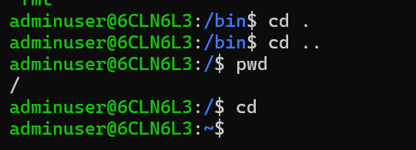
Mkdir
Rmdir
Rm

adminuser@6CLN6L3:~/Balakrishna$ cd
adminuser@6CLN6L3:~$ mkdir Krishna
adminuser@6CLN6L3:~$ ls
Balakrishna Krishna backuppractice bala_linux error.txt fruits output.txt practice practice1.sh
adminuser@6CLN6L3:~$ cd Krishna
adminuser@6CLN6L3:~/Krishna$ cd
adminuser@6CLN6L3:~$ rmdir Krishna
adminuser@6CLN6L3:~$ ls
Balakrishna backuppractice bala_linux error.txt fruits output.txt practice practice1.sh

adminuser@6CLN6L3:~$ cd /
adminuser@6CLN6L3:/$ ls
Docker boot etc init lib32 libx32 media opt root sbin srv tmp var
bin dev home lib lib64 lost+found mnt proc run snap sys usr
adminuser@6CLN6L3:/$ ls -l
total 1952
drwxr-xr-x 3 root root 4096 Oct 9 2024 Docker
lrwxrwxrwx 1 root root 7 Nov 23 2023 bin -> usr/bin
drwxr-xr-x 2 root root 4096 Apr 18 2022 boot
drwxr-xr-x 16 root root 3560 Nov 4 13:29 dev
drwxr-xr-x 73 root root 4096 Nov 4 13:29 etc
drwxr-xr-x 3 root root 4096 Mar 5 2024 home
-rwxrwxrwx 1 root root 1928824 Mar 12 2024 init
lrwxrwxrwx 1 root root 7 Nov 23 2023 lib -> usr/lib
lrwxrwxrwx 1 root root 9 Nov 23 2023 lib32 -> usr/lib32
lrwxrwxrwx 1 root root 9 Nov 23 2023 lib64 -> usr/lib64
lrwxrwxrwx 1 root root 10 Nov 23 2023 libx32 -> usr/libx32
drwx------ 2 root root 16384 Apr 10 2019 lost+found
drwxr-xr-x 2 root root 4096 Nov 23 2023 media
drwxr-xr-x 5 root root 4096 Mar 5 2024 mnt
drwxr-xr-x 2 root root 4096 Nov 23 2023 opt
dr-xr-xr-x 220 root root 0 Nov 4 13:29 proc
drwx------ 5 root root 4096 Oct 9 2024 root
drwxr-xr-x 18 root root 520 Nov 4 13:29 run
lrwxrwxrwx 1 root root 8 Nov 23 2023 sbin -> usr/sbin
drwxr-xr-x 8 root root 4096 Nov 23 2023 snap
drwxr-xr-x 2 root root 4096 Nov 23 2023 srv
dr-xr-xr-x 11 root root 0 Nov 4 13:29 sys
drwxrwxrwt 11 root root 4096 Nov 4 13:29 tmp
drwxr-xr-x 14 root root 4096 Nov 23 2023 usr
drwxr-xr-x 13 root root 4096 Nov 23 2023 var

Basic commands
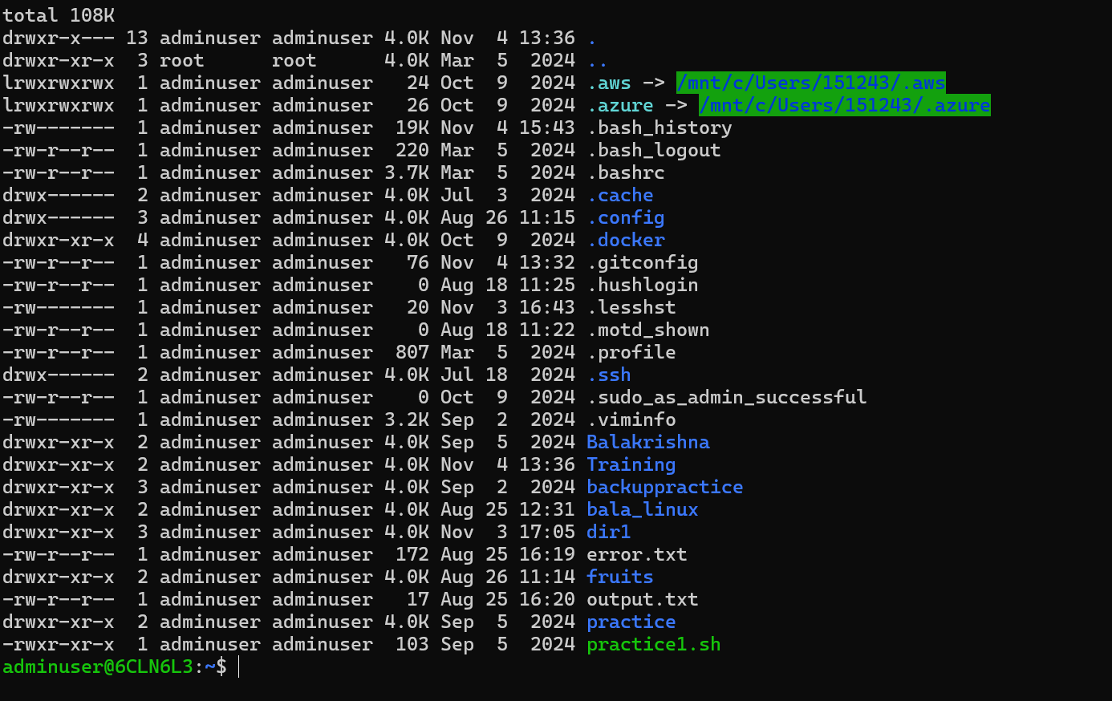

Ls -lah
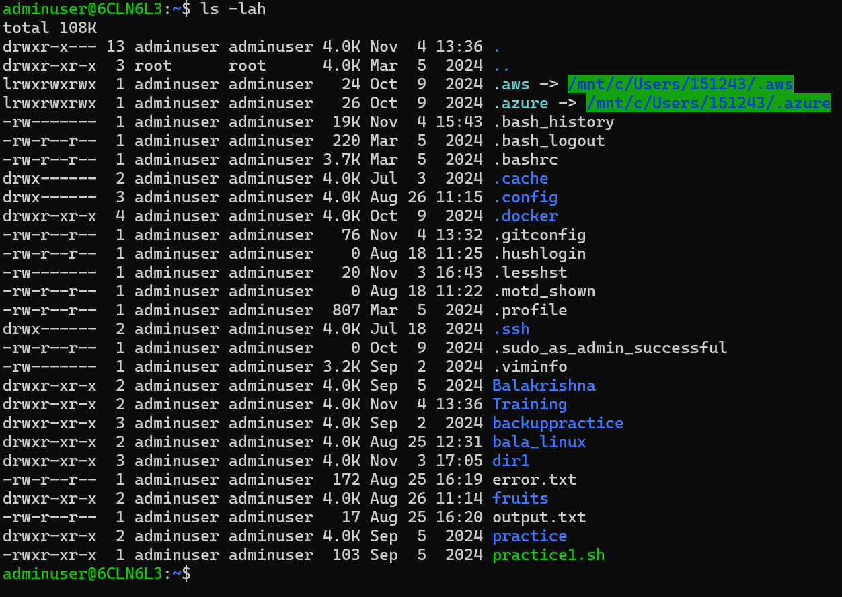

Cd change directory
Cd /tmp , cd .., cd~

Tree directory
-l 2
File & directory operations
- mkdir — make directory
mkdir mydir → Exercise: mkdir testdir && ls
- rmdir — remove empty directory
rmdir testdir
- touch — create empty file / update timestamp
touch file.txt
- cp — copy files/directories
cp file.txt copy.txt / cp -r dir1 dir2
- mv — move/rename
mv oldname newname
- rm — remove files/directories
rm file.txt / rm -r dir (dangerous)
Exercise: create a.txt, copy to b.txt, then remove both.
- stat — file details
stat file.txt
- ln -s — create symbolic link
ln -s /path/to/target linkname
Viewing & editing files
- cat — print file
cat README.md
- tac — reverse cat (end-to-start)
- less — pager (better for large files)
less /var/log/syslog (use q to quit)
- head / tail — view start/end lines
head -n 20 file / tail -f /var/log/syslog (follow)
- nl — show line numbers
- sed — stream editor (substitute etc.)
Example: sed -n '1,10p' file or sed 's/old/new/g' file
- awk — field processing / reporting
Example: awk '{print $1}' file
- vim, nano, emacs — editors
Example: nano file.txt (Ctrl+O save, Ctrl+X exit)
Exercise: echo "hello" > hi.txt && nano hi.txt

Searching & finding
- grep — search text patterns
grep -n "TODO" -R .
Exercise: grep -R "TODO" . || echo "no TODOs"
- find — find files by name/age/size
find . -name "*.log" -type f
Example: find /tmp -maxdepth 2 -type f -mtime -1
- locate — fast name search (needs updatedb)
locate passwd
- which / whereis (see above)
Permissions & ownership
- chmod — change permissions
chmod 644 file / chmod +x script.sh
Exercise: chmod +x script.sh then ./script.sh
- chown — change owner/group
sudo chown user:group file
- umask — default new file perms
umask 022
- sudo — run as root
sudo apt update (or other admin command)

Process management
- ps — list processes
ps aux | grep ssh
- top / htop — interactive process viewer (htop often needs install)
top
- kill — send signals to processes
kill <pid> (SIGTERM) / kill -9 <pid> (SIGKILL)
Exercise: start sleep 1000 & get PID with jobs/ps, then kill it.
- nice / renice — set priority
nice -n 10 command
- bg / fg / jobs — job control for background/foreground
Networking
- ip (replace ifconfig) — show network interfaces
ip addr show
- ifconfig — older tool (may not exist)
- ping — check connectivity
ping -c 4 google.com
- curl — fetch URLs (useful)
curl -I https://example.com
Exercise: curl https://api.github.com
- wget — download files
wget https://example.com/file.zip
- ssh — remote shell
ssh user@host
- scp / rsync — copy files across hosts
scp file user@host:/path/
rsync -avz local/ remote:/path/ (great for sync)
- netstat / ss — sockets and ports (ss -tulwn)
- telnet — test TCP connectivity to a port
Package management (Debian/Ubuntu & RHEL/Fedora examples)
- Debian/Ubuntu (apt):
sudo apt update — refresh package lists
sudo apt install <pkg> — install
sudo apt remove <pkg> — remove
apt-cache search <term>
- RHEL/CentOS (yum/dnf):
sudo dnf install <pkg> / sudo yum install <pkg>
- Arch: pacman -S <pkg>
Exercise: sudo apt update && sudo apt install tree -y then tree .

MV commands output-
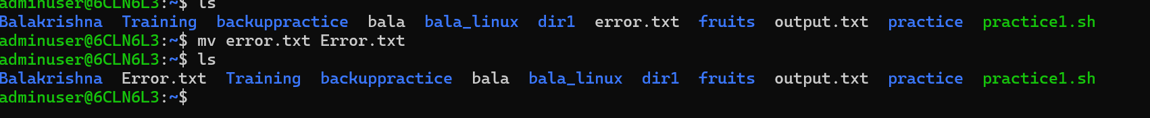
rm- rename function/command
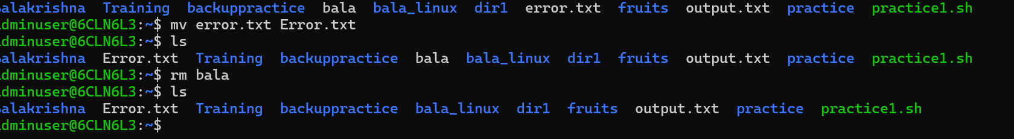

Rm -r dir = remove the directory

Exercise: create a.txt, copy to b.txt, then remove both.

Stat - file details
Stat.file.txt
Ln -s – symbolic link
Ln -s /path/to/target link name

Searching and finding

Grep
Grep -n “…”-R
Grep -R “todo”
Locate- fast name search
Which 0r where do we see above
Permission mgmt.
List of processing – PS

Ps aux |grep ssh
Top -interactive process viewer
Kill- killing the process

Time & scheduling

date — show current date/time
date

timedatectl — timezone & clock
timedatectl status

cron / crontab — scheduled tasks

Edit user crontab: crontab -e

Example entry to run backup.sh daily at 2am: 0 2 * * * /home/user/backup.sh
Exercise: crontab -l (view) or crontab -e to add a harmless cron like * * * * * echo "tick" >> /tmp/cron_test.log

Shell basics & scripting

bash / sh — shells

Environment variables: export VAR=value / echo $VAR

chmod +x script.sh then ./script.sh to run

Shebang at top: #!/usr/bin/env bash

for, if, while loops in scripts

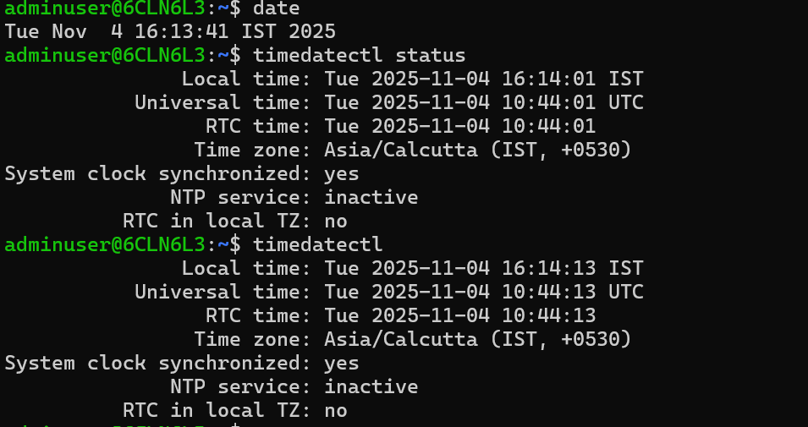

Development & Git basics (local)

git init — init repo

git add . → git commit -m "msg" → git push (covered earlier)

git status, git log --oneline, git branch, git checkout -b feature/x

Security & certificates

ssh-keygen — create SSH keys
ssh-keygen -t ed25519 -C "you@example.com"

ssh-copy-id — copy key to a host (Linux)
ssh-copy-id user@host

openssl — inspect certs / create keys
openssl s_client -connect example.com:443

mkdir: cannot create directory ‘/home/adminuser/linux_practice’: File exists
total 120K
drwxr-x--- 16 adminuser adminuser 4.0K Nov 4 16:24 .
drwxr-xr-x 3 root root 4.0K Mar 5 2024 ..
lrwxrwxrwx 1 adminuser adminuser 24 Oct 9 2024 .aws -> /mnt/c/Users/151243/.aws
lrwxrwxrwx 1 adminuser adminuser 26 Oct 9 2024 .azure -> /mnt/c/Users/151243/.azure
-rw------- 1 adminuser adminuser 19K Nov 4 16:20 .bash_history
-rw-r--r-- 1 adminuser adminuser 220 Mar 5 2024 .bash_logout
-rw-r--r-- 1 adminuser adminuser 3.7K Mar 5 2024 .bashrc
drwx------ 2 adminuser adminuser 4.0K Jul 3 2024 .cache
drwx------ 3 adminuser adminuser 4.0K Aug 26 11:15 .config
drwxr-xr-x 4 adminuser adminuser 4.0K Oct 9 2024 .docker
-rw-r--r-- 1 adminuser adminuser 76 Nov 4 13:32 .gitconfig
-rw-r--r-- 1 adminuser adminuser 0 Aug 18 11:25 .hushlogin
-rw------- 1 adminuser adminuser 20 Nov 3 16:43 .lesshst
-rw-r--r-- 1 adminuser adminuser 0 Aug 18 11:22 .motd_shown
-rw-r--r-- 1 adminuser adminuser 807 Mar 5 2024 .profile
drwx------ 2 adminuser adminuser 4.0K Jul 18 2024 .ssh
-rw-r--r-- 1 adminuser adminuser 0 Oct 9 2024 .sudo_as_admin_successful
-rw------- 1 adminuser adminuser 3.2K Sep 2 2024 .viminfo
drwxr-xr-x 2 adminuser adminuser 4.0K Sep 5 2024 Balakrishna
-rw-r--r-- 1 adminuser adminuser 172 Aug 25 16:19 Error.txt
drwxr-xr-x 2 adminuser adminuser 4.0K Nov 4 13:36 Training
drwxr-xr-x 3 adminuser adminuser 4.0K Sep 2 2024 backuppractice
drwxr-xr-x 2 adminuser adminuser 4.0K Aug 25 12:31 bala_linux
drwxr-xr-x 2 adminuser adminuser 4.0K Nov 4 16:24 data
drwxr-xr-x 2 adminuser adminuser 4.0K Aug 26 11:14 fruits
drwxr-xr-x 5 adminuser adminuser 4.0K Nov 4 16:24 linux_practice
drwxr-xr-x 2 adminuser adminuser 4.0K Nov 4 16:24 notes
-rw-r--r-- 1 adminuser adminuser 17 Aug 25 16:20 output.txt
drwxr-xr-x 2 adminuser adminuser 4.0K Sep 5 2024 practice
-rwxr-xr-x 1 adminuser adminuser 103 Sep 5 2024 practice1.sh
drwxr-xr-x 2 adminuser adminuser 4.0K Nov 4 16:24 scripts
hello world
line2
hello world
line2
total 120K
drwxr-x--- 16 adminuser adminuser 4.0K Nov 4 16:24 .
drwxr-xr-x 3 root root 4.0K Mar 5 2024 ..
lrwxrwxrwx 1 adminuser adminuser 24 Oct 9 2024 .aws -> /mnt/c/Users/151243/.aws
lrwxrwxrwx 1 adminuser adminuser 26 Oct 9 2024 .azure -> /mnt/c/Users/151243/.azure
-rw------- 1 adminuser adminuser 19K Nov 4 16:20 .bash_history
-rw-r--r-- 1 adminuser adminuser 220 Mar 5 2024 .bash_logout
-rw-r--r-- 1 adminuser adminuser 3.7K Mar 5 2024 .bashrc
drwx------ 2 adminuser adminuser 4.0K Jul 3 2024 .cache
drwx------ 3 adminuser adminuser 4.0K Aug 26 11:15 .config
drwxr-xr-x 4 adminuser adminuser 4.0K Oct 9 2024 .docker
-rw-r--r-- 1 adminuser adminuser 76 Nov 4 13:32 .gitconfig
-rw-r--r-- 1 adminuser adminuser 0 Aug 18 11:25 .hushlogin
-rw------- 1 adminuser adminuser 20 Nov 3 16:43 .lesshst
-rw-r--r-- 1 adminuser adminuser 0 Aug 18 11:22 .motd_shown
-rw-r--r-- 1 adminuser adminuser 807 Mar 5 2024 .profile
drwx------ 2 adminuser adminuser 4.0K Jul 18 2024 .ssh
-rw-r--r-- 1 adminuser adminuser 0 Oct 9 2024 .sudo_as_admin_successful
-rw------- 1 adminuser adminuser 3.2K Sep 2 2024 .viminfo
drwxr-xr-x 2 adminuser adminuser 4.0K Sep 5 2024 Balakrishna
-rw-r--r-- 1 adminuser adminuser 172 Aug 25 16:19 Error.txt
drwxr-xr-x 2 adminuser adminuser 4.0K Nov 4 13:36 Training
drwxr-xr-x 3 adminuser adminuser 4.0K Sep 2 2024 backuppractice
drwxr-xr-x 2 adminuser adminuser 4.0K Aug 25 12:31 bala_linux
drwxr-xr-x 2 adminuser adminuser 4.0K Nov 4 16:24 data
drwxr-xr-x 2 adminuser adminuser 4.0K Aug 26 11:14 fruits
drwxr-xr-x 5 adminuser adminuser 4.0K Nov 4 16:24 linux_practice
drwxr-xr-x 2 adminuser adminuser 4.0K Nov 4 16:24 notes
-rw-r--r-- 1 adminuser adminuser 17 Aug 25 16:20 output.txt
drwxr-xr-x 2 adminuser adminuser 4.0K Sep 5 2024 practice
-rwxr-xr-x 1 adminuser adminuser 103 Sep 5 2024 practice1.sh
drwxr-xr-x 2 adminuser adminuser 4.0K Nov 4 16:24 scripts
notes/
notes/hello.txt
scripts/
scripts/list.sh
data/
data/hello.txt
notes/
notes/hello.txt
scripts/
scripts/list.sh
data/
data/hello.txt
adminuser@6CLN6L3:~$

