10 Python Programming Case Studies
Beginner-friendly solutions using the assigned syllabus | First-year B.Tech level
Included for every case study:
- • Problem statement, objectives, and assumptions
- • Algorithm and pseudocode
- • Standard flowchart description and decision tree logic
- • Four-line Python source code using basic concepts
- • Sample test input, console-output screenshot panel, and analytical conclusion
Standard Flowchart Symbol & Color Key
Symbol Shape | Flowchart Function | Prescribed Color Key
Oval / Ellipse | Start / Stop (Terminator) | Green / Light Red
Parallelogram | Input / Output Data | Light Blue
Rectangle | Process / Calculate / Validate | Light Yellow
Diamond / Rhombus | Decision (Conditions Met?) | Light Orange
Flowline / Arrow | Control Flow Direction | Dark Grey
Note: Amounts, thresholds, taxes, and policies are illustrative classroom assumptions. Real-world rules may differ.

Case Study 1: University Scholarship Allocation
Problem Statement
Evaluate applicants using aggregate marks, minimum subject scores, attendance, and family income. Rank eligible applicants and break ties using aggregate marks, then attendance.
Objectives
- • Check eligibility consistently across multiple academic and financial parameters.
- • Rank eligible applicants using fixed tie-break rules.
- • Display applicant eligibility status and a conclusive rank score.
Assumptions
- • Marks and attendance are percentages measured on a scale from 0 to 100.
- • Eligibility criteria: Aggregate >= 80%, each subject score >= 60%, attendance >= 75%, and annual family income <= Rs. 3,00,000.
- • This four-line implementation evaluates one applicant; multiple records can be stored as tuples and sorted.
Algorithm
1. Read applicant aggregate marks, individual subject marks tuple, attendance percentage, and annual income.
2. Evaluate composite eligibility using a compound Boolean expression.
3. Print eligibility status ('Eligible' or 'Not eligible').
4. For multiple candidates, sort eligible records in descending order of aggregate marks, followed by attendance percentage.
Pseudocode
ALGORITHM LOGIC
INPUT aggregate, subject1, subject2, subject3, attendance, income
eligible = (aggregate >= 80) AND (min(subjects) >= 60) AND (attendance >= 75) AND (income <= 300000)
IF eligible THEN
OUTPUT 'Eligible'
ELSE
OUTPUT 'Not eligible'
For ranking: Sort records by (aggregate, attendance) in descending order
Flowchart Architecture
Flowchart Execution Sequence
Start [Green] -> Input values (aggregate, subjects, attendance, income) [Light Blue] -> Calculate/validate conditions [Light Yellow] -> Decision: Conditions met? [Light Orange] -> Display result (Eligible / Not eligible with rank score) [Light Blue] -> Stop [Light Red].
Python Source Code (4-Line Implementation)
PYTHON 3 SCRIPT
aggregate = 86; subjects = (78, 64, 91); attendance = 88; income = 240000
eligible = aggregate >= 80 and min(subjects) >= 60 and attendance >= 75 and income <= 300000
print('Eligible' if eligible else 'Not eligible')
print('Rank score:', aggregate, 'Attendance:', attendance)

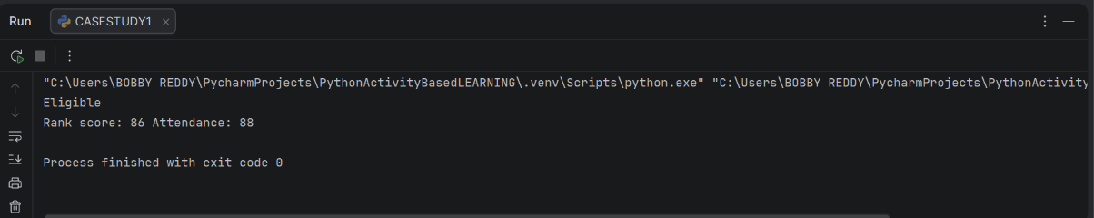

Conclusion & Analysis
The program successfully validates all four eligibility conditions. For institution-wide allocation, candidate records can be ingested as tuples into a list and sorted dynamically by aggregate and attendance.

Case Study 2: Progressive Electricity Billing
Problem Statement
Calculate an electricity bill using progressive consumption slabs, fixed charges, surcharge, and rebate. Compare bills across consecutive months and flag an abnormal consumption increase.
Objectives
- • Compute slab-wise tiered energy charges accurately.
- • Add mandatory fixed charges and surcharges, then deduct applicable rebate incentives.
- • Identify and flag month-to-month billing increases exceeding a 30% anomaly threshold.
Assumptions
- • Tiered rates: First 100 units at Rs. 2/unit; next 100 units (101-200) at Rs. 3/unit; units beyond 200 at Rs. 5/unit.
- • Fixed charge of Rs. 50; surcharge of 5% on subtotal; rebate of Rs. 20 if total consumption is under 100 units.
- • An increase greater than 30% over the previous month's bill is classified as unusual.
Algorithm
1. Read current consumption units and the previous month's total bill.
2. Calculate progressive slab charges using min/max piecewise boundaries.
3. Add fixed charge (Rs. 50), apply 5% surcharge, and deduct Rs. 20 rebate if units < 100.
4. Compare the calculated bill with previous bill and flag an alert if bill > previous_bill * 1.30.
Pseudocode
ALGORITHM LOGIC
INPUT units, previous_bill
energy = slab_charge(units) # min(u, 100)*2 + min(max(u-100, 0), 100)*3 + max(u-200, 0)*5
bill = (energy + 50) * 1.05
IF units < 100 THEN bill = bill - 20
IF bill > (previous_bill * 1.30) THEN OUTPUT 'Unusual increase: True' ELSE OUTPUT 'False'
Flowchart Architecture
Flowchart Execution Sequence
Start [Green] -> Input current units & previous bill [Light Blue] -> Calculate slab-wise energy charge & apply taxes/rebate [Light Yellow] -> Decision: Increase > 30%? [Light Orange] -> Display total bill & unusual surge alert [Light Blue] -> Stop [Light Red].

Python Source Code (4-Line Implementation)
PYTHON 3 SCRIPT
u = 180; prev_bill = 350
energy = min(u, 100)*2 + min(max(u-100, 0), 100)*3 + max(u-200, 0)*5
bill = (energy + 50) * 1.05 - (20 if u < 100 else 0)
print(f'Bill: {bill:.2f}', 'Unusual increase:', bill > prev_bill * 1.30)
Test Case & Execution Output
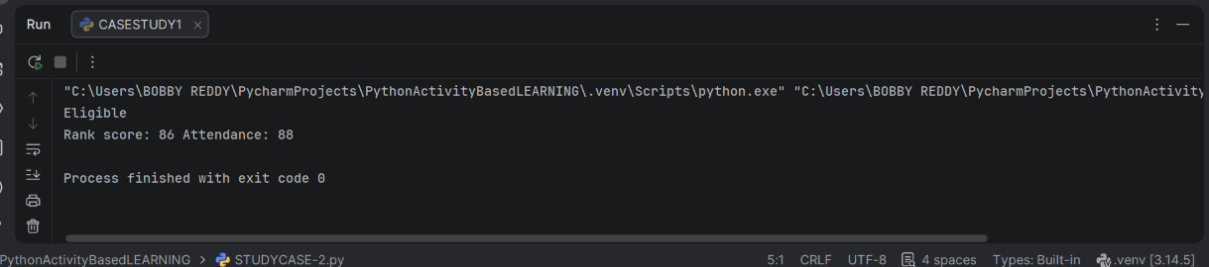
Conclusion & Analysis
The progressive slab structure applies equitable tiered tariffs while automated surge detection immediately isolates erratic consumption shifts.

Case Study 3: Hospital Billing and Patient Classification
Problem Statement
Calculate total charges for consultation, diagnostics, and treatment, apply age-based concessions, validate charges, and classify the patient into standard billing tiers.
Objectives
- • Sum departmental service charges accurately.
- • Apply senior-citizen concessions (10%) strictly when age eligibility is met.
- • Validate all inputs against negative figures and categorize bills into Basic or Standard.
Assumptions
- • All fee items must be non-negative (consultation, diagnostics, treatment >= 0).
- • A 10% concession is granted to senior citizens aged 60 and above.
- • Classification policy: Total bill under Rs. 2,000 = 'Basic'; Rs. 2,000 or above = 'Standard'.
Algorithm
1. Read patient age, consultation fee, diagnostic charges, and treatment costs.
2. Validate that every individual fee component is non-negative.
3. Calculate total cost and apply 10% discount if patient age >= 60.
4. Classify category ('Basic' if total < 2000 else 'Standard') and print invoice.
Pseudocode
ALGORITHM LOGIC
INPUT age, consultation, diagnostics, treatment
IF min(consultation, diagnostics, treatment) < 0 THEN OUTPUT 'Invalid charges'
total = sum(charges)
IF age >= 60 THEN total = total * 0.90
category = 'Basic' IF total < 2000 ELSE 'Standard'
OUTPUT total, category
Flowchart Architecture
Flowchart Execution Sequence
Start [Green] -> Input age and service charges [Light Blue] -> Validate charges >= 0 [Light Yellow] -> Decision: Age >= 60? [Light Orange] -> Apply discount & determine category [Light Yellow] -> Display itemized total & tier [Light Blue] -> Stop [Light Red].

Python Source Code (4-Line Implementation)
PYTHON 3 SCRIPT
age = 65; consultation = 500; diagnostics = 900; treatment = 1200
valid = min(consultation, diagnostics, treatment) >= 0
total = (consultation + diagnostics + treatment) * (0.9 if age >= 60 else 1)
print('Invalid charges' if not valid else f'Total: {total:.2f} | Category: {"Basic" if total < 2000 else "Standard"}')
Test Case & Execution Output
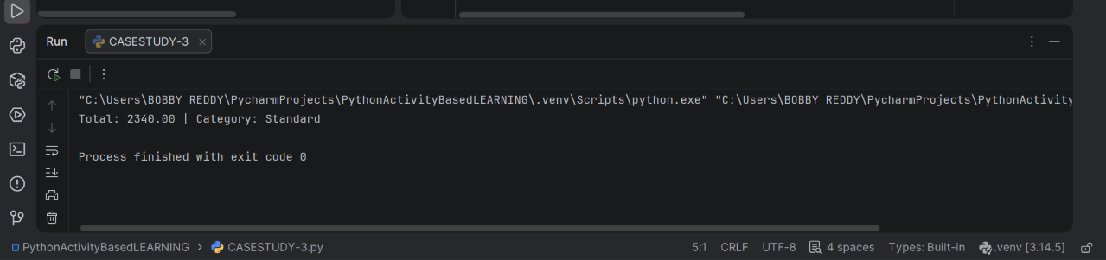
Conclusion & Analysis
The script enforces data integrity by rejecting negative fees, automatically integrates senior subsidies, and categorizes patients into standard billing brackets.

Case Study 4: Employee Payroll and Deduction Analysis
Problem Statement
Calculate gross earnings from basic pay, allowances, overtime, and performance incentives, apply a progressive tiered deduction model, and generate a clear take-home pay statement.
Objectives
- • Aggregate multiple salary streams into gross remuneration.
- • Implement a progressive, multi-band deduction formula.
- • Provide an itemized salary slip showing gross pay, deductions, and net take-home salary.
Assumptions
- • Gross salary = basic pay + allowances + overtime + performance incentives.
- • Deduction slabs: 5% on the initial Rs. 20,000 band, and 10% on earnings exceeding Rs. 20,000.
- • Standardized educational payroll model.
Algorithm
1. Read basic salary, allowances, overtime pay, and incentives.
2. Sum components to compute gross salary.
3. Compute progressive statutory deductions across the two income bands.
4. Deduct total deductions from gross earnings to arrive at net salary and display results.
Pseudocode
ALGORITHM LOGIC
INPUT basic, allowances, overtime, incentives
gross = basic + allowances + overtime + incentives
deduction = 0.05 * min(gross, 20000) + 0.10 * max(gross - 20000, 0)
net = gross - deduction
OUTPUT gross, deduction, net
Flowchart Architecture
Flowchart Execution Sequence
Start [Green] -> Input pay components [Light Blue] -> Compute gross earnings [Light Yellow] -> Calculate band deductions [Light Yellow] -> Display Net Take-Home Statement [Light Blue] -> Stop [Light Red].
Python Source Code (4-Line Implementation)
PYTHON 3 SCRIPT
basic = 25000; allowances = 5000; overtime = 2000; incentives = 1500
gross = basic + allowances + overtime + incentives
deduction = 0.05 * min(gross, 20000) + 0.10 * max(gross - 20000, 0)
print(f'Gross: {gross:.2f} | Deduction: {deduction:.2f} | Net: {gross - deduction:.2f}')
Test Case & Execution Output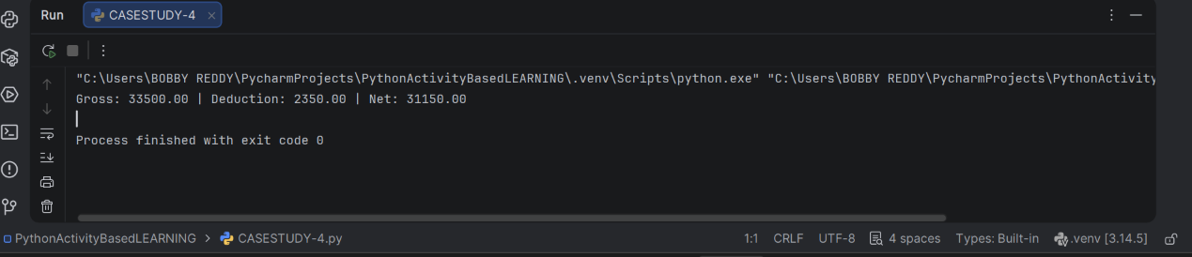

Conclusion & Analysis
The implementation segregates fixed and variable earnings, cleanly executes progressive withholding computations, and yields an accurate net remittance figure.

Case Study 5: Multi-Plan Telecommunications Cost Optimization
Problem Statement
Compare multiple mobile cellular plans against expected data consumption, required validity, and strict user budget limits, adding excess usage penalties to identify the cheapest feasible plan.
Objectives
- • Calculate effective aggregate costs including overage data penalties.
- • Filter plans based on duration constraints and overall budget ceilings.
- • Select and display the most economical qualifying plan.
Assumptions
- • Plan A: Base price Rs. 199, 2 GB quota, 28 days validity; Plan B: Base price Rs. 299, 5 GB quota, 56 days validity.
- • Extra data overage fee: Rs. 20 per GB beyond bundled quota.
- • Target requirements: Minimum validity 28 days, maximum expenditure ceiling Rs. 350.
Algorithm
1. Define plan configurations as tuples of (name, base_price, data_quota, validity).
2. Calculate total cost for each plan: base price + max(usage - quota, 0) * 20.
3. Filter plans satisfying both validity >= required_days and total cost <= budget.
4. Determine the eligible plan with the minimal total cost and display recommendation.
Pseudocode
ALGORITHM LOGIC
plans = [('A', 199, 2, 28), ('B', 299, 5, 56)]
FOR each (name, price, data, validity) in plans:
cost = price + max(usage - data, 0) * 20
IF validity >= required_days AND cost <= budget THEN keep as eligible
OUTPUT eligible plan with minimum cost
Flowchart Architecture
Flowchart Execution Sequence
Start [Green] -> Input usage requirements & budget constraints [Light Blue] -> Compute plan costs including overage penalties [Light Yellow] -> Decision: Meets validity and budget? [Light Orange] -> Select min-cost eligible plan & display [Light Blue] -> Stop [Light Red].

Python Source Code (4-Line Implementation)
PYTHON 3 SCRIPT
usage = 3; days = 28; budget = 350; plans = [('A', 199, 2, 28), ('B', 299, 5, 56)]
costs = [(n, p + max(usage - d, 0)*20, v) for n, p, d, v in plans if v >= days and p + max(usage - d, 0)*20 <= budget]
best = min(costs, key=lambda x: x[1]) if costs else None
print('Best plan:', best if best else 'No eligible plan')
Test Case & Execution Output
Conclusion & Analysis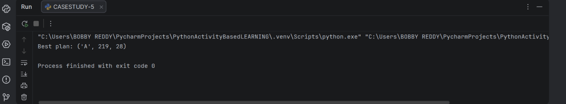
The algorithm prevents deceptive decisions based solely on sticker prices by factoring in realistic consumption overages before matching against budgetary constraints.

Case Study 6: Railway Fare and Reservation Calculator
Problem Statement
Calculate passenger rail fares based on travel distance, accommodation class, senior-citizen concessions, reservation fees, and potential cancellation refund entitlements.
Objectives
- • Compute base journey tariffs from distance and class multipliers.
- • Incorporate age concessions and mandatory reservation surcharges.
- • Estimate net refund entitlements following standard cancellation penalty deductions.
Assumptions
- • Tariff rates: Sleeper class @ Rs. 1.20/km; AC class @ Rs. 2.00/km.
- • Senior citizen concession: 20% discount on base fare for passengers aged 60 and above.
- • Fixed reservation surcharge: Rs. 40; Cancellation retention penalty: 25% of discounted base fare.
Algorithm
1. Read journey distance, travel class, passenger age, and cancellation flag.
2. Calculate base fare = distance * class_rate.
3. Apply 20% discount if age >= 60; add fixed reservation surcharge (Rs. 40).
4. If cancellation is requested, deduct 25% base penalty and compute net payable refund.
Pseudocode
ALGORITHM LOGIC
INPUT distance, travel_class, age, cancelled
rate = 1.2 IF travel_class == 'Sleeper' ELSE 2.0
fare = distance * rate
IF age >= 60 THEN fare = fare * 0.80
total = fare + 40
IF cancelled THEN refund = total - (0.25 * fare) ELSE refund = 0
OUTPUT total, refund
Flowchart Architecture
Flowchart Execution Sequence
Start [Green] -> Input distance, class, age, cancellation [Light Blue] -> Compute base fare & apply senior concession [Light Yellow] -> Decision: Ticket cancelled? [Light Orange] -> Calculate cancellation penalty/refund [Light Yellow] -> Display final ticket summary [Light Blue] -> Stop [Light Red].

Python Source Code (4-Line Implementation)
PYTHON 3 SCRIPT
distance = 350; travel_class = 'AC'; age = 65; cancelled = True
rate = 1.2 if travel_class == 'Sleeper' else 2.0; fare = distance * rate
fare = fare * (0.8 if age >= 60 else 1); total = fare + 40; refund = total - 0.25*fare if cancelled else 0
print(f'Fare: {total:.2f} | Refund on cancellation: {refund:.2f}')
Test Case & Execution Output
Conclusion & Analysis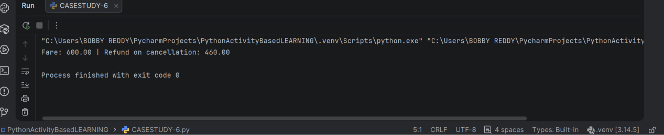
The script faithfully models multi-tiered passenger fare computation, concessional adjustments, and cancellation fee reconciliation in a concise four-line structure.

Case Study 7: Retail Billing with Multiple Discount Rules
Problem Statement
Generate a retail invoice processing multiple line items, applying category-dependent tax rates, and computing threshold-based promotional discounts capped by a hard maximum ceiling.
Objectives
- • Calculate itemized subtotal from quantity and unit pricing.
- • Apply a 10% threshold discount capped at a maximum concession limit.
- • Levy category-specific sales tax on post-discount amounts to generate final payable invoices.
Assumptions
- • Category taxation: Electronics @ 18% GST; Groceries @ 5% GST.
- • Promotional concession: 10% off subtotal when order value >= Rs. 2,000, capped at Rs. 300.
- • Tax is assessed strictly on taxable net amounts (subtotal minus discount).
Algorithm
1. Ingest basket items as tuples of (item_name, quantity, unit_price).
2. Calculate subtotal = sum(quantity * unit_price).
3. Evaluate threshold discount: min(subtotal * 0.10, 300) if subtotal >= 2000 else 0.
4. Apply category tax rate to (subtotal - discount) and display itemized invoice.
Pseudocode
ALGORITHM LOGIC
subtotal = sum(quantity * price)
discount = min(0.10 * subtotal, 300) IF subtotal >= 2000 ELSE 0
tax_rate = 0.18 IF category == 'Electronics' ELSE 0.05
total = (subtotal - discount) * (1 + tax_rate)
OUTPUT subtotal, discount, tax, total
Flowchart Architecture
Flowchart Execution Sequence
Start [Green] -> Input item details & category [Light Blue] -> Compute subtotal [Light Yellow] -> Decision: Subtotal >= 2000? [Light Orange] -> Apply capped discount and tax rate [Light Yellow] -> Display invoice breakdown & total [Light Blue] -> Stop [Light Red].

Python Source Code (4-Line Implementation)
PYTHON 3 SCRIPT
items = [('Headphones', 2, 900), ('Cable', 1, 300)]; category = 'Electronics'
subtotal = sum(q * p for name, q, p in items); discount = min(subtotal * 0.10, 300) if subtotal >= 2000 else 0
rate = 0.18 if category == 'Electronics' else 0.05; total = (subtotal - discount) * (1 + rate)
print(f'Subtotal: {subtotal:.2f} | Discount: {discount:.2f} | Tax: {(subtotal-discount)*rate:.2f} | Total: {total:.2f}')
Test Case & Execution Output
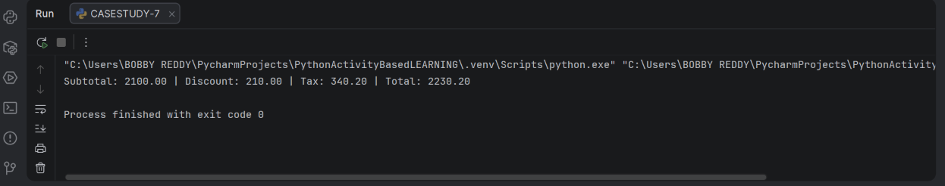
Conclusion & Analysis
The billing pipeline ensures fair retail taxation by applying discounts prior to sales tax computations while protecting merchant margins via hard discount caps.

Case Study 8: Manufacturing Cost and Profitability Analysis
Problem Statement
Determine comprehensive industrial manufacturing expenses factoring in raw materials, scrap wastage, direct labour, and machinery overhead to verify production profit targets.
Objectives
- • Compute total manufacturing expenditure including scrap wastage.
- • Calculate gross revenue, gross profit, and unit cost.
- • Evaluate financial profitability against designated organizational targets.
Assumptions
- • Raw material unit rate Rs. 500 across a production batch of 100 units.
- • Wastage allowance: 8% on total material cost; direct labour Rs. 12,000; machinery overhead Rs. 5,000.
- • Product wholesale selling price Rs. 750/unit; benchmark target profit Rs. 15,000.
Algorithm
1. Calculate base raw material cost = quantity * material_rate.
2. Compute material wastage allowance = material_cost * 0.08.
3. Aggregate total cost = material + wastage + labour + machine overhead.
4. Calculate gross revenue = quantity * selling_price; determine profit = revenue - total_cost and compare with target.
Pseudocode
ALGORITHM LOGIC
material = quantity * material_rate
wastage = material * 0.08
cost = material + wastage + labour + machine
revenue = quantity * selling_price
profit = revenue - cost
target_met = (profit >= target_profit)
OUTPUT cost, revenue, profit, target_met
Flowchart Architecture
Flowchart Execution Sequence
Start [Green] -> Input production parameters [Light Blue] -> Compute material wastage, overheads, & total cost [Light Yellow] -> Decision: Profit >= Target? [Light Orange] -> Display cost, revenue, profit, and target status [Light Blue] -> Stop [Light Red].

Python Source Code (4-Line Implementation)
PYTHON 3 SCRIPT
qty = 100; material_rate = 500; labour = 12000; machine = 5000; selling_price = 750
material = qty * material_rate; wastage = material * 0.08; cost = material + wastage + labour + machine
revenue = qty * selling_price; profit = revenue - cost; target = 15000
print(f'Cost: {cost:.2f} | Revenue: {revenue:.2f} | Profit: {profit:.2f} | Target met: {profit >= target}')
Test Case & Execution Output
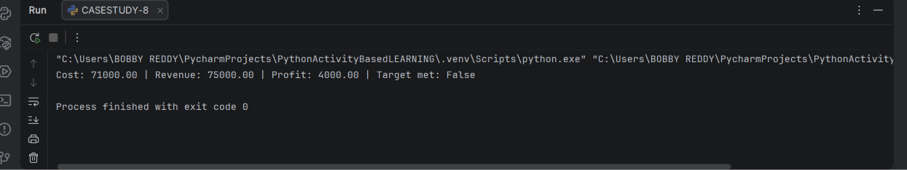
Conclusion & Analysis
The analysis demonstrates the critical impact of physical material wastage and operational overheads on commercial profitability viability.

Case Study 9: Multi-Currency Travel Budget Analysis
Problem Statement
Convert multi-category overseas travel expenses to domestic currency using prevailing exchange rates, append banking transaction fees, verify budget conformity, and pinpoint top expense drains.
Objectives
- • Convert multiple foreign currency line items into domestic INR equivalents.
- • Levy statutory 2% foreign remittance / transaction processing fees.
- • Determine the single largest expenditure category and verify overall budget adherence.
Assumptions
- • All offshore expenses are denominated in a uniform foreign currency unit.
- • Benchmark foreign exchange rate: Rs. 83.00 per unit, plus a 2% bank processing fee on net conversion.
- • Overall budget limit Rs. 50,000; category evaluation is based on converted nominal expenditure.
Algorithm
1. Store travel expense categories and amounts as tuples in a list.
2. Convert each expense item to domestic currency = foreign_amount * exchange_rate.
3. Calculate total cost with transaction fees = sum(converted_amounts) * 1.02.
4. Identify the maximal category using max() and verify if total <= budget.
Pseudocode
ALGORITHM LOGIC
expenses = [('Hotel', 300), ('Food', 100), ('Transport', 80)]
FOR each (category, amount) in expenses:
converted = amount * exchange_rate
total = sum(converted) * 1.02
largest = category with max(converted)
within_budget = (total <= budget)
OUTPUT total, largest, within_budget
Flowchart Architecture
Flowchart Execution Sequence
Start [Green] -> Input foreign expenditures & exchange rate [Light Blue] -> Convert currencies & apply 2% conversion fee [Light Yellow] -> Decision: Total <= Budget? [Light Orange] -> Identify dominant category & display status [Light Blue] -> Stop [Light Red].

Python Source Code (4-Line Implementation)
PYTHON 3 SCRIPT
expenses = [('Hotel', 300), ('Food', 100), ('Transport', 80)]; rate = 83; budget = 50000
converted = [(name, amount * rate) for name, amount in expenses]
total = sum(amount for name, amount in converted) * 1.02; largest = max(converted, key=lambda x: x[1])
print(f'Total with fee: {total:.2f} | Largest: {largest[0]} | Within budget: {total <= budget}')
Test Case & Execution Output
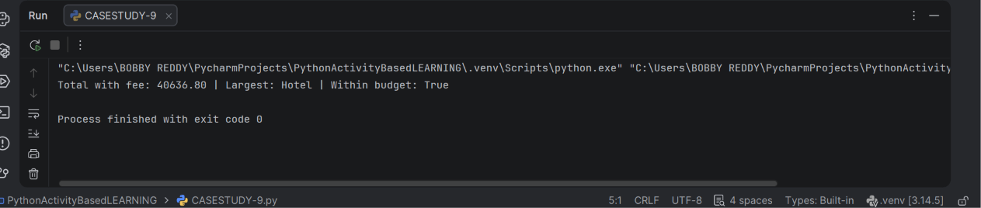
Conclusion & Analysis
The script encapsulates foreign exchange risk management by factoring in conversion fees and isolating major expense drivers for budgetary tracking.

Case Study 10: Campus Event Financial Planning
Problem Statement
Formulate a campus event financial model tracking fixed logistics, variable delegate hospitality, institutional sponsorships, and delegate fees to compute deficits and break-even attendance.
Objectives
- • Segregate fixed overheads from per-attendee variable operational expenses.
- • Quantify net financial deficit/shortfall after factoring in sponsorship and registration receipts.
- • Calculate the exact break-even attendee turnout threshold required to attain self-sufficiency.
Assumptions
- • Fixed logistics: Venue Rs. 20,000; Equipment Rs. 8,000; Transport Rs. 5,000.
- • Per-participant variable cost: Catering Rs. 250 + Kit/Certificate Rs. 50 = Rs. 300.
- • Revenues: Corporate sponsorship Rs. 15,000; Registration fee Rs. 400 per participant.
- • Net contribution per participant = Rs. 400 - Rs. 300 = Rs. 100.
Algorithm
1. Compute fixed logistics = venue + equipment + transport.
2. Compute per-participant variable rate = catering + certificate.
3. Compute total event expenditure = fixed + (participants * per_person_rate).
4. Calculate funding shortfall = max(total_cost - sponsorship - (participants * fee), 0).
5. Compute break-even registrations = ceil((fixed - sponsorship) / (fee - per_person_rate)).
Pseudocode
ALGORITHM LOGIC
fixed = venue + equipment + transport
per_person = catering + certificate
total_cost = fixed + (participants * per_person)
shortfall = max(total_cost - sponsorship - (participants * fee), 0)
break_even = ceil((fixed - sponsorship) / (fee - per_person))
OUTPUT total_cost, shortfall, break_even
Flowchart Architecture
Flowchart Execution Sequence
Start [Green] -> Input event logistics, headcounts & revenues [Light Blue] -> Aggregate fixed/variable expenses [Light Yellow] -> Decision: Shortfall > 0? [Light Orange] -> Compute break-even turnout threshold [Light Yellow] -> Display budget analysis & break-even metric [Light Blue] -> Stop [Light Red].

Python Source Code (4-Line Implementation)
PYTHON 3 SCRIPT
venue = 20000; equipment = 8000; transport = 5000; people = 120; catering = 250; certificate = 50
fixed = venue + equipment + transport; per_person = catering + certificate; total = fixed + people * per_person
sponsor = 15000; fee = 400; shortfall = total - sponsor - people * fee; minimum = (fixed - sponsor) // (fee - per_person) + 1
print(f'Total cost: {total} | Funding shortfall: {max(shortfall, 0)} | Break-even registrations: {minimum}')
Test Case & Execution Output
Conclusion & Analysis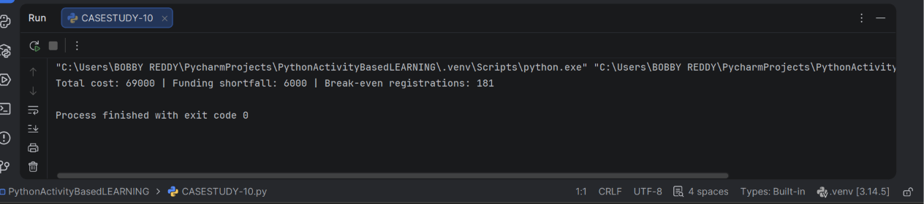
The financial model delineates operational fixed burdens from variable costs, empowering student organizers to determine exact delegate targets for financial break-even.

